**Validation test results of QuickSetLoad**

Test that the GUI can open each individual tab and program from all buttons available

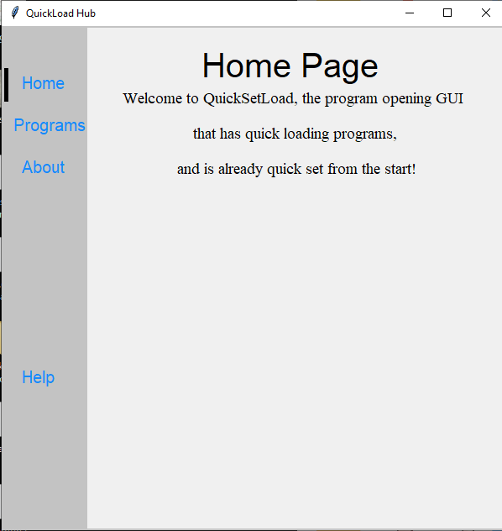

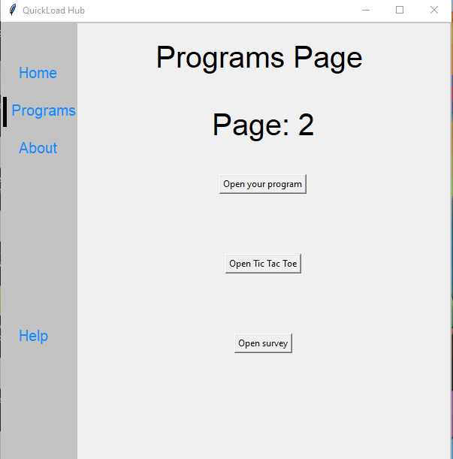

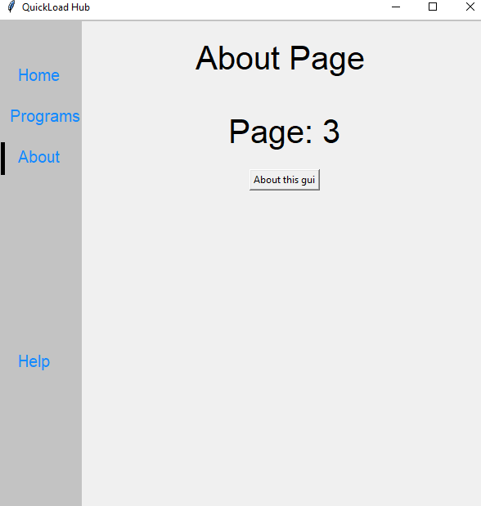

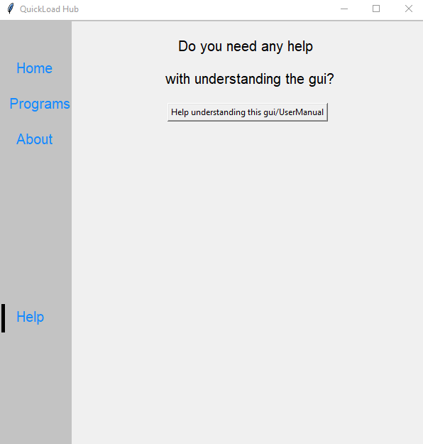

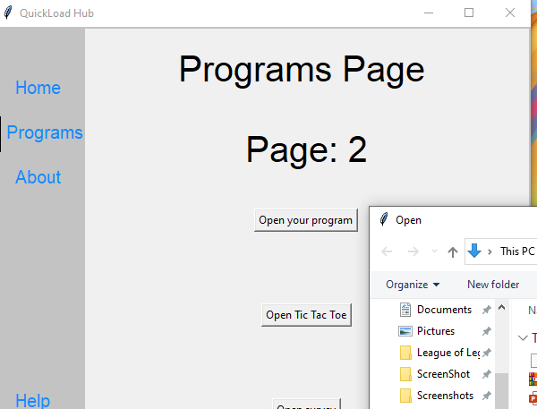

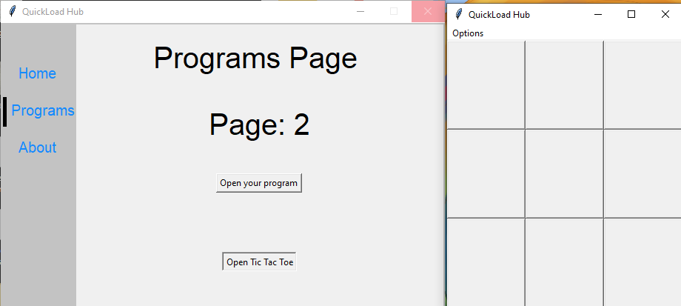

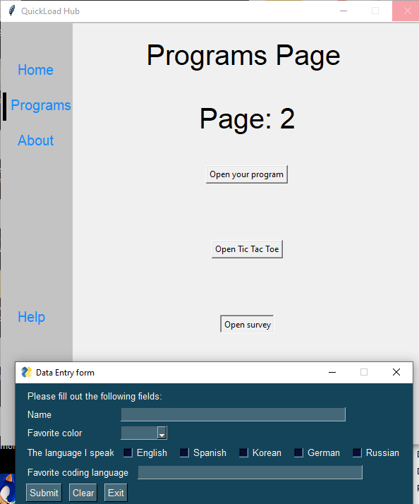

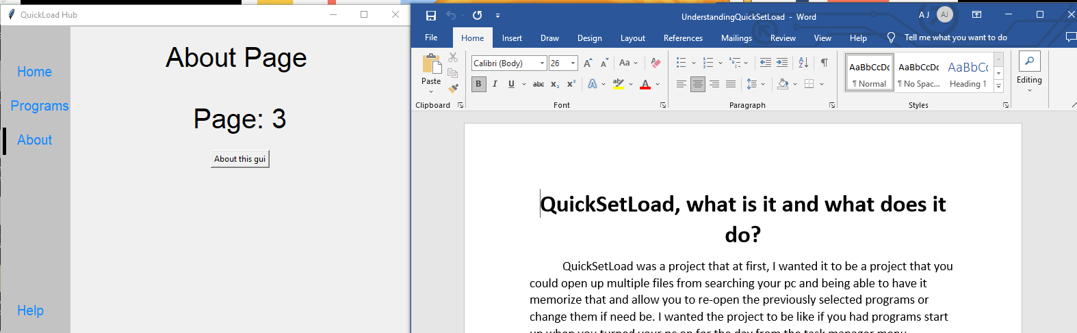

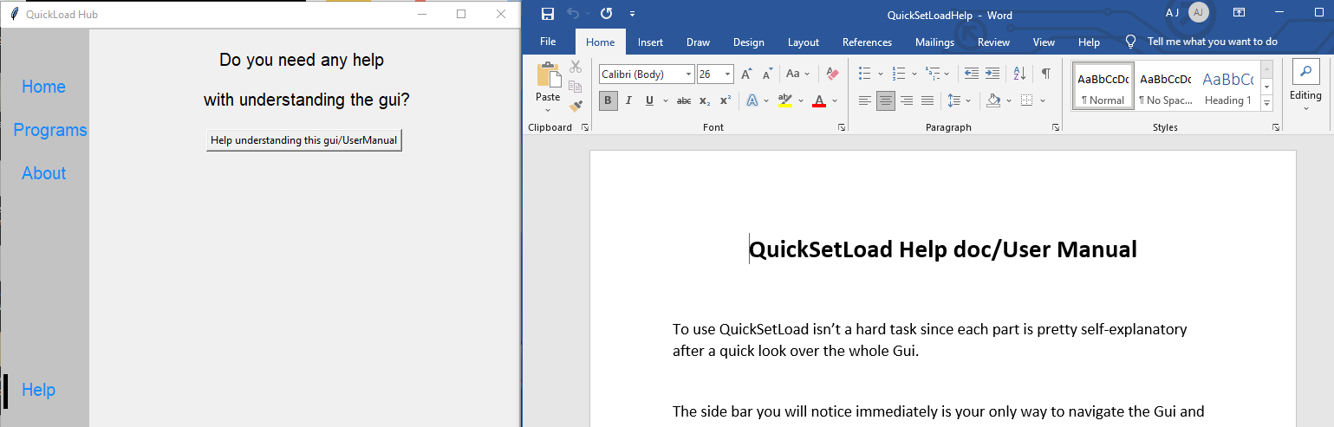

Next I will test if the tic tac toe program works correctly for both resetting the game, and winning.

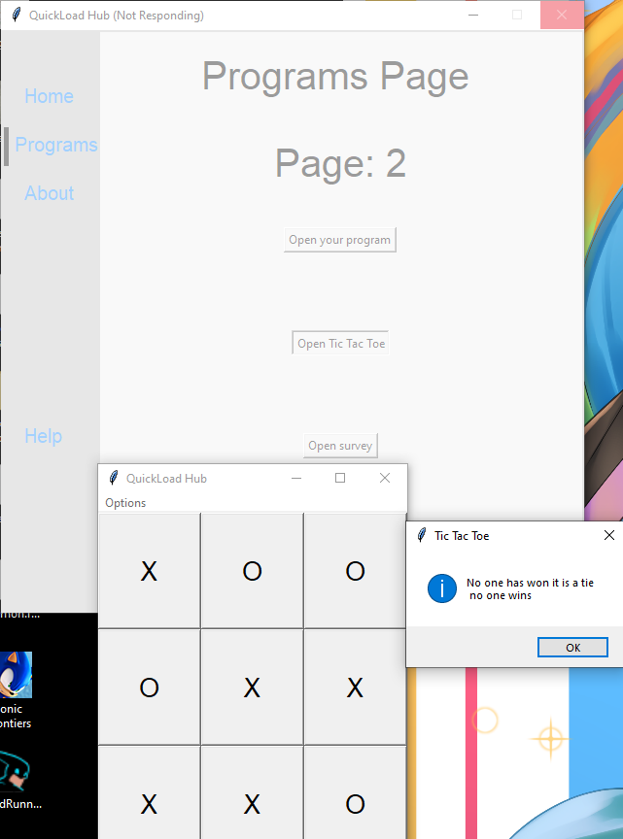

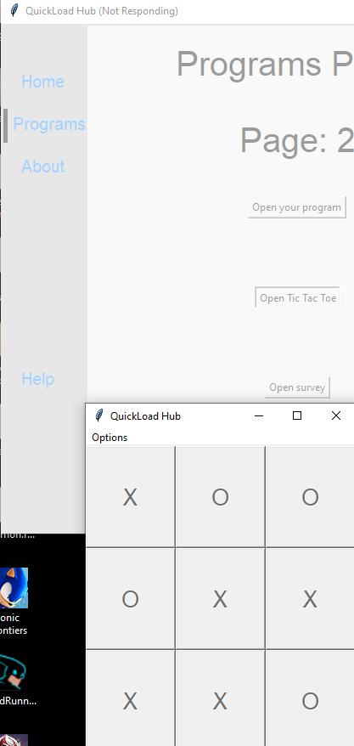

As you can tell it can call if a tie occurs, and greys out the buttons when the game is won or tied

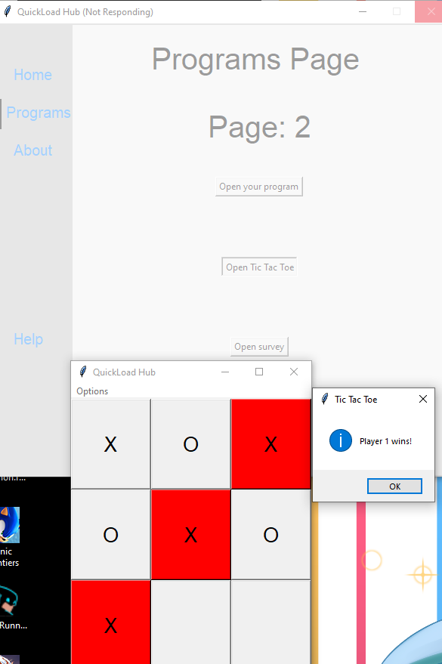

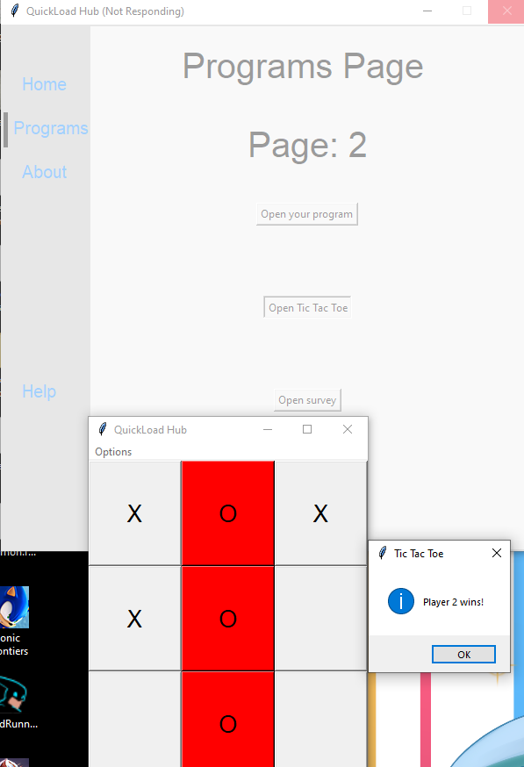

Next to test the Survey to see if it both works, and that the data is saved to the excel file that is in the python directory for QuickSetLoad. This will show if every selectable option works and if your input works.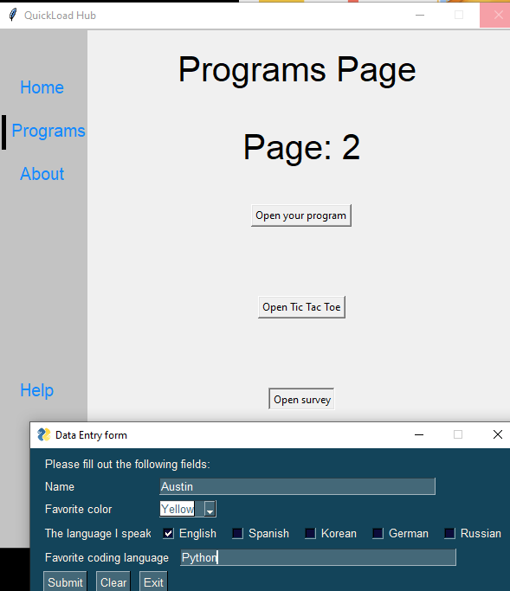

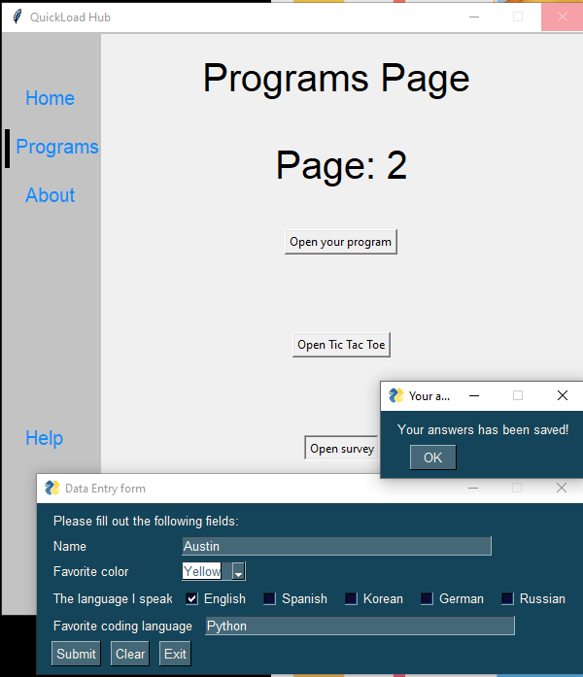

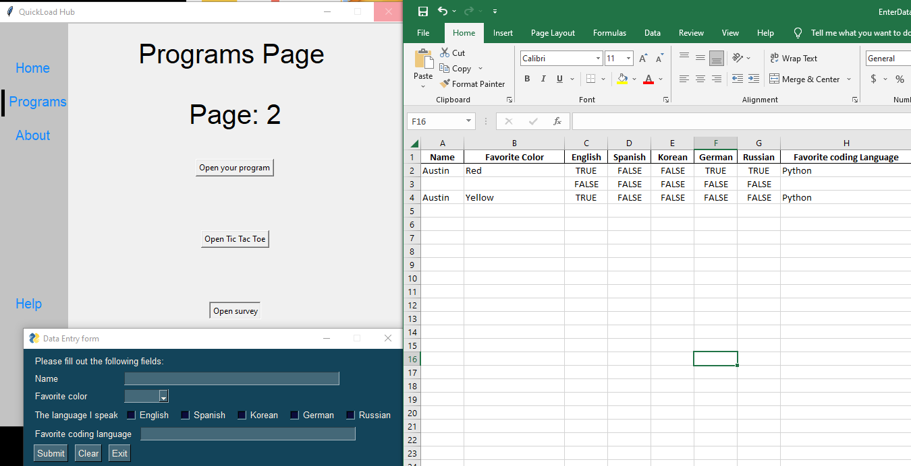

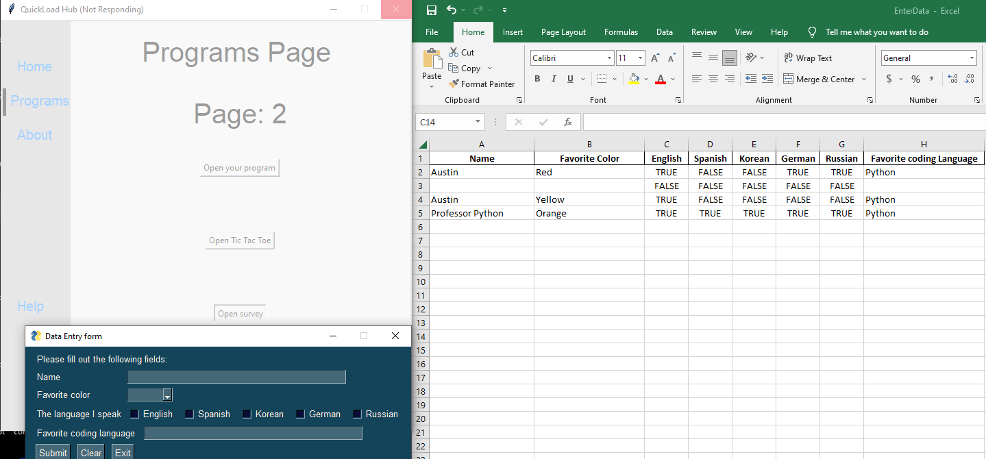

As proven by the validation testing the inputted fields save your information straight to excel, and shows that whichever fields are not submitted as shown by all 4 inputted sets of data, will either show false, or not have any answer associated with the box. If you have a keen eye, you’ll notice that after ever use of this second survey gui, your inputs are cleared so another user can take their turn, or you can add more data to the excel file. One last note is that if you have the excel file open during the survey instead of opening it after using the survey, it will crash the survey gui and cause it to close, and no data will be inputted into the excel file, so make sure you keep the excel file closed till you input all data from the survey.

One final validation and that is can the Gui open up the Validation test doc under the About section?

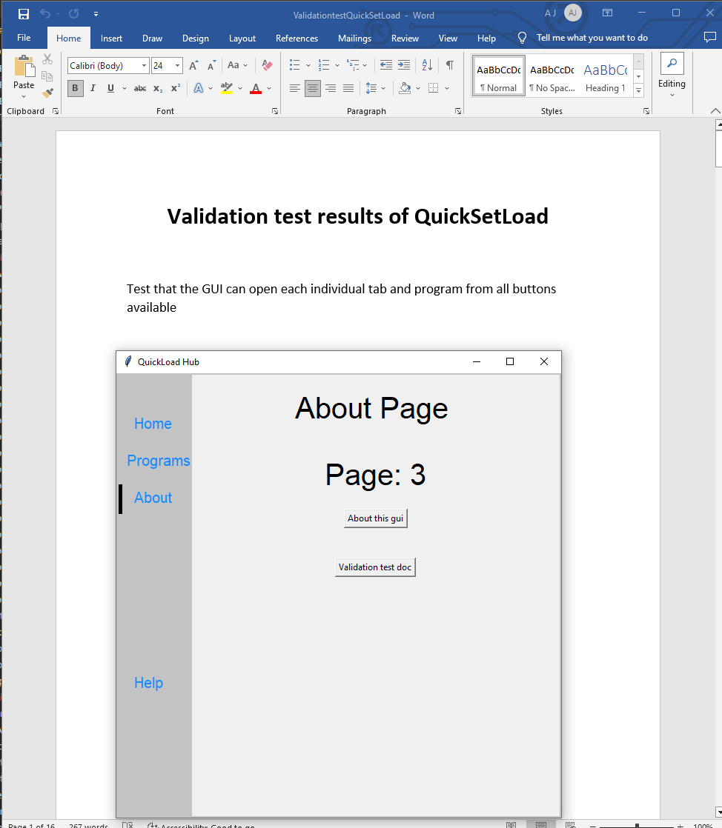

Yes, it can!