Materialize Tutorial Notes

* Use CDN two links under the Get Started then add the Google fonts down further on the page.
* Materialize is built on a 14 px scale then uses rem values which is multiplied by the 14px. Example 4.34rem will create (14x4.34)px or 60.76px
* Create a div class=“container” for each area you want styling to affect
* <p class=”flow-text”></p> is useful for emphasizing introductions or the first few lines of text on a block to help them standout
* You can hide items on large, med, small screens by using these:
  + <h4 class=””></h4> and inserting “hide” to always hide
  + “hide-on-small-only” or replace small with med or large to hide on those screen sizes
  + “hide-on-med-and-down” or replace down with up to group screen size hiding
* Color – they have pallet options built in and you can modify text easily with color by adding something like <h5 class=”blue”>Your Text</h5> or replacing “blue” with “blue darken-1” “red darken-5” or use lighten instead of darken.
  + class=”blue” will turn the background to this color
  + To change text color in a p or h tag use “yellow-text”
  + String commands like “yellow lighten-3 purple-text text-darken-2
* To align text use class=”center-align” or left-align or right-align
* He created a box in CSS then called it in HTML
  + CSS: .box { height:200px;}
  + HTML: <div class-“container grey lighten-2 box”></div>
  + Add vertically aligned text with h or p tag and add “valign-wrapper” in the above end of the div container
* Say you have a paragraph under a picture with text but you don’t want to show more than 1 line and at the end of that one line you want to indicate more text is available with …, this can be done and will adjust to screen size automatically by using <p class=”truncate”>paragraph</p>
* Here is a screen of his HTML on buttons
* 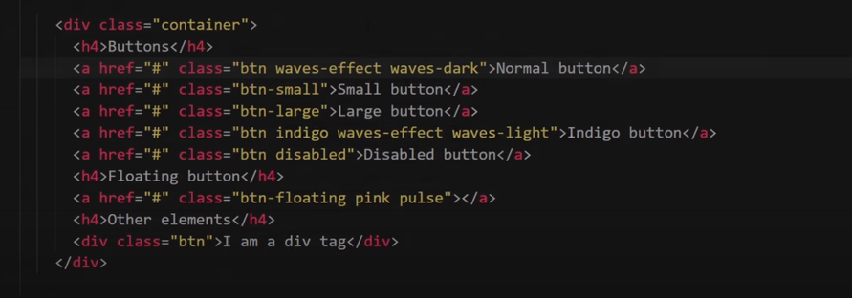
  + “waves-effect waves-light” would be great for our buttons
  + Recommend the floating button to capture attention to have our user select a starting point…it pulses to attract attention, you can make it round which will be helpful if you want to put an icon inside
  + You can create a div button as he did in the last line but there is less flexibility so not recommended
* Icons need this: <i class=””></i> (fonts.google… link called here)
  + Use icon name inside the class <i class=””> error</i> add color to the end like <i class=””>error red-text</i> if you leave off -text, it is a background color
  + 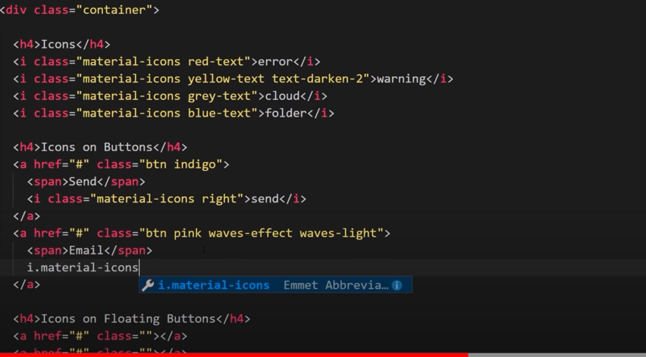
  + 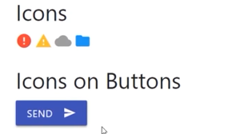
  + 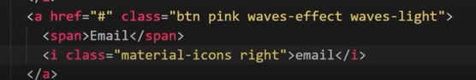
  + Floating and pulsing button 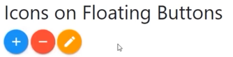
  + 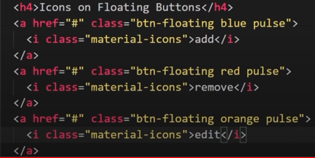
* Columns – grid system is similar to Bootstrap - rows and columns, 12 is still std
  + Requires div class=“row” with “class=col” under the row
  + Leaving col without any identifiers will force the column to auto adjust to size of the content/words inside so use “col s3” to split into 4ths, etc. (different from Bootstrap)
  + Want 2 rows of columns just force column width to 6 for 4 columns
  + 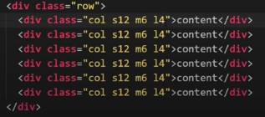To change for medium size screens use m3 or add this to the “col s6 m3” use l for large
  + use xl for extra large screens
* 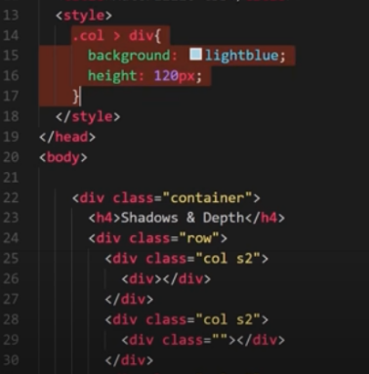Shadows and depth using grid
* 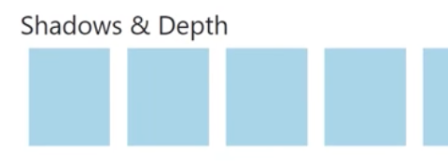
* To give depth “z-depth-1” or 3 it give the item more depth 4&5 are not natural so 2-3 are good

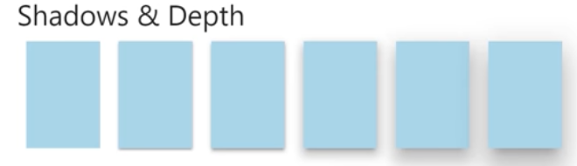

* Using JQuery with Materialize starts in Tutorial #11 (<https://www.youtube.com/watch?v=5gHr8RfB0zs>)
* Navbar – start with <nav class=”nav-wrapper”> add color to end and close </nav>
  + Add title in the container nav bar that was created
  + Could add a ul and li items then brand to the nav by adding a container
* 
* 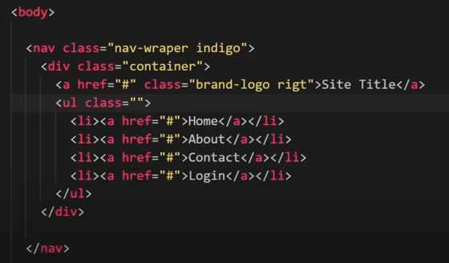
* Make it work in phone? Add I tag and get the hamburger
* 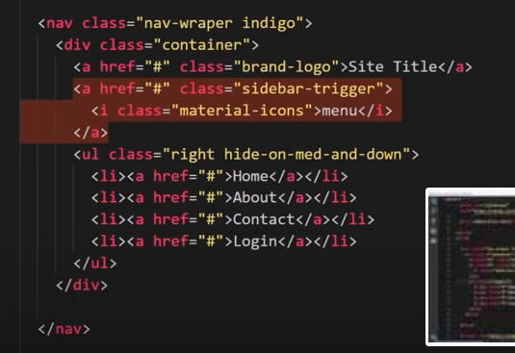highlighted area controls links to that sidebar
* To make this work you need a new ul class=”sidenav” id=”mobile-links” then in the first nav menu add the data-target=”mobile-links”
* 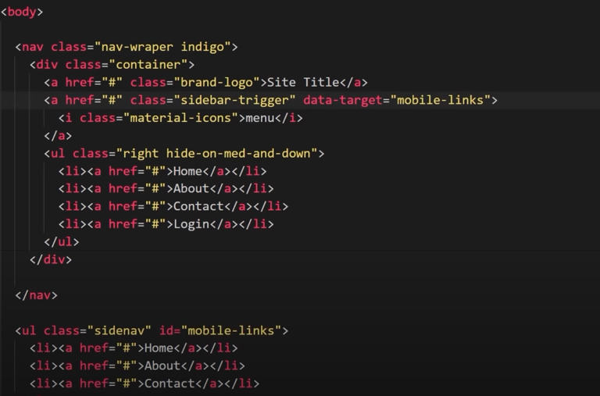(note his sidebar should be sidenav in screen shot)
* To activate you need to use $(document).ready(function)(){$(`.sidenav`).sidenav();})
* This allows the menu to fold to hamburger style in small screens but expand in large screens
* Stopped at 12 <https://www.youtube.com/watch?v=R3-jcIVW4og>