**FoodTrucksATX**

Designed for users of all ages to determine the available food trucks in the user’s desired area of Austin, TX then allowing them to choose to walk, bike, take public transit, or personal car based on their desired time to arrival.

**User Stories**

Ask a friend/relative to give us feedback to answer user type, goal of app effectiveness, and benefit (1 video clip or words – need 2-3)

**Acceptance Criteria**

* Given I am within the City of Austin in search of a food truck, this application allows me to find options around town that I wish to target.
* If I desire a particular type of food or cuisine, the FoodTrucksATX application allows me to search by food type with all results provided. If I desire to see all food trucks, regardless of food type, that should also be an option.
* Given options to walk, bicycle, take public transit, or car, I am able access directions that let me know how long my trip to the desired food truck will take and directions to find them.
* Having an up to date weather report available allows me to make the best travel decision.
* Then I expect the address, directions, map, duration of the trip, and short bio on the food truck I select.
* After determining this application is helpful, having Linked-In information on the development team allows me to contact the group to find out what other applications may be available.

**Bugs and Rabbit Holes**

* Began defining “destinATX, a transportation application but after several days were not able to gain access to Uber and Lyft APIs so redirected efforts to focus on FoodTrucksATX.
* Used proxy to fix CORS error which was blocking data from Google Direction API.
  + [3 Ways to Fix the CORS Error — and How Access-Control-Allow-Origin works](https://medium.com/@dtkatz/3-ways-to-fix-the-cors-error-and-how-access-control-allow-origin-works-d97d55946d9#:~:text=Fix%20two%3A%20send%20your%20request%20to%20a%20proxy&text=But%20you%20can%20control%20the,between%20a%20client%20and%20server.&text=Then%20it%20makes%20the%20request%20to%20get%20that%20server's%20response)
* While Materialize offered some incredible tools for the project, it is challenging to work with when manipulating text and image alignment within themes and containers.
* Team had planned to have users search on how they wanted to travel, how long or distance to their destination, and what type of food. Time or duration required data storage and the team agreed this should be added to the nice to have. Alternatively, the “time available” section of the Search Screen became more of a flashy carousel of food choice ideas.

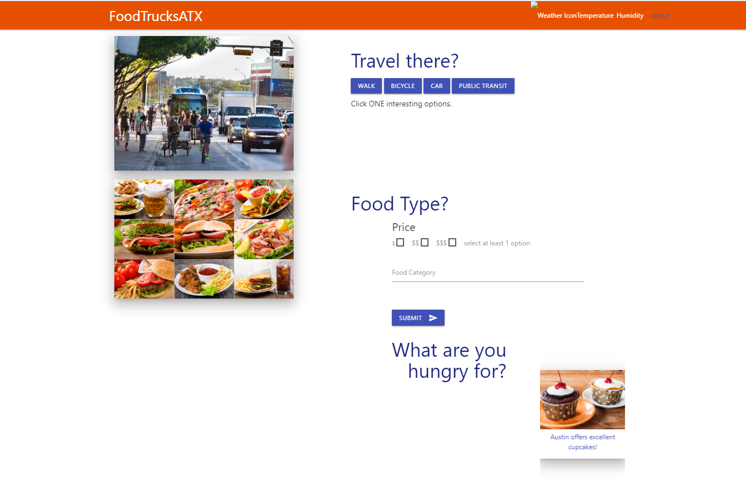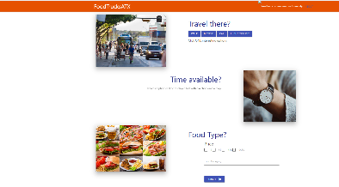

audit trail information would be helpful, diagrams, screen shots, notes, etc.

**Resources and Tech Stack**

GitHub used to leverage project management, work flow, and application storage.

Frontend:  HTML. CSS, JavaScript, JQuery, AJAX, JSON

APIs: Google Maps JavaScript, Google Directions, CORS Anywhere Yelp, OpenWeather, CityBikes

Sample code of CSS, etc.

**Team Management**

**Adrian Palacios**

*Full-Stack Engineer*

linkedin.com/in/adrian-palacios-centraltexas/



[](mailto:adrianpalacios33@yahoo.com)adrianpalacios33@yahoo.com (956) 252-7270

Changyeon (Daniel) Hong

*Full-Stack Engineer*

linkedin.com/in/changyeon-hong-centraltexas/



[](mailto:hongchangyeon@gmail.com)hongchangyeon@gmail.com(737)218-3825

**Diane Candler**

*Full-Stack Engineer*

linkedin.com/in/diane-candler-centraltexas/



[](mailto:dianedcandler@gmail.com) [dianedcandler@gmail.com](mailto:dianedcandler@gmail.com)  (512)964-9473

**Marlon Mora**

*Full-Stack Engineer*

linkedin.com/in/dmarlon-mora-centraltexas/



[marlonmora.ndr@gmail.com](mailto:marlonmora.ndr@gmail.com) (929)2296136



Review the team’s work on our GitHub <https://github.com/DestinATX/Project-1>

**Value Add Proposal**

TBD

**Demo**

Screen Shots – use Zoom to video

**MVP**

Phase One - select APIs and high-level product description

Phase Two – Psuedo Code, StoryBoard, Set Project Goals and Responsibilities

Welcome, Results, Selection Pages(list closest) - StoryBoard (Marlon, Diane) & DrawIO (done) Materialize – add context to UI, finalize results UI

Psuedo Code –

Yelp API – target food truck by name

Google & CORS – target map with Yelp API and load on map (radius, custom setting?)

Goal to create an actual schedule during class 6/2 – after Weather HW is turned in

Phase Three - get data flowing and filtered

Phase Four – Build HTML and CSS infrastructure using available data

Phase Five – Develop user interface

Phase Six – Finalize deliverables including readme, screen shots, user stories, etc.

**UI Design**

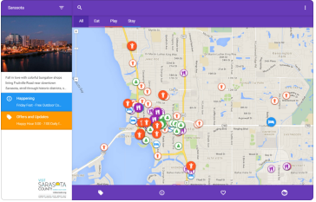

images - storyboarding

**Google Maps API**

*The Maps JavaScript API lets you customize maps with your own content and imagery for display on web pages and mobile devices.*

Google Directions API

*With the Directions API, it is possible to access driving, cycling, walking and public transportation routing by using an HTTP request.*

**Yelps API**

Short description

**cors-anywhere**

This API enables cross-origin requests to anywhere.

**Release 2.0**

Enhancements we want to see in the next version:

* Add API links to enhance bike data
* Add GEO Location
* Add Food Truck attributes such as rating, reviews, menus, etc.

