Corrigé Diaporama : l'objectif



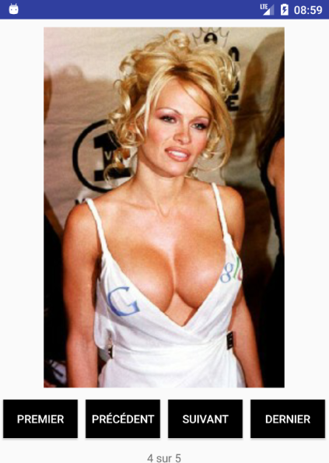

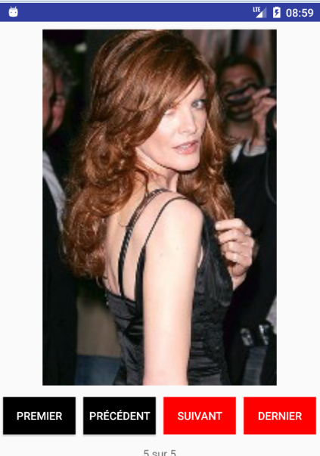

Le layout

<?xml version="1.0" encoding="utf-8"?>
<LinearLayout xmlns:android="http://schemas.android.com/apk/res/android"
android:layout_width="match_parent"
android:layout_height="match_parent"
android:orientation="vertical">
<ImageView
android:id="@+id/imageViewDiapo"
android:layout_width="wrap_content"
android:layout_height="500dp"
android:layout_gravity="center"
android:layout_margin="10dp"
android:adjustViewBounds="true"
android:src="@drawable/logo_google" />
<LinearLayout
android:layout_width="match_parent"
android:layout_height="wrap_content"
android:orientation="horizontal">
<Button
android:id="@+id/buttonFirst"
style="?android:attr/buttonStyleSmall"
android:layout_width="0dp"
android:layout_height="wrap_content"
android:layout_margin="5dp"
android:layout_weight="25"
android:background="#FF0000"
android:text="Premier"
android:textColor="#FFFFFF" />
<Button
android:id="@+id/buttonPrevious"
style="?android:attr/buttonStyleSmall"
android:layout_width="0dp"
android:layout_height="wrap_content"
android:layout_margin="5dp"
android:layout_weight="25"
android:background="#FF0000"
android:text="Précédent"
android:textColor="#FFFFFF" />
<Button
android:id="@+id/buttonNext"
style="?android:attr/buttonStyleSmall"
android:layout_width="0dp"
android:layout_height="wrap_content"
android:layout_margin="5dp"
android:layout_weight="25"
android:background="#000000"
android:text="Suivant"
android:textColor="#FFFFFF" />
<Button
android:id="@+id/buttonLast"
style="?android:attr/buttonStyleSmall"
android:layout_width="0dp"
android:layout_height="wrap_content"
android:layout_margin="5dp"
android:layout_weight="25"
android:background="#000000"
android:text="Dernier"
android:textColor="#FFFFFF" />
</LinearLayout>
<TextView
android:id="@+id/textViewCompteur"
android:layout_width="match_parent"
android:layout_height="wrap_content"
android:layout_margin="10dp"
android:gravity="center"
android:text="1/10" />
<TextView
android:id="@+id/textViewMessage"
android:layout_width="match_parent"
android:layout_height="wrap_content"
android:layout_margin="10dp"
android:gravity="center"
android:text="Message" />
</LinearLayout>

Le code java

package pb.fr.diaporama;
import android.app.Activity;
import android.content.Context;
import android.graphics.Bitmap;
import android.graphics.BitmapFactory;
import android.graphics.Color;
import android.os.Bundle;
import android.view.View;
import android.widget.Button;
import android.widget.ImageView;
import android.widget.TextView;
import java.io.*;
import java.util.*;
public class Diaporama extends Activity implements View.OnClickListener {
private ImageView imageViewDiapo;
private Button buttonFirst;
private Button buttonPrevious;
private Button buttonNext;
private Button buttonLast;
private TextView textViewCompteur;
private TextView textViewMessage;
private List<String> listeFichiersImage;
private int iiCount;
private int iiPosition;
@Override
protected void onCreate(Bundle savedInstanceState) {
super.onCreate(savedInstanceState);
setContentView(R.layout.diaporama);
imageViewDiapo = (ImageView) findViewById(R.id.imageViewDiapo);
buttonFirst = (Button) findViewById(R.id.buttonFirst);
buttonPrevious = (Button) findViewById(R.id.buttonPrevious);
buttonNext = (Button) findViewById(R.id.buttonNext);
buttonLast = (Button) findViewById(R.id.buttonLast);
textViewCompteur = (TextView) findViewById(R.id.textViewCompteur);
textViewMessage = (TextView) findViewById(R.id.textViewMessage);
buttonFirst.setOnClickListener(this);
buttonPrevious.setOnClickListener(this);
buttonNext.setOnClickListener(this);
buttonLast.setOnClickListener(this);
iiPosition = 0;
listeFichiersImage = recupererListeImages();
iiCount = listeFichiersImage.size();
afficherImage();
} /// onCreate
/**
*
*/
private void afficherImage() {
textViewCompteur.setText(Integer.toString(iiPosition + 1) + " sur " + Integer.toString(iiCount));
buttonFirst.setEnabled(iiPosition != 0);
buttonPrevious.setEnabled(iiPosition != 0);
buttonNext.setEnabled(iiPosition != iiCount - 1);
buttonLast.setEnabled(iiPosition != iiCount - 1);
buttonFirst.setBackgroundColor(Color.BLACK);
buttonPrevious.setBackgroundColor(Color.BLACK);
buttonNext.setBackgroundColor(Color.BLACK);
buttonLast.setBackgroundColor(Color.BLACK);
if (iiPosition == 0) {
buttonFirst.setBackgroundColor(Color.RED);
buttonPrevious.setBackgroundColor(Color.RED);
}
if (iiPosition == iiCount - 1) {
buttonNext.setBackgroundColor(Color.RED);
buttonLast.setBackgroundColor(Color.RED);
}
try {
/*
SOIT AVEC un URI
*/
// URI uri = new URI("file:///" + this.getFilesDir().getAbsolutePath() + "/" + listeFichiersImage.get(iiPosition));
// URL url = uri.toURL();
// InputStream is = url.openStream();
/*
SOIT EN MODE "ANDROID"
*/
FileInputStream fis = this.openFileInput(listeFichiersImage.get(iiPosition));
Bitmap bitmap = BitmapFactory.decodeStream(fis);
imageViewDiapo.setImageBitmap(bitmap);
} catch (Exception e) {
textViewMessage.setText(e.getMessage());
}
} /// afficherImage
/**
* @return
*/
private List<String> recupererListeImages() {
List<String> listeImages = new ArrayList();
Context contexte = getBaseContext();
File dir;
String[] tFichiers;
try {
/*
* Le dossier files donc /data/data/nom.du.package/files/
*/
// Renvoie /data/data/fr.pb.data.fichier/files
dir = contexte.getFilesDir();
// Liste les fichiers
tFichiers = dir.list();
// Filtrage
for (int i = 0; i < tFichiers.length; i++) {
if (tFichiers[i].endsWith(".jpg") || tFichiers[i].endsWith(".png")) {
listeImages.add(tFichiers[i]);
}
}
} catch (Exception e) {
textViewMessage.setText(e.getMessage());
} finally {
} // / finally
return listeImages;
} /// recupererListeImages
@Override
public void onClick(View v) {
if (v == buttonFirst) {
iiPosition = 0;
}
if (v == buttonPrevious) {
iiPosition--;
}
if (v == buttonNext) {
iiPosition++;
}
if (v == buttonLast) {
iiPosition = iiCount - 1;
}
afficherImage();

} /// onClick
} /// class

