1. **Importing source files into Vivado**

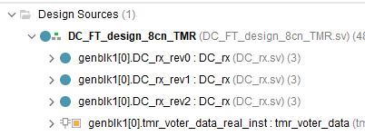

Fig. 1 Structure of the project

1. **Configuration of IP cores**

**(1) TMR Voter**

For tmr_voter_data:

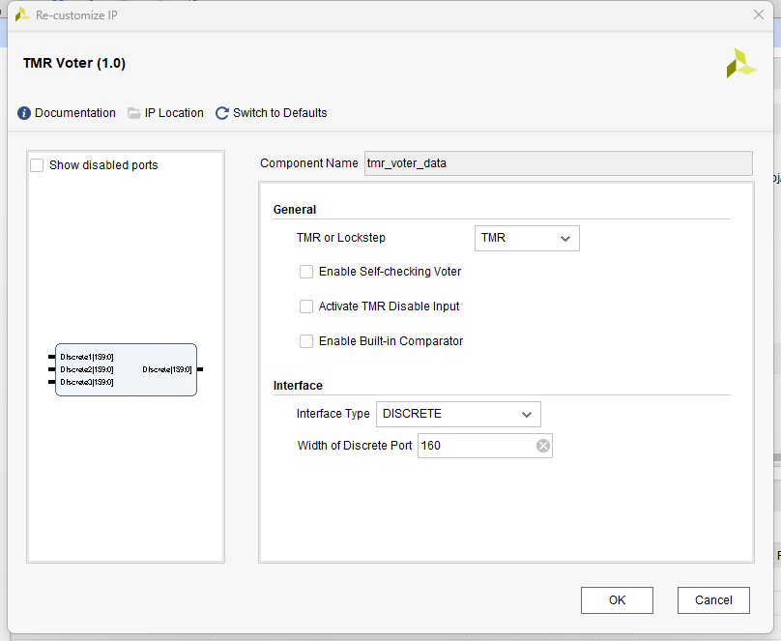

For tmr_voter_tvalid:

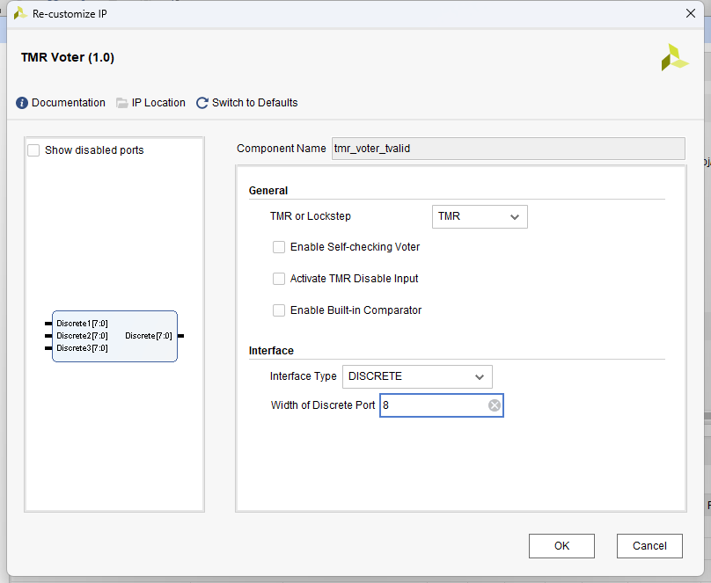

1. **Set “DC_FT_design_8cn_TMR.sv” as the top module**