1. **Importing source files into Vivado**

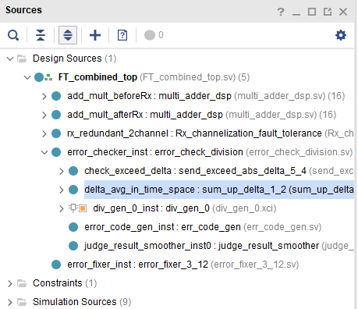

Fig. 1 Structure of the project

1. **Configuration of IP cores**

(1) divider generator:

In “Channel Setting”:

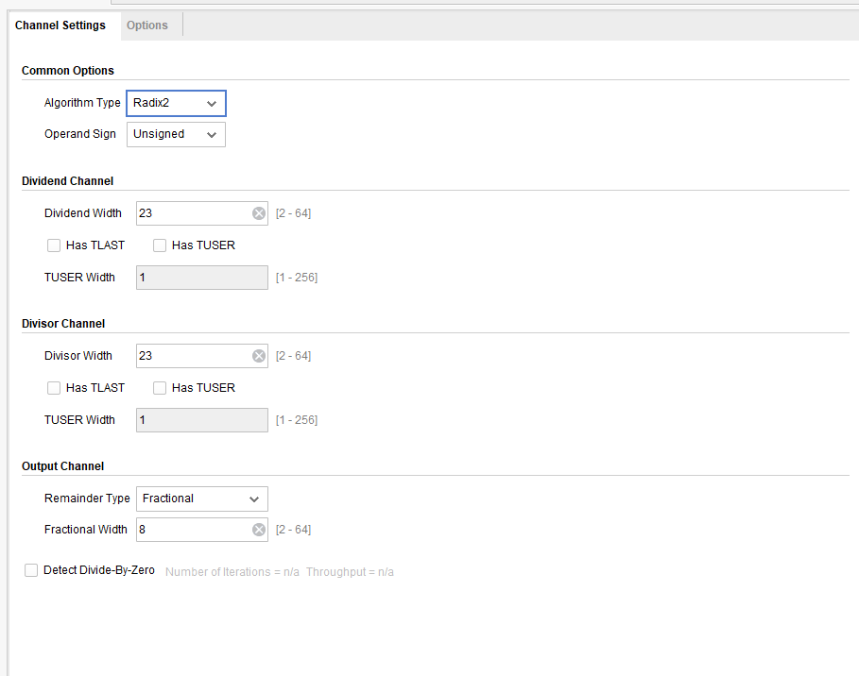

In “Options”:

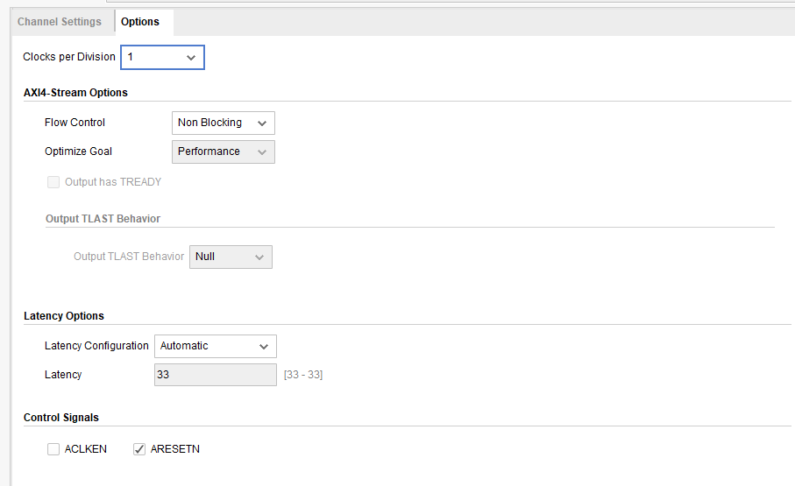

1. **Set “FT_combined_top.sv” as the top module**