**Campus Event Management Platform  
  
Report Document  
  
*Submitted By*Name : Darshan Ramesh  
Degree : B.Tech in Information Science and Engineering  
University : REVA University  
SRN : R22EQ064  
  
Date: 7th September 2025**

**Project: Campus Drive Assignment – Webknot Technologies**

1. Event Popularity Report

Description:  
This report shows the most popular events based on the total number of student registrations.

API Endpoint:

GET /reports/popular-events

Query Logic:  
Aggregates the registrations collection by eventId and sorts them in descending order of total registrations.

Sample Output (JSON):

[

{ "event": "Hackathon 2025", "totalRegistrations": 10 },

{ "event": "Tech Talk: AI", "totalRegistrations": 6 }

]

Screenshot (Postman):

2. Student Participation Report

Description:  
This report shows how many events a student has attended.

API Endpoint:

GET /reports/student/:id

Query Logic:  
Counts attendance records where status = "Present" for a given student.

Sample Output (JSON):

{

"student": "Alice",

"eventsAttended": 3

}

Screenshot (Postman):

3. Event Feedback Report

Description:  
This report calculates the average feedback score for an event.

API Endpoint:

GET /reports/event/:id

Query Logic:  
Computes the average of all feedback ratings (1–5) linked to a given event.

Sample Output (JSON):

[

{ "event": "Hackathon 2025", "avgRating": 4.5 }

]

Screenshot (Postman):

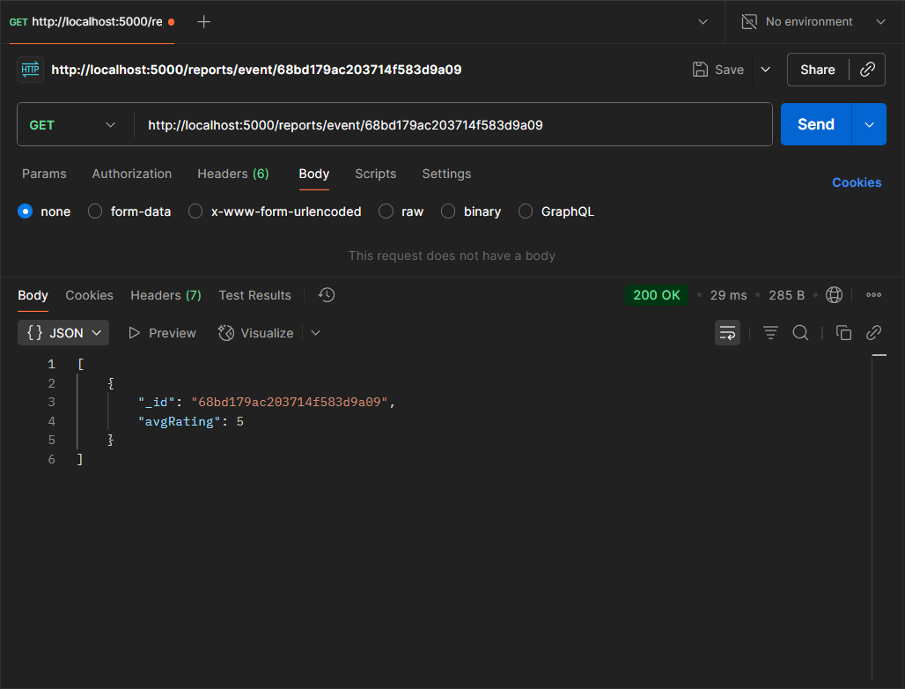

4. Top 3 Most Active Students

Description:  
This report shows the top 3 students who attended the most events.

API Endpoint:

GET /reports/top-students

Query Logic:  
Aggregates the attendance collection by studentId where status = "Present", sorts by count, and limits to 3.

Sample Output (JSON):

[

{ "student": "Alice", "eventsAttended": 5 },

{ "student": "Bob", "eventsAttended": 4 },

{ "student": "Charlie", "eventsAttended": 3 }

]

Screenshot (Postman):

