Educational Inequality in Nigeria
Causal Analysis Report: Teacher Supply and Out-of-School Rates
26 October 2026

What this document is, and what it is not
This report re-runs the portal's causal analysis for every outcome and confounder combination offered on the 'Run a custom analysis' form, and explains each in plain English. Treatment is the number of public pupils per qualified teacher (PQTR, 2016/17); outcomes are the primary out-of-school (OOS) rates from the 2021 UNICEF/MICS survey. The design is one cross-section of at most 37 states. Results are adjusted associations depending on stated assumptions - they are not proof of causation. Every section embeds the portal's six charts (both causal graphs, the forest plot, the specification curve and the two predictive-model charts) as numbered screenshots. See Section 2 (Reader's guide) before interpreting any number.

Contents
1. Reader's guide (methods, definitions, assumptions)
2. All Children vs. Poverty + Region
3. All Children vs. Region Only
4. All Children vs. Poverty Only
5. Boys vs. Poverty + Region
6. Boys vs. Region Only
7. Boys vs. Poverty Only
8. Girls vs. Poverty + Region
9. Girls vs. Region Only
10. Girls vs. Poverty Only
11. Glossary of technical terms
Note: this outline is a fixed list (not a Word auto-TOC). Section numbering matches the headings in the body.

1. Reader's guide

1.1 The causal question
Treatment (T): log of the pupil-per-qualified-teacher ratio (PQTR) in public primary schools, 2016/17. Log scale means effects are reported per proportional change (a 10% reduction in PQTR), not per pupil.
Outcome (Y): the out-of-school (OOS) rate in 2021 from the UNICEF MICS6 survey - the share of primary-school-age children not attending school, as a percentage. Separate sections run this in turn for all children, for boys, and for girls.
Estimand: the average effect on the OOS rate (in percentage points, pp) of a 10% proportional reduction in PQTR, across the states in the analysis sample. A negative number means states with fewer pupils per qualified teacher tend to have lower OOS rates (and vice versa).
Confounders (Z): adjustment sets of the state poverty headcount rate at $2.15/day (World Bank, 2018) or a binary indicator for the state being in the North (NC/NE/NW zones). The best-justified set is poverty 2018 + region; the single-confounder sets are shown for transparency about what each adjustment does, and are weaker (regions differ in much else besides poverty).

1.2 How to read the numbers
- Effect sizes are always percentage-point changes in the state OOS rate per 10% reduction in PQTR. Log-unit coefficients never appear in the prose.
- Every effect carries a 95% confidence interval: we are 95% confident the true effect lies between the two endpoints (approximate; see assumptions).
- p-values come with the reminder: a value below 0.05 suggests the result is unlikely to be due to chance alone.
- The 'Unadjusted' row is the raw association with no statistical control at all; it is shown only to expose confounding and is NOT a causal estimate.
- Each section embeds six screenshots of the portal's own charts, numbered Figure N.1 to N.6 for section N: both causal graphs (N.1, N.2), the forest plot (N.3), the specification curve (N.4) and the two predictive-model charts (N.5, N.6). Figures 5 and 6 are explicitly labelled as NOT causal evidence.
- Only the data itself decides the outcome; where every adjusted interval includes zero the honest reading is 'Inconclusive' - the data are consistent with effects of modest size and with no effect.

1.3 The three estimators
- Regression adjustment (OLS): ordinary regression of the OOS rate on log PQTR and the confounders, with HC3 robust standard errors. This is the primary estimate.
- GPS-weighted regression: weighting states by a generalised propensity score so confounders are balanced; a robustness check for the same effect.
- Double/debiased machine learning (DML): random-forest cross-fitting estimate; noisy with ~31 states, reported as a cross-check only.

1.4 How to read the causal graphs (DAGs)
A directed acyclic graph (DAG) is a diagram of assumed cause-and-effect directions: an arrow A -> B means 'we assume A influences B'. Circles are variables; a dashed red arrow is a path through a variable nobody measured (labelled U). In the portal's charts the treatment circle is amber, the outcome circle is blue, measured confounder circles are grey, and the unmeasured 'U' circle is red.
Section 3 explains every element of both graphs for each combination - each section embeds screenshots of them (Figure 3.1 and Figure 3.2 there): the identifying DAG used for estimation, and the threat DAG that adds one unmeasured common cause U of treatment and outcome. Under the threat DAG, adjusting for the observed confounders can no longer fully separate the effect from confounding - the sensitivity (Cinelli-Hazlett) analysis quantifies how strong U would need to be to overturn the conclusion, measured in partial R-squared terms.

1.5 Data provenance and honesty limits
- Inputs are published aggregate statistics (UNICEF/NBS Digest and MICS6, World Bank WDI) registered with URLs, licences and limitations; rows failing integrity checks were excluded rather than repaired.
- The analysis sample holds about 31 states; with n < 40, intervals are wide and estimates can change markedly when a single state is dropped (leave-one-out shown in every section).
- Software and data checksums: extracted from the engine at generation time; a full audit trail exists on the portal's run pages for the standard (full-fidelity) analyses.
- Generated with: python 3.14.6, numpy 2.5.3, pandas 3.0.6, statsmodels 0.15.0, dowhy 0.8, econml 0.17.0.

2. All Children vs. Poverty + Region
Item | Value
Section | Primary OOS rate, all children (primary outcome) - adjusted for Poverty (2018) + region
Outcome variable (state-level, 2021) | oos_total_2021
Treatment variable | log_pqtr
Confounders in the adjustment set | pov_215, north
States in the sample (n) | 31
Diagnostic detail / settings | Generalised results use 300 bootstrap resamples, 30 refutation simulations, 3 DML cross-fit repeats

Causal graphs

Assumed causal graph (identifying DAG) - elements
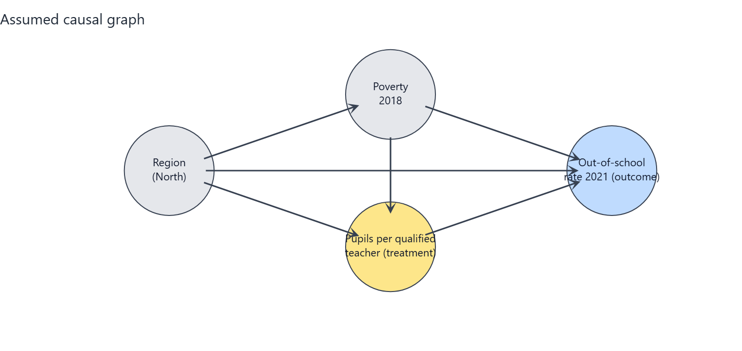
Figure 2.1: Screenshot of the portal's identifying DAG for this combination. Every circle and arrow is explained in the table beneath.
Element (in the chart) | What it is | Plain-English meaning
log_pqtr (amber circle) | Treatment | Average number of pupils in a state's public primary schools per qualified teacher, 2016/17 (log scale). Higher = fewer qualified teachers relative to pupils.
oos_total_2021 (blue circle) | Outcome | The share of primary-school-age children (girls and boys) who are not in school (2021). This is what we want to change.
pov_215 (grey circle) | Measured confounder | The share of the state population living on less than $2.15 per day (2018). Poorer states have more pupils per qualified teacher and higher OOS rates, so it must be held constant.
north (grey circle) | Measured confounder | A flag for whether the state is in the North (1) or South (0). Northern states differ systematically in education infrastructure, poverty and OOS rates, so it must be held constant.

Arrow | What it represents | Plain-English meaning
pov_215 -> log_pqtr | Confounding path into treatment | Poverty pushes the pupil-per-teacher ratio (e.g. poorer or more northern states staff schools differently).
pov_215 -> oos_total_2021 | Confounding path into outcome | Poverty also drives OOS rates directly (e.g. via household resources), independently of teacher supply.
north -> log_pqtr | Confounding path into treatment | Region pushes the pupil-per-teacher ratio (e.g. poorer or more northern states staff schools differently).
north -> oos_total_2021 | Confounding path into outcome | Region also drives OOS rates directly (e.g. via household resources), independently of teacher supply.
north -> pov_215 | Confounder-to-confounder path | Northern states are on average poorer, so region partly causes poverty; poverty is therefore the deeper control variable.
log_pqtr -> oos_total_2021 | The arrow of interest | After holding the confounders constant, this is the estimated effect of teacher supply on the OOS rate - the quantity the analysis estimates.

Assumed causal graph with an unmeasured common cause (threat DAG) - extra elements
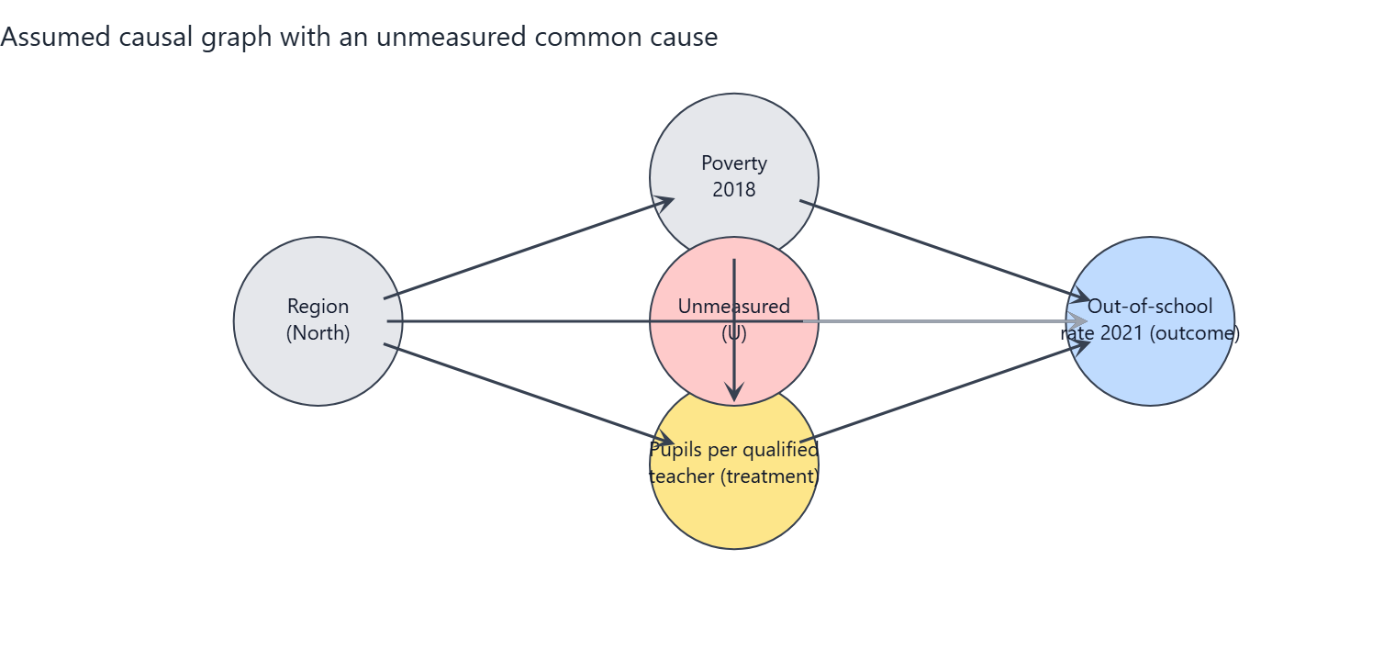
Figure 2.2: Screenshot of the portal's threat DAG. The red circle U is a stand-in for everything unmeasured; its dashed red arrows are the paths the observed data cannot block.
Element (in the chart) | What it is | Plain-English meaning
U (red circle, dashed border) | Unmeasured confounder | A stand-in for everything unobserved that raises or lowers both teacher supply and OOS rates: state governance capacity, conflict and insecurity, cultural attitudes to schooling, school construction funding.
U --> log_pqtr (dashed red arrow) | Unmeasured path into treatment | Better-governed states also attract and retain more qualified teachers, they are not purely set by poverty and region.
U --> oos_total_2021 (dashed red arrow) | Unmeasured path into outcome | The same governance/attitude factors also move OOS rates on their own.
What changes vs. Graph 1 | Non-identifiability | With U present, adjusting for the observed confounders is no longer sufficient to isolate the causal effect; the estimate can be biased up or down by an unknown amount. This is the honest limit of the study design.
What it means for the reader | Interpret with care | Graph 1 is the best-case assumption (conditional ignorability). The sensitivity analysis in this section quantifies in partial R-squared terms how strong U would have to be to overturn the conclusion.

Assumptions the conclusion depends on
- A1 Conditional ignorability: given poverty (2018) and region, states' PQTR is as good as randomly assigned with respect to potential OOS outcomes (no unmeasured common causes).
- A2 Positivity/overlap: states with similar poverty and region show a range of PQTR values (checked with overlap diagnostics).
- A3 Consistency / SUTVA: no spillovers of teachers or pupils between states; 'a 10% lower PQTR' is a well-defined intervention.
- A4 Temporal order: PQTR (2016/17) precedes the outcome (2021); poverty (2018) is treated as pre-treatment although it could be partly shaped by earlier schooling (tested by dropping it).
- A5 Functional form: the effect is linear in log(PQTR) and additive in the confounders (tested with alternative forms and DML).
- A6 Measurement: PQTR from the Digest and OOS from MICS are measured without systematic error related to the other variable (administrative reporting errors are documented and the worst rows excluded).
- A7 Excluded variables: private-school share and enrolment rates are possible mediators/colliders and are deliberately NOT adjusted for.

Analysis results

Estimates of the effect
Estimator | Effect size (pp per 10% PQTR reduction) | 95% interval (pp) | p-value | Notes
Regression adjustment (OLS, HC3 robust SE, t-interval) | -0.43 pp | -1.36 to +0.51 | p = 0.356 | Primary estimate
GPS-weighted regression (stabilised weights truncated 5/95, outcome model adjusted) | -0.37 pp | -1.49 to +0.24 |  | Percentile bootstrap CI (300 resamples, GPS re-estimated). ESS=25.9 of 31.
Double/debiased ML (EconML LinearDML, RF nuisance, 5-fold x3) | -0.07 pp | -0.63 to +0.48 | p = 0.784 | Median over repeated cross-fits; t-quantile interval (n is small, so the interval is approximate and probably too narrow).
Unadjusted association (for comparison only - NOT a causal estimate) | -1.77 pp | -2.83 to -0.72 | p = 0.002

Reminder: a p-value below 0.05 suggests the result is unlikely to be due to chance alone. All effect sizes are percentage-point (pp) changes in the OOS rate per 10% reduction in PQTR.
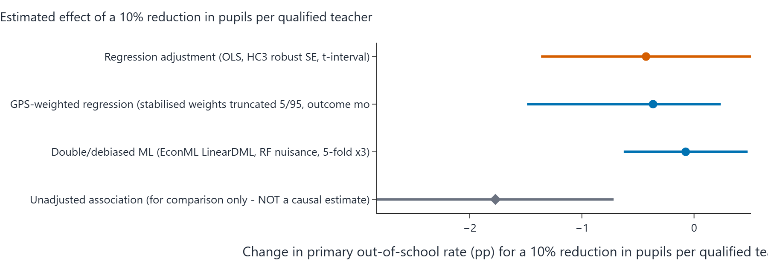
Figure 2.3: Screenshot of the portal's forest plot - rounded effect estimate and 95% interval for each estimator in the table above, on a common percentage-point scale.

Sensitivity analysis (How wrong could this be?)
An omitted confounder explaining 18.1% of the residual variance of BOTH PQTR and the OOS rate (partial R^2) would be enough to reduce the point estimate to zero. The adjusted estimate is already statistically insignificant at 5%, so no additional confounding is needed for that. The observed confounders have partial R^2 with the outcome of pov_215: 19.8%, north: 8.9% (benchmarks).
Benchmark confounder | Partial R-squared with the outcome | Partial R-squared with the treatment
pov_215 | 19.8% | 9.8%
north | 8.9% | 3.1%

How to read it: if an unmeasured factor were correlated with PQTR and the OOS rate at a partial R-squared larger than the robustness value (RV) above, it could erase the point estimate. The observed confounders themselves provide a scale on the benchmark table.

Robustness across specifications
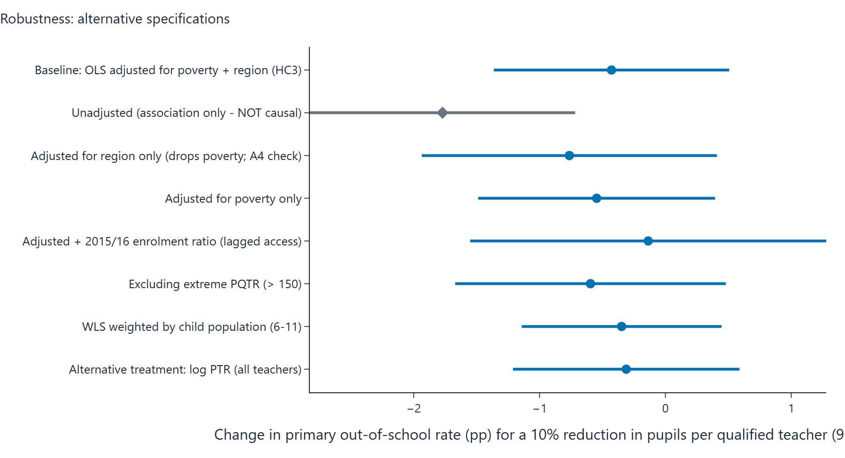
Figure 2.4: Screenshot of the portal's specification curve - the effect of a 10% PQTR reduction for every robustness row in the table beneath, sorted by estimate.
Specification | Effect size (pp per 10% PQTR reduction) | 95% interval (pp) | p-value
Baseline: OLS adjusted for poverty + region (HC3) | -0.43 pp | -1.36 to +0.51 | 0.356
Unadjusted (association only - NOT causal) | -1.77 pp | -2.83 to -0.72 | 0.002
Adjusted for region only (drops poverty; A4 check) | -0.76 pp | -1.94 to +0.41 | 0.193
Adjusted for poverty only | -0.55 pp | -1.49 to +0.40 | 0.245
Adjusted + 2015/16 enrolment ratio (lagged access) | -0.14 pp | -1.55 to +1.28 | 0.844
Excluding extreme PQTR (> 150) | -0.59 pp | -1.67 to +0.48 | 0.265
WLS weighted by child population (6-11) | -0.35 pp | -1.14 to +0.45 | 0.377
Alternative treatment: log PTR (all teachers) | -0.31 pp | -1.21 to +0.59 | 0.484

Alternative treatment scale: measured on the raw pupil count (not the log), each extra 10 pupils per qualified teacher is associated with about +0.21 pp (95% interval from -1.40 to +1.81), from the same specification family.
Bounded-outcome form: a fractional logit on the school-share scale gives an average effect of -0.34 pp per 10% PQTR reduction (p = 0.235), reassuring that conclusions do not hinge on the linear-percentage-point model.
Stability check: dropping each state once moves the estimated effect between +2.80 pp (lowest when leaving Yobe out) and +6.88 pp (highest when leaving Nasarawa out). Sign changes across the leave-one-out estimates: no.
Interval cross-checks: pairs bootstrap gives -3.59 to +13.61 pp (300 valid resamples); a (Freedman-Lane) permutation test puts the chance-only p at 0.291.

Predictive-model charts (NOT causal evidence)
These two charts appear on every portal run page and summarise the machine-learning predictive layer of the analysis, which is entirely separate from the causal estimate above. A feature that predicts the OOS rate well is not necessarily a cause of it: importance and prediction error describe association in the sample. They are included here for completeness, clearly labelled so they cannot be mistaken for causal results.
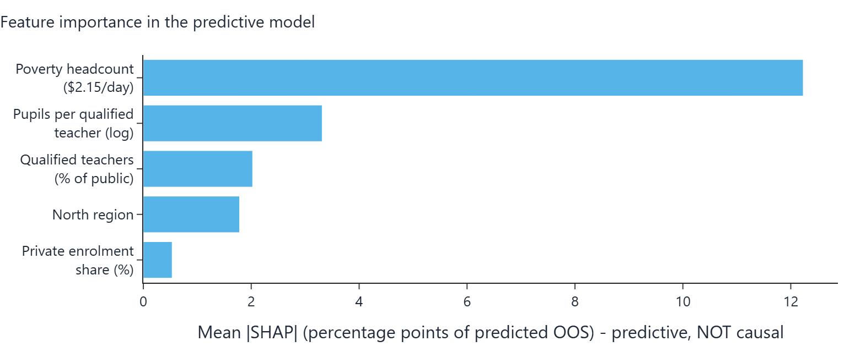
Figure 2.5: Screenshot of the portal's feature-importance chart - mean absolute SHAP value of each feature in the predictive model. High importance is not a causal claim.
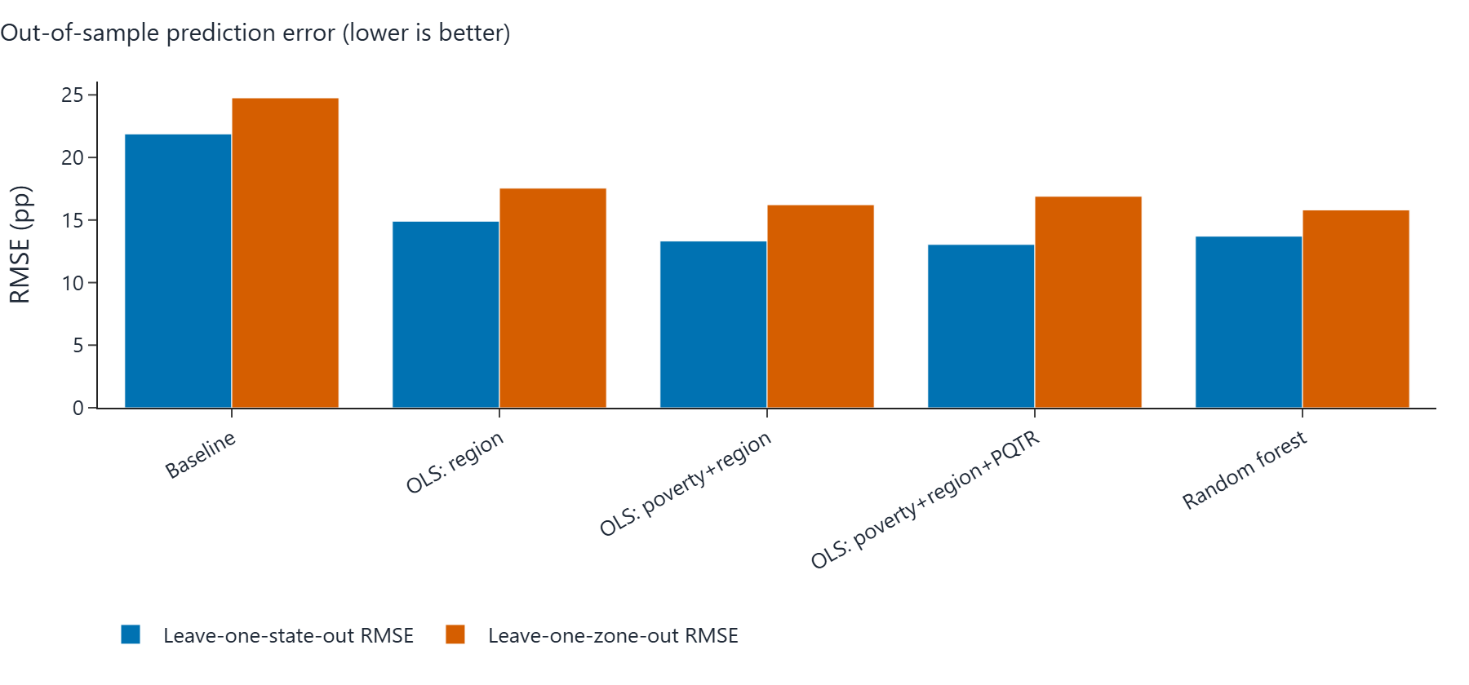
Figure 2.6: Screenshot of the portal's prediction-error chart - out-of-sample RMSE in pp per model. Prediction accuracy says nothing about the causal direction of any relationship.

Verdict (in plain words)
Verdict band: AMBER (inconclusive): the data cannot separate 'no effect' from effects of modest size.
Under assumptions A1-A7, the regression-adjusted estimate is that a 10% reduction in pupils per qualified teacher changes a state's primary out-of-school rate by -0.43 percentage points (95% interval -1.36 to +0.51), n = 31 states.
The unadjusted association is much larger (-1.77 pp per 10% reduction) because states with high PQTR are also poorer and mostly in the North; most of that raw association is explained by poverty and region.
Every adjusted estimator gives an interval that includes zero: the data are CONSISTENT WITH both no effect and effects of modest size, and cannot distinguish them.
Sensitivity: an unmeasured confounder would need a partial R^2 of about 18% with both PQTR and the outcome to explain the point estimate away (RV); this is a measure of fragility, not evidence of causation.

Caveats carried through from the engine:
- Only 31 states are available: intervals are wide and estimates unstable.
- Cross-sectional design: results are adjusted associations interpreted causally only under assumptions A1-A7.

3. All Children vs. Region Only
Item | Value
Section | Primary OOS rate, all children (primary outcome) - adjusted for Region only
Outcome variable (state-level, 2021) | oos_total_2021
Treatment variable | log_pqtr
Confounders in the adjustment set | north
States in the sample (n) | 31
Diagnostic detail / settings | Generalised results use 300 bootstrap resamples, 30 refutation simulations, 3 DML cross-fit repeats

Causal graphs

Assumed causal graph (identifying DAG) - elements
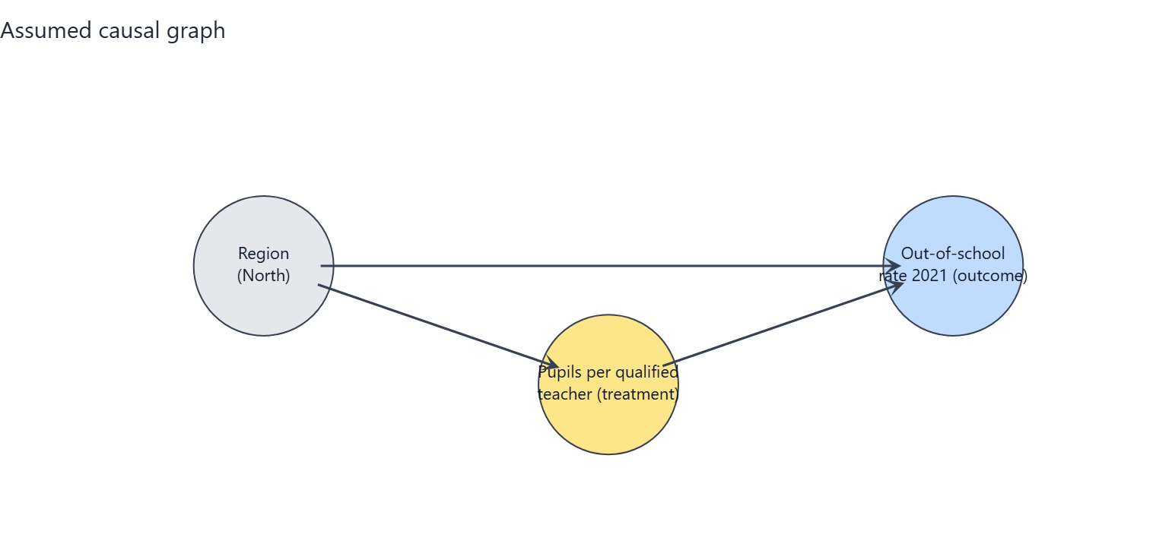
Figure 3.1: Screenshot of the portal's identifying DAG for this combination. Every circle and arrow is explained in the table beneath.
Element (in the chart) | What it is | Plain-English meaning
log_pqtr (amber circle) | Treatment | Average number of pupils in a state's public primary schools per qualified teacher, 2016/17 (log scale). Higher = fewer qualified teachers relative to pupils.
oos_total_2021 (blue circle) | Outcome | The share of primary-school-age children (girls and boys) who are not in school (2021). This is what we want to change.
north (grey circle) | Measured confounder | A flag for whether the state is in the North (1) or South (0). Northern states differ systematically in education infrastructure, poverty and OOS rates, so it must be held constant.

Arrow | What it represents | Plain-English meaning
north -> log_pqtr | Confounding path into treatment | Region pushes the pupil-per-teacher ratio (e.g. poorer or more northern states staff schools differently).
north -> oos_total_2021 | Confounding path into outcome | Region also drives OOS rates directly (e.g. via household resources), independently of teacher supply.
log_pqtr -> oos_total_2021 | The arrow of interest | After holding the confounders constant, this is the estimated effect of teacher supply on the OOS rate - the quantity the analysis estimates.

Assumed causal graph with an unmeasured common cause (threat DAG) - extra elements
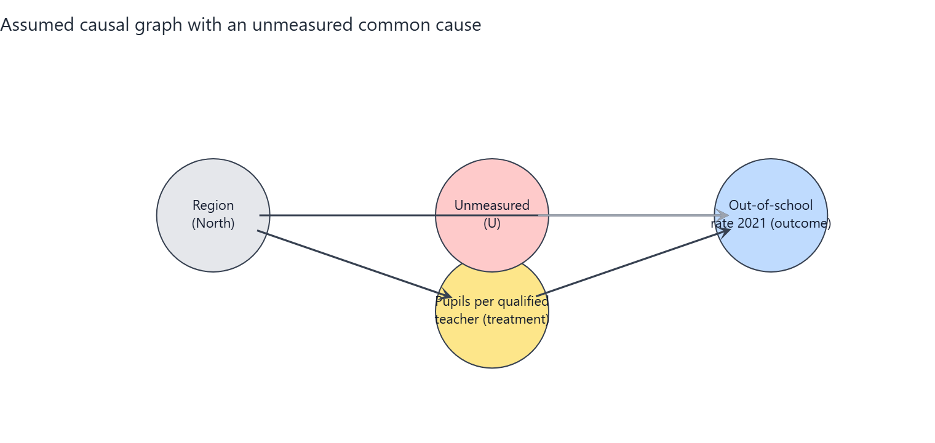
Figure 3.2: Screenshot of the portal's threat DAG. The red circle U is a stand-in for everything unmeasured; its dashed red arrows are the paths the observed data cannot block.
Element (in the chart) | What it is | Plain-English meaning
U (red circle, dashed border) | Unmeasured confounder | A stand-in for everything unobserved that raises or lowers both teacher supply and OOS rates: state governance capacity, conflict and insecurity, cultural attitudes to schooling, school construction funding.
U --> log_pqtr (dashed red arrow) | Unmeasured path into treatment | Better-governed states also attract and retain more qualified teachers, they are not purely set by poverty and region.
U --> oos_total_2021 (dashed red arrow) | Unmeasured path into outcome | The same governance/attitude factors also move OOS rates on their own.
What changes vs. Graph 1 | Non-identifiability | With U present, adjusting for the observed confounders is no longer sufficient to isolate the causal effect; the estimate can be biased up or down by an unknown amount. This is the honest limit of the study design.
What it means for the reader | Interpret with care | Graph 1 is the best-case assumption (conditional ignorability). The sensitivity analysis in this section quantifies in partial R-squared terms how strong U would have to be to overturn the conclusion.

Assumptions the conclusion depends on
- A1 Conditional ignorability: given poverty (2018) and region, states' PQTR is as good as randomly assigned with respect to potential OOS outcomes (no unmeasured common causes).
- A2 Positivity/overlap: states with similar poverty and region show a range of PQTR values (checked with overlap diagnostics).
- A3 Consistency / SUTVA: no spillovers of teachers or pupils between states; 'a 10% lower PQTR' is a well-defined intervention.
- A4 Temporal order: PQTR (2016/17) precedes the outcome (2021); poverty (2018) is treated as pre-treatment although it could be partly shaped by earlier schooling (tested by dropping it).
- A5 Functional form: the effect is linear in log(PQTR) and additive in the confounders (tested with alternative forms and DML).
- A6 Measurement: PQTR from the Digest and OOS from MICS are measured without systematic error related to the other variable (administrative reporting errors are documented and the worst rows excluded).
- A7 Excluded variables: private-school share and enrolment rates are possible mediators/colliders and are deliberately NOT adjusted for.

Analysis results

Estimates of the effect
Estimator | Effect size (pp per 10% PQTR reduction) | 95% interval (pp) | p-value | Notes
Regression adjustment (OLS, HC3 robust SE, t-interval) | -0.76 pp | -1.94 to +0.41 | p = 0.193 | Primary estimate
GPS-weighted regression (stabilised weights truncated 5/95, outcome model adjusted) | -0.95 pp | -2.29 to -0.08 |  | Percentile bootstrap CI (300 resamples, GPS re-estimated). ESS=24.0 of 31.
Double/debiased ML (EconML LinearDML, RF nuisance, 5-fold x3) | -0.70 pp | -1.67 to +0.27 | p = 0.149 | Median over repeated cross-fits; t-quantile interval (n is small, so the interval is approximate and probably too narrow).
Unadjusted association (for comparison only - NOT a causal estimate) | -1.77 pp | -2.83 to -0.72 | p = 0.002

Reminder: a p-value below 0.05 suggests the result is unlikely to be due to chance alone. All effect sizes are percentage-point (pp) changes in the OOS rate per 10% reduction in PQTR.
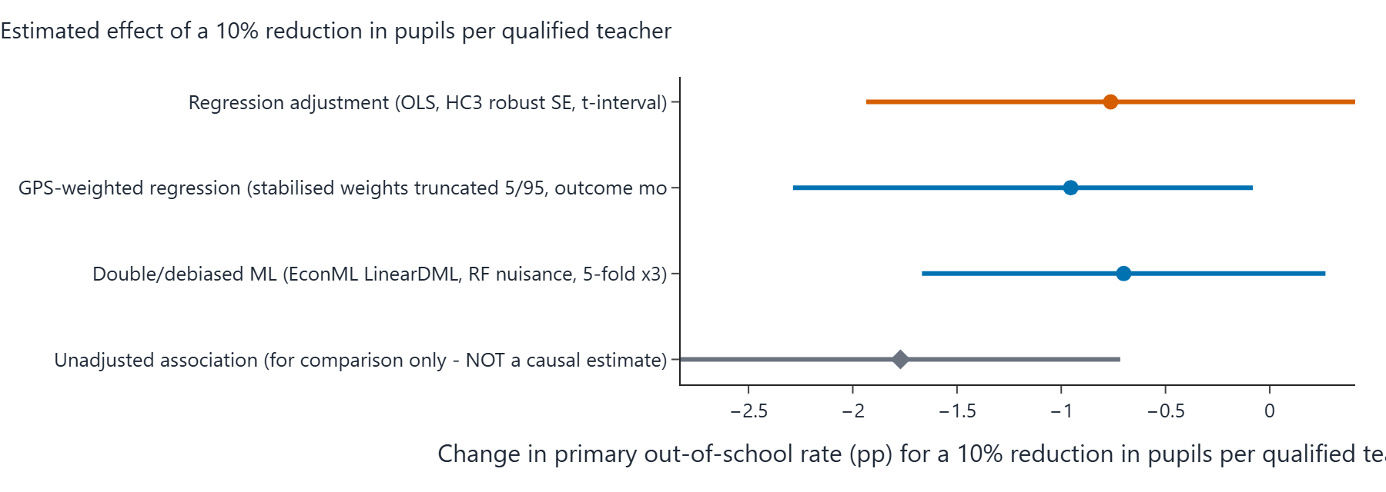
Figure 3.3: Screenshot of the portal's forest plot - rounded effect estimate and 95% interval for each estimator in the table above, on a common percentage-point scale.

Sensitivity analysis (How wrong could this be?)
An omitted confounder explaining 28.4% of the residual variance of BOTH PQTR and the OOS rate (partial R^2) would be enough to reduce the point estimate to zero. The adjusted estimate is already statistically insignificant at 5%, so no additional confounding is needed for that. The observed confounders have partial R^2 with the outcome of north: 38.7% (benchmarks).
Benchmark confounder | Partial R-squared with the outcome | Partial R-squared with the treatment
north | 38.7% | 31.1%

How to read it: if an unmeasured factor were correlated with PQTR and the OOS rate at a partial R-squared larger than the robustness value (RV) above, it could erase the point estimate. The observed confounders themselves provide a scale on the benchmark table.

Robustness across specifications
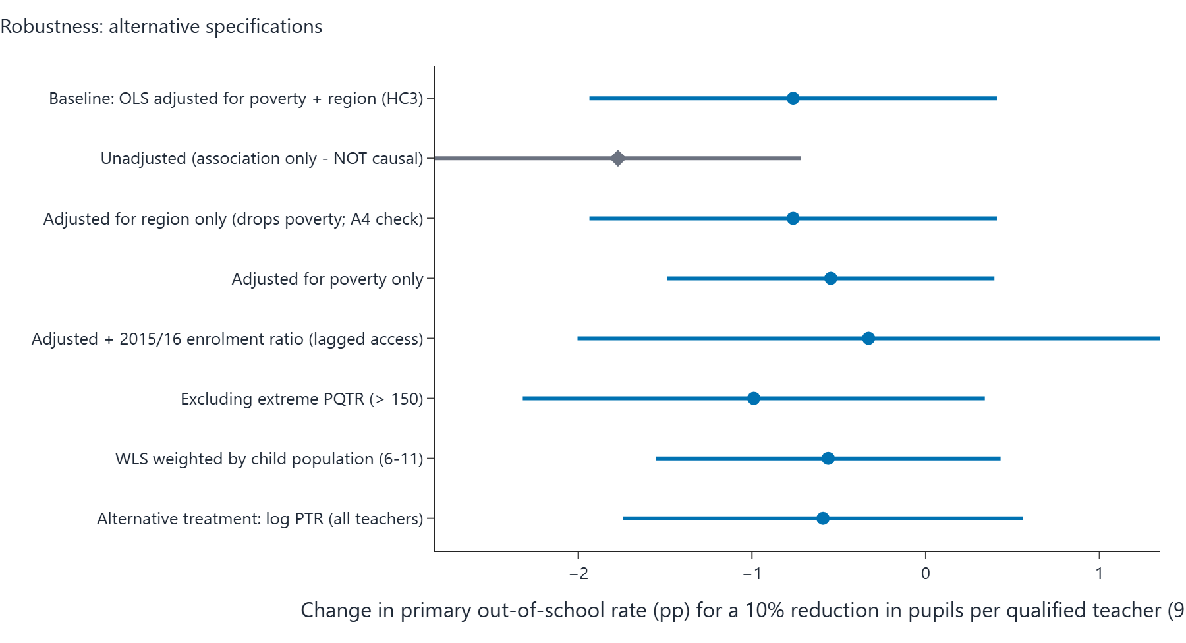
Figure 3.4: Screenshot of the portal's specification curve - the effect of a 10% PQTR reduction for every robustness row in the table beneath, sorted by estimate.
Specification | Effect size (pp per 10% PQTR reduction) | 95% interval (pp) | p-value
Baseline: OLS adjusted for poverty + region (HC3) | -0.76 pp | -1.94 to +0.41 | 0.193
Unadjusted (association only - NOT causal) | -1.77 pp | -2.83 to -0.72 | 0.002
Adjusted for region only (drops poverty; A4 check) | -0.76 pp | -1.94 to +0.41 | 0.193
Adjusted for poverty only | -0.55 pp | -1.49 to +0.40 | 0.245
Adjusted + 2015/16 enrolment ratio (lagged access) | -0.33 pp | -2.00 to +1.35 | 0.689
Excluding extreme PQTR (> 150) | -0.99 pp | -2.32 to +0.34 | 0.138
WLS weighted by child population (6-11) | -0.56 pp | -1.55 to +0.43 | 0.256
Alternative treatment: log PTR (all teachers) | -0.59 pp | -1.74 to +0.56 | 0.302

Alternative treatment scale: measured on the raw pupil count (not the log), each extra 10 pupils per qualified teacher is associated with about +0.51 pp (95% interval from -1.61 to +2.63), from the same specification family.
Bounded-outcome form: a fractional logit on the school-share scale gives an average effect of -0.64 pp per 10% PQTR reduction (p = 0.092), reassuring that conclusions do not hinge on the linear-percentage-point model.
Stability check: dropping each state once moves the estimated effect between +4.95 pp (lowest when leaving FCT out) and +10.52 pp (highest when leaving Nasarawa out). Sign changes across the leave-one-out estimates: no.
Interval cross-checks: pairs bootstrap gives -2.65 to +18.99 pp (300 valid resamples); a (Freedman-Lane) permutation test puts the chance-only p at 0.083.

Predictive-model charts (NOT causal evidence)
These two charts appear on every portal run page and summarise the machine-learning predictive layer of the analysis, which is entirely separate from the causal estimate above. A feature that predicts the OOS rate well is not necessarily a cause of it: importance and prediction error describe association in the sample. They are included here for completeness, clearly labelled so they cannot be mistaken for causal results.
Figure 3.5: Screenshot of the portal's feature-importance chart - mean absolute SHAP value of each feature in the predictive model. High importance is not a causal claim.
Figure 3.6: Screenshot of the portal's prediction-error chart - out-of-sample RMSE in pp per model. Prediction accuracy says nothing about the causal direction of any relationship.

Verdict (in plain words)
Verdict band: AMBER (inconclusive): the data cannot separate 'no effect' from effects of modest size.
Under assumptions A1-A7, the regression-adjusted estimate is that a 10% reduction in pupils per qualified teacher changes a state's primary out-of-school rate by -0.76 percentage points (95% interval -1.94 to +0.41), n = 31 states.
The unadjusted association is much larger (-1.77 pp per 10% reduction) because states with high PQTR are also poorer and mostly in the North; most of that raw association is explained by poverty and region.
Sensitivity: an unmeasured confounder would need a partial R^2 of about 28% with both PQTR and the outcome to explain the point estimate away (RV); this is a measure of fragility, not evidence of causation.

Caveats carried through from the engine:
- Only 31 states are available: intervals are wide and estimates unstable.
- Cross-sectional design: results are adjusted associations interpreted causally only under assumptions A1-A7.

4. All Children vs. Poverty Only
Item | Value
Section | Primary OOS rate, all children (primary outcome) - adjusted for Poverty only
Outcome variable (state-level, 2021) | oos_total_2021
Treatment variable | log_pqtr
Confounders in the adjustment set | pov_215
States in the sample (n) | 31
Diagnostic detail / settings | Generalised results use 300 bootstrap resamples, 30 refutation simulations, 3 DML cross-fit repeats

Causal graphs

Assumed causal graph (identifying DAG) - elements
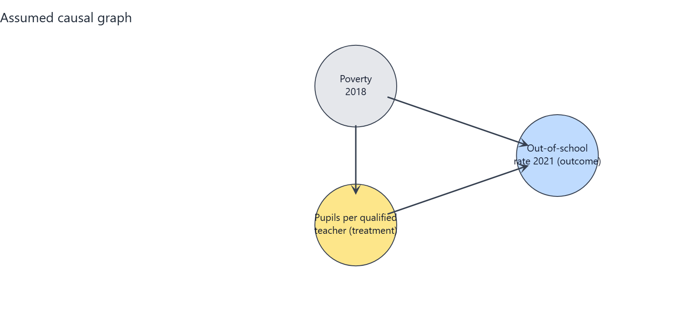
Figure 4.1: Screenshot of the portal's identifying DAG for this combination. Every circle and arrow is explained in the table beneath.
Element (in the chart) | What it is | Plain-English meaning
log_pqtr (amber circle) | Treatment | Average number of pupils in a state's public primary schools per qualified teacher, 2016/17 (log scale). Higher = fewer qualified teachers relative to pupils.
oos_total_2021 (blue circle) | Outcome | The share of primary-school-age children (girls and boys) who are not in school (2021). This is what we want to change.
pov_215 (grey circle) | Measured confounder | The share of the state population living on less than $2.15 per day (2018). Poorer states have more pupils per qualified teacher and higher OOS rates, so it must be held constant.

Arrow | What it represents | Plain-English meaning
pov_215 -> log_pqtr | Confounding path into treatment | Poverty pushes the pupil-per-teacher ratio (e.g. poorer or more northern states staff schools differently).
pov_215 -> oos_total_2021 | Confounding path into outcome | Poverty also drives OOS rates directly (e.g. via household resources), independently of teacher supply.
log_pqtr -> oos_total_2021 | The arrow of interest | After holding the confounders constant, this is the estimated effect of teacher supply on the OOS rate - the quantity the analysis estimates.

Assumed causal graph with an unmeasured common cause (threat DAG) - extra elements
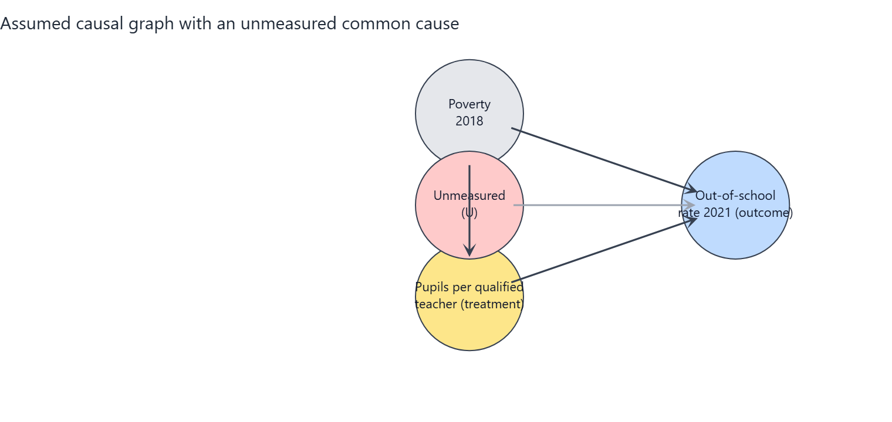
Figure 4.2: Screenshot of the portal's threat DAG. The red circle U is a stand-in for everything unmeasured; its dashed red arrows are the paths the observed data cannot block.
Element (in the chart) | What it is | Plain-English meaning
U (red circle, dashed border) | Unmeasured confounder | A stand-in for everything unobserved that raises or lowers both teacher supply and OOS rates: state governance capacity, conflict and insecurity, cultural attitudes to schooling, school construction funding.
U --> log_pqtr (dashed red arrow) | Unmeasured path into treatment | Better-governed states also attract and retain more qualified teachers, they are not purely set by poverty and region.
U --> oos_total_2021 (dashed red arrow) | Unmeasured path into outcome | The same governance/attitude factors also move OOS rates on their own.
What changes vs. Graph 1 | Non-identifiability | With U present, adjusting for the observed confounders is no longer sufficient to isolate the causal effect; the estimate can be biased up or down by an unknown amount. This is the honest limit of the study design.
What it means for the reader | Interpret with care | Graph 1 is the best-case assumption (conditional ignorability). The sensitivity analysis in this section quantifies in partial R-squared terms how strong U would have to be to overturn the conclusion.

Assumptions the conclusion depends on
- A1 Conditional ignorability: given poverty (2018) and region, states' PQTR is as good as randomly assigned with respect to potential OOS outcomes (no unmeasured common causes).
- A2 Positivity/overlap: states with similar poverty and region show a range of PQTR values (checked with overlap diagnostics).
- A3 Consistency / SUTVA: no spillovers of teachers or pupils between states; 'a 10% lower PQTR' is a well-defined intervention.
- A4 Temporal order: PQTR (2016/17) precedes the outcome (2021); poverty (2018) is treated as pre-treatment although it could be partly shaped by earlier schooling (tested by dropping it).
- A5 Functional form: the effect is linear in log(PQTR) and additive in the confounders (tested with alternative forms and DML).
- A6 Measurement: PQTR from the Digest and OOS from MICS are measured without systematic error related to the other variable (administrative reporting errors are documented and the worst rows excluded).
- A7 Excluded variables: private-school share and enrolment rates are possible mediators/colliders and are deliberately NOT adjusted for.

Analysis results

Estimates of the effect
Estimator | Effect size (pp per 10% PQTR reduction) | 95% interval (pp) | p-value | Notes
Regression adjustment (OLS, HC3 robust SE, t-interval) | -0.55 pp | -1.49 to +0.40 | p = 0.245 | Primary estimate
GPS-weighted regression (stabilised weights truncated 5/95, outcome model adjusted) | -0.40 pp | -1.56 to +0.26 |  | Percentile bootstrap CI (300 resamples, GPS re-estimated). ESS=25.7 of 31.
Double/debiased ML (EconML LinearDML, RF nuisance, 5-fold x3) | -0.07 pp | -0.63 to +0.50 | p = 0.813 | Median over repeated cross-fits; t-quantile interval (n is small, so the interval is approximate and probably too narrow).
Unadjusted association (for comparison only - NOT a causal estimate) | -1.77 pp | -2.83 to -0.72 | p = 0.002

Reminder: a p-value below 0.05 suggests the result is unlikely to be due to chance alone. All effect sizes are percentage-point (pp) changes in the OOS rate per 10% reduction in PQTR.
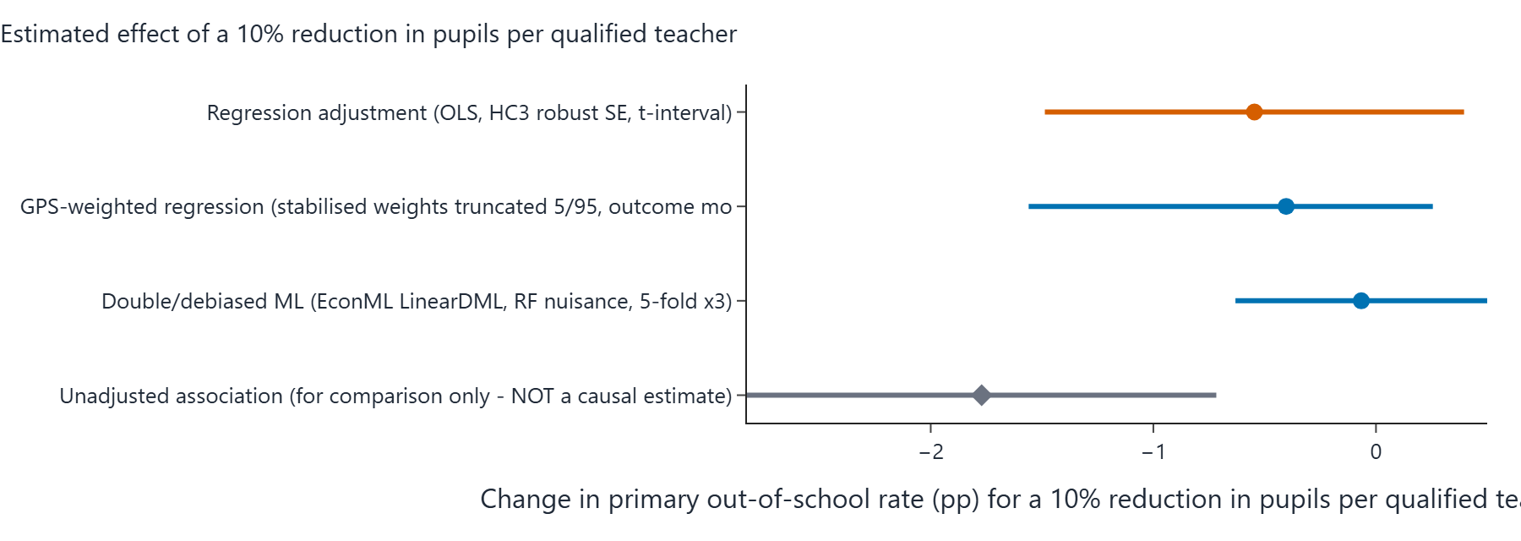
Figure 4.3: Screenshot of the portal's forest plot - rounded effect estimate and 95% interval for each estimator in the table above, on a common percentage-point scale.

Sensitivity analysis (How wrong could this be?)
An omitted confounder explaining 21.8% of the residual variance of BOTH PQTR and the OOS rate (partial R^2) would be enough to reduce the point estimate to zero. The adjusted estimate is already statistically insignificant at 5%, so no additional confounding is needed for that. The observed confounders have partial R^2 with the outcome of pov_215: 46.0% (benchmarks).
Benchmark confounder | Partial R-squared with the outcome | Partial R-squared with the treatment
pov_215 | 46.0% | 35.9%

How to read it: if an unmeasured factor were correlated with PQTR and the OOS rate at a partial R-squared larger than the robustness value (RV) above, it could erase the point estimate. The observed confounders themselves provide a scale on the benchmark table.

Robustness across specifications
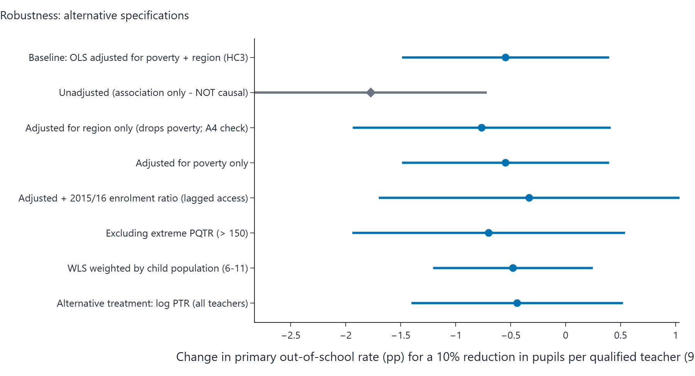
Figure 4.4: Screenshot of the portal's specification curve - the effect of a 10% PQTR reduction for every robustness row in the table beneath, sorted by estimate.
Specification | Effect size (pp per 10% PQTR reduction) | 95% interval (pp) | p-value
Baseline: OLS adjusted for poverty + region (HC3) | -0.55 pp | -1.49 to +0.40 | 0.245
Unadjusted (association only - NOT causal) | -1.77 pp | -2.83 to -0.72 | 0.002
Adjusted for region only (drops poverty; A4 check) | -0.76 pp | -1.94 to +0.41 | 0.193
Adjusted for poverty only | -0.55 pp | -1.49 to +0.40 | 0.245
Adjusted + 2015/16 enrolment ratio (lagged access) | -0.33 pp | -1.70 to +1.04 | 0.621
Excluding extreme PQTR (> 150) | -0.70 pp | -1.94 to +0.54 | 0.257
WLS weighted by child population (6-11) | -0.48 pp | -1.20 to +0.25 | 0.188
Alternative treatment: log PTR (all teachers) | -0.44 pp | -1.40 to +0.52 | 0.356

Alternative treatment scale: measured on the raw pupil count (not the log), each extra 10 pupils per qualified teacher is associated with about +0.31 pp (95% interval from -1.15 to +1.78), from the same specification family.
Bounded-outcome form: a fractional logit on the school-share scale gives an average effect of -0.51 pp per 10% PQTR reduction (p = 0.063), reassuring that conclusions do not hinge on the linear-percentage-point model.
Stability check: dropping each state once moves the estimated effect between +3.76 pp (lowest when leaving Ekiti out) and +7.77 pp (highest when leaving Nasarawa out). Sign changes across the leave-one-out estimates: no.
Interval cross-checks: pairs bootstrap gives -1.89 to +15.14 pp (300 valid resamples); a (Freedman-Lane) permutation test puts the chance-only p at 0.198.

Predictive-model charts (NOT causal evidence)
These two charts appear on every portal run page and summarise the machine-learning predictive layer of the analysis, which is entirely separate from the causal estimate above. A feature that predicts the OOS rate well is not necessarily a cause of it: importance and prediction error describe association in the sample. They are included here for completeness, clearly labelled so they cannot be mistaken for causal results.
Figure 4.5: Screenshot of the portal's feature-importance chart - mean absolute SHAP value of each feature in the predictive model. High importance is not a causal claim.
Figure 4.6: Screenshot of the portal's prediction-error chart - out-of-sample RMSE in pp per model. Prediction accuracy says nothing about the causal direction of any relationship.

Verdict (in plain words)
Verdict band: AMBER (inconclusive): the data cannot separate 'no effect' from effects of modest size.
Under assumptions A1-A7, the regression-adjusted estimate is that a 10% reduction in pupils per qualified teacher changes a state's primary out-of-school rate by -0.55 percentage points (95% interval -1.49 to +0.40), n = 31 states.
The unadjusted association is much larger (-1.77 pp per 10% reduction) because states with high PQTR are also poorer and mostly in the North; most of that raw association is explained by poverty and region.
Every adjusted estimator gives an interval that includes zero: the data are CONSISTENT WITH both no effect and effects of modest size, and cannot distinguish them.
Sensitivity: an unmeasured confounder would need a partial R^2 of about 22% with both PQTR and the outcome to explain the point estimate away (RV); this is a measure of fragility, not evidence of causation.

Caveats carried through from the engine:
- Only 31 states are available: intervals are wide and estimates unstable.
- Cross-sectional design: results are adjusted associations interpreted causally only under assumptions A1-A7.

5. Boys vs. Poverty + Region
Item | Value
Section | Primary OOS rate, boys - adjusted for Poverty (2018) + region
Outcome variable (state-level, 2021) | oos_male_2021
Treatment variable | log_pqtr
Confounders in the adjustment set | pov_215, north
States in the sample (n) | 31
Diagnostic detail / settings | Generalised results use 300 bootstrap resamples, 30 refutation simulations, 3 DML cross-fit repeats

Causal graphs

Assumed causal graph (identifying DAG) - elements
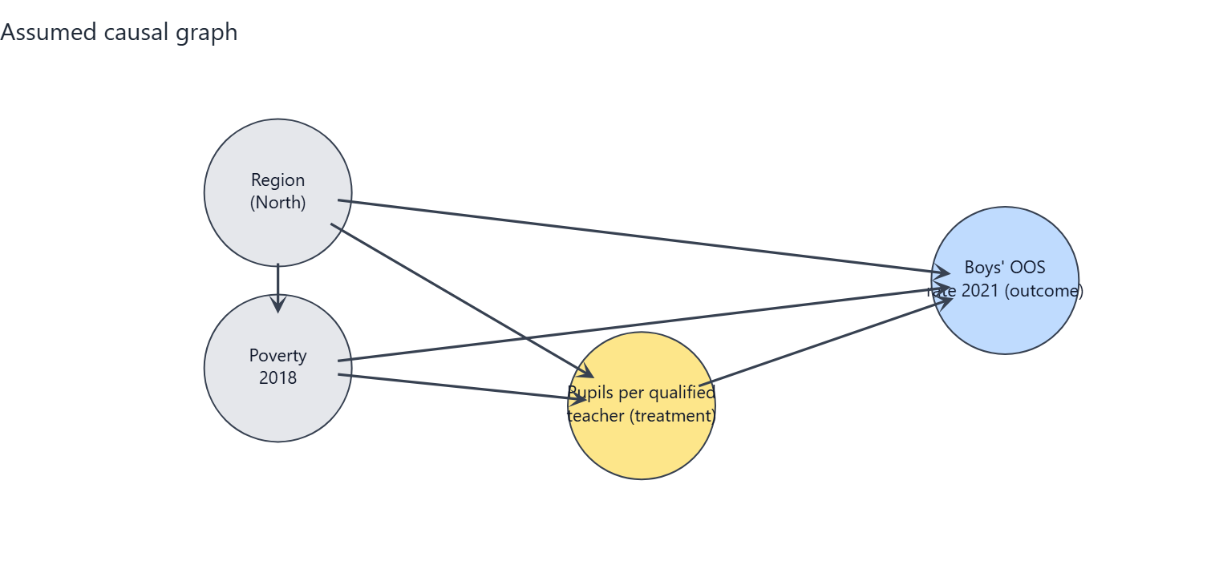
Figure 5.1: Screenshot of the portal's identifying DAG for this combination. Every circle and arrow is explained in the table beneath.
Element (in the chart) | What it is | Plain-English meaning
log_pqtr (amber circle) | Treatment | Average number of pupils in a state's public primary schools per qualified teacher, 2016/17 (log scale). Higher = fewer qualified teachers relative to pupils.
oos_male_2021 (blue circle) | Outcome | The share of primary-school-age boys who are not in school (2021). This is what we want to change.
pov_215 (grey circle) | Measured confounder | The share of the state population living on less than $2.15 per day (2018). Poorer states have more pupils per qualified teacher and higher OOS rates, so it must be held constant.
north (grey circle) | Measured confounder | A flag for whether the state is in the North (1) or South (0). Northern states differ systematically in education infrastructure, poverty and OOS rates, so it must be held constant.

Arrow | What it represents | Plain-English meaning
pov_215 -> log_pqtr | Confounding path into treatment | Poverty pushes the pupil-per-teacher ratio (e.g. poorer or more northern states staff schools differently).
pov_215 -> oos_male_2021 | Confounding path into outcome | Poverty also drives OOS rates directly (e.g. via household resources), independently of teacher supply.
north -> log_pqtr | Confounding path into treatment | Region pushes the pupil-per-teacher ratio (e.g. poorer or more northern states staff schools differently).
north -> oos_male_2021 | Confounding path into outcome | Region also drives OOS rates directly (e.g. via household resources), independently of teacher supply.
north -> pov_215 | Confounder-to-confounder path | Northern states are on average poorer, so region partly causes poverty; poverty is therefore the deeper control variable.
log_pqtr -> oos_male_2021 | The arrow of interest | After holding the confounders constant, this is the estimated effect of teacher supply on the OOS rate - the quantity the analysis estimates.

Assumed causal graph with an unmeasured common cause (threat DAG) - extra elements
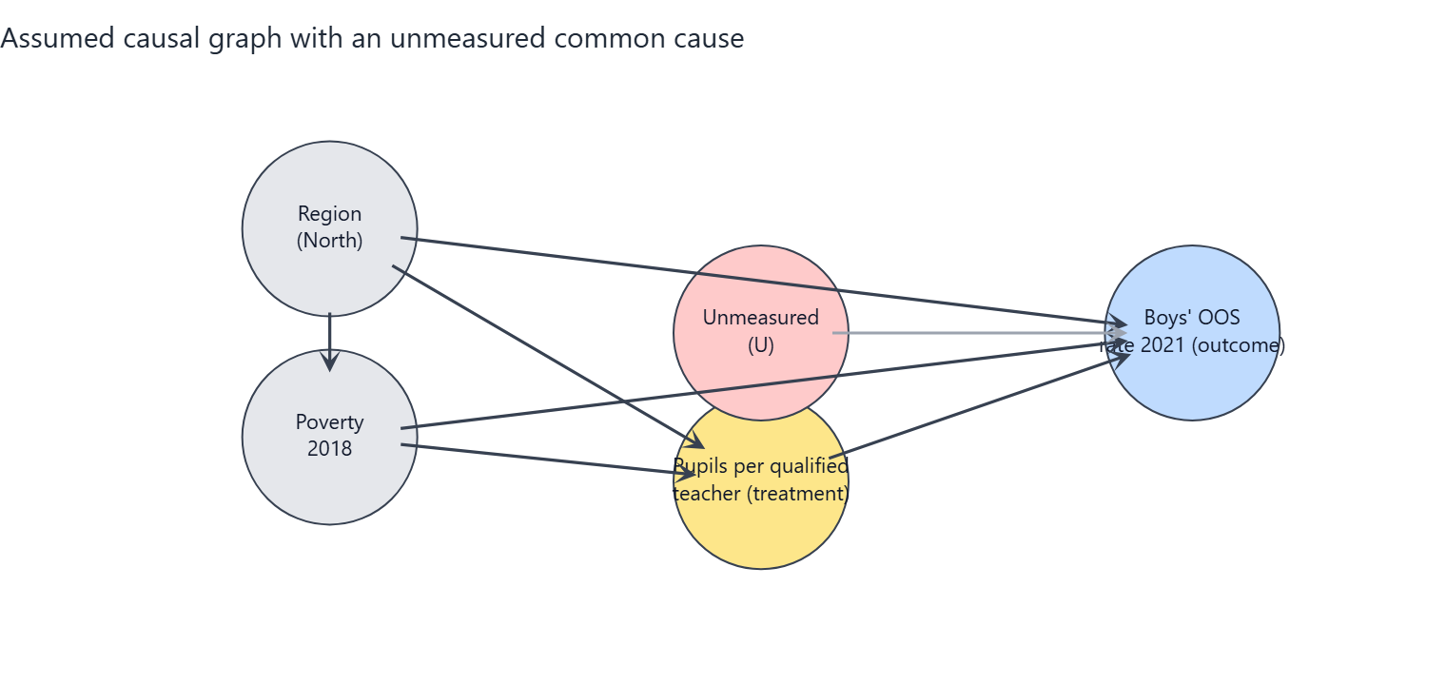
Figure 5.2: Screenshot of the portal's threat DAG. The red circle U is a stand-in for everything unmeasured; its dashed red arrows are the paths the observed data cannot block.
Element (in the chart) | What it is | Plain-English meaning
U (red circle, dashed border) | Unmeasured confounder | A stand-in for everything unobserved that raises or lowers both teacher supply and OOS rates: state governance capacity, conflict and insecurity, cultural attitudes to schooling, school construction funding.
U --> log_pqtr (dashed red arrow) | Unmeasured path into treatment | Better-governed states also attract and retain more qualified teachers, they are not purely set by poverty and region.
U --> oos_male_2021 (dashed red arrow) | Unmeasured path into outcome | The same governance/attitude factors also move OOS rates on their own.
What changes vs. Graph 1 | Non-identifiability | With U present, adjusting for the observed confounders is no longer sufficient to isolate the causal effect; the estimate can be biased up or down by an unknown amount. This is the honest limit of the study design.
What it means for the reader | Interpret with care | Graph 1 is the best-case assumption (conditional ignorability). The sensitivity analysis in this section quantifies in partial R-squared terms how strong U would have to be to overturn the conclusion.

Assumptions the conclusion depends on
- A1 Conditional ignorability: given poverty (2018) and region, states' PQTR is as good as randomly assigned with respect to potential OOS outcomes (no unmeasured common causes).
- A2 Positivity/overlap: states with similar poverty and region show a range of PQTR values (checked with overlap diagnostics).
- A3 Consistency / SUTVA: no spillovers of teachers or pupils between states; 'a 10% lower PQTR' is a well-defined intervention.
- A4 Temporal order: PQTR (2016/17) precedes the outcome (2021); poverty (2018) is treated as pre-treatment although it could be partly shaped by earlier schooling (tested by dropping it).
- A5 Functional form: the effect is linear in log(PQTR) and additive in the confounders (tested with alternative forms and DML).
- A6 Measurement: PQTR from the Digest and OOS from MICS are measured without systematic error related to the other variable (administrative reporting errors are documented and the worst rows excluded).
- A7 Excluded variables: private-school share and enrolment rates are possible mediators/colliders and are deliberately NOT adjusted for.

Analysis results

Estimates of the effect
Estimator | Effect size (pp per 10% PQTR reduction) | 95% interval (pp) | p-value | Notes
Regression adjustment (OLS, HC3 robust SE, t-interval) | -0.46 pp | -1.40 to +0.47 | p = 0.321 | Primary estimate
GPS-weighted regression (stabilised weights truncated 5/95, outcome model adjusted) | -0.41 pp | -1.54 to +0.21 |  | Percentile bootstrap CI (300 resamples, GPS re-estimated). ESS=25.9 of 31.
Double/debiased ML (EconML LinearDML, RF nuisance, 5-fold x3) | -0.13 pp | -0.67 to +0.42 | p = 0.631 | Median over repeated cross-fits; t-quantile interval (n is small, so the interval is approximate and probably too narrow).
Unadjusted association (for comparison only - NOT a causal estimate) | -1.78 pp | -2.80 to -0.75 | p = 0.001

Reminder: a p-value below 0.05 suggests the result is unlikely to be due to chance alone. All effect sizes are percentage-point (pp) changes in the OOS rate per 10% reduction in PQTR.
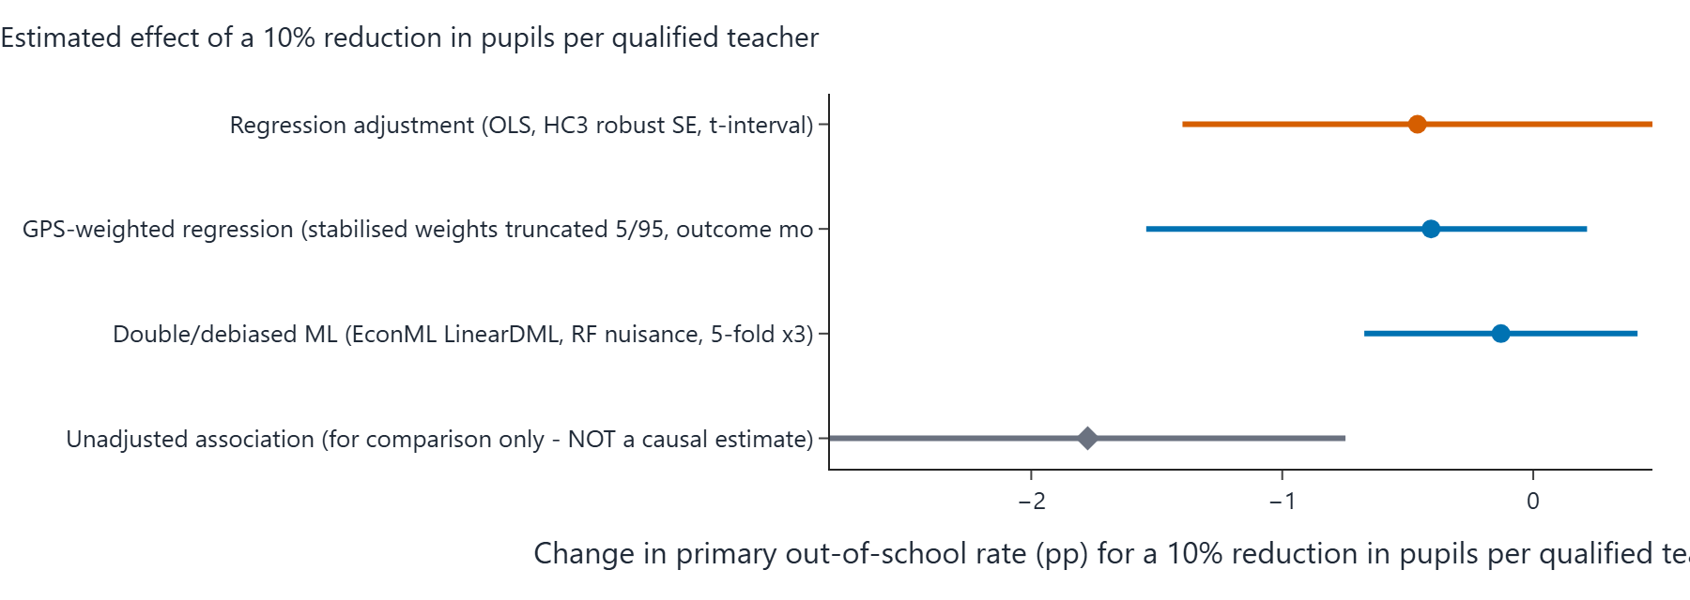
Figure 5.3: Screenshot of the portal's forest plot - rounded effect estimate and 95% interval for each estimator in the table above, on a common percentage-point scale.

Sensitivity analysis (How wrong could this be?)
An omitted confounder explaining 19.8% of the residual variance of BOTH PQTR and the OOS rate (partial R^2) would be enough to reduce the point estimate to zero. The adjusted estimate is already statistically insignificant at 5%, so no additional confounding is needed for that. The observed confounders have partial R^2 with the outcome of pov_215: 20.0%, north: 8.9% (benchmarks).
Benchmark confounder | Partial R-squared with the outcome | Partial R-squared with the treatment
pov_215 | 20.0% | 9.8%
north | 8.9% | 3.1%

How to read it: if an unmeasured factor were correlated with PQTR and the OOS rate at a partial R-squared larger than the robustness value (RV) above, it could erase the point estimate. The observed confounders themselves provide a scale on the benchmark table.

Robustness across specifications
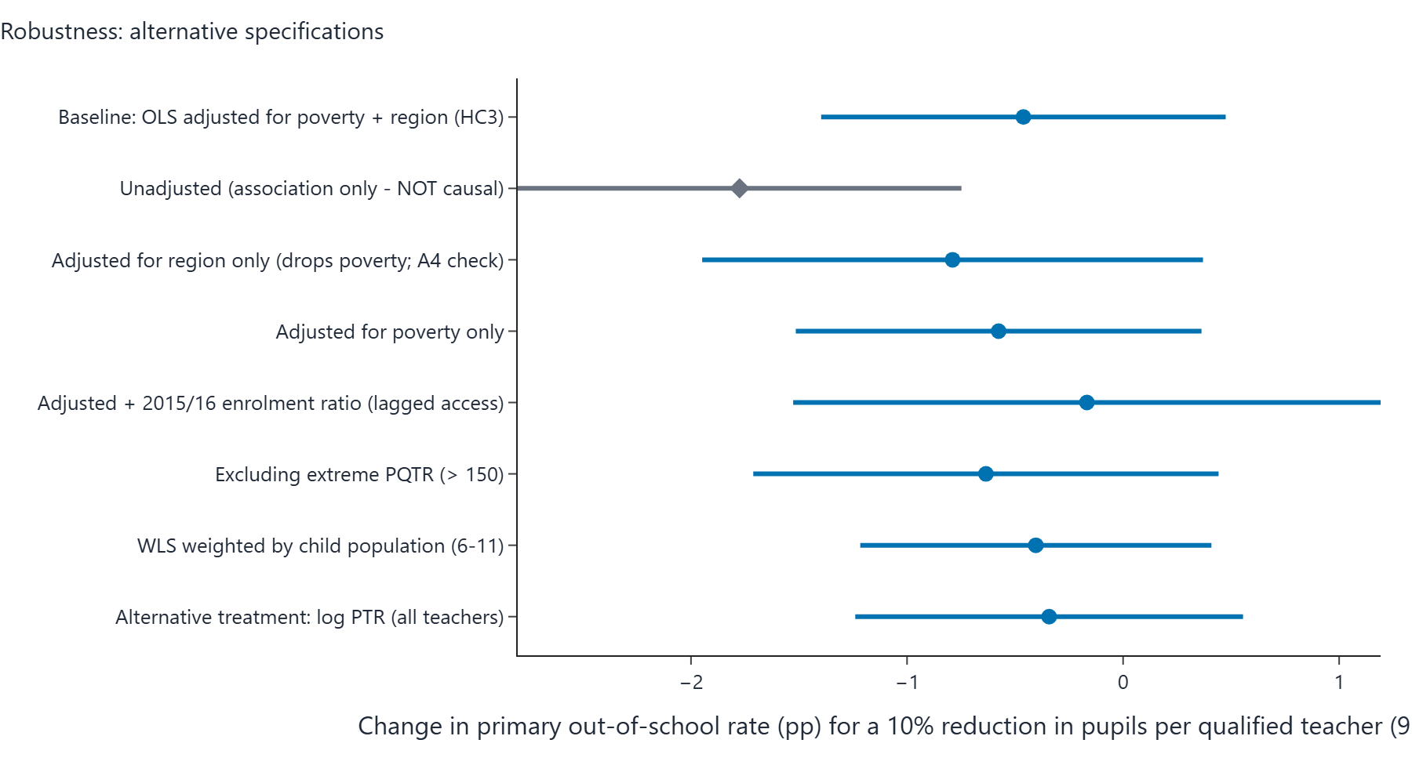
Figure 5.4: Screenshot of the portal's specification curve - the effect of a 10% PQTR reduction for every robustness row in the table beneath, sorted by estimate.
Specification | Effect size (pp per 10% PQTR reduction) | 95% interval (pp) | p-value
Baseline: OLS adjusted for poverty + region (HC3) | -0.46 pp | -1.40 to +0.47 | 0.321
Unadjusted (association only - NOT causal) | -1.78 pp | -2.80 to -0.75 | 0.001
Adjusted for region only (drops poverty; A4 check) | -0.79 pp | -1.95 to +0.37 | 0.174
Adjusted for poverty only | -0.58 pp | -1.51 to +0.36 | 0.219
Adjusted + 2015/16 enrolment ratio (lagged access) | -0.17 pp | -1.53 to +1.19 | 0.801
Excluding extreme PQTR (> 150) | -0.63 pp | -1.71 to +0.44 | 0.236
WLS weighted by child population (6-11) | -0.40 pp | -1.22 to +0.41 | 0.317
Alternative treatment: log PTR (all teachers) | -0.34 pp | -1.24 to +0.56 | 0.441

Alternative treatment scale: measured on the raw pupil count (not the log), each extra 10 pupils per qualified teacher is associated with about +0.23 pp (95% interval from -1.36 to +1.82), from the same specification family.
Bounded-outcome form: a fractional logit on the school-share scale gives an average effect of -0.37 pp per 10% PQTR reduction (p = 0.198), reassuring that conclusions do not hinge on the linear-percentage-point model.
Stability check: dropping each state once moves the estimated effect between +3.18 pp (lowest when leaving Yobe out) and +7.17 pp (highest when leaving Nasarawa out). Sign changes across the leave-one-out estimates: no.
Interval cross-checks: pairs bootstrap gives -3.19 to +13.48 pp (300 valid resamples); a (Freedman-Lane) permutation test puts the chance-only p at 0.248.

Predictive-model charts (NOT causal evidence)
These two charts appear on every portal run page and summarise the machine-learning predictive layer of the analysis, which is entirely separate from the causal estimate above. A feature that predicts the OOS rate well is not necessarily a cause of it: importance and prediction error describe association in the sample. They are included here for completeness, clearly labelled so they cannot be mistaken for causal results.
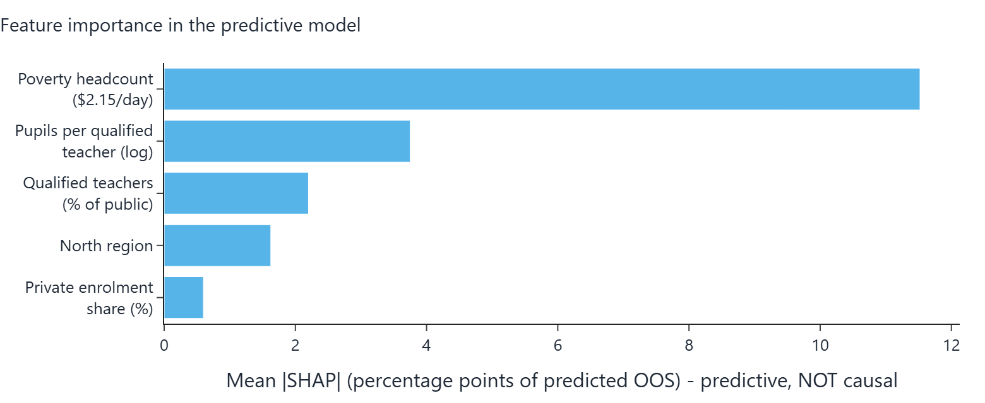
Figure 5.5: Screenshot of the portal's feature-importance chart - mean absolute SHAP value of each feature in the predictive model. High importance is not a causal claim.
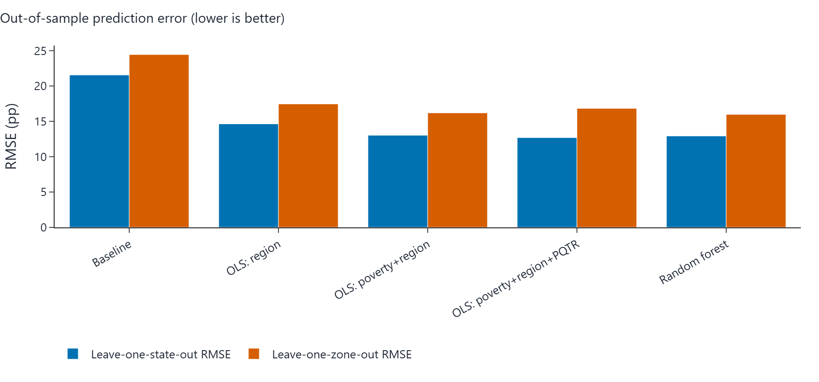
Figure 5.6: Screenshot of the portal's prediction-error chart - out-of-sample RMSE in pp per model. Prediction accuracy says nothing about the causal direction of any relationship.

Verdict (in plain words)
Verdict band: AMBER (inconclusive): the data cannot separate 'no effect' from effects of modest size.
Under assumptions A1-A7, the regression-adjusted estimate is that a 10% reduction in pupils per qualified teacher changes a state's primary out-of-school rate by -0.46 percentage points (95% interval -1.40 to +0.47), n = 31 states.
The unadjusted association is much larger (-1.78 pp per 10% reduction) because states with high PQTR are also poorer and mostly in the North; most of that raw association is explained by poverty and region.
Every adjusted estimator gives an interval that includes zero: the data are CONSISTENT WITH both no effect and effects of modest size, and cannot distinguish them.
Sensitivity: an unmeasured confounder would need a partial R^2 of about 20% with both PQTR and the outcome to explain the point estimate away (RV); this is a measure of fragility, not evidence of causation.

Caveats carried through from the engine:
- Only 31 states are available: intervals are wide and estimates unstable.
- Cross-sectional design: results are adjusted associations interpreted causally only under assumptions A1-A7.

6. Boys vs. Region Only
Item | Value
Section | Primary OOS rate, boys - adjusted for Region only
Outcome variable (state-level, 2021) | oos_male_2021
Treatment variable | log_pqtr
Confounders in the adjustment set | north
States in the sample (n) | 31
Diagnostic detail / settings | Generalised results use 300 bootstrap resamples, 30 refutation simulations, 3 DML cross-fit repeats

Causal graphs

Assumed causal graph (identifying DAG) - elements
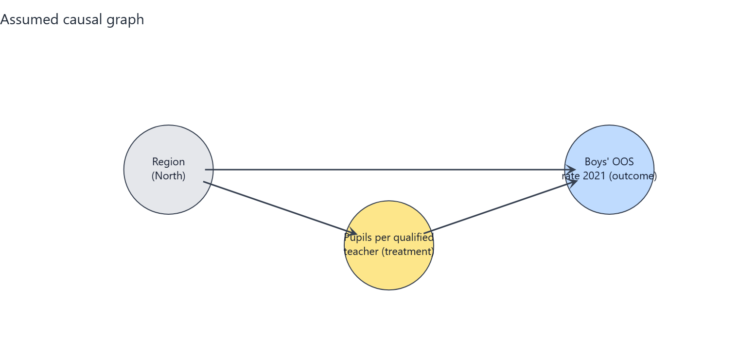
Figure 6.1: Screenshot of the portal's identifying DAG for this combination. Every circle and arrow is explained in the table beneath.
Element (in the chart) | What it is | Plain-English meaning
log_pqtr (amber circle) | Treatment | Average number of pupils in a state's public primary schools per qualified teacher, 2016/17 (log scale). Higher = fewer qualified teachers relative to pupils.
oos_male_2021 (blue circle) | Outcome | The share of primary-school-age boys who are not in school (2021). This is what we want to change.
north (grey circle) | Measured confounder | A flag for whether the state is in the North (1) or South (0). Northern states differ systematically in education infrastructure, poverty and OOS rates, so it must be held constant.

Arrow | What it represents | Plain-English meaning
north -> log_pqtr | Confounding path into treatment | Region pushes the pupil-per-teacher ratio (e.g. poorer or more northern states staff schools differently).
north -> oos_male_2021 | Confounding path into outcome | Region also drives OOS rates directly (e.g. via household resources), independently of teacher supply.
log_pqtr -> oos_male_2021 | The arrow of interest | After holding the confounders constant, this is the estimated effect of teacher supply on the OOS rate - the quantity the analysis estimates.

Assumed causal graph with an unmeasured common cause (threat DAG) - extra elements
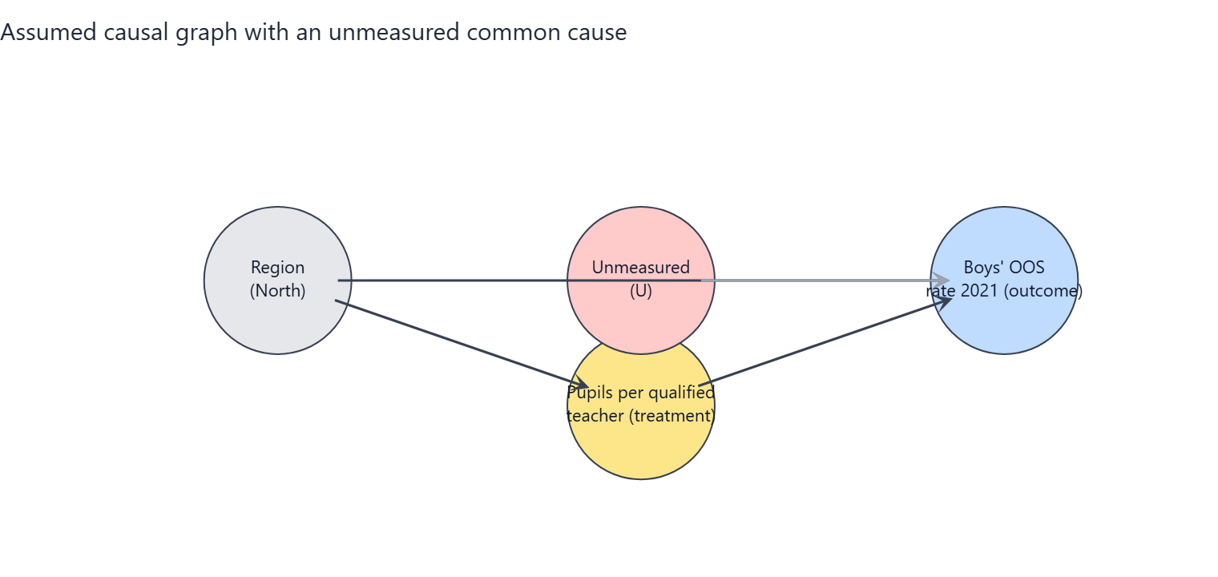
Figure 6.2: Screenshot of the portal's threat DAG. The red circle U is a stand-in for everything unmeasured; its dashed red arrows are the paths the observed data cannot block.
Element (in the chart) | What it is | Plain-English meaning
U (red circle, dashed border) | Unmeasured confounder | A stand-in for everything unobserved that raises or lowers both teacher supply and OOS rates: state governance capacity, conflict and insecurity, cultural attitudes to schooling, school construction funding.
U --> log_pqtr (dashed red arrow) | Unmeasured path into treatment | Better-governed states also attract and retain more qualified teachers, they are not purely set by poverty and region.
U --> oos_male_2021 (dashed red arrow) | Unmeasured path into outcome | The same governance/attitude factors also move OOS rates on their own.
What changes vs. Graph 1 | Non-identifiability | With U present, adjusting for the observed confounders is no longer sufficient to isolate the causal effect; the estimate can be biased up or down by an unknown amount. This is the honest limit of the study design.
What it means for the reader | Interpret with care | Graph 1 is the best-case assumption (conditional ignorability). The sensitivity analysis in this section quantifies in partial R-squared terms how strong U would have to be to overturn the conclusion.

Assumptions the conclusion depends on
- A1 Conditional ignorability: given poverty (2018) and region, states' PQTR is as good as randomly assigned with respect to potential OOS outcomes (no unmeasured common causes).
- A2 Positivity/overlap: states with similar poverty and region show a range of PQTR values (checked with overlap diagnostics).
- A3 Consistency / SUTVA: no spillovers of teachers or pupils between states; 'a 10% lower PQTR' is a well-defined intervention.
- A4 Temporal order: PQTR (2016/17) precedes the outcome (2021); poverty (2018) is treated as pre-treatment although it could be partly shaped by earlier schooling (tested by dropping it).
- A5 Functional form: the effect is linear in log(PQTR) and additive in the confounders (tested with alternative forms and DML).
- A6 Measurement: PQTR from the Digest and OOS from MICS are measured without systematic error related to the other variable (administrative reporting errors are documented and the worst rows excluded).
- A7 Excluded variables: private-school share and enrolment rates are possible mediators/colliders and are deliberately NOT adjusted for.

Analysis results

Estimates of the effect
Estimator | Effect size (pp per 10% PQTR reduction) | 95% interval (pp) | p-value | Notes
Regression adjustment (OLS, HC3 robust SE, t-interval) | -0.79 pp | -1.95 to +0.37 | p = 0.174 | Primary estimate
GPS-weighted regression (stabilised weights truncated 5/95, outcome model adjusted) | -0.98 pp | -2.29 to -0.12 |  | Percentile bootstrap CI (300 resamples, GPS re-estimated). ESS=24.0 of 31.
Double/debiased ML (EconML LinearDML, RF nuisance, 5-fold x3) | -0.73 pp | -1.69 to +0.22 | p = 0.127 | Median over repeated cross-fits; t-quantile interval (n is small, so the interval is approximate and probably too narrow).
Unadjusted association (for comparison only - NOT a causal estimate) | -1.78 pp | -2.80 to -0.75 | p = 0.001

Reminder: a p-value below 0.05 suggests the result is unlikely to be due to chance alone. All effect sizes are percentage-point (pp) changes in the OOS rate per 10% reduction in PQTR.
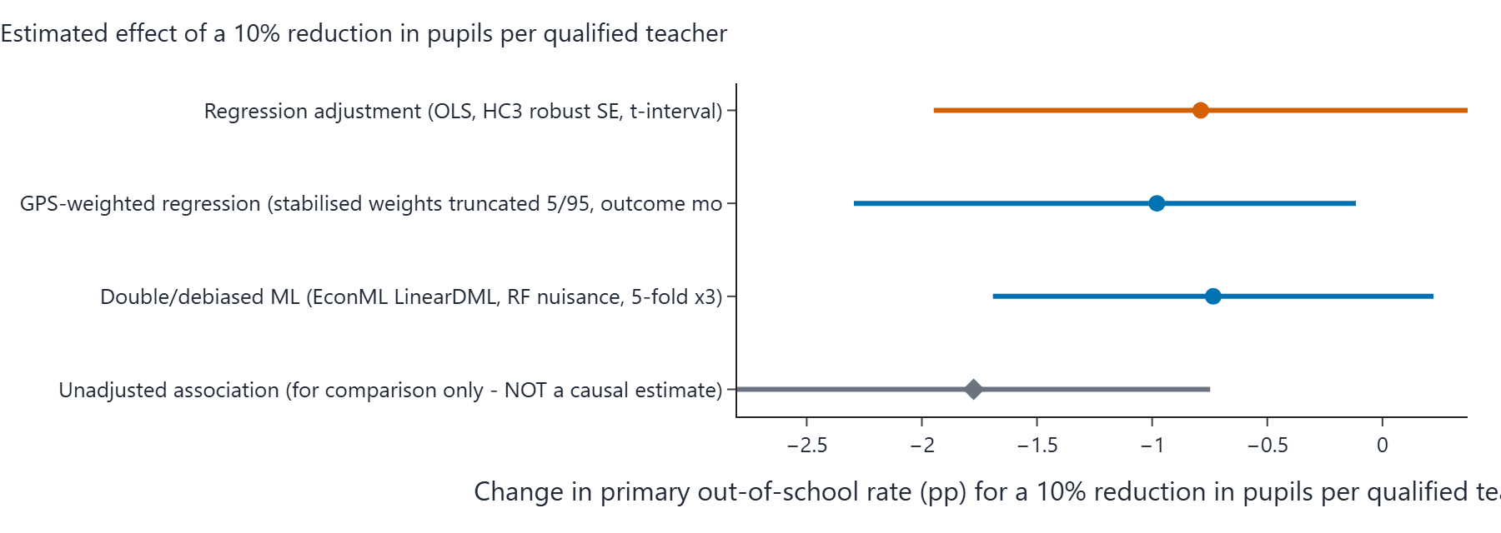
Figure 6.3: Screenshot of the portal's forest plot - rounded effect estimate and 95% interval for each estimator in the table above, on a common percentage-point scale.

Sensitivity analysis (How wrong could this be?)
An omitted confounder explaining 29.8% of the residual variance of BOTH PQTR and the OOS rate (partial R^2) would be enough to reduce the point estimate to zero. The adjusted estimate is already statistically insignificant at 5%, so no additional confounding is needed for that. The observed confounders have partial R^2 with the outcome of north: 38.8% (benchmarks).
Benchmark confounder | Partial R-squared with the outcome | Partial R-squared with the treatment
north | 38.8% | 31.1%

How to read it: if an unmeasured factor were correlated with PQTR and the OOS rate at a partial R-squared larger than the robustness value (RV) above, it could erase the point estimate. The observed confounders themselves provide a scale on the benchmark table.

Robustness across specifications
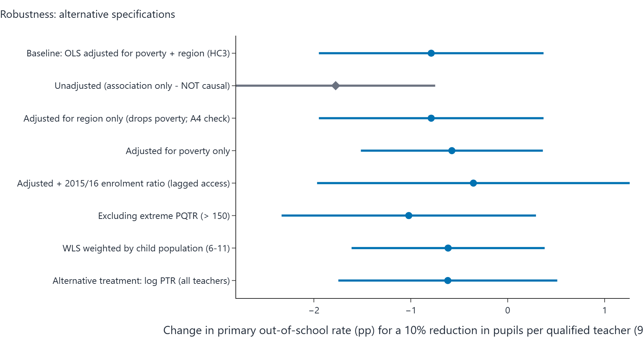
Figure 6.4: Screenshot of the portal's specification curve - the effect of a 10% PQTR reduction for every robustness row in the table beneath, sorted by estimate.
Specification | Effect size (pp per 10% PQTR reduction) | 95% interval (pp) | p-value
Baseline: OLS adjusted for poverty + region (HC3) | -0.79 pp | -1.95 to +0.37 | 0.174
Unadjusted (association only - NOT causal) | -1.78 pp | -2.80 to -0.75 | 0.001
Adjusted for region only (drops poverty; A4 check) | -0.79 pp | -1.95 to +0.37 | 0.174
Adjusted for poverty only | -0.58 pp | -1.51 to +0.36 | 0.219
Adjusted + 2015/16 enrolment ratio (lagged access) | -0.35 pp | -1.97 to +1.26 | 0.655
Excluding extreme PQTR (> 150) | -1.02 pp | -2.33 to +0.29 | 0.122
WLS weighted by child population (6-11) | -0.61 pp | -1.61 to +0.38 | 0.217
Alternative treatment: log PTR (all teachers) | -0.62 pp | -1.75 to +0.51 | 0.272

Alternative treatment scale: measured on the raw pupil count (not the log), each extra 10 pupils per qualified teacher is associated with about +0.53 pp (95% interval from -1.56 to +2.62), from the same specification family.
Bounded-outcome form: a fractional logit on the school-share scale gives an average effect of -0.66 pp per 10% PQTR reduction (p = 0.079), reassuring that conclusions do not hinge on the linear-percentage-point model.
Stability check: dropping each state once moves the estimated effect between +5.18 pp (lowest when leaving FCT out) and +10.72 pp (highest when leaving Nasarawa out). Sign changes across the leave-one-out estimates: no.
Interval cross-checks: pairs bootstrap gives -2.32 to +18.96 pp (300 valid resamples); a (Freedman-Lane) permutation test puts the chance-only p at 0.066.

Predictive-model charts (NOT causal evidence)
These two charts appear on every portal run page and summarise the machine-learning predictive layer of the analysis, which is entirely separate from the causal estimate above. A feature that predicts the OOS rate well is not necessarily a cause of it: importance and prediction error describe association in the sample. They are included here for completeness, clearly labelled so they cannot be mistaken for causal results.
Figure 6.5: Screenshot of the portal's feature-importance chart - mean absolute SHAP value of each feature in the predictive model. High importance is not a causal claim.
Figure 6.6: Screenshot of the portal's prediction-error chart - out-of-sample RMSE in pp per model. Prediction accuracy says nothing about the causal direction of any relationship.

Verdict (in plain words)
Verdict band: AMBER (inconclusive): the data cannot separate 'no effect' from effects of modest size.
Under assumptions A1-A7, the regression-adjusted estimate is that a 10% reduction in pupils per qualified teacher changes a state's primary out-of-school rate by -0.79 percentage points (95% interval -1.95 to +0.37), n = 31 states.
The unadjusted association is much larger (-1.78 pp per 10% reduction) because states with high PQTR are also poorer and mostly in the North; most of that raw association is explained by poverty and region.
Sensitivity: an unmeasured confounder would need a partial R^2 of about 30% with both PQTR and the outcome to explain the point estimate away (RV); this is a measure of fragility, not evidence of causation.

Caveats carried through from the engine:
- Only 31 states are available: intervals are wide and estimates unstable.
- Cross-sectional design: results are adjusted associations interpreted causally only under assumptions A1-A7.

7. Boys vs. Poverty Only
Item | Value
Section | Primary OOS rate, boys - adjusted for Poverty only
Outcome variable (state-level, 2021) | oos_male_2021
Treatment variable | log_pqtr
Confounders in the adjustment set | pov_215
States in the sample (n) | 31
Diagnostic detail / settings | Generalised results use 300 bootstrap resamples, 30 refutation simulations, 3 DML cross-fit repeats

Causal graphs

Assumed causal graph (identifying DAG) - elements
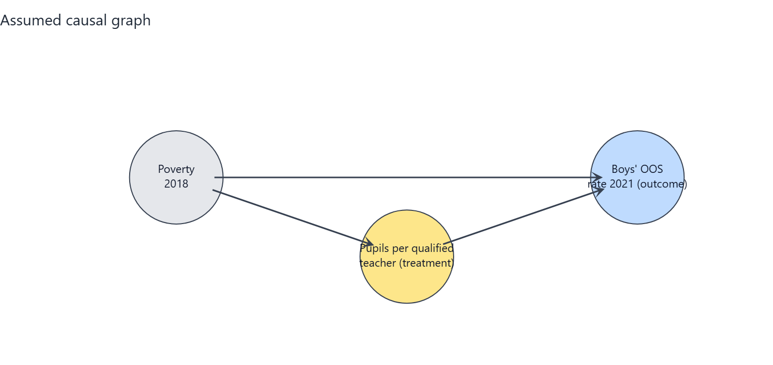
Figure 7.1: Screenshot of the portal's identifying DAG for this combination. Every circle and arrow is explained in the table beneath.
Element (in the chart) | What it is | Plain-English meaning
log_pqtr (amber circle) | Treatment | Average number of pupils in a state's public primary schools per qualified teacher, 2016/17 (log scale). Higher = fewer qualified teachers relative to pupils.
oos_male_2021 (blue circle) | Outcome | The share of primary-school-age boys who are not in school (2021). This is what we want to change.
pov_215 (grey circle) | Measured confounder | The share of the state population living on less than $2.15 per day (2018). Poorer states have more pupils per qualified teacher and higher OOS rates, so it must be held constant.

Arrow | What it represents | Plain-English meaning
pov_215 -> log_pqtr | Confounding path into treatment | Poverty pushes the pupil-per-teacher ratio (e.g. poorer or more northern states staff schools differently).
pov_215 -> oos_male_2021 | Confounding path into outcome | Poverty also drives OOS rates directly (e.g. via household resources), independently of teacher supply.
log_pqtr -> oos_male_2021 | The arrow of interest | After holding the confounders constant, this is the estimated effect of teacher supply on the OOS rate - the quantity the analysis estimates.

Assumed causal graph with an unmeasured common cause (threat DAG) - extra elements
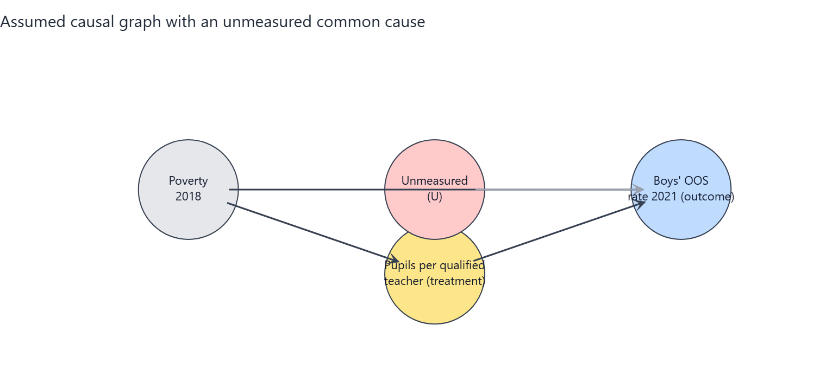
Figure 7.2: Screenshot of the portal's threat DAG. The red circle U is a stand-in for everything unmeasured; its dashed red arrows are the paths the observed data cannot block.
Element (in the chart) | What it is | Plain-English meaning
U (red circle, dashed border) | Unmeasured confounder | A stand-in for everything unobserved that raises or lowers both teacher supply and OOS rates: state governance capacity, conflict and insecurity, cultural attitudes to schooling, school construction funding.
U --> log_pqtr (dashed red arrow) | Unmeasured path into treatment | Better-governed states also attract and retain more qualified teachers, they are not purely set by poverty and region.
U --> oos_male_2021 (dashed red arrow) | Unmeasured path into outcome | The same governance/attitude factors also move OOS rates on their own.
What changes vs. Graph 1 | Non-identifiability | With U present, adjusting for the observed confounders is no longer sufficient to isolate the causal effect; the estimate can be biased up or down by an unknown amount. This is the honest limit of the study design.
What it means for the reader | Interpret with care | Graph 1 is the best-case assumption (conditional ignorability). The sensitivity analysis in this section quantifies in partial R-squared terms how strong U would have to be to overturn the conclusion.

Assumptions the conclusion depends on
- A1 Conditional ignorability: given poverty (2018) and region, states' PQTR is as good as randomly assigned with respect to potential OOS outcomes (no unmeasured common causes).
- A2 Positivity/overlap: states with similar poverty and region show a range of PQTR values (checked with overlap diagnostics).
- A3 Consistency / SUTVA: no spillovers of teachers or pupils between states; 'a 10% lower PQTR' is a well-defined intervention.
- A4 Temporal order: PQTR (2016/17) precedes the outcome (2021); poverty (2018) is treated as pre-treatment although it could be partly shaped by earlier schooling (tested by dropping it).
- A5 Functional form: the effect is linear in log(PQTR) and additive in the confounders (tested with alternative forms and DML).
- A6 Measurement: PQTR from the Digest and OOS from MICS are measured without systematic error related to the other variable (administrative reporting errors are documented and the worst rows excluded).
- A7 Excluded variables: private-school share and enrolment rates are possible mediators/colliders and are deliberately NOT adjusted for.

Analysis results

Estimates of the effect
Estimator | Effect size (pp per 10% PQTR reduction) | 95% interval (pp) | p-value | Notes
Regression adjustment (OLS, HC3 robust SE, t-interval) | -0.58 pp | -1.51 to +0.36 | p = 0.219 | Primary estimate
GPS-weighted regression (stabilised weights truncated 5/95, outcome model adjusted) | -0.44 pp | -1.62 to +0.22 |  | Percentile bootstrap CI (300 resamples, GPS re-estimated). ESS=25.7 of 31.
Double/debiased ML (EconML LinearDML, RF nuisance, 5-fold x3) | -0.12 pp | -0.68 to +0.44 | p = 0.661 | Median over repeated cross-fits; t-quantile interval (n is small, so the interval is approximate and probably too narrow).
Unadjusted association (for comparison only - NOT a causal estimate) | -1.78 pp | -2.80 to -0.75 | p = 0.001

Reminder: a p-value below 0.05 suggests the result is unlikely to be due to chance alone. All effect sizes are percentage-point (pp) changes in the OOS rate per 10% reduction in PQTR.
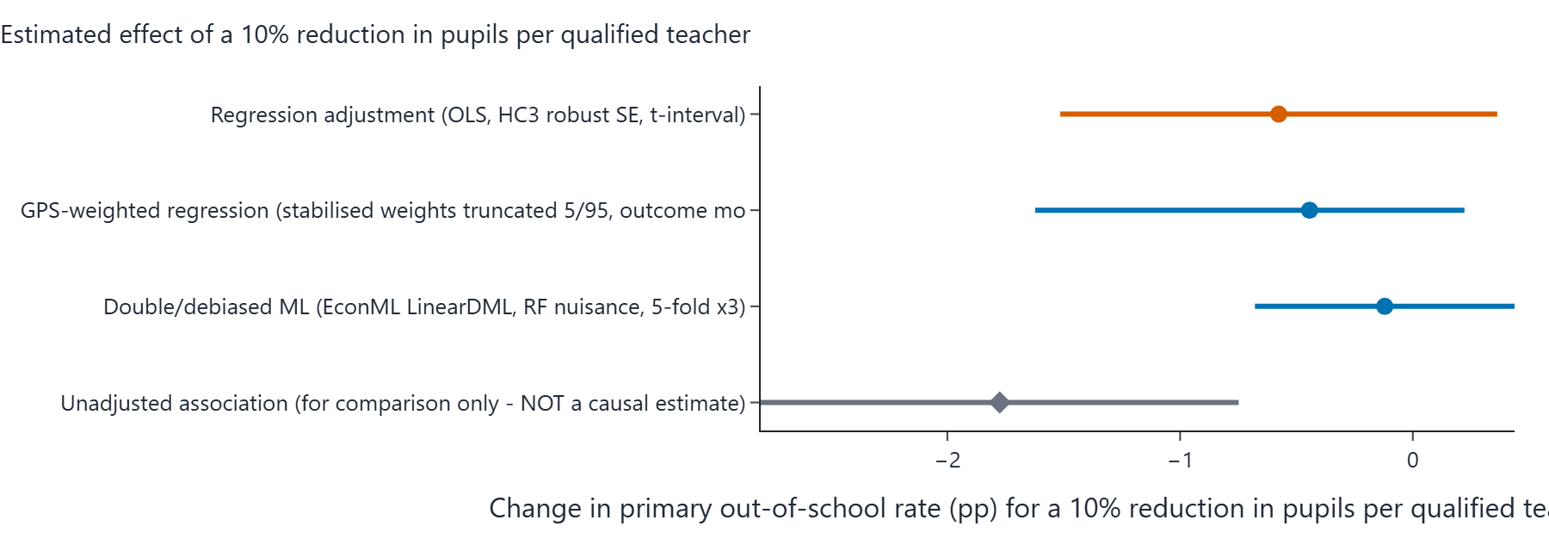
Figure 7.3: Screenshot of the portal's forest plot - rounded effect estimate and 95% interval for each estimator in the table above, on a common percentage-point scale.

Sensitivity analysis (How wrong could this be?)
An omitted confounder explaining 23.4% of the residual variance of BOTH PQTR and the OOS rate (partial R^2) would be enough to reduce the point estimate to zero. The adjusted estimate is already statistically insignificant at 5%, so no additional confounding is needed for that. The observed confounders have partial R^2 with the outcome of pov_215: 46.2% (benchmarks).
Benchmark confounder | Partial R-squared with the outcome | Partial R-squared with the treatment
pov_215 | 46.2% | 35.9%

How to read it: if an unmeasured factor were correlated with PQTR and the OOS rate at a partial R-squared larger than the robustness value (RV) above, it could erase the point estimate. The observed confounders themselves provide a scale on the benchmark table.

Robustness across specifications
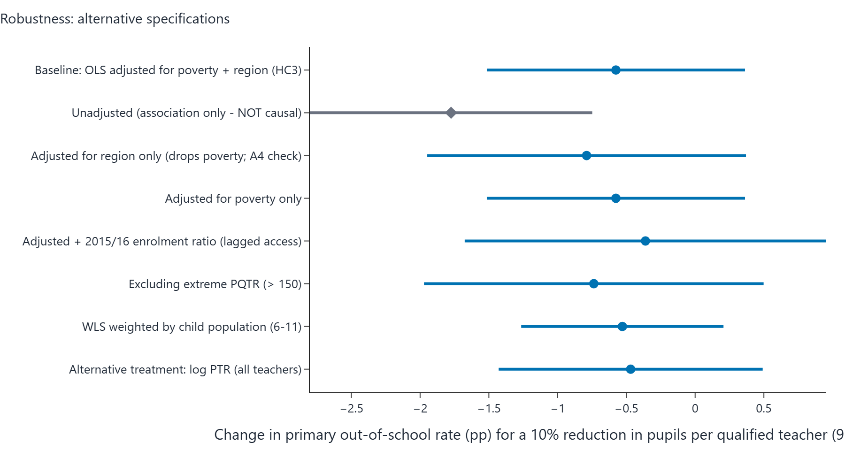
Figure 7.4: Screenshot of the portal's specification curve - the effect of a 10% PQTR reduction for every robustness row in the table beneath, sorted by estimate.
Specification | Effect size (pp per 10% PQTR reduction) | 95% interval (pp) | p-value
Baseline: OLS adjusted for poverty + region (HC3) | -0.58 pp | -1.51 to +0.36 | 0.219
Unadjusted (association only - NOT causal) | -1.78 pp | -2.80 to -0.75 | 0.001
Adjusted for region only (drops poverty; A4 check) | -0.79 pp | -1.95 to +0.37 | 0.174
Adjusted for poverty only | -0.58 pp | -1.51 to +0.36 | 0.219
Adjusted + 2015/16 enrolment ratio (lagged access) | -0.36 pp | -1.68 to +0.95 | 0.576
Excluding extreme PQTR (> 150) | -0.74 pp | -1.97 to +0.50 | 0.231
WLS weighted by child population (6-11) | -0.53 pp | -1.26 to +0.21 | 0.152
Alternative treatment: log PTR (all teachers) | -0.47 pp | -1.43 to +0.49 | 0.326

Alternative treatment scale: measured on the raw pupil count (not the log), each extra 10 pupils per qualified teacher is associated with about +0.34 pp (95% interval from -1.12 to +1.79), from the same specification family.
Bounded-outcome form: a fractional logit on the school-share scale gives an average effect of -0.54 pp per 10% PQTR reduction (p = 0.050), reassuring that conclusions do not hinge on the linear-percentage-point model.
Stability check: dropping each state once moves the estimated effect between +4.02 pp (lowest when leaving Ekiti out) and +8.03 pp (highest when leaving Nasarawa out). Sign changes across the leave-one-out estimates: no.
Interval cross-checks: pairs bootstrap gives -1.61 to +14.99 pp (300 valid resamples); a (Freedman-Lane) permutation test puts the chance-only p at 0.161.

Predictive-model charts (NOT causal evidence)
These two charts appear on every portal run page and summarise the machine-learning predictive layer of the analysis, which is entirely separate from the causal estimate above. A feature that predicts the OOS rate well is not necessarily a cause of it: importance and prediction error describe association in the sample. They are included here for completeness, clearly labelled so they cannot be mistaken for causal results.
Figure 7.5: Screenshot of the portal's feature-importance chart - mean absolute SHAP value of each feature in the predictive model. High importance is not a causal claim.
Figure 7.6: Screenshot of the portal's prediction-error chart - out-of-sample RMSE in pp per model. Prediction accuracy says nothing about the causal direction of any relationship.

Verdict (in plain words)
Verdict band: AMBER (inconclusive): the data cannot separate 'no effect' from effects of modest size.
Under assumptions A1-A7, the regression-adjusted estimate is that a 10% reduction in pupils per qualified teacher changes a state's primary out-of-school rate by -0.58 percentage points (95% interval -1.51 to +0.36), n = 31 states.
The unadjusted association is much larger (-1.78 pp per 10% reduction) because states with high PQTR are also poorer and mostly in the North; most of that raw association is explained by poverty and region.
Every adjusted estimator gives an interval that includes zero: the data are CONSISTENT WITH both no effect and effects of modest size, and cannot distinguish them.
Sensitivity: an unmeasured confounder would need a partial R^2 of about 23% with both PQTR and the outcome to explain the point estimate away (RV); this is a measure of fragility, not evidence of causation.

Caveats carried through from the engine:
- Only 31 states are available: intervals are wide and estimates unstable.
- Cross-sectional design: results are adjusted associations interpreted causally only under assumptions A1-A7.

8. Girls vs. Poverty + Region
Item | Value
Section | Primary OOS rate, girls - adjusted for Poverty (2018) + region
Outcome variable (state-level, 2021) | oos_female_2021
Treatment variable | log_pqtr
Confounders in the adjustment set | pov_215, north
States in the sample (n) | 31
Diagnostic detail / settings | Generalised results use 300 bootstrap resamples, 30 refutation simulations, 3 DML cross-fit repeats

Causal graphs

Assumed causal graph (identifying DAG) - elements
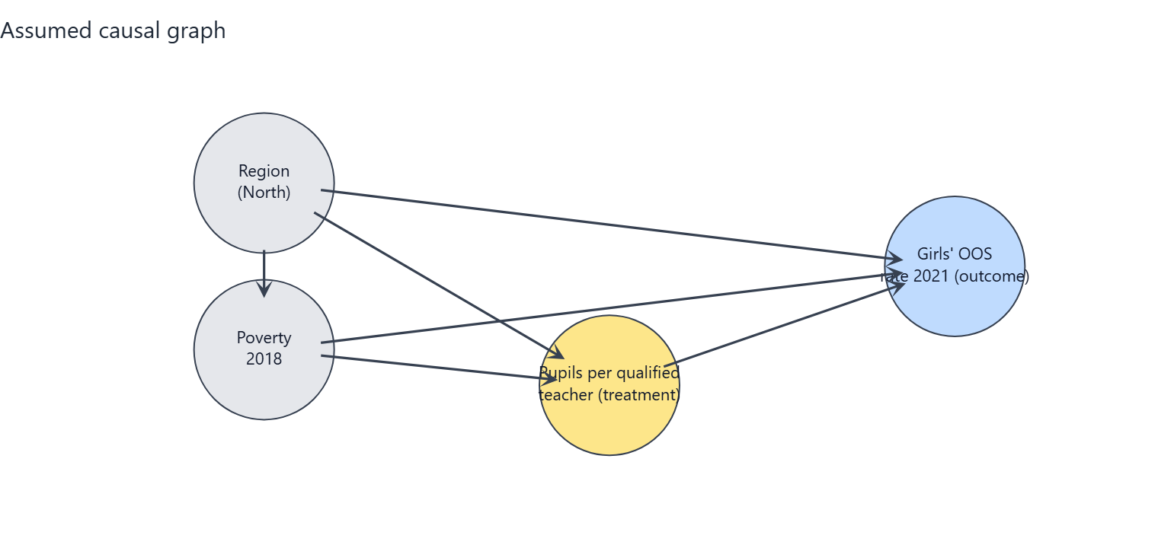
Figure 8.1: Screenshot of the portal's identifying DAG for this combination. Every circle and arrow is explained in the table beneath.
Element (in the chart) | What it is | Plain-English meaning
log_pqtr (amber circle) | Treatment | Average number of pupils in a state's public primary schools per qualified teacher, 2016/17 (log scale). Higher = fewer qualified teachers relative to pupils.
oos_female_2021 (blue circle) | Outcome | The share of primary-school-age girls who are not in school (2021). This is what we want to change.
pov_215 (grey circle) | Measured confounder | The share of the state population living on less than $2.15 per day (2018). Poorer states have more pupils per qualified teacher and higher OOS rates, so it must be held constant.
north (grey circle) | Measured confounder | A flag for whether the state is in the North (1) or South (0). Northern states differ systematically in education infrastructure, poverty and OOS rates, so it must be held constant.

Arrow | What it represents | Plain-English meaning
pov_215 -> log_pqtr | Confounding path into treatment | Poverty pushes the pupil-per-teacher ratio (e.g. poorer or more northern states staff schools differently).
pov_215 -> oos_female_2021 | Confounding path into outcome | Poverty also drives OOS rates directly (e.g. via household resources), independently of teacher supply.
north -> log_pqtr | Confounding path into treatment | Region pushes the pupil-per-teacher ratio (e.g. poorer or more northern states staff schools differently).
north -> oos_female_2021 | Confounding path into outcome | Region also drives OOS rates directly (e.g. via household resources), independently of teacher supply.
north -> pov_215 | Confounder-to-confounder path | Northern states are on average poorer, so region partly causes poverty; poverty is therefore the deeper control variable.
log_pqtr -> oos_female_2021 | The arrow of interest | After holding the confounders constant, this is the estimated effect of teacher supply on the OOS rate - the quantity the analysis estimates.

Assumed causal graph with an unmeasured common cause (threat DAG) - extra elements
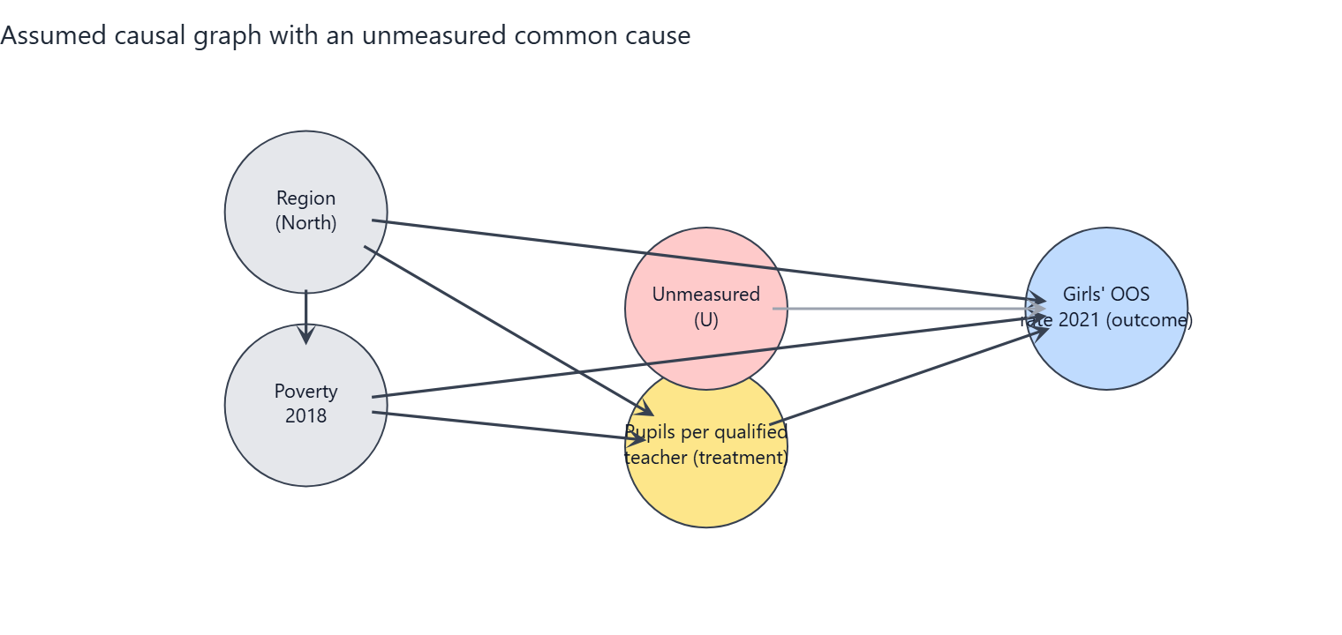
Figure 8.2: Screenshot of the portal's threat DAG. The red circle U is a stand-in for everything unmeasured; its dashed red arrows are the paths the observed data cannot block.
Element (in the chart) | What it is | Plain-English meaning
U (red circle, dashed border) | Unmeasured confounder | A stand-in for everything unobserved that raises or lowers both teacher supply and OOS rates: state governance capacity, conflict and insecurity, cultural attitudes to schooling, school construction funding.
U --> log_pqtr (dashed red arrow) | Unmeasured path into treatment | Better-governed states also attract and retain more qualified teachers, they are not purely set by poverty and region.
U --> oos_female_2021 (dashed red arrow) | Unmeasured path into outcome | The same governance/attitude factors also move OOS rates on their own.
What changes vs. Graph 1 | Non-identifiability | With U present, adjusting for the observed confounders is no longer sufficient to isolate the causal effect; the estimate can be biased up or down by an unknown amount. This is the honest limit of the study design.
What it means for the reader | Interpret with care | Graph 1 is the best-case assumption (conditional ignorability). The sensitivity analysis in this section quantifies in partial R-squared terms how strong U would have to be to overturn the conclusion.

Assumptions the conclusion depends on
- A1 Conditional ignorability: given poverty (2018) and region, states' PQTR is as good as randomly assigned with respect to potential OOS outcomes (no unmeasured common causes).
- A2 Positivity/overlap: states with similar poverty and region show a range of PQTR values (checked with overlap diagnostics).
- A3 Consistency / SUTVA: no spillovers of teachers or pupils between states; 'a 10% lower PQTR' is a well-defined intervention.
- A4 Temporal order: PQTR (2016/17) precedes the outcome (2021); poverty (2018) is treated as pre-treatment although it could be partly shaped by earlier schooling (tested by dropping it).
- A5 Functional form: the effect is linear in log(PQTR) and additive in the confounders (tested with alternative forms and DML).
- A6 Measurement: PQTR from the Digest and OOS from MICS are measured without systematic error related to the other variable (administrative reporting errors are documented and the worst rows excluded).
- A7 Excluded variables: private-school share and enrolment rates are possible mediators/colliders and are deliberately NOT adjusted for.

Analysis results

Estimates of the effect
Estimator | Effect size (pp per 10% PQTR reduction) | 95% interval (pp) | p-value | Notes
Regression adjustment (OLS, HC3 robust SE, t-interval) | -0.43 pp | -1.35 to +0.50 | p = 0.354 | Primary estimate
GPS-weighted regression (stabilised weights truncated 5/95, outcome model adjusted) | -0.36 pp | -1.46 to +0.24 |  | Percentile bootstrap CI (300 resamples, GPS re-estimated). ESS=25.9 of 31.
Double/debiased ML (EconML LinearDML, RF nuisance, 5-fold x3) | -0.07 pp | -0.63 to +0.49 | p = 0.799 | Median over repeated cross-fits; t-quantile interval (n is small, so the interval is approximate and probably too narrow).
Unadjusted association (for comparison only - NOT a causal estimate) | -1.78 pp | -2.87 to -0.70 | p = 0.002

Reminder: a p-value below 0.05 suggests the result is unlikely to be due to chance alone. All effect sizes are percentage-point (pp) changes in the OOS rate per 10% reduction in PQTR.
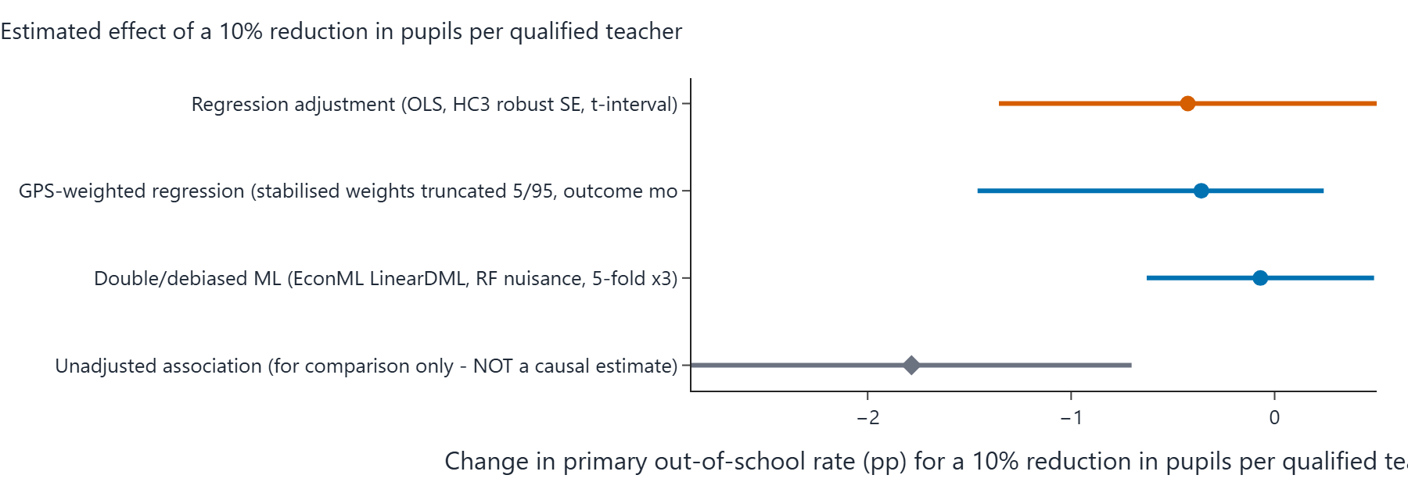
Figure 8.3: Screenshot of the portal's forest plot - rounded effect estimate and 95% interval for each estimator in the table above, on a common percentage-point scale.

Sensitivity analysis (How wrong could this be?)
An omitted confounder explaining 17.6% of the residual variance of BOTH PQTR and the OOS rate (partial R^2) would be enough to reduce the point estimate to zero. The adjusted estimate is already statistically insignificant at 5%, so no additional confounding is needed for that. The observed confounders have partial R^2 with the outcome of pov_215: 20.1%, north: 8.1% (benchmarks).
Benchmark confounder | Partial R-squared with the outcome | Partial R-squared with the treatment
pov_215 | 20.1% | 9.8%
north | 8.1% | 3.1%

How to read it: if an unmeasured factor were correlated with PQTR and the OOS rate at a partial R-squared larger than the robustness value (RV) above, it could erase the point estimate. The observed confounders themselves provide a scale on the benchmark table.

Robustness across specifications
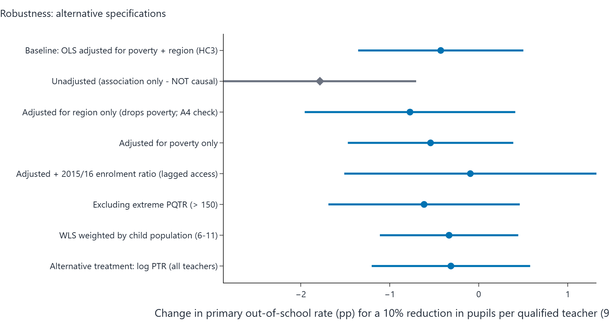
Figure 8.4: Screenshot of the portal's specification curve - the effect of a 10% PQTR reduction for every robustness row in the table beneath, sorted by estimate.
Specification | Effect size (pp per 10% PQTR reduction) | 95% interval (pp) | p-value
Baseline: OLS adjusted for poverty + region (HC3) | -0.43 pp | -1.35 to +0.50 | 0.354
Unadjusted (association only - NOT causal) | -1.78 pp | -2.87 to -0.70 | 0.002
Adjusted for region only (drops poverty; A4 check) | -0.77 pp | -1.96 to +0.41 | 0.192
Adjusted for poverty only | -0.54 pp | -1.47 to +0.39 | 0.243
Adjusted + 2015/16 enrolment ratio (lagged access) | -0.09 pp | -1.51 to +1.32 | 0.892
Excluding extreme PQTR (> 150) | -0.61 pp | -1.69 to +0.46 | 0.251
WLS weighted by child population (6-11) | -0.33 pp | -1.11 to +0.44 | 0.387
Alternative treatment: log PTR (all teachers) | -0.31 pp | -1.20 to +0.58 | 0.478

Alternative treatment scale: measured on the raw pupil count (not the log), each extra 10 pupils per qualified teacher is associated with about +0.20 pp (95% interval from -1.42 to +1.82), from the same specification family.
Bounded-outcome form: a fractional logit on the school-share scale gives an average effect of -0.34 pp per 10% PQTR reduction (p = 0.235), reassuring that conclusions do not hinge on the linear-percentage-point model.
Stability check: dropping each state once moves the estimated effect between +2.85 pp (lowest when leaving Yobe out) and +6.94 pp (highest when leaving Nasarawa out). Sign changes across the leave-one-out estimates: no.
Interval cross-checks: pairs bootstrap gives -3.33 to +13.82 pp (300 valid resamples); a (Freedman-Lane) permutation test puts the chance-only p at 0.304.

Predictive-model charts (NOT causal evidence)
These two charts appear on every portal run page and summarise the machine-learning predictive layer of the analysis, which is entirely separate from the causal estimate above. A feature that predicts the OOS rate well is not necessarily a cause of it: importance and prediction error describe association in the sample. They are included here for completeness, clearly labelled so they cannot be mistaken for causal results.
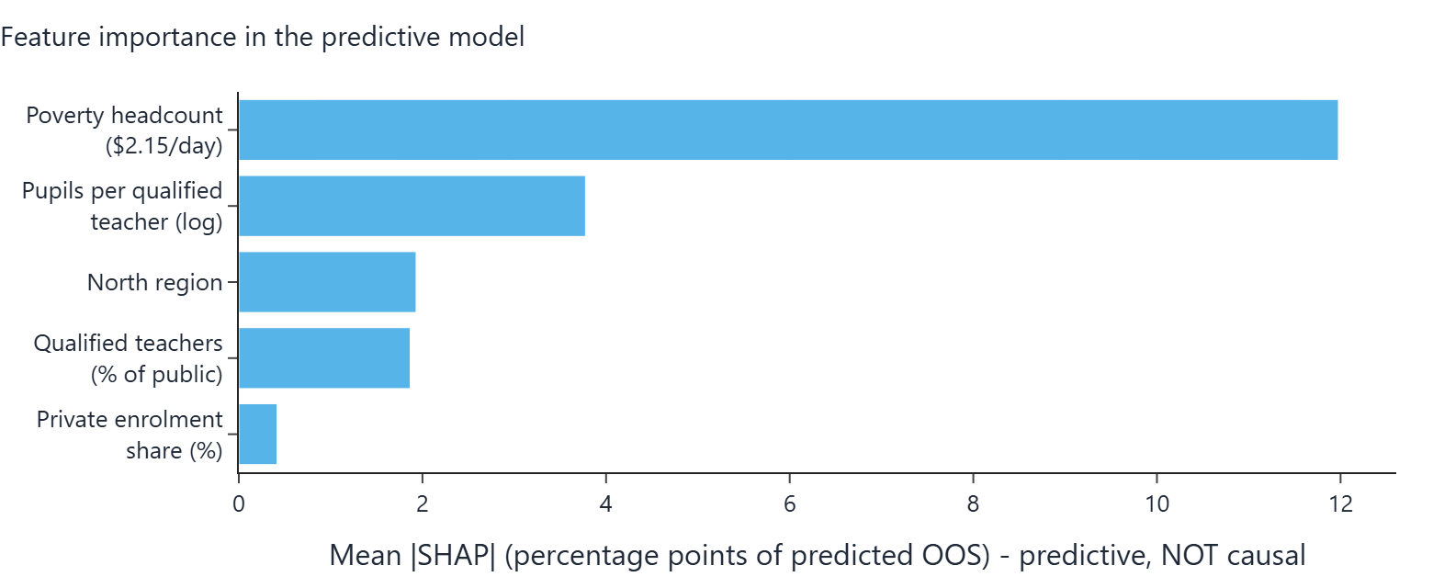
Figure 8.5: Screenshot of the portal's feature-importance chart - mean absolute SHAP value of each feature in the predictive model. High importance is not a causal claim.
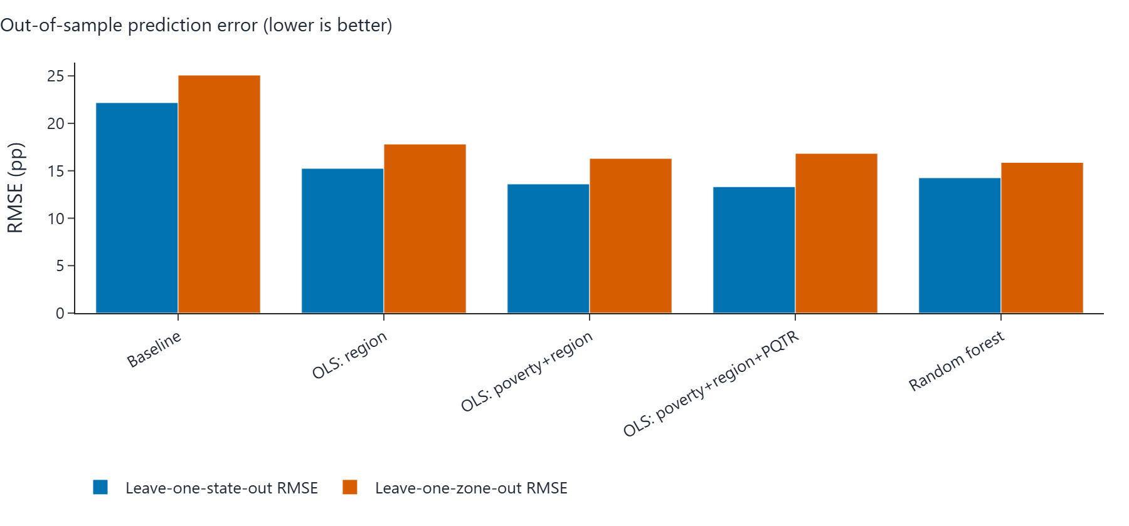
Figure 8.6: Screenshot of the portal's prediction-error chart - out-of-sample RMSE in pp per model. Prediction accuracy says nothing about the causal direction of any relationship.

Verdict (in plain words)
Verdict band: AMBER (inconclusive): the data cannot separate 'no effect' from effects of modest size.
Under assumptions A1-A7, the regression-adjusted estimate is that a 10% reduction in pupils per qualified teacher changes a state's primary out-of-school rate by -0.43 percentage points (95% interval -1.35 to +0.50), n = 31 states.
The unadjusted association is much larger (-1.78 pp per 10% reduction) because states with high PQTR are also poorer and mostly in the North; most of that raw association is explained by poverty and region.
Every adjusted estimator gives an interval that includes zero: the data are CONSISTENT WITH both no effect and effects of modest size, and cannot distinguish them.
Sensitivity: an unmeasured confounder would need a partial R^2 of about 18% with both PQTR and the outcome to explain the point estimate away (RV); this is a measure of fragility, not evidence of causation.

Caveats carried through from the engine:
- Only 31 states are available: intervals are wide and estimates unstable.
- Cross-sectional design: results are adjusted associations interpreted causally only under assumptions A1-A7.

9. Girls vs. Region Only
Item | Value
Section | Primary OOS rate, girls - adjusted for Region only
Outcome variable (state-level, 2021) | oos_female_2021
Treatment variable | log_pqtr
Confounders in the adjustment set | north
States in the sample (n) | 31
Diagnostic detail / settings | Generalised results use 300 bootstrap resamples, 30 refutation simulations, 3 DML cross-fit repeats

Causal graphs

Assumed causal graph (identifying DAG) - elements
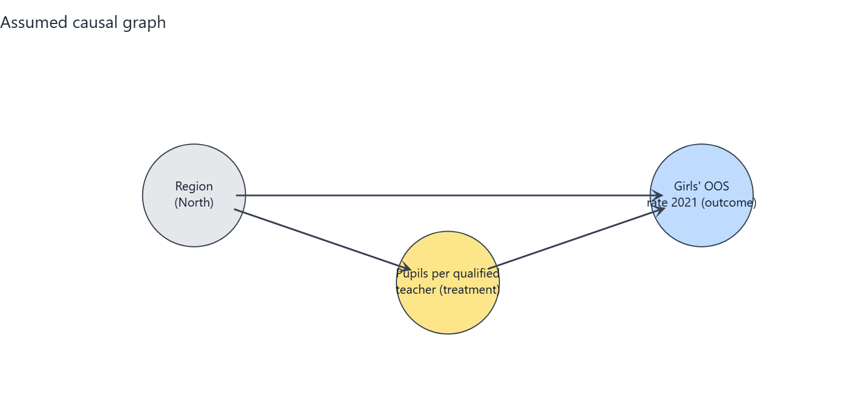
Figure 9.1: Screenshot of the portal's identifying DAG for this combination. Every circle and arrow is explained in the table beneath.
Element (in the chart) | What it is | Plain-English meaning
log_pqtr (amber circle) | Treatment | Average number of pupils in a state's public primary schools per qualified teacher, 2016/17 (log scale). Higher = fewer qualified teachers relative to pupils.
oos_female_2021 (blue circle) | Outcome | The share of primary-school-age girls who are not in school (2021). This is what we want to change.
north (grey circle) | Measured confounder | A flag for whether the state is in the North (1) or South (0). Northern states differ systematically in education infrastructure, poverty and OOS rates, so it must be held constant.

Arrow | What it represents | Plain-English meaning
north -> log_pqtr | Confounding path into treatment | Region pushes the pupil-per-teacher ratio (e.g. poorer or more northern states staff schools differently).
north -> oos_female_2021 | Confounding path into outcome | Region also drives OOS rates directly (e.g. via household resources), independently of teacher supply.
log_pqtr -> oos_female_2021 | The arrow of interest | After holding the confounders constant, this is the estimated effect of teacher supply on the OOS rate - the quantity the analysis estimates.

Assumed causal graph with an unmeasured common cause (threat DAG) - extra elements
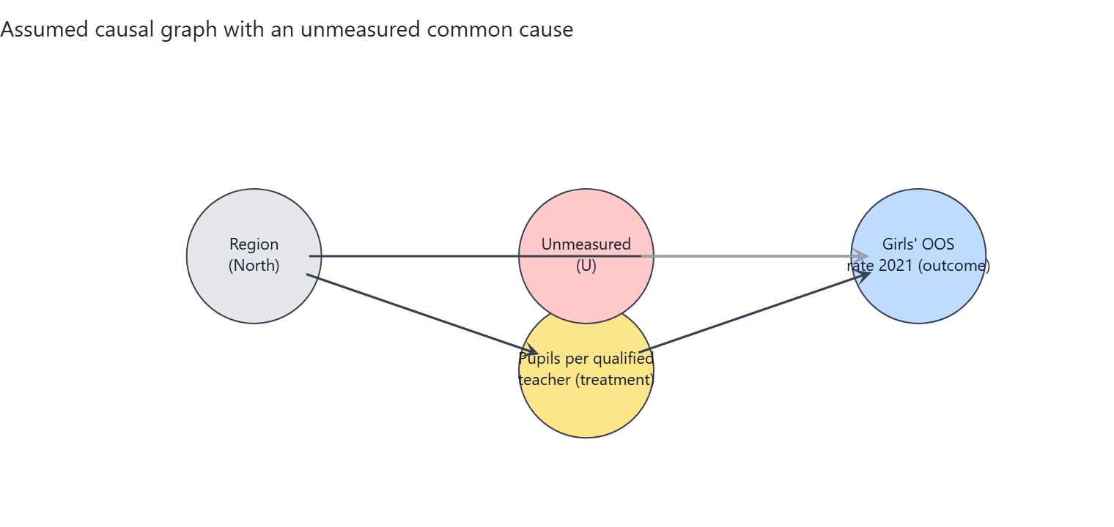
Figure 9.2: Screenshot of the portal's threat DAG. The red circle U is a stand-in for everything unmeasured; its dashed red arrows are the paths the observed data cannot block.
Element (in the chart) | What it is | Plain-English meaning
U (red circle, dashed border) | Unmeasured confounder | A stand-in for everything unobserved that raises or lowers both teacher supply and OOS rates: state governance capacity, conflict and insecurity, cultural attitudes to schooling, school construction funding.
U --> log_pqtr (dashed red arrow) | Unmeasured path into treatment | Better-governed states also attract and retain more qualified teachers, they are not purely set by poverty and region.
U --> oos_female_2021 (dashed red arrow) | Unmeasured path into outcome | The same governance/attitude factors also move OOS rates on their own.
What changes vs. Graph 1 | Non-identifiability | With U present, adjusting for the observed confounders is no longer sufficient to isolate the causal effect; the estimate can be biased up or down by an unknown amount. This is the honest limit of the study design.
What it means for the reader | Interpret with care | Graph 1 is the best-case assumption (conditional ignorability). The sensitivity analysis in this section quantifies in partial R-squared terms how strong U would have to be to overturn the conclusion.

Assumptions the conclusion depends on
- A1 Conditional ignorability: given poverty (2018) and region, states' PQTR is as good as randomly assigned with respect to potential OOS outcomes (no unmeasured common causes).
- A2 Positivity/overlap: states with similar poverty and region show a range of PQTR values (checked with overlap diagnostics).
- A3 Consistency / SUTVA: no spillovers of teachers or pupils between states; 'a 10% lower PQTR' is a well-defined intervention.
- A4 Temporal order: PQTR (2016/17) precedes the outcome (2021); poverty (2018) is treated as pre-treatment although it could be partly shaped by earlier schooling (tested by dropping it).
- A5 Functional form: the effect is linear in log(PQTR) and additive in the confounders (tested with alternative forms and DML).
- A6 Measurement: PQTR from the Digest and OOS from MICS are measured without systematic error related to the other variable (administrative reporting errors are documented and the worst rows excluded).
- A7 Excluded variables: private-school share and enrolment rates are possible mediators/colliders and are deliberately NOT adjusted for.

Analysis results

Estimates of the effect
Estimator | Effect size (pp per 10% PQTR reduction) | 95% interval (pp) | p-value | Notes
Regression adjustment (OLS, HC3 robust SE, t-interval) | -0.77 pp | -1.96 to +0.41 | p = 0.192 | Primary estimate
GPS-weighted regression (stabilised weights truncated 5/95, outcome model adjusted) | -0.97 pp | -2.27 to -0.10 |  | Percentile bootstrap CI (300 resamples, GPS re-estimated). ESS=24.0 of 31.
Double/debiased ML (EconML LinearDML, RF nuisance, 5-fold x3) | -0.71 pp | -1.68 to +0.27 | p = 0.151 | Median over repeated cross-fits; t-quantile interval (n is small, so the interval is approximate and probably too narrow).
Unadjusted association (for comparison only - NOT a causal estimate) | -1.78 pp | -2.87 to -0.70 | p = 0.002

Reminder: a p-value below 0.05 suggests the result is unlikely to be due to chance alone. All effect sizes are percentage-point (pp) changes in the OOS rate per 10% reduction in PQTR.
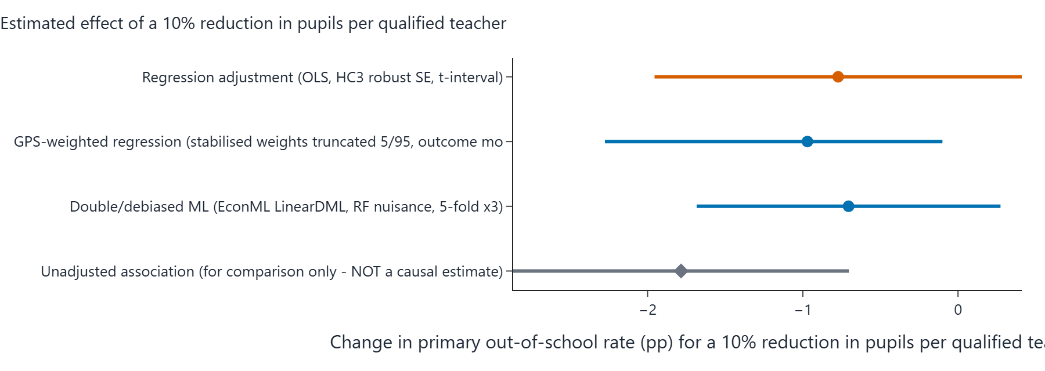
Figure 9.3: Screenshot of the portal's forest plot - rounded effect estimate and 95% interval for each estimator in the table above, on a common percentage-point scale.

Sensitivity analysis (How wrong could this be?)
An omitted confounder explaining 28.1% of the residual variance of BOTH PQTR and the OOS rate (partial R^2) would be enough to reduce the point estimate to zero. The adjusted estimate is already statistically insignificant at 5%, so no additional confounding is needed for that. The observed confounders have partial R^2 with the outcome of north: 37.7% (benchmarks).
Benchmark confounder | Partial R-squared with the outcome | Partial R-squared with the treatment
north | 37.7% | 31.1%

How to read it: if an unmeasured factor were correlated with PQTR and the OOS rate at a partial R-squared larger than the robustness value (RV) above, it could erase the point estimate. The observed confounders themselves provide a scale on the benchmark table.

Robustness across specifications
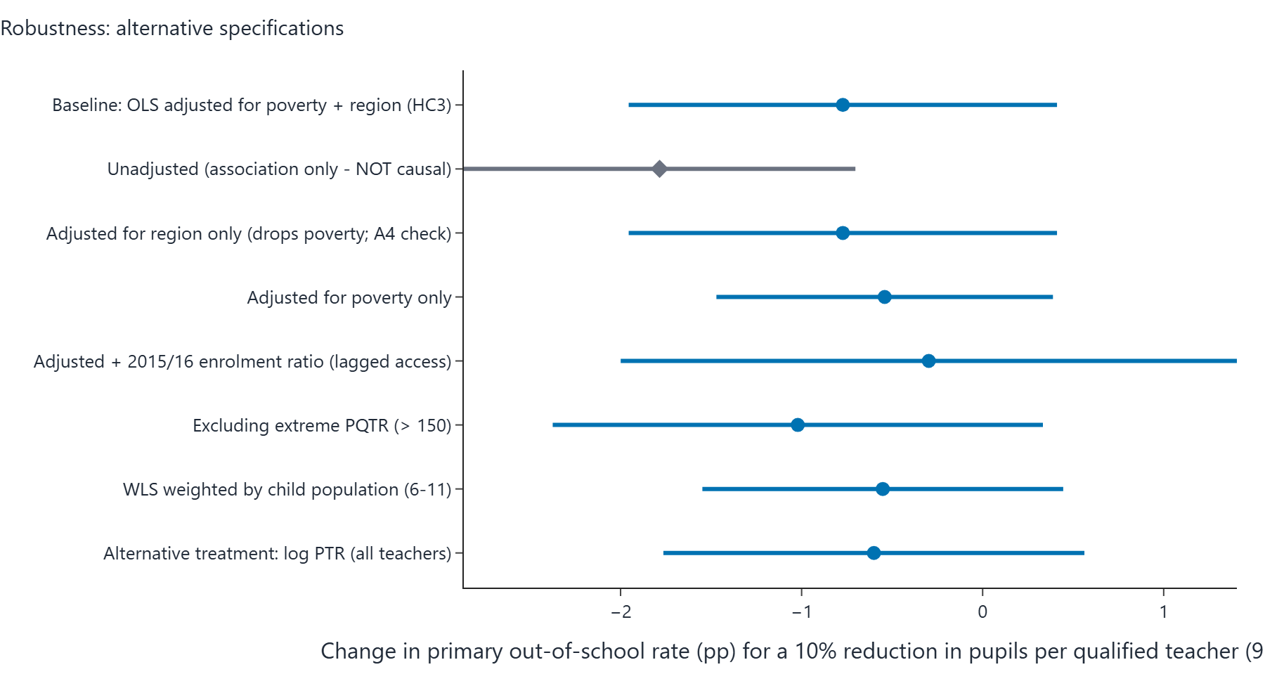
Figure 9.4: Screenshot of the portal's specification curve - the effect of a 10% PQTR reduction for every robustness row in the table beneath, sorted by estimate.
Specification | Effect size (pp per 10% PQTR reduction) | 95% interval (pp) | p-value
Baseline: OLS adjusted for poverty + region (HC3) | -0.77 pp | -1.96 to +0.41 | 0.192
Unadjusted (association only - NOT causal) | -1.78 pp | -2.87 to -0.70 | 0.002
Adjusted for region only (drops poverty; A4 check) | -0.77 pp | -1.96 to +0.41 | 0.192
Adjusted for poverty only | -0.54 pp | -1.47 to +0.39 | 0.243
Adjusted + 2015/16 enrolment ratio (lagged access) | -0.30 pp | -2.00 to +1.40 | 0.721
Excluding extreme PQTR (> 150) | -1.02 pp | -2.37 to +0.33 | 0.133
WLS weighted by child population (6-11) | -0.55 pp | -1.55 to +0.45 | 0.267
Alternative treatment: log PTR (all teachers) | -0.60 pp | -1.76 to +0.56 | 0.299

Alternative treatment scale: measured on the raw pupil count (not the log), each extra 10 pupils per qualified teacher is associated with about +0.51 pp (95% interval from -1.64 to +2.67), from the same specification family.
Bounded-outcome form: a fractional logit on the school-share scale gives an average effect of -0.65 pp per 10% PQTR reduction (p = 0.092), reassuring that conclusions do not hinge on the linear-percentage-point model.
Stability check: dropping each state once moves the estimated effect between +5.10 pp (lowest when leaving FCT out) and +10.70 pp (highest when leaving Nasarawa out). Sign changes across the leave-one-out estimates: no.
Interval cross-checks: pairs bootstrap gives -2.67 to +18.83 pp (300 valid resamples); a (Freedman-Lane) permutation test puts the chance-only p at 0.084.

Predictive-model charts (NOT causal evidence)
These two charts appear on every portal run page and summarise the machine-learning predictive layer of the analysis, which is entirely separate from the causal estimate above. A feature that predicts the OOS rate well is not necessarily a cause of it: importance and prediction error describe association in the sample. They are included here for completeness, clearly labelled so they cannot be mistaken for causal results.
Figure 9.5: Screenshot of the portal's feature-importance chart - mean absolute SHAP value of each feature in the predictive model. High importance is not a causal claim.
Figure 9.6: Screenshot of the portal's prediction-error chart - out-of-sample RMSE in pp per model. Prediction accuracy says nothing about the causal direction of any relationship.

Verdict (in plain words)
Verdict band: AMBER (inconclusive): the data cannot separate 'no effect' from effects of modest size.
Under assumptions A1-A7, the regression-adjusted estimate is that a 10% reduction in pupils per qualified teacher changes a state's primary out-of-school rate by -0.77 percentage points (95% interval -1.96 to +0.41), n = 31 states.
The unadjusted association is much larger (-1.78 pp per 10% reduction) because states with high PQTR are also poorer and mostly in the North; most of that raw association is explained by poverty and region.
Sensitivity: an unmeasured confounder would need a partial R^2 of about 28% with both PQTR and the outcome to explain the point estimate away (RV); this is a measure of fragility, not evidence of causation.

Caveats carried through from the engine:
- Only 31 states are available: intervals are wide and estimates unstable.
- Cross-sectional design: results are adjusted associations interpreted causally only under assumptions A1-A7.

10. Girls vs. Poverty Only
Item | Value
Section | Primary OOS rate, girls - adjusted for Poverty only
Outcome variable (state-level, 2021) | oos_female_2021
Treatment variable | log_pqtr
Confounders in the adjustment set | pov_215
States in the sample (n) | 31
Diagnostic detail / settings | Generalised results use 300 bootstrap resamples, 30 refutation simulations, 3 DML cross-fit repeats

Causal graphs

Assumed causal graph (identifying DAG) - elements
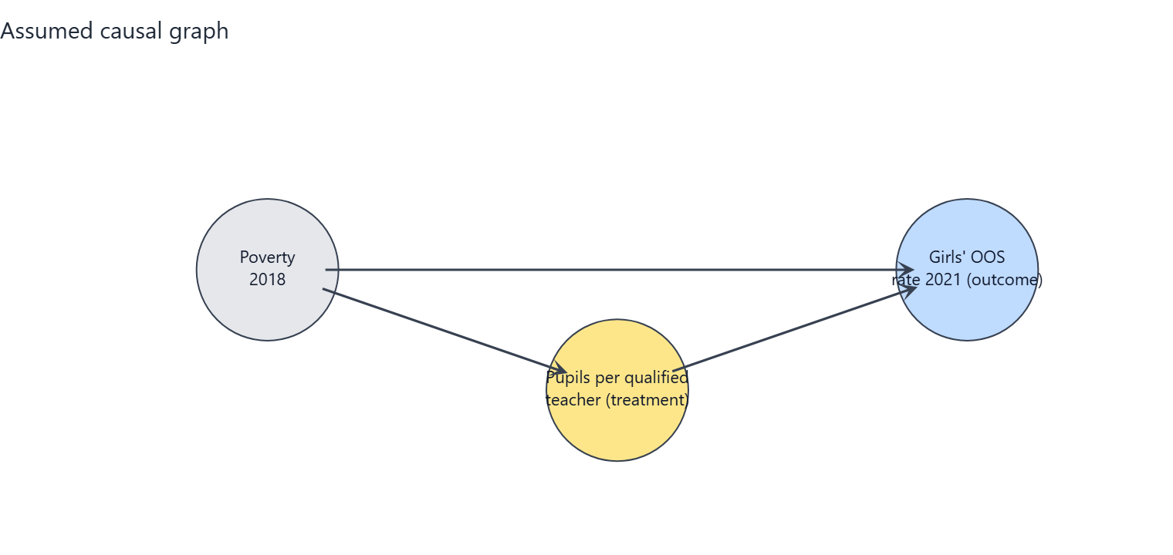
Figure 10.1: Screenshot of the portal's identifying DAG for this combination. Every circle and arrow is explained in the table beneath.
Element (in the chart) | What it is | Plain-English meaning
log_pqtr (amber circle) | Treatment | Average number of pupils in a state's public primary schools per qualified teacher, 2016/17 (log scale). Higher = fewer qualified teachers relative to pupils.
oos_female_2021 (blue circle) | Outcome | The share of primary-school-age girls who are not in school (2021). This is what we want to change.
pov_215 (grey circle) | Measured confounder | The share of the state population living on less than $2.15 per day (2018). Poorer states have more pupils per qualified teacher and higher OOS rates, so it must be held constant.

Arrow | What it represents | Plain-English meaning
pov_215 -> log_pqtr | Confounding path into treatment | Poverty pushes the pupil-per-teacher ratio (e.g. poorer or more northern states staff schools differently).
pov_215 -> oos_female_2021 | Confounding path into outcome | Poverty also drives OOS rates directly (e.g. via household resources), independently of teacher supply.
log_pqtr -> oos_female_2021 | The arrow of interest | After holding the confounders constant, this is the estimated effect of teacher supply on the OOS rate - the quantity the analysis estimates.

Assumed causal graph with an unmeasured common cause (threat DAG) - extra elements
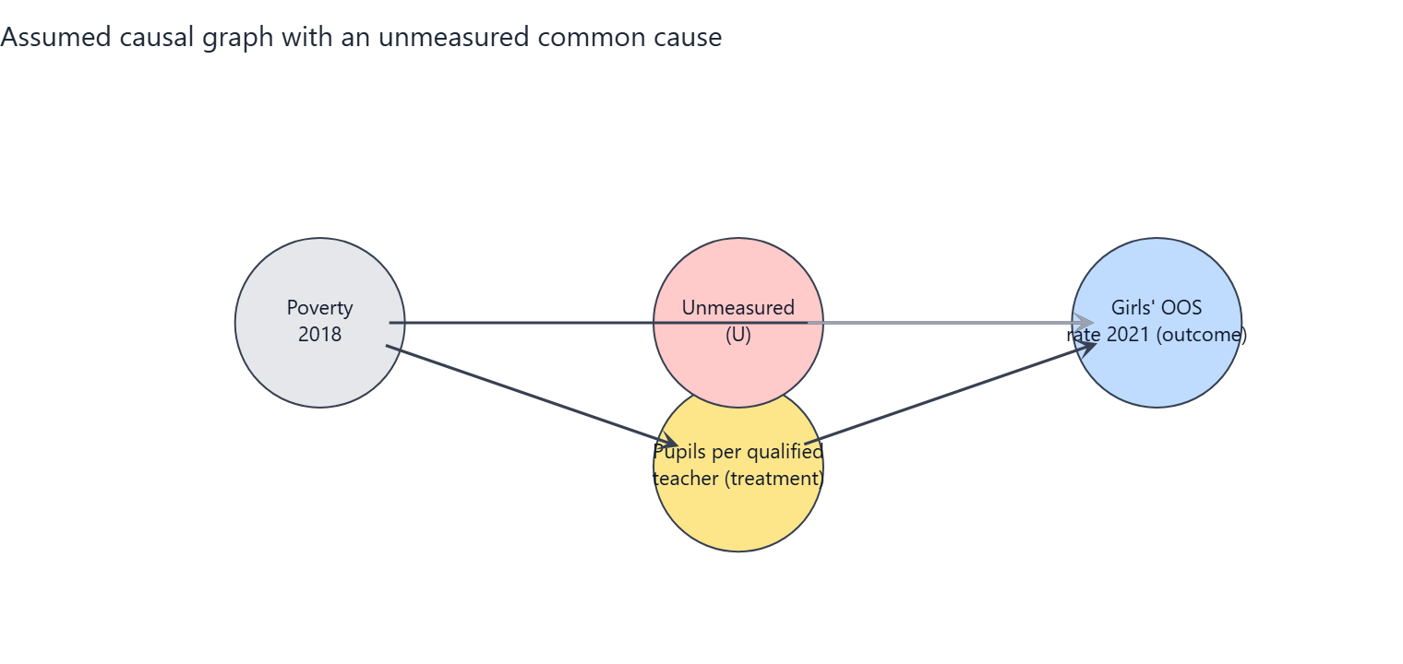
Figure 10.2: Screenshot of the portal's threat DAG. The red circle U is a stand-in for everything unmeasured; its dashed red arrows are the paths the observed data cannot block.
Element (in the chart) | What it is | Plain-English meaning
U (red circle, dashed border) | Unmeasured confounder | A stand-in for everything unobserved that raises or lowers both teacher supply and OOS rates: state governance capacity, conflict and insecurity, cultural attitudes to schooling, school construction funding.
U --> log_pqtr (dashed red arrow) | Unmeasured path into treatment | Better-governed states also attract and retain more qualified teachers, they are not purely set by poverty and region.
U --> oos_female_2021 (dashed red arrow) | Unmeasured path into outcome | The same governance/attitude factors also move OOS rates on their own.
What changes vs. Graph 1 | Non-identifiability | With U present, adjusting for the observed confounders is no longer sufficient to isolate the causal effect; the estimate can be biased up or down by an unknown amount. This is the honest limit of the study design.
What it means for the reader | Interpret with care | Graph 1 is the best-case assumption (conditional ignorability). The sensitivity analysis in this section quantifies in partial R-squared terms how strong U would have to be to overturn the conclusion.

Assumptions the conclusion depends on
- A1 Conditional ignorability: given poverty (2018) and region, states' PQTR is as good as randomly assigned with respect to potential OOS outcomes (no unmeasured common causes).
- A2 Positivity/overlap: states with similar poverty and region show a range of PQTR values (checked with overlap diagnostics).
- A3 Consistency / SUTVA: no spillovers of teachers or pupils between states; 'a 10% lower PQTR' is a well-defined intervention.
- A4 Temporal order: PQTR (2016/17) precedes the outcome (2021); poverty (2018) is treated as pre-treatment although it could be partly shaped by earlier schooling (tested by dropping it).
- A5 Functional form: the effect is linear in log(PQTR) and additive in the confounders (tested with alternative forms and DML).
- A6 Measurement: PQTR from the Digest and OOS from MICS are measured without systematic error related to the other variable (administrative reporting errors are documented and the worst rows excluded).
- A7 Excluded variables: private-school share and enrolment rates are possible mediators/colliders and are deliberately NOT adjusted for.

Analysis results

Estimates of the effect
Estimator | Effect size (pp per 10% PQTR reduction) | 95% interval (pp) | p-value | Notes
Regression adjustment (OLS, HC3 robust SE, t-interval) | -0.54 pp | -1.47 to +0.39 | p = 0.243 | Primary estimate
GPS-weighted regression (stabilised weights truncated 5/95, outcome model adjusted) | -0.39 pp | -1.52 to +0.25 |  | Percentile bootstrap CI (300 resamples, GPS re-estimated). ESS=25.7 of 31.
Double/debiased ML (EconML LinearDML, RF nuisance, 5-fold x3) | -0.06 pp | -0.63 to +0.51 | p = 0.836 | Median over repeated cross-fits; t-quantile interval (n is small, so the interval is approximate and probably too narrow).
Unadjusted association (for comparison only - NOT a causal estimate) | -1.78 pp | -2.87 to -0.70 | p = 0.002

Reminder: a p-value below 0.05 suggests the result is unlikely to be due to chance alone. All effect sizes are percentage-point (pp) changes in the OOS rate per 10% reduction in PQTR.
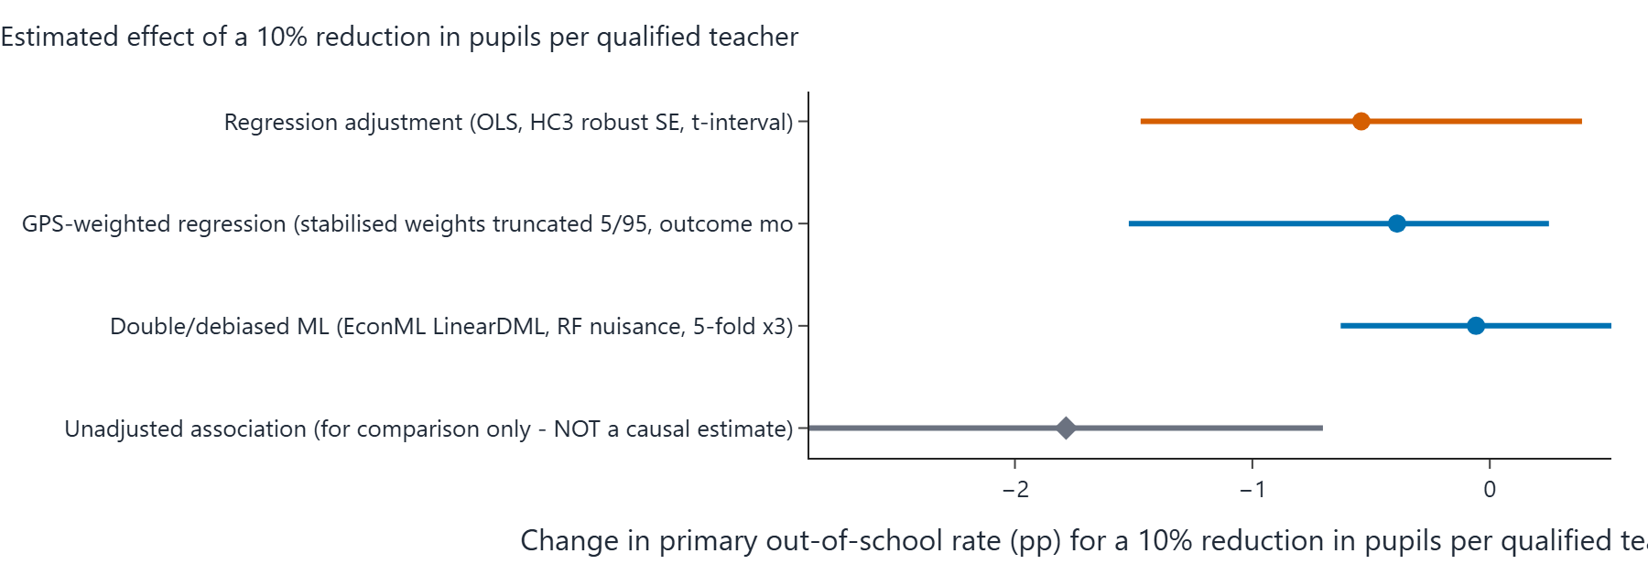
Figure 10.3: Screenshot of the portal's forest plot - rounded effect estimate and 95% interval for each estimator in the table above, on a common percentage-point scale.

Sensitivity analysis (How wrong could this be?)
An omitted confounder explaining 21.3% of the residual variance of BOTH PQTR and the OOS rate (partial R^2) would be enough to reduce the point estimate to zero. The adjusted estimate is already statistically insignificant at 5%, so no additional confounding is needed for that. The observed confounders have partial R^2 with the outcome of pov_215: 45.8% (benchmarks).
Benchmark confounder | Partial R-squared with the outcome | Partial R-squared with the treatment
pov_215 | 45.8% | 35.9%

How to read it: if an unmeasured factor were correlated with PQTR and the OOS rate at a partial R-squared larger than the robustness value (RV) above, it could erase the point estimate. The observed confounders themselves provide a scale on the benchmark table.

Robustness across specifications
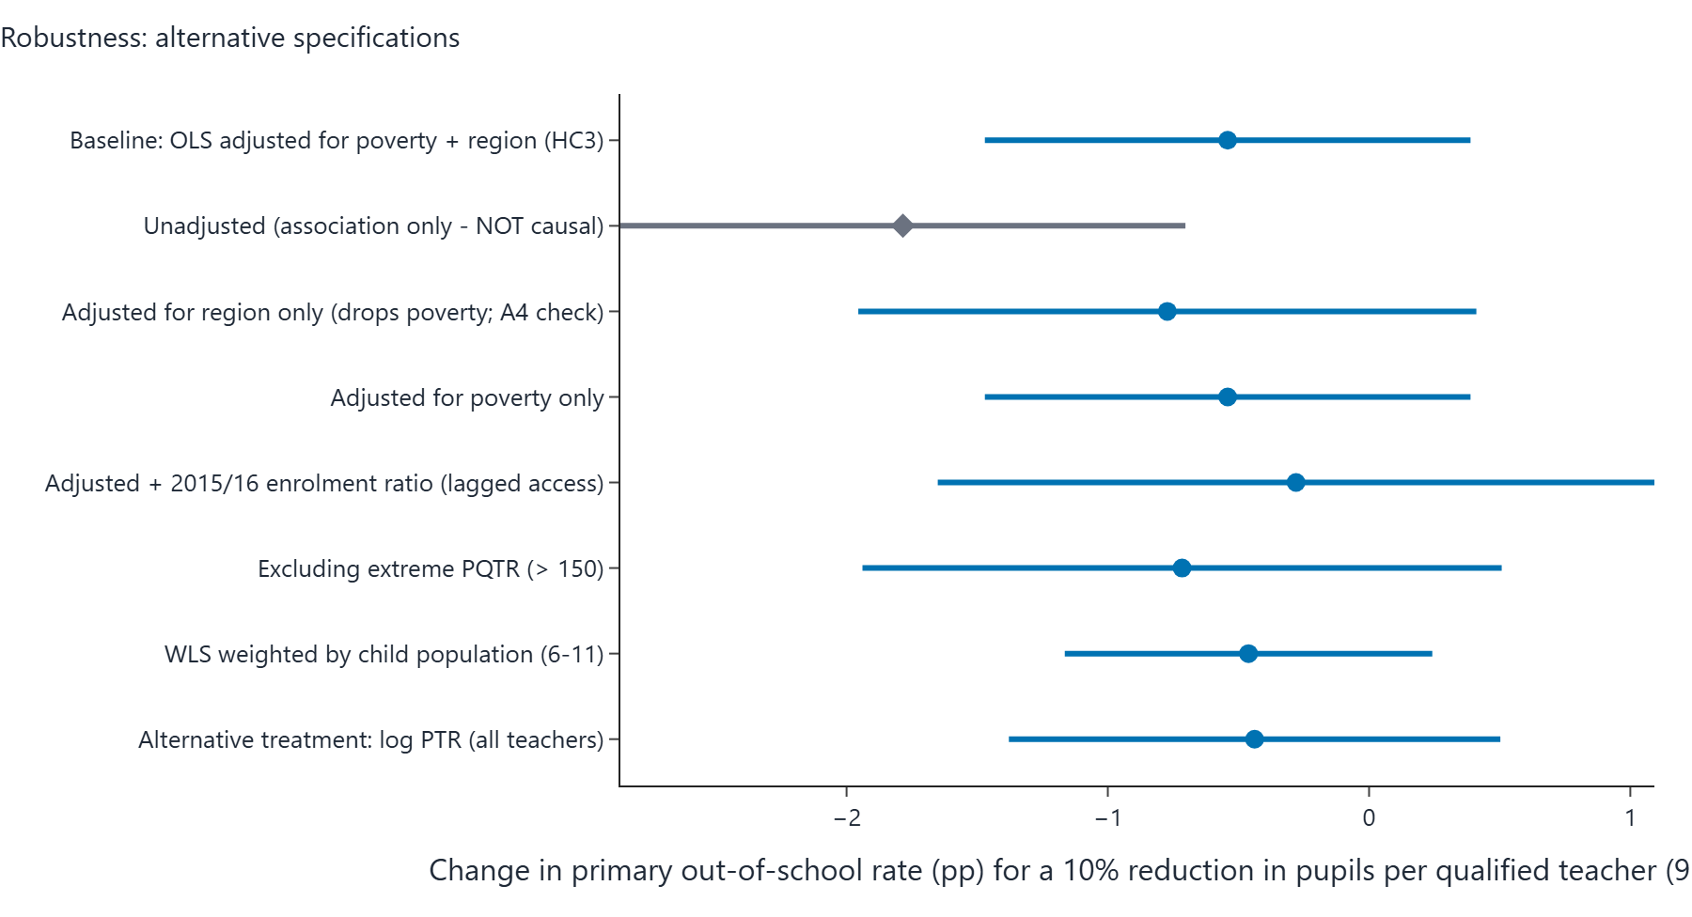
Figure 10.4: Screenshot of the portal's specification curve - the effect of a 10% PQTR reduction for every robustness row in the table beneath, sorted by estimate.
Specification | Effect size (pp per 10% PQTR reduction) | 95% interval (pp) | p-value
Baseline: OLS adjusted for poverty + region (HC3) | -0.54 pp | -1.47 to +0.39 | 0.243
Unadjusted (association only - NOT causal) | -1.78 pp | -2.87 to -0.70 | 0.002
Adjusted for region only (drops poverty; A4 check) | -0.77 pp | -1.96 to +0.41 | 0.192
Adjusted for poverty only | -0.54 pp | -1.47 to +0.39 | 0.243
Adjusted + 2015/16 enrolment ratio (lagged access) | -0.28 pp | -1.65 to +1.09 | 0.678
Excluding extreme PQTR (> 150) | -0.72 pp | -1.94 to +0.51 | 0.240
WLS weighted by child population (6-11) | -0.46 pp | -1.16 to +0.24 | 0.190
Alternative treatment: log PTR (all teachers) | -0.44 pp | -1.38 to +0.50 | 0.348

Alternative treatment scale: measured on the raw pupil count (not the log), each extra 10 pupils per qualified teacher is associated with about +0.30 pp (95% interval from -1.18 to +1.78), from the same specification family.
Bounded-outcome form: a fractional logit on the school-share scale gives an average effect of -0.51 pp per 10% PQTR reduction (p = 0.062), reassuring that conclusions do not hinge on the linear-percentage-point model.
Stability check: dropping each state once moves the estimated effect between +3.79 pp (lowest when leaving Ekiti out) and +7.81 pp (highest when leaving Nasarawa out). Sign changes across the leave-one-out estimates: no.
Interval cross-checks: pairs bootstrap gives -1.66 to +15.33 pp (300 valid resamples); a (Freedman-Lane) permutation test puts the chance-only p at 0.211.

Predictive-model charts (NOT causal evidence)
These two charts appear on every portal run page and summarise the machine-learning predictive layer of the analysis, which is entirely separate from the causal estimate above. A feature that predicts the OOS rate well is not necessarily a cause of it: importance and prediction error describe association in the sample. They are included here for completeness, clearly labelled so they cannot be mistaken for causal results.
Figure 10.5: Screenshot of the portal's feature-importance chart - mean absolute SHAP value of each feature in the predictive model. High importance is not a causal claim.
Figure 10.6: Screenshot of the portal's prediction-error chart - out-of-sample RMSE in pp per model. Prediction accuracy says nothing about the causal direction of any relationship.

Verdict (in plain words)
Verdict band: AMBER (inconclusive): the data cannot separate 'no effect' from effects of modest size.
Under assumptions A1-A7, the regression-adjusted estimate is that a 10% reduction in pupils per qualified teacher changes a state's primary out-of-school rate by -0.54 percentage points (95% interval -1.47 to +0.39), n = 31 states.
The unadjusted association is much larger (-1.78 pp per 10% reduction) because states with high PQTR are also poorer and mostly in the North; most of that raw association is explained by poverty and region.
Every adjusted estimator gives an interval that includes zero: the data are CONSISTENT WITH both no effect and effects of modest size, and cannot distinguish them.
Sensitivity: an unmeasured confounder would need a partial R^2 of about 21% with both PQTR and the outcome to explain the point estimate away (RV); this is a measure of fragility, not evidence of causation.

Caveats carried through from the engine:
- Only 31 states are available: intervals are wide and estimates unstable.
- Cross-sectional design: results are adjusted associations interpreted causally only under assumptions A1-A7.

Glossary of technical terms
Term | Plain-English meaning
OOS / out-of-school rate | Percentage of primary-school-age children not attending school (source: UNICEF MICS6 2021).
PQTR | Pupils per Qualified Teacher Ratio: average public primary pupils per teacher recognised as qualified (source: 2016/17 Digest).
Treatment / T | The variable whose effect we estimate: here log PQTR; moving it 10% down is the intervention being evaluated.
Outcome / Y | The variable that responds to the treatment: the OOS rate, in percentage points.
Confounder | A cause of both treatment and outcome; dropping it from the model leaves the effect estimate contaminated.
DAG (Directed Acyclic Graph) | A diagram of assumed causal directions; arrows only point forward, so there is no feedback loop in the picture.
Backdoor path | Any path from treatment to outcome that starts with an arrow into the treatment; confounder adjustment shuts it.
ATE / estimand | Average Treatment Effect: the average change in the outcome per 10% PQTR reduction across states.
Conditional ignorability (A1) | Assumes that once you compare states with the same poverty and region values, their teacher-supply differences are as good as random.
Positivity / overlap (A2) | Every combination of confounder values shows a spread of PQTR values, so regression has something to compare.
Consistency / SUTVA (A3) | People receive the treatment as defined and do not affect one another across state borders.
HC3 robust SE | A robust sandwich standard error that tolerates heteroskedasticity; HC3 is the small-sample default variant.
GPS / generalised propensity score | For a continuous treatment, the fitted T-given-confounders distribution used to reweight states.
Stabilised IP weights | Multiplicative weights correcting confounding; truncated at the 5th/95th percentile to avoid extreme reweights.
ESS (Effective Sample Size) | How many datapoints the weighted sample is effectively worth after reweighting.
DML (Double/debiased ML) | Estimation that bypasses parametric assumptions by cross-fitting machine-learnt predictions of treatment and outcome.
Cross-fitting (5-fold) | Splinter the sample into 5 folds and predict fold outcomes with models trained on the other folds.
Bootstrap percentile interval | Recompute the estimate on 1000 resampled datasets; the interval is where the middle 95% land.
p-value | How often a pure-random-data process would produce an estimate as extreme - below 0.05 flags a noteworthy result.
Partial R-squared | Share of the residual variance variable X explains after other model components (used for the sensitivity analysis).
Robustness value (RV) | The minimum partial R-squared strength with BOTH treatment and outcome an unmeasured confounder needs to null the estimate.
Leave-one-out (LOO) | Drop a state, re-estimate, repeat for every state - checks how fragile the estimate is to a single datapoint.
Fractional logit | Binomial GLM for a bounded outcome like a percentage; expressed here through its average marginal effect.
Permutation test (Freedman-Lane) | Shuffle the treatment residuals 5000 times to get a distribution of what randomness alone produces.
Sensitivity analysis (Cinelli & Hazlett) | Benchmarks how strong an unmeasured confounder would need to be to overturn the finding.
Adjusted association | The statistical relationship after controls; causal only when the identification assumptions (A1-A7) hold.

