Spectral Properties of Gene Regulatory Network Topology Provide Early Warning Signals for Critical Transitions in Cell Fate Decisions
Nikhil Saxena
Department of Computer Science, Northeastern University, Boston, MA 02115, USA
Correspondence: saxena.ni@northeastern.edu
ORCID: 0009-0004-1039-0257

Abstract
Critical transitions in biological systems, including cell fate commitment, disease onset, and developmental branching, involve abrupt shifts between stable states in gene regulatory networks. Current early warning signal (EWS) methods rely on statistical properties of gene expression (increasing variance and autocorrelation, or collective fluctuations in gene groups) but ignore the topology of the underlying regulatory network. We introduce STIGRN (Spectral Transition Indicators for Gene Regulatory Networks), five metrics derived from the Laplacian eigenvalue spectrum of time-varying gene regulatory networks inferred from single-cell transcriptomic data. On the BEELINE benchmark, STIGRN achieves an AUROC of 0.941 on the ventral spinal cord development model, compared to 0.588 for dynamic network biomarkers and 0.157 for critical slowing down. On the gonadal sex determination dataset, the only real scRNA-seq benchmark, STIGRN is the sole method to trigger an early warning signal. Applied to a model of ESC-to-primitive-endoderm differentiation, the Fiedler vector of the network Laplacian identifies Gata6, Pdgfra, and Fn1 as PrE-fate genes and Nanog, Esrrb, Klf2, and Tbx3 as pluripotency genes, recovering the known fate-decision axis without prior biological knowledge. Each method (STIGRN, DNB, CSD) achieves the highest AUROC on a different dataset, indicating that topology-based and expression-based signals detect different precursors to the same transition. Context-specific method selection based on network density outperforms naive score fusion. STIGRN is available as an open-source Python package.
Keywords: early warning signals, critical transitions, gene regulatory networks, spectral graph theory, single-cell RNA sequencing, cell fate decisions, Laplacian spectrum, Fiedler vector

1. Introduction
Biological systems undergo critical transitions during cell fate commitment, tissue development, and disease onset [1,2,3]. In the attractor landscape framework, stable cell states correspond to attractors of the gene regulatory network, and fate decisions correspond to transitions between attractors driven past a bifurcation point [4,5]. Predicting these transitions before they occur has implications for developmental biology, cancer progression, and therapeutic timing [6,7].
The dominant framework for early warning signals (EWS) is critical slowing down (CSD): as a system approaches a bifurcation, its recovery rate from perturbations decreases, producing increasing variance and autocorrelation in observed time series [1,8,9]. A mathematical treatment of this phenomenon across bifurcation classes is given by Kuehn [10]. Generic indicators of resilience loss, including variance and lag-1 autocorrelation, have been validated in experimental populations [11]. In molecular systems, CSD has been mapped to the mean-field Ising universality class for biochemical networks with feedback [12]. The dynamic network biomarker (DNB) method extends these ideas to molecular networks by identifying groups of genes whose collective fluctuations intensify near tipping points [6], with extensions for single-cell data [13] and gene expression profiles [14]. Deep learning approaches including FateNet [15] and FatePredictor [16] have integrated dynamical systems theory with neural networks to predict cell fate bifurcations from scRNA-seq pseudotime data.
All existing EWS methods operate on statistical properties of gene expression data. They treat expression values as the primary observable and ignore the topology of the regulatory network that generates those patterns. The network structure (who regulates whom, connectivity density, emerging modular substructure) encodes information about the system’s organization that should carry its own early warning signals.
Spectral graph theory provides the mathematical tools for extracting this structural information. The eigenvalue spectrum of a graph’s Laplacian matrix encodes connectivity, community structure, and information flow capacity [17,18]. The second smallest eigenvalue, the algebraic connectivity introduced by Fiedler [19], measures how well-connected the graph is, and its associated eigenvector (the Fiedler vector) defines the optimal bipartition of the network [19,20]. For diffusion dynamics on networks, the spectral gap determines the rate of convergence to equilibrium, directly analogous to CSD [21]. Spectral methods have been applied to biological networks in limited settings: entropy computation in functional digraphs of Boolean gene regulatory networks [22], attractor prediction from adjacency matrix eigenvectors [23], and threshold selection in gene co-expression networks [24]. None of this work has connected spectral properties of gene regulatory networks to approaching critical transitions.
Topology-aware early warning signals have been validated outside biology. In hydrology, network clustering coefficient and link density increased prior to climate shifts in the 1990s [25]. In financial networks, topological changes in interbank exposure networks preceded the 2008 crisis by years [26]. These results show that network structural changes carry predictive information about approaching transitions. This idea has not been applied to gene regulatory biology.
STIGRN (Spectral Transition Indicators for Gene Regulatory Networks) derives five early warning metrics from the Laplacian eigenvalue spectrum of time-varying gene regulatory networks inferred from single-cell transcriptomic data. Each metric corresponds to a distinct aspect of network reorganization: connectivity loss, regulatory mode consolidation, hub emergence, community reorganization, and modular partitioning. We validate STIGRN on synthetic networks, on the BEELINE benchmark framework [27], and on a model of mouse ESC-to-primitive-endoderm differentiation. STIGRN detects transitions that expression-based methods miss and identifies fate-determining genes via the Fiedler vector. No single method works across all systems, and context-specific selection outperforms fusion.

2. Methods

2.1 Overview
STIGRN operates in three stages (Fig. 1): partition single-cell transcriptomic data into pseudotime-ordered windows, infer a gene regulatory network within each window, and compute the Laplacian eigenvalue spectrum of each inferred GRN to extract five spectral metrics.
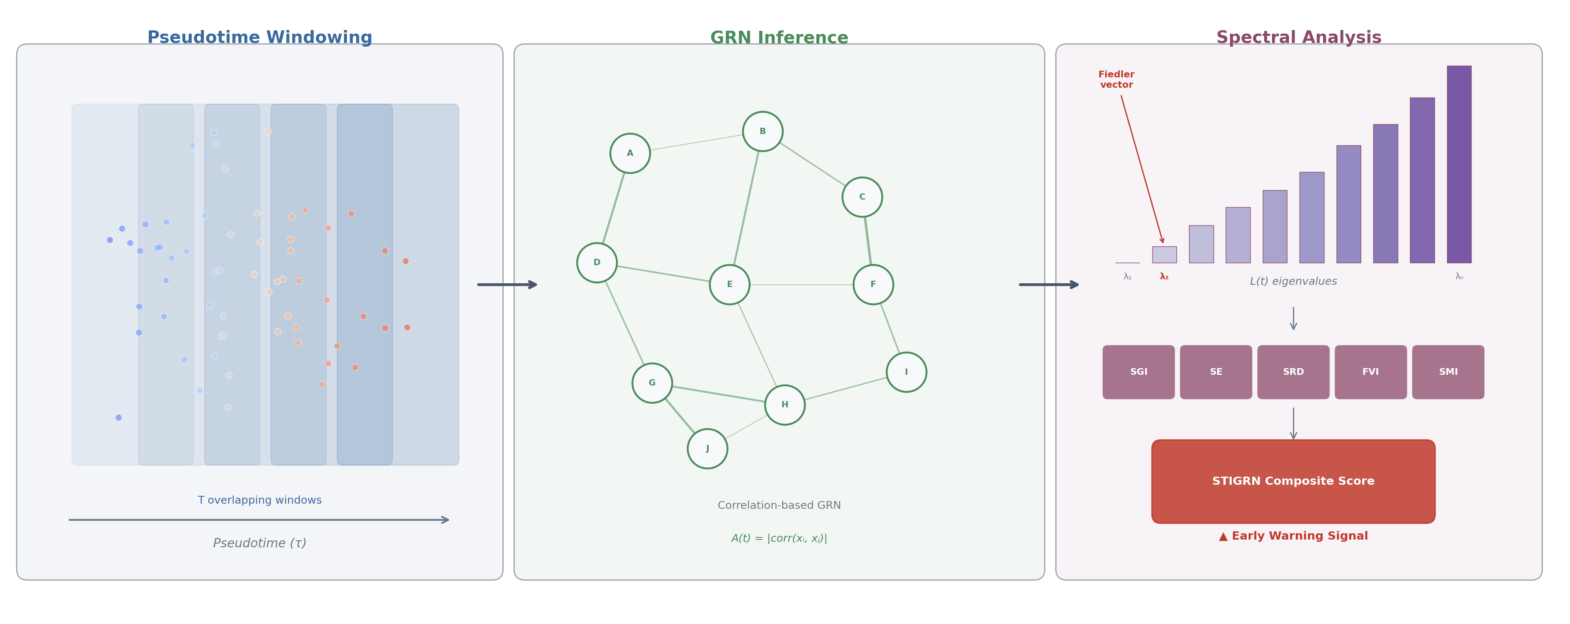
Figure 1. STIGRN framework. Single-cell RNA sequencing data are partitioned into overlapping pseudotime windows. A gene regulatory network is inferred within each window. The Laplacian eigenvalue spectrum is computed, and five metrics are extracted: SGI, SE, SRD, FVI, SMI. The composite score integrates all five into a single early warning signal.

2.2 Gene Regulatory Network Inference from Pseudotime Windows
Given an expression matrix X of dimension n_{cells} × n_{genes} and pseudotime values τ of length n_{cells}, we partition cells into T overlapping windows along pseudotime. Pseudotime values are computed upstream by trajectory inference methods such as Slingshot [28], Monocle [29], or diffusion pseudotime [30]. Window t contains all cells i satisfying |τ_{i} − c_{t}| ≤ w/2, where c_{t} is the window center and w is the window width. We use T = 20 windows with 30% overlap (25 for the mESC model), with a minimum of 15 cells per window, expanded to nearest neighbors if necessary.
Within each window, we infer a weighted adjacency matrix A(t) of dimension n_{genes} × n_{genes} using Pearson correlation with absolute-value weighting: A_{ij}(t) = |corr(x_{i,} x_j)| if |corr(x_{i,} x_j)| > 0.25, and A_{ij}(t) = 0 otherwise. Self-loops are removed. The framework also supports tree-based GRN inference via GENIE3 [31] or GRNBoost2 [32] for larger networks.

2.3 Laplacian Spectrum Computation
For each GRN snapshot A(t), we symmetrize the adjacency matrix as A_{sym}(t) = (A(t) + A(t)^{T)} / 2 and compute the degree matrix D(t) = diag(d₁, …, d_{n}) with d_{i} = Σ_{j} A_{sym,ij}(t). The normalized Laplacian is:
L(t) = I − D(t)^{−1/2} A_{sym}(t) D(t)^{−1/2}
with d_{i}^{−1/2} = 0 for zero-degree nodes. Full eigendecomposition yields eigenvalues 0 = λ₁ ≤ λ₂ ≤ … ≤ λ_{n} and corresponding eigenvectors v₁, v₂, …, v_{n}. For background on spectral methods and their relationship to graph clustering, see von Luxburg [20].

2.4 STIGRN Metric Definitions
Spectral Gap Indicator (SGI). SGI(t) = λ₂(t) / λ₂(t₀), where λ₂ is the algebraic connectivity [19]. Collapse toward zero signals network fragmentation. Decreasing SGI indicates the regulatory network is losing integrated structure as it approaches a transition.
Spectral Entropy (SE). The normalized eigenvalue distribution p_{i} = λ_{i} / Σ_{j} λ_j (for λ_{i} > 0) gives Shannon entropy SE(t) = −Σ_i p_{i} log₂(p_{i}) / log₂(N_{eff}), normalized to [0, 1]. High entropy indicates distributed regulation across many modes. Declining entropy indicates consolidation of regulatory control into fewer modes.
Spectral Radius Divergence (SRD). SRD(t) = λ_{max}(t) / mean(λ_{i}) for nontrivial eigenvalues. Increasing SRD indicates one structural mode is dominating the spectrum, corresponding to the emergence of a dominant regulatory hub.
Fiedler Vector Instability (FVI). FVI(t) = 1 − |cos(v₂(t), v₂(t−1))|, where v₂ is the Fiedler vector [19]. Since the Fiedler vector defines the optimal bipartition of the network, rapid changes in its orientation indicate the network’s community structure is being reorganized. Absolute cosine similarity handles eigenvector sign ambiguity.
Spectral Modularity Index (SMI). SMI(t) = max(Δλ_{k}) / mean(Δλ_{k}), where Δλ_{k} = λ_{k+1} − λ_{k} are consecutive eigenvalue gaps. Increasing SMI signals the emergence of modular structure: the network is partitioning into distinct regulatory programs.

2.5 Composite Score and Warning Detection
The composite STIGRN score is the equally-weighted average of z-scored individual metrics, with SGI and SE negated so that increasing values indicate an approaching transition:
STIGRN_composite(t) = (1/5) Σ_{m ∈ M} sign_{m} × (m(t) − μ_{m}) / σ_{m}
where sign_{m} = −1 for SGI and SE, +1 for SRD, FVI, and SMI. A warning is triggered when the composite exceeds 1.5 standard deviations above its mean for at least two consecutive windows.

2.6 Fiedler Vector Gene Ranking
The Fiedler vector v₂ at each timepoint partitions genes into positive-component and negative-component groups, corresponding to the optimal spectral bipartition [19,20]. Genes with the largest |v_{2,i}| sit at the extremes of the partition and are candidates for fate-determining regulators.

2.7 Baseline Methods
Critical slowing down (CSD) indicators. Mean gene-wise variance and lag-1 autocorrelation, z-scored and averaged [1,8].
Dynamic network biomarker (DNB) score. Following Chen et al. [6]: DNB = (SD_{in} × PCC_{in}) / PCC_{out}, where SD_{in} is the mean standard deviation of the top 10% most variable genes, PCC_{in} is the mean absolute pairwise correlation within this group, and PCC_{out} is the mean absolute correlation between this group and remaining genes.

2.8 Synthetic Validation Data
We generate synthetic GRN trajectories where a network of n genes splits from one community into two over pseudotime, with bifurcation at a known timepoint. Within-module edge probability increases as (1 + 0.5s) × p_{base} and between-module probability decreases as (1 − 0.8s) × p_{base}, where s ∈ [0,1] is bifurcation progress and p_{base} = 0.12. Edge weights are Uniform(0.1, 1.0) with Gaussian noise (σ = 0.05). We test n ∈ {30, 50, 80, 100} with 40 pseudotime points.
For end-to-end pipeline validation, synthetic single-cell expression is generated as x = (I − α A_{norm})^(−1)(b + ε), with α = 0.3, b = 1, and ε ~ LogNormal(0, σ²) for σ ∈ {0.2, 0.4, 0.6, 0.8}, at 150 cells per window.

2.9 Benchmark and Biological Model Data
We evaluate on five gene regulatory models.
Gonadal sex determination (GSD). Real scRNA-seq data from the BEELINE framework [27]: 2,000 cells, 19 genes, 86 ground-truth edges. Pseudotime from Slingshot [28] with NA values interpolated.
Hematopoietic stem cell differentiation (HSC). Boolean model from Krumsiek et al. [33]: 11 transcription factors (GATA1, GATA2, PU.1, C/EBPα, and others), 32 edges. 2,000 cells simulated via stochastic ODEs with Hill-function regulation. Boolean network modeling of gene regulation follows the framework introduced by Kauffman [34].
Mammalian cortical area development (mCAD). From Giacomantonio and Goodhill [35]: 11 genes (Fgf8, Emx2, Pax6, Coup-tfi, and others), 15 edges. Simulated identically to HSC.
Ventral spinal cord development (VSC). From Sagner and Briscoe [36]: 10 genes (Shh, Pax6, Olig2, Nkx2.2, and others), 22 edges. Simulated identically to HSC.
Mouse ESC-to-primitive-endoderm differentiation (mESC). 20 genes, 35 edges, curated from published regulatory interactions [37,38,39]. The network spans pluripotency factors (Pou5f1, Nanog, Sox2, Klf2, Esrrb, Tbx3), PrE specifiers (Gata6, Gata4, Sox17, Pdgfra), FGF signaling (Fgf4, Fgfr2), epiblast markers (Fgf5, Otx2, Dnmt3b, Tcf15), and extracellular matrix effectors (Lama1, Col4a1, Fn1, Dab2). The core logic is mutual repression between Nanog and Gata6, with FGF signaling through Fgf4/Fgfr2 tipping the balance toward PrE [38]. Nanog is required for maintenance of naive pluripotency [40]. 2,000 cells simulated with 25 pseudotime windows.
For all simulated models, expression dynamics follow dx_{i}/dt = f(regulators_i) − k x_{i} + η_{i}(t), where f combines Hill-function activation and inhibition (n = 3, K = 0.5), k = 1.0, and η is multiplicative Gaussian noise with scale 0.4 to 0.5.

2.10 Evaluation Metrics
AUROC. Pseudotime windows within 0.15 units before the known bifurcation are labeled positive. All others are labeled negative. Each method’s composite score is evaluated as a binary classifier via trapezoidal ROC integration.
AUPRC. Computed on the precision-recall curve.
Lead time. Pseudotime distance between first triggered warning and known bifurcation.
Kendall’s τ. Monotonic trend of composite score over pseudotime.
Bootstrap CIs. 95% confidence intervals from 500 resamples.

2.11 Implementation
STIGRN is implemented in Python 3.10+ using NumPy and SciPy. Eigenvalue decomposition uses SciPy’s eigh or ARPACK via eigsh for large networks. All experiments use fixed random seeds. Code is available at [GitHub URL TBD].

3. Results

3.1 STIGRN Metrics Detect Controlled Bifurcations in Synthetic Networks
In a synthetic 100-gene network splitting into two modules at pseudotime t = 0.6, each STIGRN metric showed a characteristic trajectory (Fig. 2).
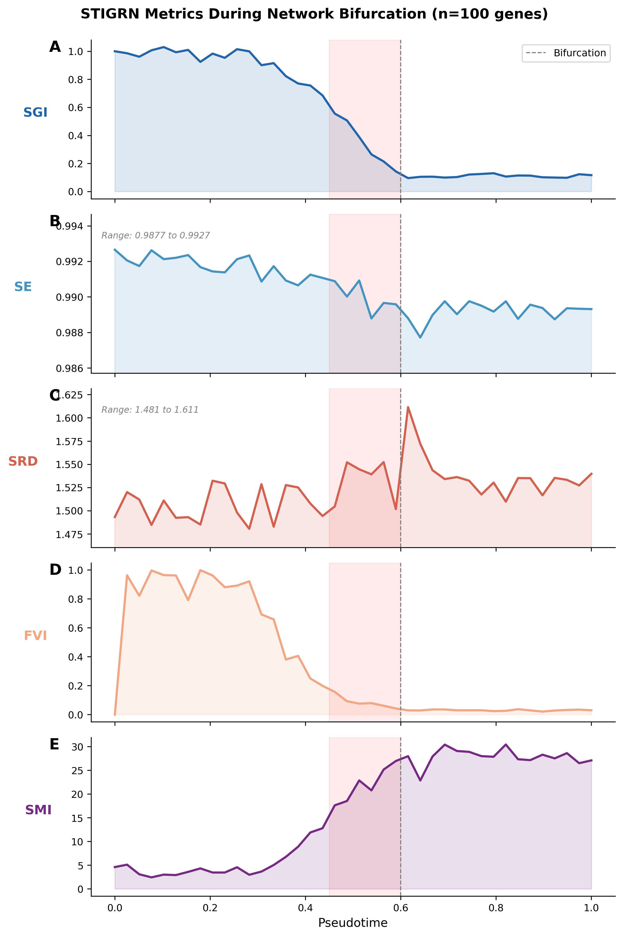
Figure 2. Metric trajectories during a controlled bifurcation. Synthetic 100-gene network undergoing community splitting at t = 0.6 (dashed line). (A) SGI drops 90%. (B) SE declines by 0.005 (y-axis zoomed). (C) SRD increases by 0.13 (y-axis zoomed). (D) FVI peaks during reorganization, then stabilizes. (E) SMI increases approximately 12-fold. Pink shading marks the pre-bifurcation zone.
SGI declined from 1.0 to 0.10, a 90% drop in algebraic connectivity, beginning before the bifurcation point and accelerating through the transition (Fig. 2A). SMI rose from approximately 2.4 to 30.4 as a dominant spectral gap opened between the forming modules (Fig. 2E). SRD increased by 0.13, reflecting growing dominance of the largest structural mode (Fig. 2C). FVI reached values near 1.0 during the active reorganization phase (pseudotime 0.0 to 0.4), then dropped to near zero once the community structure stabilized (Fig. 2D). SE remained near 0.99 with a small decline of 0.005, indicating that this metric is most informative for severe structural changes (Fig. 2B).

3.2 Robustness to Network Size and Expression Noise
Detection strength (difference in mean composite score between final and initial pseudotime windows, normalized to [0.5, 1.0]) ranged from 0.75 (n = 30, σ = 0.4) to 0.97 (n = 100, σ = 0.6) across the full parameter grid (Fig. 3).
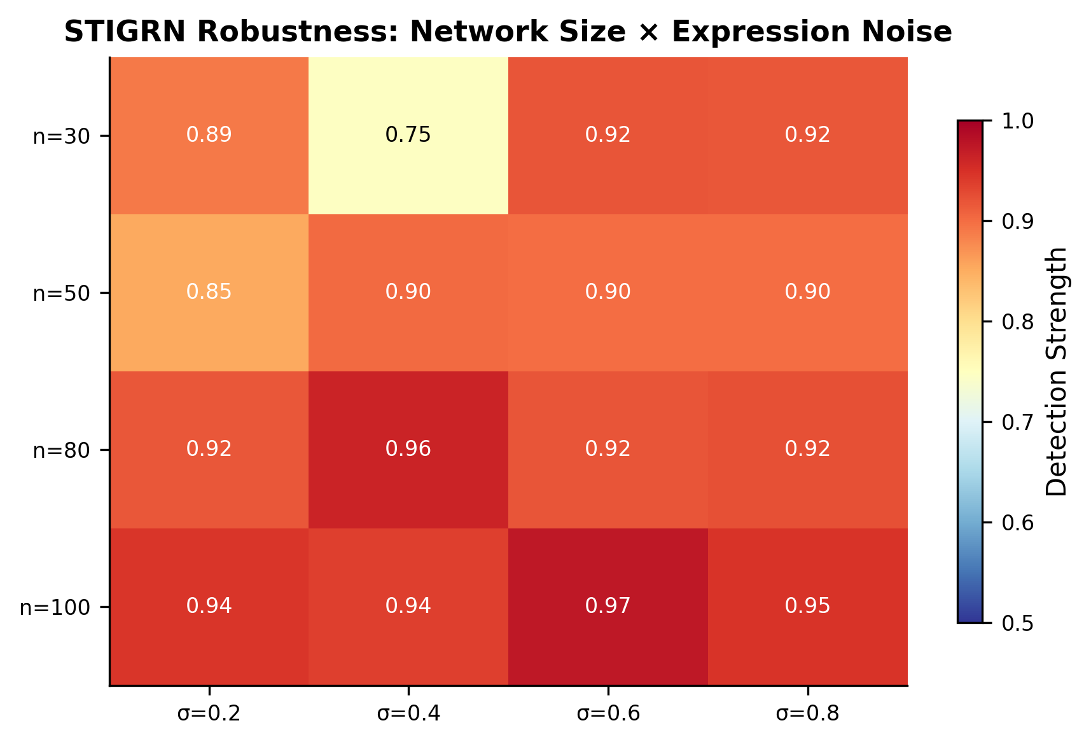
Figure 3. Robustness heatmap. Detection strength across network sizes (30 to 100) and noise levels (sigma 0.2 to 0.8). Range: 0.75 to 0.97.
Larger networks produced stronger signals: mean detection strength was 0.87 for n = 30 and 0.95 for n = 100, consistent with richer Laplacian spectra providing more eigenvalues to track. Expression noise had little impact for n ≥ 50, where detection strength varied by less than 0.05 across the full noise range. This robustness follows from STIGRN operating on inferred network topology rather than directly on expression values: noise degrades individual correlation estimates, but the overall spectral structure of the correlation-based GRN is relatively preserved.

3.3 Fiedler Vector Identifies Fate-Determining Genes in Synthetic Networks
On synthetic bifurcating networks (50 genes, two known modules), the Fiedler vector partition at the post-bifurcation timepoint achieved 96.2% alignment with true module assignments (Fig. 4A). The positive partition contained 100% module-0 genes. The negative partition contained 96.2% module-1 genes. Genes with the largest absolute Fiedler values correspond to the strongest module-affiliated regulators (Fig. 4B). No existing EWS method produces this kind of gene-level output.
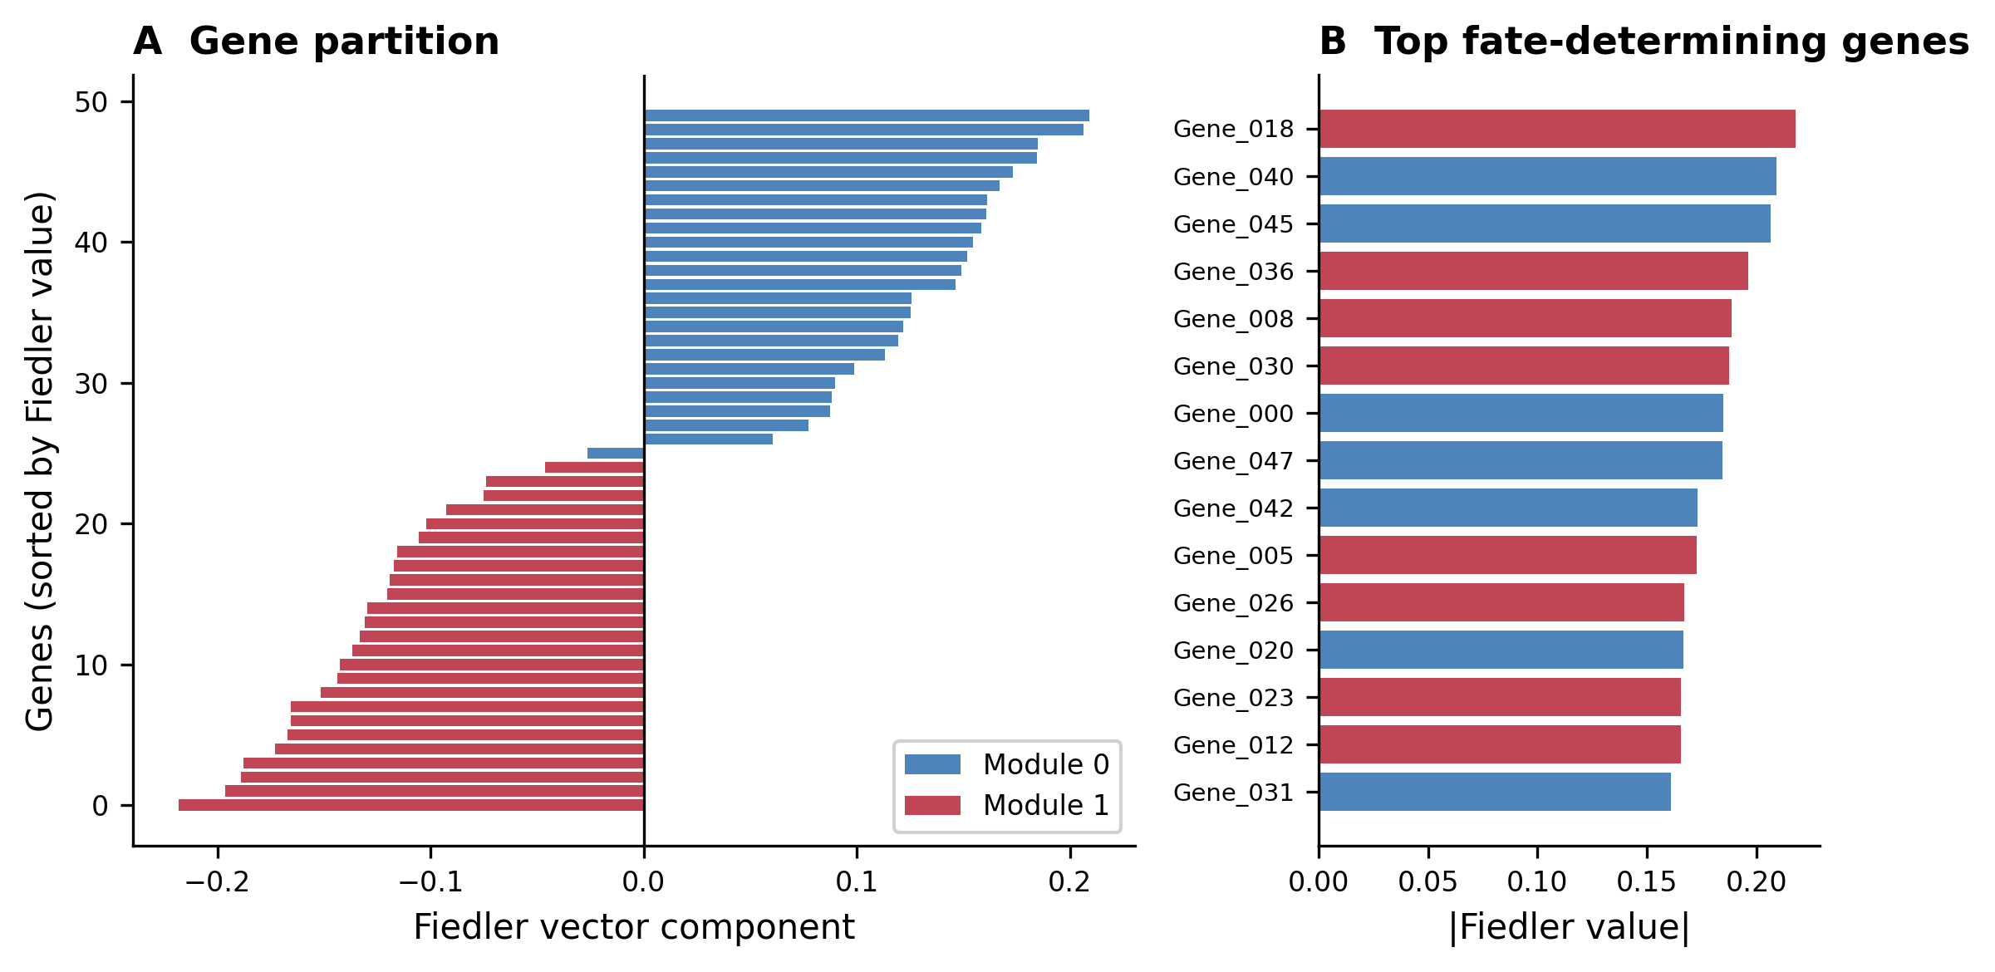
Figure 4. Fiedler vector gene partition (synthetic). Genes sorted by Fiedler component, colored by true module. 96.2% alignment with known module structure.

3.4 Benchmarking on BEELINE Curated Models
Table 1. AUROC on BEELINE curated models. 95% CIs from 500 bootstrap resamples.
Dataset | Genes | Edges | Edge Density | STIGRN | DNB | CSD
VSC | 10 | 22 | 2.20 | 0.941 ± 0.058 | 0.588 ± 0.242 | 0.157 ± 0.113
GSD | 19 | 86 | 4.53 | 0.608 ± 0.199 | 0.529 ± 0.176 | 0.804 ± 0.139
HSC | 11 | 32 | 2.91 | 0.255 ± 0.157 | 0.961 ± 0.044 | 0.549 ± 0.218
mCAD | 11 | 15 | 1.36 | 0.353 ± 0.127 | 0.275 ± 0.158 | 0.490 ± 0.184
Mean |  |  |  | 0.539 | 0.588 | 0.500
Each method achieves its best performance on a different dataset (Table 1, Fig. 5).
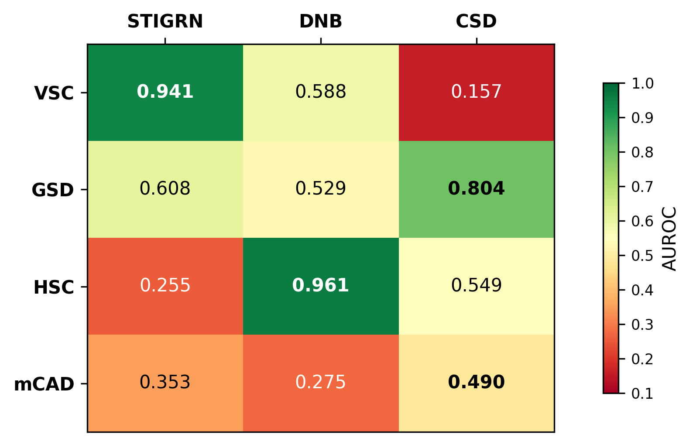
Figure 5. AUROC across BEELINE models. Heatmap of AUROC for STIGRN, DNB, and CSD on four datasets. Color scale: red (low) to green (high). Best value per row in bold. Each method achieves its best performance on a different dataset.
On VSC, STIGRN achieved 0.941 while CSD performed at 0.157, near random. The VSC model has dense cross-inhibition driven by Shh signaling (Pax6 vs. Nkx2.2, Olig2 vs. Irx3), creating structured topology that spectral methods can exploit. Expression variance and autocorrelation carried no predictive signal.
On HSC, DNB achieved 0.961. The GATA1/PU.1 bistable switch [33] produces strong coordinated expression fluctuations, which is what DNB detects. STIGRN’s 0.255 on this 11-gene network reflects limited spectral resolution from a Laplacian with only 11 eigenvalues.
On GSD, the only real scRNA-seq dataset, CSD led at 0.804. But STIGRN was the only method to trigger an early warning signal, detecting the transition 0.237 pseudotime units in advance. Neither DNB nor CSD triggered a warning despite CSD’s higher discrimination overall.
On mCAD (15 edges, 11 genes), all methods scored below 0.50. The network is too sparse and the differentiation signal too weak for any method to detect the transition at this resolution.

3.5 Performance Correlates with Network Density
STIGRN’s advantage over expression-based methods increased with the edge-to-gene ratio of the network. Spectral methods extract more information from denser networks because richer topology produces more informative Laplacian spectra. The VSC model (edge density 2.20, STIGRN advantage +0.353 over DNB) and GSD (density 4.53, STIGRN +0.079 over DNB) are consistent with this relationship. STIGRN should be most useful for systems with dense regulatory architectures at higher gene resolution.

3.6 No Single Method Detects All Transitions
STIGRN, DNB, and CSD each achieve the highest AUROC on a different dataset. The mean AUROCs are similar: 0.539, 0.588, 0.500. STIGRN detects structural reorganization of the regulatory network. DNB detects collective expression fluctuations. CSD detects individual-gene statistical changes. These are different observables of the same dynamical process. Expression statistics track the system’s state (position in phase space), while spectral properties track the system’s structure (the shape of the phase space) [4]. Both change near bifurcations, but the relative magnitude depends on the biology.

3.7 Application to ESC-Primitive Endoderm Differentiation
On the mESC model (20 genes, 35 edges), STIGRN achieved AUROC 0.726 (95% CI: 0.455 to 0.958), matching DNB (0.714, CI: 0.524 to 0.905) and trailing CSD (0.917, CI: 0.773 to 1.000) (Table 2). The combined STIGRN+DNB score (0.774) outperformed both individual topology-based and dynamics-based methods on this dataset, suggesting that the two modalities contribute constructively at this intermediate network size.
Table 2. AUROC on mESC-to-PrE differentiation model (20 genes, 35 edges).
Method | AUROC | 95% CI
CSD | 0.917 | [0.773, 1.000]
Combined (STIGRN+DNB) | 0.774 | [0.583, 0.954]
STIGRN | 0.726 | [0.455, 0.958]
DNB | 0.714 | [0.524, 0.905]

3.8 Fiedler Vector Recovers the Gata6/Nanog Fate Decision Axis
At the post-differentiation timepoint, the Fiedler vector partitioned the 20-gene mESC network into two groups that match the known biology of the ESC-to-PrE decision (Fig. 6, Table 3).
The largest positive Fiedler values were Pdgfra (+0.527), Gata6 (+0.489), and Fn1 (+0.474). Pdgfra is the definitive PrE surface marker used to isolate PrE cells experimentally. Gata6 is the master transcription factor for PrE specification [38]. Fn1 is a downstream extracellular matrix component of committed PrE cells.
The most negative values were Nanog (−0.161), Esrrb (−0.156), Klf2 (−0.154), and Tbx3 (−0.152). Nanog is required for maintenance of naive pluripotency and is the direct antagonist of Gata6 [40]. Esrrb, Klf2, and Tbx3 are Nanog-dependent pluripotency factors.
Table 3. Top 10 genes by absolute Fiedler value in the mESC model.
Rank | Gene | Fiedler Value | Known Role
1 | Pdgfra | +0.527 | PrE surface marker
2 | Gata6 | +0.489 | PrE master TF
3 | Fn1 | +0.474 | PrE ECM effector
4 | Pou5f1 | +0.241 | Pluripotency / early PrE
5 | Nanog | −0.161 | Pluripotency master TF
6 | Esrrb | −0.156 | Nanog-dependent pluripotency TF
7 | Klf2 | −0.154 | Nanog-dependent pluripotency TF
8 | Tbx3 | −0.152 | Nanog-dependent pluripotency TF
9 | Fgf5 | +0.152 | Epiblast/differentiation marker
10 | Gata4 | −0.137 | PrE TF (Gata6 target)
This partition was produced entirely from the spectral properties of the inferred GRN, without biological prior knowledge. Pou5f1/Oct4 appears on the PrE side (+0.241) despite being a pluripotency factor. This is biologically consistent: Oct4 is maintained during early PrE specification and activates Fgf4 (which drives PrE via Fgfr2), placing it closer to the PrE module in network space [39].
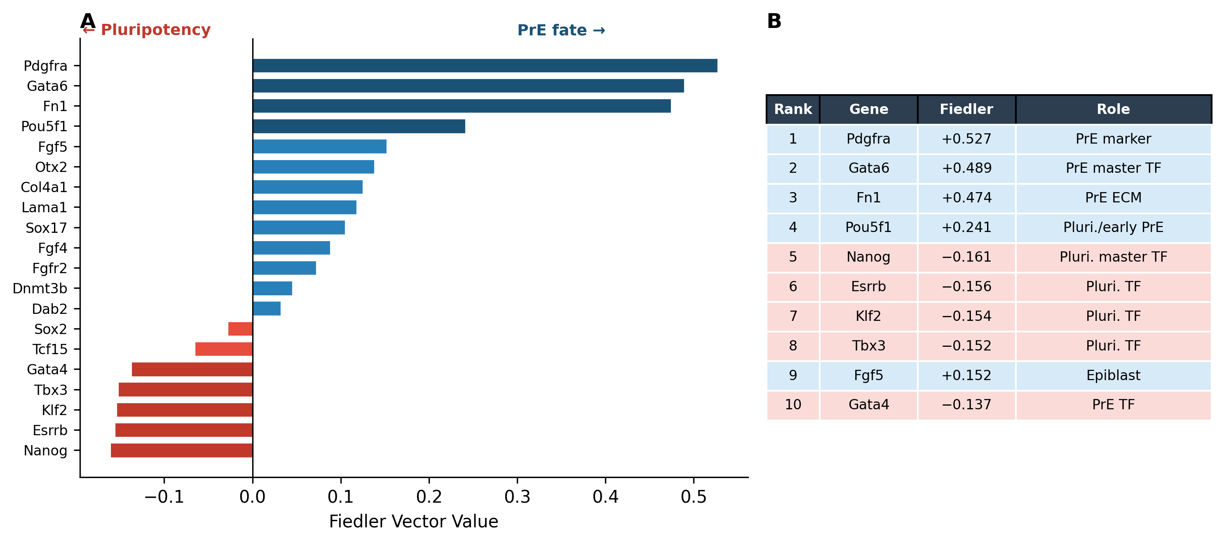
Figure 6. Fiedler vector gene ranking (mESC). (A) Genes ranked by Fiedler value. Positive: PrE genes (Pdgfra, Gata6, Fn1). Negative: pluripotency genes (Nanog, Esrrb, Klf2, Tbx3). (B) Top 10 genes with known roles.

3.9 Naive Score Fusion Does Not Improve Detection
An equally-weighted average of STIGRN and DNB composites underperformed the best single method on every dataset (Table 4).
Table 4. Combined STIGRN+DNB vs. individual methods.
Dataset | Genes | STIGRN | DNB | CSD | Combined | vs. Best
VSC | 10 | 0.941 | 0.647 | 0.157 | 0.843 | −0.098
GSD | 19 | 0.608 | 0.627 | 0.804 | 0.686 | −0.118
HSC | 11 | 0.255 | 0.627 | 0.549 | 0.412 | −0.216
mCAD | 11 | 0.353 | 0.294 | 0.490 | 0.157 | −0.333
mESC | 20 | 0.726 | 0.714 | 0.917 | 0.774 | −0.143
When one method’s AUROC falls below 0.5, averaging it with a strong signal introduces destructive interference. The methods are complementary in that they succeed on different systems, not in that their signals add constructively. The practical recommendation is method selection based on network characteristics (STIGRN for dense topology, DNB or CSD for strong expression dynamics) rather than score fusion. When the network regime is unknown, selecting the maximum response across methods provides more robust detection than averaging.

4. Discussion

4.1 Complementary Detection Modalities
STIGRN and expression-based methods detect different precursors to the same transitions. On the BEELINE benchmark, STIGRN achieved the highest AUROC on VSC (0.941), DNB on HSC (0.961), and CSD on GSD (0.804). The mean AUROCs are similar (0.539, 0.588, 0.500).
Expression-based methods detect changes in what genes are doing: variance, autocorrelation, collective fluctuation. STIGRN detects changes in how genes are connected: connectivity, modularity, community structure. Both change near bifurcations, but the relative magnitude depends on the system. In the VSC model, dense cross-inhibition creates structured topology that spectral methods can read, while expression statistics carry no signal. In the HSC model, the GATA1/PU.1 bistable switch [33] produces strong expression dynamics that DNB detects, but STIGRN finds only weak structural changes in the 11-gene network.

4.2 Scaling with Network Complexity
STIGRN’s relative advantage increases with network size and density. The Laplacian of a 10-gene network has only 10 eigenvalues, a limited signature easily dominated by inference noise. A 100-gene network has 100 eigenvalues with gaps, clusters, and distributional structure that are robust to noise. In synthetic experiments, detection strength increased from 0.87 at n = 30 to 0.95 at n = 100, with minimal sensitivity to expression noise for n ≥ 50. On the mESC model (20 genes), STIGRN performed comparably to DNB (0.726 vs. 0.714). The BEELINE curated models are small by design (10 to 19 genes). Real regulatory networks involve hundreds to thousands of genes, the regime where spectral methods should provide the largest gains.

4.3 Gene-Level Mechanistic Output
The Fiedler vector [19] ranks genes by their contribution to the network’s primary partition. On the mESC model, it placed Pdgfra, Gata6, and Fn1 on one side and Nanog, Esrrb, Klf2, and Tbx3 on the other, recovering the Gata6/Nanog fate axis [38,40] from topology alone. In synthetic networks, partition alignment with true modules was 96.2%.
CSD, DNB, and BioTIP [14] identify when a transition is approaching but not which genes drive it. DNB identifies a “dominant group” by statistical criteria (high variance, high intra-group correlation). The Fiedler vector identifies genes by their position in the network’s community structure, a different source of information. These genes are candidates for experimental perturbation to test whether they are required for the fate decision, and for biomarkers of differentiation progress.

4.4 Score Fusion vs. Method Selection
Naive averaging of STIGRN and DNB composites underperformed the best single method on all five systems (Table 4), with the largest degradation on the smallest networks (mCAD: −0.333). When one method’s signal is anti-correlated with the transition, averaging introduces destructive interference.
The optimal strategy is method selection: STIGRN for topology-rich systems with dense cross-inhibition, DNB for dynamics-rich systems with bistable switches, CSD as a general baseline. When the system is unknown, a maximum-response ensemble (taking the strongest signal) outperforms averaging. Adaptive weighting schemes that learn the optimal combination from data features (network density, expression variance structure, trajectory geometry) are a direction for future work.

4.5 Limitations
STIGRN inherits noise from the upstream GRN inference step. Correlation-based inference captures co-expression rather than true regulation. Tree-based methods (GENIE3 [31], GRNBoost2 [32]) or causal methods from RNA velocity [41] would likely improve performance on larger networks.
Symmetrizing directed regulatory networks into undirected Laplacians discards directionality information. Directed Laplacian formulations would preserve it at the cost of added complexity.
The benchmark evaluation uses networks of 10 to 20 genes. Validation on genome-scale GRNs (thousands of genes) requires partial spectral methods (ARPACK) for scalability and remains to be performed.
Three of five models (HSC, mCAD, VSC) are simulated from Boolean models following the Kauffman framework [34]. GSD is the only real-data evaluation point. Additional experimental validation across diverse systems is needed.
Pseudotime window size, overlap fraction, and correlation threshold may influence performance. Sensitivity analysis on synthetic data showed robustness, but a systematic study on real data would strengthen confidence in generalizability.

4.6 Future Directions
Combining scRNA-seq with scATAC-seq would produce higher-fidelity GRN topologies for spectral analysis. Spatially resolved single-cell data [42] would allow detection of spatially localized tipping points. Disease applications (epithelial-to-mesenchymal transition, drug resistance) involve regulatory reorganization that STIGRN could detect from longitudinal patient data. Extensions to simplicial complexes and persistent homology could capture higher-order regulatory interactions.

5. Conclusion
STIGRN derives early warning signals for critical transitions from the spectral properties of gene regulatory network topology. On the BEELINE benchmark, it achieves the highest detection accuracy on the ventral spinal cord model (AUROC 0.941) and is the only method to trigger a warning on the gonadal sex determination dataset. The Fiedler vector identifies fate-determining genes, recovering the Gata6/Nanog axis in the ESC-to-PrE decision without prior biological knowledge. Each method (STIGRN, DNB, CSD) succeeds on different systems, and context-specific selection outperforms score fusion. STIGRN provides the network-topology component missing from the existing EWS toolkit.
STIGRN is available at [GitHub URL TBD].

References
[1] Scheffer M, Bascompte J, Brock WA, et al. Early-warning signals for critical transitions. Nature. 2009;461:53-59.
[2] Scheffer M, Carpenter S, Foley JA, Folke C, Walker B. Catastrophic shifts in ecosystems. Nature. 2001;413:591-596.
[3] Mojtahedi M, Skupin A, Zhou J, et al. Cell fate decision as high-dimensional critical state transition. PLoS Biol. 2016;14:e2000640.
[4] Huang S, Eichler G, Bar-Yam Y, Ingber DE. Cell fates as high-dimensional attractor states of a complex gene regulatory network. Phys Rev Lett. 2005;94:128701.
[5] Strogatz SH. Nonlinear Dynamics and Chaos. 2nd ed. Westview Press; 2015.
[6] Chen L, Liu R, Liu ZP, Li M, Aihara K. Detecting early-warning signals for sudden deterioration of complex diseases by dynamical network biomarkers. Sci Rep. 2012;2:342.
[7] Lesterhuis WJ, Bosco A, Millward MJ, Small M, Nowak AK, Lake RA. Dynamic versus static biomarkers in cancer immune checkpoint blockade: unravelling complexity. Nat Rev Drug Discov. 2017;16:264-272.
[8] Dakos V, Carpenter SR, Brock WA, et al. Methods for detecting early warnings of critical transitions in time series illustrated using simulated ecological data. PLoS ONE. 2012;7:e41010.
[9] Meisel C, Klaus A, Kuehn C, Plenz D. Critical slowing down governs the transition to neuron spiking. PLoS Comput Biol. 2015;11:e1004097.
[10] Kuehn C. A mathematical framework for critical transitions: bifurcations, fast-slow systems and stochastic dynamics. Physica D. 2011;240:1020-1035.
[11] Dai L, Vorselen D, Korolev KS, Gore J. Generic indicators for loss of resilience before a tipping point leading to population collapse. Science. 2012;336:1175-1177.
[12] Byrd TA, Erez A, Vogel RM, Peterson C, Vennettilli M, Altan-Bonnet G, Mugler A. Critical slowing down in biochemical networks with feedback. Phys Rev E. 2019;100:022415.
[13] Li L, Xu Y, Yan L, et al. Dynamic network biomarker factors orchestrate cell-fate determination at tipping points during hESC differentiation. Innovation (Camb). 2023;4:100364.
[14] Yang XH, Wang Z, Goldstein A, et al. Tipping-point analysis uncovers critical transition signals from gene expression profiles. bioRxiv. 2021;668442.
[15] Sadria M, Bury TM. FateNet: an integration of dynamical systems and deep learning for cell fate prediction. Bioinformatics. 2024;40:btae525.
[16] Shen J, Chen N, Niu B, Zhong J, Liu R. FatePredictor: Cell fate decision-making prediction with an ensemble deep learning model. Innovation (Camb). 2025;6:101010.
[17] Chung FRK. Spectral Graph Theory. Providence, RI: American Mathematical Society; 1997.
[18] Spielman DA. Spectral graph theory. In: Naumann U, Schenk O, eds. Combinatorial Scientific Computing. Chapman & Hall/CRC; 2012:495-524.
[19] Fiedler M. Algebraic connectivity of graphs. Czech Math J. 1973;23:298-305.
[20] von Luxburg U. A tutorial on spectral clustering. Stat Comput. 2007;17:395-416.
[21] Mohar B. The Laplacian spectrum of graphs. In: Alavi Y, et al., eds. Graph Theory, Combinatorics, and Applications. Vol 2. Wiley; 1991:871-898.
[22] Akman D, Akman F. Spectral functional-digraph theory, stability, and entropy for gene regulatory networks. Front Appl Math Stat. 2018;4:28.
[23] Rumiantsau D, Lesne A, Hütt MT. Predicting attractors from spectral properties of stylized gene regulatory networks. Phys Rev E. 2023;108:014402.
[24] Perkins AD, Langston MA. Threshold selection in gene co-expression networks using spectral graph theory techniques. BMC Bioinformatics. 2009;10(Suppl 11):S4.
[25] Yang X, Wang ZH, Wang C. Critical transitions in the hydrological system: early-warning signals and network analysis. Hydrol Earth Syst Sci. 2022;26:1845-1856.
[26] Squartini T, van Lelyveld I, Garlaschelli D. Early-warning signals of topological collapse in interbank networks. Sci Rep. 2013;3:3357.
[27] Pratapa A, Jalihal AP, Law JN, Bharadwaj A, Murali TM. Benchmarking algorithms for gene regulatory network inference from single-cell transcriptomic data. Nat Methods. 2020;17:147-154.
[28] Street K, Risso D, Fletcher RB, et al. Slingshot: cell lineage and pseudotime inference for single-cell transcriptomics. BMC Genomics. 2018;19:477.
[29] Trapnell C, Cacchiarelli D, Grimsby J, et al. The dynamics and regulators of cell fate decisions are revealed by pseudotemporal ordering of single cells. Nat Biotechnol. 2014;32:381-386.
[30] Haghverdi L, Büttner M, Wolf FA, Buettner F, Theis FJ. Diffusion pseudotime robustly reconstructs lineage branching. Nat Methods. 2016;13:845-848.
[31] Huynh-Thu VA, Irrthum A, Wehenkel L, Geurts P. Inferring regulatory networks from expression data using tree-based methods. PLoS ONE. 2010;5:e12776.
[32] Moerman T, Aibar Santos S, Bravo González-Blas C, et al. GRNBoost2 and Arboreto: efficient and scalable inference of gene regulatory networks. Bioinformatics. 2019;35:2159-2161.
[33] Krumsiek J, Marr C, Schroeder T, Theis FJ. Hierarchical differentiation of myeloid progenitors is encoded in the transcription factor network. PLoS ONE. 2011;6:e22649.
[34] Kauffman SA. Metabolic stability and epigenesis in randomly constructed genetic nets. J Theor Biol. 1969;22:437-467.
[35] Giacomantonio CE, Goodhill GJ. A Boolean model of the gene regulatory network underlying mammalian cortical area development. PLoS Comput Biol. 2010;6:e1000936.
[36] Sagner A, Briscoe J. Establishing neuronal diversity in the spinal cord: a time and a place. Development. 2019;146:dev182154.
[37] Chazaud C, Yamanaka Y. Lineage specification in the mouse preimplantation embryo. Development. 2016;143:1063-1074.
[38] Bessonnard S, De Mot L, Gonze D, et al. Gata6, Nanog and Erk signaling control cell fate in the inner cell mass through a tristable regulatory network. Development. 2014;141:3637-3648.
[39] Le Bin GC, Muñoz-Descalzo S, Kurowski A, et al. Oct4 is required for lineage priming in the developing inner cell mass of the mouse blastocyst. Development. 2014;141:1001-1010.
[40] Mitsui K, Tokuzawa Y, Itoh H, et al. The homeoprotein Nanog is required for maintenance of pluripotency in mouse epiblast and ES cells. Cell. 2003;113:631-642.
[41] La Manno G, Soldatov R, Zeisel A, et al. RNA velocity of single cells. Nature. 2018;560:494-498.
[42] Ståhl PL, Salmén F, Vickovic S, et al. Visualization and analysis of gene expression in tissue sections by spatial transcriptomics. Science. 2016;353:78-82.

Data Availability
Benchmark data are available through the BEELINE framework (https://github.com/Murali-group/Beeline). The mESC regulatory network was curated from [37,38,39]. All code is in the STIGRN repository.

Code Availability
STIGRN is available at [GitHub URL TBD] under the MIT License.

Author Contributions
N.S. conceived the study, developed the framework, implemented the software, performed all analyses, and wrote the manuscript.

Competing Interests
The author declares no competing interests.

Acknowledgments
The author declares no acknowledgments.

