

New School Breaks Ground in One of the Bronx’s Neediest Neighborhoods

The NYC School Construction Authority and Department of Education has begun construction on the New Settlement Community Campus, a 172,000-square-foot, pre-K-12th grade public school and community center in the Mount Eden section of the Bronx. Designed by Dattner Architects and Edelman Sultan Knox Wood Architects (ESKW Architects), the four-story building will be composed of two volumes — a primary school and an intermediate/high school. The project’s key architectural element is the interplay of the volumes and expression of the two wings set at a roughly 90-degree angle. Although predominantly brick, zinc panels, and a curtain wall are used to express special functions and provide visual interest and scale. The library, auditorium, and gymnasium (with an indoor pool) will serve the entire school as well as the community. The project is the culmination of two decades of commitment to the rehabilitation of Mount Eden by the Settlement Housing Fund and its subsidiary, New Settlement Apartments.
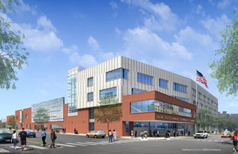
New Settlement Community Campus.
Dattner Architects/ESKW Architects

