**Circuit Description:**

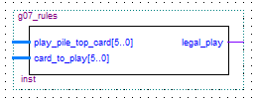 Figure 1: Pin-Out diagram of the g07_rules circuit

Above is a pin-out diagram of the g07_rules circuit. A more detailed description of these ports will be given below.

**Description of ports:**

**play_pile_top_card[5..0]**

The play_pile_top_card[5..0] is a 6 input bit vector that is used show the top card of the pile of played cards.

**Card_to_play[5..0]**

The card_to_play[5.0] is a 6 input bit vector that corresponds to the users card that they wish to play.

**Legal_play**

The legal_play output bit is active when the g07_rules circuit determines that the input corresponds to a legal play and not active otherwise.

**VHDL portrayal of the g07_rules circuit**

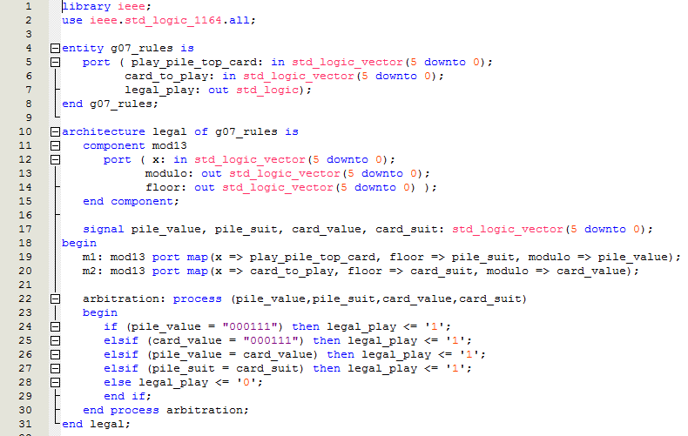

**With Regards to the Testing of the Rules Circuit:**

The rules of the game are very simple since crazy eights is a game that is played by people of all ages. Here are the rules just in case the reader forgot. A card of face value of 8 in any suit can be played on any card and can have any card played on it. Furthermore, any card of a suit can be played on a card of the same suit. A card with a given face value can be played on another card with the same face value but of a different suit.

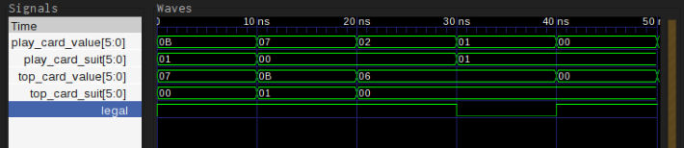Figure 2: Timing Analysis of the g07_rules circuit

For any testing process to be considered as legitimate, the testers must implement the appropriate tests. Therefore, the test that were generated for this tremendous circuit were created to make sure that every rule was tested. It was all done in the spirit of good testing.

The first clock cycle is used to show that any card can be played over the value of eight independent of the suit of the eight since the eight is crazy after all. The second clock cycle was also used to show how crazy the eights can be. It displayed the rule that an eight of any suit can be played over any card and due to the design of the circuit, the test was past. The third clock cycle was designed to make sure that a given card of a certain suit can be played on any card of the same suit and it was an engineering success. The penultimate clock cycle showed that a card of given value and suit cannot be played on another with a different value and suit and the circuit performed like a dream. The final test gave insight into the behavior when a card with a given face value would be played on a card with the same face value and as stated in the rules, it was legal and did not require any additional action to fix this violation.

**Computer Analysis of the Rules Circuit:**

**The Flow Summary:**

Quartus II’s Flow Summary reveals that the g07_rules circuit uses only 46 total combinational functions which is impressive. There is a total of 18 752 combinational logic functions available in the Cyclone II DE1 and therefore, the total usage is under 1%. This is a tremendous achievement because so many logic functions are left over to be used in the final design of the great crazy eights cared game. The g07_rules circuit also uses zero memory bits which is a great benefit overall.

**The Timing Analysis:**