RELICS OF THE FORGOTTEN

**A Capstone Title Proposal Presented to the Faculty of the**

**Information and Communications Technology Program**

**In Partial Fulfilment**

**of the Requirements for the Degree Bachelor of Science in Information Technology**

**MAY 2025**

**INTRODUCTION**

**Project Context**

PC technology has advanced significantly, making interactive learning more accessible and engaging. Computers today provide smooth performance, clear visuals, and easy-to-use controls, making it possible to create games that help players learn in an enjoyable way. Relics of the Forgotten takes advantage of these improvements by allowing players to explore past eras and see historical artifacts in a way that feels natural and immersive.

Complementing this is the use of full 3D environments, which allow players to move and interact freely within a fully navigable virtual space. These environments support dynamic perspectives and spatial immersion, offering detailed visual storytelling and more flexible interaction. The inclusion of 3D segments enhances the user experience by creating moments of heightened realism and engagement.

With many people now using computers for both education and entertainment, this game provides an opportunity to make history more interesting. Instead of reading about artifacts in textbooks, players can discover them in an interactive setting. This approach makes learning history more engaging and helps players appreciate the importance of the artifact’s impact in history.

Relics of the Forgotten is a platformer game that blends exploration, historical education, and strategic problem-solving. Set in a distant future where historical artifacts are at risk of being forgotten due to future challenges such as rising sea levels, theft, climate change, and natural disasters humanity struggles to preserve its past. With only fragments remaining, these relics hold the last traces of lost history, waiting to be analyzed and recovered before their stories fade forever. Players take on the role of Kael, an explorer and historian, tasked with recovering lost knowledge through advanced AI-driven simulations. By analyzing artifact fragments, the AI reconstructs virtual renditions of ancient eras, allowing Kael to step into the past, explore long-forgotten civilizations, and uncover the true history behind these relics before they are lost forever.

Many historical artifacts remain underappreciated due to a lack of public awareness and engagement. Studies indicate that community involvement plays a crucial role in the preservation of cultural heritage, yet many people remain unaware of the significance of historical artifacts or the challenges involved in their conservation. Without purposeful public engagement, interest in cultural heritage diminishes, weakening the connection between modern society and ancient civilizations. As a result, efforts to preserve historical artifacts are often overlooked, and their importance is not fully understood. Additionally, research highlights those traditional educational methods sometimes fail to make historical learning accessible and appealing, especially to younger generations, as history can seem distant and disconnected from everyday life.

To address these issues, innovative approaches are needed to foster a deeper appreciation for cultural heritage, historical preservation, and archaeological exploration. Interactive experiences, such as educational video games, provide an effective way to engage players in historical learning by allowing them to actively explore and discover historical artifacts. Research suggests that conventional teaching strategies may not effectively capture students’ interest or encourage critical thinking about history, making alternative methods necessary (The History Teacher). Games like *Relics of the Forgotten* integrate real-world historical artifacts into problem-solving and exploration-based gameplay, bridging the gap between modern audiences and ancient civilizations. By making history more immersive and interactive, such approaches can increase public awareness, strengthen cultural appreciation, and support ongoing preservation efforts.

# Purpose and Description of the Project:

The purpose of Relics of the Forgotten is to provide an interactive and engaging platform for players to learn about real-world historical artifacts while solving environmental problems and exploring ancient ruins. The game aims to bridge the gap between education and entertainment by presenting historical discovery in a way that feels immersive, challenging, and rewarding. Instead of passively reading about history, players actively engage with it by uncovering, assembling, and learning about artifacts hidden throughout the game’s levels.

The project is designed as a single-player, Windows-exclusive experience with a structured level-based progression system. Players navigate side-scrolling environments, solve problems to unlock hidden artifacts, and reveal historically significant relics at the end of each level. By completing each artifact, players gain insight into its historical origins and cultural importance through concise and informative storytelling. The game emphasizes strategic problem-solving, exploration-based learning, and platforming mechanics while maintaining an accessible and visually immersive experience.

With its unique combination of historical education, problem mechanics, and engaging exploration, Relics of the Forgotten serves as an interactive medium for fostering cultural appreciation and historical awareness. The game is targeted at students, 8 – 22 years old, and casual gamers who enjoy discovery-based gameplay and thought-provoking challenges.

# General Objectives

The primary objective of Relics of the Forgotten is to create an interactive and immersive gaming experience that promotes historical awareness and cultural appreciation. By integrating real-world artifacts into engaging gameplay, the project aims to educate players on the significance of historical artifact while providing an enjoyable platform for exploration and discovery. Through interactive storytelling, problem-solving, the game seeks to bridge the gap between modern audiences and our history, fostering a deeper understanding of cultural heritage in an engaging manner.

This proposed project provides the following:

# To enhance Public Awareness of Historical Artifacts

Introduce players to real-world historical artifacts through interactive exploration. Provide historical context, origins, and cultural significance of artifacts in an engaging, gameplay-driven format.

# To offer an Engaging Educational Experience Through Gameplay

Integrate historical learning with problem-solving and platforming mechanics to create a more immersive approach to education. Move beyond traditional textbook learning by allowing players to actively engage with history through discovery and interaction.

# To spark interest in history among modern audiences

Inspire curiosity about ancient civilizations by weaving historical elements into the game's world and atmosphere. Encourage players to appreciate the past through subtle storytelling and immersive exploration.

# To promote the value of historical artifacts

Highlight the cultural and historical significance of real-world artifacts by embedding accurate information, context, and origin stories into the gameplay, encouraging players to recognize their relevance and the need for their preservation in the real world.

# To promote Artifact Preservation and Cultural Heritage Conservation

Highlight the importance of preserving historical artifacts and the challenges involved in their conservation. Educate players on efforts to protect and restore cultural heritage, fostering a greater appreciation for historical preservation.

# Scope and Limitation

Relics of the Forgotten is a platformer problem game focused on historical exploration and artifact discovery. It offers a structured, single-player experience where players navigate handcrafted levels, solve problems, and learn about real-world artifacts through interactive storytelling. The game emphasizes exploration-based learning, strategic problem-solving.

However, it does not include multiplayer features, online connectivity, and Cross Platform. These limitations ensure a focused and accessible gameplay experience that aligns with the game's educational and entertainment objectives

# Scope

* **Platforming**

Players navigate the environment through precision jumps, and spatial awareness.

# Artifact Discovery

Each level contains hidden artifact, which remains unknown until the player completes the level. Upon completion, the artifact is revealed, and its historical information is unlocked.

# Problem-Solving

Strategic thinking is required to navigate environmental problems.

# Exploration-Based Learning

Players uncover pieces of historical information through storytelling.

# Achievements

Players can track discovered artifacts in an in-game collection that provides full historical details.

# Main Menu

The main menu contains three buttons: Play, Settings, and Exit. The Play button leads to Continue (resume previous session), New Game (start from the beginning), and Load Game (load from a saved slot).

# User Slots

Players can manage up to three user slots, allowing them to create and delete game profiles.

# Customization

Players can unlock different character skins upon completing or progressing through levels.

# Shop

A virtual shop allows players to purchase various weapons with differing stats, providing strategic gameplay options.

# Combat System

Players must draw their weapon (e.g., sword) to enter a combat state. Only while in this state can they execute attacks.

# Test

Once players approach the artifact a test will pop up, Players need to answer the questions correctly (at least 4/5) to complete the level.

# Limitations Controller Support:

The game does not support third party input such as controller (PlayStation, Xbox), the game only uses mouse and keyboard.

# Online Mode:

The game does not feature online connectivity, meaning there are no leaderboards, online achievements, or live multiplayer interactions.

# Cross-Platform Support:

The game is exclusively available on Windows and does not support other platforms such as consoles or mobile devices.

# METHODOLOGY

The methodology adopted for the development of Relics of the Forgotten follows a systematic approach that combines educational design principles with iterative development practices. This section outlines the technical tools used, the process of requirements gathering, and the development strategy. In particular, the Agile methodology was utilized to ensure continuous refinement, collaboration, and responsiveness to user feedback. The following outlines each major phase of the project, including planning, design, implementation, and testing.

# Requirement Analysis

This involves addressing the needs of the users and the project requirements in terms of players, features, education goals, system capabilities, and procedures.

# Project Overview

* 1. **Project Name:**

**Relics of the Forgotten:** A 3D Adventure Game

# Project Objectives

The primary objectives of the game are to provide players with an immersive and educational experience that transforms traditional historical learning into an engaging activity. By integrating real historical artifacts into an interactive digital format, the game allows users to explore and discover cultural relics in a way that encourages active participation. Through this approach, the project aims to foster a deeper awareness and appreciation for cultural heritage, helping players understand the historical significance of artifacts and the importance of preserving them for future generations.

# Stakeholders Identification

* 1. **Internal Stakeholders**

**Development Team:** Composed of game designers, developers, testers, and project managers responsible for all aspects of implementation.

**Advisers:** Guide the team in applying effective instructional design principles.

**Grammarian:** Ensures documentation quality and academic clarity.

# External Stakeholders

**Users / Players:** Individuals aged 8–22, including students and casual gamers seeking meaningful, enjoyable, and educational gameplay.

# Business Activity

* 1. **Current Business Process**

Current approaches to teaching history are often passive, relying on textbooks and lectures. This limits student engagement and practical understanding of cultural topics.

# Proposed Business Process

Relics of the Forgotten seeks to revolutionize historical learning through gamification. The game offers interactive simulations of artifact discovery, historical storytelling, and problem-solving tasks.

# People Involved

* 1. **Project Team**

**Game Designers:** Develop game mechanics and aesthetics**. Developers:** Code and implement systems and interactions. **Advisers:** Ensure historical content is accurate and meaningful. **Panelist:** Evaluate educational value and usability.

**Grammarian:** Maintains clarity and structure of documentation.

# End Users

The game targets learners aged 8–22 and casual players who are curious about history and culture, providing an enjoyable method of engagement.

# Environmental Considerations

* 1. **Technical Environment**

The game is optimized for Windows platforms and supports low-spec PCs. A JSON-based system is used for saving progress, ensuring data persistence without heavy system load.

# Regulatory Environment

The game complies with appropriate content standards and follows data privacy laws to protect user information, especially for minors.

# Timing

* 1. **Project Timeline**

The development of Relics of the Forgotten is planned to span a total of 10 months. The first month is allocated for the preparation and approval of the project proposal. Once approved, the following nine months will be dedicated to the full development of the game, including the implementation of core features, rigorous testing, and continuous refinement to ensure both educational effectiveness and gameplay quality.

# Dependencies

Includes external feedback loops, such as academic review processes and testing for functional improvements.

# Procedures Performed

* 1. **Existing Procedures**

Historical education currently uses minimal interactive content, making it difficult to engage students in meaningful learning.

# Proposed Procedures

The project proposes the implementation of gamified modules to promote hands-on learning and enhance user engagement. These modules will be supported by a system of player profiles or user slots, allowing individual progress tracking and personalized experiences. Additionally, the game will integrate artifact-based quizzes and narrative- driven segments to reinforce historical knowledge, making the learning process more interactive, immersive, and effective.

# Requirements Documentation

This section outlines what the software product is expected to do, based on the agreement between the project team and the end-users. It includes both functional and non-functional requirements to ensure that Relics of the Forgotten meets its educational and gameplay goals.

# Functional Requirements User Slots

The game will allow players to create and manage multiple user profiles. These slots will store individual progress, achievements, and customization preferences, enabling personalized gameplay experiences.

# Artifact Interaction

Players will be able to explore environments and interact with historical artifacts. Each artifact triggers educational events, such as information pop-ups and in-game quizzes, that support learning objectives.

# Educational Content

The game will integrate concise and accurate historical content related to real-world artifacts. Story-driven levels and mini-assessments will help reinforce knowledge in an engaging way.

# Progress Tracking

Player learning progress will be monitored through completed levels, quiz results, and artifact discoveries. The progress will provide feedback on performance and encourage replayability.

# Customization System

A character customization system will allow players to unlock and equip different skins, weapons, and cosmetic upgrades. These rewards serve to maintain motivation and engagement throughout the game.

# Combat and Quiz Integration

The game will blend combat mechanics with historical assessments. To complete a level, players must pass a short quiz related to the discovered artifact, reinforcing educational takeaways.

# Non-functional Requirements Performance

The game must run smoothly on low-end Windows PCs. This includes optimized rendering of 3D environments, fast loading times, and lag-free navigation to ensure a seamless experience.

# User Interface

A clean, intuitive user interface will cater to younger audiences. Menus, instructions, and gameplay elements will be designed for ease of use and quick understanding.

# Content Accuracy and Accessibility

All historical information presented in the game must be accurate, age-appropriate, and easy to understand. Visual and textual content will follow academic standards while remaining accessible to casual players.

# Compatibility

While the game is developed exclusively for Windows platforms, it will be optimized to support a wide range of system specifications, ensuring accessibility for most users with standard PCs.

# Design of Software, System, Product, and/or Processes

The development of Relics of the Forgotten followed a structured process to integrate educational content with engaging gameplay. It was divided into five key phases: Planning and Requirements Gathering, Design, Development, Testing, and Evaluation—each contributing to the game’s overall quality and effectiveness.

# Agile Methodology

To manage development efficiently, the Agile methodology was employed, which promotes adaptive planning, evolutionary development, and early delivery. Agile allowed the development team to iterate on game features, incorporate feedback, and prioritize functionality based on educational value and gameplay satisfaction. This method was particularly effective for a game project that required frequent prototyping and adjustments based on playtesting and user experience.

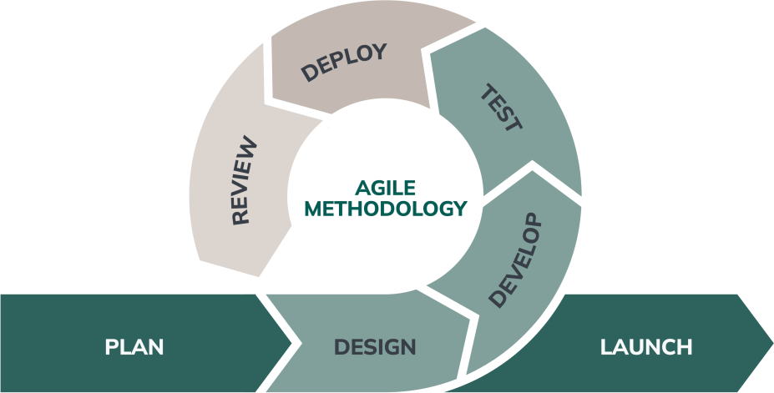

Figure 1. Agile Methodology

# Planning and Requirements Gathering

The planning and requirements gathering phase was foundational to the success of Relics of the Forgotten. This stage involved thorough research on real-world historical artifacts, cultural preservation topics, and effective learning methods suitable for younger audiences. Team members investigated how educational games have successfully incorporated learning into gameplay and identified key shortcomings in traditional history education. This research helped shape the scope of the game and ensured that the design would address actual educational gaps.

In parallel, the development team also defined user personas and technical requirements. Specific decisions were made regarding the platform (Windows-only), user interface preferences, hardware compatibility, and the learning objectives for each game level. Internal and external stakeholders were identified, and their roles were clearly defined— from project advisers and panelists to the end users. These insights were compiled into a comprehensive requirements document that would serve as the blueprint for all future phases. The outcome was a clear, achievable set of goals grounded in both educational theory and technical feasibility.

# Design

The design phase was where the concepts and ideas developed during planning were translated into structured game elements. A significant part of this stage was the development of a visually coherent and user-friendly interface that would appeal to both younger users and casual gamers. The main menu was designed with simplicity in mind, containing accessible navigation options such as Play, Settings, and Exit. UI wireframes were created to streamline how players interact with the game and track their progress through discovered artifacts, character customization, and quiz performance.

Level layouts and asset planning were also undertaken during this phase. Environments were sketched out based on historical contexts, with each level containing hidden artifact locations, environmental obstacles, and thematic visuals reflecting different civilizations. Characters and storylines were mapped to ensure cohesion between narrative flow and educational content. Game aesthetics, color palettes, and 3D models were chosen to balance historical representation with an engaging game atmosphere. In short, the design phase served as the creative bridge between research and implementation, setting a strong visual and structural foundation for development.

# Develop

After the design was finalized, the Develop phase focused on transforming all planned features into a working game environment. This involved coding the primary game systems including player movement, jumping mechanics, platforming interactions, and the combat system. Developers implemented key features such as character customization, the in-game shop, and weapon switching to enrich player engagement. Special attention was given to ensuring smooth, responsive controls and stable performance across devices.

In parallel, supporting systems such as inventory management, player progression, and customization unlocks were also created. These elements allowed players to feel a sense of growth and achievement as they advanced through the game. The overall goal of this phase was to construct the core gameplay loop—exploration, challenge, and reward—in a way that was technically sound and enjoyable.

# Test

The testing phase was a comprehensive effort to validate the technical integrity and user experience of Relics of the Forgotten. Initially, the development team conducted unit testing on individual components, such as player controls, inventory systems, and quiz mechanics, to ensure each worked as intended in isolation. Integration testing followed, focusing on the interactions between different systems to verify smooth transitions and overall stability. Throughout this phase, the team utilized a bug tracking system to document and address any defects, while regression testing was routinely performed to confirm that updates and new features did not introduce new issues or disrupt existing functionality. Special attention was given to performance and compatibility on the designated Windows platform to guarantee a consistent experience for all users.

Beyond internal testing, the team also evaluated the user interface and overall gameplay flow to identify areas needing refinement. Playtesting sessions were organized within the team to simulate real user interactions, allowing testers to follow typical player journeys and uncover usability concerns. Feedback from these sessions led to iterative adjustments in game controls, navigation, and visual cues. By systematically addressing both technical and experiential factors during this phase, the project established a robust, user-friendly foundation for the subsequent evaluation process.

# Evaluate

The evaluation phase shifted focus from technical verification to assessing the game’s effectiveness and impact from the perspective of actual users. This began with organizing playtesting sessions involving participants from the target demographic, including students and educators. These sessions were designed to observe natural gameplay behaviors, measure engagement, and collect immediate feedback on the educational content and user interface. Participants completed structured surveys and interviews, providing insights into the clarity of instructions, the intuitiveness of navigation, and the overall enjoyment of the learning experience. The team also analyzed participant performance in in-game quizzes to gauge knowledge acquisition and retention.

Building on this user feedback, the team identified both strengths and opportunities for further improvement. Metrics such as user satisfaction, learning outcomes, and engagement levels were carefully reviewed to determine whether the game met its educational and entertainment objectives. Suggestions from participants guided final refinements, such as adjusting the difficulty of quizzes, enhancing the visibility of key features, and improving instructional elements. The evaluation phase concluded with a comprehensive review of findings, ensuring that Relics of the Forgotten not only functioned reliably but also delivered a meaningful and enjoyable educational experience for its intended audience.

Figure 2. Block Diagram

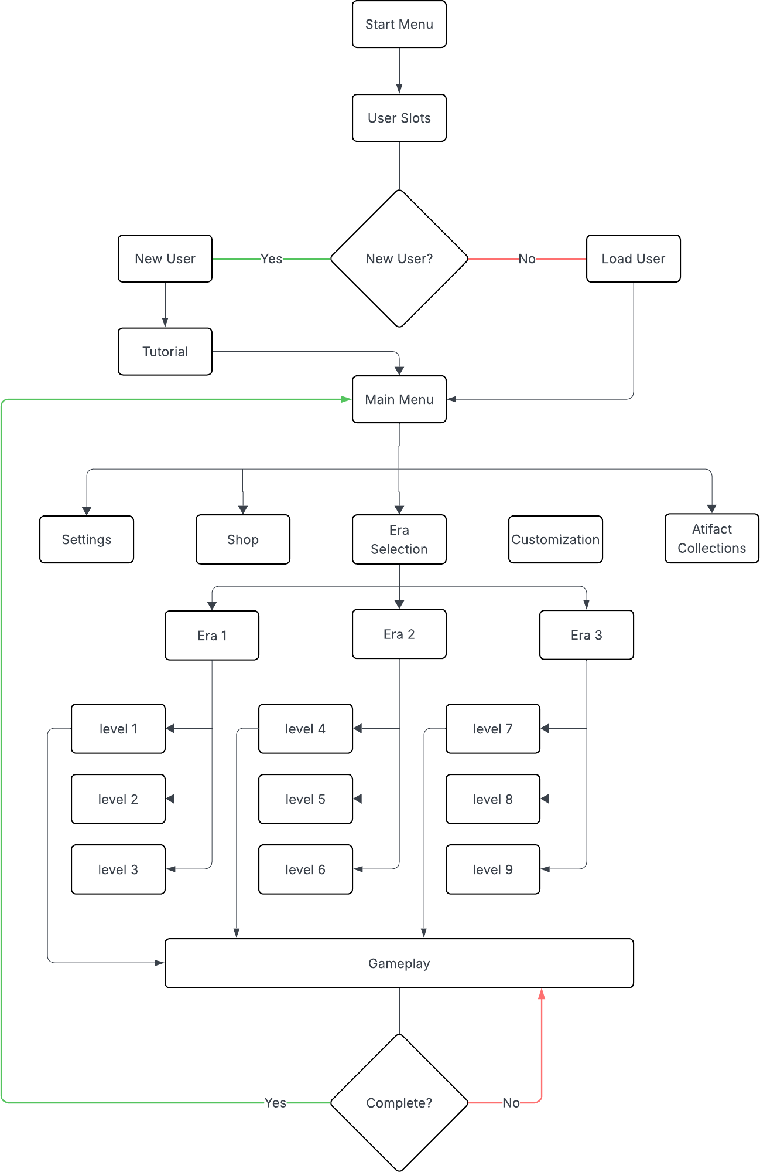

# Development and Testing

This phase focused on building the game’s core systems and ensuring all features functioned effectively. It involved turning designs into a working product and validating gameplay, performance, and educational impact through thorough testing.

# Development

During the development phase of *Relics of the Forgotten*, the team focused on implementing core systems such as the main menu, character customization, combat mechanics, and artifact interactions. Early issues included animation controller errors, mismatched animator parameters, root motion bugs, and camera transitions not syncing with menu states. Shared components between the shop and customization UI caused preview models to conflict, and equipped items failed to appear correctly in-game. User slots also faced a state-loading bug, and marker canvases unintentionally blocked UI buttons. Combat animations showed sliding and delayed transitions, while enemies displayed odd behaviors like rotating vertically or accelerating unnaturally. Delays in death animations and bugs in artifact triggers—especially in the tutorial level—further challenged development but were addressed progressively.

# Testing

Testing involved unit, integration, and playtesting to validate gameplay functionality, system stability, and educational impact. Users reported UI scaling problems, equipment not applying correctly, and preview overlaps between the shop and customization systems. Enemy AI behavior, weapon draw/sheath timing, and quiz triggers were also refined based on feedback. Canvas layering was corrected to restore UI interactivity, and multiple iterations were made to smooth out combat flow and improve artifact discovery reliability. Overall, testing ensured the prototype met its goals by identifying technical issues early and enhancing both player experience and historical engagement.

# Description of Prototype

The prototype of *Relics of the Forgotten* is a working version of the game that demonstrates its main systems and intended gameplay structure. It includes a fully navigable 3D environment where players control the character Kael to explore ancient ruins, solve environmental puzzles, and engage in basic combat. Key systems such as the main menu, user slots, a tutorial level, weapon-based combat, and a quiz-based artifact discovery mechanic are functional in this version. The prototype also includes a customization menu where players can preview and select character skins and weapons, as well as an in-game shop with purchasable items. Players must complete level objectives and pass a short quiz to successfully reveal the artifact and complete the stage. Overall, the prototype represents the foundational elements of the game, focusing on interaction, progression, and integration of educational content.

# Calendar of Activities

This section presents the project’s development timeline, summarizing the major phases and tasks scheduled throughout the duration of *Relics of the Forgotten* to ensure timely completion and progress tracking.

|  |  |  |  |  |  |  |
| --- | --- | --- | --- | --- | --- | --- |
| **APRIL 2025** | | | | | | |
| **SUNDAY** | **MONDAY** | **TUESDAY** | **WEDNESDAY** | **THURSDAY** | **FRIDAY** | **SATURDAY** |
|  |  | 1 | 2 | 3 | 4 | 5 |
| 6 | 7 | 8 | 9 | 10 | 11 | 12 |
| 13 | 14 | 15 | 16 | 17 | 18  Main Menu | 19  Main Menu |
| 20  Documentation | 21  PPT | 22  Mock Defense | 23 | 24 | 25 | 26 |
| 27 | 28 | 29 | 30 |  |  |  |

|  |  |  |  |  |  |  |
| --- | --- | --- | --- | --- | --- | --- |
| **MAY 2025** | | | | | | |
| **SUNDAY** | **MONDAY** | **TUESDAY** | **WEDNESDAY** | **THURSDAY** | **FRIDAY** | **SATURDAY** |
|  |  |  |  | 1 | 2 | 3 |
| 4 | 5 | 6 | 7 | 8 | 9 | 10 |
| 11  Tutorial | 12  Tutorial | 13  Documentation  and PPT revisions | 14  Pre-defense | 15 | 16 | 17 |
| 18 | 19  Shop, and Customization | 20  Shop, and Customization | 21  Document and PPT revisions | 22  Final Defense | 23  Game Enhancements | 24 |
| 25 | 26 | 27 | 28 | 29 | 30 |  |

# REVIEW OF RELATED LITERATURE

**Educational Games and Situated Learning**

Gee (2003) argues that games foster situated learning by immersing players in meaningful problem-solving contexts. This aligns with the design of Relics of the Forgotten, where players actively engage in historical analysis and decision-making through exploratory gameplay.

Gee, J. P. (2003). What video games have to teach us about learning and literacy. Computers in Entertainment (CIE), 1(1), 20–20.

# Cultural Heritage and Virtual Preservation

Champion (2016) emphasizes the potential of virtual archaeology to engage the public with immersive simulations of historical content. These methods make history accessible to wider audiences and support long-term cultural conservation.

Champion, E. (2016). Critical gaming: Interactive history and virtual heritage. Routledge.

# Gamified History Education

Squire (2008) found that historical games allow users to explore the consequences of past decisions in ways traditional textbooks cannot. Experiential learning promotes deeper understanding, particularly among students who find conventional learning passive and uninspiring.

Squire, K. (2008). Video games and education: Designing learning systems for an interactive age. Educational Technology, 48(2), 17–26.

# Use of Real-World Artifacts in Games

Ubisoft’s Discovery Tour (2017) and E-Line Media’s Never Alone (2014) demonstrate how real-world artifacts and folklore can be integrated into games to deliver cultural knowledge. These models influenced Relics of the Forgotten, particularly in presenting interactive storytelling rooted in factual content.

Ubisoft. (2017). Assassin’s Creed: Discovery Tour Mode [Game]. Ubisoft Montreal. E-Line Media. (2014). Never Alone [Game]. E-Line Media.

# Gaps in Existing Systems

While several games attempt to educate, few balance engagement with accuracy or emphasize localized cultural content. Relics of the Forgotten addresses this by integrating real historical artifacts and aligning with educational standards.

# References

Champion, E. (2016). Critical gaming: Interactive history and virtual heritage. Routledge. E-Line Media. (2014). Never Alone [Game]. E-Line Media.

Gee, J. P. (2003). What video games have to teach us about learning and literacy. Computers in Entertainment (CIE), 1(1), 20–20.

Squire, K. (2008). Video games and education: Designing learning systems for an interactive age. Educational Technology, 48(2), 17–26.

Ubisoft. (2017). Assassin’s Creed: Discovery Tour Mode [Game]. Ubisoft Montreal.