# Asset Redirect/DNA Enhanced Page SOP

## Introduction

DNA Enhanced Page is a webpage designed to provide all the information related to an asset on a single page and accelerate the process of taking actions regarding the asset.

## Interface

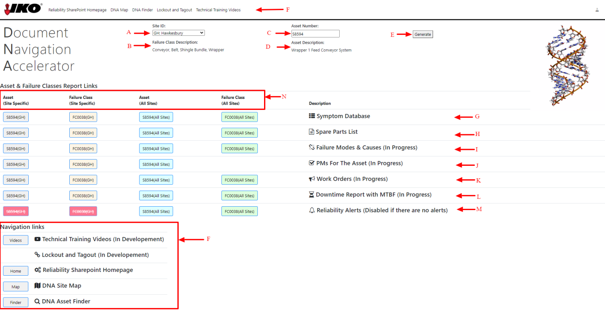

Figure : Main Interface

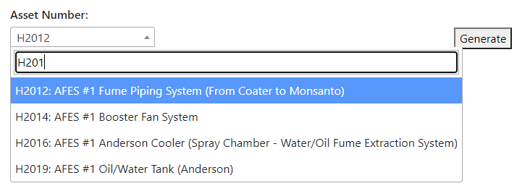

Figure : Asset Number Selector

1. **Site:** Select the name of the site you are searching for from a dropdown menu
2. **Failure Class Description:** Description of the Failure Class associated with the asset will be displayed here if available
3. **Asset Number:** Select the asset you are searching for from a dropdown menu, use the input box to filter for assets, see Figure 2
4. **Asset Description:** Description of the asset will be shown here if available
5. **Generate:** Once the Site ID and Asset Number have been selected, press this button to get descriptions and generate links to reports
6. **Navigation Links:** Uses these links to access other resources
   1. **Reliability SharePoint Homepage**
   2. **DNA Map**
   3. **DNA Finder**
   4. **Lockout and Tagout**
   5. **Technical Training Videos**
7. **Symptom Database**
8. **Spare Parts List:** Search for spare parts
   1. Grey: Spare parts of the asset from a specific site
   2. Orange: Spare parts for the failure class associated with the asset at the specific site (This will be assets similar to the one selected)
   3. Blue: Spare parts of the asset from all sites that has that asset
   4. Green: Spare parts for the failure class associated with the asset at all sites that has that asset (This will be assets similar to the one selected)
9. **Failure Modes & Causes:** Failure Modes & Causes information
   1. Grey: Failure Modes & Causes information of the asset from a specific site
   2. Orange: Failure Modes & Causes information for the failure class associated with the asset at the specific site (This will be assets similar to the one selected)
   3. Blue: Failure Modes & Causes information of the asset from all sites that has that asset
   4. Green: Failure Modes & Causes information for the failure class associated with the asset at all sites that has that asset
10. **PMs For The Asset:** Get Preventive Maintenance Report
11. Grey: PMs of the asset from a specific site
12. Orange: PMs for the failure class associated with the asset at the specific site (This will be assets similar to the one selected)
13. Blue: PMs of the asset from all sites that has that asset
14. **Work Orders:** Work Order information
    1. Grey: Work Order information of the asset from a specific site
    2. Orange: Work Order information for the failure class associated with the asset at the specific site (This will be assets similar to the one selected)
    3. Blue: Work Order information of the asset from all sites that has that asset
    4. Green: Work Order information for the failure class associated with the asset at all sites that has that asset (This will be assets similar to the one selected)
15. **Downtime Report with MTBF:** Downtime report with Mean Time Between Failure
    1. Grey: Downtime report of the asset from a specific site
    2. Orange: Downtime report for the failure class associated with the asset at the specific site (This will be assets similar to the one selected)
    3. Blue: Downtime report of the asset from all sites that has that asset
    4. Green: Downtime report for the failure class associated with the asset at all sites that has that asset (This will be assets similar to the one selected)
16. **Reliability Alerts:** Plant generated Reliability Alerts in the SharePoint
    1. Grey: Reliability Alerts of the asset from a specific site
    2. Orange: Reliability Alerts for the failure class associated with the asset at the specific site (This will be assets similar to the one selected)
    3. Blue: Reliability Alerts of the asset from all sites that has that asset
    4. Green: Reliability Alerts for the failure class associated with the asset at all sites that has that asset (This will be assets similar to the one selected)
17. **Report Links Categories:** There are up to 4 different types of links available for each row
    1. **Grey:** This column of links will show information that is specifically related to the **chosen asset** at the **chosen site**
    2. **Orange:** This column uses the failure code of the selected asset to show information about similar asset at the **chosen site**
    3. **Blue:** This column shows information specifically related to the **chosen asset** at all IKO sites that has assets with this Asset Number
    4. **Green:** This column uses the failure code of the selected asset to show information about similar asset at all IKO sites

## Code Maintenance

Remember to exported a PDF version to the [Assets folder](http://operations.connect.na.local/support/Reliability/ReliabilityShared/Pages/Forms/AllItems.aspx?RootFolder=%2Fsupport%2FReliability%2FReliabilityShared%2FPages%2FAssets&FolderCTID=0x012000581EC42A3BD89948BB9EDC7213991941&View=%7BBBC311C9%2D17EB%2D4C39%2D8564%2DB3B6252E6BED%7D)

### Intro

Due to the lack of a proper webserver, this webpage is written in single HTML page style.[1] The HTML file is saved as ‘AssetRedirect.aspx’ at on the [SharePoint](http://operations.connect.na.local/support/Reliability/ReliabilityShared/Pages/Forms/AllItems.aspx?InitialTabId=Ribbon%2ERead&VisibilityContext=WSSTabPersistence).[2]

The code can be edited with any text editor, though some kind of IDE like Visual Studio Code is recommended instead of Notepad.

The code has three main sections <html>, <script>, and <style> all IKO developed code for this website is contained within these three sections, <script> includes JavaScript, and <style> contains CSS.

Various CSV files are loaded by the website, since there is no webserver this is our readonly ‘database’, since there is no writing to csv from the website[3]

### Dependencies

This page has the following 3rd party dependencies

* [jQuery](https://jquery.com/)
  + Required by select2, bootstrap 4
* [papaparse](https://www.papaparse.com/)
  + Used to quickly read csv files to memory
* [Bootstrap](https://getbootstrap.com/)
  + Popular front end toolkit with lots of documentation that supports ie11
* [Select2](https://select2.org/)
  + Adds an input box to filter dropdown menus, see Figure 2
* [Font Awesome 4](https://fontawesome.com/v4.7.0/)
  + Icon Library

### Data Resources

The following resources are saved on the SharePoint and used by this webpage. These files are stored under the [Assets folder here](http://operations.connect.na.local/support/Reliability/ReliabilityShared/Pages/Forms/AllItems.aspx?RootFolder=%2fsupport%2fReliability%2fReliabilityShared%2fPages%2fAssets&FolderCTID=0x012000581EC42A3BD89948BB9EDC7213991941)[4]

* [siteid].csv
  + Various csv files that are named by siteid are used by this website to populate the dropdown menu for assets at a site
  + Required Information:
    - Asset ID [Column 0]
    - Asset Description [Column 1]
  + Link to SOP (TODO)
* RotatingDNA.mp4
  + The animated DNA logo that plays on the right side
* FailureClasses.csv
  + Links assets and site id with failure classes
  + Required information:
    - Asset ID [Column 0]
    - Failure Class [Column 1]
    - Site ID [Column 2]
* FailureClassDescriptions.csv
  + Gives descriptions for each failure class
  + Required Information:
    - Failure Class [Column 0]
    - Failure Class Description [Column 1]
* ReliabilityAlerts.csv
  + Lists all reliability alerts on the sharepoint
  + No information about files are included, just that assets, failure code and their sites have alerts
  + Required information:
    - Siteid_assetnumber [row 0]
    - Siteid_failurecode [row 1]
    - Assetnumber [row 2]
    - Failurecode [row 3]
  + This csv file can be generated using the SharepointReliabilityAlerts.xlsm file
    - Press the refresh button then ctrl + q to auto generate the csv file
    - 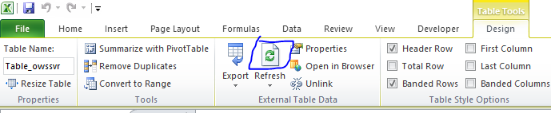

### HTML

HTML defines the content of a webpage. Since bootstrap is being used most elements have bootstrap class names such as <div class="table-responsive text-nowrap"> which means a responsive bootstrap table is being created, and the bootstrap text-nowrap setting is being applied.

2 Main sections, the navigation bar under the <nav> tag and the main body under <div class="container-fluid">

Since the view should be similar on desktop and mobile, tables are used so that components do not rearrange themselves. A nested table is used to place the different components; the structure has been replicated below

|  |  |  |  |  |  |
| --- | --- | --- | --- | --- | --- |
| |  |  |  |  |  | | --- | --- | --- | --- | --- | | DNA | Site ID  Failure Class Desc | Asset Number  Asset Desc | Generate | RotatingDNA | |
| Asset & Failure Classes Report Links   |  |  |  |  |  | | --- | --- | --- | --- | --- | | Asset  (Site Specific) | Failure Class  (Site Specific) | Asset  (All Sites) | Failure Class  (All Sites) | Description | | Link | Link | Link | Link | Description | | Link | Link | Link | Link | Description | | Link | Link | Link | Link | Description | | Link | Link | Link | Link | Description | | Link | Link | Link | Link | Description | | Link | Link | Link | Link | Description | | Link | Link | Link | Link | Description | |
| Navigation Links   |  |  | | --- | --- | | Link | Description | | Link | Description | | Link | Description | | Link | Description | | Link | Description | |

Since the links in the report section changes based on what site and asset the user selected it is generated via javascript

### CSS

To mimize the amount of styling within the HTML, styling is mostly kept in the CSS section of the code, similar to how class tags are used by bootstrap, css rules are also applied via class selection

Since bootstrap takes care of most of the styling, the custom css is mostly color and element width definitions

### JavaScript

Once the page finishes loading, document.addEventListener('DOMContentLoaded', function () { runs which loads the csv files for FailureClasses and ReliabilityAlerts. In addition it reads the asset number and site id parameters from the URL if any and saves them to the url_query variable document.addEventListener('DOMContentLoaded', function () {

Then ChangeSite() runs which will populate the Asset number dropdown field with assets from the site, if the url did not specify then the site is GH by default

The function to generate links to reports is called genLinks(selected_data) it first determines the failure class of the asset, the creates the links table using nested arrays: urls, cellFormat, cellText, and descriptions, finally the Reliability Alerts links are disabled if there are no related alerts

readCSV(url, callback)

Special notes about this functions, papaparse loads remote csv files asynchronously, which means that js will not wait for the readCSV function to finish reading the csv file before continuing, this is why callbacks are used, the callback function executes when readCSV itself has finished. If special care is not taken for asynchronous functions a race condition will occur. In our case our code will try to read the variable where the csv data will be stored, but error out since the data has not been populated yet.

If you need to add sites just add the site Id in the siteName field of the search table and in global variables of the JavaScript.

1. I don’t think that’s actually a thing, but it’s what I’ll be calling it
2. Why aspx you might ask? For some reason .html caused an error, however it does not anymore, but the links to the page in PDFs are already .aspx so it is too much work to change it
3. Writing to csv might actually be possible since SharePoint 2010 does have an API, however credentials and such would be complicated so it has not been implimented
4. Other webpages expect the csv files to be stored in the root folder which is messy and now frowned upon