V3_DCModels_R1_I1_2010Sep- org.hl7.HeartRate-v0.74



HL7 Version 3 Detailed Clinical Models (DCM)
Release 1
(Universal Realm)
1st Informative Ballot

DCM example org.hl7.HeartRate-v0.74
September 2010 / Version after ballot reconciliation September 2013
Updated for implementation May 2014 v 0.74

© 2010 / 2013 Health Level Seven, Inc.
Ann Arbor, MI
All rights reserved.

Co-Chair/Co-Editor | William Goossen  Results 4 Care B.V.  wgoossen@results4care.nl
Co-Chair | Ian Townend  NHS  ian.townend@nhs.net
Co-Chair | Stephen Chu  NEHTA  stephen.chu@nehta.gov.au
Co-Chair | Klaus D Veil  HL7 Systems and Services  Klaus@Veil.net.au
Primary Editor: | Anneke Goossen  Results 4 Care B.V.  agoossen@results4care.nl
Co-Editor: | Jos Baptist  Nictiz  Baptist@nictiz.nl
Co-Editor: | Ewout Kramer  Parelsnoer Initiative  e.kramer@furore.com
Co-Editor: | Abel Enthoven  Furore B.V.  a.enthoven@furore.com
Co-Editor: | Michael van der Zel  University Medical Center Groningen  m.van.der.zel@ict.umcg.nl and  Results 4 Care B.V.  mvdzel@results4care.eu
Co-Editor: | Ybranda Koster-de Jong  At time of development at Results 4 Care B.V.  info@results4care.nl
Technical Editor | William Goossen
Project Working Group also includes: | Nictiz, Parelsnoer initiative, OIZ
Table of Contents
org.hl7.HeartRate-v0.74 4
Revision History 4
Heart Rate 4
Purpose 4
Evidence Base 5
Information Model 5
Example Instances 11
Instructions 11
Interpretation 12
Care Process 12
Example of the Instrument 12
Constraints 12
Issues 12
References 12
Functional Model 13
Traceability to other Standards 13
Disclaimer 13
Terms of Use 14
Copyrights 14

org.hl7.HeartRate-v0.74
DCM::CoderList | Anneke Goossen, Michael van der Zel, Abel Enthoven
DCM::ContactInformation.Name | Results4Care
DCM::ContactInformation.Telecom | info@Results4care.nl
DCM::ContentAuthorList | Anneke Goossen, Ybranda Koster
DCM::CreationDate | 5-11-2009
DCM::DescriptionLanguage | nl, en
DCM::Id | DCMR4C00009
DCM::KeywordList | Heart Rate, Pulse Rate D006339
DCM::LifecycleStatus | Draft
DCM::ModelerList | Michael van der Zel, Ybranda Koster, William Goossen
DCM::Name | org.hl7.HeartRate
DCM::PublicationDate | 2014-May-24
DCM::PublicationStatus | Published
DCM::ReviewerList
DCM::Version | 0.74

Revision History
Version 0.1 till version 0.64 is development, review and adjustments of the DCM. Version 0.64 is developed in Enterprise Architect.
Version 0.64 till version 0.66 are adjusted in cooperation with the project Parelsnoer Initiative. The scope was the development of the information model.
Version 0.65 is the English translation of version 0.64.
Version 0.66 is the adjustment to the new template for a DCM and the preparation for the HL7 ballot in 2010.
0.70 is information model style corrected. Versions 0.71 and 0.72 deal with partial ballot reconciliation from HL7 community.
Version 0.73: all HL7 comments have been reconciled in the text and model and verified one by one. E.g. added duration of measure and others.
Added missing codes for codes for 1 minute min, max, mean.
Version 0.74. Added missing code for palpation.

Heart Rate
This DCM concerns the observation pulse rate. The pulse rate is the pumping motion of the heart. In this DCM all concepts that belong to the manual measurement of the pulse rate are addressed.

Purpose
Purpose is to measure the pulse rate to check the blood flow of the patient. During this measuring the frequency, strength, equality, regularity and volume of the heart is checked.
In a lot of patients the measuring of the pulse rate is important. In patients with a defect of the blood flow, by whom the blood flow might change, the pulse rate should be measured more than twice a day (Arets, Vaessen & Gijselaers, 1988). These are all patients with a heart or cardiovascular condition due to various causes, such as bleeding, medications, or alterations in nervous system function (Arets, Vaessen & Gijselaers, 1988).

Evidence Base
In counting the heartbeats the speed, frequency per minute, in which the heart pumps the blood through the body is observed. During one heart beat the heart muscle first contracts the atriums and than the ventricles. The pulse is measured by putting pressure on any artery in which pulsations can be felt (Usually the radial artery pulse). In addition to this list, the pulse can be felt directly from the precordium in the chest. The frequency per minute is the pulse rate. This is usually equal to the heart rate. Therefore both terms are used. (medicine online, 2008)
Arteries the pulse rate can be observed are (TPVO, 2002):
1. Superficial temporal artery (temple)
2. Carotid artery (neck): in circulation problems this site is most often used, because the artery is easy perceptible and accessible;
3. Brachial artery (upper arm);
4. Radial artery (pulse);
5. Femoral artery (groin);
6. Popliteal artery (popliteal);
7. Artery Dorsalis pedis (top of the foot);
8. Posterior Tibial artery ( ankle);
9 Tibial artery (lower leg);
10. Subclavian artery (clavicle);
11. Fontanel (on baby’s);
12. External carotid artery (jaw)

Beside the beats per minute, the frequency, there are more aspects to the pulse rate than can be observed: regularity, volume, equality, strength (TPVO, 2002; http://mens-en-gezondheid.infonu.nl).

The regularity is the rhythm. This can be regular or irregular. This means that the pause between the beats, are just as long or are different in length.The irregular rhythm has several forms:
- Premature atrial contraction (Extra-systoles): A weak beat is followed by a strong beat.
- Palpitations: Patient is aware of the beating of his or her own heart.
- Bigeminal pulse: Two heart beats in quick succession, each pair is separated by a longer interval
- Trigeminal pulse: A pause after every third heart beat.
- Pulsus alternans: Strong and weak beats alternate
- Pulsus irregularis perpetuus: The pulse is completely irregular and unequal.
- Pulsus Bisferiens: A pulse with two systolic peaks.

The filling is the (estimated) amount of blood that is forced through the arteries with each contraction. The equality how equal the amount of blood forced through the arteries is each contraction. The strength is the pressure with which the heart muscle pumps the blood through the heart into the aorta.

Information Model
HeartRate is rootconcept
HeartRate has Method
HeartRate has Exertion
HeartRate has BodyPosition
HeartRate has Regularity
HeartRate has FrequencyQualification
HeartRate has Volume
HeartRate has Location
HeartRate has Strength
HeartRate has Rhythm
HeartRate has Frequency
Location is a coded description
FrequencyQualification is a coded description
BodyPosition has Position
Exertion is a coded description
PositionMeasure is a Position
Frequency is a physical quantity
Volume is a coded description
Regularity is a coded description
Strength is a coded description
Rhythm is a coded description
Method is a coded description

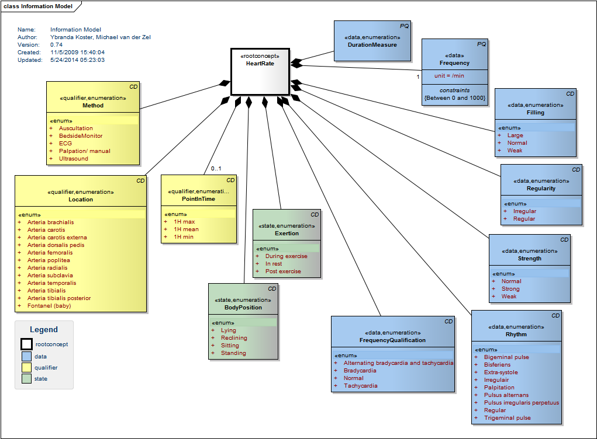

Concept | Definition
HeartRate  SCT:364075005 heart rate | This is about the observation and documentation of the heart rate of a person.

Concept | Definition
BodyPosition  SCT:9851009 body position finding, SCT:397155001 body position | The body position of the patient during the measure of the heart rate.
  Lying
  SCT: 102538003 recumbent body position
  Reclining
  SCT: 272587006 position with tilt
  Sitting
  SCT: 33586001 sitting position
  Standing
  SCT: 10904000 orthostatic body position

Concept | Definition
DurationMeasure  LOINC:code 8888-0 displayName Heart rate measure duration | Time used for this measure (e.g. 15 seconds, 1 minute).

Concept | Definition
Exertion  SCT:19487008 Exertion | After exercise the pulse rate is increased
  During exercise
  SCT: 128976003 exercise state
  In rest
  SCT: 128975004 resting state
  Post exercise
  SCT: 128978002 post exercise state

Concept | Definition
Filling  SCT:366201008 pulse volume - finding | Interpretation of the filling of the vessels during heartbeat.
  Large  SCT: 271640005 large volume pulse | The volume is large
  Normal  SCT: 421014001 full pulse volume | The volume of the pulse is normal
  Weak  SCT: 64661000 weak pulse | The volume is weak

Concept | Definition
Frequency  SCT:364075005 heart rate, LOINC:code 8867-4 displayName heart rate | The mechanics of the heart rate: number of beats per minute
Constraint | Between 0 and 1000 | inv:self.value>=0 and self.value<1000

Concept | Definition
FrequencyQualification  SCT:301113001 Finding of heart rate | Interpretation of the rate of the heart as beats per minute
  Alternating bradycardia and tachycardia  SCT: 74615001 tachycardia-bradycardia | Alternating bradycardia and tachycardia: heart beats alternately more than 100 beats per minute and less than 60 beats per minute.
  Bradycardia  SCT: 48867003 bradycardia | Heart beats less than 60 beats per minute in rest
  Normal  SCT: 76863003 normal heart rate | The frequency of the heart rate is normal.
  Tachycardia  SCT: 3424008 tachycardia | Heart beats more than 100 beats per minute.

Concept | Definition
PointInTime  SnomedCT:code: 272105005 displayName: points in time
  1H max
  LOINC: code 8869-0 displayName Heart rate 1 hour maximum
  1H mean
  LOINC:code 41920-0 displayName Heart rate 1 hour mean
  1H min
  LOINC: code 8879-9 displayName Heart rate 1 hour minimum

Concept | Definition
Regularity  SCT: 364074009 Regularity of heart rhytm | Interpretation of the regularity of the heart rate.
  Irregular
  SCT:61086009 pulse irregular
  Regular
  SCT: 271636001 pulse regular

Concept | Definition
Location  SCT: 363704007 procedure site | The location where the heart rate is measured.
  Arteria brachialis
  SCT: 17137000 brachial artery
  Arteria carotis
  SCT: 69105007 carotid artery
  Arteria carotis externa
  SCT: 22286001 external carotid artery
  Arteria dorsalis pedis
  SCT: 86547008 dorsalis pedis artery
  Arteria femoralis
  SCT: 181349008 superficial femoral artery
  Arteria poplitea
  SCT: 43899006 popliteal artery
  Arteria radialis
  SCT: 45631007 radial artery
  Arteria subclavia
  SCT: 36765005 subclavian artery
  Arteria temporalis
  SCT: 15672000 superficial temporal artery
  Arteria tibialis
  SCT: 181351007 tibial artery
  Arteria tibialis posterior
  SCT: 181358001 posterior tibial artery
  Fontanel (baby)
  SCT: 272681004 fontanelle

Concept | Definition
Method  SCT:84203001 has method | The way how the heart rate is measured and observed.
  Auscultation  SCT: 37931006 auscultation | The heart rate is determined by auscultation.
  BedsideMonitor  SCT: 88140007 cardiac monitor surveillance | The heart rate is determined by continious monitoring.
  ECG  SCT: 46825001 ecg monitoring | The heart rate is determined by an electrocardiographic monitoring
  Palpation/ manual  SCT: 113011001 Palpation | The heart rate is determined by palpation on a peripheral artery.
  Ultrasound
  SnomedCT:16310003 Ultrasound(procedure)

Concept | Definition
Strength  Parelsnoer: 3.4 | The power with which the blood is pumped through the heart and arteries. This is subtle different from the filling. It is not the peak volume, but the volume increase / decrease per time unit.
  Normal  Parelsnoer: 3.1 | The strength is normal
  Strong  Parelsnoer: 3.2 | The strength is strong
  Weak  Parelsnoer: 3.3 | The strength is weak

Concept | Definition
Durationofmeasure  LOINC:code 8888-0 displayName Heart rate measure duration | Describes how long the heart rate was measured, e.g. 15 seconds, one minute

Concept | Definition
Rhythm  SCT:301149000 Pulse rhythm | Interpretation of the rhythm of the heart rate.
  Bigeminal pulse  SCT: 195103000 bigeminal pulse | Double beats with intervening gap
  Bisferiens  SCT: 415216000 pulses bisferiens | Pulse with two systolic peaks
  Extra-systole  SCT: 284470004 premature atrial contraction | A weak beat is followed by a strong beat
  Irregulair  SCT: 248650006 heart irregular | Irregular heart rate
  Palpitation  SCT: 80313002 palpitations | Being aware of the beating of one's own heart
  Pulsus alternans  SCT: 42807005 pulsus alternans | Strong and weak beats alternate
  Pulsus irregularis perpetuus  SCT: 271638000 pulse regularly irregular | Pulse is completely irregular and unequal
  Regular  SCT: 248649006 heart regular | Regular heart beat
  Trigeminal pulse  SCT: 29036000 trigeminal pulse | Triple beats with intervening gap  .

Example Instances
Not available

Instructions
For the manual measurement of the pulse rate a watch with a second hand or a pulse counter. The pulse rate is measured at the pulse, in case the pulse is not very perceptible, the neck artery, temporal artery or the groin artery are also often used (Schnell, 1990). Put the index-, middle-, and ring finger length wise on the artery in order to measure the pulse rate. When measuring with the thumb it is possible to feel the own pulse rate (Vlaamse kruis, 2008).
The pulse is barely perceptible in case of severely disturbed circulation, such as a massive bleeding. The measurement preferably takes place when the patient is at rest and is relaxed and sitting down. The pulse rate can be measured for 15 or 30 seconds and than respectively be multiplied by 4 or 2 to get the pulse rate per minute. The outcome has to be corrected for the inaccuracy of the measurement. In a measurement of 15 seconds the pulse rate is calculated by: (amount of beats in 15 seconds) * 4 ± 4. In a measurement of 30 seconds the pulse rate in calculated by: (amount of beats in 30 seconds) * 2 ± 2. This means that the calculated pulse rate is a margin where the actual pulse rate is. For example, when 15 beats are measured in 15 seconds, the pulse rate is 15 * 4 ± 4 = 60 ± 4. The pulse rate per minute in this case is between 56 and 64.
Usually the pulse rate is measured for 15 seconds, but in case of a irregular pulse rate, the pulse is measured for 30 seconds. (Arets, Vaessen & Gijselaers, 1988).
After the measurement is done the pulse rate is documented on the list of physical data. The other aspects of the pulse rate, such as regularity, strength, are documented in the patients health record. Also improvements are documented.

The heart rate can also be determined by auscultation, continues monitoring and ECG.

Interpretation
The average pulse rate in rest is:
- 100-160 beats per minute in baby’s younger than 1 year old
- 70-120 beats per minute in children between 1 and 10 years old
- 60-100 beats per minute in people more than 10 years old. The average pulse rate in a male is between 70 and 85 beats per minute and in a female the pulse rate is between 75 and 90 beats per minute.
- 40-60 beats per minute in trained athletes

When the pulse rate in an adult is more than 100 beats per minute we speak of tachycardia. In a pulse rate less than 60 beats per minute we speak of a bradycardia. A patient can also have an alternating heartbeat with slow and then fast pulse rate. This interpretation is the frequency qualification of the heart beat.
The interpretation of the deviation of the pulse rate is, for a physician, reason to make an ECG. The interpretation of an ECG is restricted to physicians or specialised nurses.

Care Process

The pulse rate provides information about the functioning of the heart. Together with other data, such as body temperature, respiration and blood pressure, the pulse rate provides important indications to the health condition of a person. These observations are put into a curve in the hospitals so the progress can be followed in time.
The observation of the pulse rate is often done. Usually as a part of the physical examination. This is done to monitor the progression of the disease. Just like in other observations the outcome of the pulse rate can be of influence on the treatment (Schnell, 1990).
The pulse rate can also be measured using a ECG or a Doppler test. These methods of observation however, are beyond the scope of this DCM.

Example of the Instrument
None available

Constraints
None known

Issues
- The DCM Body Position needs to be developed
- Need SCT for PointInTime, Method.Ultrasound?

References
Projects/ Projecten:
eDiabetes, Nictiz, Parelsnoer Initiative

Literature/ Literatuur:
Archetype openEHR-EHR-OBSERVATION.Heart_rate_pulse.v1.html. Verkregen op 23 juni 2010, van http://www.openehr.org/knowledge/

Zorginformatiemodel Doc_Obs_Hartslag_V1.1.doc. Verkregen op 2 oktober 2008, van http://www.zorginformatiemodel.nl

De Hartslag. Verkregen op 2 oktober 2008, van http://www.hetvlaamsekruis.be/ehbo_info/cursus/09_Algemene_onderdelen/DeHartslag.htm

Hartfilmpje of electrocardiogram (ECG). Verkregen op 2 oktober 2008, van http://www.hartstichting.nl/go/default.asp?mID=5545&rID=1877

Schnell, H., (1990). Handleiding verpleegkundige vaardigheidstraining. Diagnose. Het observeren en beoordelen van de pols. Lochem, De Tijdstroom.
Arets, J. R. M., Vaessen, J. P. & Gijselaers, H., (1988). Met zorg verplegen. Deel 1b. Spruyt, Van Mantgem & De Does: Leiden.

Hamilton, H.K., Rose, M.B., (1993) Verpleegkundige handelingen en procedures, De praktijk van het verplegen. Lemma BV: Utrecht.

Custers, A., Nas, H., Transferpunt Vaardigheidsonderwijs (TPVO), (2002). Docentenhandleiding Kwalificatieniveau 4. Observatietechnieken. Houten/ Mechelen, Bohn Stafleu Van Loghum.

MacCloskey Dochterman, J. C., Bulechek, G.M., (2000). Verpleegkundige interventies. St Louis, Missouri, Mosby inc.

De pols. Verkregen op 2 oktober 2008, van http://mens-en-gezondheid.infonu.nl

Heart rate- Pulse rate. Verkregen op 11 december 2008, van http://www.medicineonline.com/topics/H/2/Heart-Rate/Pulse-Rate.html

Vocabulary/ Vocabulair:
Name code system/ Naam code systeem: Snomed CT (SCT)

OID code system/ OID code systeem : 2.16.840.1.113883.6.96

Functional Model
Not defined

Traceability to other Standards
Not defined

Disclaimer
Nictiz as ordering customer and Results 4 Care B.V. and Parelsnoer as subcontractor give utmost care to the reliability and timeliness of data in this DCM, Detailed Clinical Model. Errors and inaccuracies may occur. Nictiz, Results 4 Care and Parelsnoer are not responsible for damages resulting from errors or inaccuracies in the information, nor for damages arising from problems caused by, or inherent in the spreading of information via the Internet, as failures or interruptions from either errors or delays in the distribution of information or services by Nictiz, Results 4 Care or Parelsnoer, or form you to Nictiz, Results 4 Care or Paerlsnoer by means of a website from Nictiz, Results 4 Care or Parelsnoer of by e-mail, or otherwise electronically.
Nictiz , Results 4 care and Parelsnoer do not accept responsibility for possible damage suffered as a result of the use of data, advise or ideas provided by or in name of Nictiz, Results 4 Care or Parelsnoer by way of this DCM. Nictiz does not accept responsibility for the content of information in this DCM to which or from which using a hyperlink or otherwise, is referred.

In case of contradictions in the mentioned DCM documents en files the priority of the relevant documents is stated by the most recent and highest version mentioned in the revision (version management).
In case information that is included in the electronic version of this DCM is also provided in writing, in case of textual differences the written version will determine. This applies if the version description and date of both are equal. The definitive version has priority over a concept version. A revised version has priority over a previous version.

Terms of Use
The DCM is open source, so free to use, not to be changed.
Changes in the content en codes are seen upon as a infringement of copyright and is damaging for the goal of use: realisation of semantic interoperability.
You can suggest changes at info@results4care.nl
Revision suggestions will be looked at and may lead to:

a. revised DCM and results if accepted
b. variations of the DCM adapted on a local situation.

This is all based upon : a “common ownership” but not a “special stewardship”.

Copyrights
none applicable

