PHYS 2310H

Assignment 4

David Stothers

Mar. 23 2020

(1a) Inner Function: L E G

Outer Function: E E G

Main Program: G G G

The variables have no local value when they are used without being declared in a function, so each variable used like this retains its value from the layer above the current one.

(1b) The global tells outer to use the global memory address of x, so when x is changed in outer, it changes for the main function too.

Inner Function: L E G

Outer Function: E E G

Main Program: E G G

(1c) This time, x has its global address inside inner but not outer, so once x changes to L, it’s like that in the main program too.

Inner Function: L E G

Outer Function: E E G

Main Program: L G G

(1d)

(2) x = x+10 assigns a value to a variable, and assigns it only. The new x takes the value of the argument x added to 10. Meanwhile, += takes a variable’s address and increments it, so the old address of x is used and then added to.

(3d)

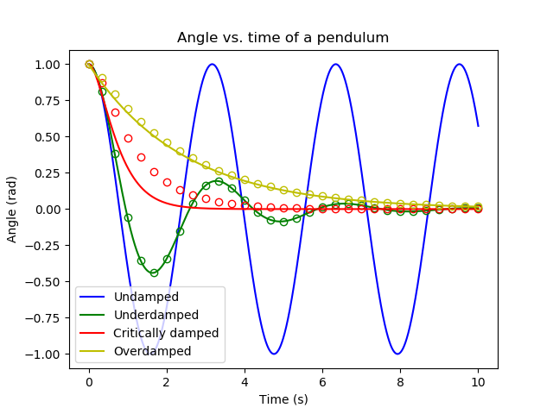

Figure 1: The graph of a pendulum’s various cases. The assumptions in (3a) were used in the calculations. In addition, the undamped case of the pendulum is shown. The lines of the damped cases represent the exact solution curves, and the dots represent the numerical solutions found. Each case has been colour coded as well.

(3e)

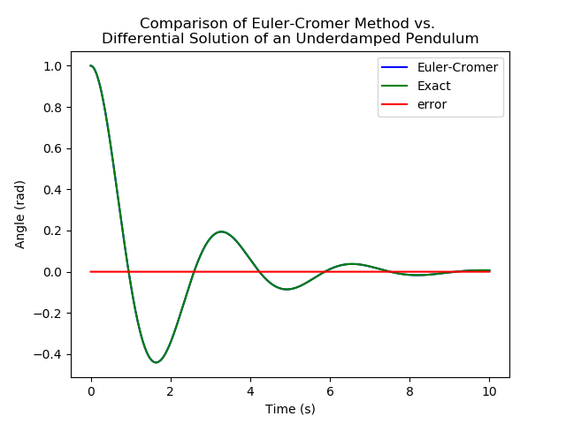

Figure 2: The exact and numerical solutions of the underdamped pendulum from (3d), graphed side by side. The error on this graph was so small at N = 150001 (the default value I used) that it might as well have been 0.

(3f)

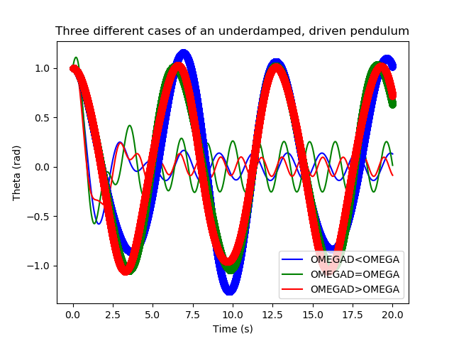

Figure 3: Three exact solutions of an underdamped, driven pendulum. Note the green case being of higher amplitude than the rest, showing a resonance at OMEGAD = OMEGA. The thick lines are the numerical solutions, which do not appear to follow the exact solutions.

(4b) For the following figures, the textbook’s initial parameters were taken – both pendulums start from rest and from an angle of 0.2 radians. Their masses were both 1 kg and their lengths were both 9.81 metres. The textbook differed here in that it used only 9.8 m/s2 for gravitational acceleration, but I erred in favour of the string lengths and the gravitational acceleration having the “same” magnitudes, if one can call it that.

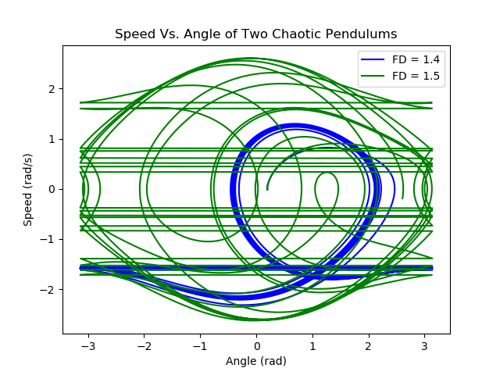

Figure 4: A plot of the pendulums’ speeds as they change with angle. Here we can see – disregarding the horizontal lines corresponding to a remapping of the angle back into the interval [-pi,pi) – that the pendulum with FD = 1.5 has its maximum speed near theta = 0, but the pendulum with FD = 1.4 follows a cyclic, repetitive pattern. As an aside, I found these types of figures in the textbook to look incredibly cool.

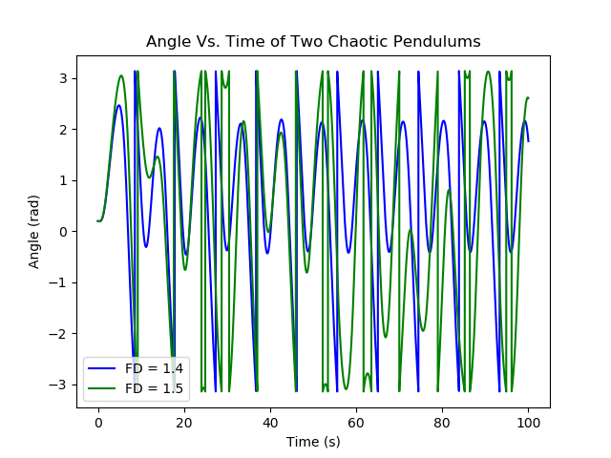

Figure 5: A plot of the two pendulums’ angles with respect to time. Note the vertical lines corresponding to mapping, and the erratic behaviour of the pendulums.