Computational Physics Asst. 5

David Stothers 0643608

Apr. 3 2020

(1a) strobe is an array of Boolean variables, with the same size and shape as dt, one very long, thin array.

t>10\*TD appears to be a limiter, spacing the data read away from the initial part of the equation, where the transient portion rules.

np.abs(np.remainder(t,TD))<dt/2 is the functional part of this line, making sure the time at which the data is read is close to TD. The dt/2 comes into play, I believe, by making sure that each TD is the centre of its remainder zone, and making sure that none of these remainder zones overlap.

In essence, this array sets up a sort of punch card containing data on whether or not to plot its matching point.

(1b) Included in the source code of a5lib is the Verlet algorithm method.

(1c)

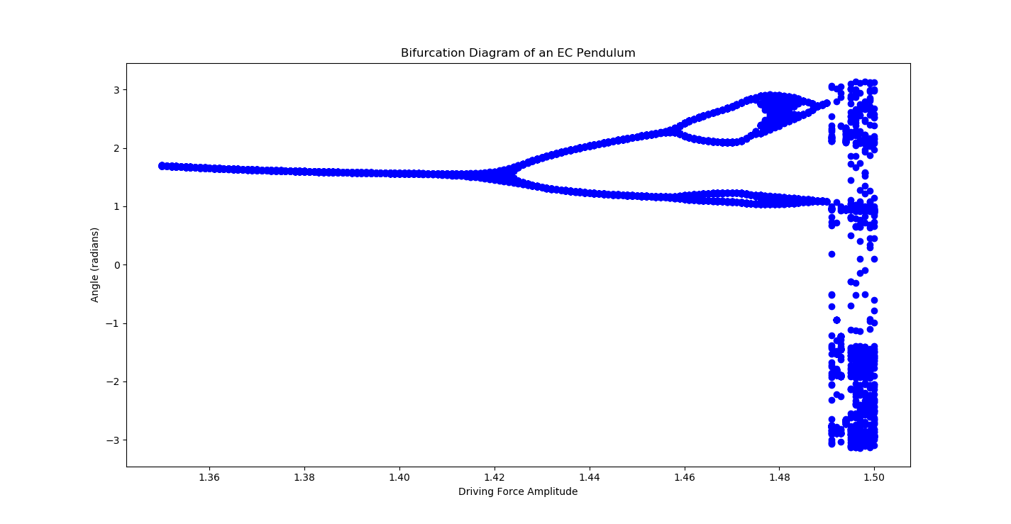

Figure 1: A bifurcation diagram of a 9.81m long pendulum, starting from rest at an angle of 0.2 radians, as it approaches chaos, simulated using the Euler-Cromer method.

A timestep of 0.01 seconds was used over a simulation length of 30 minutes; gravity was assumed to be 9.81 m/s2; q was assumed to be 0.5, and the driving frequency was taken to be 2/3.

Note the splitting in the paths where the period doubles as chaos is approached, and the fuzzy area beginning around FD = 1.49 as one arrives at chaos.

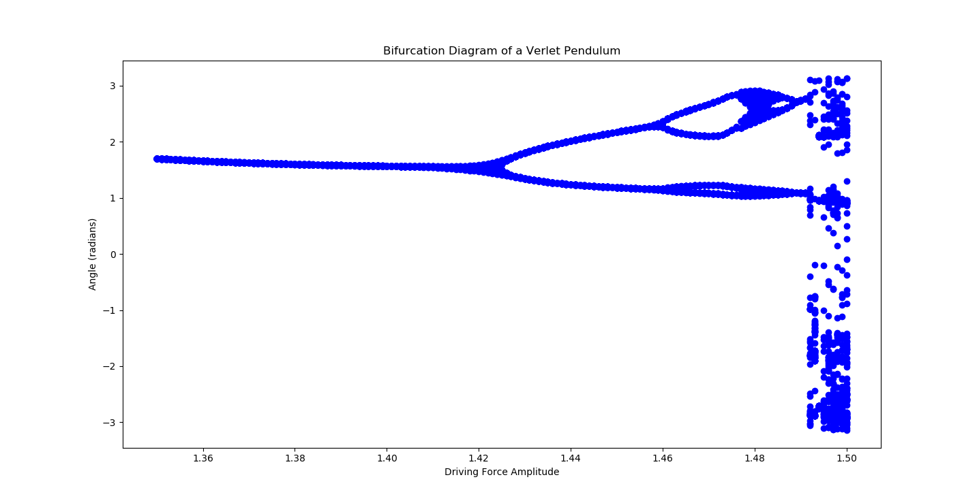

Figure 2: The same bifurcation diagram, done using my Verlet method and the same conditions as the EC diagram.

(1d) If my diagram is anything to go by – and I should hope it is; it was simulated using a .01s timestep over a period of half an hour, beginning the strobe some 10 driving force periods into the simulation – one arrives at chaotic behaviour upon reaching a driving force maximum magnitude of 1.49 N. As one can see, the motion of the pendulum follows no apparent pattern in phase with the driving force, and instead, as the angle is measured, a fuzzy, cloudy shape arises.