Immigration Detention Statistics Summary
31 January 2013

About this report
This report provides an overview of the number of people in immigration detention in Australia as at midnight on the date of the report. The report is produced on a monthly basis.
Data is sourced from several departmental processing and recording systems. Data relating to the immigration detention population is dynamic and there can be delays in transmission of information from the department's immigration detention network operations. Variations in figures between this report and previous issues can occur. Due to these issues, data from the current financial year should always be considered provisional.
This report includes people in immigration detention as set out under s189 or s249 of the Migration Act 1958.
Alternative places of detention includes detention in the community in private houses, hotels, apartments, foster care and hospitals with a person designated under the act.
Further information about immigration detention is available at: www.immi.gov.au/managing-australias- borders/detention.

Enquiries
Any comments or enquiries concerning this report should be sent using our client service feedback form quoting the name and date of the report.
See: http://www.immi.gov.au/managing-australias-borders/detention/visiting/enquiries-feedback.htm

Table of contents
IMMIGRATION DETENTION STATISTICS SUMMARY 3
People in Immigration Detention by Arrival Type 5
People in Immigration Detention by Nationality 6
Children in Immigration Detention 7
Time in Detention 9

Immigration Detention Statistics Summary
As at: 31 January 2013
There were 5697 people in immigration detention facilities and alternative places of detention, including 4526 in immigration detention on the mainland and 1135 in immigration detention on Christmas Island as at 31 January 2013.
Separately, 2178 people have been approved for a residence determination to live in the community. September 2012 to November 2012 saw an increase in arrivals, including children. This has impacted on the number of children in detention facilities for this month.
Table 1 –People in Immigration Detention Facilities and Alternative Places of Detention
Place of immigration detention | Men | Women | Children | Total | Change from 31 December Summary
Christmas Island IDC | 323 |  |  | 323 | - 530
Curtin IDC | 748 |  |  | 748 | - 184
Maribyrnong IDC | 71 | 12 |  | 83 | - 11
Northern IDC (Darwin) | 279 |  |  | 279 | - 62
Perth IDC | 21 |  |  | 21 | - 7
Scherger IDC | 510 |  |  | 510 | + 11
Villawood IDC | 340 | 40 |  | 380 | + 30
Wickham Point IDC | 878 |  |  | 878 | + 188
Yongah Hill IDC | 243 |  |  | 243 | - 211
Total in IDCs | 3413 | 52 |  | 3465 | - 870
Perth Immigration Residential Housing | 2 | 2 | 7 | 11 | - 9
Port Augusta Immigration Residential Housing | 15 | 15 | 22 | 52 | + 13
Sydney Immigration Residential Housing | 8 | 10 | 10 | 28 | - 1
Adelaide Immigration Transit Accommodation | 12 | 5 | 1 | 18 | + 18
Brisbane Immigration Transit Accommodation | 33 | 12 | 18 | 63 | + 2
Melbourne Immigration Transit Accommodation | 59 |  | 40 | 99 | - 2
Total in IRH and ITA | 129 | 44 | 98 | 271 | + 21
Alternative Places of Detention (Christmas Island and Cocos Keeling Island) | 232 | 226 | 354 | 812 | - 567
Alternative Places of Detention (Mainland) | 330 | 271 | 548 | 1149 | - 124
Restricted on Board Vessels in Port |  |  |  | 0 | 0
Total | 4104 | 593 | 1000 | 5697 | - 1540
People in Community under Residence Determination | 781 | 474 | 923 | 2178 | + 356

Immigration Detention Population from 1990 to 31 January 2013
The number of people in immigration detention month to month continues to fluctuate, predominantly due to the changing pattern of irregular maritime arrivals. The number of irregular maritime arrivals in December 2012 and January 2013 were down compared to the preceding 11 months.
Figure 1 - Population in Immigration Detention
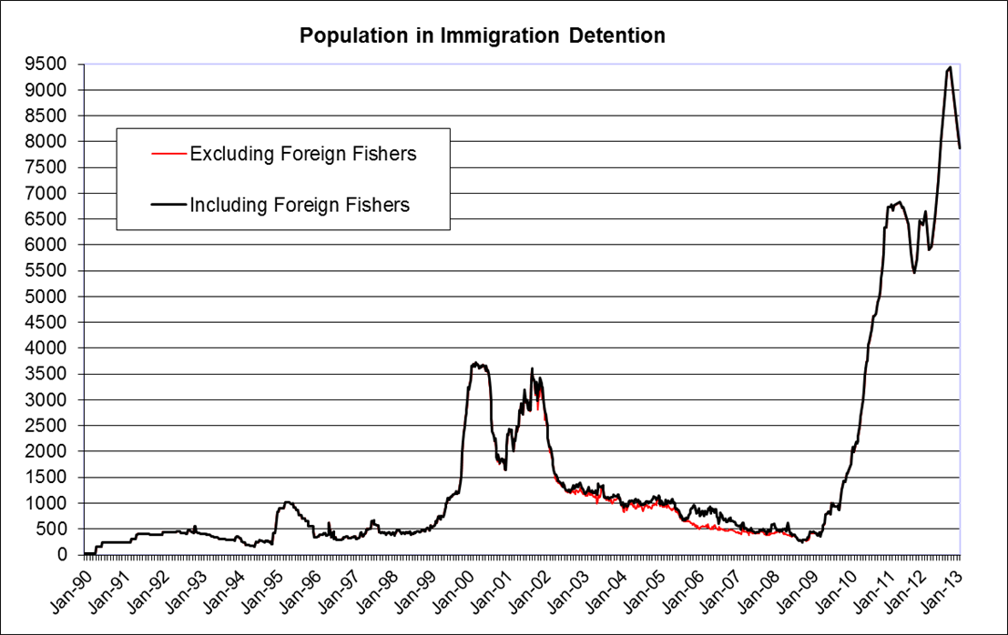

People in Immigration Detention by Arrival Type
The number of people in immigration detention who arrived unlawfully by air or boat as at 31 January 2013 was 7569. This represents about 96% of the total immigration detention population.
There were also 305 people (about 4% of the total immigration population) who arrived in Australia lawfully and were subsequently taken into immigration detention for either overstaying or breaching their visa conditions, resulting in visa cancellations.
Figure 2 - People in Immigration Detention by Arrival Type
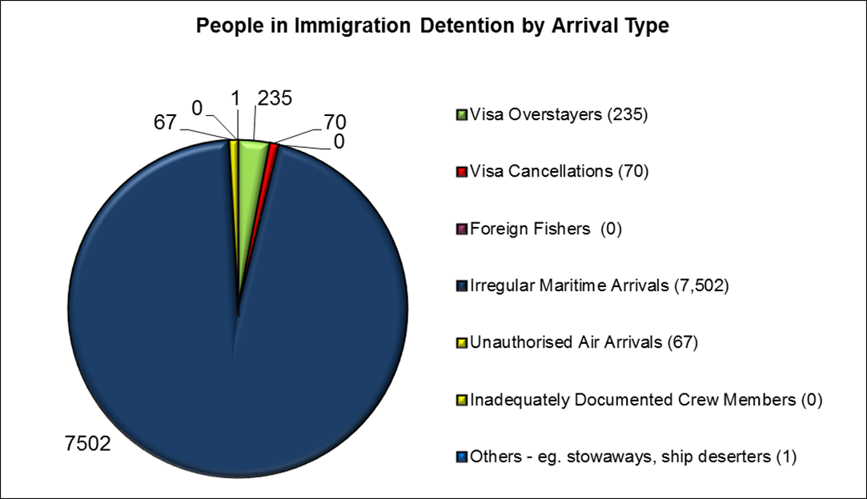

People in Immigration Detention by Nationality
Of the 5697 people in immigration detention facilities and alternative places of detention as at 31 January 2013 around 47% were Sri Lankan nationals, 13% were Iranian nationals and 11% were Afghan nationals.
Table 2 - People in Immigration Detention Facilities and Alternative Places of Detention as at 31 January 2013
Nationalities | Adult |  | Child (<18 years) |  | Total
Nationalities | Female | Male | Female | Male | Total
Sri Lanka | 186 | 2168 | 112 | 197 | 2663
Iran | 172 | 355 | 91 | 106 | 724
Afghanistan | 29 | 445 | 25 | 135 | 634
Iraq | 38 | 112 | 39 | 41 | 230
Bangladesh |  | 195 |  | 2 | 197
Pakistan | 9 | 132 | 5 | 25 | 171
Indonesia | 8 | 103 | 1 | 7 | 119
Myanmar | 15 | 30 | 15 | 19 | 79
China, Peoples Republic Of | 18 | 55 |  |  | 73
Vietnam | 7 | 39 | 3 | 12 | 61
Other | 111 | 470 | 74 | 91 | 746
Total | 593 | 4104 | 365 | 635 | 5697

Of the 2178 people approved to live in the community under residence determination, as at 31 January 2013 around 34% were Iranian nationals, 18% were Sri Lankan nationals and 15% were Afghan nationals.
Table 3 - People in the community under Residence Determination as at 31 January 2013
Nationalities | Adult |  | Child (<18 years) |  | Total
Nationalities | Female | Male | Female | Male | Total
Sri Lanka | 214 | 268 | 110 | 152 | 774
Iran | 72 | 143 | 47 | 130 | 392
Afghanistan | 30 | 125 | 19 | 153 | 327
Iraq | 37 | 72 | 19 | 42 | 170
Palestinian Authority | 18 | 20 | 22 | 15 | 75
Other | 103 | 153 | 83 | 131 | 470
Total | 474 | 781 | 300 | 623 | 2178

Children in Immigration Detention
As at 31 January 2013 there were 1000 children (aged under 18 years) in immigration detention facilities and alternative places of detention.
The increase in the number of children in detention facilities in November and December 2012 was due to a rapid increase in irregular maritime arrivals, from October to November 2012. This number has reduced as children complete mandatory processing and are transferred into the community.
Figure 3 - Children in Immigration Detention Facilities and Alternative Places of Detention
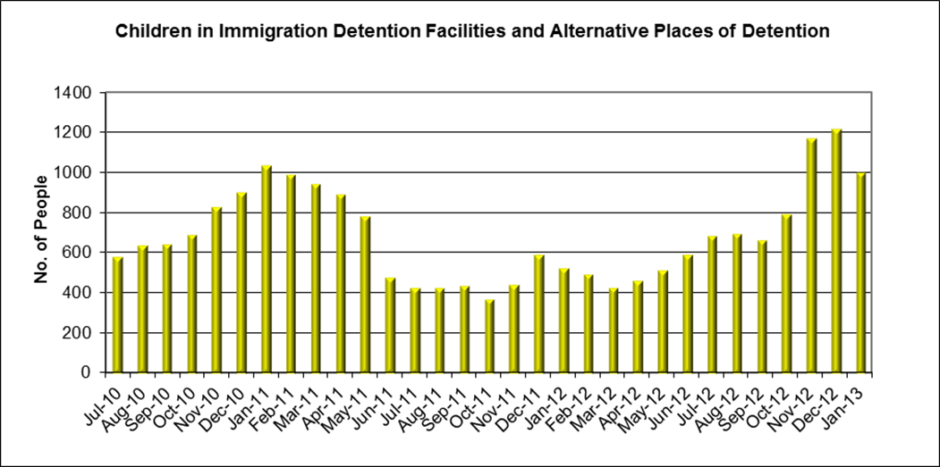

The number of children approved to live in the community under a residence determination has been maintained at a high level. The government announced on 18 October 2010 it would move the majority of children and vulnerable families into community based arrangements by 30 June 2010.
Figure 4 - Children in the community under Residence Determination
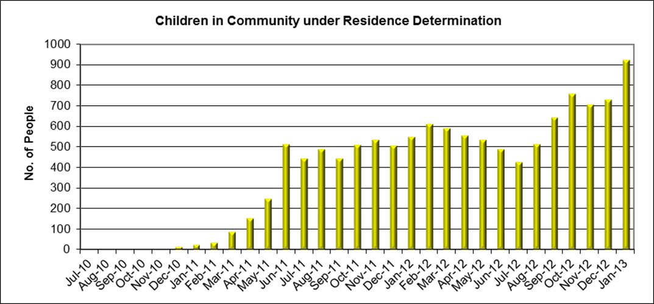

As at 31 January 2013, 1000 children remain in immigration detention while undergoing initial processing. 923 children were approved under residence determination for community placement. In addition 5 children had been granted a bridging visa and were living in the community.

Table 4 - Children in Immigration Detention as at 31 January 2013
Type | Total
Immigration Residential Housing | 39
Immigration Transit Accommodation | 59
Alternative Places of Detention | 902
Total | 1000
Children in Community under Residence Determination | 923
Children Granted Bridging Visa E (BVE) | 5

Time in Detention
Of the 7875 people in immigration detention as at 31 January 2013 around 34% had been detained for three months or less and 90% had been detained for 12 months or less.

Table 5 - Length of time in detention as at 31 January 2013
Period Detained | Total | % of Total
7 days or less | 154 | 2.0%
8 days - 31 days | 327 | 4.2%
32 days - 91 days | 2161 | 27.4%
92 days - 182 days | 3348 | 42.5%
183 days - 365 days | 1120 | 14.2%
366 days - 547 days | 162 | 2.1%
548 days - 730 days | 155 | 2.0%
Greater than 730 days | 448 | 5.7%
Total | 7875 | 100%
The average period people are held in detention facilities has significantly decreased from 277 days in November 2011 to 124 days as at 31 January 2013.
Figure 5 - Average days in immigration detention facilities only
