**Chatbot Documentation**

Done by: David Zhu (1703177)

Class: DISM/1B/21

**Features- All Panels**

1. Dismiss alarm button
   1. Dismisses any alarm set.
2. Dock menu
   1. Brings you to the selected panel.
3. Message bar
   1. Shows the current song playing on Chat and About Panel, shows “Remember to key in your ATS!” on the Home panel.

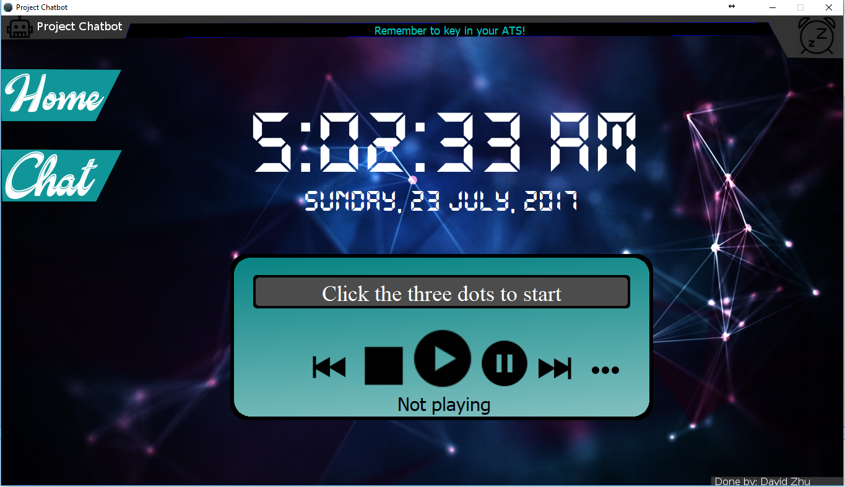

**Features - Home Panel**

1. Clock
   1. Display live clock the time is taken from system clock.
   2. Date displayed is also taken from system clock.
2. Music player
   1. Plays mp3 files in a local directory. (Order is auto shuffled.)
   2. Controls available: Stop, Play/Resume, Next, Previous, Choose directory/Reshuffle playlist.
   3. Displays number of songs in playlist and current song number.

**Features- Chat Panel**

1. Chat Area
   1. Shows the messages sent and received
   2. Orange colour text is user sent, blue colour is sent by chatbot.
2. Input field
   1. Type the message you want to send here
3. Send button
   1. Click to send your message
   2. You can also send by pressing the enter key.

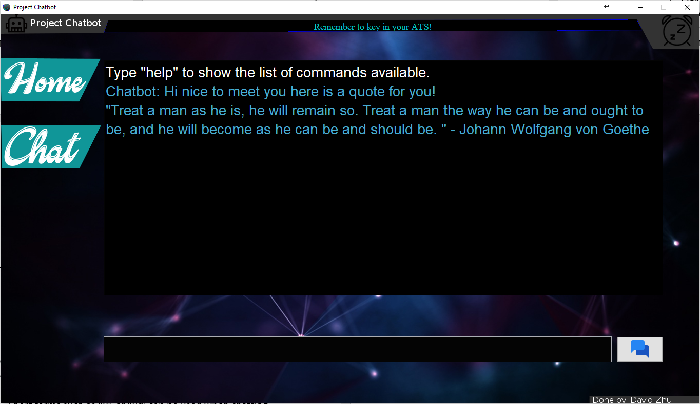

**Features- Chatbot Commands**

1. Help
   1. Shows all the commands available.
2. Clear
   1. Clears the chat area.
3. Encode
   1. Converts a decimal number to binary and hexadecimal. Use in format encode <decimal number>. Eg. encode 10
4. Decode
   1. Converts a binary or hexadecimal number to decimal. Use in format decode <binary/hexadecimal> <base>. For example, converting 0101 to decimal will be decode 0101 2
5. Set question
   1. Allows the user to set their own question and answer.
   2. Users can set multiple answers to the question by separating the answers with a comma followed by a space.

Eg. Answer1, Answer2, Answer3

1. List questions
   1. Lists all the set questions.
2. UV
   1. Gets UV reading data from data.gov.sg api
3. quote
   1. Gets a new quote from forismatic.com
4. Coin flip
   1. Returns either heads or tails.
5. Joke
   1. Tells a joke.
6. Music Commands
   1. mc dir
      1. Starts playing music if you already set your music directory, else it will ask you to set your music directory. Same as clicking the Choose directory/Reshuffle playlist button on home panel.
   2. mc stop
      1. Stops the music, the next time you play the songs will be reshuffled.
   3. mc pause
      1. Pauses the music, allowing you to resume from where you stopped
   4. mc resume
      1. Resume from where you paused your music.
   5. mc next
      1. Plays the next song in the playlist.
   6. mc prev
      1. Plays the previous song.
   7. mc change dir
      1. Changes the music directory.
7. Alarm commands
   1. alarm
      1. Shows the currently set alarm if any.
   2. set alarm
      1. Sets an alarm use in format hh:mm:ss AM/PM Eg. set alarm 12:30:00 PM
   3. dismiss alarm
      1. Dismisses any alarm set.
8. Exit
   1. Closes the program.

**Features- Chatting**

* Greets the user with a random quote.
* All non-alphanumeric characters are removed, thus use of punctuation will not affect chatting.
* Short forms such as “u” or “ur” can be used when chatting
* Able to respond to most common messages.

**Features- Others**

1. Chatbot replies are read from txt files when the program starts. This allows replies to be add, removed or edited easily by the user.
2. All the set questions are persistent. The ArrayList storing all the question objects is serialized to questions.ser.
3. The music directory is stored to a file so the user does not have to set it every time they reopen the program.

**Known Issues**

* The chat screen does not auto scroll.