FACTORY MANAGEMENT SYSTEM
User Manual
Administrator and Master Data
Department | Administration
Document no. | UM-ADM-001
Version | 0.1 (draft)
System version | [e.g. v1.0.0]
Prepared by | [Name / Role]
Reviewed by | [Name / Role]
Date issued | [YYYY-MM-DD]
Language | English

Document Control

Revision history
Version | Date | Author | Description of change
0.1 | [date] | [name] | Initial draft

How to use this manual
- Sections are grouped by business process. Each procedure follows the same layout so users can find information quickly.
- Menu paths are written like this: Sales > Quotations > Create Quotation.
- Fields marked * on screen are required.
- Screenshots are numbered Figure x.y and sit next to the step they illustrate.

Contents
Document Control
Revision history
How to use this manual
Contents
1 Introduction
1.1 Purpose of this manual
1.2 Who should read this
1.3 Departments and roles
1.4 Conventions used
2 Getting Started as Administrator
2.1 Sign in and open Administration
3 Users
3.1 Find users
3.2 Create a user
3.3 Edit a user and change departments or roles
3.4 Deactivate or activate a user
3.5 Reset a password
3.6 View a user's activity history
3.7 Worker profiles
4 Permissions
4.1 Read the role permissions
4.2 Give a user access to another department
5 Management Dashboard
5.1 Read the management dashboard
6 Master Data Guide: Overview
6.1 What is master data?
6.2 Where to find the masters
6.3 Open a master from the department dashboard
6.4 Common behaviour of all masters
7 Recommended Setup Order
8 Master Data Catalog
9 Stock and Service Masters
9.1 Warehouses
9.2 Storage locations
9.3 Stock categories
9.4 Units of measure
9.5 Movement reasons
9.6 Reorder policies
9.7 Service masters
10 Master Data Rules and Good Practice
11 Troubleshooting and FAQ
Appendix A Permission Actions
Appendix B Modules
Appendix C Screenshot Checklist
Appendix D Contact and Support

1 Introduction

1.1 Purpose of this manual
This manual has two parts. Part A (sections 2 to 5) is for the system administrator: creating users, giving them roles and department access, resetting passwords, reviewing activity and reading the management dashboard. Part B (sections 6 to 11) is the Master Data Guide: what master data is, who owns each master, the order in which to set it up, how to maintain the masters that have no manual of their own (stock and service masters), and the rules that keep master data clean. Each procedure shows the screen, its page address (URL) and the messages you may see.

1.2 Who should read this
Role | Typical tasks
System administrator | Create and maintain users, roles and access; reset passwords; review activity
President / manager | Read the management dashboard; maintain the masters of their department
Master data owner (each department) | Keep the department's masters complete and current

1.3 Departments and roles
Every user belongs to one or more departments and has one role in each department.
Department | Code
Management | MGMT
Sales | SALES
Manufacturing | FACTORY
Quality Control | QC
Stock | INVENTORY
Purchasing | PURCHASING
Logistics | LOGISTICS
Service | SERVICE
Accounting | ACCOUNTING

Role | Actions it can do | Notes
Admin | View, Create, Edit, Approve, Reject, Cancel, Delete, Export | Global access to every department.
President | All actions | Global access to every department.
Manager | View, Create, Edit, Approve, Reject, Cancel, Export | Sees the other departments' menus and dashboards.
Worker | View, Create, Edit | The general-user role. A user with the Worker role is also a shop-floor worker with a worker profile.

1.4 Conventions used
- Names of buttons, menus and fields are written exactly as they appear on screen.
- The Administration items (Users, Permissions, Management Dashboard) are at the bottom of the left menu and appear only for users who hold the permission.
- Every procedure has a Page URL written as [system address]/admin/... Replace [system address] with the address of your system.
- Figure 3.2-3 is the third picture of procedure 3.2.
- On the screenshots, red numbered markers point to the buttons and fields you use. The table under each figure explains what each marked item does.

2 Getting Started as Administrator

2.1 Sign in and open Administration
Purpose | Reach the administration screens.
Who uses it | System administrator
Menu path | (login page) > left menu > Administration
Page URL | [system address]/login
Before you start | You have the administrator account.

Step-by-step
No. | What to do | What you should see | Figure
1 | Open the system address in your browser. | The login page appears. | Fig 2.1-1
2 | Enter the administrator user name and password and sign in. | The Home page opens. | Fig 2.1-2
3 | Scroll the left menu to the Administration group. | Users, Permissions and Management Dashboard are listed. They appear only if your account holds the permission (Users: Create, Management: View). | Fig 2.1-3

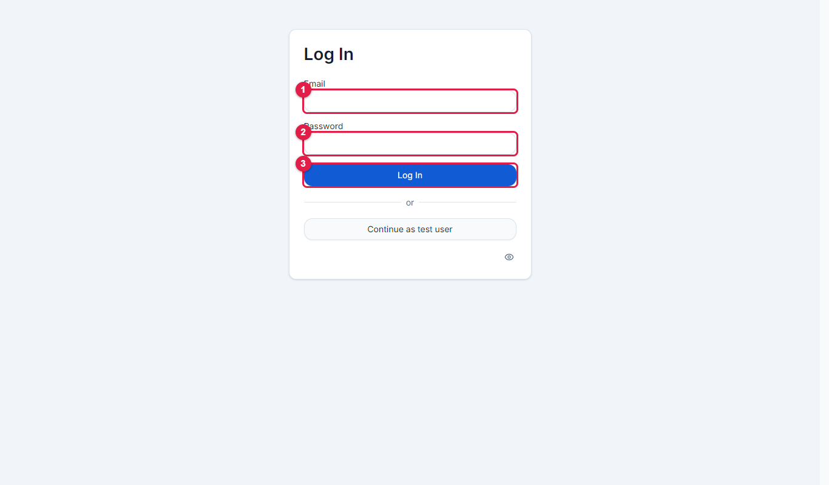
Figure 2.1-1 Login page
No. | Marked item | What it does
1 | Email | Type the administrator user name.
2 | Password | Type the password. Characters are hidden.
3 | Log In | Signs you in and opens the Home page.

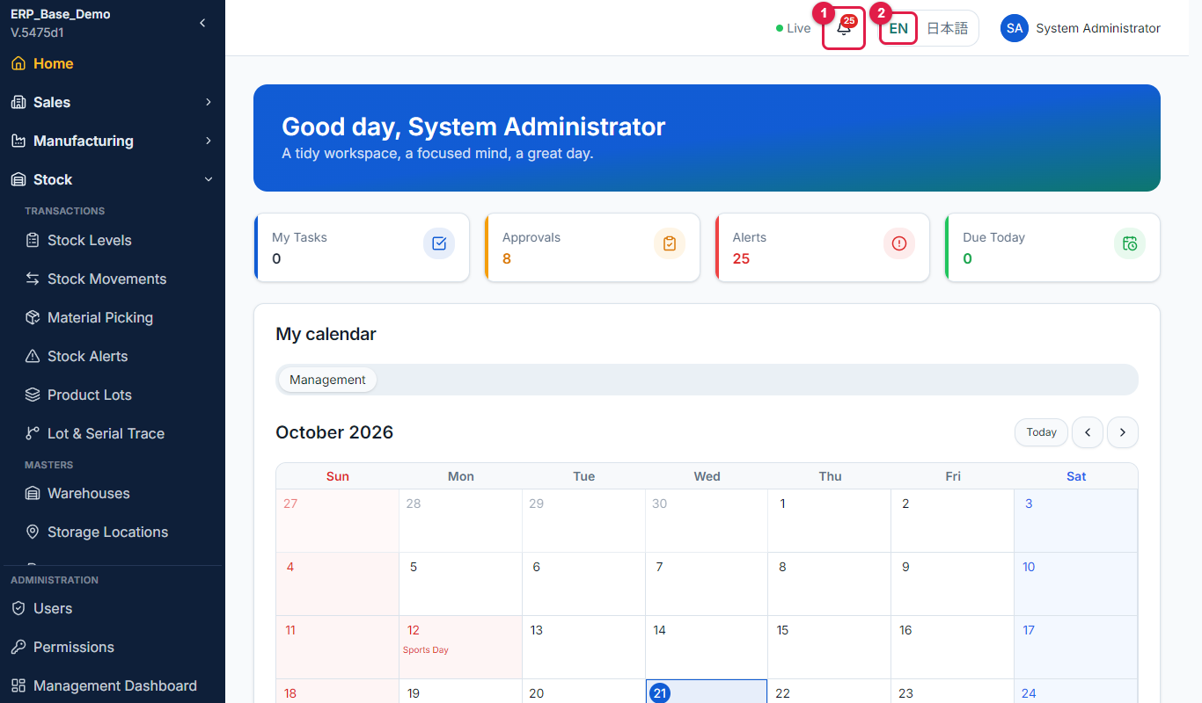
Figure 2.1-2 Home page
No. | Marked item | What it does
1 | Notification bell | Shows unread notifications.
2 | Language switch | Changes the screen language between English (EN) and Japanese.

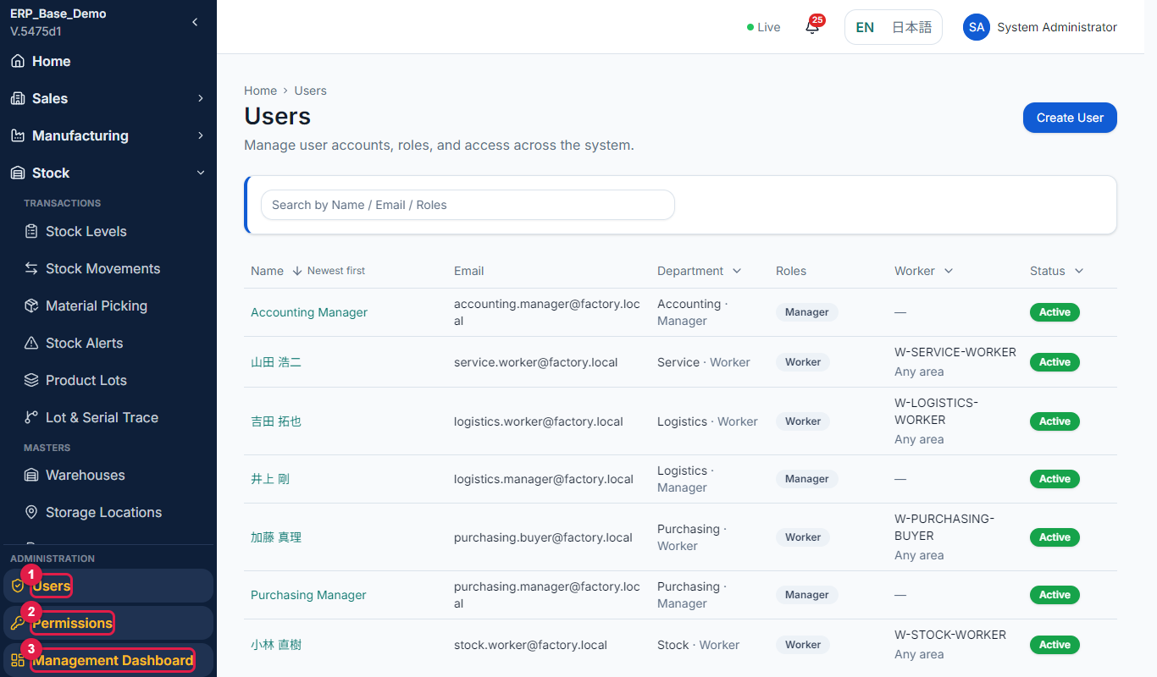
Figure 2.1-3 Administration menu
No. | Marked item | What it does
1 | Users | Accounts, roles and department access.
2 | Permissions | What each role can do, and extra access per person.
3 | Management Dashboard | One view of the whole company.

Important: Keep the administrator account for administration only. Give daily users their own accounts.

If something goes wrong
Message / problem | What to do
You cannot see Users or Permissions. | Your account lacks the Users Create permission. Sign in as an administrator.

3 Users

3.1 Find users
Purpose | See who has an account and in which department.
Who uses it | System administrator
Menu path | Administration > Users
Page URL | [system address]/admin/users
Before you start | None.

Step-by-step
No. | What to do | What you should see | Figure
1 | Open Administration > Users. | The list shows Name, Email, Department, Roles, Status, Worker and Actions. | Fig 3.1-1
2 | Search by Name / Email / Roles. | The list narrows. | -
3 | Open the filter in the Department, Worker or Status column header. The Worker filter offers All users, Shop-floor workers and Without a worker profile. | Only matching users remain. | Fig 3.1-2

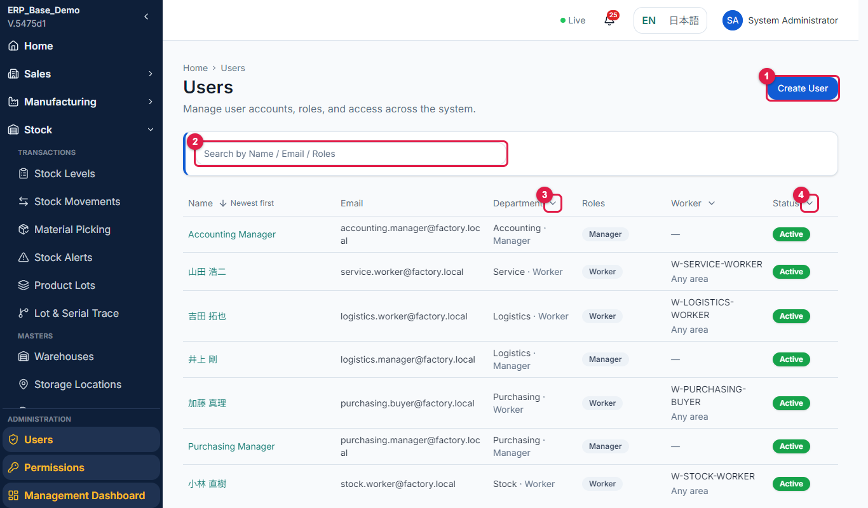
Figure 3.1-1 User list
No. | Marked item | What it does
1 | Create User | Opens the form to create a new account.
2 | Search box | Finds a user by name, email or role.
3 | Department filter | Opens a drop-down to show the users of one department.
4 | Status filter | Opens a drop-down to show Active or Inactive users.

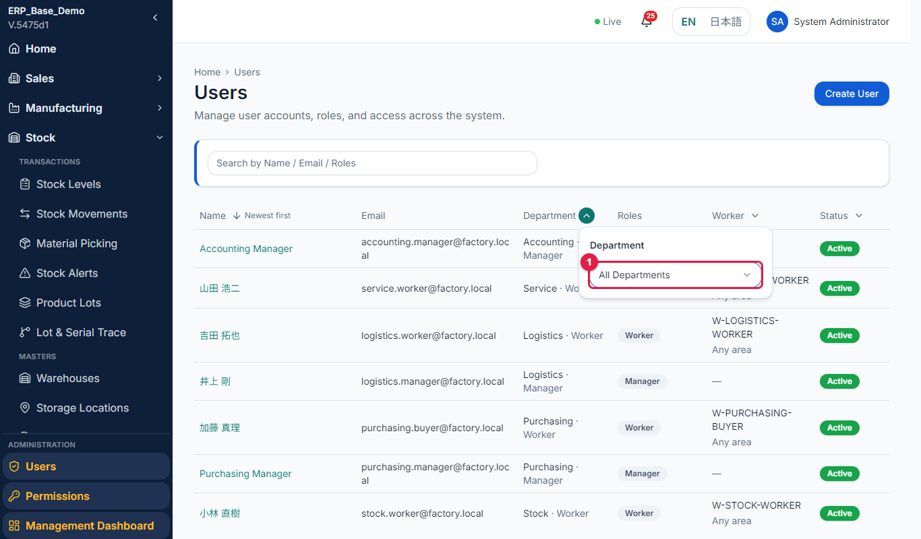
Figure 3.1-2 Filter in a column header
No. | Marked item | What it does
1 | Department drop-down | Choose All Departments or one department.

Status guide
Status | Meaning / what you can do next
Active | The user can sign in.
Inactive | The user cannot sign in. History is kept.

3.2 Create a user
Purpose | Give a person an account with a role in a department.
Who uses it | System administrator
Menu path | Administration > Users > Create User
Page URL | [system address]/admin/users/new
Before you start | You know the person's name, email, department and role.

Step-by-step
No. | What to do | What you should see | Figure
1 | On the Users list select Create User. | The Create User form opens. | Fig 3.2-1
2 | Enter the Name and the Email. | Both are filled in. The email is the user name for sign-in. | Fig 3.2-2
3 | In Departments & roles choose the Department and the Role. Select Add department for another department; each department can be added only once. | Each row has its own role. The first row is marked Primary. | Fig 3.2-3
4 | Enter a Password of at least 8 characters. | Password is entered. A message appears if it is too short. | Fig 3.2-4
5 | Select Save. | The user appears in the list. Give the person the email and the password. | Fig 3.2-5

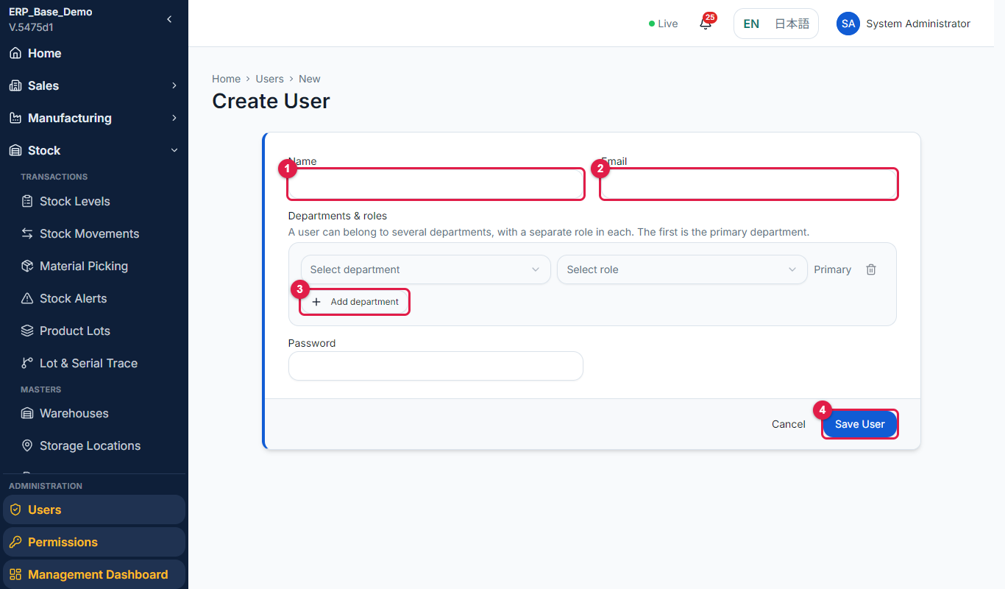
Figure 3.2-1 Empty form
No. | Marked item | What it does
1 | Name | The person's full name.
2 | Email | The sign-in name. Must be a valid email address.
3 | Add department | Adds a row for a second department with its own role.
4 | Save User | Creates the user.

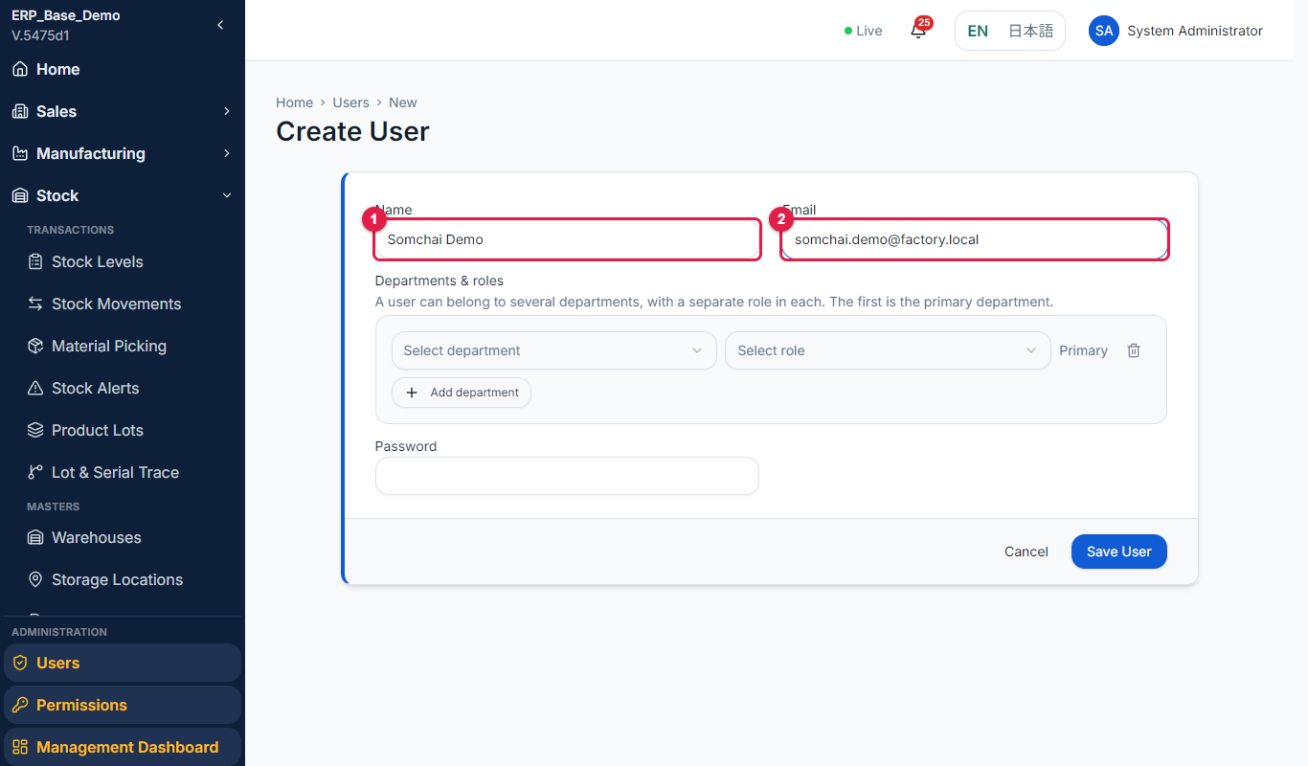
Figure 3.2-2 Name and email entered
No. | Marked item | What it does
1 | Name | The person's full name.
2 | Email | The sign-in name. Must be a valid email address.

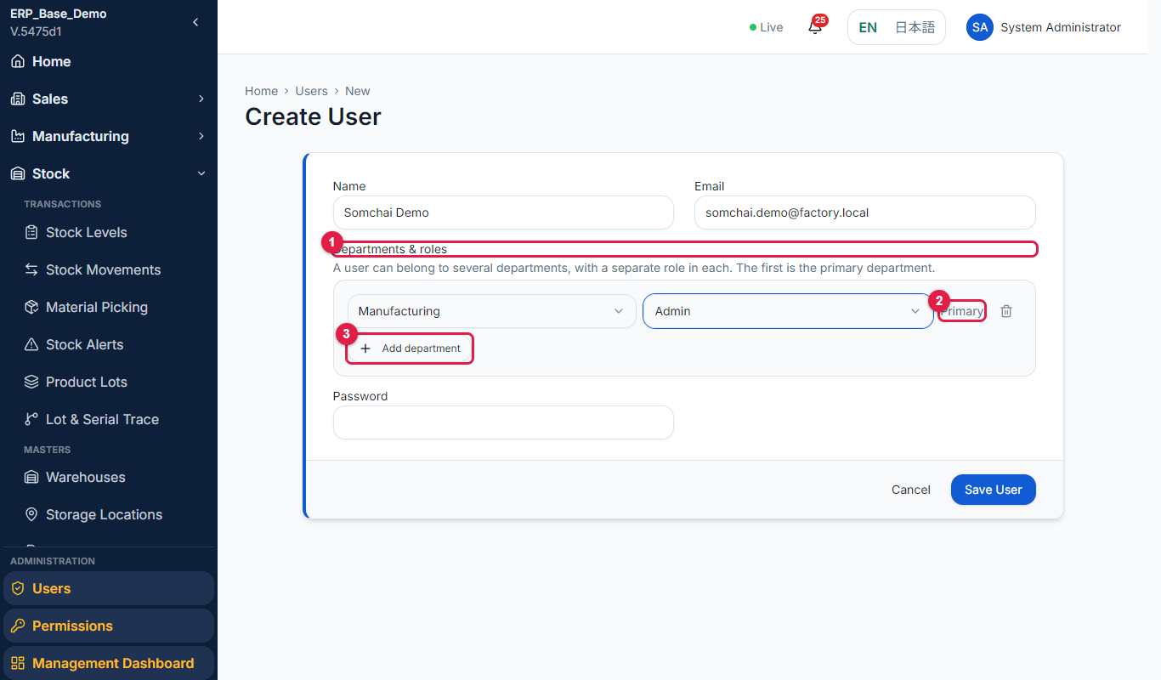
Figure 3.2-3 Departments and roles
No. | Marked item | What it does
1 | Departments & roles | One row per department, each with a role. The first row is the primary department.
2 | Primary | Marks the primary department.
3 | Add department | Adds another department row. Each department can be added only once.

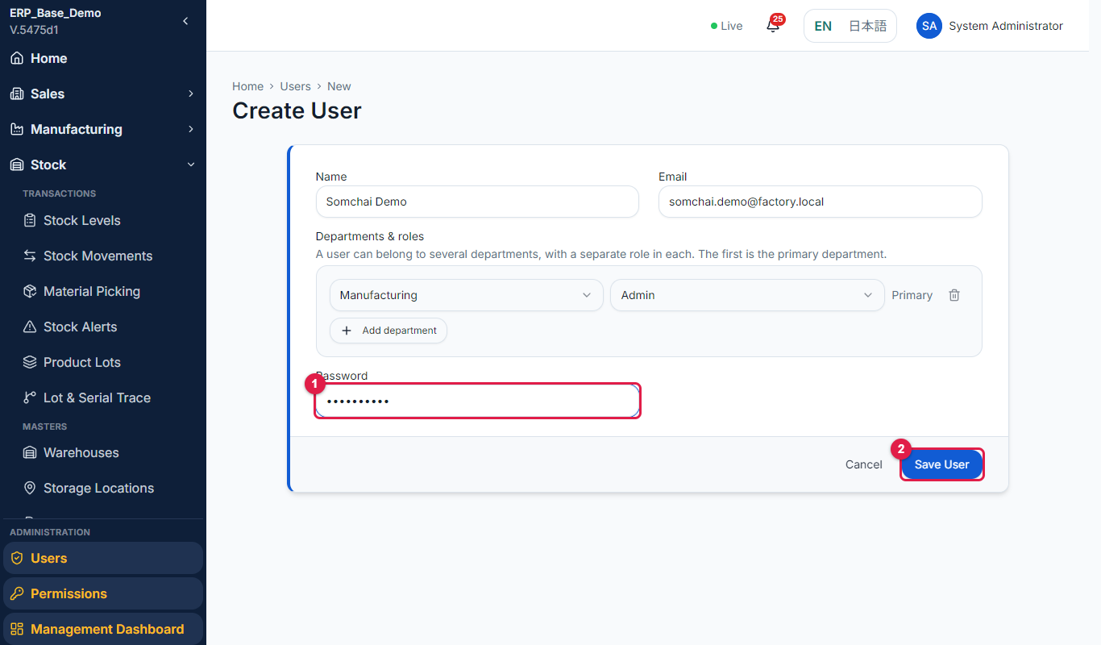
Figure 3.2-4 Password entered
No. | Marked item | What it does
1 | Password | The first password. At least 8 characters.
2 | Save User | Creates the user.

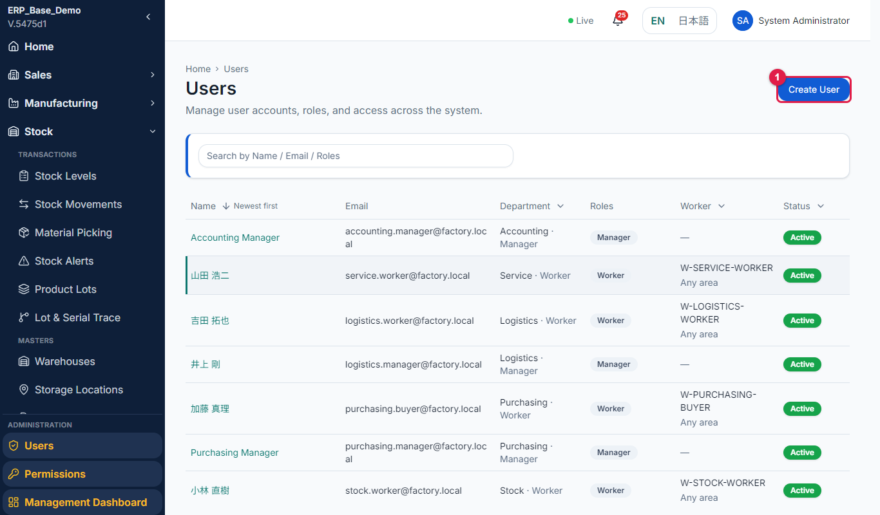
Figure 3.2-5 User in the list
No. | Marked item | What it does
1 | Create User | Adds another user.

Field reference
Field | Required | Description / rule
Name | Yes | Full name shown in the system.
Email | Yes | Sign-in name. Must be a valid email.
Departments & roles | Yes | At least one row, each with a department and a role. The first row is the primary department.
Password | Yes (new user) | At least 8 characters.
Active / Inactive | - | Controls sign-in.

Rules to remember
- A user can belong to several departments with a separate role in each.
- A user with the Worker role in a department becomes a shop-floor worker with a worker profile automatically.

Tip: Choose the role by what the person does: Worker for daily users, Manager for approvers and department heads.

If something goes wrong
Message / problem | What to do
Choose a department and a role on every row. | Complete or remove the incomplete row.
Each department can be added only once. | Remove the duplicate department.
Failed to save user. | Check that the email is not already used and retry.

3.3 Edit a user and change departments or roles
Purpose | Change a person's name, department or role.
Who uses it | System administrator
Menu path | Administration > Users > (row menu) > Edit
Page URL | [system address]/admin/users/{id}/edit
Before you start | The user exists.

Step-by-step
No. | What to do | What you should see | Figure
1 | On the list open the Actions menu of the user and select Edit. | The Edit User form opens. | Fig 3.3-1
2 | Change the name, or change the department and role in Departments & roles. | The rows show the new values. | Fig 3.3-2
3 | Select Add department to give the user a second department. | A new row appears. | -
4 | Select Save. | The changes are saved and apply the next time the user signs in. | -

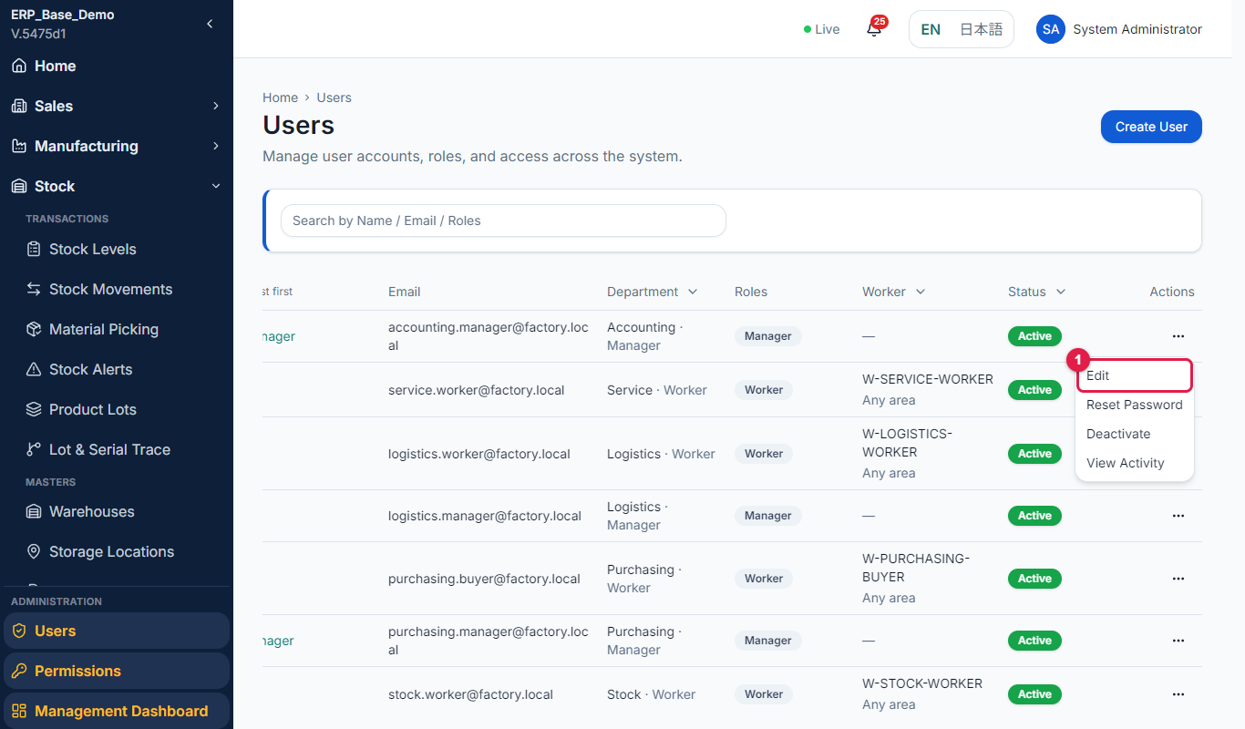
Figure 3.3-1 Row Actions menu
No. | Marked item | What it does
1 | Edit | Opens the user to change the name, departments or roles.

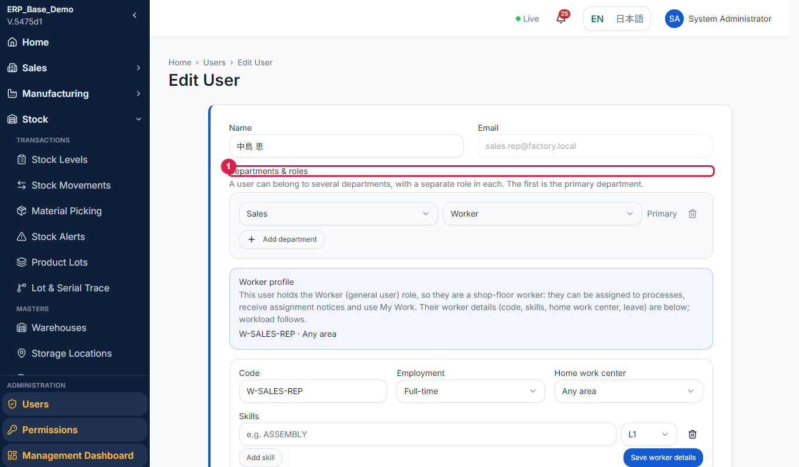
Figure 3.3-2 Edit form
No. | Marked item | What it does
1 | Departments & roles | Change or add the department and role rows.

Rules to remember
- If you remove the Worker role, the user is no longer a worker. Their worker profile becomes inactive, and past assignments are kept.

If something goes wrong
Message / problem | What to do
Failed to save user details. | Check the form and retry.
User details were saved, but the status change failed. | Reopen the user and change the status again.

3.4 Deactivate or activate a user
Purpose | Stop or restore a person's access without deleting history.
Who uses it | System administrator
Menu path | Administration > Users > (row menu) > Activate / Deactivate
Page URL | [system address]/admin/users
Before you start | The user exists.

Step-by-step
No. | What to do | What you should see | Figure
1 | Open the Actions menu of the user row. | The menu shows Edit, Activate or Deactivate, View Activity, Reset password and (for workers) View workload. | Fig 3.4-1
2 | Select Deactivate (or Activate). | A window asks "Deactivate [name]?" or "Activate [name]?" and says it takes effect immediately. | Fig 3.4-2
3 | Confirm. | The Status column changes. | Fig 3.4-3

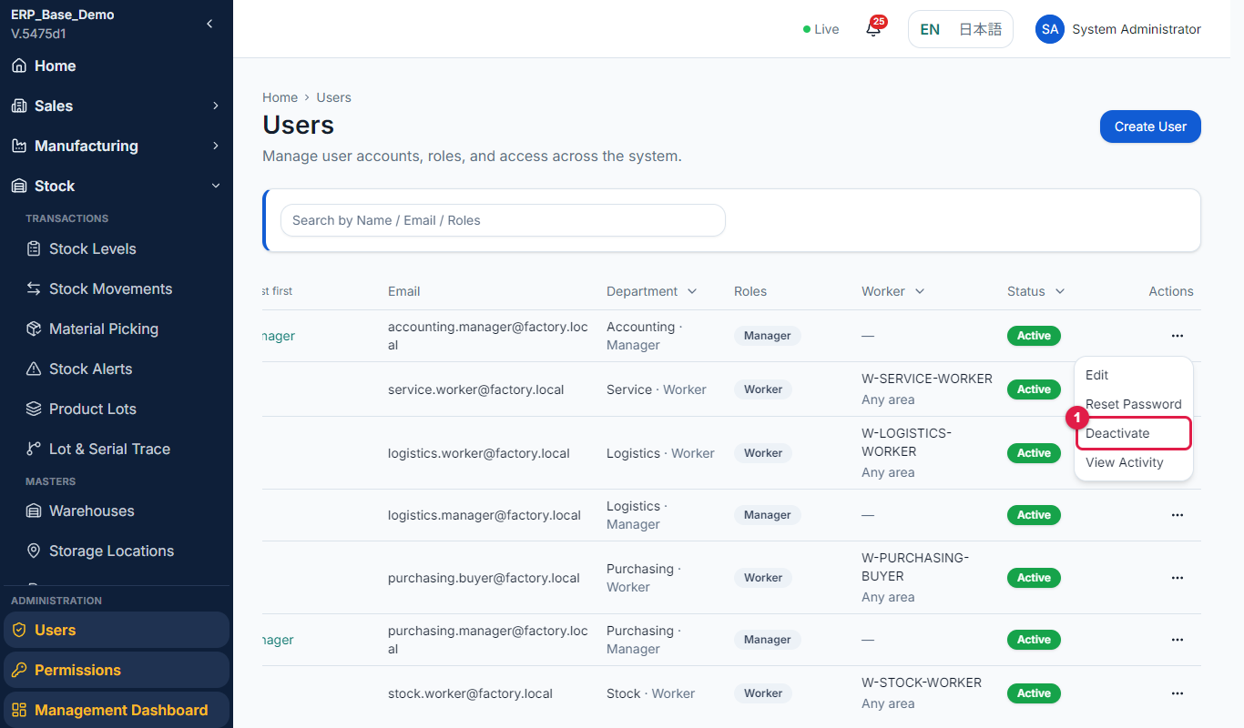
Figure 3.4-1 Actions menu
No. | Marked item | What it does
1 | Deactivate / Activate | Stops or restores the user's access.

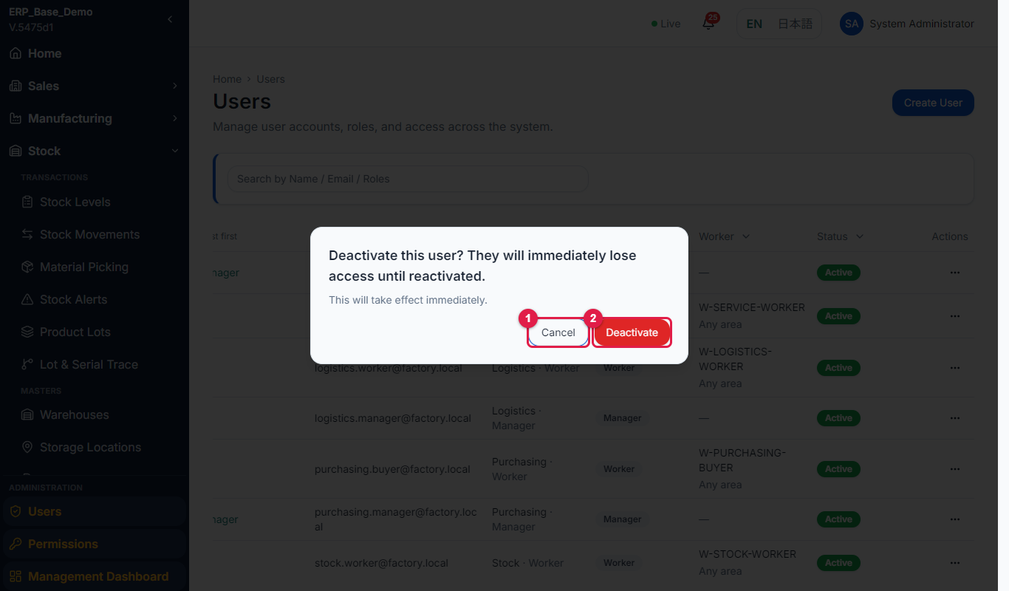
Figure 3.4-2 Confirmation window
No. | Marked item | What it does
1 | Cancel | Closes the window without changing the user.
2 | Deactivate / Activate | Confirms. Takes effect immediately.

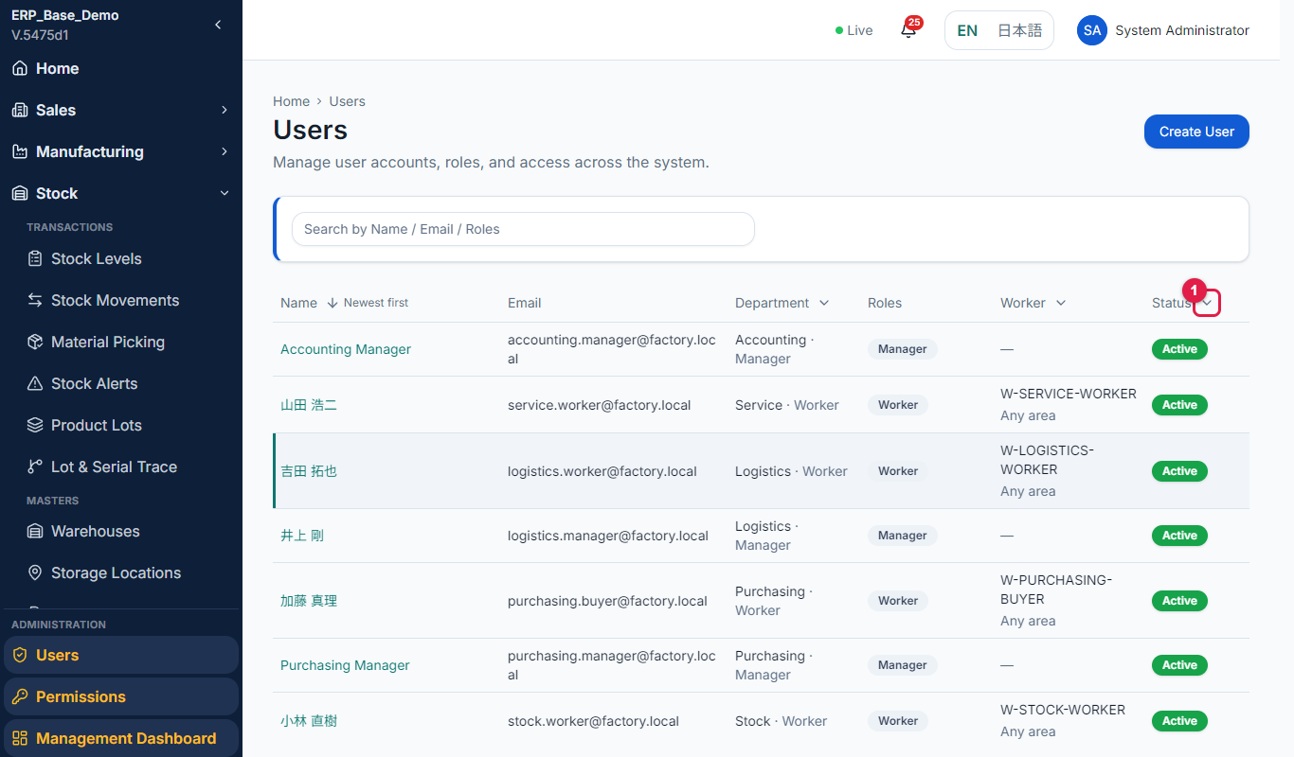
Figure 3.4-3 Status changed
No. | Marked item | What it does
1 | Status column | Shows Active or Inactive.

Important: Deactivate people who leave instead of deleting them. Their history and approvals stay in the system.

If something goes wrong
Message / problem | What to do
Failed to update user status. | Retry; contact support if it repeats.

3.5 Reset a password
Purpose | Give a user a new password when they forget theirs.
Who uses it | System administrator
Menu path | Administration > Users > (row menu) > Reset password
Page URL | [system address]/admin/users
Before you start | The user exists and is active.

Step-by-step
No. | What to do | What you should see | Figure
1 | Open the Actions menu of the user and select Reset password. | A window asks you to confirm the reset. | Fig 3.5-1
2 | Confirm. | A window "Temporary Password" shows the new password: "Copy this password and hand it to the user. It will not be shown again." | -
3 | Copy the password and give it to the user in person or by a safe channel. | The user signs in with it. | -

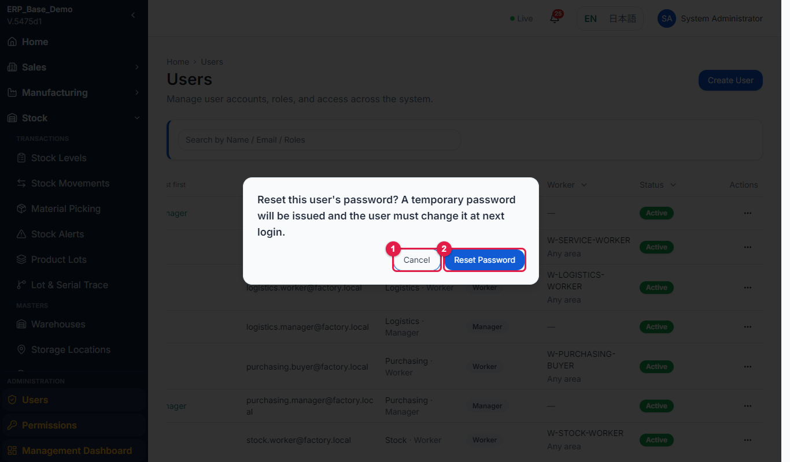
Figure 3.5-1 Reset password confirmation
No. | Marked item | What it does
1 | Cancel | Closes the window without resetting.
2 | Reset password | Creates a temporary password and shows it once.

Important: The temporary password is shown only once. Do not send it by open email or chat.

If something goes wrong
Message / problem | What to do
Failed to reset password. | Retry; contact support if it repeats.

3.6 View a user's activity history
Purpose | See what a user did in the system (audit trail).
Who uses it | System administrator
Menu path | Administration > Users > (row menu) > View Activity
Page URL | [system address]/admin/users/{id}/activity
Before you start | The user exists.

Step-by-step
No. | What to do | What you should see | Figure
1 | Open the Actions menu of the user and select View Activity. | The page "Activity History for [name]" opens. | Fig 3.6-1
2 | Set Date from and Date to to limit the period. | Only activity in the period is listed. | Fig 3.6-2
3 | Read the table: Timestamp, Action, Module, Reference and Previous > New. | Each line shows what changed, for example a status from Pending to Confirmed. | Fig 3.6-3

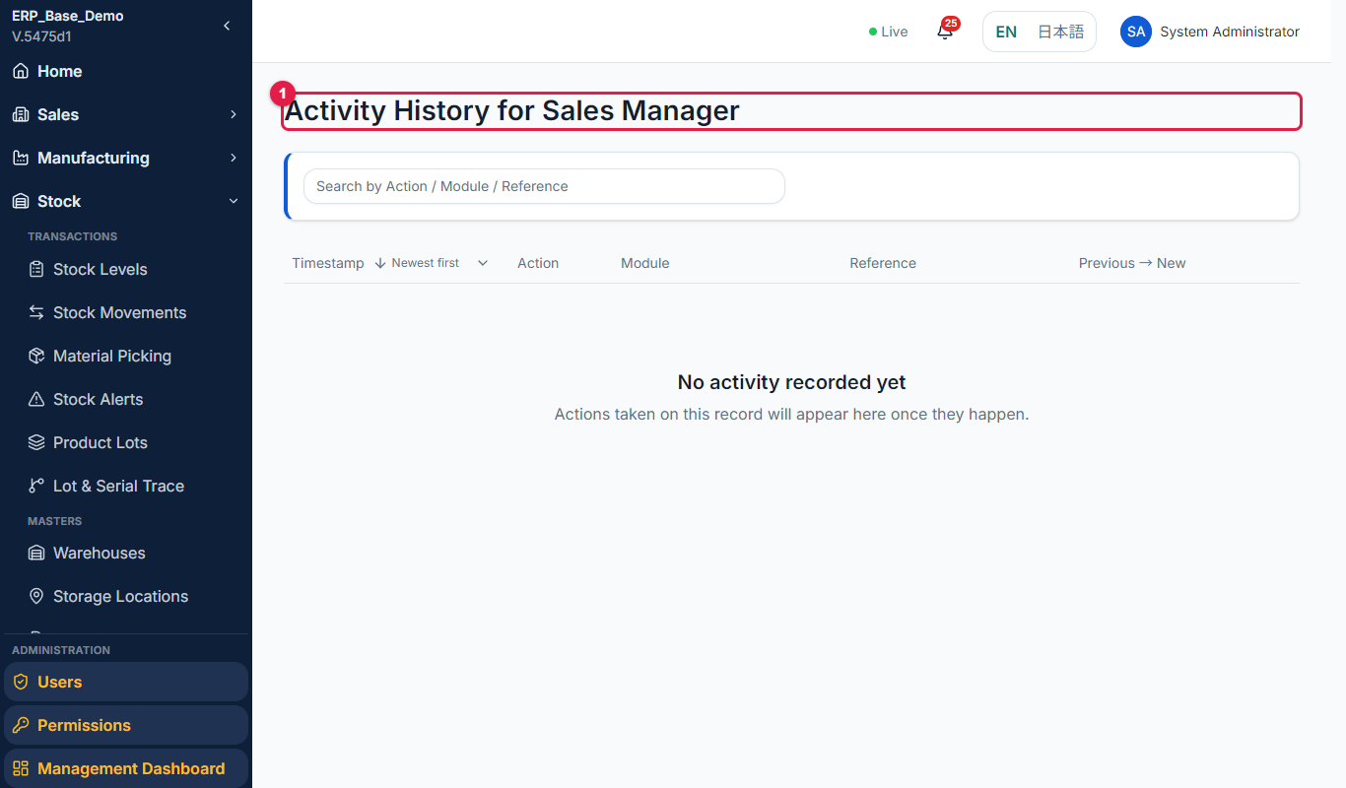
Figure 3.6-1 Activity history
No. | Marked item | What it does
1 | Activity History | The audit trail of the user.

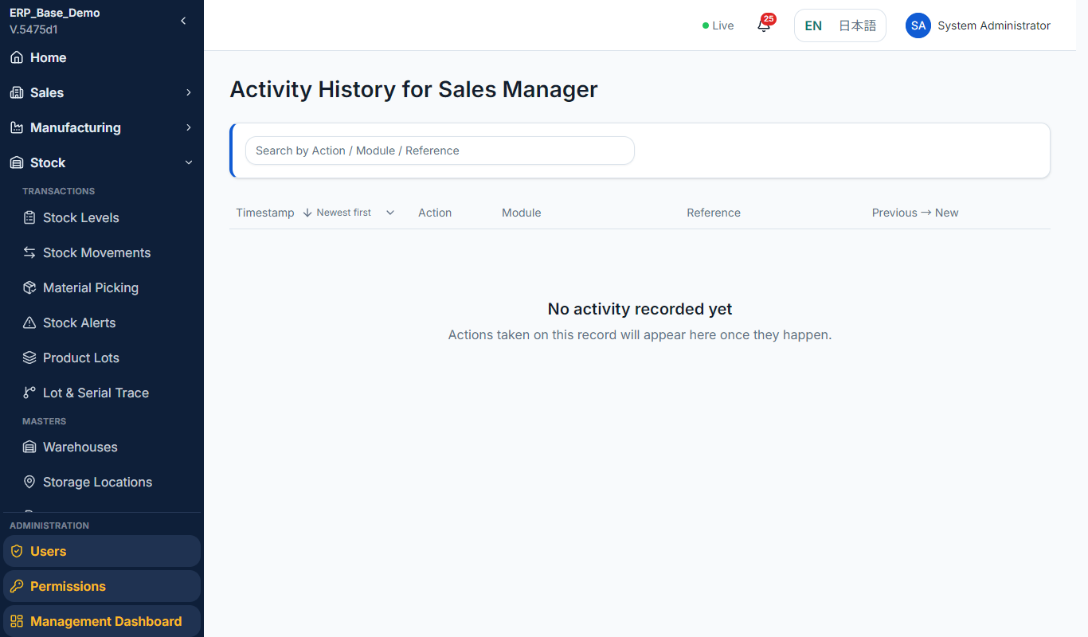
Figure 3.6-2 Date filter
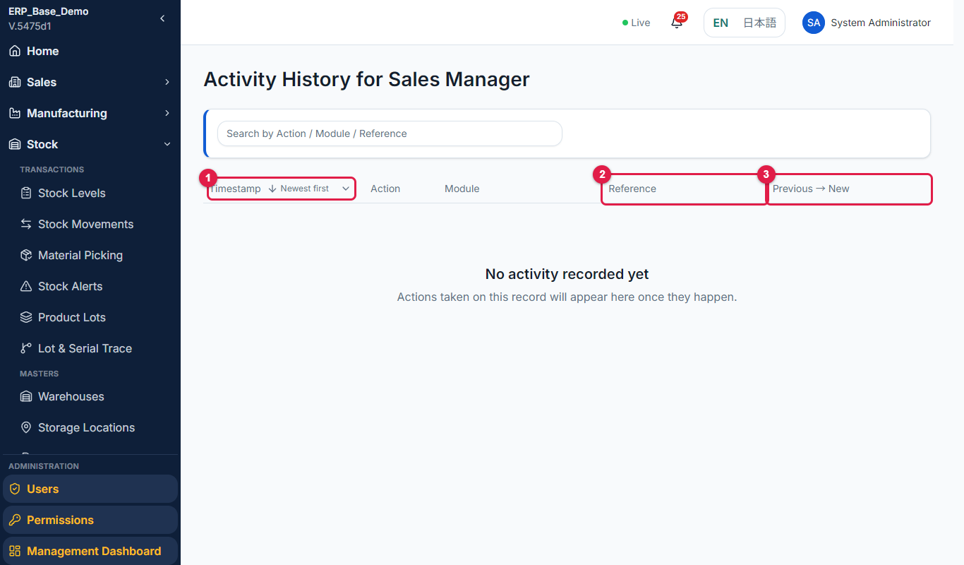
Figure 3.6-3 Activity table
No. | Marked item | What it does
1 | Timestamp | When it happened.
2 | Reference | The document the action refers to, for example SO-2610-0013.
3 | Previous > New | What changed, for example a status from Pending to Confirmed.

Tip: Use the Reference column to find the document (for example SO-2610-0013) and the Previous > New column to see what was changed.

3.7 Worker profiles
Purpose | See which users are shop-floor workers and open their workload.
Who uses it | System administrator, Manufacturing manager
Menu path | Administration > Users (worker filter)
Page URL | [system address]/admin/users?worker=linked
Before you start | Users with the Worker role exist.

Step-by-step
No. | What to do | What you should see | Figure
1 | On the Users list open the filter in the Worker column header and choose Shop-floor workers. | Only users with a worker profile (skills, assignments, My Work) remain, and the Worker column is filled. | Fig 3.7-1
2 | Choose Without a worker profile to find users who are not workers. | The list shows the other users. | -
3 | Open the Actions menu of a worker and select View workload. | The worker workload calendar opens (Manufacturing manual, section 5.2). | Fig 3.7-2

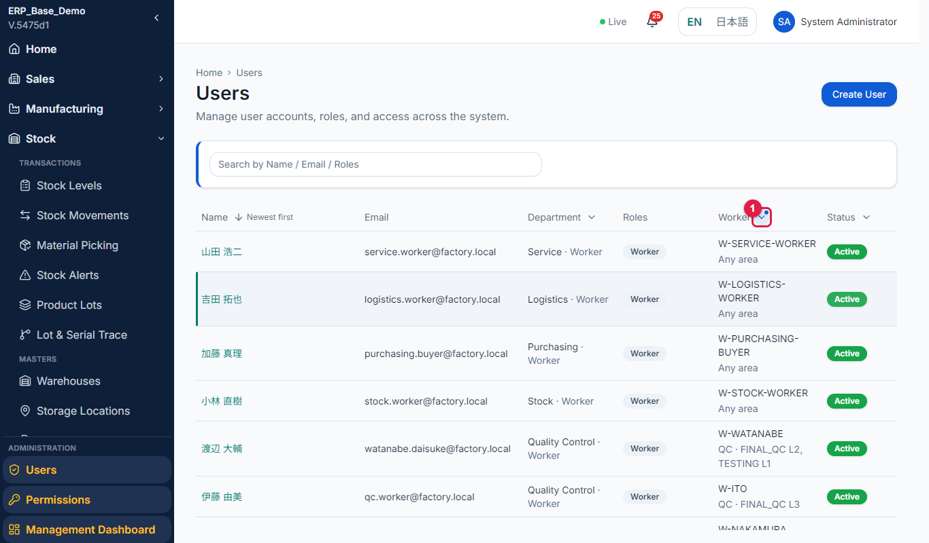
Figure 3.7-1 Shop-floor workers filter
No. | Marked item | What it does
1 | Worker filter | Opens the filter: All users, Shop-floor workers or Without a worker profile.

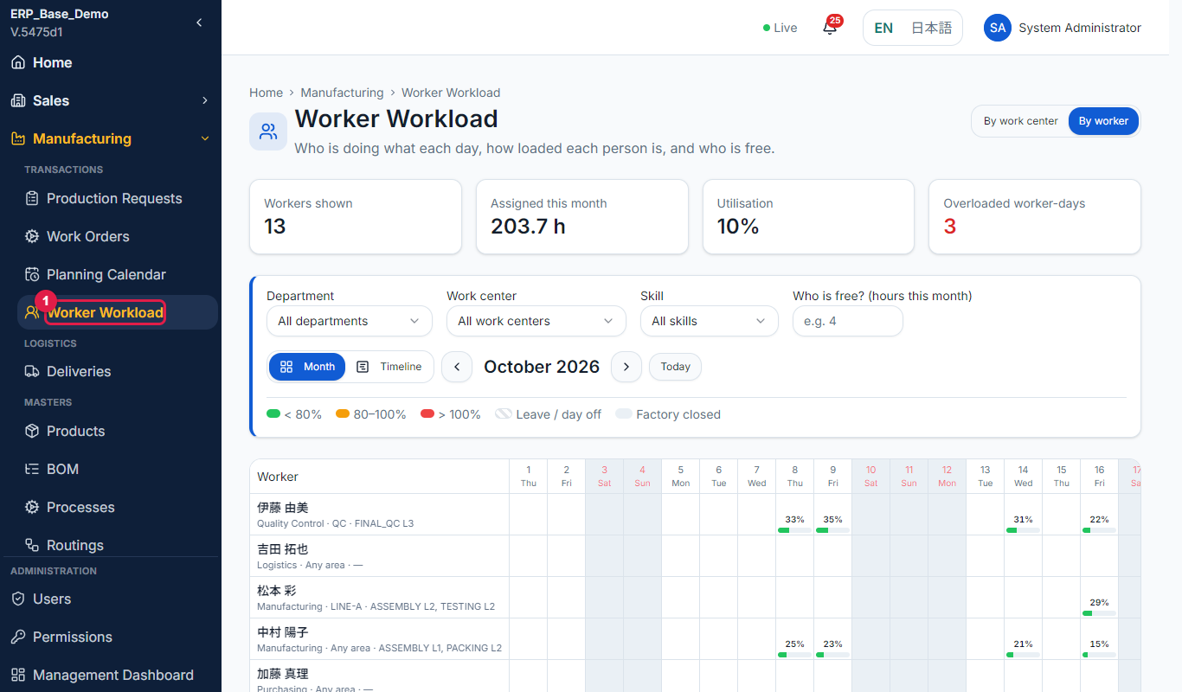
Figure 3.7-2 View workload
No. | Marked item | What it does
1 | Worker workload | The calendar of each worker's assigned load.

4 Permissions
Permissions decide what each position can do in each module, and which departments a person can see. Changes apply the next time the user signs in.

4.1 Read the role permissions
Purpose | See what each role can do in each module.
Who uses it | System administrator
Menu path | Administration > Permissions > Role Permissions
Page URL | [system address]/admin/permissions
Before you start | None.

Step-by-step
No. | What to do | What you should see | Figure
1 | Open Administration > Permissions. | Two tabs: Role Permissions and Access. | Fig 4.1-1
2 | On Role Permissions choose the Role. | A table lists each Module against the actions View, Create, Edit, Approve, Reject, Cancel, Delete, Export. | Fig 4.1-2
3 | For Admin and President a badge says "Global access". These roles already see every department, so their permissions are not scoped. | The badge and a hint are shown. | -
4 | If you cannot edit, a hint says "You can view but not edit roles." | The table is read-only. | -

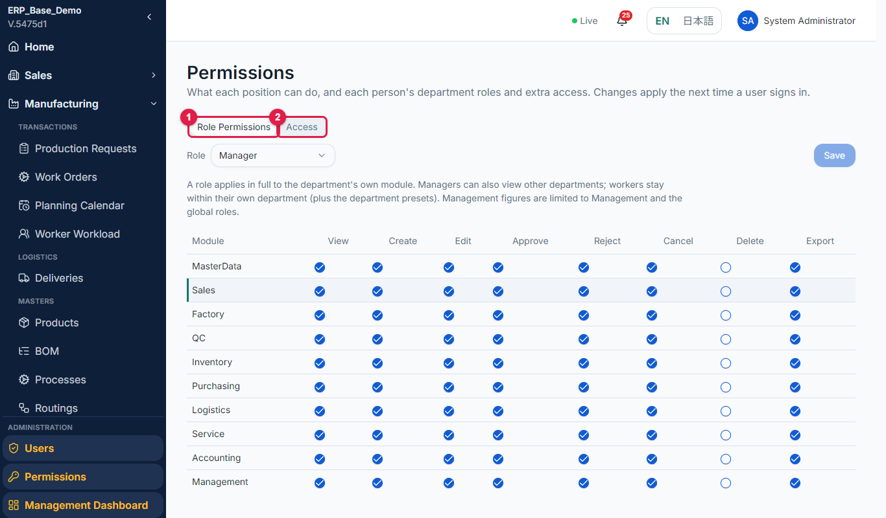
Figure 4.1-1 Permissions page
No. | Marked item | What it does
1 | Role Permissions tab | What each role can do in each module.
2 | Access tab | Each person's department roles and extra access.

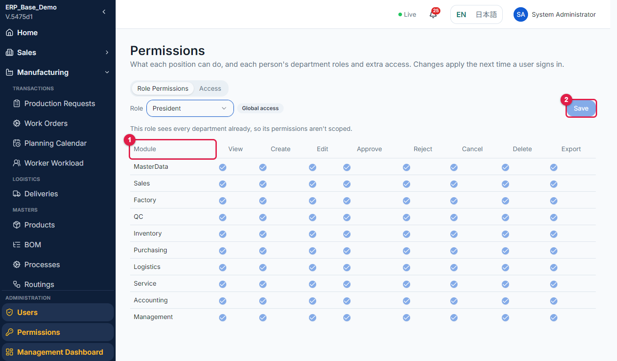
Figure 4.1-2 Role permission table
No. | Marked item | What it does
1 | Module | The modules, with a column for each action: View, Create, Edit, Approve, Reject, Cancel, Delete, Export.
2 | Save | Saves the role permissions. It may be a preview only in this version.

DEVELOPER NOTE: In this version the Save on this tab may show "Preview only - nothing was saved." Confirm whether role permissions are editable before documenting changes to roles.

4.2 Give a user access to another department
Purpose | Grant a role in another department, or read-only visibility.
Who uses it | System administrator
Menu path | Administration > Permissions > Access
Page URL | [system address]/admin/permissions
Before you start | The user exists.

Step-by-step
No. | What to do | What you should see | Figure
1 | Open Administration > Permissions and select the Access tab. | A table lists users with Home Department, Department and Access. Search by user name or email. | Fig 4.2-1
2 | Select a user. Their department roles and extra access are shown. | You see the primary department (marked primary) and any extra access. | Fig 4.2-2
3 | Select Add Access. | A window "Add Access" opens: grant a role in another department, or just read-only visibility. | Fig 4.2-3
4 | Choose Assign Role (full role: can Create, Edit and Approve there) or Grant View Access (read-only visibility). | A hint explains the difference. | -
5 | Choose the department and the role (or the module for view access) and save. | Message "Access updated." | -
6 | To remove access select Revoke or Remove assignment. | The access is removed. | Fig 4.2-4

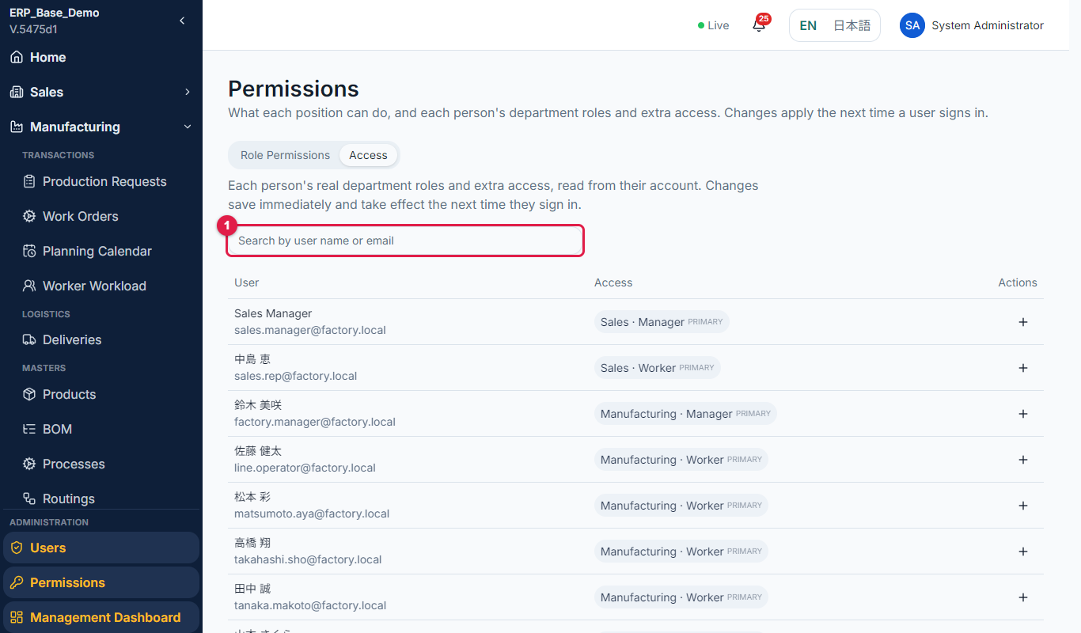
Figure 4.2-1 Access tab
No. | Marked item | What it does
1 | Search box | Finds a user by name or email.

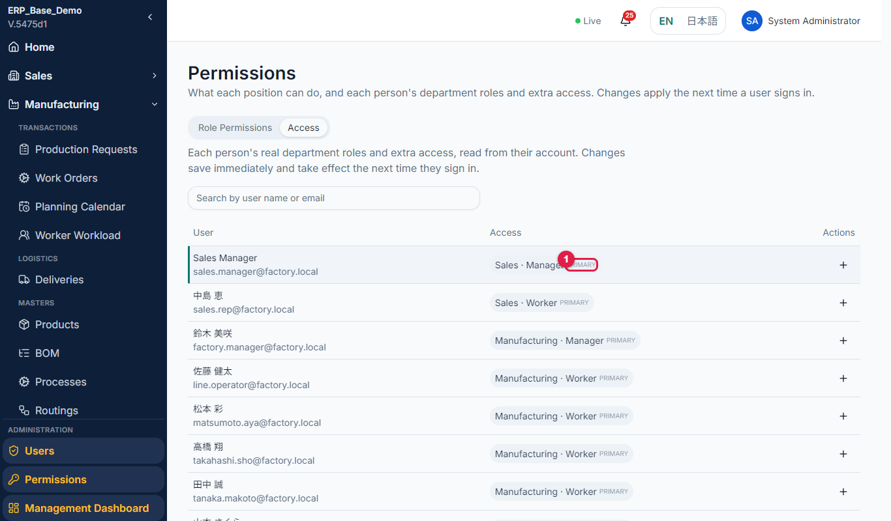
Figure 4.2-2 User access
No. | Marked item | What it does
1 | Primary | The user's primary department.

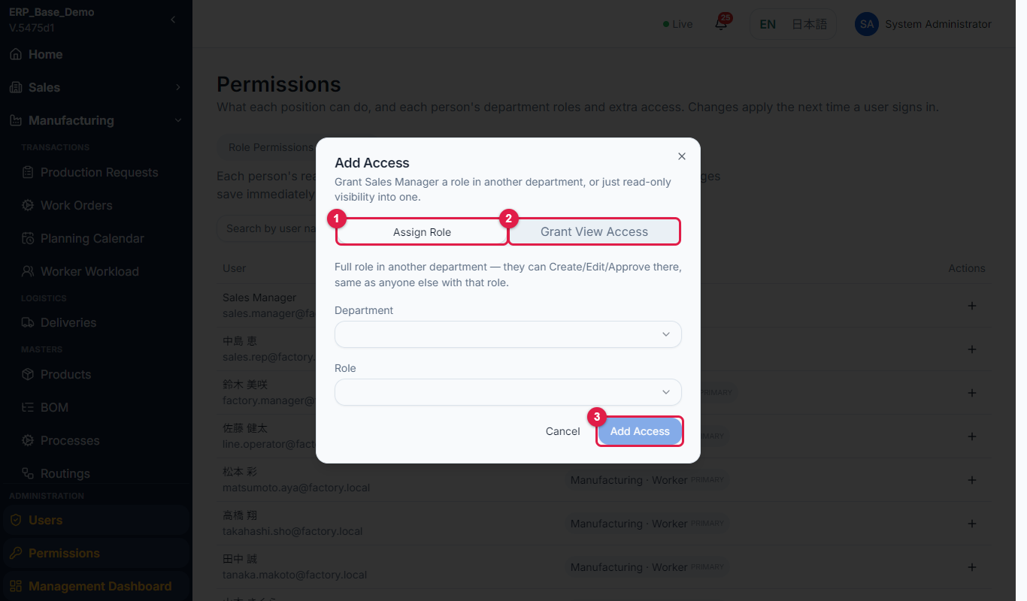
Figure 4.2-3 Add Access window
No. | Marked item | What it does
1 | Assign Role | A full role in another department: they can Create, Edit and Approve there.
2 | Grant View Access | Read-only visibility into another department.
3 | Add Access | Saves the access. It applies the next time the user signs in.

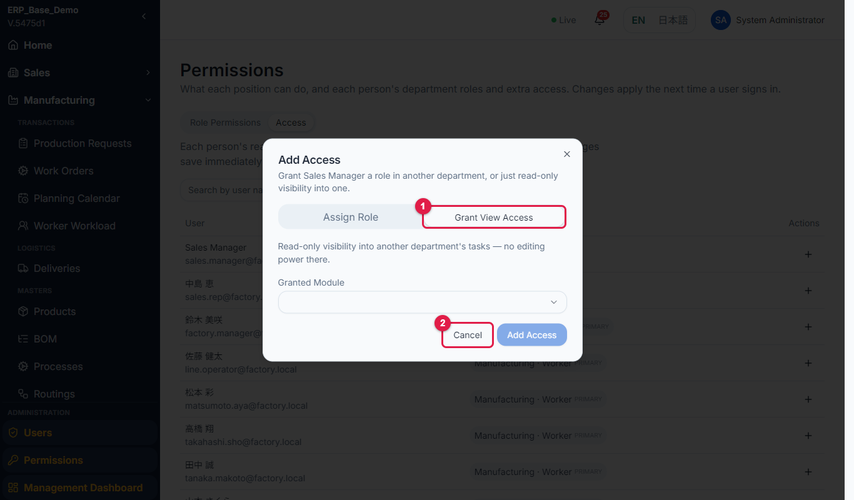
Figure 4.2-4 Revoke
No. | Marked item | What it does
1 | Grant View Access | Read-only visibility into one module. No editing power.
2 | Cancel | Closes the window without granting access.

Rules to remember
- Changes save immediately and take effect the next time the user signs in.
- A user already holding a role in a department cannot be given another role there, and cannot be granted the same module twice.

If something goes wrong
Message / problem | What to do
This user already has a role assigned in that department. | Choose another department or edit the existing role.
This user already has access to that module. | The access already exists.
Could not update access. | Retry; contact support if it repeats.

5 Management Dashboard

5.1 Read the management dashboard
Purpose | Give management one view of the whole company.
Who uses it | President, managers, administrator
Menu path | Administration > Management Dashboard
Page URL | [system address]/admin/management-dashboard
Before you start | You hold the Management View permission.

Step-by-step
No. | What to do | What you should see | Figure
1 | Open Administration > Management Dashboard. | The page shows KPIs and charts for a period, with From and To dates and an Export button. | Fig 5.1-1
2 | Set From and To to see another period. | The figures update. | -
3 | Read the KPIs: Total Sales, Gross Profit, Total Orders, On-Time Delivery, Production Achievement and Efficiency, Defect Rate, Inventory Value, Purchase Cost, Accounts Receivable and Payable, Open Service Tickets. | Each tile shows a value; some link to the related list. | Fig 5.1-2
4 | Read the charts: sales and order trends, production output vs capacity, defect rate trend, late deliveries trend, supplier on-time performance. | You see trends over recent months. | Fig 5.1-3

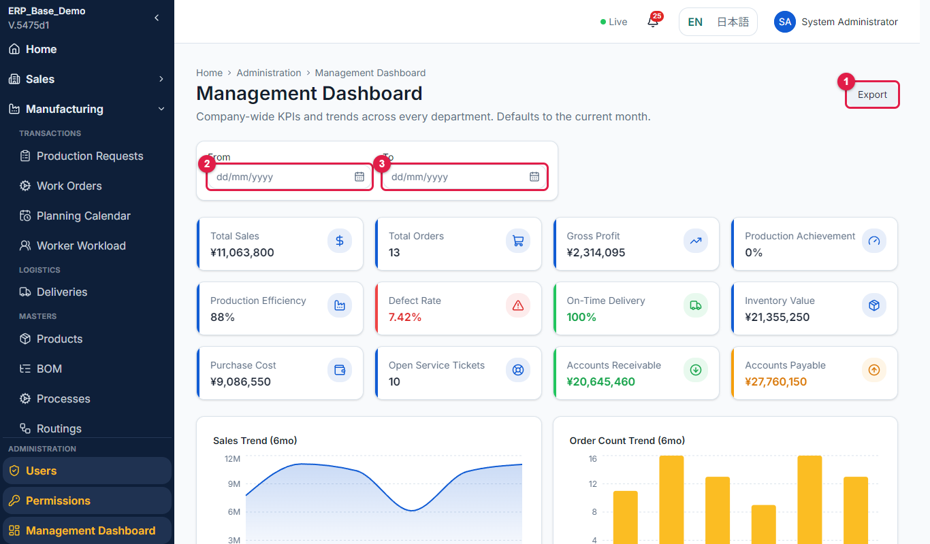
Figure 5.1-1 Management dashboard
No. | Marked item | What it does
1 | Export | Downloads the dashboard figures.
2 | From | Start of the period.
3 | To | End of the period.

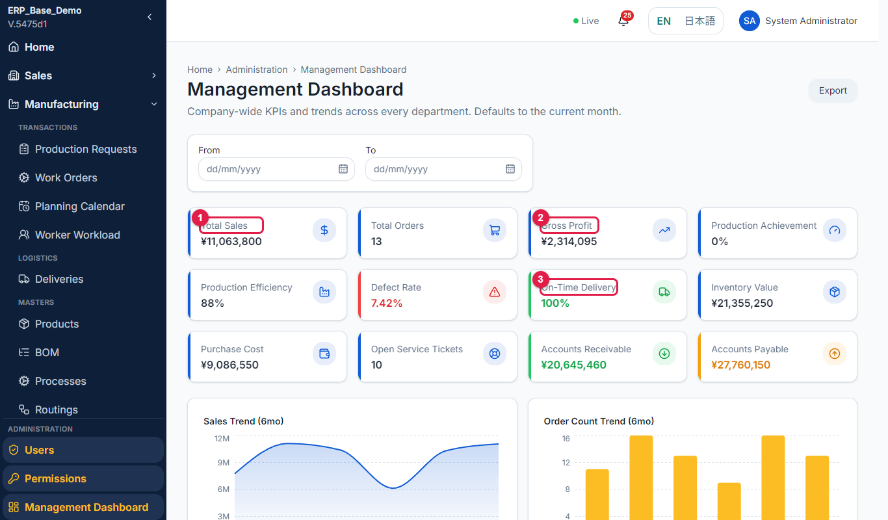
Figure 5.1-2 KPI tiles
No. | Marked item | What it does
1 | Total Sales | Value of sales in the period.
2 | Gross Profit | Sales less costs.
3 | On-Time Delivery | Share of deliveries made on time.

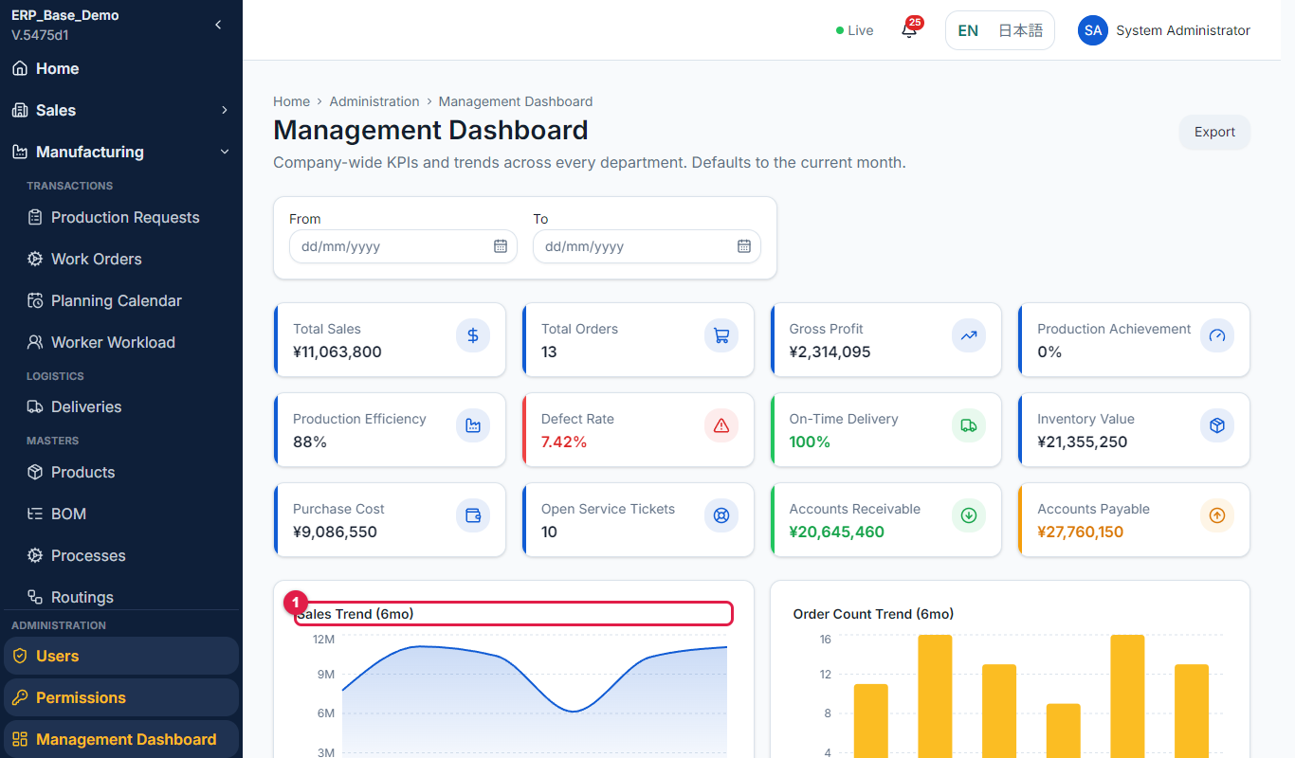
Figure 5.1-3 Charts
No. | Marked item | What it does
1 | Chart | Trends over recent months for sales, production, defects, late deliveries and supplier performance.

6 Master Data Guide: Overview

6.1 What is master data?
Master data is the reference information that every transaction uses: customers, suppliers, products, bills of materials, routings, warehouses, accounts and so on. If a master is wrong or missing, documents are wrong or cannot be created. For example, no routing means no work order; an inactive customer cannot be chosen on a quotation; no open fiscal period means no accounting posting.

6.2 Where to find the masters
- Each department menu has a Masters group (for example Sales > Masters > Customers).
- Each department dashboard has a "[Department] Masters" panel listing the masters the department owns. Select Open to go to a master. A master that is not yet available shows "Not yet available".
- You see a master only if your account holds the permission for it. Maintaining a master needs the Create or Edit permission.

6.3 Open a master from the department dashboard
Purpose | Find all masters of a department in one place.
Who uses it | Master data owners, administrator
Menu path | (Department) > Dashboard > Masters panel
Page URL | [system address]/sales/dashboard
Before you start | None.

Step-by-step
No. | What to do | What you should see | Figure
1 | Open a department dashboard, for example Sales > Dashboard. | The dashboard loads. | Fig 6.3-1
2 | Scroll to the "Sales Masters" panel. | Each master of the department is shown as a card. | Fig 6.3-2
3 | Select Open on a card. | The master opens (for example Customers). | -

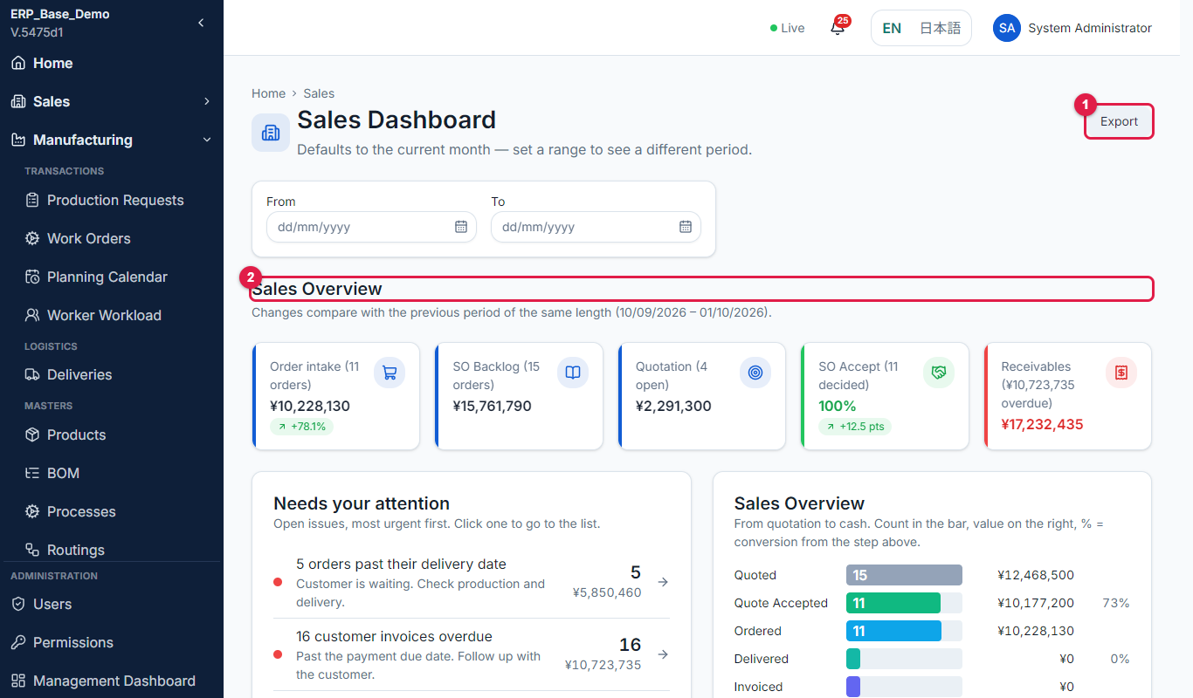
Figure 6.3-1 Department dashboard
No. | Marked item | What it does
1 | Export | Downloads the dashboard figures.
2 | Sales Overview | The department dashboard.

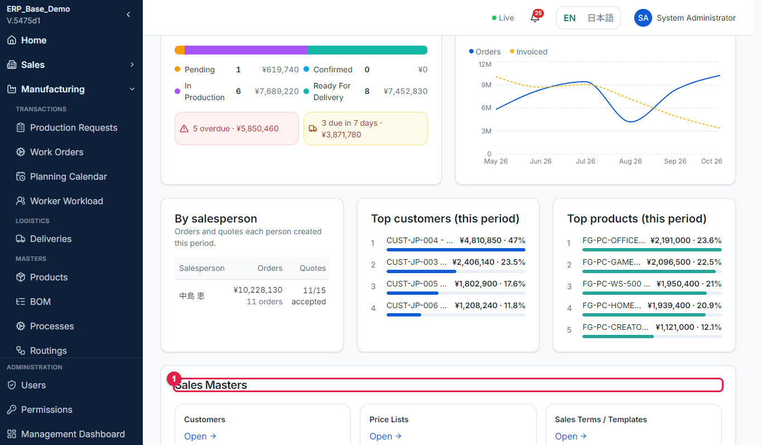
Figure 6.3-2 Masters panel
No. | Marked item | What it does
1 | Sales Masters panel | Lists the masters this department owns.

Rules to remember
- A card that says "Not yet available" is not implemented in this version.

6.4 Common behaviour of all masters
- Add creates a record; Edit changes it. Both need the Create or Edit permission.
- Records are never deleted. Use Deactivate to stop using a record. Inactive records stay on old documents and are hidden from new ones; Show inactive displays them.
- Codes are unique. Choose the code carefully, because documents refer to it.
- Many masters keep an English and a Japanese name; fill both.
- Changes take effect immediately on new documents. Existing documents keep their original data unless the manual for that master says otherwise.

7 Recommended Setup Order
Set up the masters in this order so that each one already has what it depends on. Keep the order when you start a new system or a new factory.
Step | Master | Owner | Why this order
1 | Departments, roles and users (Part A) | Administrator | Everyone needs an account before they can enter data.
2 | Fiscal periods, currencies, exchange rates | Accounting | Documents need an open period and a base currency.
3 | Chart of accounts, tax codes, payment methods and terms, cost centers, posting rules | Accounting | Accounts are used by tax codes, payment methods and posting rules.
4 | Units of measure, stock categories, movement reasons | Stock | Products refer to units and categories.
5 | Warehouses and storage locations | Stock | Stock, receipts and deliveries need places.
6 | Calendar, shifts, operating locations (work centers) and machines | Manufacturing | The scheduler needs working time and places to book.
7 | Products | Manufacturing | Everything bought, made or sold refers to a product.
8 | Processes, then BOM, then routings, then QC checklists | Manufacturing | Routings use processes; work orders need a routing; BOM drives material needs.
9 | Reorder policies | Stock | They need the products.
10 | Procurement categories, purchasing terms, delivery terms, suppliers, supplier products | Purchasing | A supplier uses terms and categories; supplier products need products.
11 | Customers, price lists, sales terms | Sales | Quotations need active customers.
12 | Service masters (types, categories, symptoms, SLA, warranty, resolutions) | Service | Service tickets use them.

Tip: After setup, create one test quotation, sales order, production request, work order, purchase order and invoice. If any step is blocked, a master is missing.

8 Master Data Catalog
The table lists every master, the department that owns it, where to open it and where it is described. Replace [system address] with your system address.
Master | Owner | Page URL | Described in
Customers | Sales | [system address]/sales/customers | Sales manual, section 3
Price Lists | Sales | [system address]/sales/price-lists | Sales manual, section 7 (view only)
Sales Terms / Templates | Sales | [system address]/sales/terms | Sales manual, section 7 (view only)
Products | Manufacturing | [system address]/manufacturing/products | Factory manual, section 7.1
Bill of Materials | Manufacturing | [system address]/manufacturing/bom | Factory manual, section 7.2
Processes | Manufacturing | [system address]/manufacturing/processes | Factory manual, section 7.3
Routings | Manufacturing | [system address]/manufacturing/routings | Factory manual, section 7.4
Operating Locations (Work Centers) | Manufacturing | [system address]/manufacturing/work-centers | Factory manual, section 7.5
Machines | Manufacturing | [system address]/manufacturing/machines | Factory manual, section 7.5
Calendar, Shifts, Resource exceptions | Manufacturing | [system address]/manufacturing/calendar | Factory manual, section 7.6
QC Checklists | Manufacturing / QC | [system address]/manufacturing/qc-checklists | Factory manual, section 7.7
Warehouses | Stock | [system address]/stock/warehouses | This manual, section 9.1
Storage Locations | Stock | [system address]/stock/masters/locations | This manual, section 9.2
Stock Categories | Stock | [system address]/stock/masters/categories | This manual, section 9.3
Units of Measure | Stock | [system address]/stock/masters/units | This manual, section 9.4
Movement Reasons | Stock | [system address]/stock/masters/reasons | This manual, section 9.5
Reorder Policies | Stock | [system address]/stock/masters/policies | This manual, section 9.6
Suppliers | Purchasing | [system address]/purchasing/suppliers | Purchasing manual, section 5.1
Supplier Products | Purchasing | [system address]/purchasing/supplier-products | Purchasing manual, section 5.2
Procurement Categories | Purchasing | [system address]/purchasing/masters/procurement-categories | Purchasing manual, section 5.3
Purchasing Terms | Purchasing | [system address]/purchasing/masters/purchasing-terms | Purchasing manual, section 5.4
Delivery Terms | Purchasing | [system address]/purchasing/masters/delivery-terms | Purchasing manual, section 5.5
Chart of Accounts | Accounting | [system address]/accounting/masters/chart-of-accounts | Accounting manual, section 4.1
Tax Codes | Accounting | [system address]/accounting/masters/tax-codes | Accounting manual, section 4.2
Payment Methods / Terms | Accounting | [system address]/accounting/masters/payment-methods | Accounting manual, section 4.3
Currencies / Exchange Rates | Accounting | [system address]/accounting/masters/currencies | Accounting manual, section 4.4
Fiscal Periods | Accounting | [system address]/accounting/masters/fiscal-periods | Accounting manual, section 4.5
Cost Centers | Accounting | [system address]/accounting/masters/cost-centers | Accounting manual, section 4.6
Posting Rules | Accounting | [system address]/accounting/masters/posting-rules | Accounting manual, section 4.7
Service Types | Service | [system address]/service/masters/service-types | This manual, section 9.7
Complaint Categories | Service | [system address]/service/masters/complaint-categories | This manual, section 9.7
Symptoms | Service | [system address]/service/masters/symptoms | This manual, section 9.7
SLA / Priorities | Service | [system address]/service/masters/sla-priorities | This manual, section 9.7
Warranty Policies | Service | [system address]/service/masters/warranty-policies | This manual, section 9.7
Resolution Codes | Service | [system address]/service/masters/resolution-codes | This manual, section 9.7

Note: Repair Actions and Failure Causes (Manufacturing) are listed in the catalog but are not available in this version.

9 Stock and Service Masters
The masters of Sales, Manufacturing, Purchasing and Accounting are described in their own manuals (see the catalog in section 8). This section describes the Stock and Service masters.

9.1 Warehouses
Purpose | Define the places where stock is held.
Who uses it | Stock manager
Menu path | Stock > Masters > Warehouses
Page URL | [system address]/stock/warehouses
Before you start | None.

Step-by-step
No. | What to do | What you should see | Figure
1 | Open Stock > Warehouses. | The list shows Code, Name, Category, Status and Actions. Search by code or name; filter by Category and Status. | Fig 9.1-1
2 | Select Add Warehouse. | The Create Warehouse form opens. | Fig 9.1-2
3 | Enter Code and Name and choose the Category: Raw Material, Spare Parts, WIP, Finished Goods, QC Hold or Defective Goods. | Fields are set. | -
4 | Select Save Warehouse. | The warehouse is listed. The form then shows Storage Locations for it. | -
5 | To stop using a warehouse open the row menu and select Deactivate. | A window says it will no longer be selectable for new stock movements, but existing history is preserved. | Fig 9.1-3

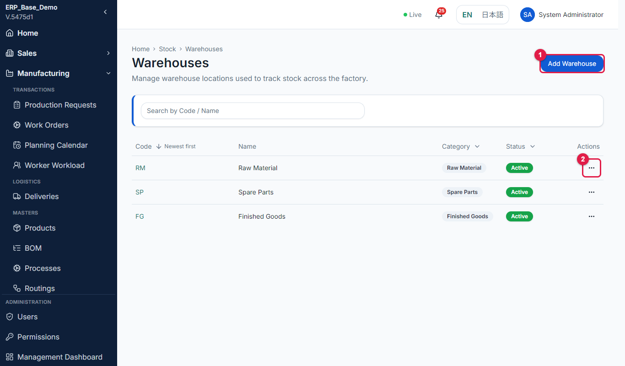
Figure 9.1-1 Warehouse list
No. | Marked item | What it does
1 | Add Warehouse | Opens the form to add a warehouse.
2 | Row actions | Opens the menu for the row: Edit, Activate or Deactivate, View Activity, Reset password and, for workers, View workload.

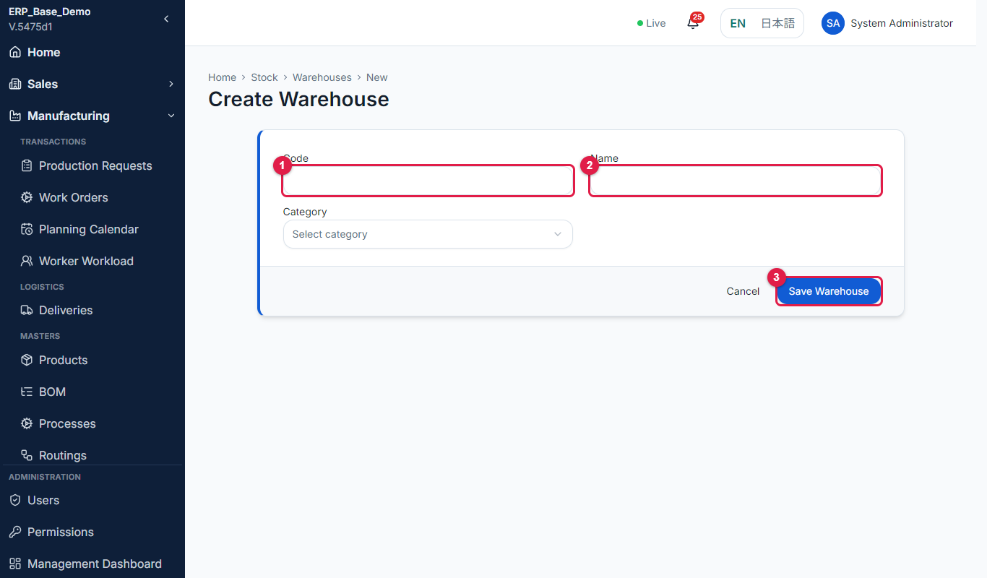
Figure 9.1-2 Warehouse form
No. | Marked item | What it does
1 | Code | The unique warehouse code.
2 | Name | The warehouse name.
3 | Save Warehouse | Saves the warehouse. Storage locations can then be added.

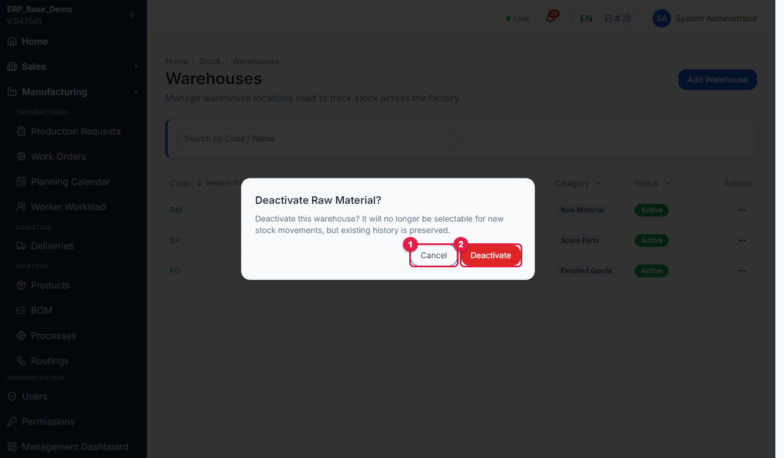
Figure 9.1-3 Deactivate window
No. | Marked item | What it does
1 | Cancel | Closes the window without changing the warehouse.
2 | Deactivate | The warehouse can no longer be chosen on new stock movements. History is kept.

Field reference
Field | Required | Description / rule
Code | Yes | Unique warehouse code.
Name | Yes | Warehouse name.
Category | Yes | Kind of stock held.
Active / Inactive | - | Controls whether it can be chosen on new movements.

If something goes wrong
Message / problem | What to do
Warehouse code already in use. Choose a different code. | Use another code.
Failed to save warehouse. | Check the form and retry.

9.2 Storage locations
Purpose | Define racks, shelves and bays inside warehouses.
Who uses it | Stock manager
Menu path | Stock > Masters > Storage Locations
Page URL | [system address]/stock/masters/locations
Before you start | The warehouse exists.

Step-by-step
No. | What to do | What you should see | Figure
1 | Open Stock > Storage Locations. | The list shows Warehouse, Code, Name, Type, Category, QC hold and Restricted. Filter by All warehouses or one warehouse. | Fig 9.2-1
2 | Select Add and choose the Warehouse, then enter Code and Name. | Warehouse, code and name are required. | Fig 9.2-2
3 | Set Type, Category, maximum capacity and, if needed, QC hold or Restricted. | QC hold marks quarantine locations; Restricted limits use. | -
4 | Select Save. | The location is listed. | -

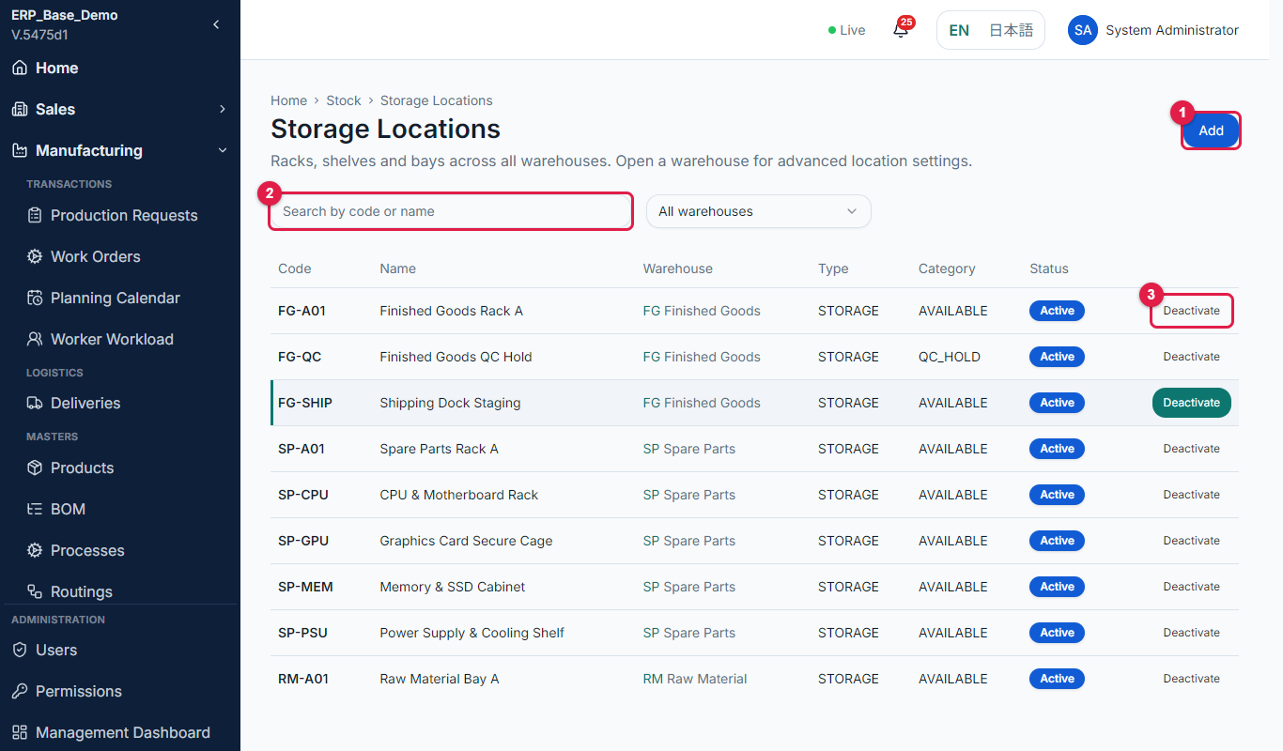
Figure 9.2-1 Storage location list
No. | Marked item | What it does
1 | Add | Opens a form to add a new record to this master.
2 | Search box | Finds a record by code or name.
3 | Deactivate | Makes the record inactive so it is not offered on new documents. History is kept.

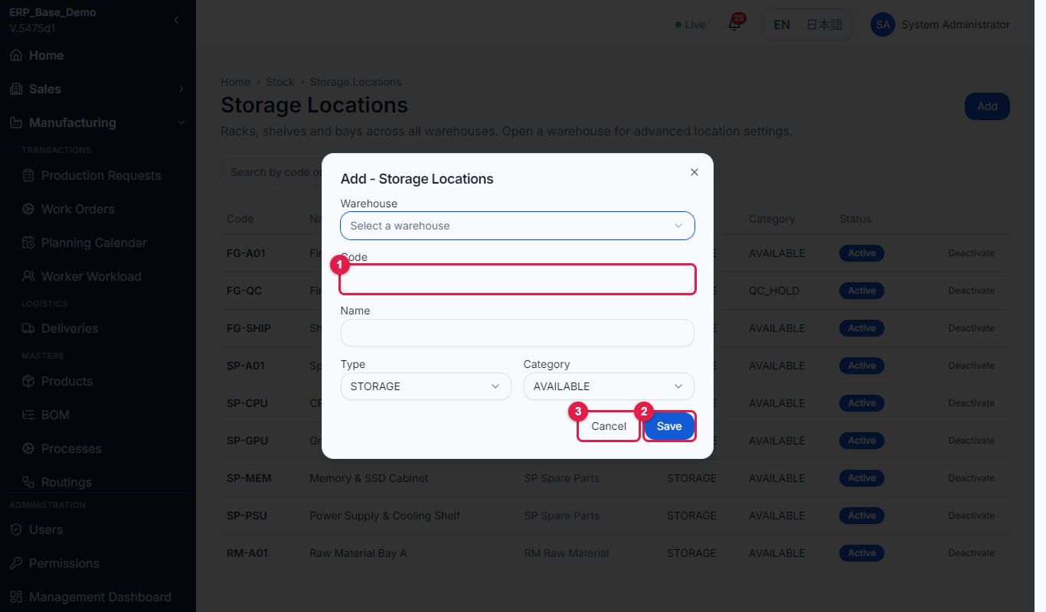
Figure 9.2-2 Add location form
No. | Marked item | What it does
1 | Code | The unique code of the record.
2 | Save | Saves the record.
3 | Cancel | Closes the form without saving.

If something goes wrong
Message / problem | What to do
Warehouse, code and name are required. | Fill the three fields.

9.3 Stock categories
Purpose | Group items so they are easy to find and report on.
Who uses it | Stock manager
Menu path | Stock > Masters > Stock Categories
Page URL | [system address]/stock/masters/categories
Before you start | None.

Step-by-step
No. | What to do | What you should see | Figure
1 | Open Stock > Stock Categories. | The list shows Code, Name, Items and Usage. | Fig 9.3-1
2 | Select Add and enter Code and Name (English and Japanese). | Fields are set. | Fig 9.3-2
3 | Select Save. | Message "Saved." The category is available on the product form. | -

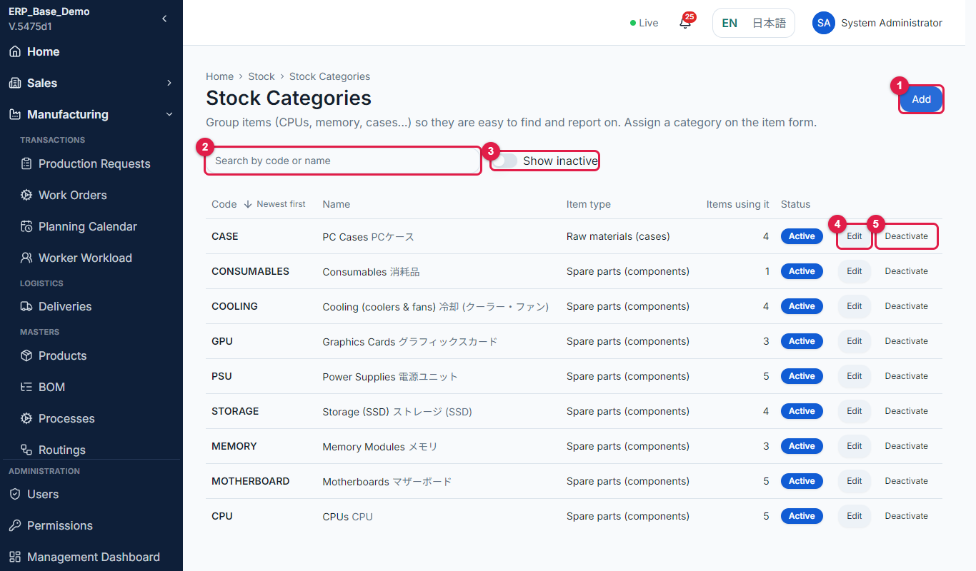
Figure 9.3-1 Stock category list
No. | Marked item | What it does
1 | Add | Opens a form to add a new record to this master.
2 | Search box | Finds a record by code or name.
3 | Show inactive | Turn on to include inactive records.
4 | Edit | Opens the record to change it.
5 | Deactivate | Makes the record inactive so it is not offered on new documents. History is kept.

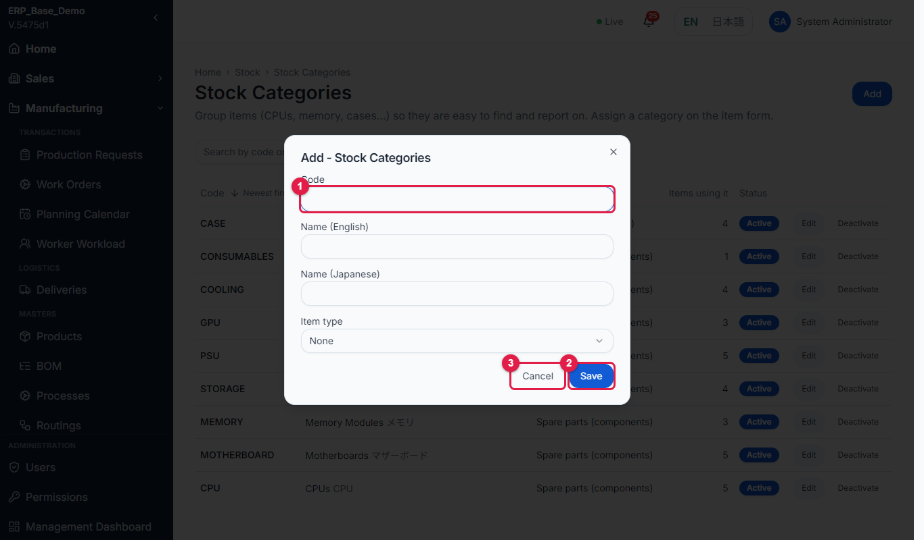
Figure 9.3-2 Add category form
No. | Marked item | What it does
1 | Code | The unique code of the record.
2 | Save | Saves the record.
3 | Cancel | Closes the form without saving.

9.4 Units of measure
Purpose | Define the units items are counted in.
Who uses it | Stock manager
Menu path | Stock > Masters > Units of Measure
Page URL | [system address]/stock/masters/units
Before you start | None.

Step-by-step
No. | What to do | What you should see | Figure
1 | Open Stock > Units of Measure. | The list shows the units and how many items use each. | Fig 9.4-1
2 | Select Add and enter Code and Name. | Fields are set. | Fig 9.4-2
3 | Select Save. | The unit appears on item forms. | -

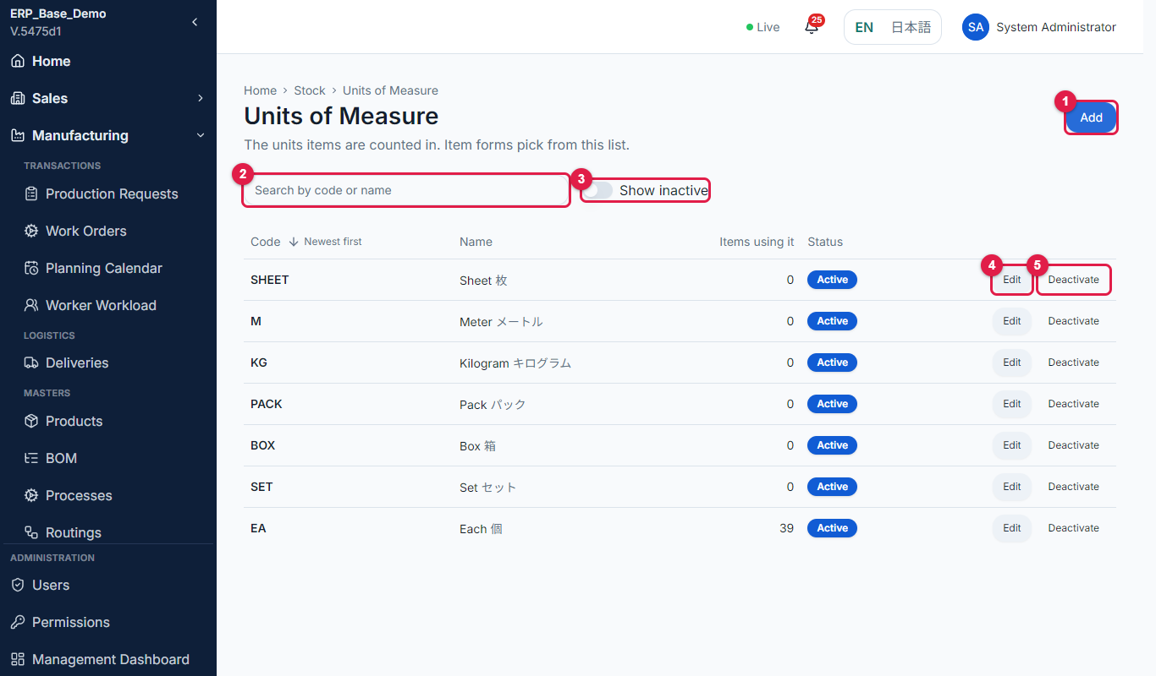
Figure 9.4-1 Unit list
No. | Marked item | What it does
1 | Add | Opens a form to add a new record to this master.
2 | Search box | Finds a record by code or name.
3 | Show inactive | Turn on to include inactive records.
4 | Edit | Opens the record to change it.
5 | Deactivate | Makes the record inactive so it is not offered on new documents. History is kept.

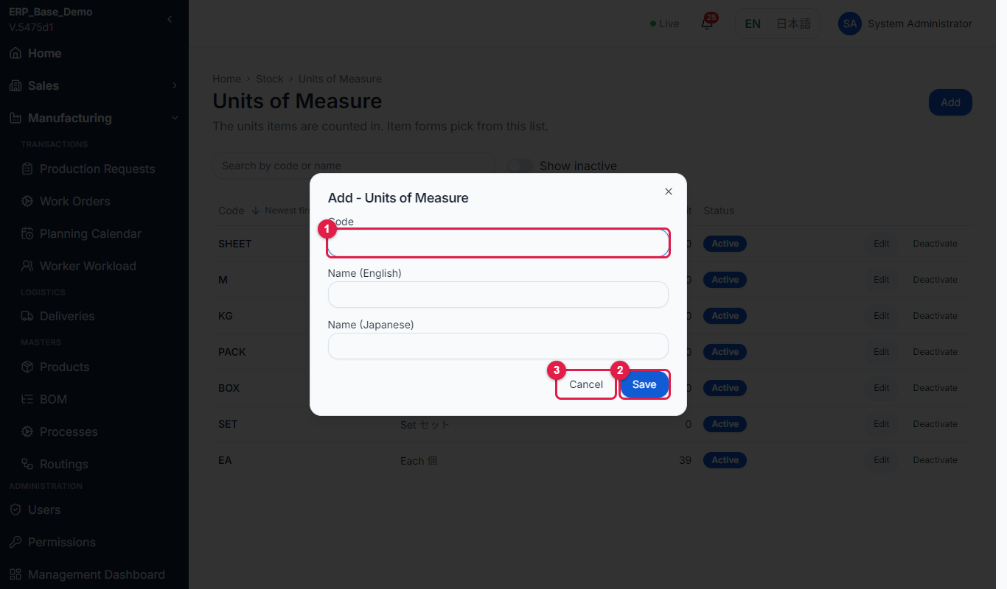
Figure 9.4-2 Add unit form
No. | Marked item | What it does
1 | Code | The unique code of the record.
2 | Save | Saves the record.
3 | Cancel | Closes the form without saving.

9.5 Movement reasons
Purpose | Define why stock is adjusted or issued.
Who uses it | Stock manager
Menu path | Stock > Masters > Movement Reasons
Page URL | [system address]/stock/masters/reasons
Before you start | None.

Step-by-step
No. | What to do | What you should see | Figure
1 | Open Stock > Movement Reasons. | The list shows Code, Name, Applies to and Note required. | Fig 9.5-1
2 | Select Add. Enter Code and Name, choose Applies to (Any movement, Adjustments, Issues / outgoing or Receipts / incoming) and turn on Note required if a note must be typed. | Fields are set. | Fig 9.5-2
3 | Select Save. | The reason can be chosen when recording a movement. | -

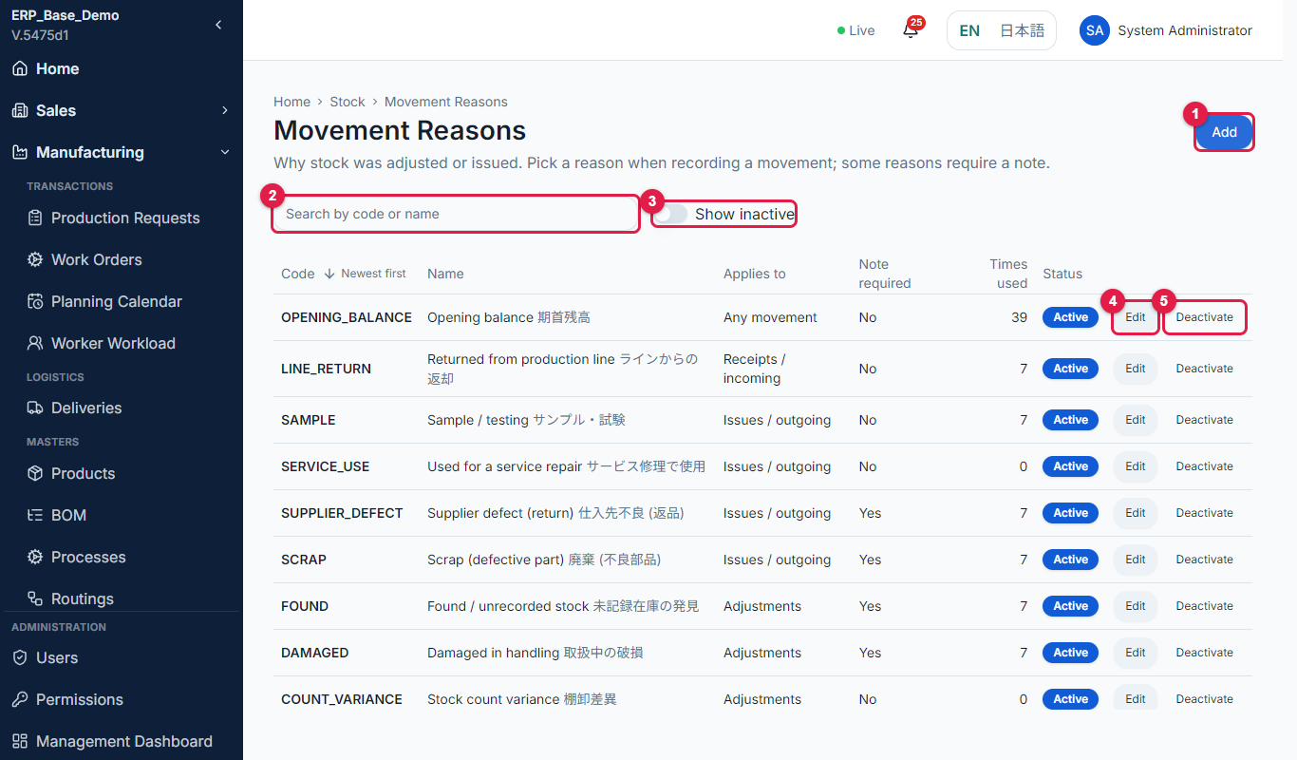
Figure 9.5-1 Movement reason list
No. | Marked item | What it does
1 | Add | Opens a form to add a new record to this master.
2 | Search box | Finds a record by code or name.
3 | Show inactive | Turn on to include inactive records.
4 | Edit | Opens the record to change it.
5 | Deactivate | Makes the record inactive so it is not offered on new documents. History is kept.

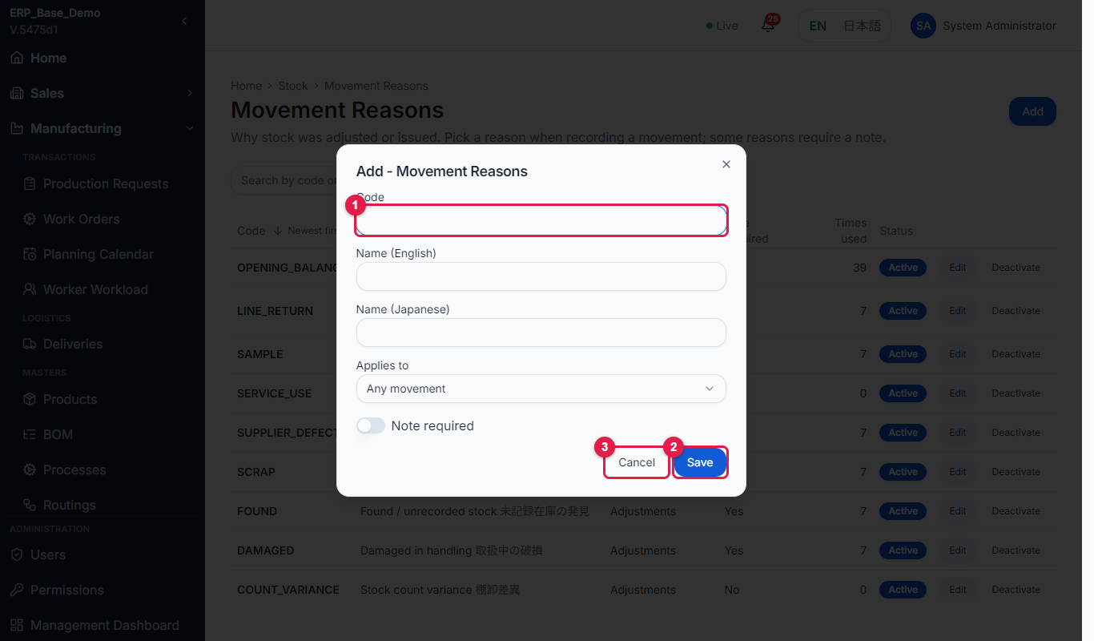
Figure 9.5-2 Add reason form
No. | Marked item | What it does
1 | Code | The unique code of the record.
2 | Save | Saves the record.
3 | Cancel | Closes the form without saving.

Rules to remember
- A reason with Note required forces the user to type a note when it is chosen.

9.6 Reorder policies
Purpose | Define when to reorder each item and in what batch size.
Who uses it | Stock manager, Purchasing
Menu path | Stock > Masters > Reorder Policies
Page URL | [system address]/stock/masters/policies
Before you start | The items exist.

Step-by-step
No. | What to do | What you should see | Figure
1 | Open Stock > Reorder Policies. | The list shows Item, Available, Reorder point, Order quantity, Max stock, Lead time and Supplier. Items at or below the reorder point are marked. | Fig 9.6-1
2 | Select Add, choose the Item and enter the Reorder point, Order quantity, Max stock, Lead time and Supplier. | A hint says suggested purchase quantities are rounded up to whole multiples of the order quantity. | Fig 9.6-2
3 | Select Save. | Stock Control uses the policy to suggest purchase quantities and to raise alerts. | -

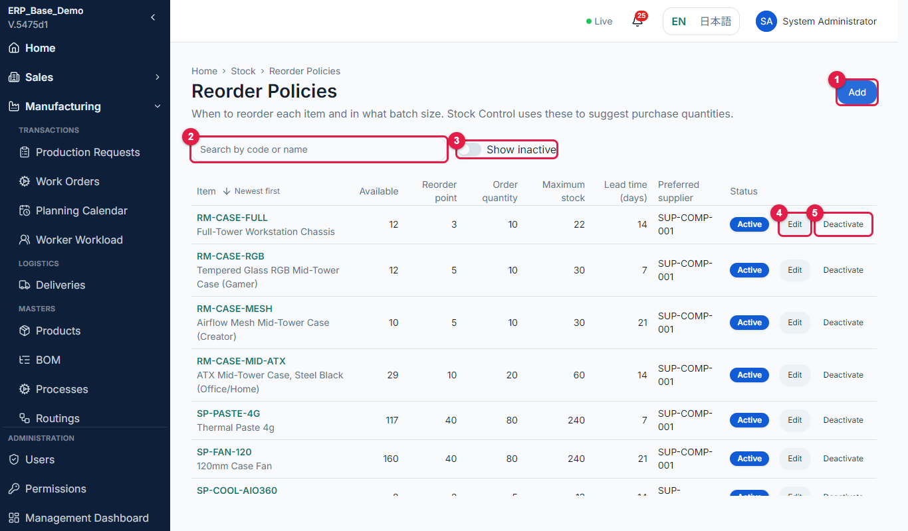
Figure 9.6-1 Reorder policy list
No. | Marked item | What it does
1 | Add | Opens a form to add a new record to this master.
2 | Search box | Finds a record by code or name.
3 | Show inactive | Turn on to include inactive records.
4 | Edit | Opens the record to change it.
5 | Deactivate | Makes the record inactive so it is not offered on new documents. History is kept.

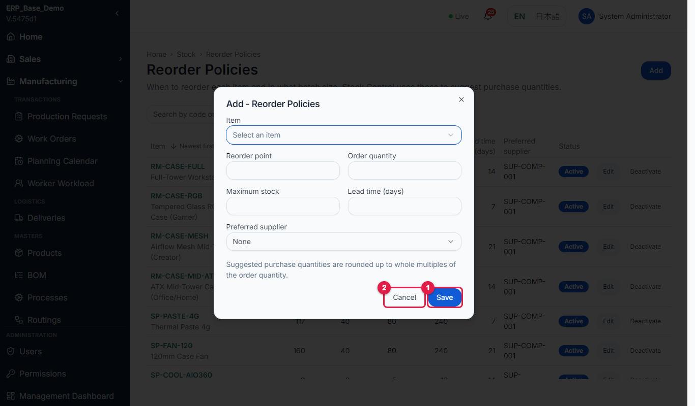
Figure 9.6-2 Add policy form
No. | Marked item | What it does
1 | Save | Saves the record.
2 | Cancel | Closes the form without saving.

9.7 Service masters
Purpose | Define the lists used by service tickets.
Who uses it | Service manager
Menu path | Service > Service Masters
Page URL | [system address]/service/masters/service-types
Before you start | None.

Step-by-step
No. | What to do | What you should see | Figure
1 | Open the Service Masters page (/service/masters/service-types). | The page shows six tabs: Types, Categories, Symptoms, SLA, Warranty and Resolutions, a note that the values are used by service tickets, and the table of the selected tab. Types lists Code, Name, Product required and Default handling. | Fig 9.7-1
2 | Select the Categories tab. | Shows Code, Category, Applies to, Default priority and Owner. Selecting a category on a ticket suggests its priority. | Fig 9.7-2
3 | Select the Symptoms tab. | Shows Code, Symptom, Category, Product scope and Diagnostic hint. The ticket form filters symptoms by the chosen category. | Fig 9.7-3
4 | Select the SLA tab. | Shows Priority, Name, Response (min), Resolution (hr), Escalate (min) and Notify. These fill the priority lists. | Fig 9.7-4
5 | Select the Warranty tab. | Shows Code, Policy, Product scope, Duration (days), Starts from (delivery date, purchase date, invoice date or repair completion) and Coverage. | Fig 9.7-5
6 | Select the Resolutions tab. | Shows Code, Resolution, Decision, Outcome, Next document and Closes. Choosing a resolution on a ticket sets the matching decision. | Fig 9.7-6
7 | On any tab select Add record, fill the fields and save. Use Search and Show inactive to find records. | Message "Saved." The record is available on the service ticket form. | -

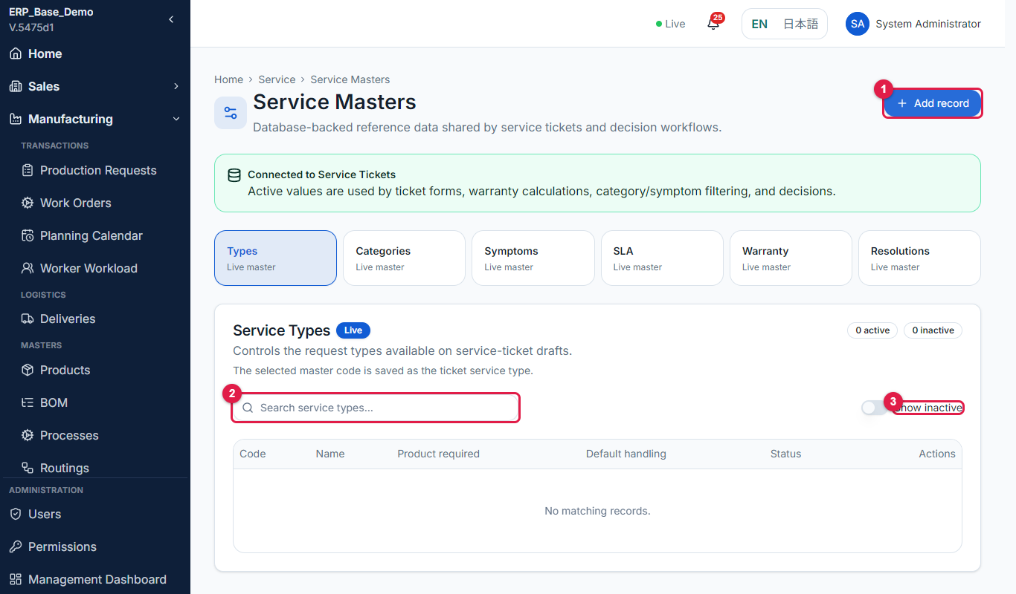
Figure 9.7-1 Service Masters, Types tab
No. | Marked item | What it does
1 | Add record | Adds a record to the selected master.
2 | Search box | Finds a record in the selected master.
3 | Show inactive | Turn on to include inactive records.

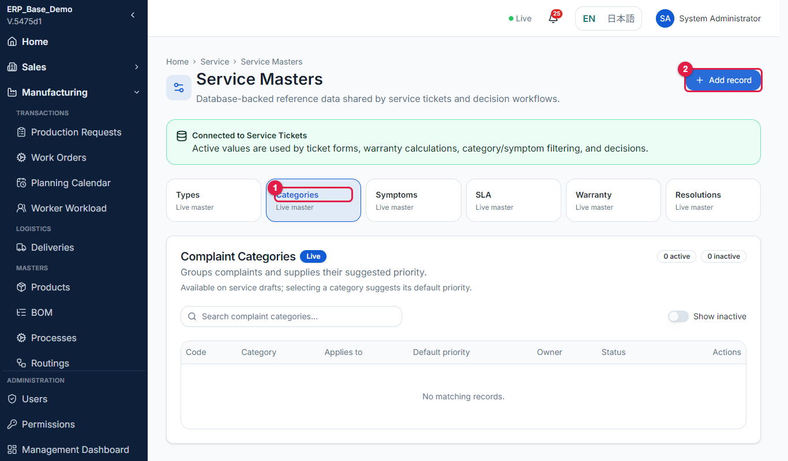
Figure 9.7-2 Categories tab
No. | Marked item | What it does
1 | Categories tab | The complaint categories master.
2 | Add record | Adds a record.

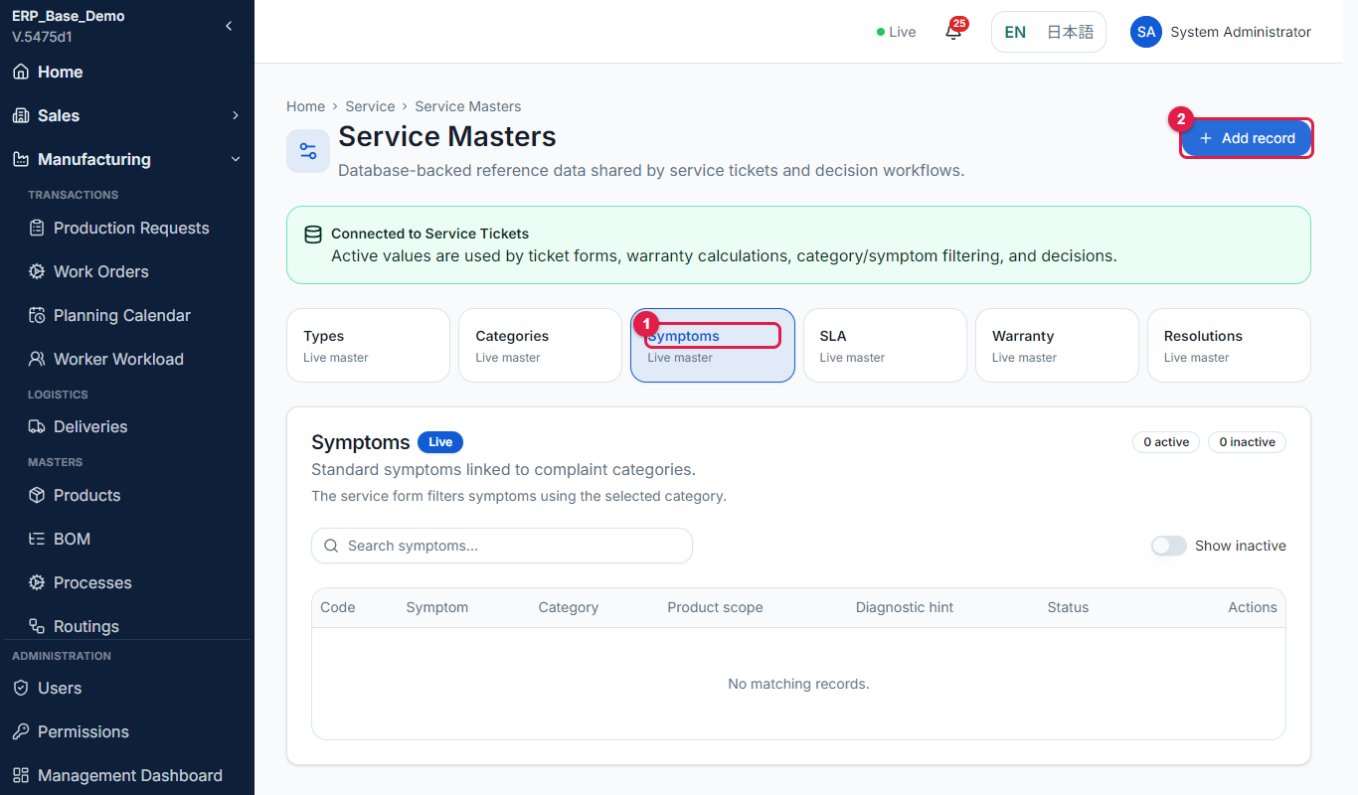
Figure 9.7-3 Symptoms tab
No. | Marked item | What it does
1 | Symptoms tab | The symptoms master.
2 | Add record | Adds a record.

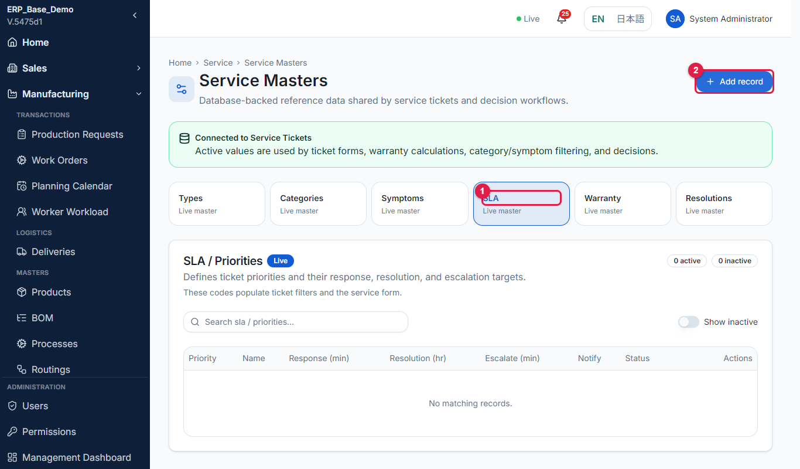
Figure 9.7-4 SLA tab
No. | Marked item | What it does
1 | SLA tab | Response, resolution and escalation targets per priority.
2 | Add record | Adds a record.

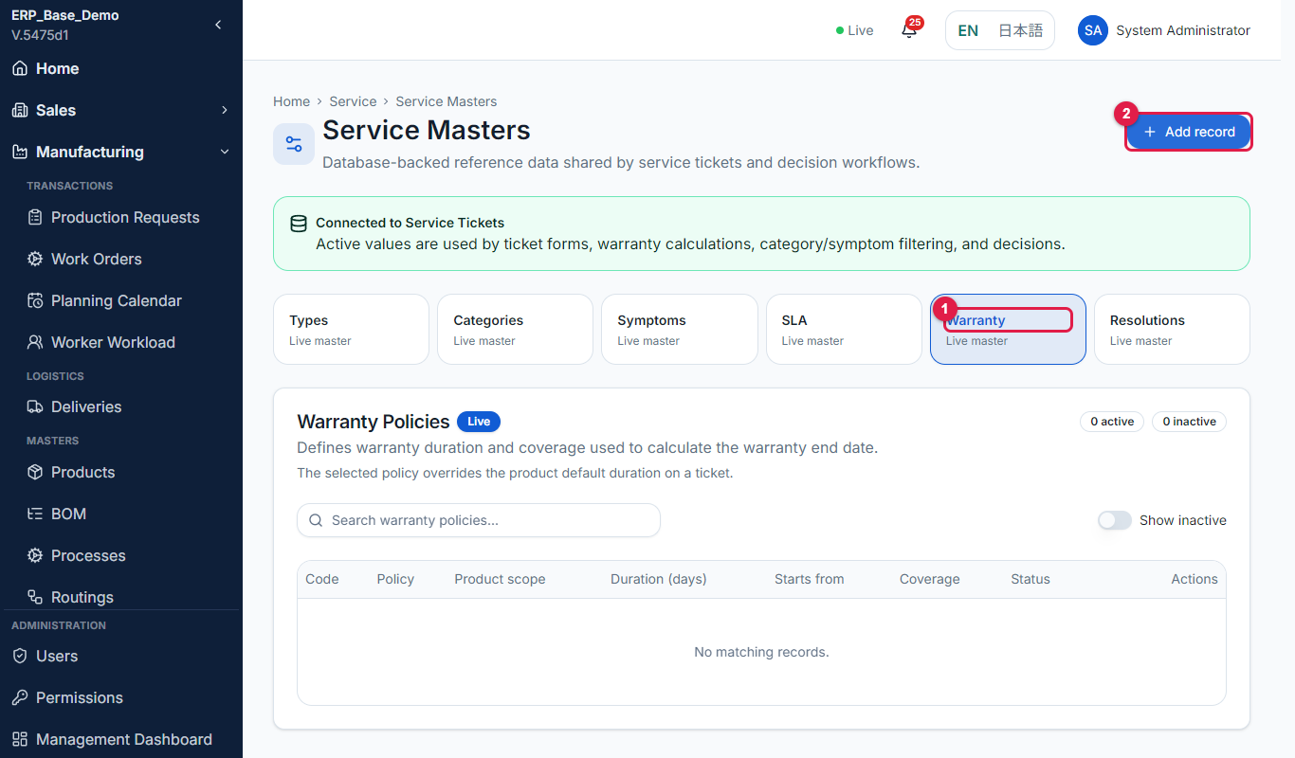
Figure 9.7-5 Warranty tab
No. | Marked item | What it does
1 | Warranty tab | Warranty policies: duration and what starts the period.
2 | Add record | Adds a record.

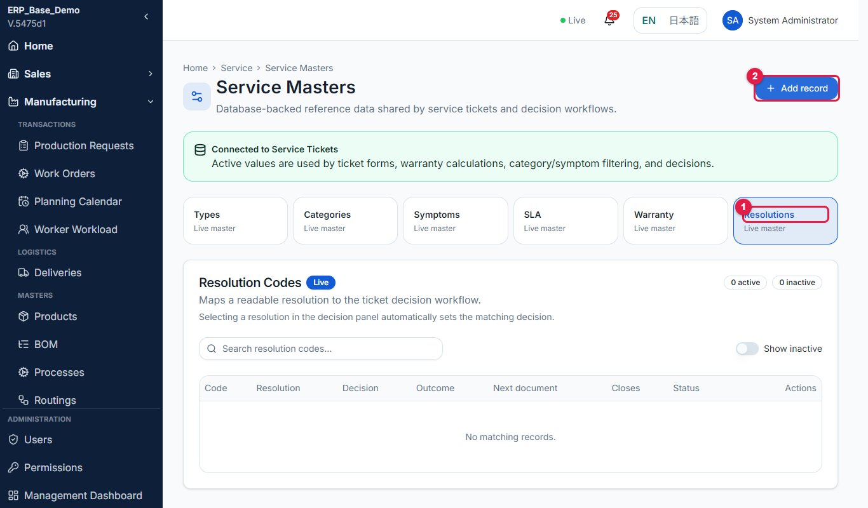
Figure 9.7-6 Resolutions tab
No. | Marked item | What it does
1 | Resolutions tab | Resolution codes that set the ticket decision.
2 | Add record | Adds a record.

Rules to remember
- A warranty policy chosen on a ticket overrides the default warranty duration of the product.

DEVELOPER NOTE: The demo database has no service master records yet (each tab shows "No matching records"). Load them with the service masters seed (npm run seed:service-masters) before capturing or training.

10 Master Data Rules and Good Practice
Rule | Why
Never delete; deactivate. | History on old documents stays correct.
Keep codes short, unique and consistent (for example CUST-JP-004, SUP-COMP-001, WC-004). | Codes appear in search, on documents and in reports.
Fill English and Japanese names. | Both languages are shown to users.
One owner per master (see the catalog). | The owner keeps it complete and correct.
Create masters in the setup order (section 7). | Later masters depend on earlier ones.
Check dependencies before deactivating (for example an active routing for a product). | Documents cannot be created if a required master is inactive.
Review the masters at month end: fiscal period, exchange rate, calendar and holidays. | Postings and schedules depend on them.
Test after changing a master that drives scheduling or posting (routing, calendar, posting rule). | The effect is on every new document.

11 Troubleshooting and FAQ
Message / problem | What to do
Failed to save user. | Check the email is valid and not already used; retry.
Password must be at least 8 characters. | Enter a longer password.
Choose a department and a role on every row. | Complete or remove the incomplete row.
This user already has a role assigned in that department. | Edit the existing role instead.
Failed to reset password. | Retry; contact support if it repeats.
The user cannot see a menu item. | Check the role and the department access (section 4.2). Changes apply after the next sign-in.
A document cannot be created because a master is missing or inactive. | Open the master in the catalog (section 8), create or activate the record.
A master card says "Not yet available". | The master is not implemented in this version.
Warehouse code already in use. | Use another code.

Question | Answer
Can I delete a user? | No. Deactivate the user; history is kept.
How do I make someone a worker? | Give them the Worker role in a department. A worker profile is created automatically.
When do permission changes apply? | The next time the user signs in.
Where do I see who changed a record? | Administration > Users > View Activity.
[Add your own question] | [Answer]

Appendix A Permission Actions
Action | Meaning
View | See records and open pages
Create | Add records
Edit | Change records and perform standard steps
Approve | Approve documents (for example purchase orders, deliveries)
Reject | Reject documents
Cancel | Cancel documents (for example accounting documents)
Delete | Remove records (Admin and President only)
Export | Download lists

Appendix B Modules
Module | Used for
Users, Roles, Departments, Audit, Attachments | Administration and system functions
MasterData | Customers, products, BOM, routings, suppliers
Sales, Factory, QC, Inventory, Purchasing, Logistics, Service, Accounting | The department transactions and masters
Management | The management dashboard

Appendix C Screenshot Checklist
Each figure shows the page at the URL below. Replace [system address] with your system address. {id} means a real record number.
Figure | Page URL | What it shows | Done
2.1-1 | /login | Login page | [ ]
2.1-2 | / | Home page | [ ]
2.1-3 | /admin/users | Administration menu | [ ]
3.1-1 | /admin/users | User list | [ ]
3.1-2 | /admin/users | Filter in a column header | [ ]
3.2-1 | /admin/users/new | Empty form | [ ]
3.2-2 | /admin/users/new | Name and email entered | [ ]
3.2-3 | /admin/users/new | Departments and roles | [ ]
3.2-4 | /admin/users/new | Password entered | [ ]
3.2-5 | /admin/users | User in the list | [ ]
3.3-1 | /admin/users | Row Actions menu | [ ]
3.3-2 | /admin/users/{id}/edit | Edit form | [ ]
3.4-1 | /admin/users | Actions menu | [ ]
3.4-2 | /admin/users | Confirmation window | [ ]
3.4-3 | /admin/users | Status changed | [ ]
3.5-1 | /admin/users | Reset password confirmation | [ ]
3.6-1 | /admin/users/{id}/activity | Activity history | [ ]
3.6-2 | /admin/users/{id}/activity | Date filter | [ ]
3.6-3 | /admin/users/{id}/activity | Activity table | [ ]
3.7-1 | /admin/users?worker=linked | Shop-floor workers filter | [ ]
3.7-2 | /manufacturing/workers/calendar | View workload | [ ]
4.1-1 | /admin/permissions | Permissions page | [ ]
4.1-2 | /admin/permissions | Role permission table | [ ]
4.2-1 | /admin/permissions | Access tab | [ ]
4.2-2 | /admin/permissions | User access | [ ]
4.2-3 | /admin/permissions | Add Access window | [ ]
4.2-4 | /admin/permissions | Revoke | [ ]
5.1-1 | /admin/management-dashboard | Management dashboard | [ ]
5.1-2 | /admin/management-dashboard | KPI tiles | [ ]
5.1-3 | /admin/management-dashboard | Charts | [ ]
6.3-1 | /sales/dashboard | Department dashboard | [ ]
6.3-2 | /sales/dashboard | Masters panel | [ ]
9.1-1 | /stock/warehouses | Warehouse list | [ ]
9.1-2 | /stock/warehouses/new | Warehouse form | [ ]
9.1-3 | /stock/warehouses | Deactivate window | [ ]
9.2-1 | /stock/masters/locations | Storage location list | [ ]
9.2-2 | /stock/masters/locations | Add location form | [ ]
9.3-1 | /stock/masters/categories | Stock category list | [ ]
9.3-2 | /stock/masters/categories | Add category form | [ ]
9.4-1 | /stock/masters/units | Unit list | [ ]
9.4-2 | /stock/masters/units | Add unit form | [ ]
9.5-1 | /stock/masters/reasons | Movement reason list | [ ]
9.5-2 | /stock/masters/reasons | Add reason form | [ ]
9.6-1 | /stock/masters/policies | Reorder policy list | [ ]
9.6-2 | /stock/masters/policies | Add policy form | [ ]
9.7-1 | /service/masters/service-types | Service Masters, Types tab | [ ]
9.7-2 | /service/masters/complaint-categories | Categories tab | [ ]
9.7-3 | /service/masters/symptoms | Symptoms tab | [ ]
9.7-4 | /service/masters/sla-priorities | SLA tab | [ ]
9.7-5 | /service/masters/warranty-policies | Warranty tab | [ ]
9.7-6 | /service/masters/resolution-codes | Resolutions tab | [ ]

Appendix D Contact and Support
System administrator | [Name / email / phone]
IT support | [Name / email / phone]
Master data owners | [Per department]
Support hours | [Days / time]

