ЗАПРОС 1: Все сеансы на сегодня с количеством свободных мест
SELECT f.title AS 'Фильм', d.date AS 'Дата', d.time AS 'Время', d.price AS 'Цена билета', COUNT(s.seat_id) AS 'Всего мест', SUM(CASE WHEN s.status = 'free' THEN 1 ELSE 0 END) AS 'Свободно', SUM(CASE WHEN s.status = 'booked' THEN 1 ELSE 0 END) AS 'Забронировано' FROM dates d JOIN films f ON d.film_id = f.film_id LEFT JOIN seats s ON d.date_id = s.date_id WHERE d.date = '2026-04-29' GROUP BY d.date_id, f.title, d.date, d.time, d.price ORDER BY d.time;
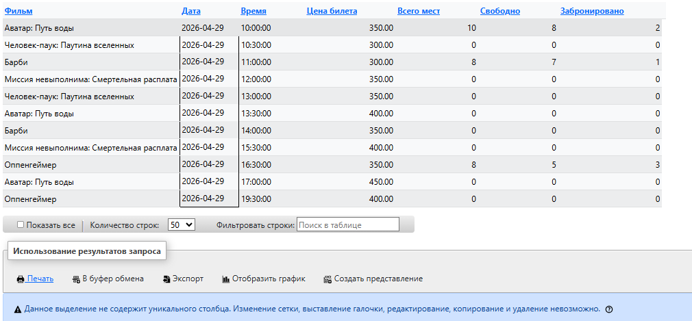

ЗАПРОС 2: История заказов конкретного пользователя (user_id = 1)
SELECT o.order_id AS '№ заказа', o.created_at AS 'Дата заказа', f.title AS 'Фильм', o.date AS 'Дата сеанса', o.time AS 'Время', o.seats_list AS 'Места', o.total_amount AS 'Сумма', o.status AS 'Статус' FROM orders o JOIN films f ON o.date = (SELECT date FROM dates WHERE date_id IN (SELECT date_id FROM seats WHERE seat_id IN (SELECT seat_id FROM order_details WHERE order_id = o.order_id))) AND o.time = (SELECT time FROM dates WHERE date_id IN (SELECT date_id FROM seats WHERE seat_id IN (SELECT seat_id FROM order_details WHERE order_id = o.order_id))) WHERE o.user_id = 1 ORDER BY o.created_at DESC;
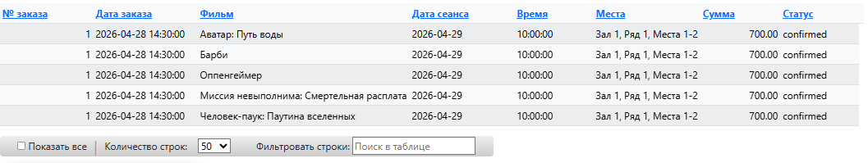

ЗАПРОС 3: Статистика продаж по фильмам
SELECT f.title AS 'Фильм', f.genre AS 'Жанр', COUNT(DISTINCT od.order_id) AS 'Количество заказов', COUNT(od.seat_id) AS 'Продано билетов', SUM(s.price) AS 'Выручка (руб)', ROUND(AVG(s.price), 2) AS 'Средняя цена билета' FROM films f LEFT JOIN dates d ON f.film_id = d.film_id LEFT JOIN seats s ON d.date_id = s.date_id LEFT JOIN order_details od ON s.seat_id = od.seat_id GROUP BY f.film_id, f.title, f.genre ORDER BY COUNT(od.seat_id) DESC;
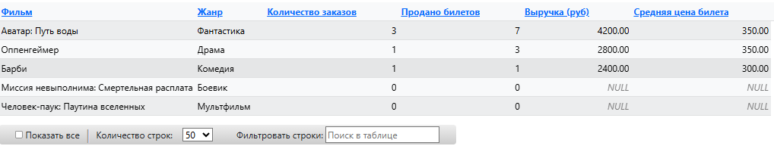
ЗАПРОС 4: Свободные места на конкретный сеанс
SELECT f.title AS 'Фильм', d.date AS 'Дата', d.time AS 'Время', s.hall AS 'Зал', s.row AS 'Ряд', s.seat_number AS 'Место', s.price AS 'Цена (руб)' FROM seats s JOIN dates d ON s.date_id = d.date_id JOIN films f ON d.film_id = f.film_id WHERE s.status = 'free' AND d.date = '2026-04-29' AND d.time = '10:00:00' ORDER BY s.row, s.seat_number;
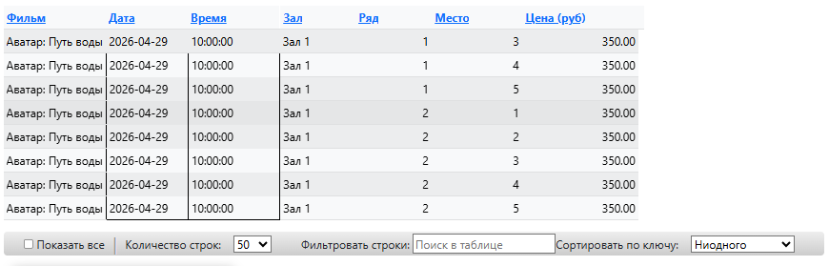

ЗАПРОС 5: Топ-5 пользователей по сумме покупок
SELECT u.full_name AS 'Пользователь', u.email AS 'Email', u.phone AS 'Телефон', COUNT(o.order_id) AS 'Всего заказов', SUM(o.total_amount) AS 'Общая сумма (руб)', ROUND(AVG(o.total_amount), 2) AS 'Средний чек', MIN(o.created_at) AS 'Первый заказ', MAX(o.created_at) AS 'Последний заказ' FROM users u LEFT JOIN orders o ON u.user_id = o.user_id GROUP BY u.user_id, u.full_name, u.email, u.phone HAVING COUNT(o.order_id) > 0 ORDER BY SUM(o.total_amount) DESC LIMIT 5;
