Nate Harris

ADV 0853

Advertisement In Ireland and Belarus In the Context of Hofstede’s Model

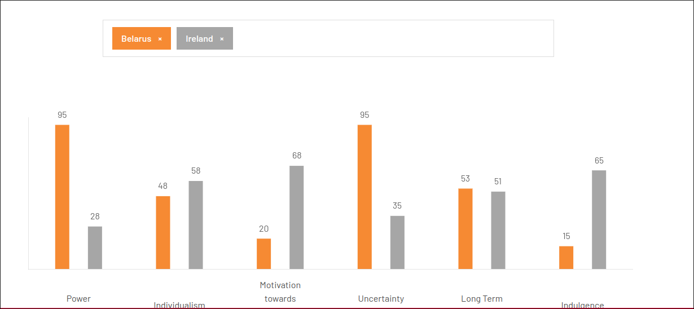 Briefly defining all the cultural dimensions in my own terms using the de Mooij and Hofstede paper:

Power Distance: Acceptance of power disparities in society. (de Mooij and Hofstede, 5)

Individualism/Collectivism: People caring about their close family and selves versus people considering themselves in the context of a larger community (de Mooij and Hofstede, 5-6)

Masculinity/Femininity: Society’s enforcing strict gender roles versus less so. (de Mooij and Hofstede, 6)

Uncertainty Avoidance: People’s tendency to avoid things in which existing, trusted, systems do not approve (de Mooij and Hofstede, 6)

Long-/Short-term Orientation: People who plan for the future versus people who want happiness in the present and value tradition (de Mooij and Hofstede, 7)

While the website does not include feminine versus masculine, it includes the extra two indulgence and motivation towards achievement and success. Indulgence, herein considered as the tendency to enjoy things such as partying or consumables like alcohol or expensive food. Motivation towards achievement and success being considered one’s internal drive to find success in activities such as sport or a career.

Quoting Bush from the BBC News profile of Alexander Lukashenko from 2007 the current president of Belarus is the “last dictator in Europe” (BBC News). Belarus is a nation that is run on similar principles to those during is Soviet occupation. While the continuous election of Lukashenko is a controversial matter as well is his allying with Russia, Belarus remains firm in his party’s grip. Despite this, the chart determines that uncertainty towards change and power distance and incredibly important in Belarus as well as a strong aversion towards indulgence and motivation towards achievement and success. This along with the fact that it is participating in the current war of Russia and Ukraine its markets may be pretty unwilling to accept new commerce if not thoroughly vetted through the existing systems. This may suggest that the largely middle class consumer-base primarily want to buy safe and practical commodities. Also, many goods and services may come State run organizations which are already may be valued and trusted.

Ireland is a very different country than Belarus. It has no history of Soviet rule, rather a former one of British oppression, and is generally considered to be a lovely, although wet place. At least in the minds of American tourists. There is a large drinking and sports culture, as well as many historical landmarks and a deep folk mythos. Ireland also has a large tourism industry and many people from the surrounding countries visit and intermingle. Ireland’s lowest dimensions are power distance and uncertainty suggesting that people are generally viewing others as equal without regard for social status, and there is a large willingness to try new things. Motivation towards achievement and success and indulgence are the highest meaning that they value improving oneself in, for example, career and enjoy simple pleasures. These opinions stem from my family’s trip to Ireland where we visited small towns along the Ring of Kerry and others as well as the cities of Galway and Dublin.

Starting with the three ads from Belarus, I will be using the YouTube channel MEDIACREW PRODUCTION which bases itself in Belarus. The first ad, number 2 in the citations, is an ad for a beer brewed in the City of Lida. This ad shows a man’s trip a bathhouse in the woods narrated a phone call with who I assume is his wife. The trip concludes with him setting down his cold beers, assumedly to go drink them with his friends at the cabin and eat kebabs. The ad is pretty masculine with the man taking a break from work while the wife stays home, the brand has also been around for a while and is a local one so it also appeals to that collectivism that is necessary for late Soviet style dictatorships.

The next ad is an ad for Voka (citation 3), which is a streaming service based in Belarus. It features a man and a professional soccer athlete getting ready for a soccer game ending in them both sitting down on the man’s couch as the game starts on the TV. It announces Voka’s partnership with the Premier League which makes me assume that Belarus, much like many countries in Europe, love soccer. Voka being a Belarusian company means that sports streaming services from other countries are either probably not commonly used.

The last Belarusian ad (citation 4) is for a nasal relieve spray. It will reduce symptoms such as coughing or sneezing. This is indicated by handkerchieves with animated faces then an animated infographic similar to American allergy medication ads. The translated description talks about giving oneself a break during the allergy season. The use of the handkerchief may be an appeal to short-term oriented values like tradition as handkerchieves have been a long used in Belarus instead of facial tissues.

The first Irish ad (citation 5) is an ad from the internet and TV provider Sky. Pretty similar Brand to Voka of Belarus. This ad appeals to the National pride of Ireland as it is the sponsor of the national teams. Despite the vastly different dimensions soccer is popular in both countries. The style in this one is actually more nationalistic than the first. One must assume Ireland fans support their teams hard.

The second ad (citation 6) is a McDonald’s Ireland ad for a McRib, which is a pretty simple ad just announcing its return. This ad demonstrates advertising towards the low uncertainty aversion as the McRib is not something for the faint of heart or visually healthy or appealing. In announcing that it is back one who had it once or maybe not at all with low uncertainty aversion may be excited or interested in trying it.

The last ad (citation 7) is an ad for Guinness beer which features Michael Fassbender crossing the ocean by swimming in order to meet a friend at a bar to bond over a Guinness in a hyperbolized Hallmark-like narrative. This ad appeals to motivation achievement and success as well as indulgence as it features a famous actor doing something crazy as well as Guinness beer. It may motivate one to go to a pub to share a drink with a friend.

I think the framework is valuable for examining a culture, and maybe it could be good to show someone why you are structuring an ad as such. Given this I think most successful advertisers are very immersed in the culture you are advertising to. Even global brands should seek out local directors, for example I would have no clue about the common use of handkerchiefs in Belarus given the analysis, but if I did I could use the value of handkerchiefs in Belarus and their high score in desiring old, tested, products it may move one away from making another ad that uses tissues. So I think it is helpful but not an end all-- be all solution.

Citations

1 “Profile: Alexander Lukashenko.” News.bbc.co.uk, 9 Jan. 2007, news.bbc.co.uk/2/hi/europe/3882843.stm.

‌2 <https://www.youtube.com/watch?v=4794IEKbmtY>

3 <https://www.youtube.com/watch?v=fM6I7e9uXCs>

4 <https://www.youtube.com/watch?v=Lps96iUlo3g>

5 <https://www.youtube.com/watch?v=8BV5sOpetj8>

6 <https://youtu.be/BVTmjPwGyg0>

7 <https://www.youtube.com/watch?v=mSh1NNp0q5Q>

8 Marieke de Mooij & Geert Hofstede (2010) The Hofstede model, International Journal of Advertising, 29:1, 85-110, DOI: 10.2501/S026504870920104X

9 <https://www.theculturefactor.com/country-comparison-tool?countries=belarus%2Cireland> (graph image)