**OUTPUTS**  
*All the programs were run on visual studio code without a virtual environment*

*You can find the outputs in the following pictures*

**Training_model.py**

*The training output*

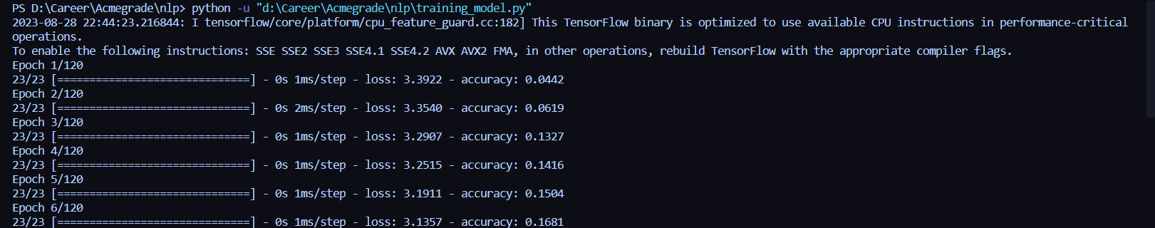

.

.

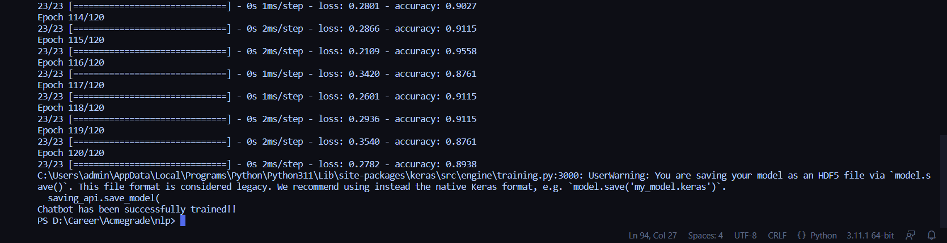

*Training Data loss visualization:*

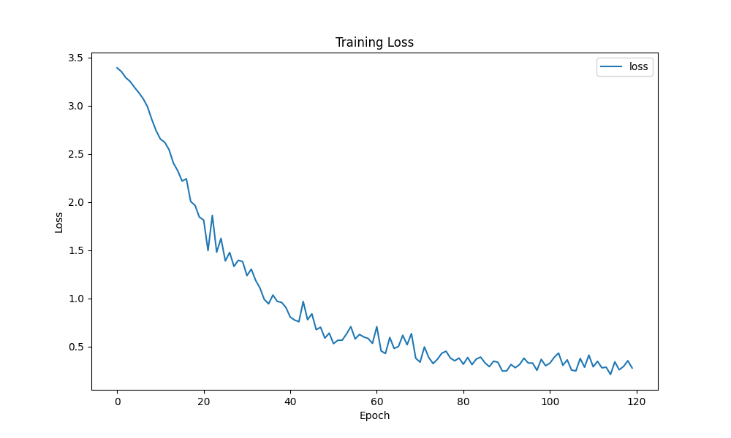

*Training Data accuracy visualization*

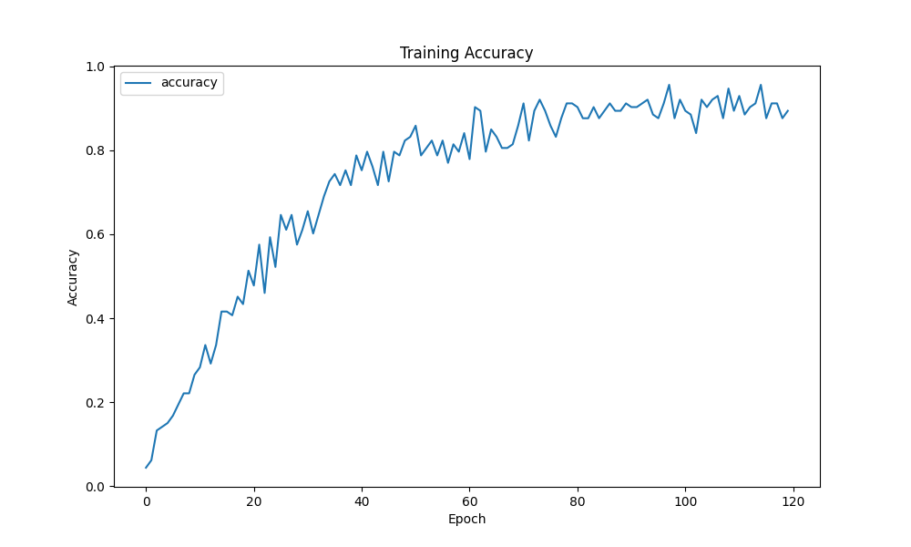

**MAIN.py**

Final output with chatbot working:  
