RASD

Langze YE，December 2022

Contents

1 Introduction 3

1.1 Purpose 3

1.1.1 Goals 3

1.2 Scope 3

1.2.1 World Phenomena 4

1.2.2 Shared Phenomena 4

1.3 Definitions, Acronyms, Abbreviations 4

1.3.1 Definitions 4

1.3.2 Abbreviations 4

1.4 Revision History 5

1.5 Reference Documents 5

1.6 Document Structure 5

2 Overall description 5

2.1 Product perspective 5

2.1.1 Scenarios 5

2.1.2 Class diagram 6

2.1.3 State charts 6

2.2 Production functions 6

2.2.1 Offer users the information about the charging station 7

2.2.2 Enable users to book a charge 7

2.2.3 Enable users to start the charging process and pay for it 7

2.3 User characteristics 8

2.4 Assumptions, dependencies and constraints 8

2.4.1 Domain assumptions 8

3 Specific Requirements 8

3.1 External Interface Requirements 8

3.1.1 User Interfaces 8

3.1.3 Communication Interfaces 9

3.2 Functional Requirements 9

3.2.1 Use case diagrams 9

3.2.2 Use cases 10

3.2.3 Requirements 13

3.2.4 Mapping on goals and requirements 14

3.3 Performance Requirements 14

3.4 Design Constraints 15

3.4.1 Standards compliance 15

3.4.2 Hardware limitations 15

3.5 Software System Attributes 15

4 Formal analysis 16

5 Effort spent 16

6 References 16

# Introduction

## Purpose

With the development of new means of transportation, electric vehicles have become one of the most popular choices of more people. At the same time, more and more charging stations come into our cities and villages.

To reduce the carbon footprint caused by our urban and sub-urban mobility needs and to facilitate the life of electric vehicles drivers, our new system, E-Mall will play an important role which can help the drivers solving their charging problems. What’s more, it will also provide Charging Point Operators (CPOs) the information of charging station, such as the number of charging sockets available. That means E-Mall will contain the Charge Point Management System.

This document will further expand on the goals and requirements put on the system.

### 1.1.1 Goals

|  |  |
| --- | --- |
| Goals | Description |
| G1 | Help drivers to find the charging stations nearby and know their cost and special offer. |
| G2 | Allow drivers to book a charge in a specific charging station for a certain timeframe. |
| G3 | Allow drivers to start the charging process at a certain station. |
| G4 | Allow drivers to know when the charging process is finished |
| G5 | Allow drivers to pay for the obtained service. |
| G6 | Help CPOs to know the location and “external” statue of a charging station. |
| G7 | Help CPOs to know the amount of power can be supplied by every socket |
| G8 | Help CPOs to infer when the battery is full during the charging of a vehicle. |

## Scope

E-Mall not only serves for users (electric vehicles drivers), but also helps Charging Point Operators to manage a charging station. That means eMall system contains 2 parts: e-Mobility Service Providers(eMSPs) and Charge Point Management System (CPMS). What’s more, the eMPS will interact with the CPMS of a single CPO. Although Distribution System Operator will be mentioned but we won’t consider his interests.

### World Phenomena

|  |  |
| --- | --- |
| **Identifier** | **Description** |
| WP1 | The CPOs provides a special offer or other information to the system. |
| WP2 | The cost of charging station. |
| WP3 |  |

### Shared Phenomena

|  |  |
| --- | --- |
| **Identifier** | **Description** |
| SP1 | Users register an account. |
| SP2 | Users book a charge. |
| SP3 | CPOs request to check status of a charging station. |

## Definitions, Acronyms, Abbreviations

### Definitions

|  |  |
| --- | --- |
| **Definition** | **Description** |
| Users | Normally it means the electric vehicle drivers. |
| Operators | Normally it means Charging Point Operators. |

### Abbreviations

|  |  |
| --- | --- |
| **Abbreviation** | **Description** |
| RASD | Requirements Analysis and Specification Document |
| WP | World Phenomena |
| SP | Shared Phenomena |
| eMSPs | e-Mobility Service Providers |
| CPOs | Charging Point Operators |
| CPMS | Charge Point Management System |
| DSOs | Distribution System Operators |

## Revision History

## Reference Documents

The specification document “01. Assignment RDD AY 2022-2023.pdf”

## Document Structure

This document is composed of six sections.

The first section shows the purpose and scope, which includes the goals of the project and an analysis of the world and the shared phenomena. It also contains the definitions, the abbreviations and the reference documents.

The second section contains an overall description of the system, including product perspectives (which contains some scenarios and a domain model), product functions, user characteristics and the domain assumptions.

The third section shows the specific requirements of the system, including the external interface requirements, the function requirements, the performance requirements, the design constraints and the software system attributes.

The fourth section contains a formal analysis with the help of Alloy. Together with the Alloy code, the analysis objective is described.

In section five there is a presentation of the project members total effort spent.

Section six contains the references used.

# Overall description

## Product perspective

### Scenarios

1, **User want to start using eMall to find the charging stations nearby.**

Jack is a new electric vehicle driver and he tries to use eMall in order to take advantage of its service, such as the map which shows all the charging stations. He launches the service and sign up with his name, phone number, e-mail and so on. He selects “charging stations nearby”, then he successfully finds three charging stations in close proximity. He clicked “more information” to know more about the three stations. He finds that this first station can give a special offer for new drivers so it’s much cheaper than the others. Finally, he drives his new car there without hesitation in a happy mind.

**2, Users want to book a charge in a specific charging station**

Mark is a manager who will have a business trip in another city next week so he needs to charging his electric vehicle the night before the business trip to guarantee his long trip. Unfortunately, the charging station near his home is always very busy during the nights. Mark decides to book a charge for next Monday to ensure that he can have a socket to charge his car. He clicks the function “book a charge”, and he choses his familiar charging station. He enters the day and the time he wants and choses an available socket. He also has to enters how much energy he needs so that the station will

reserve enough power for his car. What’s more, he can cancel his order at any time if he doesn’t need it any more. If necessary, he can also contact the CPO to ask more information.

**3, Users start the charging process at a certain station**

It’s not Ben’s first time to charge his car at the station near his company. As usual, he drives to the station. He already knows through eMall that there are some available sockets which has enough energy for his car. He comes to a vacant position and just scans the QR code on the socket with his smartphone to login his account. He starts the charging process and connects his car to the charging plug. Then he enters how much energy he needs, or he can just click “full charge”, the system will calculate the price and the time he needs to wait. He can also click “remind me”, so that the system will send him a message when the charging process is finished.

**4.CPOs manage charging stations**

Oliver is a CPO who uses eMall to help himself to manage his charging station. He shows the address and other information of his station on eMall. Sometimes he needs to answer customer calls and give them more information either about the special offer or about the reservation. He login the CPMS and he can find a list which show the “external” status of his charging station. Such as the number of charging sockets available and their serial number, their type(slow/fast/rapid), their cost, the remaining battery power. What’s more, all the charging processes are monitored and he can know when the sockets will be free. That can help him answer more customer questions. When he finds that the remaining battery power is not enough. He decides to contact DSOs for more energy.

### Class diagram

### State charts

## Production functions

In this section the main functionalities of eMall are presented and described in more detail.

### Offer users the information about the charging station

The most important and basic function of eMall is to make information of charging station available for users. In detail, the system should offer the charging station address, the cost and the special offer (if it has one). In addition, it must have the ability to calculate the distance to every charging station in order to give drivers some useful advices. That means, the GPS function is necessary for our system. The information is provided by CPOs. Users also can know whether a charging station has sockets available and enough energy.

### Enable users to book a charge

The system should provide a tool to enable registered users to book a charge in a specific charging station for a certain timeframe. Users can Complete the reservation by entering the date, the time, the serial number of socket and also how much energy he need. At the same time, the system will ensure there will be a socket available which has enough energy for users. What’s more, users can modify the information of reservation for example modify the date, or they can also cancel the reservation if they want. Normally, the contact details of CPOs are mentioned in the information of the charging station. So, if necessary, users can contact the CPO for more information.

### Enable users to start the charging process and pay for it

Another function of eMall is to enable users to start charging process and pay for it when finish. Users can connect the plug to the car and scan the QR code, or enter the serial number of the socket on eMall to start charging. User should enter how much energy he needs or just choose “full charge”. The system will calculate the time and the cost. When it finishes, users can pay for the obtained service by his smartphone. In addition, users should make sure that the socket has enough energy for him, if not, the plug will not work.

* + 1. **Notify the user when the charging process is finished**

A user can use the function “remind me”, which will send him a message when the charging process is finished. This is a feature that can be turned on.

* + 1. **Help CPOs managing their charging station**

CPMS can enable CPOs to know the “external” status of their charging station. They can know the number of charging sockets available and their serial number, their type, their cost. The system also monitors the charging process and it has the ability to give the estimated amount time of every charging process so that CPOs can know when the occupied sockets will be available. What’s more, CPOs can check the remaining power of every socket so they can decide to acquire energy timely.

## User characteristics

The following three actors are considered in the eMall system.

**1, Unregistered users**

A user can’t enjoy the service so that he needs to register to eMall in order to be able to use its functionalities.

**2, Registered users**

A registered user can enjoy every service of eMSPs, for example, he can search information of a charging station, book a charge or start the charging process at a certain station and pay for the service.

**3, CPOs**

A registered user can enjoy the service of his CPMSs. He can know the status of his charging station and monitor all the charging process at his station. He can also upload some information of his station for eMSPs users.

## Assumptions, dependencies and constraints

### Domain assumptions

|  |  |
| --- | --- |
| Identifier | Description |
| D1 | CPOs insert information (such as the special) about their charging station |
| D2 |  |

# Specific Requirements

## External Interface Requirements

### User Interfaces

The user interface of eMall is a website that will be used by both users and operators. For the convenience of users, eMall has to be user-friendly on mobile devices, because sometimes users need to scan the QR code to start charging process.

* + 1. **Hardware Interfaces**

The system is fully operable on the internet, the only hardware interface needed to access eMall is a working device with a web browser, such as a computer or a mobile phone. (A mobile phone is more convenient to scan a QR code).

What’s more, the system also requires the use of different sensors to detect the remaining power of each socket.

### Communication Interfaces

The system needs 3 different communication interfaces possibly through Web APIs.

- The first interface is used to monitor of the remaining power of the plug-in real time.

- The second interface is used to monitor the electric vehicle battery power during the charging process, which can help us estimate the time required for charging.

- The third interface for GPS

## Functional Requirements

### Use case diagrams

**1, Unregistered users**

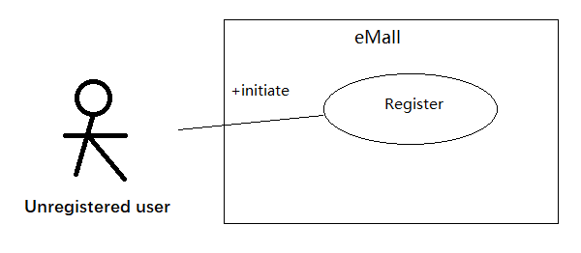

**2, Registered users**

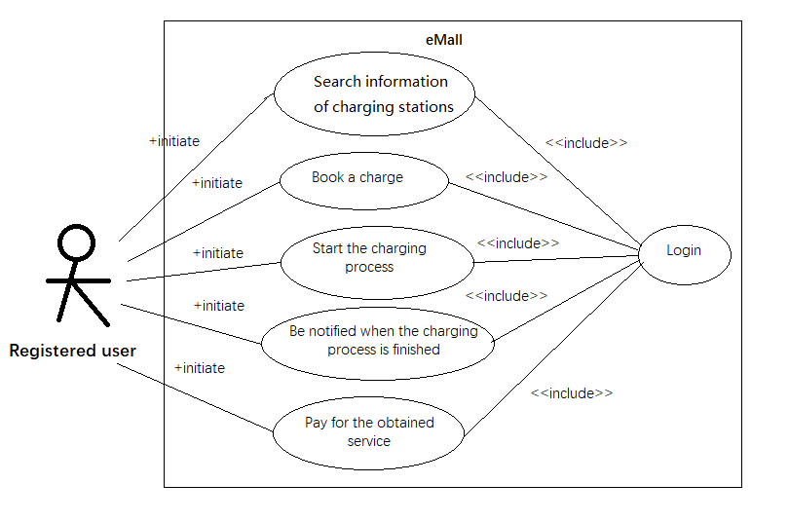

1. **CPOs**

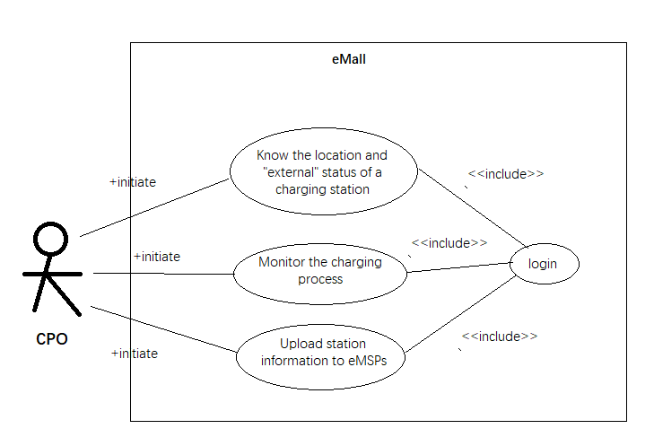

### Use cases

**1, User registration**

|  |  |
| --- | --- |
| Actor | Unregistered users |
| Entry conditions | A new user wants to register an account in our eMall system. He is in the initial interface of the system. |
| Event flow | 1. The user presses the “Register account” button  2. The user enters name, birth date, email address, phone number and password  3. The farmer inserts identification data.  4. The system processes the information and displays a success message. |
| Exit condition | A new account is created. |
| Exceptions | The user does not enter all mandatory data.  (In that case, eMall will notify the user.) |

**2, User Login to eMall**

|  |  |
| --- | --- |
| Actor | Registered users |
| Entry conditions | User is registered, not logged in and on the eMall main page. |
| Event flow | 1. User presses login button  2. User insert email address and password  3. User submits  4. The system processes the information and displays a success message |
| Exit condition | User is logged in |
| Exceptions | The user enters wrong email address or wrong password.  (In that case, eMall will notify the user.) |

**3, Know about the charging station nearby.**

|  |  |
| --- | --- |
| Actor | Registered users |
| Entry conditions | User is registered, not logged in and on the eMall main page. |
| Event flow | 1. User presses “station nearby” button  2. User choses one of the stations  3. The system shows all the information about the charging station. |
| Exit condition | The system shows the information needed |
| Exceptions | No station nearby can be found.  (In that case, eMall will notify the user.) |

**4, Book a charge in a specific charging station for a certain timeframe**

|  |  |
| --- | --- |
| Actor | Registered users |
| Entry conditions | User is registered, not logged in and on the eMall main page. |
| Event flow | 1. User presses “search a station” button  2. User enters the address or the name of the charging station  3. User choses the right station.  4. User presses “book a charge”  5. User enters the date, the time, the serial number of the socket he wants, how much energy he needs  6. The system processes the information and displays a success message. |
| Exit condition | A new reservation has been created. |
| Exceptions | 1. Station not found. 2. The user does not enter all mandatory data.   (In all cases, eMall will notify the user.) |

**5, Start the charging process at a certain station**

|  |  |
| --- | --- |
| Actor | Registered users |
| Entry conditions | User is registered, not logged in and on the eMall main page. |
| Event flow | 1. User presses “search a station” button  2. User enters the address or the name of the charging station  3. User choses the right station.  4. User plugs in and chose the serial number of the socket.  (1 to 4 can be simplified by scanning the QR code on the socket)  5. User enters how much energy he needs or press “full charge” and then press “start”.  6. The system processes the information, starts the charging process and estimates the charging time. |
| Exit condition | The charging process is started |
| Exceptions | 1. Station not found. 2. The user does not enter all mandatory data. 3. Not energy remains in the socket   (In all cases, eMall will notify the user.) |

**6, Use the function to remind the user when the charging process is finished**

|  |  |
| --- | --- |
| Actor | Registered users |
| Entry conditions | User has already started the charging process and on the eMall main page |
| Event flow | 1. User presses “my charging process” button  2. User presses “remind me” button  3. The system processes the information and will send user a message when the charging process is finished |
| Exit condition | The function is open |
| Exceptions | 1. No charging process information can be found.  (In all cases, eMall will notify the user.) |

**7, Pay for the obtained service**

|  |  |
| --- | --- |
| Actor | Registered users |
| Entry conditions | User has already finished the charging process |
| Event flow | 1. User presses “my charging process” button  2. User presses “pay” button and chose a way to pay for the service  3. The system processes the information |
| Exit condition | The service is paid. |
| Exceptions | 1. No charging process information can be found.  (In all cases, eMall will notify the user.) |

**8, CPOs check the “external” status of a charging station**

|  |  |
| --- | --- |
| Actor | CPOs |
| Entry conditions | A CPO is logged in on an account with CPO privileges and on the initial view. |
| Event flow | 1. CPO presses “my station” button 2. CPO use the filter to check the occupied/available sockets   3. CPO choses one of the charging sockets on the list  4. The system processes the information and provide more details about the socket |
| Exit condition | A list shows the status of every charging socket is found |
| Exceptions | 1. No charging sockets in the system  (In all cases, eMall will notify the user.) |

**9, CPOs want to monitor the charging process**

|  |  |
| --- | --- |
| Actor | CPOs |
| Entry conditions | A CPO is logged in on an account with CPO privileges and on the initial view. |
| Event flow | 1. CPO presses “my station” button   2. CPO choses one of the occupied sockets on the list  3. The system processes the information and provide more details about the socket |
| Exit condition | A web page shows the information of charging process is found |
| Exceptions | 1. No charging sockets in the system  (In all cases, eMall will notify the user.) |

**10, CPOs want to upload some information about their charging station to eMSPs**

|  |  |
| --- | --- |
| Actor | CPOs |
| Entry conditions | A CPO is logged in on an account with CPO privileges and on the initial view. |
| Event flow | 1. CPO presses “my station” button 2. CPO presses “upload information” button 3. CPO enters some information about a special offer for users.   3. The system processes the information and sends the message to eMSPs |
| Exit condition | A message managed to be sent to eMSPs |
| Exceptions | 1. No station information in the system  (In all cases, eMall will notify the user.) |

### Requirements

|  |  |
| --- | --- |
| **Requirement** | **Description** |
| R1 | The system shall allow an unregistered user to register an account |
| R2 | The system shall allow a registered user to know about the information of the charging stations. |
| R3 | The system shall allow a registered user to search the charging station nearby. |
| R4 | The system shall allow a registered user to book a charge in a specific charging process at a certain station. |
| R5 | The system shall allow a registered user to start the charging process at a certain station |
| R6 | The system shall notify a registered user when the charging process is finished. |
| R7 | The system shall allow a registered user |
| R8 | The system shall allow a registered CPO to know the location and status of a charging station. |
| R9 | The system shall allow a registered CPO to monitor the charging process |
| R10 | The system shall allow a registered CPO to update charging station information and send it to eMSPs. |

### Mapping on goals and requirements

|  |  |  |
| --- | --- | --- |
| **Goals** | **Domain assumption** | **Requirements** |
| G1 |  |  |
| G2 |  |  |
| G3 |  |  |
| G4 |  |  |
| G5 |  |  |
| G6 |  |  |

|  |  |
| --- | --- |
| **Use case** | **Requirements** |
| User registration |  |
|  |  |
|  |  |
|  |  |

## Performance Requirements

Because there may be some charging stations in areas with weak network signals, the system should be as light as possible to reduce the impact of network fluctuations. At the same time, with the popularity of electric vehicles, the number of users will also increase so that the system had better be able to handle enough concurrent users.

## Design Constraints

### 3.4.1 Standards compliance

First of all, basically, the application and the website should function on all widely used web browsers. In addition, the system must abide by the usage rules of the API. Finally, the privacy of all user data must also be guaranteed.

### 3.4.2 Hardware limitations

The eMall system will be made as a website so it doesn’t have too much limitation. The only hardware requirement is that it has the ability to access the internet. What’s more, in order to scan the QR code to start the charging process more conveniently, a mobile internet device, such as a smart phone will be better.

## Software System Attributes

|  |  |  |
| --- | --- | --- |
| **Nonfunctional requirements** | **Attributes** | **Description** |
| NFR1 | Reliability | The system needs to remain functional in most cases, that means it should have a high reliability. So that a maintenance should be performed regularly. |
| NFR2 | Availability | Usually, the system will maintain high availability. It is worth noting that, external APIs may affect system operation. |
| NFR3 | Security | The system will inevitably store some private privacy information. Therefore, it is necessary to ensure that user information will not be leaked. |
| NFR4 | Maintainability | We need to keep the software running in mode to ensure that the system is always easy to maintain and easy to expand in the future. |
| NFR5 | Portability | The system should be able to function on all widely used web browser, especially mobile network devices. |

# Formal analysis

# Effort spent

# References