2018-19

?

AND WHEN

HOW

,

WHERE

,

WHAT

produce for their food. They also hunted animals.

1 n

forests, and collected roots, fruits and other forest

about the vast wealth of plants in the surrounding

that is, people who gathered their food. They knew

people who lived here were skilled gatherers, —

hundred thousand years. Some of the earliest

have lived along the banks of this river for several

Find the river Narmada on Map 1 (page 2). People

Where did people live?

heard, the plays they saw, the songs they sang.

about the games children played, the stories they

musicians, and scientists. We can also find out

merchants, priests, crafts persons, artists,

the lives of hunters, herders, farmers, rulers,

houses in which they lived. We can find out about

people ate, the kinds of clothes they wore, the

There are several things we can find out — what

What can we know about the past?

can be done.

But what about long, long ago? Let us see how it

Last year: ask somebody who remembers.

television, read a newspaper.

Yesterday: you could listen to the radio, watch

Finding out what happened

so many years ago?

she wondered, could anyone know what had happened

fell on a small headline: “One Hundred Years Ago.” How,

Rasheeda sat reading the newspaper. Suddenly, her eyes

Rasheeda’s question

WHAT, WHERE, HOW AND WHEN?

CHAPTER 1

Evaluation Warning : The document was created with Spire.PDF for Python.

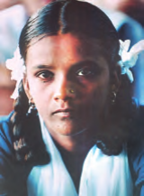

2018-19

I

–

OUR PASTS

n 2

Physical Map of the Subcontinent

MAP : 1

India. These were some of the other areas where

hills to the north-east and the Vindhyas in central

and cattle, and lived in villages. Locate the Garo

People also began rearing animals like sheep, goat,

barley about 8000 years ago are located here.

men first began to grow crops such as wheat and

northwest. Some of the areas where women and

Now find the Sulaiman and Kirthar hills to the

Evaluation Warning : The document was created with Spire.PDF for Python.

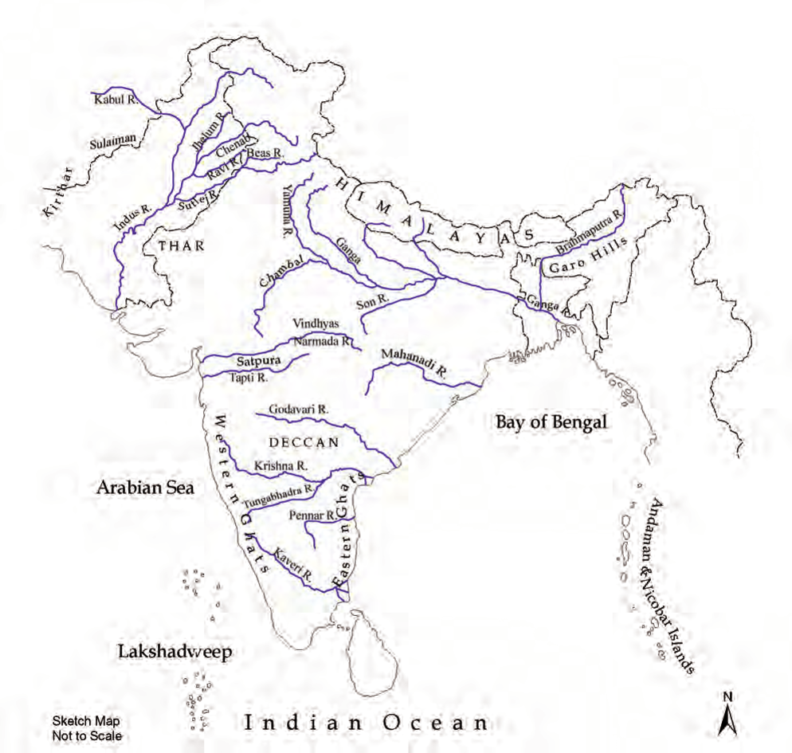

2018-19

?

AND WHEN

HOW

,

WHERE

,

WHAT

also came into the subcontinent and settled here.

3 n

and cross the seas. People from across the frontiers

who wanted could and did scale the mountains

While it was difficult to cross these frontiers, those

seas form the natural frontiers of the subcontinent.

Look at Map 1 once more. Hills, mountains and

Why do people travel nowadays?

these led to the sharing of ideas between people.

wanting to discover new and exciting places. All

perhaps travelled driven by a spirit of adventure,

and advice on the way. Finally, some people

village, town to town, stopping to offer instruction

And religious teachers walked from village to

ships, carrying valuable goods from place to place.

Besides, merchants travelled with caravans or

marched in armies, conquering others’ lands.

disasters like floods or droughts. Sometimes men

search of livelihood, as also to escape from natural

never impossible. So, men and women moved in

and seas made journeys dangerous at times, but

mountains including the Himalayas, deserts, rivers

the subcontinent to another. The hills and high

Throughout, people travelled from one part of

mountains.

were set up in other parts of the country as well.

of Asia by seas, hills and

powerful, and set up a large kingdom. Kingdoms

separated from the rest

now lying in the state of Bihar. Its rulers were very

it is very large, and is

to the south of the Ganga was known as Magadha

smaller than a continent,

Son. In ancient times the area along these rivers

because although it is

called a subcontinent

Locate the Ganga and its tributary called the

South Asia is often

tributaries, and along the sea coasts.

China and Myanmar.

developed on the banks of the Ganga and its

of Afghanistan, Iran,

rivers. Later, about 2500 years ago, cities

neighbouring countries

earliest cities flourished on the banks of these

Lanka) and the

Nepal, Bhutan and Sri

larger river). About 4700 years ago, some of the

Pakistan, Bangladesh,

(tributaries are smaller rivers that flow into a

countries of India,

Trace the river Indus and its tributaries

(including the present

first grown are to the north of the Vindhyas.

map of South Asia

agriculture developed. The places where rice was

Facing Page: This is a

Evaluation Warning : The document was created with Spire.PDF for Python.



2018-19

I

–

OUR PASTS

n 4

away by insects, some were destroyed, but many

turn to page 45.

Over the years, many manuscripts were eaten

birch bark manuscript,

as the birch, which grows in the Himalayas.

to make books. To see a

pages and tied together

or on the specially prepared bark of a tree known

leaves were cut into

hand). These were usually written on palm leaf,

years ago. The palm

(this comes from the Latin word ‘manu’, meaning

written about a thousand

manuscripts, because they were written by hand

This manuscript was

were written long ago. These are called

manuscript.

A page from a palm leaf

past. One is to search for and read books that

There are several ways of finding out about the

Finding out about the past

3500 years ago). Later it was used for the country.

earliest composition in Sanskrit (dated to about

west, and who are mentioned in the Rigveda, the

used for a group of people who lived in the north-

the river was called India. The name Bharata was

Hindos or the Indos, and the land to the east of

ago and were familiar with the Indus, called it the

who came through the northwest about 2500 years

Greece in your atlas. The Iranians and the Greeks

Indus, called Sindhu in Sanskrit. Find Iran and

India and Bharat. The word India comes from the

Two of the words we often use for our country are

Names of the land

over several hundreds of years.

stone, composing music, and even cooking food

traditions. People have shared new ways of carving

These movements of people enriched our cultural

Evaluation Warning : The document was created with Spire.PDF for Python.

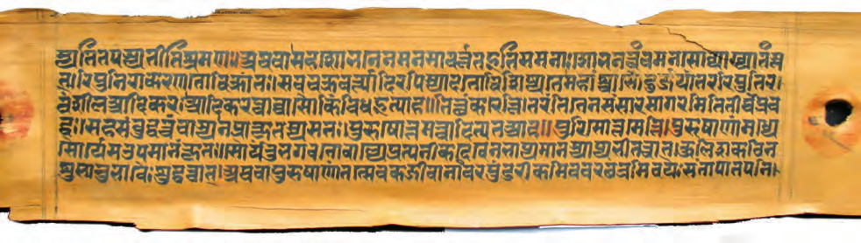

2018-19

?

AND WHEN

WHERE HOW

,

WHAT

survive for a long time.

5 n

are made of hard, imperishable substances usually

others of bone, baked clay or metal. Objects that

coins. Some of these objects may be made of stone,

find tools, weapons, pots, pans, ornaments and

excavate (dig under the surface of the earth) to

area.

which were used in this

paintings and sculpture. They also explore and

and Aramaic (below),

remains of buildings made of stone and brick,

languages, Greek (top)

They study the

different scripts and

archaeologists.

inscribed in two

objects are called

inscription was

use a language. This

who study these

written, or speak, we

the past. Those

When we read what is

made and used in

of letters or signs.

things that were

script. Scripts consist

many

other

anything, we use a

8. When we write

There were

about him in Chapter

the difficulties?

Ashoka. You will read

could have been

of a ruler named

surface? And what

inscribed on the orders

writing on a hard

Afghanistan. It was

Kandahar, present-day

the advantages of

ago, and was found in

Can you think of

to about 2250 years

kings often kept records of victories in battle.

This inscription dates

queens) recorded what they did. For example,

An old inscription.

well, where men and women (including kings and

them. There are other kinds of inscriptions as

inscribed so that people could see, read and obey

or metal. Sometimes, kings got their orders

writings on relatively hard surfaces such as stone

We can also study inscriptions. These are

(languages used by ordinary people) and Tamil.

written in Sanskrit, others were in Prakrit

were epics, poems, plays. Many of these were

of kings, medicine and science. Besides, there

subjects: religious beliefs and practices, the lives

monasteries. These books dealt with all kinds of

have survived, often preserved in temples and

Evaluation Warning : The document was created with Spire.PDF for Python.

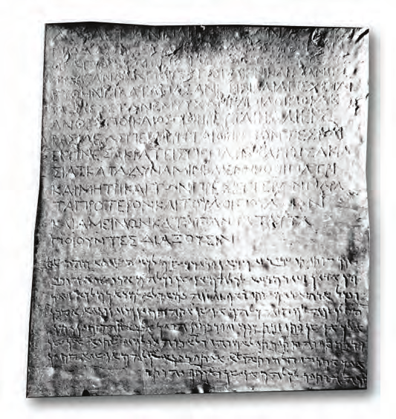

2018-19

I

–

OUR PASTS

different practices and customs in different parts

n 6

Also, as is true even today, people followed

different from those of crafts persons, and so on.

kings and queens, the lives of merchants were

of herders or farmers were different from those of

different groups of people. For example, the lives

attention to the fact that the past was different for

We have used the word ‘pasts’ in plural to draw

Did you notice the title of this book, Our Pasts?

One past or many?

sources like clues to find out about our pasts.

archaeologists are like detectives, who use all these

reconstruct it bit by bit. So historians and

about the past becomes an adventure, as we

archaeology. Once sources are found, learning

found from manuscripts, inscriptions and

often use the word source to refer to the information

Historians, that is, scholars who study the past,

is found frequently by archaeologists?

they survive in a charred form. Do you think cloth

seeds of grain or pieces of wood have been burnt,

past. Plant remains survive far more rarely — if

birds, and fish — to find out what people ate in the

Archaeologists also look for bones — of animals,

we use today?

different from the ones

In what ways is the coin

2500 years ago.

were in use from about

Coins such as this one

Right : An old silver coin.

ago.

used about 4700 years

Pots like these were

city.

Left : A pot from an old

Evaluation Warning : The document was created with Spire.PDF for Python.

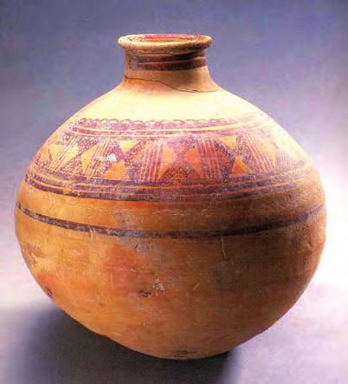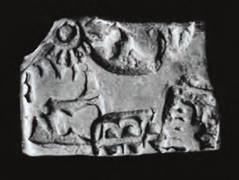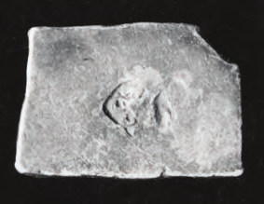

2018-19

?

AND WHEN

HOW

,

WHERE

,

WHAT

7 n

our starting point.

dates going back from the present, using 2000 as

Christ) added on. In this book, we will refer to

backwards and usually have the letters BC (Before

dates before the birth of Christ are counted

means 2000 years after the birth of Christ. All

Christ, the founder of Christianity. So, 2000

date generally assigned to the birth of Jesus

something. These years are counted from the

mention the day, month and year, 2000 and

If somebody asks you the date, you will probably

What do dates mean?

lives, there is much that remains unknown.

While archaeology helps us to find out about their

herders did not keep records of what they did.

hunters, fishing folk, gatherers, farmers or

victories. Generally, ordinary people such as

they fought because they kept records of their

We know a great deal about kings and the battles

Besides, there is another kind of difference.

as these existed in the past as well.

on others for supplies of food. Differences such

By contrast, most people living in cities depend

by fishing, hunting, and collecting forest produce.

living in the Andaman Islands get their own food

of the country. For example, today most people

Evaluation Warning : The document was created with Spire.PDF for Python.

