
Table of contents
The story 3
The game 3
Menu 4
Heads-Up Display 5
Controls 6
Items and armaments 7
Hostile creatures 8

The story
Your company is mining resources on foreign planets. You are merely a janitor, a service technician working a minimum wage job. You have been stationed on Nuclideus for last few months, and you can tell something is wrong.
You hear stories of workers getting lost and seemingly disappearing. The lucky ones speak of never-ending tunnels, infinite staircases and doors that lead to impossible spaces.
But now it was discovered that it isn’t only these anomalies that pose threat to you. An alien cult has revealed itself and they are here for blood.
You pick up your wrench and prepare to do your job: clean up the mess and fix everything.

The game
NUCLIDEAN is an action-horror shooter where you play as a janitor, and your task is to get out of this hell hole. You will travel through multiple locations looking for an exit and battling dangerous enemies.
However, the spaces you go through may be twisted. Don’t be scared if you encounter impossible geometry or an infinite loop.

Menu
When you launch a game a menu will appear and a demo starts playing. To navigate the menu, use your mouse. Hovering over a button will darken it, you can then click it with left mouse button.
This menu can be opened and closed in game with ESC key.
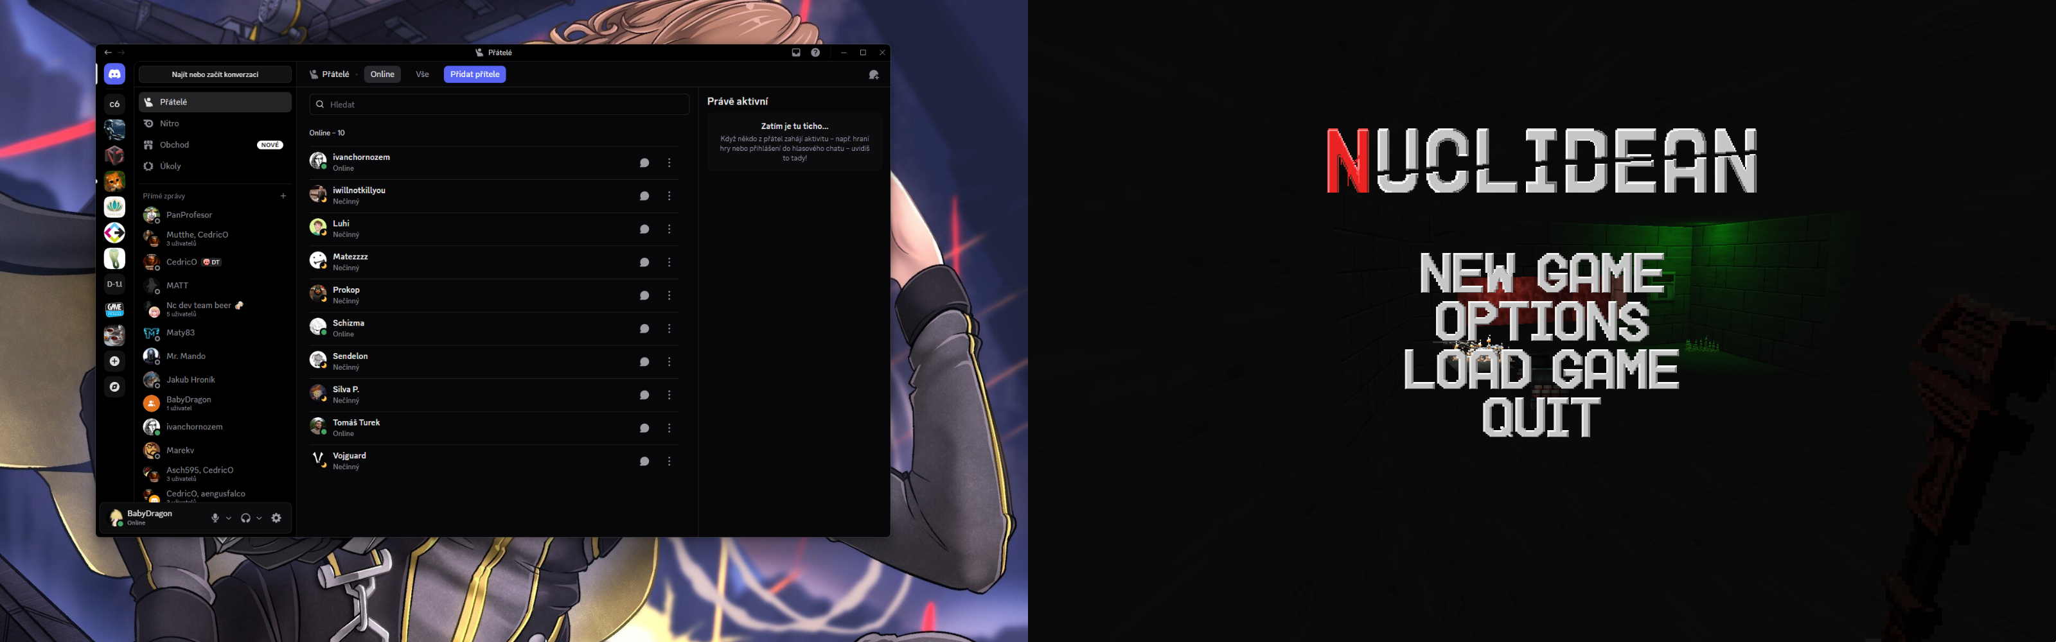
New Game: To play a game, press this button. You will then be asked to select one of three levels.
Options: Here you can modify settings like sound volume, mouse sensitivity and display mode. These settings are saved and persist through multiple playthroughs.
Load Game: Here you can select a previously saved game. Selecting a game will move you to a stage on the selected save file.
Quit: If you need to stop the game for any reason, the Quit button is the button you are looking for. Before exiting the game, NUCLIDEAN will ask you to confirm that you want to leave.

Heads-Up Display
NUCLIDEAN provides in game information in your HUD on the bottom of your screen.
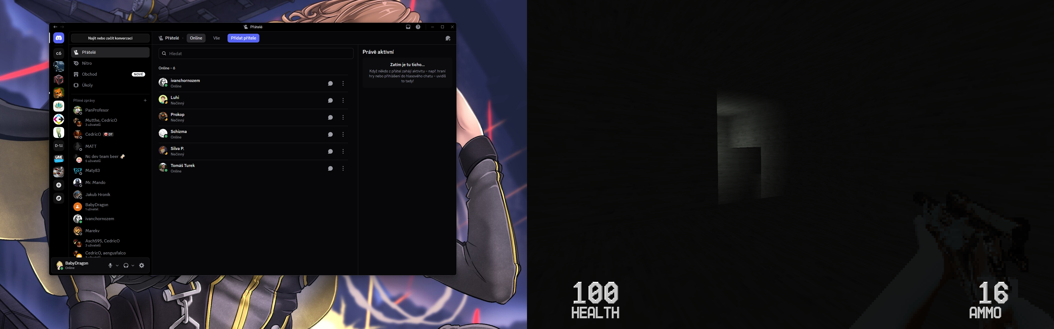
Health: You start at 100. Taking damage will lower this number and getting to 0 will kill your character. Dying is not recommended.
Ammo: This number will display how many shots you have in your current weapon. Each weapon has its own ammo pool.

Controls
Moving: You move your character using the WASD keys:
- W: forward
- S: back
- A: strafe left
- D: strafe right
Mouse: You look around using your mouse. Weapons are fired using the left mouse button.
Switches: You can interact with switches and doors using the E key.
Items: Items are picked up when you walk over them.

Items and armaments
You start the game with a wrench that you swing at your foes. However, you will want to pick up something with a bit more oomph.
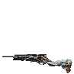
Shotgun: This cheap, mass produced, single-barrel break-action shotgun was brought in by one of your colleagues, seemingly for self defense purposes. It deals plenty of damage up close, but its spread may lead to worse long-range performance.
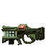
Plasma gun: This piece of alien technology shoots bolts of plasma that dissipate on contact with enemies but bounce when they hit a solid surface.
In a level you can find weapons and ammo for them, but also med-kits (large and small) to help sustain injuries.

Hostile creatures
You will not be alone; there are plenty of foes that await you.
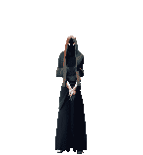
Cultist: These slender figures have been corrupted by whatever is on this planet. Their bodies are weak, but they gained the ability to cast fireballs … three of them at once even.
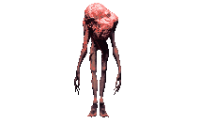
Meat sack: These creatures are a result of a never seen infection. Despite having no head, they can still sense you and will shred you with their claws if they get close enough.

