SafeText : An SMS scam detector

By:
Nano

Members:
Caitan, Justin Amiel
Cortez, Justin Paolo
Martin, Dwayne
Patenio, Sean Joseph

Course:
Systems Integration and Architecture 2

September 2026

PROBLEM AND ORGANIZATIONAL CONTEXT
SMS scams often pretend to come from GCash, banks, couriers, employers, or government agencies and lead people to fake links or payment pages. Advice like “don’t click suspicious links” is hard to follow when people cannot tell which messages are suspicious. SafeText helps by letting students and staff paste a message or upload a screenshot. It returns a Safe, Suspicious, or Malicious verdict with a confidence score, reasons, and details such as the sender ID, links, and phone numbers. We’re building it for a campus security awareness program, with the IT security office as product owner and our group as the Scrum team. SafeText combines OCR to read screenshots, an LLM to assess the message, and threat intelligence to check links. Clear rules for how these services exchange data are essential because we do not control the providers.

SYSTEMS TO BE INTEGRATED, AND WHY
SafeText integrates three external systems, each answering a different question about the message.
System | Role | What it contributes
LLM Whisperer (Unstract) | Image / document data extraction | Converts the SMS screenshot into structured text through an asynchronous job API.
Kimi API (Moonshot AI) | Semantic analysis | Judges scam intent from the extracted text and returns a strict-JSON verdict with confidence, reasons, and entities.
Google Safe Browsing API v4 | URL threat intelligence | Checks URLs found in the SMS against Google's threat lists.

WHY THESE THREE
LLM Whisperer reads the text in screenshots, including chat bubbles and images with low contrast or cropped edges. Kimi looks for scam signs such as urgency, impersonation, fake prizes or loans, and suspicious senders. It can assess new wording that fixed rules may miss. Safe Browsing checks whether any links are already known to be harmful, adding a separate check to Kimi’s judgment.

SYSTEMS TRADING DATA WITH EACH OTHER
These three don't just run side by side — they form a chain of real data exchange. The screenshot's extracted text is sent to Kimi; the URLs Kimi finds in that text are then submitted to Safe Browsing; and all three signals are fused into one verdict. A message that reads convincingly but links to a flagged phishing domain gets caught — not by any single system, but by the data flowing between them.

PROPOSED INTEGRATION APPROACH AND ALTERNATIVES
BACKEND ORCHESTRATION OVER REST/JSON
All three providers expose HTTP APIs — JSON, with multipart for the screenshot upload — so SafeText's backend simply orchestrates the pipeline between them, and no provider ever talks to another directly.
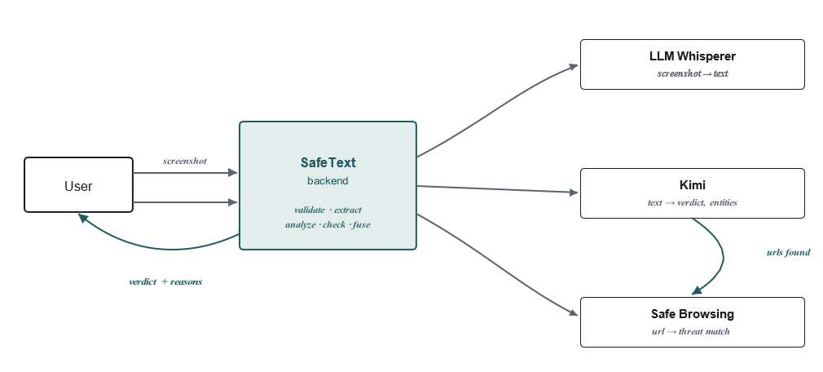
LLM Whisperer works asynchronously — submit, poll, retrieve — so scans run behind a small job queue: POST /api/v1/scan returns immediately with a 202, and the UI polls for the result. Kimi and Safe Browsing, by contrast, are synchronous calls made once extraction completes.
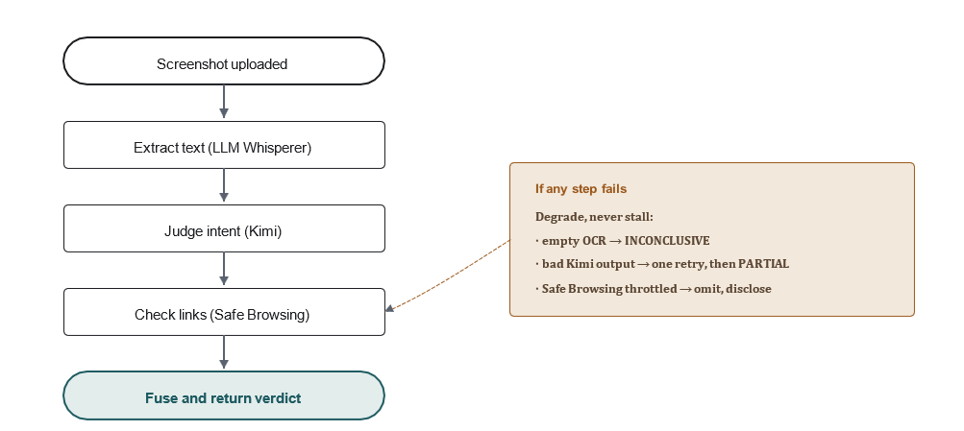

ALTERNATIVES CONSIDERED AND REJECTED
Alternative | Why rejected
Regex or keyword rules instead of an LLM | Scam wording changes often and uses several languages. Fixed rules quickly become outdated and cannot explain a verdict.
Isolation Forest (unsupervised anomaly detection) | It finds unusual patterns but cannot confirm a scam or explain its score. It also needs training data we lack.
Hosted text classifier (e.g. HuggingFace Inference API) | It gives a label and score but no reasons or details to check against threat intelligence.
Client-side OCR with direct provider calls | It would expose API keys in the app. Provider calls must go through the backend.
Fine-tuning our own classifier | It needs labeled scam messages and training resources we do not have.
A message broker (RabbitMQ / Kafka) | It adds unnecessary complexity for this small pipeline. An internal job queue is enough.

INTEGRATION POINTS: INTERFACES AND DATA FORMATS
Every external interface is HTTPS and JSON, with multipart used only at the image-upload boundary. Provider API keys travel in request headers and live solely in server-side environment secrets — never in logs, never in client code.
EXTERNAL INTEGRATION POINTS
ID | Provider | Endpoint | Direction | Request → response
LW-1 | LLM Whisperer | POST /api/v2/whisper | Submit | Bearer key, multipart {file, mode} → {whisper_hash}
LW-2 | LLM Whisperer | GET /api/v2/whisperstatus/{hash} | Poll | → {status: processing | delivered}
LW-3 | LLM Whisperer | GET /api/v2/whisperretrieve/{hash} | Retrieve | → {result_text} — the extracted text
KIMI–1 | Kimi | POST /v1/chat/completions | Sync | Bearer key, OpenAI-compatible body {model, messages[], response_format:json_schema} → strict-JSON verdict
SBL-1 | Safe Browsing | POST /v4/threatMatches:find | Sync | API key, body {client, threatInfo:{threatEntries:[urls]}} → {matches: [{threatType,...}]}

OUR OWN PUBLISHED INTERFACE
{
"scanId": "scn_01J...",
"status": "COMPLETE | PARTIAL | RUNNING | INCONCLUSIVE",
"extraction": { "text": "Gcash: Your acount has been..." }, "analysis": {
"verdict": "MALICIOUS | SUSPICIOUS | SAFE | INCONCLUSIVE",
"confidence": 91,
"reasons": ["Urgency + account-suspension threat", "Misspelled brand name"], "entities": {
"senderId": "GCASH-ALRT",
"urls": ["http://gcash-verify.top"], "phoneNumbers": []
}
},
"threatIntel": {
"urls": [ { "url": "http://gcash-verify.top", "threat": "SOCIAL_ENGINEERING" } ]
},
"incomplete": [],
"createdAt": "2026-09-22T06:14:00Z"
}

DATA-FORMAT CONVENTIONS
We use JSON for data, UTC timestamps, and multipart format for uploads. Kimi must return a verdict, a confidence score from 0 to 100, reasons, and message details in a set format. If it does not, we treat the response as an error. A screenshot’s SHA-256 hash helps us spot repeat uploads and avoid repeating OCR and LLM requests. Internal errors follow RFC 7807, while provider errors include the provider, status, and whether a retry is possible. Every contract rule has an LW, KIMI, SBL, IF, or ERR code, and each test identifies the rule it checks.

CONSTRUCTION STANDARDS
CODING STANDARDS
We’ll use a TypeScript backend on Node.js, a React frontend, and PostgreSQL for scan history. ESLint and Prettier will run in CI, and every change will follow Conventional Commits and receive a pull request review before joining the main branch. OCR, scam analysis, and URL checks will each have an internal interface, so we can change providers without changing how results are combined. Screenshots will be kept only until text extraction is complete, message text will be redacted from logs, and API keys will be stored in environment variables and masked in structured logs.

INTERFACE CONTRACT CONVENTIONS
Each endpoint in §4.1 has a written contract covering required fields, response format, errors, and rate limits. Our API uses /v1; compatible changes stay there, while breaking changes use /v2. Each adapter checks provider responses against a versioned JSON Schema so unexpected changes raise an error instead of producing incorrect results. We use image hashes to avoid duplicate Whisperer jobs and retry malformed Kimi output once with a stricter prompt. Each adapter also has a token-bucket rate limiter and circuit breaker, both checked by failure tests.

TESTING STRATEGY
We test at three levels. Unit tests check individual parts, such as image validation, duplicate detection, scoring, and provider adapters, without using the network. Contract tests check provider responses against their expected format using recorded examples in CI and live checks each week. Interface tests check that the pipeline stages work together from start to finish.
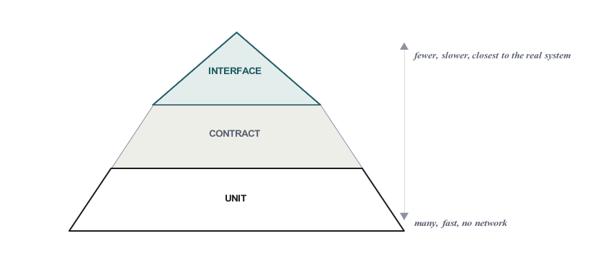

INTEGRATION-FOCUSED TEST CASES
ID | Type | Precondition | Expected behavior | Clause
CT-01 | Contract | Whisperer adapter, fixture SMS image | Job completes; extracted text is non-empty and contains the SMS body. | LW-1.2
CT-02 | Contract | Kimi adapter, sample scam text | Response parses to the verdict schema: enum, 0–100 confidence, reasons array, and entities with urls[]. | KIMI-2.1
CT-03 | Contract | Safe Browsing adapter, Google’s canonical test URL | matches[] is present with threatType in the documented enum. | SBL-3.1
IT-01 | Interface | Backend up; Whisperer and Kimi reachable | Returns 202 and a scanId; GET shows populated extraction text and a full analysis verdict. The image made it through OCR into analysis. | IF-1
IT-02 | Interface | Extraction produced URLs | Every extracted URL is submitted to Safe Browsing; threatIntel.urls[] is populated and factors into the verdict. | IF-3
IT-03 | Interface | Valid upload | One Whisperer job per unique image hash; re-upload returns the cached scan; the poller reaches COMPLETE within 60 seconds. | IF-2
FT-01 | Failure-path | Blurry or unreadable screenshot | Status is INCONCLUSIVE with incomplete: ["llmwhisperer"]; no Kimi call is made. | ERR-2
FT-02 | Failure-path | Kimi returns malformed JSON or a refusal | Retry once with a stricter prompt. If still invalid, fall back to Safe Browsing only and disclose incomplete: ["kimi"]. | ERR-3

SCRUM WORKING ARRANGEMENT
We're running four two-week sprints, preceded by a one-week Sprint 0 for account setup, API keys, and a walking skeleton — an upload flow that returns a stub verdict. Each sprint after that lands one provider as a working, doable slice: the OCR path first, then LLM analysis, then Safe Browsing enrichment, then failure hardening. There's no big-bang integration saved for the end.
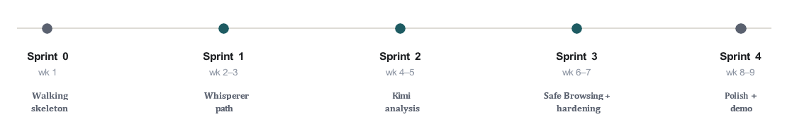

We’ll use Sprint 0 to set up accounts, API keys, and a basic upload flow. Over the next four two-week sprints, we’ll add OCR, Kimi analysis, Safe Browsing, and failure handling, with a working demo after each. The campus security office will be the product owner, and our four or five members will share Scrum Master and development work. Each member will present part of the proposal and answer questions about the whole project. A change is complete when it is reviewed, merged, tested with recorded data and a weekly live check, documented, and free of exposed secrets or stored personal data.
PRINCIPAL TECHNICAL RISK AND MITIGATION

RISK — PIPELINE NON-DETERMINISM
Two of our three providers are probabilistic in effect: OCR quality varies with screenshot quality (blur, cropping, dark mode), and an LLM can return output that's off-schema, hedged, or refused outright. Either failure produces a wrong or missing verdict, and the worst time to discover that is during the demo.
MITIGATIONS
The app requires Kimi to return a valid JSON response. It checks the response and retries once if it is invalid. If it still fails, the app marks Kimi as incomplete instead of using a bad result (FT-02). When there is not enough information to judge a message, the app returns INCONCLUSIVE rather than guessing (FT-01). Safe Browsing still checks any URLs found. Saved responses from all three providers let tests run without using API quota and keep the demo working on a poor connection. Rate limits and circuit breakers prevent one provider’s failure from stopping the whole process. JSON Schema checks and weekly tests with the live providers help catch changes to their response formats before they affect users.

