Novel methodology for producing amorphous ice micro-particles

# Overview and aim

Bulk properties of amorphous ices upon collisions is assumed to be less elastic than crystalline ice (1), thus providing a potential solution to overcoming the bouncing barrier for grains around cm size. However, collision properties of amorphous ice coated grains relevant to those found in the midplane of protoplanetary disks has never been investigated. This is due to the difficulty to produce, use and store such samples that are metastable under Earth conditions.

ASW is commonly produced by water vapor deposition on a cold plate up to few monolayers (ML) due to the heat of condensation that needs to be transmitted into the cold surface. Bar-Nun overcame this issue by scraping the surface when the sample is 200 µm thick with a cold knife, introducing it in a sample container maintained at Liquid nitrogen temperature thus, producing 5- 10 cm thick samples (2). This method has been used to study the bulk properties of comets but is not suitable to produce pebble like samples, necessary to perform collisions.

HGW however is suitable for this purpose as it involves freezing from the liquid phase where the size and shape of the frozen sample is determined and controlled by the initial liquid droplet. We have seen previously that HGW and compact ASW have similar properties and thus can be considered good analogues of each other. Water is a poor glass former though, consequently, to vitrify it, very fast cooling rates need to be achieved, typically in the order of 106 K/s.

Mayer and Brüggeler were the first to achieve the complete vitrification of water droplets by spraying them into organic cryogenic liquids, with propane yielding the best results (52). This technique has since been improved by Cryo-Biologist who freeze the sample to be seen in Electron microscopy while avoiding crystallization. In 2017, the Nobel prize in chemistry was attributed to Joachim Frank, Richard Henderson and Jacques Dubochet for the development of cryo-Electron microscopy, including the sample vitrification in another cryogen, liquid ethane.

Ethane has a similar cooling rate to propane (2.6 * 105 K/s) but a lower Boiling point (184 K vs 231 K), which makes it less likely to leave any residue in the vitrified samples (47). It is our aim to adapt this method to produce HGW particles for laboratory astrophysics and planet formation experiments and this will be described in the following sections.

# Theory of the cooling

## Nucleation theory

Homogeneous vs heterogeneous

Glass transition temperature (Tg)

Nucleation process releases energy thus leading to a local Temperature increase of the sample

Crystal growth depend on the balance between heat production and heat dissipation

cryogen thermal conductivity

## Mechanism of heat dissipation

Overview different cooling exp

Water properties

Biot formula

## Cooling rates

## Cryo-liquid comparison

# Proof of concept experiment

The overall aim is to produce and introduce µm size water droplets into a liquid cryogen maintained at cold temperature to vitrify them similarly to the spray freezing method developed by Bachman et al 1971 (3) with the difference that ethane is used as cryogen and not propane.

## Safety consideration

Ethane is a flammable gas and for that reason, the experiment has thus to be handled in a Glove Box (GB) to avoid the dispersion of ethane into the laboratory. The glove box is continuously purged with dry nitrogen gas to decrease the amount of Oxygen, thus getting below the lower flammability limit of ethane (3 % at atmospheric pressure)(4). This is also good to avoid contamination of water from the atmosphere, which is necessary as some of the experiments are performed using heavy water (D2O). I have also taken the utmost care to minimize potential spark sources by having no electrical devices within the glove box and earthing all the outer metal parts. Also, the gloves are made of butadyl, a static dissipative material. Overall, after filling a Sevron Risk Assessment RA816548 (Annex?), the risk is evaluated as low.

## Design and operation

Figure 1 Diagram of proof of concept experiment

### 3.2.a. Ethane liquefaction

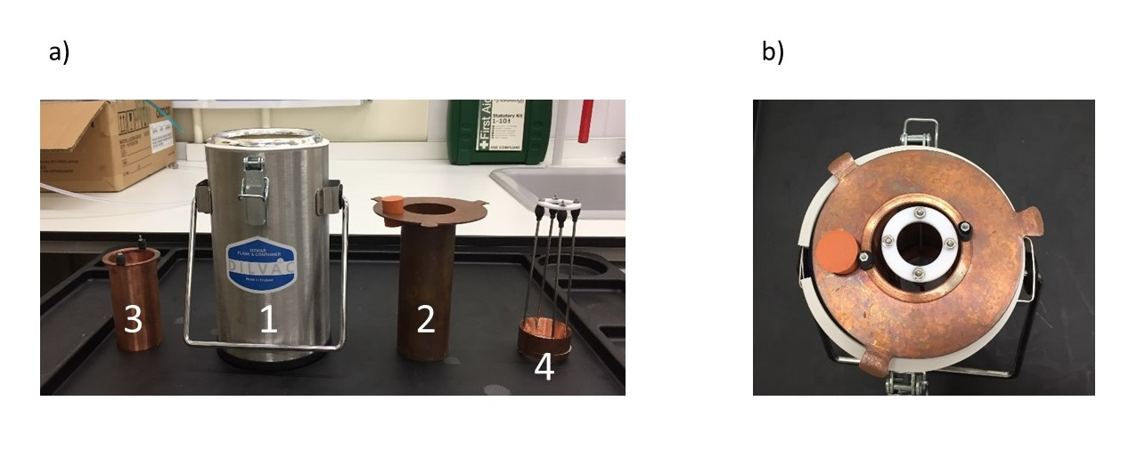

Figure 2 Cooling setup (1) liquid N2 bath – primary cryogen (2) Reaction Vessel for C2H6 – secondary cryogen (3) Frost shield (4) basket – PTFE 1 µm membrane

Ethane is liquid between 89.9 and 184.6 K at atmospheric pressure. Cooling is achieved by introducing ethane gas in the reaction vessel, made of copper (2), submerged in liquid Nitrogen (lN2) (1). (3) is a frost shield, also made in copper which is used to catch the frost that inevitably grows on the cold wall of the Dewar during the droplet introduction preventing it from falling into the cryogen, as this will be a source of impurity. (4) is a PTFE 1μm membrane screwed at the bottom of the basket that is used to fish out the particles from the ethane.

lN2 is filtered and introduced in Dewar (1) using a funnel attached to the Glove Box via a ball valve. The volume of (1) is 1L and once it is 2/3rds full, we start submerging Dewar (2) to progressively cool it down. This part can be quite time-consuming and posing risks because cooling (2) greatly enhances the lN2 evaporation which in turn increases the pressure within the GB inflating the gloves. Once this is achieved, we introduce Ethane gas into (2) via a movable copper pipe. This process generates an ethane fog and the flow is adjusted around 100 mbar to obtain a smooth introduction. lN2 within (1) is constantly boiling off due to the higher ethane temperature and after around 20 minutes of introduction the ethane stops producing the fog and is directly converted into liquid. This indicates that the ethane Dewar (2) is warmer than 90 K. At this point, the process can be sped up by doubling the ethane flow for 10 minutes. However, as the temperature keeps increasing, we need to refill the lN2 within (1) otherwise the temperature will be too high, and ethane will start evaporating. (2) needs to be lifted out of (1) and carefully re-inserted once (1) it is refilled. This procedure is repeated until the desired amount of liquid ethane has been reached corresponding to ¼ L, indicated by a filling level 2 to 3 cm below the top of the Dewar.

### 3.2.b. Water droplet production and introduction

Figure 3 a) Nebulizer b) Nozzle setup

To produce μm-sized water droplets, we use a commercially available Nebulizer, Phillips Innospire Deluxe. It is made of a compressor, pumping the air and producing a high velocity flow through a liquid sample container (10 ml), producing an aerosol. We have adapted the Nebulizer to use N2 as a carrier gas rather than the ambient air and the benefits are three-folded. It prevents the introduction of both water (an impurity when D2O is used) and oxygen (a catalyst in an explosive atmosphere). The N2 flow is also an adjustable parameter to influence the nebulization process (cf. Figure? 🡪 Chapter 6 – microscope pictures).

The droplets are introduced into the cryogen via a nozzle made of copper and sealed to the glove box. It is connected to the water reservoir via a plastic pipe, of which the geometry needs to be carefully adjusted to prevent droplet condensation on the pipe wall.

It is important to note that the efficiency of the cooling will not only depend on the thermophysical properties of the cryogen, but also on the sample dynamics within the cryoliquid. The cooling rate will be enhanced if the samples continue plunging after being introduced in the cryogen rather than if it quickly comes to rest (forced convection) (citation). The density difference between HGW (0.94 g\cm3) and liquid ethane (0.544 g\cm3 at 184.5 K) result in the particles slowly sinking at the bottom of the reaction vessel.

We usually introduce the water for 20 minutes and in two steps of 10 minutes each. Before starting, we disconnect the water reservoir (6) from the pipe linked to the nozzle and adjust the level of the Dewar to put it roughly 1 cm to the ethane level. We then setup the Nitrogen flow at 0.5 bar and then turn the nebulizer on. After a visual inspection of the flow quality, the water reservoir is connected to the nozzle and the timer is started. After the first introduction step (10 min), we can control the ethane level and adjust the nozzle level accordingly. If the ethane temperature is above 130K, we can also refill the primary cryogen Dewar (1) with liquid N2. Because the nozzle is close to the liquid ethane level, it is likely to generate some frost that needs to be cleaned. 20 minutes is generally enough to introduce the 10 ml of water.

### 3.2.c. PID and temperature control

The main parameter that that need to be monitored during the procedure is the liquid ethane temperature as shown in Figure 4. We have attached to the frost shield a K type thermocouple (submerged into the liquid ethane) that can display this temperature.

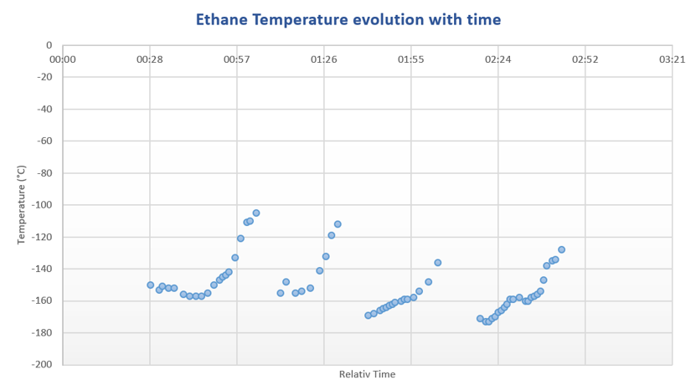

Figure 4 Ethane temperature vs time

Figure 4 show that the liquid ethane temperature is not stable because the cooling setup never reach a state of equilibrium. This is due to the constant evaporation of the primary cryogen, lN2 whom boiling temperature, 77 K is lower than the melting point of ethane, 90K. This imply to refill the liquid N2 every 30 minutes. (Hazardous and heavy task 🡪 explain why).

Another temperature of interest is located at the bottom of the nozzle as it is likely to grow frost due to its proximity to the cryogen (1cm). The frost can obstruct the aperture and big chunk of ice can fall into the cryogen; thus, the nozzle needs to be maintained above 0 °C. This temperature is monitored through a K type thermocouple (T1 in Figure 3) and is controlled using a PID, that can apply a voltage to a heating ring around a copper block (T2 in Figure 3). The PID is setup such as the temperature of the copper can`t exceed 50 degree to avoid the evaporation of the droplets.

### 3.2.d. Particle recovery

The warming curve of a 3 μl water droplet removed from lN2 at ambient temperature reached -100 ˚C after 4 seconds (5), and that is our time constraint to handle the particles out of the cryogen (either ethane or Nitrogen). A PTFE membrane (4 in Figure 2) screwed to the bottom of a basket made of copper is used to fish out the particles from the ethane, before dispersing them in a lN2 Dewar where they will remain stable. Explain why stable in Ln2, and why use of membrane (difference with cryo SEM).

We find that the particles obstruct the pores and the ethane is not drained efficiently. This results in either freezing some ethane in the liquid Nitrogen or having to wait for a long time for the ethane to be drained (or evaporated) thus losing the amorphicity of the particles. However, after dispersion we can visually observe that we obtain a milky mixture made of particles in lN2

## Limitations

This proof of concept experiment has demonstrated that we can safely produce and use liquid ethane. Progress needs to be made enable simplifying the liquefaction process and make it more reliable by being able to control and monitor the ethane temperature.

The water droplet production and introduction has proven to be efficient and reliable.

The particle recovery, however, remains a challenge along with the separation of the ice particles from the cryogen.

# 2nd Version, Hardware Development

Implementing the lessons learned from the proof-of-concept phase, we have built a second-generation experiment to address the previously described challenges. The process remains similar, cooling a Reaction vessel made of copper to liquefied gaseous ethane in which µm sized water droplet will be introduced aiming to produce HGW particles. The previous experiment required a lot of manipulations within the glove box during the cooling phase and we have thus designed this novel setup to minimize interventions from ourselves and thus making it safer and more reliable.

## Overall Design

A new glovebox made of polycarbonate (good resistance to cold temperature), has been bought enabling a bigger volume (Dimensions?) and is presented in Figure 5. Two major improvements have been implemented.

First, the reaction vessel (1 in figure 5) is no longer cooled by submersion in liquid N2 but by an open cold N2 gas flow passing through a solenoid copper pipe in contact with the copper Reaction vessel. lN2 is channeled to the Glove box via a PTFE flange (2 in figure 5) from a pressurized Dewar (200L). The temperature will be adjusted by using a 20W power heating wire featured between the pipe interstices and connected to a Lakeshore PID controller.

Secondly, we decided to abandon the membrane “fishing method” and to recover the particles within the liquid ethane, thus reducing the level of manipulation and consequently modification of the particles. A cryogenic ball valve (6 in Figure 5) has been installed at the bottom of the reaction vessel for that purpose and different recovery setup can be installed beneath the reaction vessel for various sample handling and storage method, increasing experimental versatility.

Figure 5 Glove box setup. numbers will be explained in the text

**1.** Reaction vessel with integrated copper tubing around outer wall. The pipe is silvered soldered to the copper vessel in order to achieve a maximal thermal transfer. Between the pipe interstices is attached by Kapton tape a heating wire (reference) directly connected to a PID controller (Lakeshore model 335). 2 T type thermocouples are attached to the Reaction vessel (cf. Figure 7 for thermocouple setup) in order to precisely control it temperature, allowing for (a) ethane liquification and (b) amorphous ice formation.

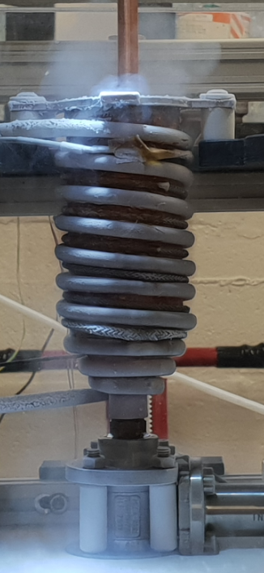

Figure 6 Reaction vessel

**2.** 1 cm thickPTFE Flange featuring liquid Nitrogen feedthrough CF-40 (MDC Vacuum 9812105). Inlet is connected to a pressurized Deware (200L) and connected to Reaction vessel piping by a corrugated hose. Flexible tubing (e in Figure 7) allow the reaction vessel to move up and down by more than 10 cm and to adjust its position with respect to the Nozzle or to the sample recovery area.

Figure 7 Liquid N2 PTFE flange setup **[a]** cryogenic hose ½“ BSP , **[b]** ½” male to female adapter, **[c]** Male tube adaptor ¼” tube OD * ½” (Swagelock SS-4-TA-1-8), **[d]** Swagelock tubing connection ¼” , **[e]** Stainless steel flexible tubing ¼” OD (Swagelock 321-4-X-12-B2), **[f]** Bulkhead union ¼” OD (Swagelock SS400-61), **[g]** Copper tubing ¼” OD, **[h]** PTFE tubing ¼” OD,

**3.** PTFE Flange for electrical equipment; One Thermocouple feedthrough (6 * T type), ATEX certified (Ex II 2 GD, Ex d IIC Gb / Ex e IIC Gb, Ex ta IIIC Da) product for explosive atmosphere and the heating wire (cf. Figure 9).

**4.** Nozzle featuring copper block heating ring attached. Prevents water freezing in nebulizer and/or line from water reservoir. Controlled via PID controller and attached thermocouples.

**5.** Nebulizer inlet. Reservoir of deionized water and/or D2O connects though this port, pressure is provided by dedicated nitrogen cylinder secured in lab to deliver water into copper vessel [5] as a fine mist through the nebulizer.

**6.** Valve attaching to base of reaction vessel. Rated for operation with cryogenic materials/environments.

**7.** Release point for material in copper vessel [1] when valve [6] is opened

**8.** Funnel port. Valve at base of funnel isolates this port from the inside of the chamber during normal operation. It can be opened to allow addition of liquids, e.g. small amounts of liquid nitrogen to a Deware if/as required. Could also serve as back-up for pressure-relief-valve.

Figure 8 Overall setup a) BOSH Design b) Gas setup

* XP transportable and self-contained
* Designed to minimize time between sample extraction and storage

1 -3 Are Nitrogen gas bottles. 1 is 0 grade and connected to the nebulizer via a custom fitting. 3 is connect via ¼ “piping to both the main and the airlock chamber of the Glove box for purging. The experiment can be long and another full bottle (2) must be present to ensure that the purge will be on at all time. 4 is the ethane bottle. 5 is a pressurized liquid Nitrogen Dewar connected to the cooling circuit via a cryogenic hose. A protection has been put in place to avoid to much condensation on the cold surfaces outside the glove box, but frost is unavoidable.

## Temperature control and recording

### 4.2.a Cooling

Liquid Nitrogen cool reaction vessel, warm up, transform to gas (expansion ratio 1:694 ) and is extracted through PTFE flange into a Deware (to recover liquid if any). Lot of Nitrogen is released into the atmosphere that need to be well ventilated. The lab needs also to have proper Oxygen alarm. Even with very long experiment, no liquid Nitrogen has been recovered into the Dewar.

The flow of Nitrogen passing through the pipe is a parameter difficult to monitor and thus to control. It could have been monitored using a flow meter connected to the exhaust, but this is not feasible as no flow meter are currently rated for use at cryogenic temperature. However, it is possible to obtain a visual information about the flow rate. Despite nitrogen being a transparent gas, when cold enough it can produce a fog due to condensation of ambient water droplets from the lab, like cloud formation in the atmosphere (to be explained much better !!).

This phenomenon allows us to get a quantitative information about the Nitrogen flow as depicted by Figure 9.

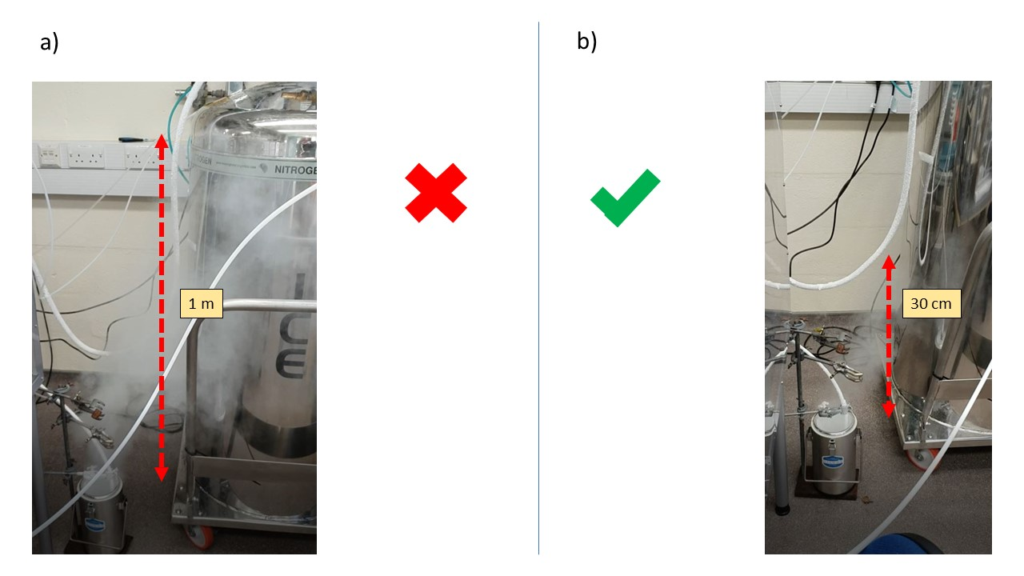

Figure 9 Liquid Nitrogen exhaust setup. a) Liquid Nitrogen flow too important b) Adequate Liquid Nitrogen flow

2 parameters are important to control the Nitrogen flow. The base pressure of the cryogenic Dewar and the valve opening percentage (cf Figure 14 b). The cryogenic pressure is usually set up by the fabricant. It can be tuned by modifying the bursting pressure of the pressure relief valve fitted on all those Deware but the pressure take time to build up and is not suitable for fine tuning on the fly as required by the experimental procedure.

So I have to use the opening of the valve as the adjustable parameter for the Nitrogen flow variable. Very fine tuning … Not consistent all along the experiment …

### 4.2.b Warming and T control

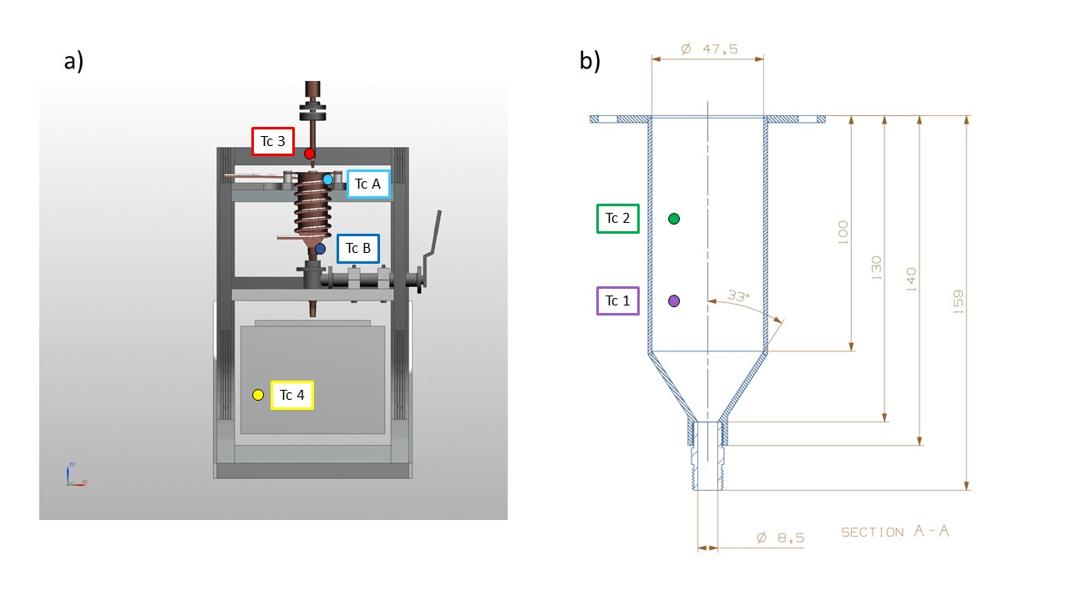

Figure 10 Thermocouple setup

6 T type thermocouple are inserted within the glove box via the same feedthrough.

TCA and TCB are attached at the top and bottom of the reaction vessel and are connected to a Lakeshore PID. A simple Labview code allow the control of TCB temperature by applying a voltage to the heater. (Why TCB – description of Labview code)

TC1,2,3,4 are attached to a Picolog TC-08 and are recorded separately from TCA and TCB.

TC1 and TC2 are attached to the frost shield at different depth to measure any temperature gradient variation within the cryogen.

TC3 is attached to the nozzle in order to prevent frost formation.

TC4 is a flying thermocouple that we can move to monitor the temperature within different area of the glove box. It is used to record different piece of equipment involved in the sample recovery and transfer procedure.

2 different software used to record the temperatures (Labview, to work with Lakeshore TCA and TCB) and Pico log software for TC1, 2, 3, 4. To be described ?

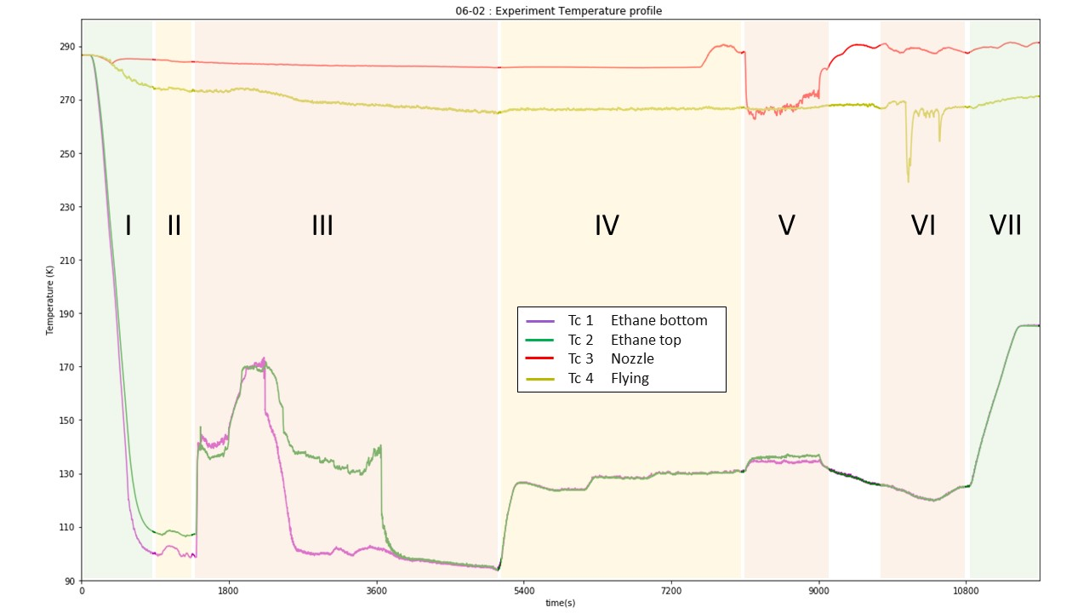

Figure 11 Experiment temperature profile. The different number refer to each experimental step : I. Reaction vessel cooling; II. lN2 flow reduction; III. Ethane introduction/liquefaction; IV. Temperature setting; V. Water introduction; VI. Sample recovery; VII. Ethane warm up/evaporation. Color refer to the level of manipulation needed for each phase, green: not much to do, red: lot of manipulation needed.

Figure 10 represent the temperature evolution of TC 1-4 for a typical experiment. The first phase corresponds to the cooling of the Reaction Vessel. 15 minutes are enough to cool the Reaction vessel (Abbreviation) to its base temperature (around 100K). TCA and B are not shown on this diagram for clarity, but a more precise cooling curve is shown in Figure 12. In order to match with the low power of the heater the N2 flow needs to be reduced at the minimum and that is achieved during the second phase. The third step is the ethane liquefaction who is characterized by a steep increase in both inner temperature TC1 and TC2. Consequently, the temperature show a steep decrease when the thermocouple are immerged by the cryogen (TC1 first and then TC2). The phase IV correspond to the time period where the ethane is set up within the desired range prior to the water introduction (V). VI correspond to the sample recovery and VII to the boiling off the ethane and the shut down procedure.

## Water droplet production

Similar but care has been taken to control and minimize pipe length to diminish droplet condensation on the pipe walls. Also, nozzle is straight

Distance heater - nozzle end.

## Sample recovery method

Because the sample is recovered from the bottom of the reaction vessel an empty space area has been designed below the reaction vessel (roughly 10*10*10 cm), allowing different sample recovery setup to be put in place. 2 method have so far been developed. One that allow filling in 1 ml cryo-vials with ice sample embedded into the cryogen to be stored in a cryoshipping Dewar (reference). The other method has been developed jointly with ISIS Neutron and muon source in order to fill a Vanadium square cell, necessary to perform Neutron scattering experiment.

### 4.4.a. Sample storage

(Picture of sample holder with vials).

A metallic sample holder designed to hold the vials is inserted into a polystyrene box. Liquid Nitrogen is filtered and introduced through funnel (8 in Figure 5) into the polystyrene box.

### 4.4.b. ISIS cell filling

(diagram + picture of the setup)

Vanadium foil + 1 or 2 mm spacer –

Copper block – long time to cool – Heat sink

Funnel made of spacer hold together by Aluminum tape.

Ethane drained through lose junction between cell and funnel.

Bucket to recover the remaining ethane.

# The cooking recipe to produce HGW µm ice particles

## Warm-up and Glove Box purging

All material putted in the glove box 🡪 nice and clean working space

Check integrity of system, thermocouple attachment …

Back panel of glove box screwed in place

Nitrogen purge 1h, stopped when the Oxygen level reach a plateau (1%). No explosive atmosphere and most of residual water removed from the glove box 🡪 use of dessicant, calcium carbonate, not that efficient … but tackled by having “cold spot” away from the reaction vessel 🡪 cold trap. Capture some of the water molecules but frost remain a big issue.

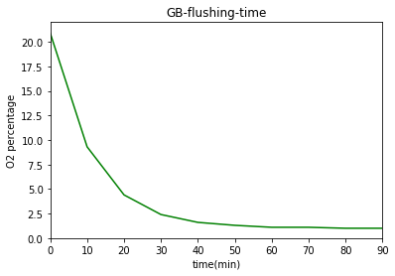

Figure 12: O2 percentage vs time with Nitrogen flow 0.2 bar

## Reaction vessel cooling

2 temperature recording software (Labview and Picolog) are started (t = 0) and the valve on the Pressurized Deware is open (2C) 1 minute later.

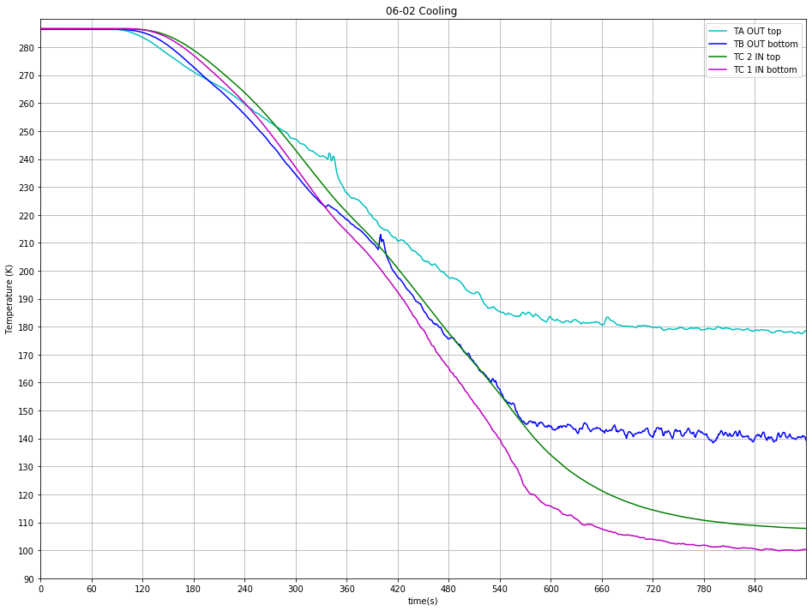

Figure 13 Typical cooling curve

As described earlier the valve opening is key to control Nitrogen flow through the pipe.

Various experiment with different valve opening percentage have been performed and show that the maximum cooling is achieved at 2C (cf Figure 14 b) and that a further opening doesn’t improve the cooling efficiency.

Cooling curve comparison (could have been good to have a comparison of each TC with increasing valve opening but data unexploitable …)

Figure 14 Flow adjustment period

After Reaction vessel has reached base temperature The Nitrogen

Deep care needs to be taken to control and adjust this parameter all along the experimental procedure as it can randomly vary. A liquid Nitrogen flow set up too high won’t allow the Heater to work properly.

## Ethane liquefaction

Once the Liquid Nitrogen flow has been adjusted correctly (as low as possible), gaseous ethane can be introduced. The ethane pipe inside the glove box (downstream to valve?) must be placed inside the Reaction vessel (cf. Figure 15) whose height can be adjusted to allow an immersion of the pipe around 2 to 3 cm inside the Reaction Vessel. Ethane flow is started by opening first the valve ? on the ethane cylinder and valve ? located on the glove box. This will result in the apparition of a fog (micro particles of solid ethane?) shown in figure 15 a) and b). Ethane flow is monitored by a digital pressure gage located downstream the regulator attached to the ethane gas cylinders. A pressure too important will result in a turbulent fog (Figure 15 a)) resulting in a loss of material. Consequently, to improve the liquefaction efficiency, the ethane flow is progressively reduced to obtain a steady introduction (Figure 15b)). It is usually obtained for a pressure around 80 mbar.

This phase is marked by a steep increase in TC1 and 2 temperature, due to the introduction of a hot gas within the reaction vessel. The first 10 minutes of introduction required a lot of attention, time for the system to reach an equilibrium (explain more).

Figure 15 Ethane liquefaction

With optimal conditions (look for data), high temperature / high ethane flow, gaseous ethane is directly converted into a liquid and the fog disappear (Figure 15 c)). This allow a direct monitoring of the speed of the liquefaction process. Otherwise we can rely on the Thermocouple data to monitor it. An important decrease in TC1 and TC2 temperature arise when they are submerged by the liquid.

* Calculation Volume of liquid per time 🡪 liquefaction speed (comparison …)

TC1 and TC2 have same temperature 🡪 no thermal gradient at different height 🡪 good

Frost growing on cold temperature experiment part (corrugated hose …) but not on reaction vessel, cold trap preventing frosting of critical areas.

Once enough ethane produced (3cm to the top)🡪 volume. Monitored by graduation engraved on Frost shield. Close the valve, ethane bottle first and then the valve on the glove box.

Stop of ethane introduction (hot gas) usually result in temperature decreasing, the system needs some time and manipulation to find an equilibrium state.

Figure 16 Ethane liquefaction

## Ethane Temperature control

Figure 17 Temperature setting

PID settings:

TCB used 🡪 more reliable

## Water introduction

The water droplet introduction phase is relatively similar to the procedure used on the previous proof of concept experiment. First the water reservoir has to be filled with the required amount (10 ml) of deionized water and the top screwed tightly in place.

The nebulizer compressor is connected to a 0 grade Nitrogen bottle whose pressure is set up to 0.5 bar. Then the Nebulizer is turned on and this will result in the production of a fine mist of µm droplets.

Figure 18 Water introduction ethane temperature

The introduction of a hot (20 °C) mixture of gas and water droplets result in an increase of the ethane temperature. TC2 equilibrate higher than TC1. Temperature difference differ with different experimental procedure (base temperature …).

Water droplet production required a full attention of the operator in order to avoid big droplets forming by condensation on the on the nozzle to fall into the cryogen. Such droplets are constantly forming and are cleaned by absorption from a Q-tip.

## Ice recovery

* Sample storage
* ISIS cell

Both required use of heat sink to maintain a temperature well below the glace transition of water (137K). Liquid Nitrogen is used to cool down the heat sink. Liquid Nitrogen is filtered and poured through funnel (8 in Figure 5) into a Dewar and then introduced into the sample recovery setup chosen.

🡪 Time consuming and heavy manipulation task. Must be started during equilibrium phase of ethane liquefaction and temperature adjustment phase. Lots of Nitrogen evaporating during cooling, has an impact on overall temperature within glove box (can reach -10 degrees). Make working conditions more difficult.

# Discussion and evaluation

Improvement

* Increasing N2 gas flow going through nebulizer
* Find a way to stir and mix the ethane

# Bibliography

1. Wang H, Bell RC, Iedema MJ, Tsekouras AA, Cowin JP. Sticky Ice Grains Aid Planet Formation: Unusual Properties of Cryogenic Water Ice. ApJ. 2005 Feb 20;620(2):1027–32.

2. Bar-Nun A, Laufer D. First experimental studies of large samples of gas-laden amorphous “cometary” ices. Icarus. 2003 Jan;161(1):157–63.

3. Bachmann L, Schmitt WW. Improved Cryofixation Applicable to Freeze Etching. Proceedings of the National Academy of Sciences. 1971 Sep 1;68(9):2149–52.

4. Le H, Liu Y, Mannan MS. Lower Flammability Limits of Hydrogen and Light Hydrocarbons at Subatmospheric Pressures. Ind Eng Chem Res. 2013 Jan 23;52(3):1372–8.

5. Silvester NR, Marchese-Ragona S, Johnston DN. The relative efficiency of various fluids in the rapid freezing of protozoa. Journal of Microscopy. 1982 Nov;128(2):175–86.