# 5. Novel methodology for producing amorphous ice micro-particles

## 5.1. Overview and aim

Bulk properties of amorphous ices upon collisions is assumed to be less elastic than crystalline ice (Wang et al. 2005), thus providing a potential solution to overcoming the bouncing barrier for grains around cm size. However, collision properties of amorphous ice coated grains relevant to those found in the midplane of protoplanetary disks has never been investigated. This is due to the difficulty to produce, use and store such samples that are metastable under Earth conditions.

ASW is commonly produced by water vapor deposition on a cold plate up to few monolayers (ML) due to the heat of condensation that needs to be transmitted into the cold surface. Bar-Nun overcame this issue by scraping the surface when the sample was 200 µm thick with a cold knife, introducing it in a sample container maintained at Liquid nitrogen temperature thus, producing 5- 10 cm thick samples (Bar-Nun and Laufer 2003). This method has been used to study the bulk properties of comets, but is not suitable to produce pebble like samples, necessary to perform collisions.

Another way to produce vitreous ice involves rapid freezing (quenching) from the liquid phase, where the size and shape of the frozen sample, named Hyperquenched Glassy Water (HGW), is determined and controlled by the initial liquid droplet. HGW and compact ASW have similar properties (citations) and thus can be considered good analogues of each other. However, water is a poor glass former and consequently, needs a very fast cooling rate to be vitrified, typically of the order of 106 K/s (citations).

Brüggeller and Mayer (1980) were the first to achieve the complete vitrification of water droplets by spraying them into organic cryogenic liquids. This technique has since been improved by cryo-biologists intending to freeze living samples to be seen in Electron microscopy while avoiding artefacts due to crystallization and have been awarded the Nobel prize in chemistry in 2017 (Dubochet and McDowall 1981).

I aim to adapt this method in order to produce µm amorphous ice grain for Astronomical purposes. The range of application is extremely broad, spanning from microgravity collision experiments to decipher the processes of planet formation, to the determination of optical constants of 3D amorphous ice, a key aspect to process future JWST Data (citations).

In this chapter (or ‘the next two chapters’, depending on whether it will be chapters 5 and 6) I will describe two experiments that I have been designed to produce ASW grains; a proof of concept will be discussed first in section 5.3 before going on to describe the second version in section 5.4 and its procedure in section 5.5. A brief Introduction to the theory of cooling and an evaluation of both experiments will be respectively debated in sections 5.2 and 5.6.

## 5.2. Theory of cooling

### 5.2.1. Nucleation theory

If one wants to produce a vitreous sample, crystallization must be avoided. Crystallization resulting from the supercooling of a liquid occur in 2 steps, nucleation and consecutive growth (explain each better)

Nucleation processes can arise from two sources. If it is induced by a foreign particle or surfaces 🡪 Heterogenous nucleation. Water molecules combining to form “embryo” relate to homogeneous nucleation (Homogeneous nucleation temperature Th) 🡪 Have to overcome a free energy barrier?

Heterogeneous nucleation is faster than homogeneous nucleation 🡪 Need to be avoided 🡪 **Sample of small sizes diminish the presence of foreign particles thus improving the chances of vitrification**

Th (homogeneous nucleation Temperature) 🡪 Decrease with increasing cooling rate

Glass transition temperature (Tg) 🡪 When T lower, molecular mobility slowed down 🡪 no structural changes

Nucleation process releases energy thus leading to a local Temperature increase of the sample

Crystal growth depend on the balance between heat production and heat dissipation

cryogen thermal conductivity

Liquid glass formation depends on crystallization kinetics (nucleation frequency and crystal growth rate) 🡪 Check Avrami and the rate at which the liquid is cooled.

* Nucleation rate (J) 🡪 approximate method 🡪 seeding
* Crystal growth (u)

Dynamics of quenching (Angel and Choi 1986) 🡪 to check (Angell and Choi 1986)

τ in , internal relaxation time τ out , escape time

τ out initially decreases due to the building of the thermodynamic driving force (G cryst - G liquid)

τ nose , in τ out curve result arise from competition between driving force and molecular mobility (τ in)

🡪 minimum of crystallization time need to be bypass to avoid crystallization.

### 5.2.2. Cooling rates and Mechanism of heat dissipation

Water properties 🡪 Reduced temperature (T boil \ T mel) < 2 (1.37) 🡪 poor glass former

Cooling rate estimation: Turnbull 1969 🡪 To check (Turnbull 1969)

Biot formula :

h is the effective heat transfer coefficient

d is the effective dimension

ks is heat conductance of the specimen

thermal properties 🡪 highly dependent on temperatures

Forced convection / conduction

Overview different cooling exp

### 5.2.3. Cryo-liquid comparison

Difficult to measure the heat transfer physical processes as many parameters have to be taken into account and measuring instrument influence the cooling process.

Ie, thermocouple, metals don’t have the same cooling properties as water, influence the cooling process …

From previous, important parameter for cooling that relate to cryoliquid properties are …

Table with different cryogen compared !!

|  |  |  |  |  |  |  |  |
| --- | --- | --- | --- | --- | --- | --- | --- |
|  | Tliquid (K) | Vapor pressure (mbar) | viscosity | Thermal conductivity () | Heat transfer coefficient h () |  | Excessive vapor formation |
| Liquid Nitrogen |  |  |  |  |  |  |  |
| Methane |  |  |  |  |  |  |  |
| Ethane |  |  |  |  |  |  |  |
| Propane |  |  |  |  |  |  |  |
|  |  |  |  |  |  |  |  |
| Butane-1-ene |  |  |  |  |  |  |  |
|  |  |  |  |  |  |  |  |
|  |  |  |  |  |  |  |  |

Ethane, propane, butane-1-ene investigated by …

Ethane has a similar cooling rate to propane (2.6 * 105 K/s) but a lower Boiling point (184 K vs 231 K), which makes it less likely to leave any residue in the vitrified samples (47). It is our aim to adapt this method to produce HGW particles for laboratory astrophysics and planet formation experiments and this will be described in the following sections.

## 5.3. Proof of concept experiment

The overall aim of this experiment is to produce and introduce µm size water droplets into a liquid cryogen maintained at a cold temperature, to vitrify them similarly to the spray-freeze-etching method developed by Bachman (Bachmann and Schmitt 1971), with the difference that ethane is used as cryogen and not propane, as being done by Mayer (Mayer and Brüggeller 1982).

Water droplet production 🡪 3D spherical samples. Cryo-SEM sample preparation usually requires cooling of a sample holder (holding the sample). The method used in this proof of concept experiment freezes the sample directly into the cryogen, so a recovery method must be put in place 🡪 different regarding, sample characterization or further use in collision.

### 5.3.1. Safety consideration

Ethane is a flammable gas and for that reason, the experiment has thus to be handled in a Glove Box (GB) to avoid the dispersion of ethane into the laboratory. The glove box is continuously purged with dry nitrogen gas to decrease the amount of oxygen, thus getting below the lower flammability limit of ethane, 3 % at atmospheric pressure (Le, Liu, and Mannan 2013). This also prevents contamination of water moisture from the atmosphere, which is necessary as some of the experiments are performed using heavy water (D2O). I have also taken the utmost care to minimize potential spark sources by having no electrical devices within the glove box and earthing all the outer metal parts. Also, the gloves are made of butadyl, a static dissipative material. Overall, after filling a Sevron Risk Assessment RA816548 (Annex?), the risk is evaluated as low.

### 5.3.2. Design and operation

Figure 1 show the overall proof of concept experimental setup. This experiment can be subdivided in 4 steps (represented by the different colored rectangles): Ethane liquefaction (green), water droplet production and introduction (dark and light blue) and sample recovery (red) that will be independently described in the following paragraphs.

The glove box is divided in two parts, the main chamber P1 and an airlock chamber P2. P1 is the main working space and contains the reaction vessel (indicated with the green square, containing part labelled 1, 2, 3 and4) and the recovery dewar (highlighted in light red, DR). P2 is a self-contained chamber connected to P1 via an air-tight door the purpose of which is to extract the recovered sample (DR) without releasing too much ethane into the laboratory. P1 has a bolted front door, that can allow all the material needed to be put inside the glove box (list of the material).

Both chambers are purged with nitrogen gas from the same gas cylinder, with its pressure set via a two-stage gas regulator at 0.2 bar (Extraction 🡪 Carbon trap ?). 30 minutes of purge is necessary to decrease the O2 level into the main chamber below the 3% representing the lower flammability limit of ethane. To monitor the oxygen levels while purging, a portable oxygen alarm is introduced into the glove box.

Once the initial purge is achieved the N2 flow is decreased to provide good working conditions, for example, a pressure set up too high will inflate the gloves thus reducing handling abilities within the glove box. However, a small nitrogen flow needs to be present at all time, maintaining a slight overpressure and preventing any air (containing O2) from entering the glove box.

Figure Diagram of proof of concept experiment

The only time when the purge is stopped during the procedure is when liquid nitrogen needs to be introduced inside the Glove box, a preliminary step before ethane liquefaction and sample recovery. The reason being that when poured in a warm container, (1) in Figure 1 and 2, liquid nitrogen evaporates quickly with a liquid to gas ratio 1:694 (citation).

Liquid Nitrogen is taken from a pressurized dewar, filtered using a tea towel into a polystyrene container (2L volume) and brought to the lab. A funnel (right corner of P1), connected to the glove box via a cryogenic ball valve (V1) is used to introduce the liquid nitrogen. A plastic tube (10 cm long) is connected to the valve inside the glove box to channel the liquid into the dewar.

Once the N2 purge is temporary paused, pressure must be applied on the gloves to decrease the overall volume of the glove box. A small amount of liquid nitrogen can then be poured into the funnel (V1 being closed). This can lead to some turbulent outpouring resulting from the initial cooling of the funnel and appropriate PPE (Personal Protective Equipment) must be worn at all times. Also, some bubble wrap and tea towels are disposed around the funnel preventing falling liquid nitrogen to get in contact with the glove box walls. V1 can then be opened and liquid Nitrogen introduced into the dewar. Because of the dewar being initially at room temperature, most of the liquid Nitrogen will evaporate, increasing the pressure within the glove box. Deflating the gloves and stopping the purge before introducing the liquid nitrogen allows for control of gas volume within the glove box. Indeed, the evaporating liquid nitrogen will first result in the glove inflation, thus counterbalancing the temporary increase in pressure. If too much LN2 is initially introduced into the funnel, the gloves will inflate fully thus increasing the pressure inside the glove box, preventing the liquid to flow through the valve. This can represent an explosion hazard that must be prevented by filling the dewar (1) gradually, and not introducing too much nitrogen in the funnel each time, particularly at the beginning of the experiment where everything is warm. Before every funnel refilling with nitrogen, it is important to make sure that the gloves are fully deflated by pressing on them with V1 open. This operation must be patiently repeated 4 times to fill the 1L Dewar (1).

#### Ethane liquefaction

Ethane is commercially available as gas (CAS info etc, where do I get it from 🡪 need to ask Tom on return, proper licensing is needed to get access to ethane delivery).

What kind of regulator, Ethane acheminated through a 1/8“ pipe, flashback arrester to avoid air to avoid reflux of gas inside bottle 🡪 safety.

Figure Cooling setup (1) liquid N2 bath – primary cryogen (2) Reaction Vessel for C2H6 – secondary cryogen (3) Frost shield (4) basket – PTFE 1 µm membrane

Ethane is liquid between 89.9 K and 184.6 K at atmospheric pressure. Cooling is achieved by introducing ethane gas in the reaction vessel, made of copper (2), submerged in liquid Nitrogen (1). Once (1) is full of liquid Nitrogen as described previously, (2) is slowly submerged into (1) to progressively cool it down. This part of the procedure can be quite time-consuming and posing risks because cooling (2) greatly enhances the liquid Nitrogen evaporation which in turn increases the pressure within the GB inflating the gloves, and V1 can be opened to improve the exhaust of overpressure. (3) is a frost shield, also made in copper which is used to catch the frost that inevitably grows on the cold wall of the Dewar (2) during the droplet introduction preventing it from falling into the cryogen, as this will be a source of impurity. (4) is a PTFE 1 μm membrane screwed at the bottom of the basket that is used to fish out the particles from the ethane. All that equipment (referred later as secondary cryogen dewar) must be in place as shown in Figure 2 (b) during the initial cooling phase which result in the metal parts contraction from the cold. Cryogenic gloves must be worn inside the glove box (on top of the glove box gloves) because the secondary cryogen dewar must be submerged in (1) by hand until full cooling is achieved. This is identified by an intense evaporation event (Leidenfrost effect ?), followed by the liquid Nitrogen becoming quiescent. As this phase could result in the evaporation of most of liquid Nitrogen, the later can be topped up in (1), no more than 2/3 of the volume of (1) to account for the volume of (2).

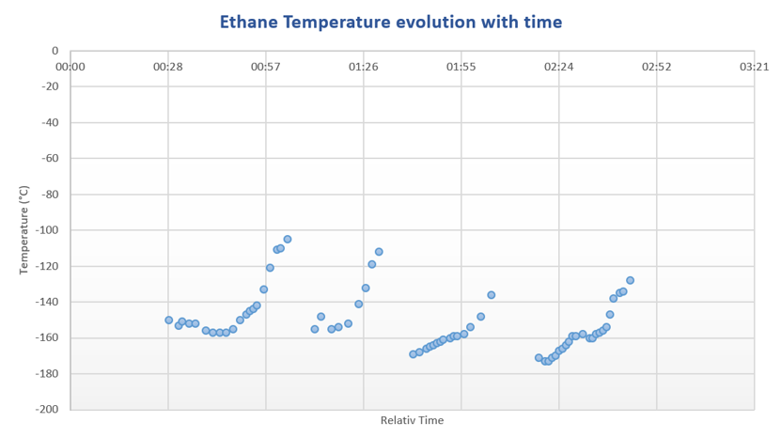Once this is achieved, Ethane gas is introduced into (2) via a movable copper pipe connected to the glove box via the valve (V4). This process generates an ethane fog (as shown in figure 15) and the flow is adjusted around 100 mbar to obtain a smooth introduction. Liquid Nitrogen within (1) is constantly boiling off due to the higher ethane temperature and after around 20 minutes of introduction the ethane stops producing the fog and is directly converted into liquid. This indicates that the ethane Dewar (2) is warmer than 90 K. At this point, the process can be sped up by doubling the ethane flow for 10 minutes. However, as the temperature keeps increasing, we need to refill the liquid Nitrogen within (1) otherwise the temperature will be too high, and ethane will start evaporating. (2) needs to be lifted out of (1) and carefully re-inserted once (1) is refilled. This procedure must be repeated 4 times (as can be seen in Figure 4) until the desired amount of liquid ethane has been reached corresponding to ¼ L, indicated by a filling level 2 to 3 cm below the top of the Dewar. This operation takes 2 hours to be completed.

Figure 3 Ethane temperature vs time

A K type thermocouple is attached to the frost shield (3) to monitor the ethane temperature and is shown in Figure 4. The liquid ethane temperature is not stable because the cooling setup never reach a state of equilibrium. This is due to the constant evaporation of the primary cryogen, liquid Nitrogen, whom boiling temperature, 77 K is lower than the melting point of ethane, 90K. This imply to refill the liquid N2 every 30 minutes. (Hazardous and heavy task 🡪 explain why).

#### Water droplet production and introduction

Two goals need to be achieved regarding the water droplet production. First, the droplets must be small, in the order of a few micrometer to perform an optimal vitrification (Explain why – fewer chances of getting impurity – reduce chances of impurity per droplets, sources of heterogeneous nucleation, also smaller sample will cool quickly). 🡪 What is the purity of the water used? – triple distilled water ?

🡪 Cleaning procedure, can the droplets get impurity from their way towards the cryogen …

Secondly, they need to be introduced at relatively high speed to be deeply embed in the cryogen thus improving the forced convection thermal transfer (source).

Both of those objectives can be achieved using commercially available nebulizers. Those devices are commonly use in lungs drug delivery (Why? 🡪 source). Droplet size relate to alveolar absorption …

Liquid nebulization is achieved by the application of a dispersing force on a liquid or solution. The dispersing force can be of two sources, a jet of gas (from air pressurization through a compressor) or ultrasonic waves, leading to two main family of nebulizer devices (jet or ultrasonic).

Ultrasonic Nebulizers gives a higher MMAD (Mass Median Aerodynamic Diameter) with respect to jet nebulizers (source). A peculiar feature of jet nebulizers is that they tend to cool down the water in the sample container during the nebulization process (source).

I have chosen to use a commercially available compressor Nebulizer, Phillips Innospire Deluxe. It is made of a compressor (maximum working pressure 3.6 bar), pumping the air and producing a high velocity flow through a liquid sample container (10 ml), producing an aerosol (Explain better 🡪 Water channeled through 4 capillaries, broke up by jet flow, baffle retain big particles and smaller particles aerosol channel out of water container).

We have adapted the Nebulizer to use Nitrogen (N2) as a carrier gas rather than the ambient air and the benefits are three-folded. It prevents the introduction of both water (an impurity when D2O is used) and oxygen (a catalyst in an explosive atmosphere). The N2 flow is also an adjustable parameter to influence the nebulization process (cf. Figure? 🡪 Chapter 6 – microscope pictures). We have blocked all the sources of auxiliary flow; The mouthpiece has been replaced by a plastic pipe that connect to the water container via a custom-made PTFE connection. An O-ring (red in figure 4) is inserted so that the system is completely airtight. (what is the effect on nebulization process?)

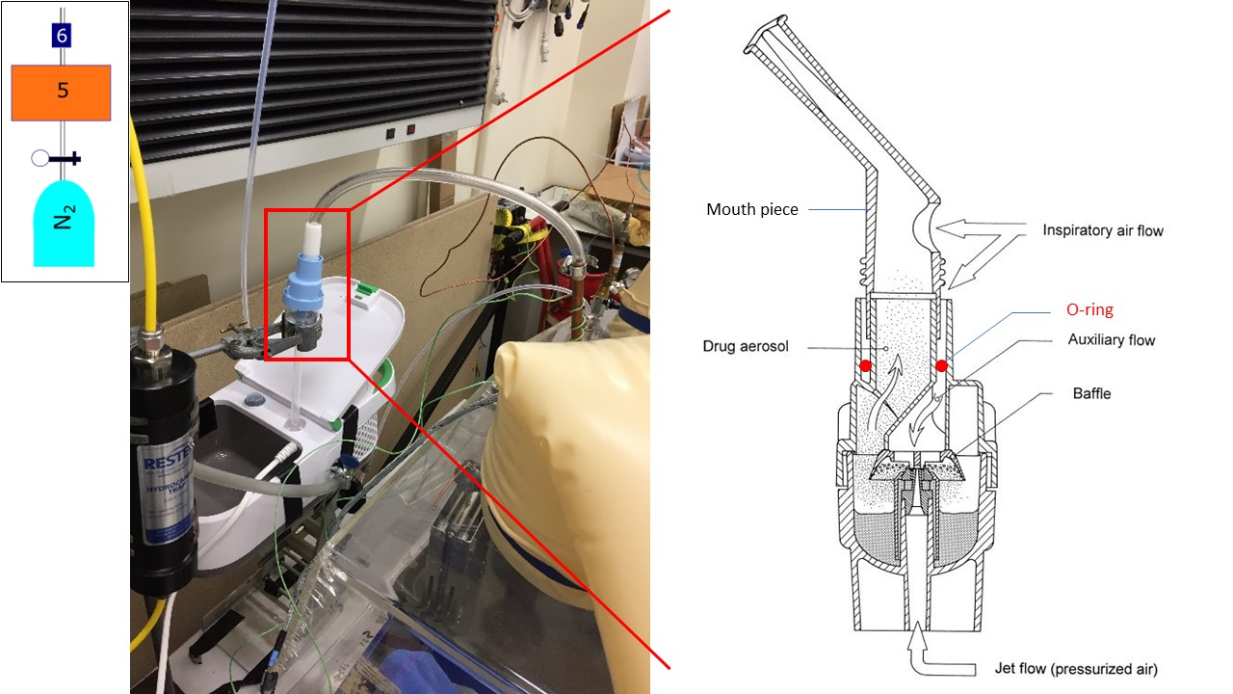

Figure 4 Nebulizer setup sketch taken from (Lebrun 2000)

The droplets are introduced into the cryogen via a nozzle made of copper and sealed to the glove box. The geometry of the plastic pipe between the water reservoir and the nozzle needs to be carefully adjusted to reduce droplet condensation on the pipe wall. Even though this condensation effect can be reduced, it is not possible to completely prevent it. This can result in big droplets falling into the cryogen and needs to be prevented at all cost. Small droplets forming on the pipes wall are usually transported by the gas flow and build up on the nozzle orifice. It is then possible to manually absorb them using a cotton bud, a task requiring particuar attention, care and dexterity.

It is important to note that the efficiency of the cooling will not only depend on the thermophysical properties of the cryogen, but also on the sample dynamics within the cryoliquid. The cooling rate will be enhanced if the samples continue plunging after being introduced in the cryogen rather than if it quickly comes to rest (forced convection) (citation). The density difference between HGW (0.94 g\cm3) and liquid ethane (0.544 g\cm3 at 184.5 K) result in the particles slowly sinking to the bottom of the reaction vessel.

We usually introduce the water for 20 minutes and in two steps of 10 minutes each. Before starting, we disconnect the water reservoir (6) from the pipe linked to the nozzle and adjust the height level of the Dewar (1 + 2) to put the nozzle close to 2 cm to the ethane level. We then setup the Nitrogen flow at 0.5 bar before turning the compressor on. After a visual inspection of the flow quality, the water reservoir is connected to the nozzle and the timer is started. After the first introduction step (10 min), we can control the ethane level and adjust the nozzle level accordingly. If the ethane temperature is above 130K, we can also refill the primary cryogen Dewar (1) with liquid Nitrogen.

Because the nozzle is close to the liquid ethane level, the water droplets may be subject to freezing before entering the cryogen, representing an issue as crystallization is expected to happen in those conditions.

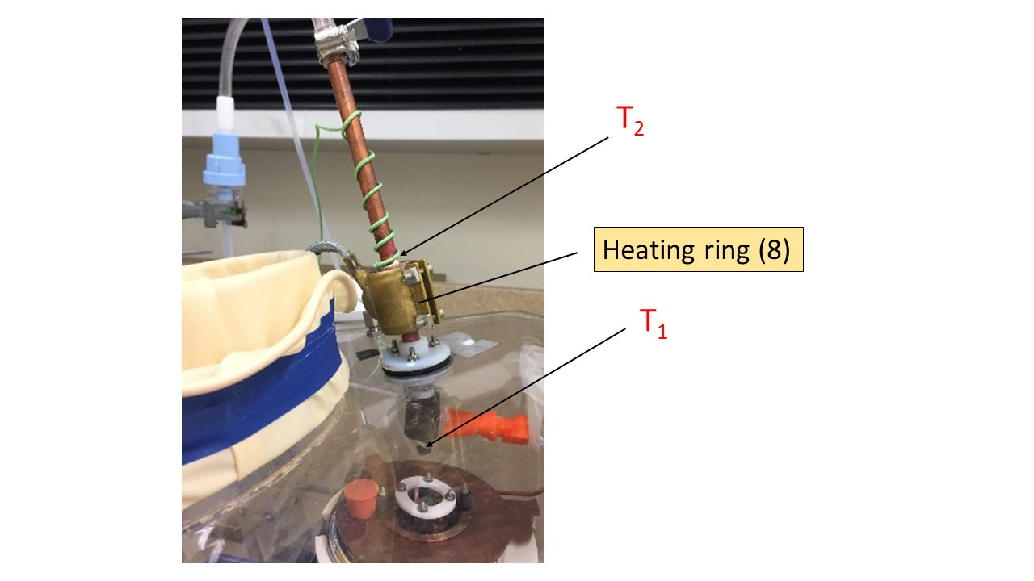

Figure 5: Nozzle setup showing heating ring attached around a copper cylindrical block. T1 is K type thermocouple fixed at the bottom of nozzle. T2 is K type thermocouple attached on top of the copper block.

Temperature at the bottom of the nozzle thermocouple (T1 in Figure 3) is monitor using a K type thermocouple. I aim to maintain this temperature above 0 °C in order to prevent water droplet freezing before reaching the cryogen. In order to prevent this to happen, a heat ring is attached around a copper block (T2 in Figure 3) in order to act as a heat sink, warming up the whole nozzle. The heating ring (Spec) is controlled using a PID, that can apply a voltage with respect to T1 temperature. The PID is setup such as the temperature of the copper can`t exceed 50 degree to avoid the evaporation of the droplets.

#### Particle recovery

The warming curve of a 3 μl water droplet removed from lN2 at ambient temperature reached -100 ˚C after 4 seconds (Silvester, Marchese-Ragona, and Johnston 1982), and that is our time constraint to handle the particles out of the cryogen (either ethane or Nitrogen). A PTFE membrane (4 in Figure 2) screwed to the bottom of a basket made of copper is used to fish out the particles from the ethane, before dispersing them in a liquid Nitrogen Dewar (DR in figure 1) where they will remain stable. Explain why stable in Ln2, and why use of membrane (difference with cryo-SEM).

We find that the particles obstruct the pores and the liquid ethane is not drained efficiently. This results in either freezing ethane in liquid Nitrogen or having to wait for a long time for the cryogen to be drained (or evaporated) thus losing the amorphic structure of the particles. However, after dispersion we can visually observe that we obtain a milky mixture made of ice particles in liquid nitrogen.

Ckeaning 🡪 Ethane is let evaporated while purge on – different pieces cleaned with ultrasonic bath ?

### 5.3.3. Limitations

This proof of concept experiment has demonstrated that we can safely produce and use liquid ethane. Progress needs to be made enable simplifying the liquefaction process and make it more reliable by being able to control and monitor the ethane temperature.

The water droplet production and introduction has proven to be efficient and reliable.

However, lots of condensation on pipes wall and droplet formation on the nozzle orifice.

The particle recovery, however, remains a challenge along with the separation of the ice particles from the cryogen.

## 5.4. 2nd Version, Hardware Development

Implementing the lessons learned from the proof-of-concept phase, we have built a second-generation experiment to address the previously described challenges. The process remains similar, cooling a Reaction vessel made of copper to liquefied gaseous ethane in which µm sized water droplet will be introduced aiming to produce HGW particles. The previous experiment required a lot of manipulations within the glove box during the cooling phase and we have thus designed this novel setup to minimize interventions from ourselves and thus making it safer and more reliable.

Additional safety feature – relief valve – gage to monitor the pressure

### 5.4.1. Overall Design

A new glovebox made of polycarbonate (good resistance to cold temperature), has been bought enabling a bigger volume (Dimensions?) and is presented in Figure 5. Two major improvements have been implemented.

First, the reaction vessel (1 in figure 5) is no longer cooled by submersion in liquid Nitrogen but by an open cold N2 gas flow passing through a solenoid copper pipe in contact with the copper Reaction vessel. Liquid Nitrogen is channeled to the Glove box via a PTFE flange (2 in figure 5) from a pressurized Dewar (200L). The temperature is control and adjusted by using a 20W power heating wire attached between the pipe interstices and connected to a PID controller.

Secondly, we decided to abandon the membrane “fishing method” and to recover the particles within the liquid ethane, thus reducing the level of manipulation and consequently modification of the particles.

Intermediate step for further separation (Link with XP Part II 🡪 recover particles in acoustic trap and evaporate ethane using low pressure)

A cryogenic ball valve (6 in Figure 5) has been installed at the bottom of the reaction vessel for that purpose and different recovery setup can be installed beneath the reaction vessel for various sample handling and storage method, increasing experimental versatility. A recovery nozzle is screwed downstream the valve and can be interchanged

Figure Glove box setup. numbers will be explained in the text

**1.** Reaction vessel with integrated copper tubing around outer wall. The pipe is silvered soldered to the copper vessel in order to achieve a maximal thermal transfer. Between the pipe interstices is attached by Kapton tape a heating wire (reference) directly connected to a PID controller (Lakeshore model 335). 2 T type thermocouples are attached to the Reaction vessel (cf. Figure 7 for thermocouple setup) in order to precisely control it temperature, allowing for (a) ethane liquification and (b) amorphous ice formation.

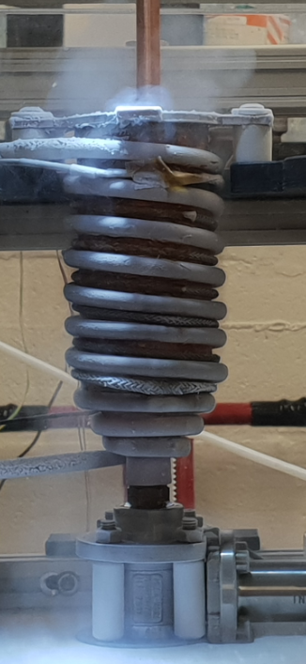

Figure Reaction vessel

**2.** 1 cm thickPTFE Flange featuring liquid Nitrogen feedthrough CF-40 (MDC Vacuum 9812105). Inlet is connected to a pressurized Deware (200L) and connected to Reaction vessel piping by a corrugated hose. Flexible tubing (e in Figure 7) allow the reaction vessel to move up and down by more than 10 cm and to adjust its position with respect to the Nozzle or to the sample recovery area.

Figure Liquid N2 PTFE flange setup **[a]** cryogenic hose ½“ BSP , **[b]** ½” male to female adapter, **[c]** Male tube adaptor ¼” tube OD * ½” (Swagelock SS-4-TA-1-8), **[d]** Swagelock tubing connection ¼” , **[e]** Stainless steel flexible tubing ¼” OD (Swagelock 321-4-X-12-B2), **[f]** Bulkhead union ¼” OD (Swagelock SS400-61), **[g]** Copper tubing ¼” OD, **[h]** PTFE tubing ¼” OD,

**3.** PTFE Flange for electrical equipment; One Thermocouple feedthrough (6 * T type), ATEX certified (Ex II 2 GD, Ex d IIC Gb / Ex e IIC Gb, Ex ta IIIC Da) product for explosive atmosphere and the heating wire (cf. Figure 9).

**4.** Nozzle featuring copper block heating ring attached. Prevents water freezing in nebulizer and/or line from water reservoir. Controlled via PID controller and attached thermocouples.

**5.** Nebulizer inlet. Reservoir of deionized water and/or D2O connects though this port, pressure is provided by dedicated nitrogen cylinder secured in lab to deliver water into copper vessel [5] as a fine mist through the nebulizer.

**6.** Valve attaching to base of reaction vessel. Rated for operation with cryogenic materials/environments.

**7.** Release point for material in copper vessel [1] when valve [6] is opened

**8.** Funnel port. Valve at base of funnel isolates this port from the inside of the chamber during normal operation. It can be opened to allow addition of liquids, e.g. small amounts of liquid nitrogen to a Deware if/as required. Could also serve as back-up for pressure-relief-valve.

Figure Overall setup a) BOSH Design b) Gas setup

* XP transportable and self-contained
* Designed to minimize time between sample extraction and storage

1 -3 Are Nitrogen gas bottles. 1 is 0 grade and connected to the nebulizer via a custom fitting. 3 is connect via ¼ “piping to both the main and the airlock chamber of the Glove box for purging. The experiment can be long and another full bottle (2) must be present to ensure that the purge will be on at all time. 4 is the ethane bottle. 5 is a pressurized liquid Nitrogen Dewar connected to the cooling circuit via a cryogenic hose. A protection has been put in place to avoid to much condensation on the cold surfaces outside the glove box, but frost is unavoidable.

### 5.4.2. Temperature control and recording

#### Cooling

Liquid Nitrogen cool reaction vessel, warm up, transform to gas (expansion ratio 1:694 ) and is extracted through PTFE flange into a Deware (to recover liquid if any). Lot of Nitrogen is released into the atmosphere that need to be well ventilated. The lab needs also to have proper Oxygen alarm. Even with very long experiment, no liquid Nitrogen has been recovered into the Dewar.

The flow of Nitrogen passing through the pipe is a parameter difficult to monitor and thus to control. It could have been monitored using a flow meter connected to the exhaust, but this is not feasible as no flow meter are currently rated for use at cryogenic temperature. However, it is possible to obtain a visual information about the flow rate. Despite nitrogen being a transparent gas, when cold enough it can produce a fog due to condensation of ambient water droplets from the lab, like cloud formation in the atmosphere (to be explained much better !!).

This phenomenon allows us to get a quantitative information about the Nitrogen flow as depicted by Figure 9.

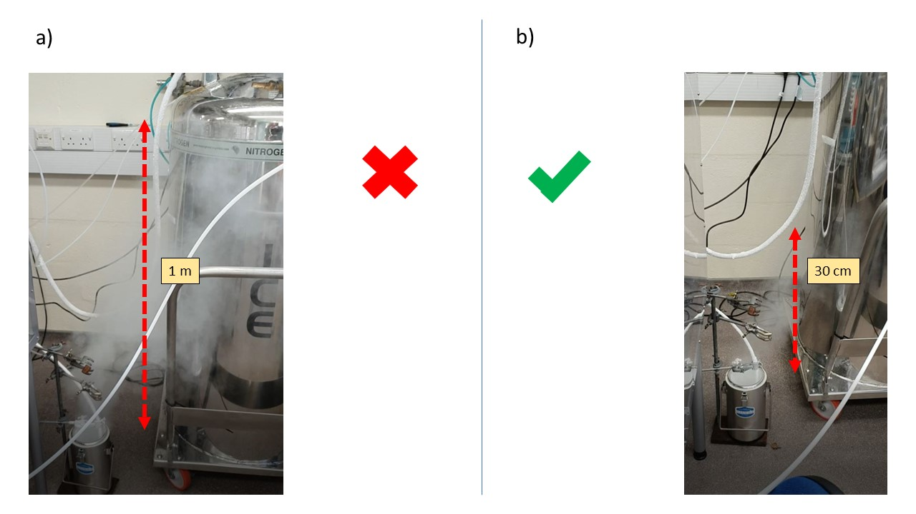

Figure Liquid Nitrogen exhaust setup.vRed arrow describe … a) Liquid Nitrogen flow too important b) Adequate Liquid Nitrogen flow

2 parameters are important to control the Nitrogen flow. The base pressure of the cryogenic Dewar and the valve opening percentage (cf Figure 14 b). The cryogenic pressure is usually set up by the fabricant. It can be tuned by modifying the bursting pressure of the pressure relief valve fitted on all those Deware but the pressure take time to build up and is not suitable for fine tuning on the fly as required by the experimental procedure.

So I have to use the opening of the valve as the adjustable parameter for the Nitrogen flow variable. Very fine tuning … Not consistent all along the experiment …

#### Warming and T control

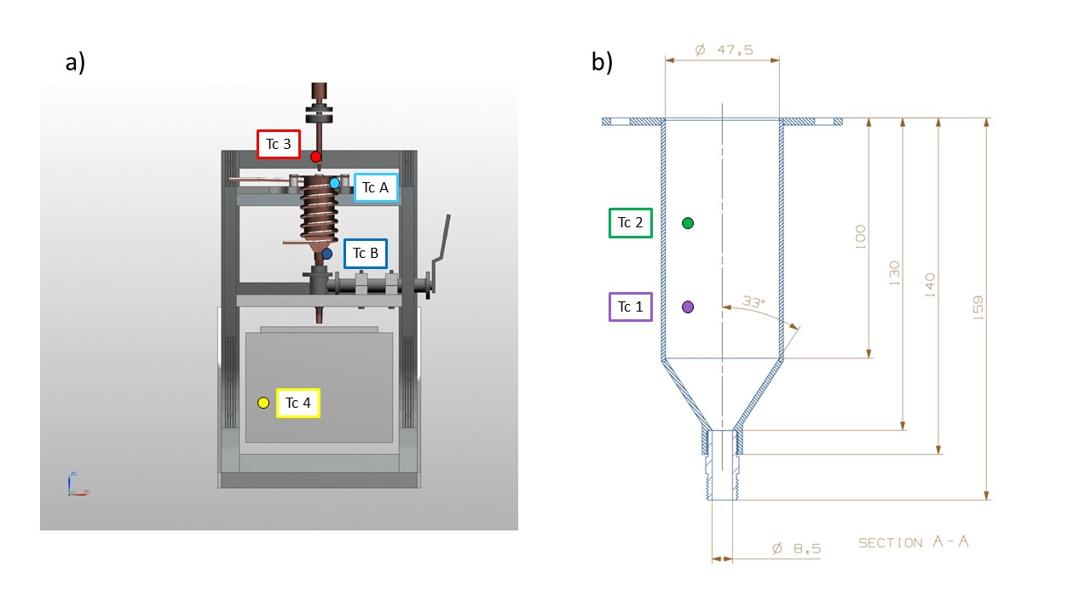

Figure Thermocouple setup

6 T type thermocouple are inserted within the glove box via the same feedthrough.

TCA and TCB are attached at the top and bottom of the reaction vessel and are connected to a Lakeshore PID. A simple Labview code allow the control of TCB temperature by applying a voltage to the heater. (Why TCB – description of Labview code)

TC1,2,3,4 are attached to a Picolog TC-08 and are recorded separately from TCA and TCB.

TC1 and TC2 are attached to the frost shield at different depth to measure any temperature gradient variation within the cryogen.

TC3 is attached to the nozzle in order to prevent frost formation.

TC4 is a flying thermocouple that we can move to monitor the temperature within different area of the glove box. It is used to record different piece of equipment involved in the sample recovery and transfer procedure.

2 different software used to record the temperatures (Labview, to work with Lakeshore TCA and TCB) and Pico log software for TC1, 2, 3, 4. To be described ?

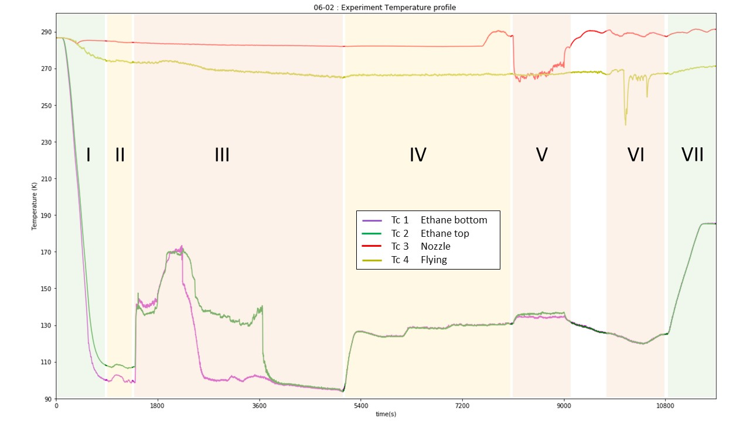

Figure Experiment temperature profile. The different number refer to each experimental step : I. Reaction vessel cooling; II. lN2 flow reduction; III. Ethane introduction/liquefaction; IV. Temperature setting; V. Water introduction; VI. Sample recovery; VII. Ethane warm up/evaporation. Color refer to the level of manipulation needed for each phase, green: not much to do, red: lot of manipulation needed.

|  |  |  |  |  |
| --- | --- | --- | --- | --- |
|  | **name** | **duration** |  |  |
| **I** | Cooling |  |  |  |
| **II** | Flow adjustment |  |  |  |
| **III** | Ethane liquefaction |  |  |  |
| **IV** | Temperature setting |  |  |  |
| **V** | Water introduction |  |  |  |
| **VI** | Sample recovery |  |  |  |
| **VII** | Warm up / close up |  |  |  |

Table Experimental steps along the procedure

Figure 10 represent the temperature evolution of TC 1-4 for a typical experiment. The first phase corresponds to the cooling of the Reaction Vessel. 15 minutes are enough to cool the Reaction vessel (Abbreviation) to its base temperature (around 100K). TCA and B are not shown on this diagram for clarity, but a more precise cooling curve is shown in Figure 12. In order to match with the low power of the heater the N2 flow needs to be reduced at the minimum and that is achieved during the second phase. The third step is the ethane liquefaction who is characterized by a steep increase in both inner temperature TC1 and TC2. Consequently, the temperature show a steep decrease when the thermocouple are immerged by the cryogen (TC1 first and then TC2). The phase IV correspond to the time period where the ethane is set up within the desired range prior to the water introduction (V). VI correspond to the sample recovery and VII to the boiling off the ethane and the shut down procedure.

### 5.4.3. Water droplet production

Similar but care has been taken to control and minimize pipe length to diminish droplet condensation on the pipe walls. Also, nozzle is straight

Distance heater - nozzle end.

### 5.4.4. Sample recovery method

Because the sample is recovered from the bottom of the reaction vessel an empty space area has been designed below the reaction vessel (roughly 10*10*10 cm), allowing different sample recovery setup to be put in place. 2 method have so far been developed. One that allow filling in 1 ml cryo-vials with ice sample embedded into the cryogen to be stored in a cryoshipping Dewar (reference). The other method has been developed jointly with ISIS Neutron and muon source in order to fill a Vanadium square cell, necessary to perform Neutron scattering experiment.

#### Sample storage

(Picture of sample holder with vials).

A metallic sample holder designed to hold the vials is inserted into a polystyrene box. Liquid Nitrogen is filtered and introduced through funnel (8 in Figure 5) into the polystyrene box.

#### ISIS cell filling

(diagram + picture of the setup)

Vanadium foil + 1 or 2 mm spacer –

Copper block – long time to cool – Heat sink

Funnel made of spacer hold together by Aluminum tape.

Ethane drained through lose junction between cell and funnel.

Bucket to recover the remaining ethane.

## 5.5. The cooking recipe to produce HGW µm ice particles

### 5.5.1. Warm-up and Glove Box purging

All material putted in the glove box 🡪 nice and clean working space

Check integrity of system, thermocouple attachment …

Back panel of glove box screwed in place

Nitrogen purge 1h, stopped when the Oxygen level reach a plateau (1%). No explosive atmosphere and most of residual water removed from the glove box 🡪 use of dessicant, calcium carbonate, not that efficient … but tackled by having “cold spot” away from the reaction vessel 🡪 cold trap. Capture some of the water molecules but frost remain a big issue.

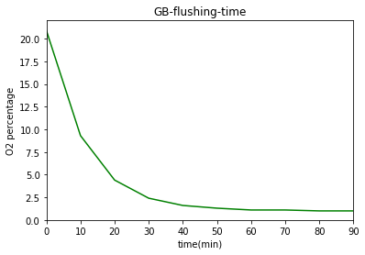

Figure : O2 percentage vs time with Nitrogen flow 0.2 bar

### 5.5.2. Reaction vessel cooling

2 temperature recording software (Labview and Picolog) are started (t = 0) and the valve on the Pressurized Deware is open (2C) 1 minute later.

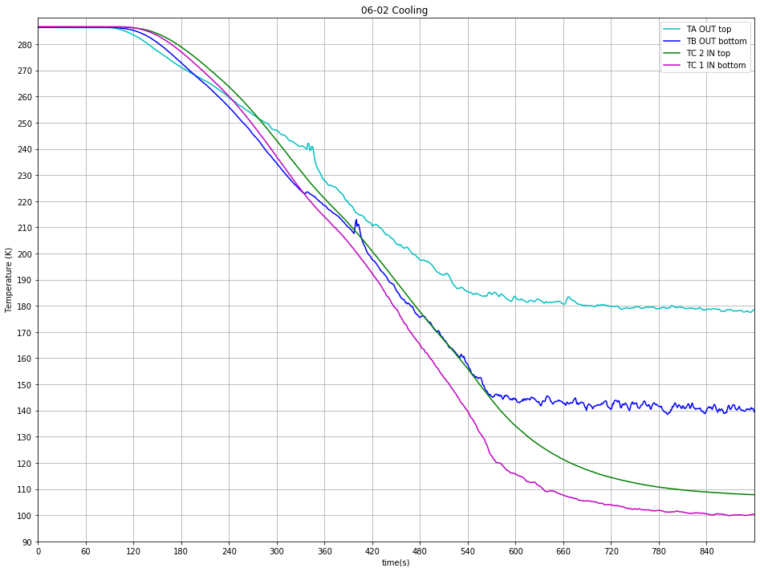

Figure Typical cooling curve

As described earlier the valve opening is key to control Nitrogen flow through the pipe.

Various experiment with different valve opening percentage have been performed and show that the maximum cooling is achieved at 2C (cf Figure 14 b) and that a further opening doesn’t improve the cooling efficiency.

Cooling curve comparison (could have been good to have a comparison of each TC with increasing valve opening but data unexploitable …)

Figure Flow adjustment period

After Reaction vessel has reached base temperature The Nitrogen

Deep care needs to be taken to control and adjust this parameter all along the experimental procedure as it can randomly vary. A liquid Nitrogen flow set up too high won’t allow the Heater to work properly.

### 5.5.3. Ethane liquefaction

Once the Liquid Nitrogen flow has been adjusted correctly (as low as possible), gaseous ethane can be introduced. The ethane pipe inside the glove box (downstream to valve?) must be placed inside the Reaction vessel (cf. Figure 15) whose height can be adjusted to allow an immersion of the pipe around 2 to 3 cm inside the Reaction Vessel. Ethane flow is started by opening first the valve ? on the ethane cylinder and valve ? located on the glove box. This will result in the apparition of a fog (micro particles of solid ethane?) shown in figure 15 a) and b). Ethane flow is monitored by a digital pressure gage located downstream the regulator attached to the ethane gas cylinders. A pressure too important will result in a turbulent fog (Figure 15 a)) resulting in a loss of material. Consequently, to improve the liquefaction efficiency, the ethane flow is progressively reduced to obtain a steady introduction (Figure 15b)). It is usually obtained for a pressure around 80 mbar.

This phase is marked by a steep increase in TC1 and 2 temperature, due to the introduction of a hot gas within the reaction vessel. The first 10 minutes of introduction required a lot of attention, time for the system to reach an equilibrium (explain more).

Figure Ethane liquefaction

With optimal conditions (look for data), high temperature / high ethane flow, gaseous ethane is directly converted into a liquid and the fog disappear (Figure 15 c)). This allow a direct monitoring of the speed of the liquefaction process. Otherwise we can rely on the Thermocouple data to monitor it. An important decrease in TC1 and TC2 temperature arise when they are submerged by the liquid.

* Calculation Volume of liquid per time 🡪 liquefaction speed (comparison …)

TC1 and TC2 have same temperature 🡪 no thermal gradient at different height 🡪 good

Frost growing on cold temperature experiment part (corrugated hose …) but not on reaction vessel, cold trap preventing frosting of critical areas.

Once enough ethane produced (3cm to the top)🡪 volume. Monitored by graduation engraved on Frost shield. Close the valve, ethane bottle first and then the valve on the glove box.

Stop of ethane introduction (hot gas) usually result in temperature decreasing, the system needs some time and manipulation to find an equilibrium state.

Figure Ethane liquefaction

### 5.5.4. Ethane Temperature control

Figure Temperature setting

PID settings:

TCB used 🡪 more reliable

### 5.5.5. Water introduction

The water droplet introduction phase is relatively similar to the procedure used on the previous proof of concept experiment. First the water reservoir has to be filled with the required amount (10 ml) of deionized water and the top screwed tightly in place.

The nebulizer compressor is connected to a 0 grade Nitrogen bottle whose pressure is set up to 0.5 bar. Then the Nebulizer is turned on and this will result in the production of a fine mist of µm droplets.

Figure Water introduction ethane temperature

The introduction of a hot (20 °C) mixture of gas and water droplets result in an increase of the ethane temperature. TC2 equilibrate higher than TC1. Temperature difference differ with different experimental procedure (base temperature …).

Water droplet production required a full attention of the operator in order to avoid big droplets forming by condensation on the on the nozzle to fall into the cryogen. Such droplets are constantly forming and are cleaned by absorption from a Q-tip.

### 5.5.6. Ice recovery

#### Sample storage

#### ISIS cell

Both required use of heat sink to maintain a temperature well below the glace transition of water (137K). Liquid Nitrogen is used to cool down the heat sink. Liquid Nitrogen is filtered and poured through funnel (8 in Figure 5) into a Dewar and then introduced into the sample recovery setup chosen.

🡪 Time consuming and heavy manipulation task. Must be started during equilibrium phase of ethane liquefaction and temperature adjustment phase. Lots of Nitrogen evaporating during cooling, has an impact on overall temperature within glove box (can reach -10 degrees). Make working conditions more difficult.

## 5.6. Discussion and evaluation

Improvement

* Increasing N2 gas flow going through nebulizer
* Anti water condensation coating to prevent condensation
* May be use an appropriate nozzle (cf different spray geometry) 🡪 What minimum sizes can we achieve
* Test nozzle + nebulizer flow by spraying with different experimental parameter (pressure) and see penetration depth into liquid with same viscosity as liquid ethane (paraffin oil ?)
* Introduce some dust to create a proper Interstellar dust analogue
* Find a way to stir and mix the ethane (wider diameter for RV)
  + Gear system (no electrical equipment)
  + Create a syphon (kind of) 🡪 Highly convective system, brough the particles at bottom of RV, Reduce temperature increase due to water introduction
* Vary the cryogen, for example mixture of ethane + propane
  + 🡪 Lower the boiling point

(Tivol, Briegel, and Jensen 2008)

# Bibliography

Angell, C. A., and Y. Choi. 1986. ‘Crystallization and Vitrification in Aqueous Systems’. *Journal of Microscopy* 141 (3): 251–61. https://doi.org/10.1111/j.1365-2818.1986.tb02720.x.

Bachmann, L., and W. W. Schmitt. 1971. ‘Improved Cryofixation Applicable to Freeze Etching’. *Proceedings of the National Academy of Sciences* 68 (9): 2149–52. https://doi.org/10.1073/pnas.68.9.2149.

Bar-Nun, Akiva, and Diana Laufer. 2003. ‘First Experimental Studies of Large Samples of Gas-Laden Amorphous “Cometary” Ices’. *Icarus* 161 (1): 157–63. https://doi.org/10.1016/S0019-1035(02)00016-7.

Brüggeller, Peter, and Erwin Mayer. 1980. ‘Complete Vitrification in Pure Liquid Water and Dilute Aqueous Solutions’. *Nature* 288 (5791): 569–71. https://doi.org/10.1038/288569a0.

Dubochet, J., and A.W. McDowall. 1981. ‘VITRIFICATION OF PURE WATER FOR ELECTRON MICROSCOPY’. *Journal of Microscopy* 124 (3): 3–4. https://doi.org/10.1111/j.1365-2818.1981.tb02483.x.

Le, Hai, Yi Liu, and M. Sam Mannan. 2013. ‘Lower Flammability Limits of Hydrogen and Light Hydrocarbons at Subatmospheric Pressures’. *Industrial & Engineering Chemistry Research* 52 (3): 1372–78. https://doi.org/10.1021/ie302504h.

Lebrun, P.P.H. 2000. ‘A Review of the Technical Aspects of Drug Nebulization’ 22: 7.

Mayer, Erwin, and Peter Brüggeller. 1982. ‘Vitrification of Pure Liquid Water by High Pressure Jet Freezing’. *Nature* 298 (5876): 715–18. https://doi.org/10.1038/298715a0.

Silvester, N. R., S. Marchese-Ragona, and D. N. Johnston. 1982. ‘The Relative Efficiency of Various Fluids in the Rapid Freezing of Protozoa’. *Journal of Microscopy* 128 (2): 175–86. https://doi.org/10.1111/j.1365-2818.1982.tb00449.x.

Tivol, William F., Ariane Briegel, and Grant J. Jensen. 2008. ‘An Improved Cryogen for Plunge Freezing’. *Microscopy and Microanalysis* 14 (5): 375–79. https://doi.org/10.1017/S1431927608080781.

Turnbull, David. 1969. ‘Under What Conditions Can a Glass Be Formed?’ *Contemporary Physics* 10 (5): 473–88. https://doi.org/10.1080/00107516908204405.

Wang, H., R. C. Bell, M. J. Iedema, A. A. Tsekouras, and J. P. Cowin. 2005. ‘Sticky Ice Grains Aid Planet Formation: Unusual Properties of Cryogenic Water Ice’. *The Astrophysical Journal* 620 (2): 1027–32. https://doi.org/10.1086/427072.