Gelei Chen

March 5, 2017

1. Number of my moves
   1. 73.5%. The heuristic function here is number of my moves. This heuristic function can help me win most of the time by selecting relatively reasonable path that maximizes this heuristic function. But it fails to consider opponent’s situation. This heuristic function canot beat ID_Improved.
   2. 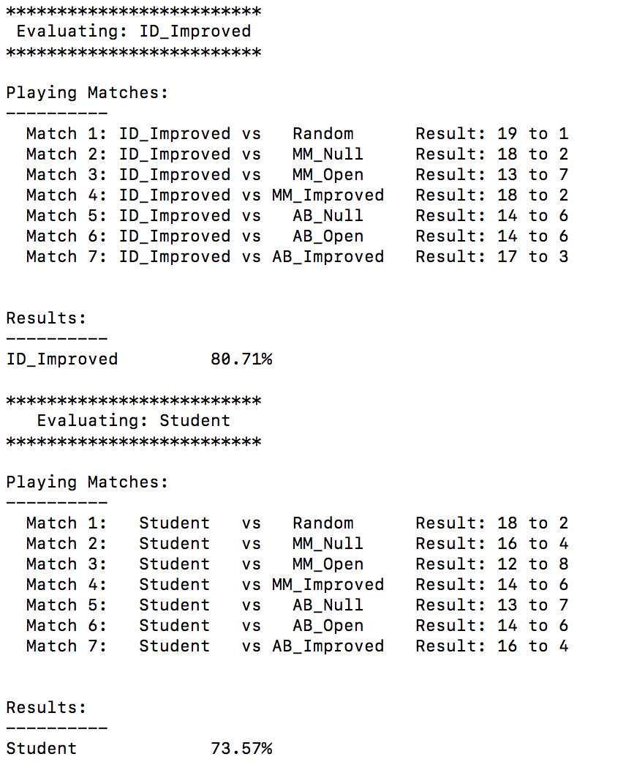
2. Number of opponent moves
   1. 69.29%. The heuristic function here is number of my opponent moves. This heuristic function achieves worse score than first heuristic function by selecting relatively reasonable path for my opponent that maximizes this heuristic function. This heuristic function canot beat ID_Improved. I definitely don’t want to use this heuristic function.
   2. 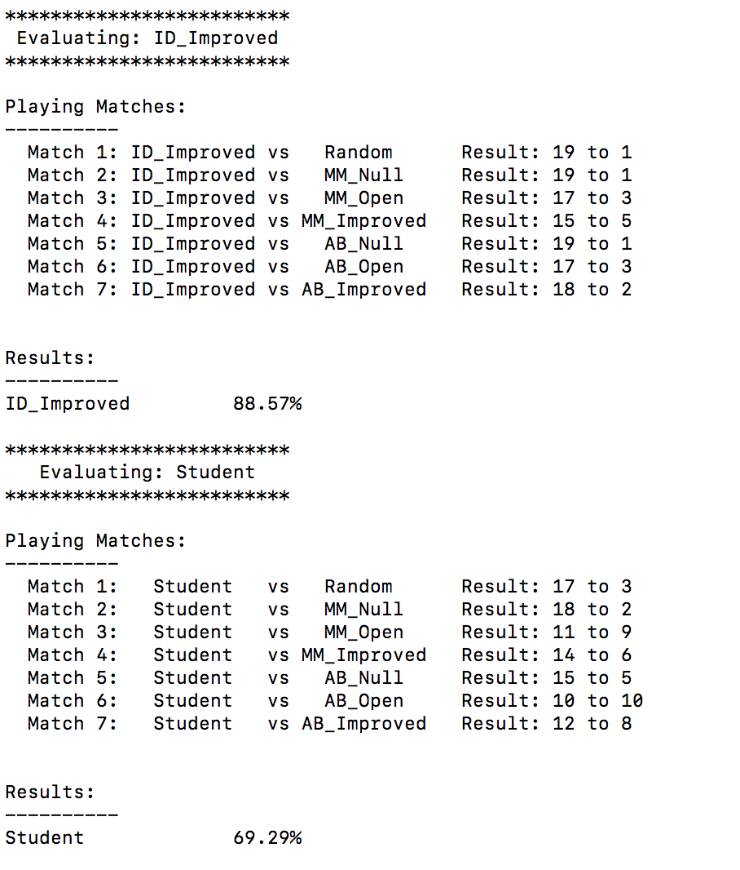
3. Number of my moves – Number of opponent moves
   1. 90%. The heuristic function here is number of my moves minus number of opponent moves. This heuristic function can help me win most of the time by selecting relatively optimal path that maximizes this heuristic function. This heuristic function beats ID_Improved.

I select this heuristic function based on the following reasons:

1. It takes number of my move into consideration.
2. It takes number of opponent move into consideration.
3. It outperforms ID_Improved baseline benchmark.
4. It has highest ‘Student’ score among all three heuristic functions.

That’s why I select this heuristic function to be my final choice.

* 1. 