AWS CC LAST YEAR PAPER WITH ANSWERS -2023

**ANSWETR ANY 8 (2X8=16)**

**Q1 What is meant by Pay-as-you-go?**

**ANS.** pay-as-you-go model, like utility billing; you only pay for what you use, when you use it.

**Q2 What is CAPEX and OPEX?**

**Ans**

* **C**apEx (Capital Expenditures): Purchasing an asset (factory, computer system, company car) is considered a capital expenditure. It requires payment for the entire asset,
* OpEx (Operational Expenditures): These expenditures are associated with purchasing services for a planned period, for example, 1-3 years.

**Q3What is Load balancing?**

**Ans.** Load balancing is defined as the methodical and efficient distribution of network or application traffic across multiple servers in a server farm

**Q4What is Apache.**

**Ans.** Apache was released in 1995, and quickly became the most widely used server in the world. It is well documented and has a huge user base. Apache has a range of modules that can be enabled or disabled in order to suit different types of websites.

**Q5**

**Ans**. VM Import/Export enables you to easily import virtual machine images from your existing environment to Amazon EC2 instances and export them back to your on-premises environment. VM Import/Export is available at no additional charge beyond standard usage charges for Amazon EC2 and Amazon S3.can import Windows and Linux VMs that use VMware ESX or Workstation, Microsoft Hyper-V, and Citrix Xen virtualization formats. And you can export previously imported EC2 instances to VMware ESX, Microsoft Hyper-V or Citrix Xen formats

**Q6 What is S3 bucket policy?**

**ANS.** Bucket Policies are similar to IAM policies in that they allow access to resources via a JSON script. However, Bucket policies are applied to Buckets in S3, where as IAM policies are assigned to user/groups/roles and are used to govern access to any AWS resource through the IAM service

**Q7 What is latency?**

**ANS.** Latency is the delay period between a client request and the response provided by the cloud service.

**Q8 List out different computer secuirty threats .**

**Ans.** Phishing, Botnet, Rootkit, Keylogger

**Q9What is AWS CLI?**

**Ans.** AWS CLI is a tool that pulls all the AWS services together in one central console, giving you easy control of multiple AWS services with a single tool. The acronym stands for Amazon Web Services Command Line Interface because, as its name suggests, users operate it from the command line

**Q10Define PING.**

**Ans**PING (Packet INternet Groper) command is the best way to test connectivity between two nodes.

**ANSWER ANY 6 (3X6=18)**

**Q1Write about the characteristics of SaaS?**

**ANS.** Network-based access to, and management of, commercially available software.  
Activities managed from central locations rather than at each customer's site, enabling customers to access applications remotely via the Web.  
Application delivery typically close…

**Q2**

**ANS.** Amazon EC2 Auto Scaling helps you ensure that you have the correct number of Amazon EC2 instances available to handle the load for your application. You create collections of EC2 instances, called Auto Scaling groups. You can specify the minimum number of instances in each Auto Scaling group, and Amazon EC2 Auto Scaling ensures that your group never goes below this size. You can specify the maximum number of instances in each Auto Scaling group, and Amazon EC2 Auto Scaling ensures that your group never goes above this size. If you specify the desired capacity, either when you create the group or at any time thereafter, Amazon EC2 Auto Scaling ensures that your group has this many instance. If you specify scaling policies, then Amazon EC2 Auto Scaling can launch or terminate instances as demand on your application increases or decreases.

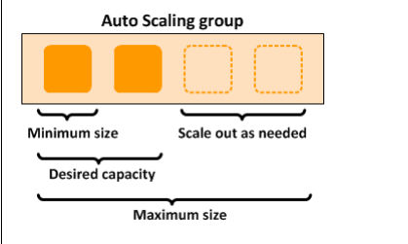

**Q3**What are the common risks found in Cloud Computing?

**Ans.** 1. The impact on a business return on investment (ROI) Migration to the cloud might sound like the most cost-effective option, but businesses should carefully compare the costs of owning software and equipment with the cost of "leasing" IT technologies. Parameters like speed, security, usage, quality of service, scalability and support must be considered.

2**. Compatibility** Migration to the cloud might pose problems of compatibility with an existing IT infrastructure, or with a company security requirements and organizational policies. Pre-planning is once again crucial in considering all these aspects prior to committing to the change.

3. **Trust** Not all providers are equal. Services through cloud computing may be interrupted by unforeseen events. Outages from a service provider, for example, can happen. Since providers are unable to guarantee no service disruptions will occur, data may not be available 24/7.

4. **Confidentiality** Probably the main concern, confidentiality is often mentioned as the reason for not embracing cloud computing. If a company's operations require the handling of sensitive data, the protection of these data becomes a priority and a concern. A business might not feel confident in sharing with an external party their vital information. Responsibility for a data leak could be hard to assign when data are handled and transmitted between two parties.

5. C**ompliance** There are risks involving non-compliance with existing policies and contractual obligations related to the handled data or the business operations. The legal implication of using an external IT provider should be carefully reviewed.

**6. Security Not just confidentiality**, but the entire structure should be evaluated. Where's your data going to be stored? Who will have access to the information? What security measures and protection does the cloud provider offer? Is all information (even when non-sensitive) transmitted in unsecured plaintext or is always it encrypted?

7. **Lack of control over performance** There is always the risk that the system quality may be inadequate or that a cloud service provider is always unable to provide quality services. It should be clear what guarantees the provider can offer in terms of systems performance and, especially, how prompt is its corrective action in case of a disruption of service. Not having direct access to the infrastructure means that a business must rely on the prompt action of the provider when something goes wrong.

8. **Lack of control over quality** A business needs to trust the quality standards that a provider can offer over time. How easy would it be to switch providers in case of an obvious degradation of quality? Many of these risks can be mitigated by careful planning and attention to details when drafting service contracts with cloud providers. For example, risks related to privacy and data confidentiality can be reduced by using hybrid cloud computing? sharing only some resources but not relinquishing data control

**Q4** Explain the benefits of Amazon EBS?

**Ans**. **Reliable and secure storage** − Each of the EBS volume will automatically respond to its Availability Zone to protect from component failure.  
  
**Secure** − Amazon’s flexible access control policies allows to specify who can access which EBS volumes. Access control plus encryption offers a strong defense-in-depth security strategy for data.  
  
**Higher performance** − Amazon EBS uses SSD technology to deliver data results with consistent I/O performance of application.  
  
**Easy data backup** − Data backup can be saved by taking point-in-time snapshots of Amazon EBS volumes

**Q5** What is the difference between Static and Dynamic IP ?

**Ans**

| **Static IP Address** | **Dynamic IP Address** |
| --- | --- |
| It is provided by [ISP](https://www.geeksforgeeks.org/isp-full-form/)(Internet Service Provider). | While it is provided by DHCP (Dynamic Host Configuration Protocol). |
| [Static ip](https://www.geeksforgeeks.org/advantages-and-disadvantages-of-static-ip/) address does not change any time, it means if a static ip address is provided then it can’t be changed or modified. | While dynamic ip address change any time. |
| Static ip address is less secure. | While in dynamic ip address, there is low amount of risk than static ip address’s risk. |
| Static ip address is difficult to designate. | While dynamic ip address is easy to designate. |
| The device designed by static ip address can be traced. | But the device designed by dynamic ip address can’t be traced. |
| Static ip address is more stable than dynamic ip address. | While dynamic ip address is less stable than static ip address. |
| The cost to maintain the static ip address is higher than dynamic ip address. | While the maintaining cost of dynamic ip address is less than static ip address. |
| It is used where computational data is less confidential. | While it is used where data is more confidential and needs more security. |
| Simplifies the troubleshooting as the ip is always the same. | While dynamic ip increases the complexity of diagnosing the network issues. |

**Q6 What you mean by S3 Life Cycle**

**ANS.** Lifecycle Management is used so that objects are stored cost-effectively throughout their lifecycle. A lifecycle configuration is a set of rules that define the actions applied by S3 to a group of objects.  
  
The lifecycle defines two types of actions:  
Transition actions: When you define the transition to another storage class. For example, you choose to transit the objects to the Standard IA storage class 30 days after you have created them or archive the objects to the Glacier storage class 60 days after you have created them.  
Expiration actions: You need to define when objects expire, the Amazon S3 deletes the expired object on your behalf.

**Q7What are the different AWS Database types?**

**ANS.** AWS provides a wide variety of databases to choose from (about 14 custom built database engines), which range from relational databases to ledger type of databases. AWS comes with support for database types like:  
  
Relational database- They are mostly used with traditional applications, ERP, CRM and in the e-commerce business.  
Key-value database- It is used with applications which get high-traffic, like e-commerce and gaming applications, since they need quick real-time responses.  
In-memory database- They are used to implement the process of caching, managing sessions, in gaming leaderboards, as well as geospatial applications.  
Document database- They are used to manage user profiles, catalogues, and to manage content.  
Graph database- Such databases are used in social networking applications, recommendation engines, and fraud detection.  
Time series database- They are used in telemetry, IoT applications and devOps.  
Ledger database- It is used in the supply chain business, for registrations, banking field, and record systems.

**Q8 Why PHP is widely used in web development? Justify with various reasons**.

**ANS.** PHP was established as the leading website programming language several years ago, even though it is much younger than other languages. The cause of the extensive popularity the PHP distribution enjoys is the easy-to-grasp syntax, allowing even people with no coding experience whatsoever to quickly enter into the PHP realm. And it is exactly the easily created scripts that make PHP so popular among the Internet community.

**ANSWER ANY 4 (4X4=16)**

**Q1** What are the different types of Cloud deployment models?

**ANS.** 1. **Private Cloud** It is a cloud-based infrastructure used by stand-alone organizations. It offers greater control over security. The data is backed up by a firewall and internally and can be hosted internally or externally. Private clouds are perfect for organizations that have high-security requirements, high management demands, and availability requirements.

2. **Public Cloud** This type of cloud services is provided on a network for public use. Customers have no control over the location of the infrastructure. It is based on a shared cost model for all the users, or in the form of a licensing policy such as pay per user. Public deployment models in the cloud are perfect for organizations with growing and fluctuating demands. It is also popular among businesses of all sizes for their web applications, webmail, and storage of non-sensitive data.

3. **Community Cloud** It is a mutually shared model between organizations that belong to a particular community such as banks, government organizations, or commercial enterprises. Community members generally share similar issues of privacy, performance, and security. This type of deployment model of cloud computing is managed and hosted internally or by a third-party vendor.

4. **Hybrid Cloud** This model incorporates the best of both private and public clouds, but each can remain as separate entities. Further, as part of this deployment of cloud computing model, the internal, or external providers can provide resources. A hybrid cloud is ideal for scalability, flexibility, and security. A perfect example of this scenario would be that of an organization who uses the private cloud to secure their data and interacts with its customers using the public cloud.

**Q2 What is CIA? Explain the CIA traid with neat sketch.**

**ANS.** • Confidentiality is ensuring that information is available only to the intended audience  
• Integrity is protecting information from being modified by unauthorized parties  
• Availability is protecting information from being modified by unauthorized parties

**Q3** Explain the characteristics of Elastic IP Addressing

**Ans.** The following are the basic characteristics of an Elastic IP address:  
  
An Elastic IP address is static; it does not change over time.  
  
An Elastic IP address is for use in a specific Region only, and cannot be moved to a different Region.  
  
An Elastic IP address comes from Amazon's pool of IPv4 addresses, or from a custom IPv4 address pool that you have brought to your AWS account.  
  
To use an Elastic IP address, you first allocate one to your account, and then associate it with your instance or a network interface.  
  
When you associate an Elastic IP address with an instance, it is also associated with the instance's primary network interface. When you associate an Elastic IP address with a network interface that is attached to an instance, it is also associated with the instance.  
  
When you associate an Elastic IP address with an instance or its primary network interface, the instance's public IPv4 address (if it had one) is released back into Amazon's pool of public IPv4 addresses. You cannot reuse a public IPv4 address, and you cannot convert a public IPv4 address to an Elastic IP address. For more information, see Public IPv4 addresses.  
  
You can disassociate an Elastic IP address from a resource, and then associate it with a different resource. To avoid unexpected behavior, ensure that all active connections to the resource named in the existing association are closed before you make the change. After you have associated your Elastic IP address to a different resource, you can reopen your connections to the newly associated resource.  
  
A disassociated Elastic IP address remains allocated to your account until you explicitly release it. We impose a small hourly charge for Elastic IP addresses that are not associated with a running instance.  
  
When you associate an Elastic IP address with an instance that previously had a public IPv4 address, the public DNS host name of the instance changes to match the Elastic IP address.  
  
We resolve a public DNS host name to the public IPv4 address or the Elastic IP address of the instance outside the network of the instance, and to the private IPv4 address of the instance from within the network of the instance.  
  
When you allocate an Elastic IP address from an IP address pool that you have brought to your AWS account, it does not count toward your Elastic IP address limits. For more information, see Elastic IP address limit.  
  
When you allocate the Elastic IP addresses, you can associate the Elastic IP addresses with a network border group. This is the location from which we advertise the CIDR block. Setting the network border group limits the CIDR block to this group. If you do not specify the network border group, we set the border group containing all of the Availability Zones in the Region (for example, us-west-2).  
  
An Elastic IP address is for use in a specific network border group only.

**Q4**What is ER model? Explain ER diagram with its components with neat sketch.

**Ans.** Entity relationship diagram displays the relationships of entity set stored in a database. In other words, we can say that ER diagrams help you to explain the logical structure of databases. Components of the ER Diagram  
This model is based on three basic concepts:  
• Entities  
• Attributes  
• Relationships

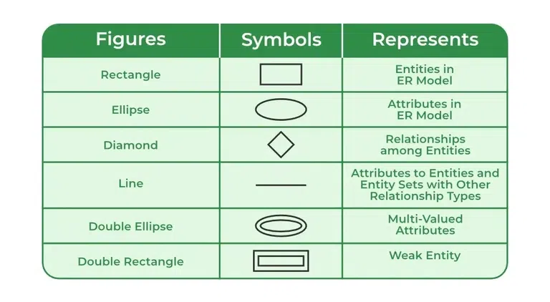

**Q5** Define 6R's. Explain the 6R's in migration strategy.

### Ans.

### Re-host

Also sometimes called “lift and shift,” this is a basic strategy that involves lifting the stuff you currently host on-premise and shifting it to the cloud. You move an exact copy of your current environment to the same type of environment on the cloud. This strategy usually does not require extensive reconfigurations or changes to architecture. Everything that worked in the on-premise environment should work the same way when hosted on the cloud.

This strategy is good for companies that are new to cloud migration and are building trust in the cloud. Because there are not a lot of differences between their current environment and the cloud environment, there’s not a huge investment with the re-hosting strategy.

### Re-platform

This one is similar to a lift and shift strategy. The difference is that you will make some more changes and adjustments to applications so they are optimized and will work better and faster when hosted on the cloud. Re-platforming requires programming knowledge so that your current environment integrates seamlessly with the cloud environment.

This strategy is also good for companies that are still testing the cloud migration waters and want to build trust in the cloud while seeing benefits like faster system performance and lower costs.

### Repurchase

With repurchasing, you are moving your environment to a new, cloud-based product. One way to do this is to abandon your current applications and replace them with software as a service (SaaS) options. This can be a challenge because team members lose the familiarity with your existing apps and will need to be trained on the new platform.

Another way to go with the repurchase strategy is to move licenses from local servers to cloud-based servers. For example, you might move a customer relationship management system (CRM) to Salesforce.

The repurchasing strategy might be a good, cost-effective way to go if you are moving applications from customized legacy environments.

### Retain

If migrating to the cloud doesn’t make sense for your company at this time, you can retain your current environment and revisit a move to the cloud later. For example, to be in compliance, you can’t move data at this time. Or, some of your applications might be too difficult to migrate and you want to keep them until you can come up with a viable and cost-effective alternative.

In this case, you might want to look at a hybrid option with some of your stuff retained on-premise while others are moved to the cloud.

### Retire

Some of your applications and services might not be useful anymore. There’s no reason to migrate them to the cloud if they are not going to be of value to your customers. If this is the case, all you need to do is turn them off.

### Re-factor

This strategy can be labor-intensive because it involves redesigning and building your existing applications from scratch so they can work in the cloud environment. Re-factoring can be time-consuming and expensive. But by taking the time to re-factor your applications, they will be more compatible with future versions, and it can make them more accessible to accommodate future growth.

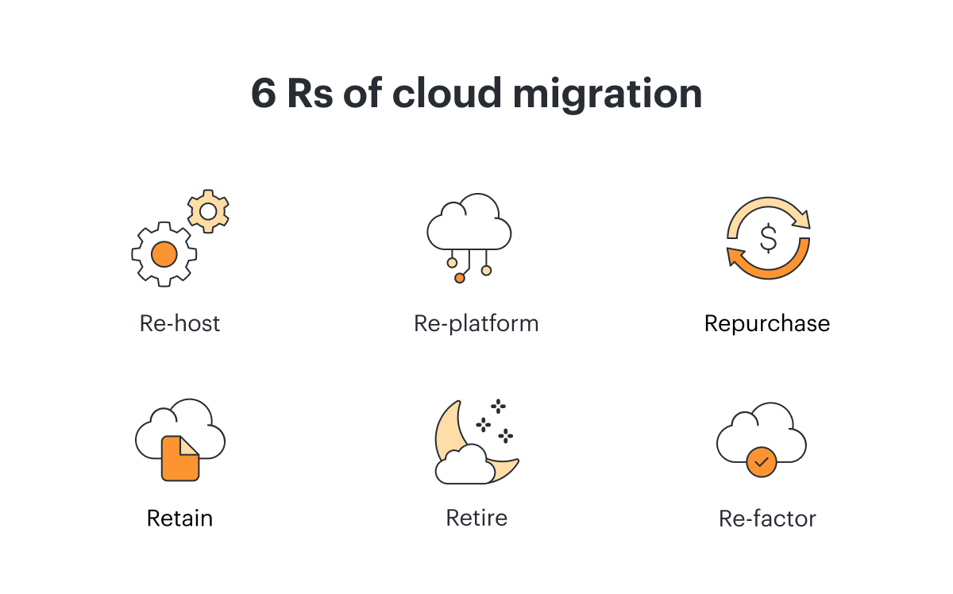

**Q6** What is instance? List out the different types of instance family.

**ANS.** An **instance** refers to a virtual server in cloud computing environments, such as Amazon Web Services (AWS), Microsoft Azure, or Google Cloud Platform (GCP). It is a computing resource that can run applications, store data, and perform various tasks, similar to a physical server.

**Different Types of Instance Families:**

1. **General Purpose**: Balanced resources for a variety of workloads (e.g., AWS T3, M5).
2. **Compute Optimized**: Designed for compute-intensive tasks (e.g., AWS C5, C6g).
3. **Memory Optimized**: Optimized for memory-intensive applications (e.g., AWS R5, R6g).
4. **Storage Optimized**: Tailored for workloads that require high storage throughput (e.g., AWS I3, D2).
5. **Accelerated Computing**: Includes hardware accelerators like GPUs for tasks such as machine learning (e.g., AWS P3, G4).

**ALL THE VERY BEST, DO WELL**

**THANKS & REGARDS,**

**MOHAMMED RAFIQUE……….**