Samir Rodriguez

Module 5.2 Assignment

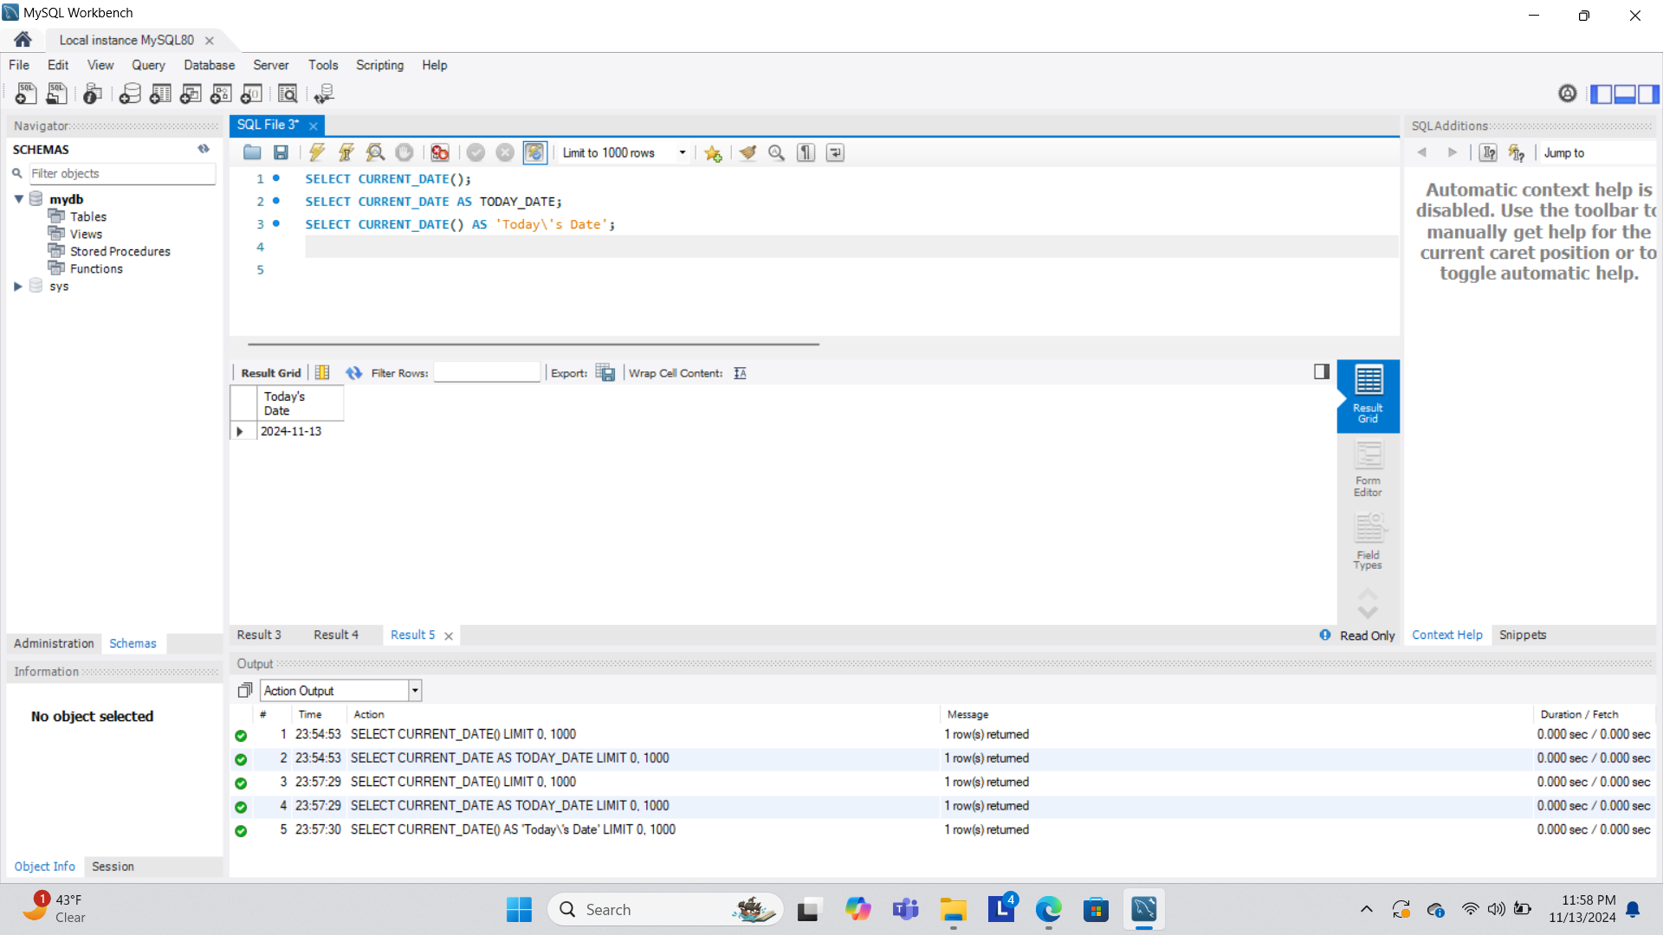

3 functions:

1. NOW(): function returns the current date and time in YYYY-MM-DD format.

Use: This function is useful for tracking exact timestamps, such as logging the date and time of an event, like when a user logs in or when a record is created.

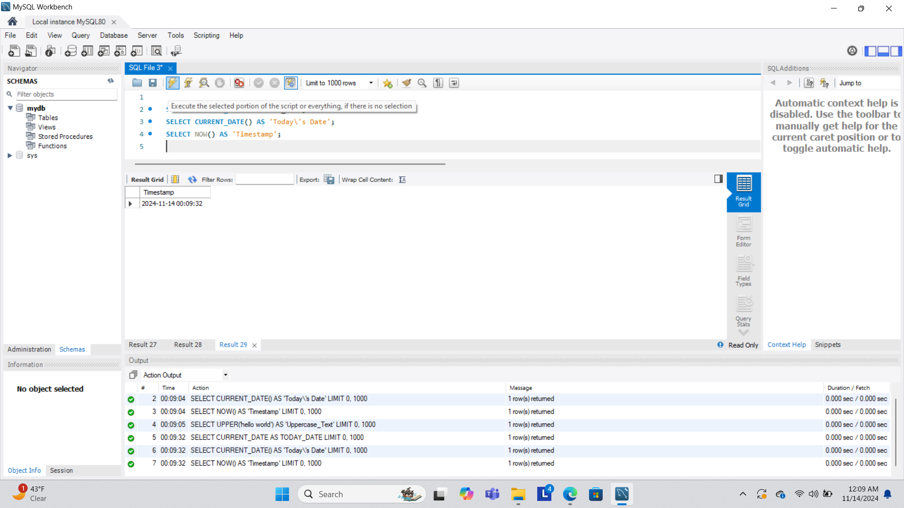

1. UPPER(): function converts a string to uppercase.

Use: This function is useful for standardizing text data. For example, if you want to ensure that all names are stored or displayed in uppercase.

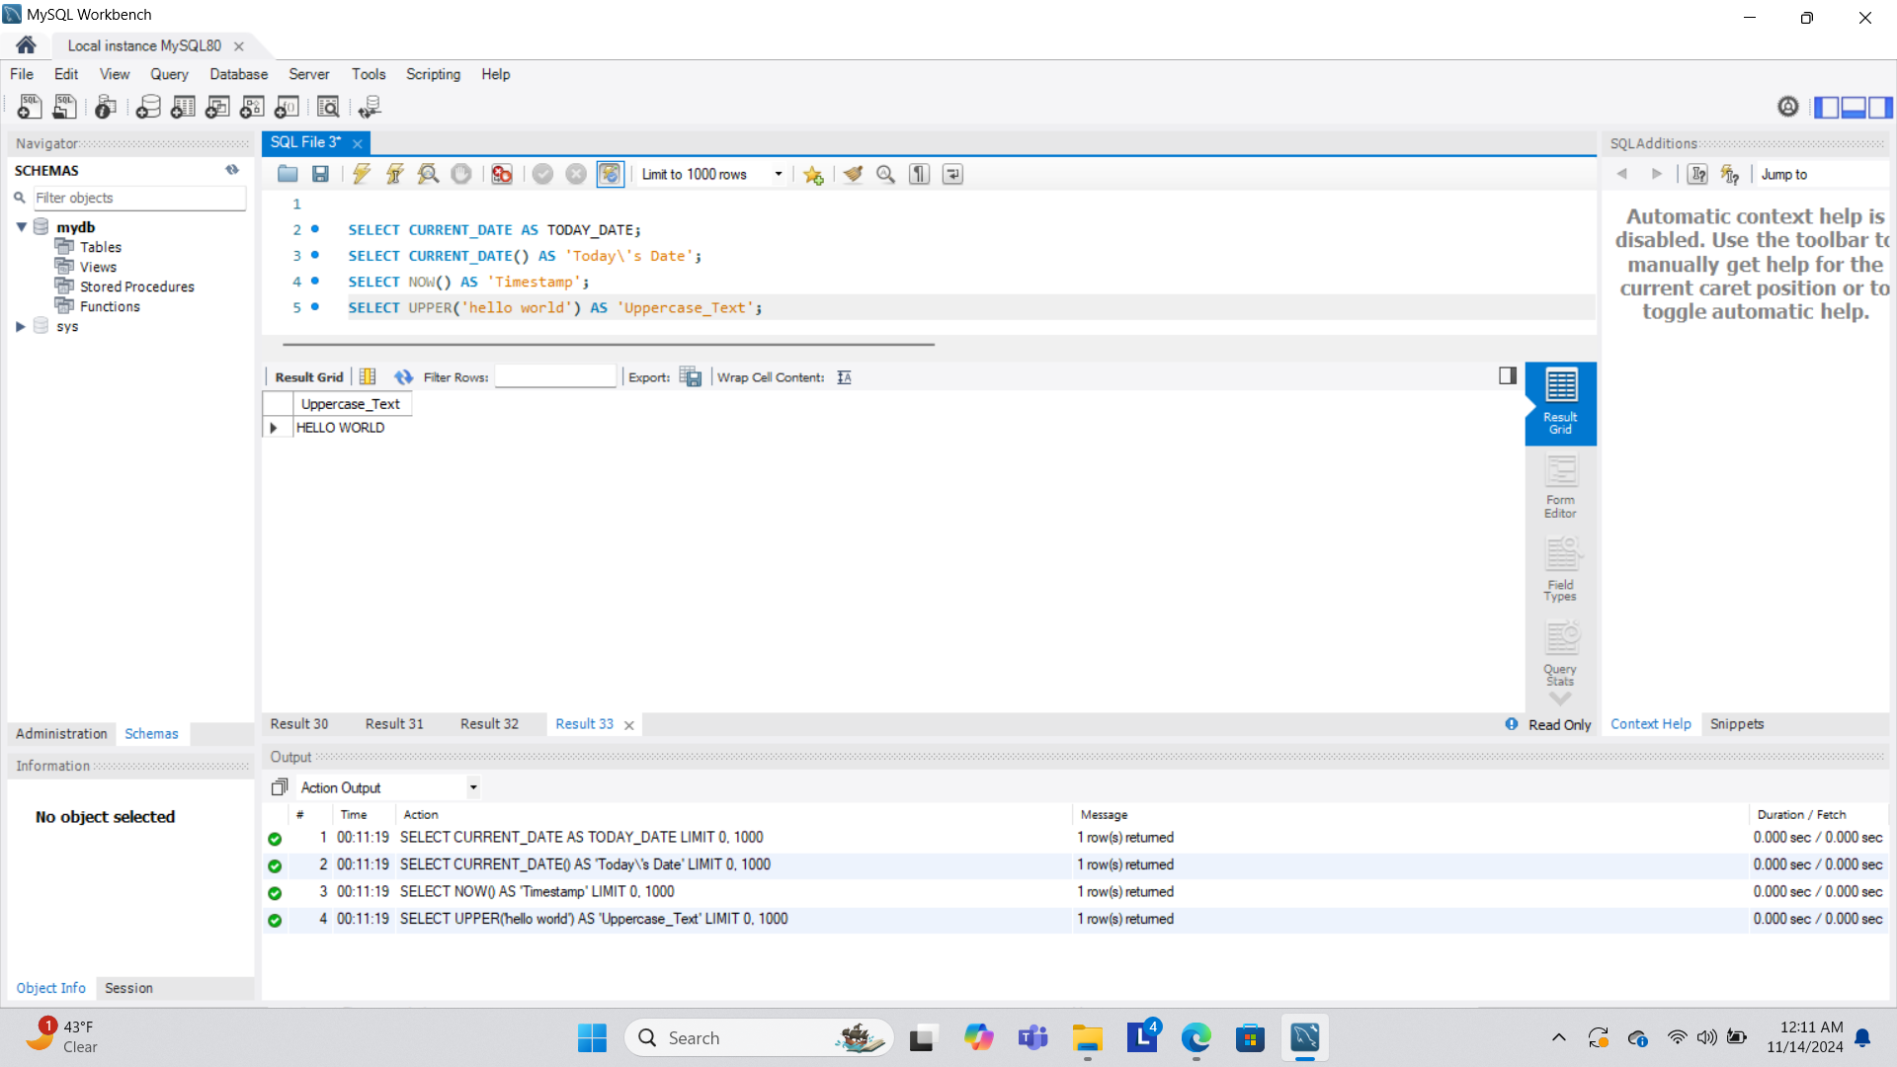

1. LENGTH(): function returns the number of characters in a string.

Use: This function is helpful for validating text input, such as ensuring a username meets a minimum or maximum character limit. It can also be used in data quality checks to find unusually short or long entries.

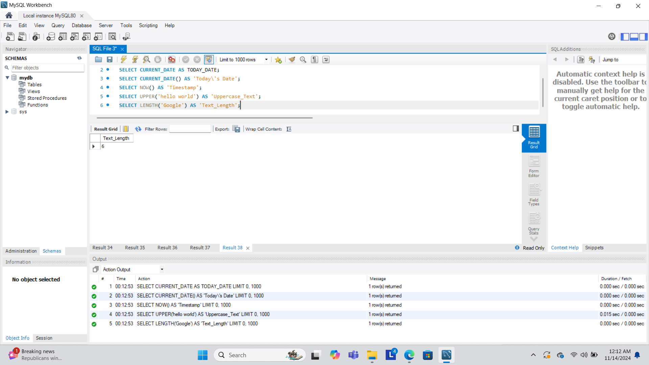

Reference:

[MySQL Functions](https://www.w3schools.com/sql/sql_ref_mysql.asp)