**THE UNIVERSITYOFDODOMA**

**COLLEGE OF INFORMATICS AND VIRTUAL EDUCATION (CIVE)**

**DEPARTMENT OF COMPUTER SCIENCE AND ENGINEERING**



LABWORK 4

COURSE CODE: CP 221

COURSE NAME: INTERNET PROGRAMMING AND APPLICATION

PROGRAM: BSC-SE

SUBMITTED TO: SIR SIPHAEL

|  |  |
| --- | --- |
| NAME | REG NO |
| KELVIN B DEUS | T/UDOM/2019/00602 |

HTML CODE FOR THE FIRST PAGE

* HTML page without css

<!DOCTYPE html>

<html>

<head>

<title>classic Horror - Edgar Allan Poe</title>

</head>

<body>

classic Horror - Edgar Allan Poe

<p>

Edgar Allan Poe:Best know for his poems and short

fction , Edgar Allan Poe born in Boston, Jan 19. 1809

died Oct 7 1894 in Baltmore deserves more credt than

any other writer for the trasnformation of the short story

from ancedote to art He virtually credet the detective

story and perfected the psychological thnller . He also

produced some of the most infuluental literary criticism

of his time--importwnt theoretical ststements on poetry and the story -

- and has had a worldwide influence on literature.

He was born as Edgar Poe in in Boston . Massachusetts; his parents<br> died

When he was young Poe was taken by john anmd Frances Allan of

Richmond , Virginia . but they never formally andopted him, After spending a>

short period at the Universty of Virginia and briefly attempting

<br> a military

career , Poe parted ways with te allans Poe's publishing career began >

humbly, with an anonymous collection of poems. Tamerlane and other

poems (1827) creadited only to "a Bostonian"

<br>

Stories by Poe

A Descent into The Maelstrom(1841)

The Black Cat (1843)

The Tell Heart (1843)

The Cask Of Amontillado (1846)

Bon-Bon (1850)

Comments / Suggestions

We want to hear from your! if you have any

comments or Suggestions on things you'd like

to see on the site please <a href="kelvin@gmail.com">let_us_know</a>

<br>

&#169;20009 a classic honor authors website

</body>

</html>

OUTPUT ON BROWSE’R FOR HTML PAGE

* HTML page without css

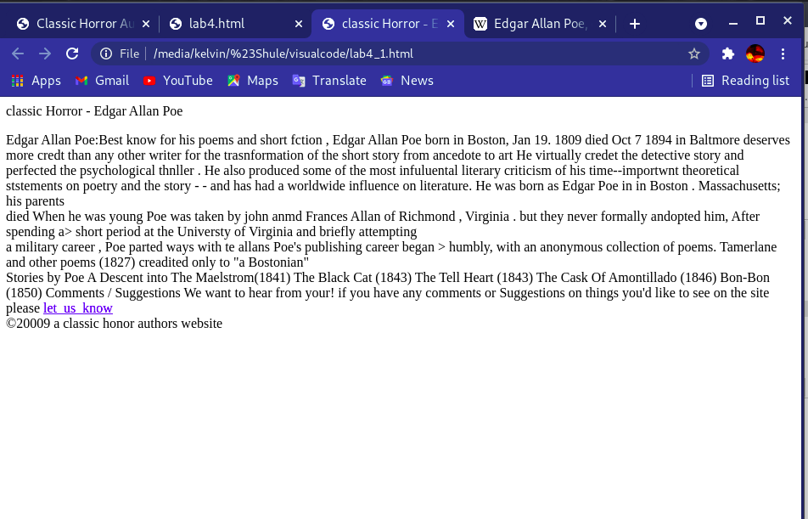

HTML AND CSS CODE FOR THE PAGE ARCHIVED AFTER COMBINE HTML AND CSS

1. HTML CODE WITH CSS

<!DOCTYPE html>

<html>

<head>

<title> </title>

<link rel="stylesheet" href="lab4.css">

</head>

<body>

<div class="div">

<header id="header">

<br>

classic Horror authors - Edgar Allan Poe

</header>

</div>

<div class="div">

<nav id="nav">

<br>

<p1>

<a href="Edgar" id="a">Edgar Allan Poe |</a>

<a href="Mary">Mary Shelley |</a>

<a href="Bram">Bram Stoker</a>

</p1>

</nav>

</div>

<div class="div">

<content id="content">

<img src="edgar.jpg" alt="Edgar Allan Poe" id="image"> <br><b>Edgar Allan Poe:</b>Best know for his poems and short

<br>fction , Edgar Allan Poe born in Boston, Jan 19. 1809

<br>died Oct 7 1894 in Baltmore deserves more credt than

<br>any other writer for the trasnformation of the short story

<br>from ancedote to art He virtually credet the detective

<br>story and perfected the psychological thnller . He also

<br>produced some of the most infuluental literary criticism<br>

<br>of his time--importwnt theoretical ststements on poetry and the story -

<br>- and has had a worldwide influence on literature.

<p>

He was born as Edgar Poe in in Boston . Massachusetts; his parents died <br>

When he was young Poe was taken by john anmd Frances Allan of <br>

Richmond , Virginia . but they never formally andopted him, After spending a<br>

short period at the Universty of Virginia and briefly attempting a military<br>

career , Poe parted ways with te allans Poe's publishing career began <br>

humbly, with an anonymous collection of poems. Tamerlane and other<br>

poems (1827) creadited only to "a Bostonian"

</p>

</content>

</div>

<div class="div">

<aside id="aside">

<p1>

<h> </h><b>Stories by Poe</b><br>

<br>

<ul id="ul">

<li> A Descent into The Maelstrom(1841)</li>

<li> The Black Cat (1843)</li>

<li> The Tell Heart (1843)</li>

<li> The Cask Of Amontillado (1846)</li>

<li> Bon-Bon (1850)</li>

</ul>

<p>

<h> <b> Comments / Suggestions</b></h><br>

We want to hear from your! if you have any<br>

comments or Suggestions on things you'd like<br>

to see on the site please <a href="kelvin@gmail.com">let_us_know</a>

</p>

</p1>

</aside>

</div>

<br>

<br>

<div class="div">

<footer id="footer">

&#169;20009 a classic honor authors website

</footer>

</div>

</body>

</html>

2. CSS CODE FILE THAT MAKE LAYOUT OF AN HTML PAGE

body

{

background-color: #666666;

font-family: Arial, Helvetica, sans-serif;

font-size: 90%;

width: 900px;

height: 400px;

}

.div

{

margin-top: 6px;

padding: 6px;

}

#header

{

background-color: #990000;

width: 880px;

height: 70px;

border: 1px solid black;

font-size: 23px;

color: white;

padding-left: 10px;

}

#nav

{

background-color: #CCCCCC;

width: 890px;

height: 45px;

border: 1px solid black;

}

#a

{

color: rgba(236, 19, 128,0.6);

}

#footer

{

background-color: #CCCCCC;

width: 890px;

height: 20px;

text-align: center;

clear: left;

font-size: 90%;

border: 1px solid black;

}

#content

{

background-color: #999999;

width: 464px;

margin-bottom: 6px;

float: left;

height: 300px;

padding-top: 15px;

font-size: 90%;

padding-left: 10px;

border: 1px solid black;

}

#image

{

width: 100px;

height: 96px;

float: left;

margin: 10px;

border: black;

margin-top: 19px;

}

#aside

{

background-color: #999999;

width: 365px;

float: right;

height: 200px;

margin-bottom: 6px;;

margin-top: -17px;

border: 1px solid black;

padding: 10px;

font-size: 90%;

}

OUTPUT FROM BROWSE’R AFTER COMPILATION OF CSS CODE

