**The University of Dodoma**



**COLLEGE OF INFORMATICS AND VIRTUAL EDUCATION**

**DEPARTMENT OF TELECOMMUNICATION AND COMPUTER NETWORKS**

**TN310: WIRELESS NETWORKING**

**Lab Assignment 1**

Submitted By

|  |  |  |
| --- | --- | --- |
| NAME | REG. NO | COURSE |
| MCHARO JOHN | T/UDOM/2013/04789 | BSC. TE |
| PALLANGYO MERCY | T/UDOM/2013/04766 | BSC. TE |
| ALLY AMINA | T/UDOM/2013/04118 | BSC. CE |
| RIMISHO INVIOLATA | T/UDOM/2013/04767 | BSC. TE |
| DEUS ,JERALDY | T/UDOM/2013/04763 | BSC. TE |

**Submitted to:** ANTONY F. SAMBAIGA

1. In which file do we define our network topology?

**Answer**: tictoc1.ned

1. How many nodes and links does our network have?

**Answer**: one link and two nodes

1. What does initialize() function do?

**Answer**: In initialize() we create a message object cMessage, and send it out on gate out

1. What does handleMessage() function do?

**Answer**: it receives and resends message when it arrives from another module by calling the send() method. It is is called whenever a message arrives at the module.

1. What does send () simulation kernel call do in the used in the initialize()  
   function?

**Answer**: it delivers message to the other module

1. What does the Define module() macro do? Can this macro be used in a  
   header file (.h file) and why?

**Answer**: Define module() macro creates subclass of OMNET++ cSimple module and register it in OMNET ++ System .It cannot be used in the header file because it is a function and a function cannot be used in the header files since the header files contains only known libraries.

1. In handleMessage() function, can we use another send() function right  
   after the first send() to send out the same message?

**Answer:** No we cannot use another send() to send out the same message as an error occurs when you want to run the project. This is shown below;

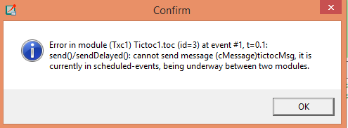

1. Following activities and questions are related to dynamic memory allocation and de-allocation in C++:  
   (a) Locate the following two statements in the initialize() function  
   cMessage *msg = new cMessage("tictocMsg");  
   send(msg, "out");  
   and comment them out. Rebuild the simulation model and run again.  
   What does happen?  
   **Answer**: an error occurred in the project tictoc1 but the project was able to run successfully
2. Now, put these lines back in. But insert delete msg; between the  
   cMessage ... and send ... statements. Does the code compile without  
   errors? If yes, run it. Does it run without any errors? If no, what is  
   the error reported?

**Answer**: yes the project compiled without any errors but it does not run without any errors. And the error reported is;

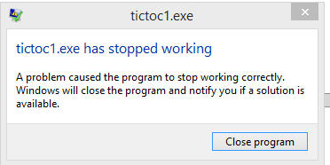

1. Modify the line containing delete ... as follows delete msg; msg =NULL, rebuild and run the code. What does happen?

**Answer**: the project compiled without any errors but it failed to run.

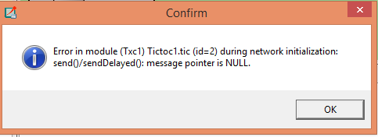

And when you try to run the project it will pop up a warning message as shown below;

