MAD ASSIGNMENT - "ASAP"

[Shopping App]

# Members

**Deux08 - Ibrahim Alrasyid Waterkamp [S10188377F]**

* Bottom Navigation Bar
* Fragments
* Firebase API
* Glide API
* Google Maps API
* ShakeDetector library - Shake Listener
* User Management - [Sign up/ Log in / Forget Password / Log out}
* [Intents / Bundles ] & passing values between fragments/activities
* Manifest Customization
* Gradle Customization
* Toasts
* User Interface

**Adellollipop - Adeline Wong [S10187871]**

* Home Fragment
* Custom List View
* Product page
* Product Class

**seannich - Sean Nicholas [S10189987]**

* Search Fragment
* List View
* Search Function

**App Description**

ASAP is a the new kind of shopping app. This app allows user to buy stuff like any other shopping app but it has a unique checkout feature. This unique feature allows the user to check out and have the items delivered the next day by just shaking the phone, if the feature is enabled. New users will be prompted to create a new account if they don't have one. These credentials can be used to login into the app not only from one device, but from multiple devices. This is because ASAP uses Firebase cloud to store the users information safely and securely.

**User guide**

**Sign up page**

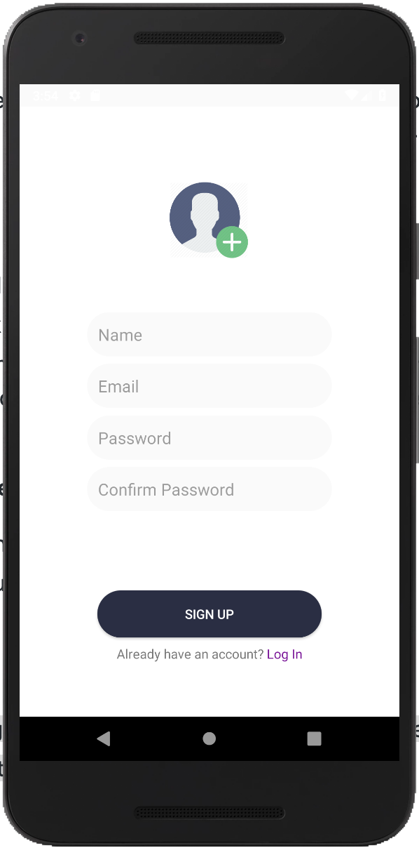

* Add picture
* Add Name
* Add Password
* Click Submit to save changes

**Log In page**

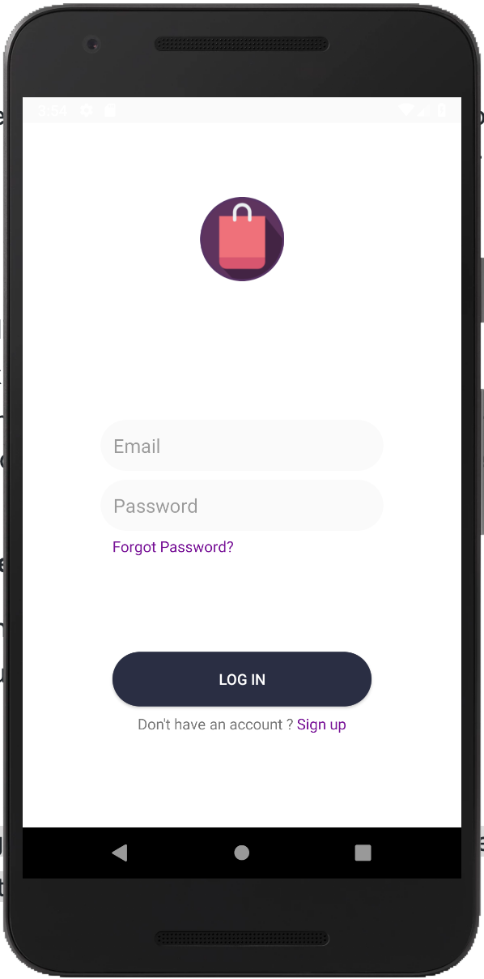

* Input Email
* Input Password
* Click Login to log in

**Home page**

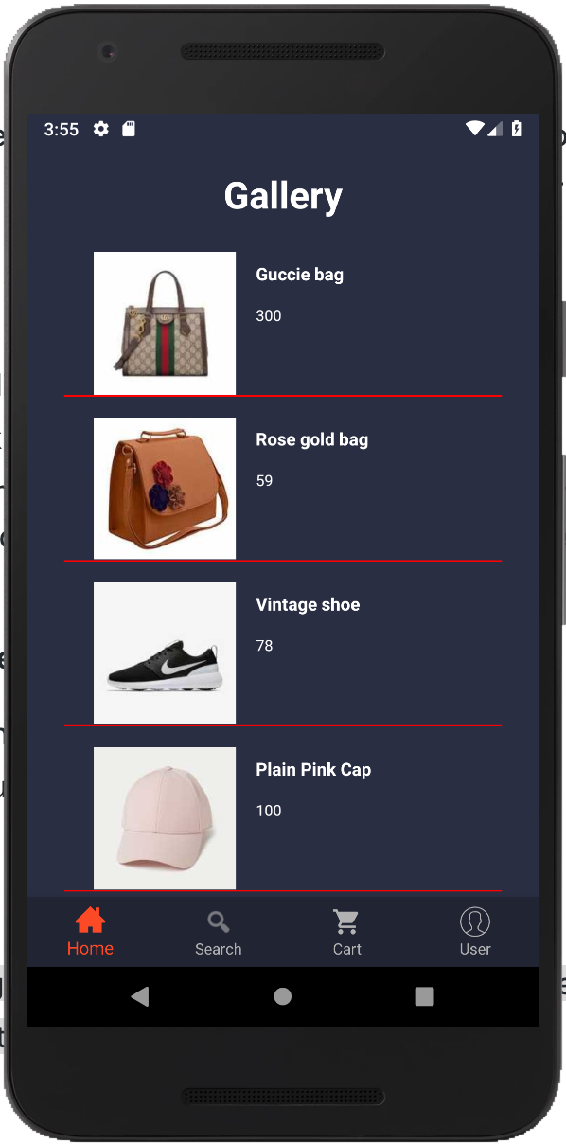

* Displays items for sale
* Click to view details (redirected to product details page)

**Product details page**

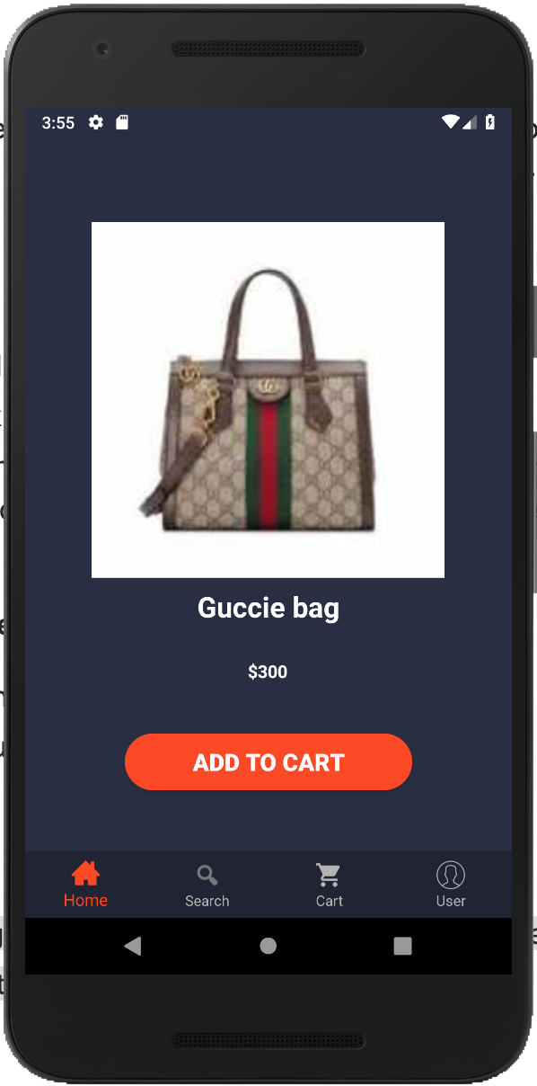

* Displays selected item information
* Add to cart button adds the item to the cart

**Search page**

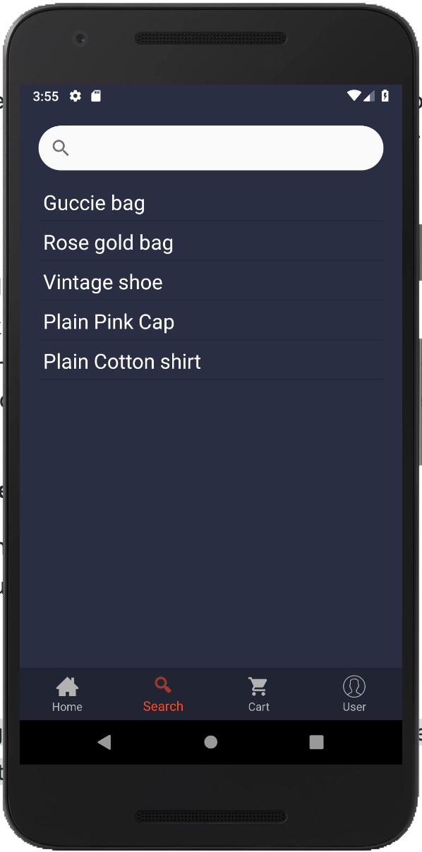

* Click on the icon on the search bar if you want to look for something
* Results will be shown if the input in user is part of or matches an item

**Cart page**

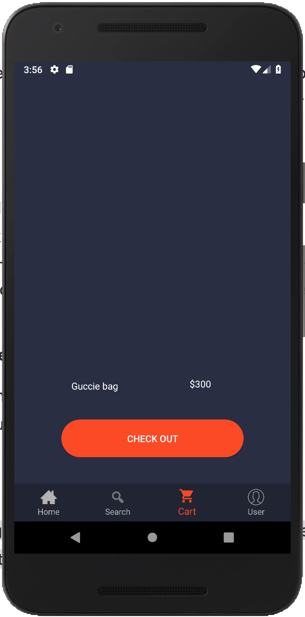

* Shows the list of items that are added to cart
* Click check out to pay and choose delivery method
* If "Shake phone to check out" is enabled, shake your phone several times to automatically check out and have the item received the next day

**Check Out page**

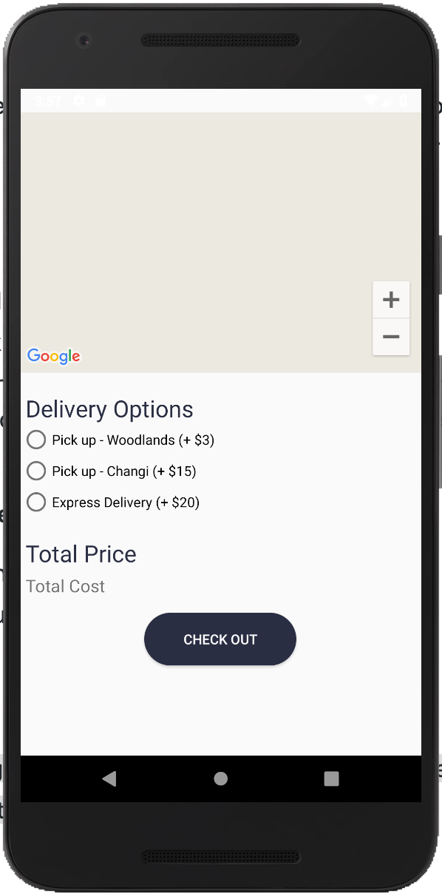

* User can choose delivery method
* Click the button to pay the total amount

**User page**

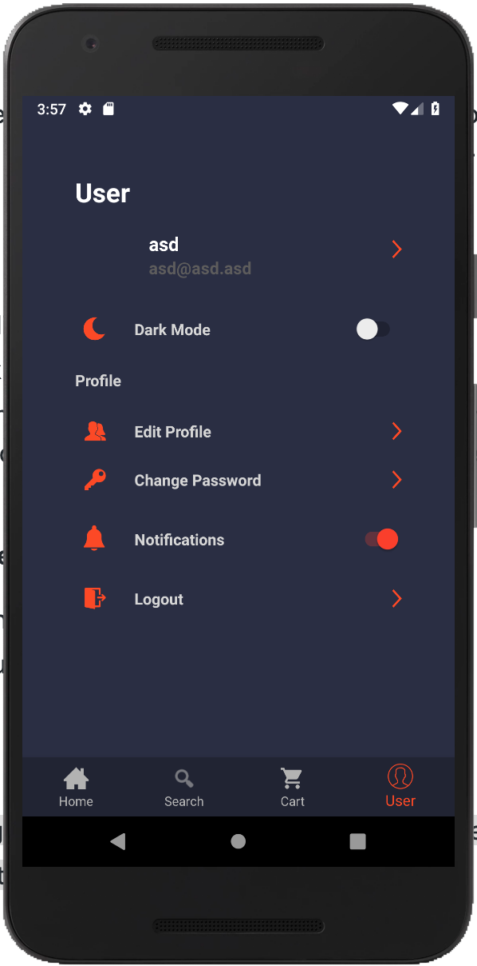

* Click change password to receive a password reset email
* Click logout to log out