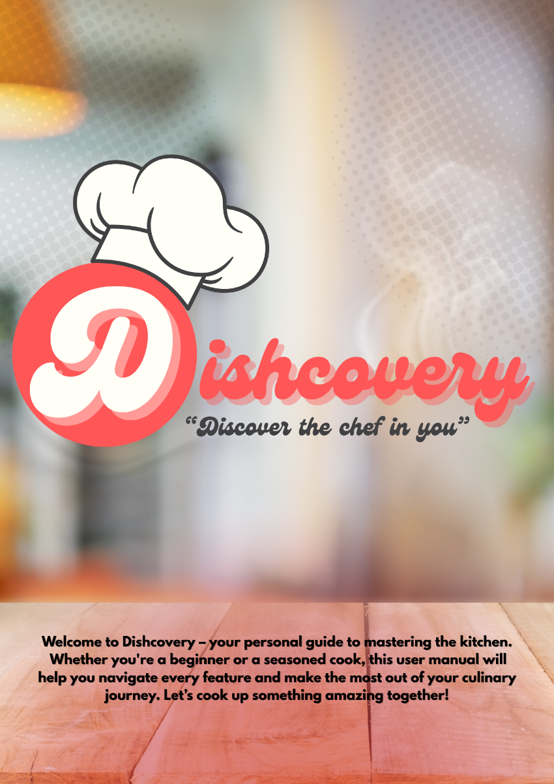
Table of Contents
Introduction 2
Rationale 3
System Requirements 3
Purpose 4
Scope and Delimitations 4
User Types 5
Applications Features Overview 5
User Guide 6
Get Started 6
Sign In 7
Logging In 8
Level of your Cooking 9
Cuisine Preference 10
Allergies 11
Home(Main Dashboard) 12
View More in Post 12
Own Recipe 14
Recipe (Own and Bookmarked) 17
Profile 18
Notifications 19
Search Bar 20
Profile Settings 23
Chatbot Feature 24
Dishcovery User Guide


App Name: Dishcovery
Version: 1.0
Target Users: Dishcovery is perfect for dorm students, beginners, and anyone who wants to cook more confidently at home. It’s also great for people looking to discover new recipes, improve their cooking skills, or connect with others who share a love for food and cooking.
Prepared By: Cello, C. Buenafe, C. Viñas, R.
Last Updated: May 2025

I. Introduction
Dishcovery is a modern mobile application designed to help users discover, create, and share recipes with ease. Built with Flutter, Dishcovery leverages cloud technology, real-time data synchronization, and an intuitive user interface to provide a seamless culinary experience. Whether you are a home cook, a food enthusiast, or someone who loves to share recipes with friends and family, Dishcovery offers a comprehensive platform to manage your recipes, store images, interact with a built-in chatbot for instant assistance, and connect with others.
With features such as secure authentication, cloud-based storage, a responsive design, a helpful chatbot for user support and cooking tips, and support for multiple languages and custom fonts, Dishcovery aims to make recipe management simple, enjoyable, and accessible to everyone. This user manual will guide you through the app’s features, usage instructions, and best practices to help you get the most out of your Dishcovery experience.
II. Rationale
As highlighted in the introduction, Dishcovery is built to address the modern need for a convenient, cloud-powered, and socially connected recipe management experience. With the increasing popularity of home cooking and digital recipe sharing, users require a platform that not only stores their culinary creations but also makes it easy to access, organize, and share them anytime, anywhere.
Dishcovery leverages secure authentication, real-time cloud storage, a responsive, animated interface, and an integrated chatbot to ensure that users can focus on creativity and community rather than technical barriers. By integrating features such as image and animation support, seamless sharing, and instant chatbot assistance for cooking questions or app navigation, the app empowers users to personalize their cooking journey and connect with others who share their passion.
Ultimately, Dishcovery’s rationale is to simplify and enrich the way people discover, create, and share recipes—making the kitchen a more collaborative, enjoyable, and innovative space for everyone, with the added benefit of on-demand chatbot support.

III. System Requirements
To ensure optimal performance, the following system requirements are recommended:
For End Users (Mobile App)
- Device: Android smartphone or tablet
- Operating System: Android 6.0 (Marshmallow) or higher
- RAM: At least 2 GB
- Storage: At least 100 MB of free space for app and assets
- Internet: Required for cloud sync, authentication, and sharing features
- Camera & Storage Permissions: Needed for image capture and upload

IV. Purpose
The purpose of Dishcovery is to make cooking more accessible, enjoyable, and personalized for everyone. It helps users discover recipes that match their skill level, ingredients, and preferences, while also offering tools to learn and connect with a community of fellow food lovers.

V. Scope and Delimitations
Scope
Dishcovery is a mobile application focused on recipe management, discovery, and sharing. The app allows users to create, edit, and organize recipes, attach images and animations, and share their culinary creations with others. It supports secure authentication, cloud-based data storage, and real-time updates, ensuring that users can access their recipes from any compatible Android device. The app also features a "Cook Now" mode for step-by-step cooking guidance, responsive design for various screen sizes, and multi-language support.
Delimitations
- Dishcovery is currently available only for Android devices; iOS and web versions are not included in this release.
- The app requires an active internet connection for cloud sync, authentication, and sharing features; offline access is limited to cached data.
- Recipe sharing is limited to in-app features and does not include direct social media integration.
- The app does not provide nutritional analysis, meal planning, or grocery list functionalities.
- User-generated content is limited to recipes, images, and basic profile information; advanced social networking features are outside the current scope.
- Integration with external kitchen devices or smart appliances is not supported.
These boundaries ensure that Dishcovery remains focused on delivering a streamlined and user-friendly recipe management experience, while leaving room for future enhancements based on user feedback and technological advancements.

VI. User Types
Dishcovery is designed to be intuitive and accessible for a wide range of users. The app primarily supports the following user types:
1. Regular Users (Home Cooks & Food Enthusiasts)
- Can create a personal account using email/password or Google sign-in.
- Add, edit, and organize their own recipes.
- Attach images, animations, and detailed instructions to recipes.
- Use the built-in chatbot for cooking tips, app guidance, or troubleshooting.
- Access and manage their recipe collection from any compatible Android device.
- Share recipes with friends and family within the app.
2. Social Sharers
- Focus on discovering new recipes and sharing their own creations.
- Interact with the chatbot for quick sharing tips or to get help with app features.
- Benefit from real-time updates and cloud sync to keep their shared content accessible.
3. Administrators/Moderators
- Manage user accounts and content (e.g., moderate inappropriate recipes or images).
- Oversee app analytics and user engagement (using Firebase Analytics).
- Access advanced features for maintaining the quality and safety of the Dishcovery community.

VII. Applications Features Overview
Dishcovery offers a comprehensive set of features designed to make recipe management, discovery, and sharing easy and enjoyable. Below is an overview of the key features available in the app:
1. User Authentication
- Secure sign-in and registration using email/password or Google accounts.
- User session management for personalized experiences.
2. Recipe Management
- Create, edit, and delete recipes with detailed instructions.
- Organize recipes with images, animations, and custom categories.
- Store recipes securely in the cloud for access across devices.
3. Image and Animation Support
- Attach multiple images to recipes using the device camera or gallery.
- Add engaging animations to enhance recipe presentation.
- Efficient image compression and caching for fast loading.
4. Chatbot Assistance
- Built-in chatbot provides instant help, cooking tips, and app navigation support.
- Users can ask questions about recipes, features, or troubleshooting directly within the app.
5. Real-Time Data Synchronization
- Recipes and user data are synced in real-time using cloud services.
- Changes are instantly reflected across all devices.
6. Responsive and Animated User Interface
- Modern, responsive design adapts to various screen sizes and orientations.
- Smooth animations and transitions for an engaging user experience.
- Support for custom fonts and multiple languages.
7. Sharing and Community Features
- Share recipes with friends and family within the app.
- Discover new recipes from other users.
- Community-driven content and feedback.

VIII. User Guide
A. Get Started
Ready to start your cooking journey?
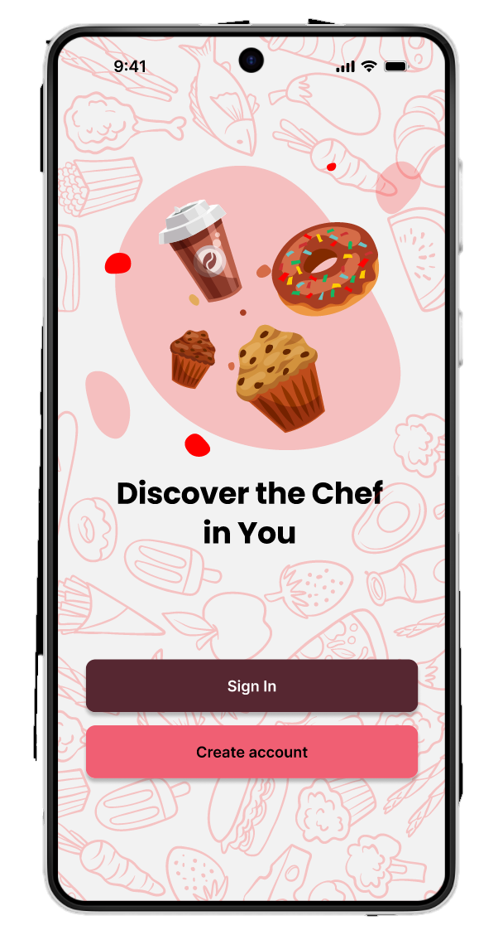
If you're new here, create an account to explore personalized recipes, track your progress, and connect with fellow food lovers. Already a member? Just Sign in and continue discovering delicious ideas!
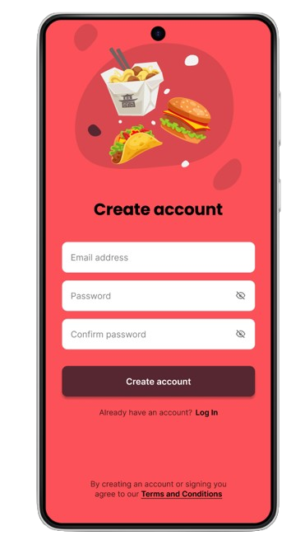

B. Sign In
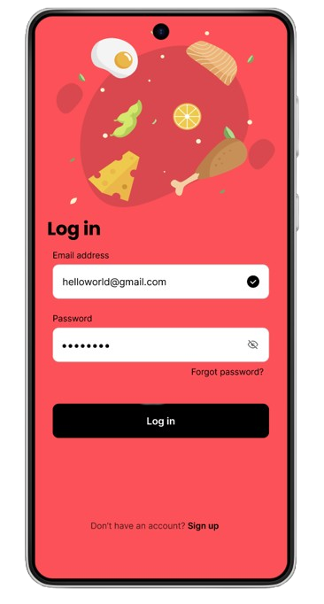
If you are a new user, click the “Sign Up” link to complete the process.
On the “Create Account” page, insert your information, including your email and desired password.
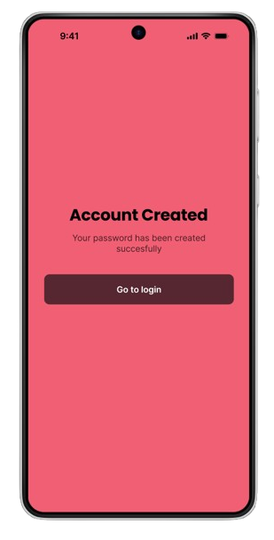
After that your account will be created.

Otherwise, if you have already an account just press log in.



C. Logging In

If you have already signed up for the latest version of the mobile app, input your username and password to login.
Then press Log in to continue.

But if you forgot your password you need to fill your email address and verify by writing the number/code that will be sent in the email address that you provided. Then provide a new password.
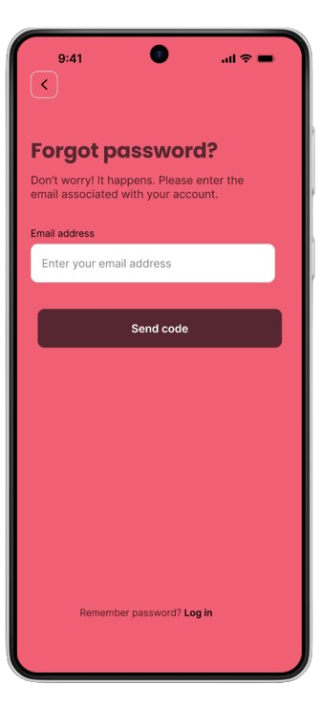

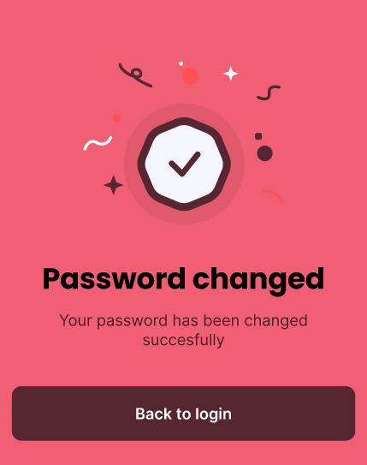

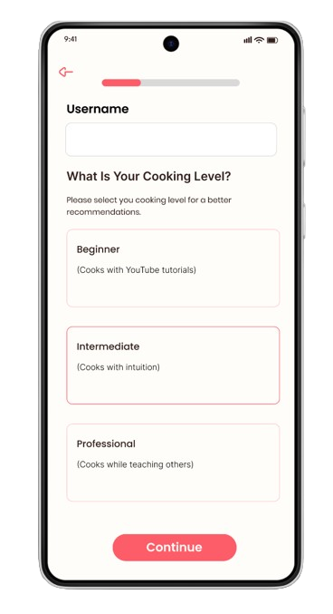
D. Level of your Cooking
After logging in, set your skill level from Beginner, Intermediate, or Professional so the app can recommend recipes and tutorials tailored to your experience.

- Beginners get simple, step-by-step guides, visual instructions, and kitchen basics.

- Intermediates unlock more advanced recipes, cooking tips, and plating ideas.

- Professional access complex dishes, pro tips, and tools to create original recipes from scratch.

Then press the “Continue” button to proceed.

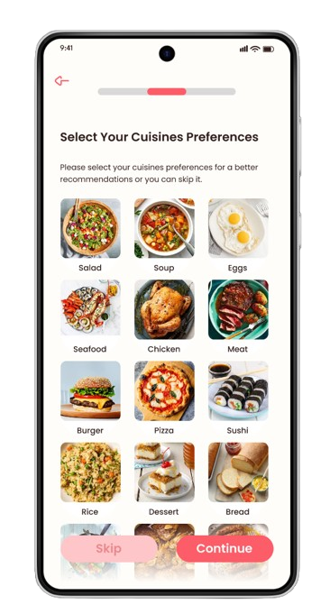
E. Cuisine Preference

Select your preferred cuisines — whether you're into Salad, Desserts, Breads, Filipino comfort food, or plant-based meals, Dishcovery adjusts your home feed and suggestions accordingly.

- Discover global dishes you’ll want to cook.

- Helps users step out of their usual go-to meals and explore similar options.

- Enables cultural appreciation through food.



You can either skip this section to proceed or fill to continue

F. Allergies
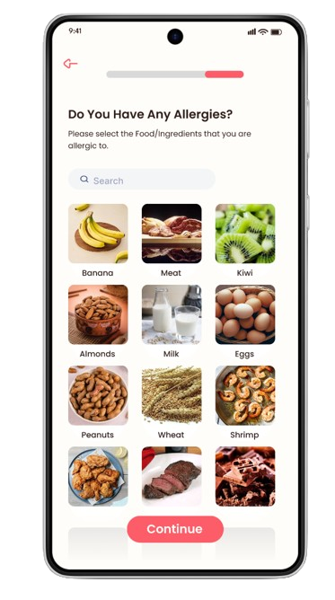

Customize your dietary safety by listing any food allergies or sensitivities (like gluten, shellfish, nuts, eggs, or soy).

- Automatically highlight or flags recipes that contain allergens.

- Suggests substitutes or alternative versions of dishes.

- Great for users with specific health concerns or family dietary restrictions.

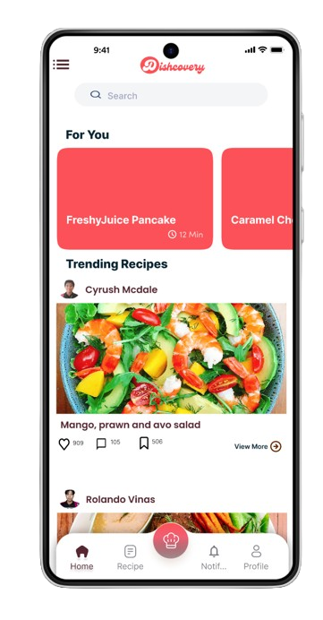
G. Home (Main Dashboard)
The home screen acts as your command center for culinary discovery.

- Displays recommended recipes based on mood, time of day, saved ingredients, and season.

- Rotating highlights of trending dishes and food creators.

- Quick access to view more, search bar, recipe (own and bookmarked), create your own recipe, profile, profile settings, and notification.

H. View More in Post
Tap on any recipe or dish post to expand and get the full cooking breakdown.

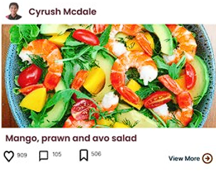

Press this to see the full description of the cuisine

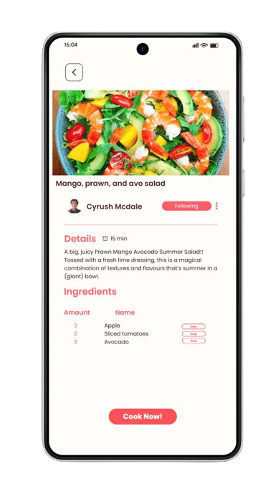
See ingredient list, measurements, descriptions, and substitutions.

Press the “Swap” button to see the available alternate ingredients.

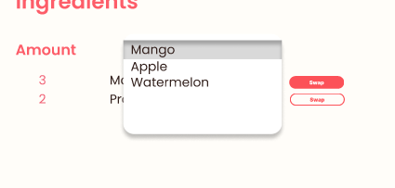

Press “Cook Now!” to start cooking and see the step-by-step instructions.

I. Own Recipe
Share your original cooking creations with the Dishcovery community.

Press this icon to create your own recipe
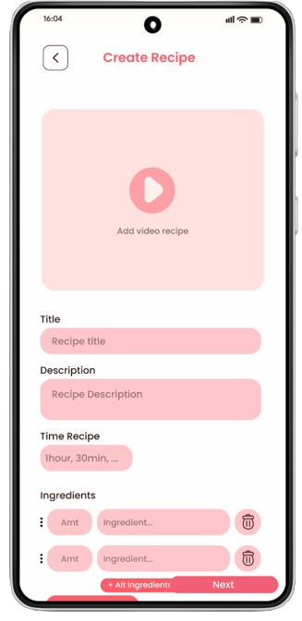

Add step-by-step instructions with timers and photos.
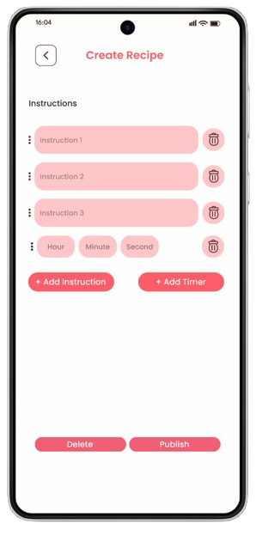

Include prep/cook time, servings, tools needed, tips, and alternative ingredient.

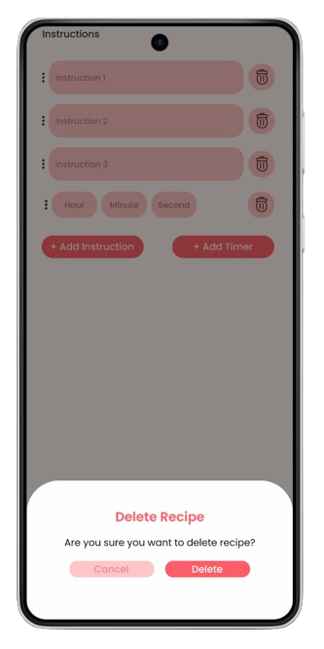
Choose to share with friends, and go public for feedback and reactions.
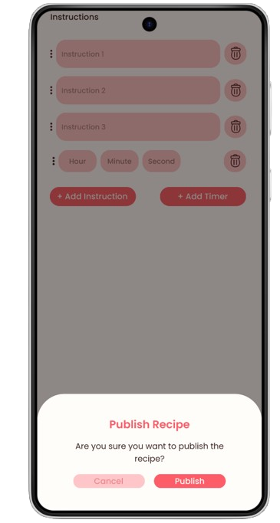
Or delete the recipe and start a new one.

J. Recipe (Own and Bookmarked)
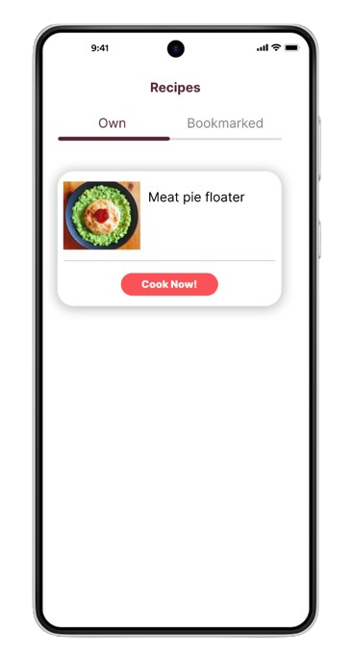


Press this icon to proceed with recipe.

See the recipes you’ve been created. Click the “Cook Now!” button to start cooking and follow the step-by-step instructions.

Make it easier to see your own progress of creating lots of ingredients.

See your saved favorite recipes from the news feed in one tap and organize them however you like.

K. Profile


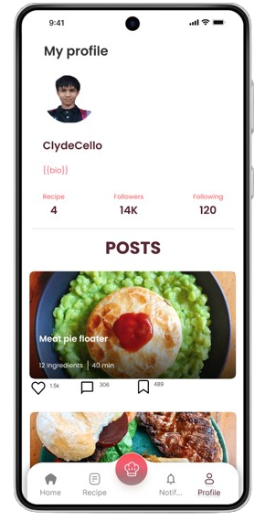

Press this icon to proceed with profile

Your public-facing profile showcases your culinary identity.

Friends and followers can interact through comments and likes.

Will show the cuisines you’ve posted showing how many likes, comments and bookmarked.

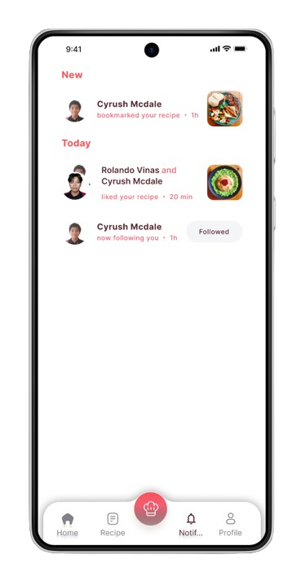
L. Notifications
Real-time updates that keep you engaged and informed

- Get notified when someone saves or comments on your recipe

- Smart notifications based on your habits and food preferences

- Give you an update on who followed you.

M. Search Bar
Find any recipe, ingredient, dish, or creator in seconds. Discover people who cook your favorite cuisine or share similar goals.
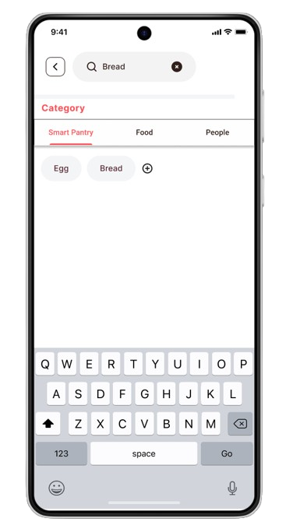

You can choose what to search for, like Smart Pantry, Food, and People.



Press the feature that u wants to use.

N. Search Bar (Smart Pantry)

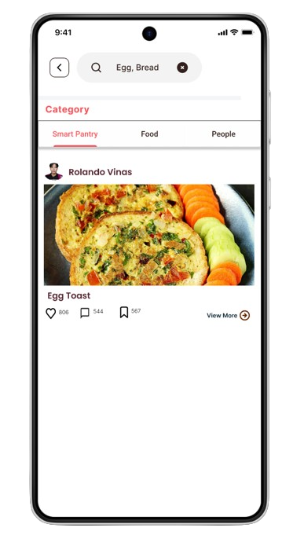

Dishcovery’s Smart Pantry helps you track ingredients you already have and suggests recipes based on what’s in stock.

Suggests meals you can make right now with what’s available.

O. Search Bar (People and Food)

Find the right recipe or the right cooking inspiration — fast. This feature lets users explore a wide world of food and culinary creators in a smart, intuitive way. Search by Dish Name or Ingredients
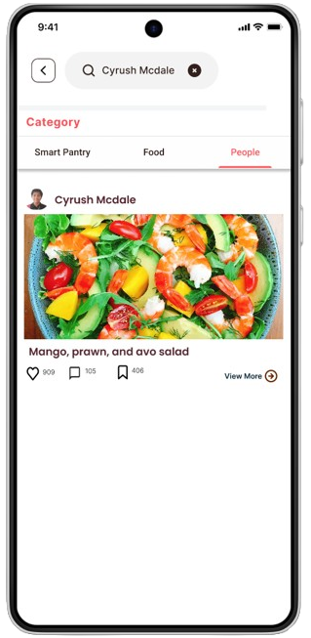
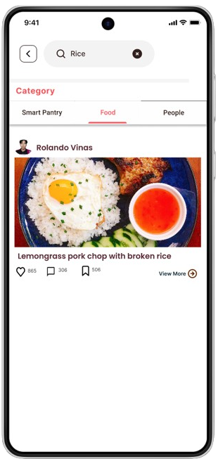

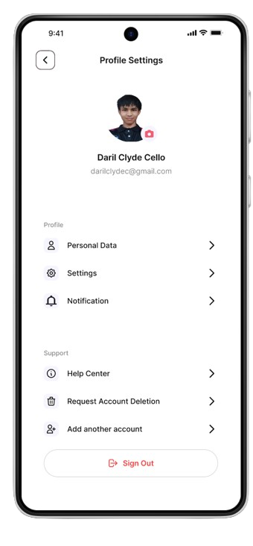
P. Profile Settings

Manage all your account and app preferences in one place.

Update email, password, and name.

Manage connected devices, notifications, and privacy settings.

Option to deactivate or delete export your data anytime

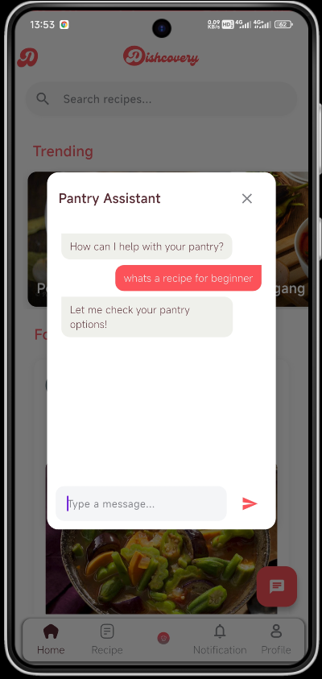
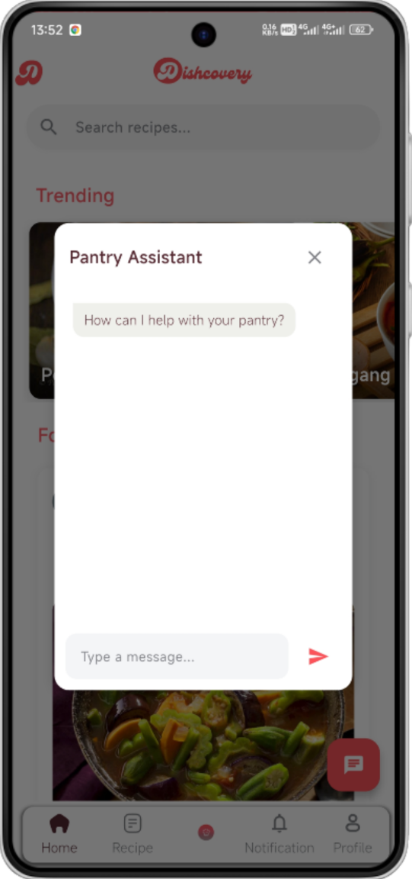
Q. Chatbot Feature

Get instant help with your cooking and pantry tasks.
Ask questions, get recipe suggestions, or let the bot check your pantry items.
Use smart replies for faster interaction.
Available anytime to assist with your Dishcovery experience.

IX. Frequently Asked Questions (FAQ)
Q: Is Dishcovery free to use?
A: Yes, the core features are free. We may offer premium features in future updates.
Q: Can I use Dishcovery offline?
A: Yes, bookmarked recipes and pantry info can be accessed offline. Uploads and community features require internet.
Q: How do I track what’s in my pantry?
A: You can manually add ingredients or use the scanner to input items. Dishcovery will suggest recipes based on what you have.
Q: What if I have food allergies?
A: In your profile settings, you can list allergies. Recipes with those ingredients will be flagged or hidden.
Q: Can I post my own recipe?
A: Yes! You can upload your original recipes with images, steps, and cooking tips.
Q: How does Dishcovery know my cooking level?
A: You select your level during setup, and it can be updated anytime. The app tailors suggestions accordingly.
Q: Can I follow other users?
A: Yes, you can follow your favorite creators, friends, and food enthusiasts to keep up with their new recipes.
Q: Why can’t I see certain recipes?
A: Some recipes may be private, restricted by allergy settings, or filtered based on your preferences. Adjust filters in your settings to see more.
Q: Can I suggest new features or report bugs?
A: Yes! We welcome your feedback. You can send suggestions or report bugs directly through the app's help center or via our support email.
Q: How do I delete my account?
A: Go to Profile Settings > Account > Delete Account. This will permanently remove your data from our system.
Q: How do I get support if something goes wrong?
A: You can contact our support team via the Help section in the app or email [support@dishcovery.app].


Contact Information
Got a question or need help using the app? Dishcovery’s support team is here for you!
Tap the “Help” button within the app to quickly send us an email, or reach out to us directly:

1-800-555-COOK (2665)

Tamag, Vigan City, Ilocos Sur, 2700

Dishcovery / Facebook Page

