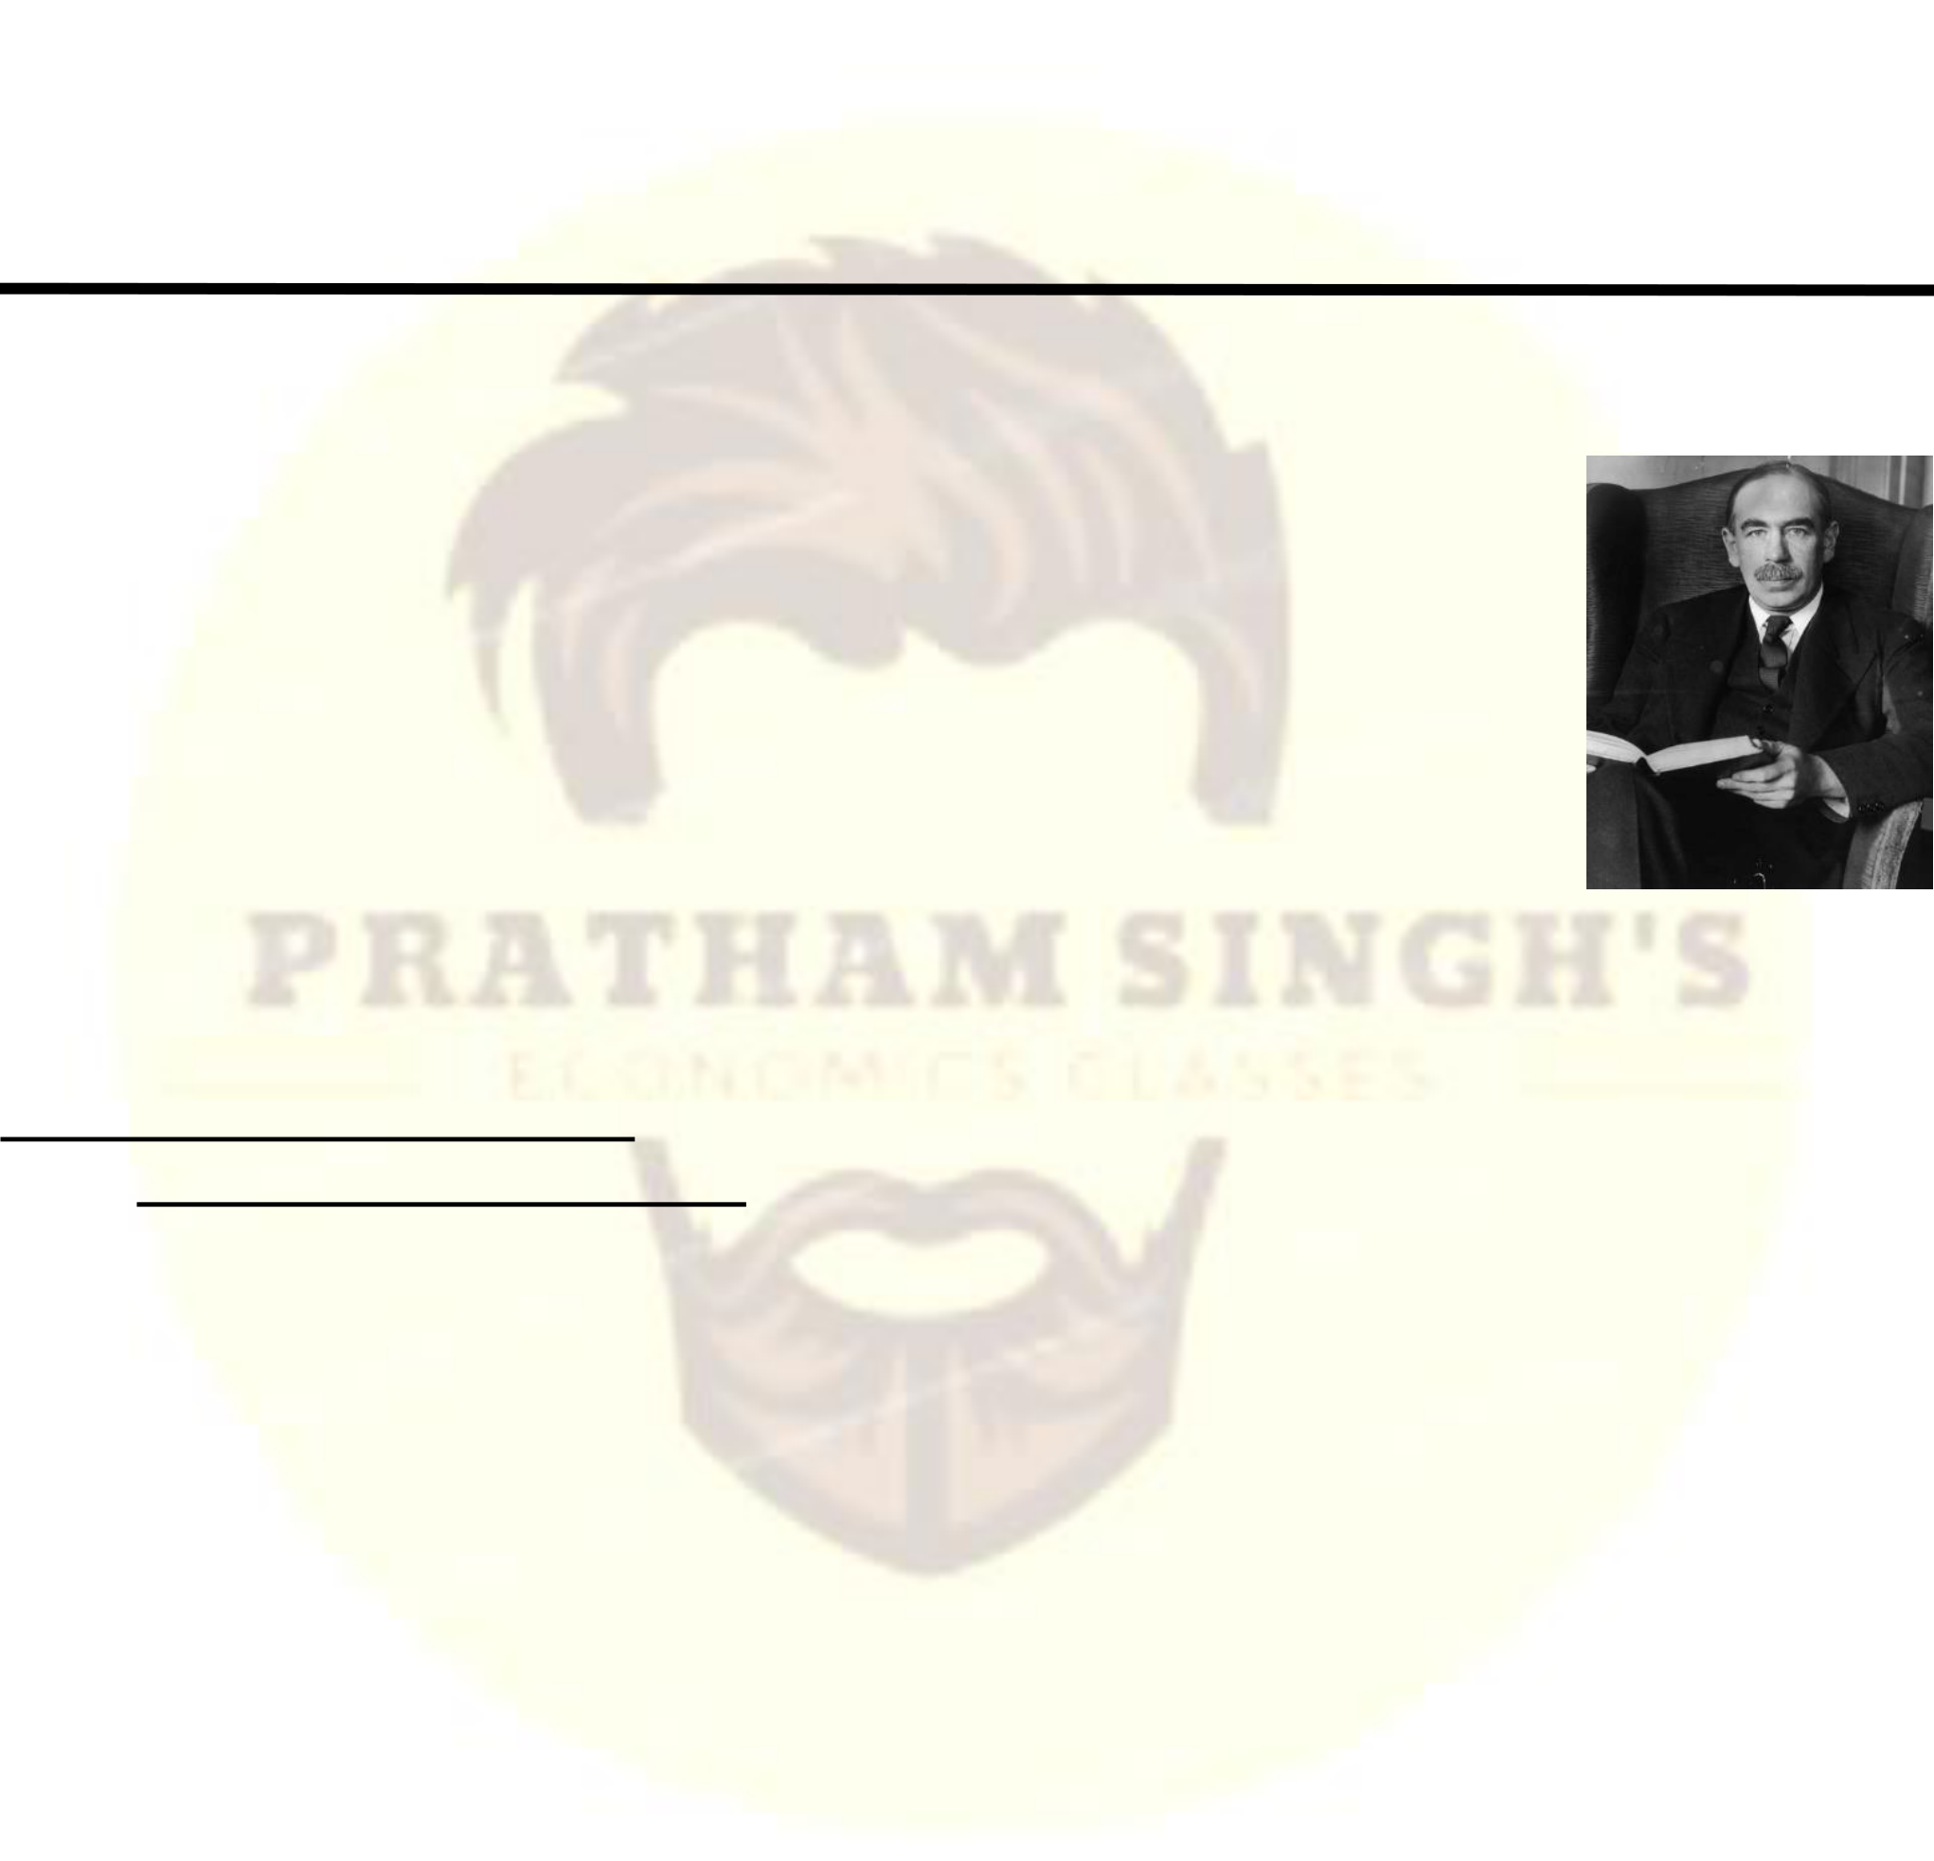

**Economics by Pratham Singh1**

**Macro - Economics**   
 **For**   
 **GE, B.Com (H/P), BA (H/P),**   
 **BBE, BA (Eco), B.Sc (GE)**   
 CHAPTER – 1   
Introduction to Macro Economics

**Q. What do you mean by Macroeconomics? And What are its Major Issue?** Ans: The term macro has been derived from the Greek word ‘makros’ meaning ‘large’. Macroeconomics has become more popular after the publication of J.M. Keynes ‘General Theory of Employment, Interest & Money’ in 1936.J.M. Keynes is regarded as the father of Macroeconomics. Macroeconomics is the study of the structure and performance of national economies and of the policies that governments use to try to affect economic performance. Macro economics is the study of aggregates but only at the level of economy as a whole. Thus, when we talk of demand in macroeconomics, we talk of aggregate demand,   
implying demand for all goods and services by all the sectors in the economy.

**Major Macroeconomics issues**   
 **1)Long Run Economic Growth**   
 Economic Growth implies the long-run growth of Income, Output and employment in an economy. The major indicators of economic growth are increase in real GDP and Per capita GDP (or Per capita Income) over a long period of time.

Economic growth is desired because it permits an increase in per capita income levels, raising standard of living, reduce poverty, increase human capital formation.

For instance, in 1870 per capita income was smaller in Norway than in Argentina. But today per capita income is three times high in Norway as in Argentina. India’s GDP has been growing since 1950 and it has been impressive since 1990s because of the New Economic Policy adopted by Indian Government.

The problem of growth can be solved only through macroeconomic knowledge. Thus, economic growth is a clear objective of macroeconomic policy of a nation.

**2)Business Cycle**   
The prices and output of an economy moves in a series of ups and downs. This situation is characterized by a term known as Trade Cycle or Business Cycle.

There are four phases of business cycle :

**Economics Classes for 11th, 12th, B.Com (H/P), BA (H/P), BBA, CA Foun., CSEET, CMA Foun., MA, MBA, UGC-NET Economics by Pratham Singh | 7011004544 (Call), 9643399334 (Whatsapp)**

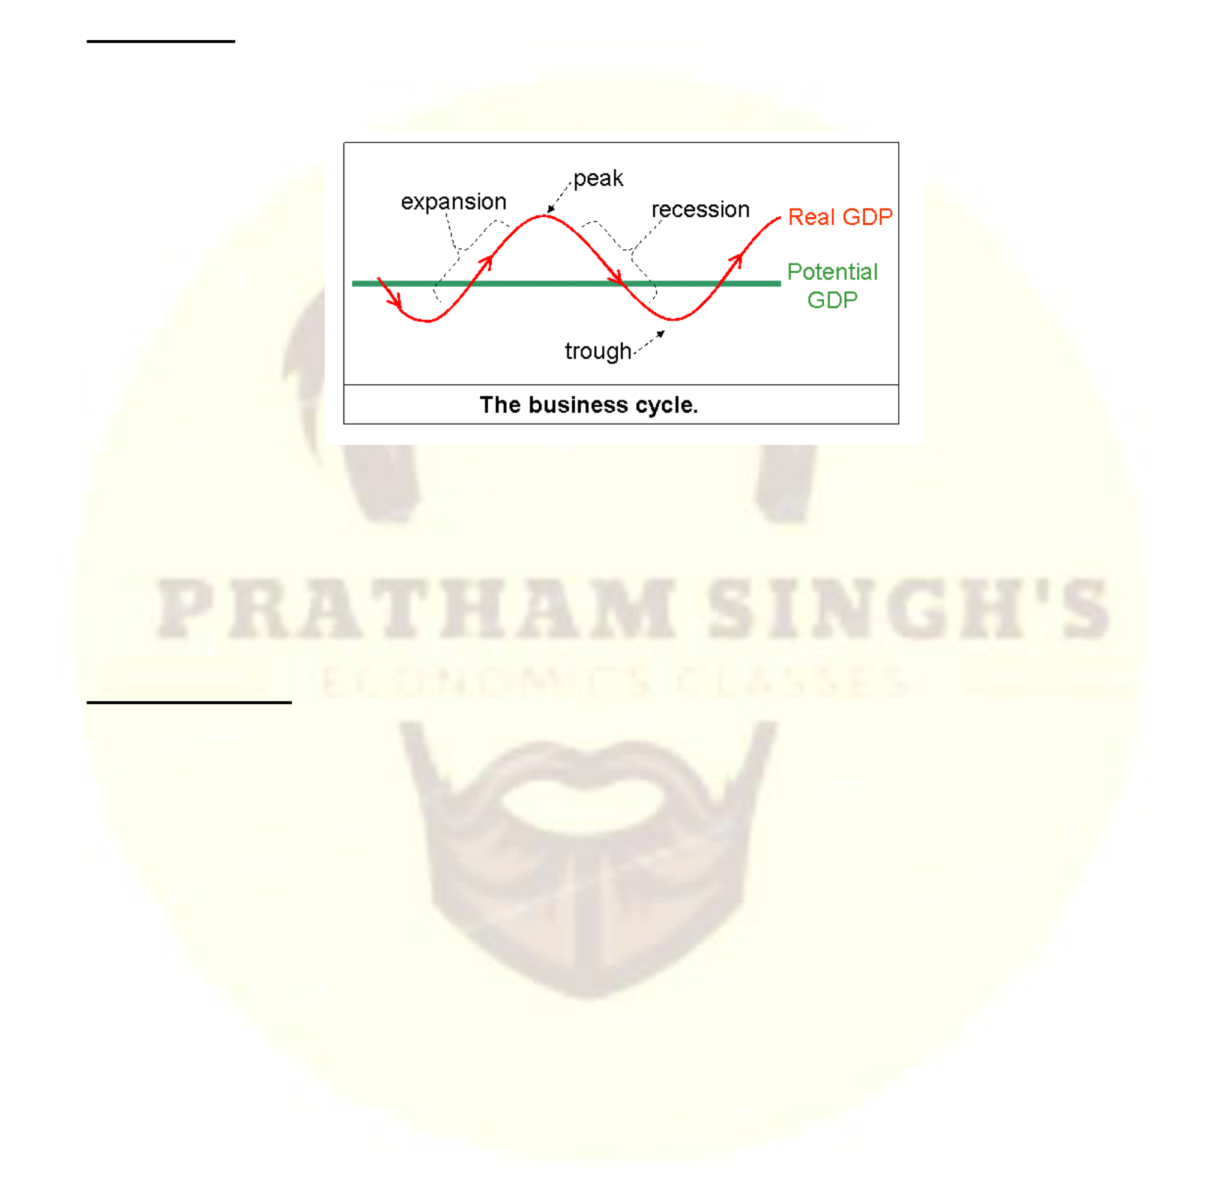

|  |
| --- |
| **Economics by Pratham Singh2**  a)**Trough (Depression) :** The characteristic of trough are High unemployment, low demand, low profits. It the bottom point is abnormally deep, it is called slump.  b)**Recovery :** The characteristics of recovery are, rise in employment, income, demand and consumer spending.  c)**Peak (Boom) :** Peak is the top of a business cycle. At this point, there are high level of employment, high demand, production capacity is utilized to a maximum level. The top of abnormally strong recovery is called a Boom.  d)**Recession :** A recession or contraction or downturn in economic activity is characterized by fall in real GDP, fall in demand, fall in production, employment and profit. A long lasting recession is called depression.  Potential GDP = It is a GDP when all resources are fully employed.  Controlling these phases of a business cycle is anther important task of the macroeconomics. Macroeconomics uses various methods to bring economic stability and economic growth in an economy.  **3)Unemployment**  Unemployment refers to the number of people who are available for work and are actively seeking work but cannot find jobs. Along with growth and business cycles, the problem of unemployment is a third major issue in macroeconomics.  The fluctuations in economic activities directly affect the level of employment in an economy. The development of macroeconomics was originally due to high rate of unemployment during 1930s. The highest and most prolonged period of unemployment occurred during the Great Depression of the 1930s. In 1933, the unemployment rate was 25%.  Macroeconomics is the off-spring of the problem of unemployment. Main method of reducing unemployment during 1930’s was the intervention of the government in economic activities.  Unemployment is not a feature of less developed countries like India. It is an equally important issue for developed countries like US or UK. Unemployment is a significant macroeconomic issue that concerns all economies of world. |
| |  | | --- | | **Economics Classes for 11th, 12th, B.Com (H/P), BA (H/P), BBA, CA Foun., CSEET, CMA Foun., MA, MBA, UGC-NET** |  |  | | --- | | **Economics by Pratham Singh | 7011004544 (Call), 9643399334 (Whatsapp)** | |



|  |
| --- |
| **Economics by Pratham Singh3**  **4)Inflation**  Inflation is a general rise in prices of almost all the commodities over a period of time. Value of money and purchasing power of people fall with inflation. Inflation affects people differently. C.N Vakil calls it an invisible robbery. Inflation must be controlled otherwise it will create a havoc in an economy (called Hyper Inflation). The study of macroeconomics helps us in controlling inflation. Fiscal Policy and Monetary Policy of Government controls the level of inflation in the economy.  The percentage increase in the average level of prices over a year is called the inflation rate. For example, If the inflation rate in consumer prices is 10%, then on average the prices of items that consumers buy are rising by 10% per year. Rates of inflation may vary, from 1 or 2 percent per year in low-inflation countries (such as Switzerland) to 1000%per year or more in countries (such as countries of former Soviet union in the early 1990s) that are experiencing hyperinflations, or extreme inflations.  **5)International Economy**  Macroeconomics also studies trade among different countries. International trade, tariff, protection, borrowing etc. have great significance in macroeconomics.  Today every major economy is an open economy, or one that has extensive trading and financial relationships with other national economies. (In contrast, a closed economy doesn't interact economically with the rest of the world.)  Macroeconomists study patterns of international trade and borrowing to understand better the links among national economies.  Trade deficit occurs when there is a excess of imports over exports. Trade surplus occurs when there is a excess of exports over imports. What causes these trade imbalances? Are they bad for the economy? These are among the questions that macroeconomists try to answer.  **6)Macroeconomic Policy**  Macroeconomic policies affect the performance of the economy as a whole. The two major types of macroeconomic policies are fiscal policy and monetary policy. Fiscal policy is the policy of government spending and taxation. Monetary policy determines the rate of growth of the nation's money supply and is under the control of the central bank. In the United States, the central bank is the Federal Reserve System, or the Fed. In India, it is RBI. According to Lipsey & Chrystal, “Monetary policy involves changing interest rates and money supply, in order to influence the economy. High interest rates are the symptoms of tight monetary policy. High interest rates lowers the demand in the economy, while low interest rates tend to stimulate demand”.  Thus the monetary policy and fiscal policy is the another issue of macroeconomics. |
| |  | | --- | | **Economics Classes for 11th, 12th, B.Com (H/P), BA (H/P), BBA, CA Foun., CSEET, CMA Foun., MA, MBA, UGC-NET** |  |  | | --- | | **Economics by Pratham Singh | 7011004544 (Call), 9643399334 (Whatsapp)** | |