Grading for this milestone:  
/1 Completed: Survey regarding substantial completion of this term  
/1 Participated: Online session  
/2 Login activity  
/2 Data visualization activity  
/2 Action control activity  
/1 Modified Code Files in Appendix  
/1 Link to Complete Code in Repository

**Login Activity**

This is the activity that enables our users to login to our app as well as also establish/recover user accounts upon clicking the appropriate buttons.

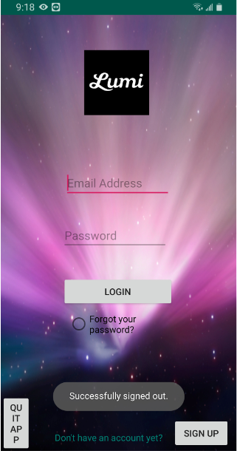

Figure 1. Login Activity

**Data visualization Activity**

After logging in to the app, the user is prompted to choose a menu option from a list of options. In the temperature and humidity section of the app, the user is displayed with a graph for both temperature and humidity recorded by the sensor supposedly, however at this point its retrieving values from firebase. The user is also displayed with a timestamp.

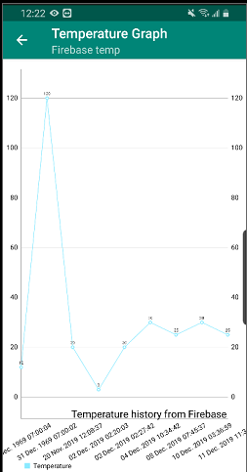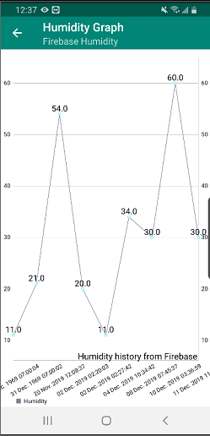

Figure 2. Temperature graph Figure 3. Humidity graph

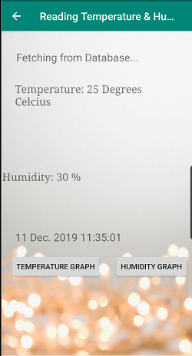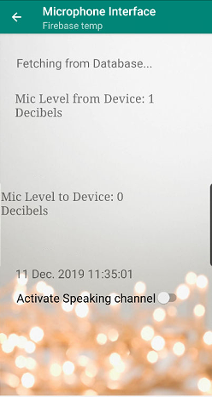

Figure 4. Displaying general readings Figure 5. Microphone readings

**Action control activity**

The app allows the user to also activate the microphone in order to talk to the baby by flipping a switch located in the communication options of the app. The user also has the option to customize a bunch of settings for the Neopixel LED strip through the light settings options. Some of the options include turning on the Neopixel manually through a switch and adjusting the brightness with the help of a seek bar.

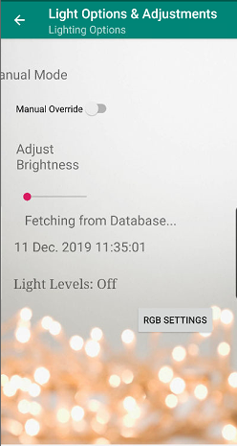

Figure 6. Light settings

The user also has the option of choosing a color for the LED ring by simply swiping on the color wheel located in the RGB settings. The values for the color chosen are displayed at the bottom in both Hex and Integer values corresponding to Red, Green and Blue. If the user taps in the middle of the wheel then it will default to white color setting.

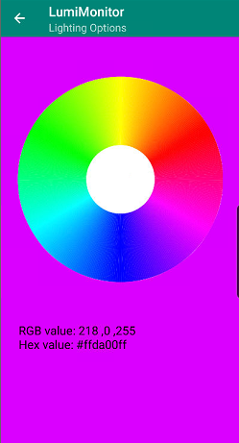

Figure 7. Color wheel

Furthermore, the user also has the option of leaving a feedback about the app and their comments through the last menu option.

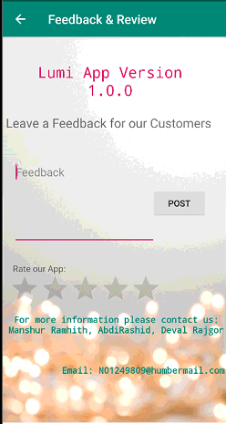

Figure 8. Feedback page

Finally, the user also has the option of writing to the database by clicking on a button located on the bottom of the menu screen. The user can enter values for temperature, humidity, lighting etc.

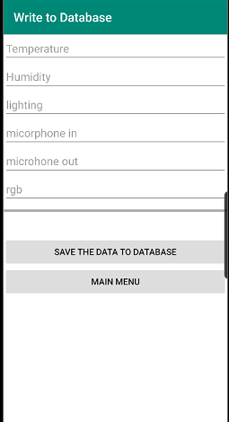

Figure 9. Add to database

Link to complete code in repository:

<https://github.com/Dev-109/LumiMonitor>

Modified code files in Appendix:

<https://github.com/Dev-109/LumiMonitor/blob/master/Documents/Report%20(2)%20(1).docx>