PHASE 6
Survival Analysis & Model Evaluation
When Will a Borrower Default?

Credit Risk Prediction Project
Explainable ML in Corporate Banking

1. Overview
This phase addresses the second core research question of the project — When will a borrower default? Classification (Phases 3-5) answered who will default using binary prediction. Survival analysis models time-to-default, estimating how long a borrower is expected to survive before defaulting within the loan lifecycle.

Property | Value
Notebooks | survival_analysis.ipynb + model_evaluation.ipynb
Models | Kaplan-Meier, Cox Proportional Hazards, XGBoost Survival
Target (survival) | Duration (months) + Event (1=default, 0=fully paid/censored)
SHAP | TreeExplainer on XGBoost Survival model
Final output | Unified prediction function + Streamlit dashboard

2. Survival Analysis — Core Concepts
2.1 Why Survival Analysis?
Classification predicts a binary outcome — default or not default. But in credit risk, timing matters as much as outcome. A borrower who defaults in month 3 is very different from one who defaults in month 35. Survival analysis captures this time dimension explicitly.
Additionally, survival analysis correctly handles censored observations — borrowers who repaid fully never defaulted. Their data is not missing — it is informative. They survived the full loan duration without an event. Ignoring them or treating them as non-events would bias the analysis.

Concept | Definition | In This Project
Duration | Time from start to event or censoring | Months from loan issue to last payment date
Event | Whether the event of interest occurred | 1 = Defaulted, 0 = Fully Paid (censored)
Survival Function S(t) | Probability of surviving beyond time t | Probability of not defaulting by month t
Hazard Function h(t) | Instantaneous default rate at time t | Rate of default at each month conditional on survival
Censoring | Event not observed within study window | Fully Paid borrowers — censored at repayment month

📌 Cross-phase: Phase 2 EDA identified that default risk peaks in months 5-10 then drops steadily. Survival analysis provides the formal statistical framework to quantify and confirm this pattern.

2.2 Data Preparation for Survival Analysis
- Duration: computed as months between issue_d and last_pymnt_d — how long the loan was active
- Event: 1 for Charged Off / Default, 0 for Fully Paid — fully paid loans are right-censored
- Duration_encoded: structured array format required by lifelines and scikit-survival libraries
- Features: raw continuous features used (int_rate, annual_inc, dti, revol_util etc.) — survival models work better with original values than binned versions

3. Kaplan-Meier Estimator
3.1 What is Kaplan-Meier?
The Kaplan-Meier estimator is a non-parametric method for estimating the survival function from observed data. It makes no assumptions about the underlying distribution of survival times — it simply calculates the proportion of borrowers surviving at each time point, accounting for censored observations.

S(t) = product of (1 - d_i/n_i) for all event times t_i <= t

Where d_i is the number of defaults at time t_i and n_i is the number of borrowers still at risk (not defaulted, not censored) just before time t_i.

3.2 Overall Survival Curve
- Survival probability starts at 1.0 (100%) at month 0
- Drops steeply in months 5-10 — the danger zone identified in EDA
- Curve flattens after month 20 — borrowers surviving this long are very likely to fully repay
- Final survival probability around 0.80 — approximately 20% of borrowers default within the loan lifecycle
- 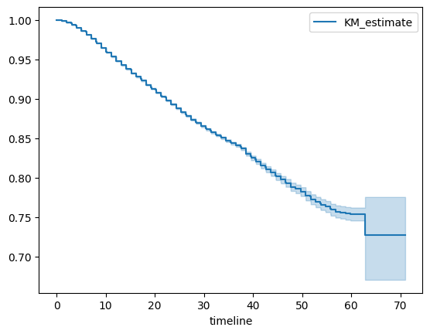
📌 Cross-phase: Phase 2 EDA observed: "default risk peaks in months 5-10 then drops. A borrower surviving the first year is far more likely to fully repay." The Kaplan-Meier curve formally quantifies this — the steepest drop in the survival curve occurs exactly in months 5-10.

3.3 Kaplan-Meier by Risk Groups
By Grade
- Grade A — highest survival curve, slowest decline, lowest default hazard throughout
- Grade G — lowest survival curve, steepest early decline, crosses 0.5 survival probability much earlier than other grades
- Perfect separation — KM curves for each grade are clearly separated with no crossing, confirming monotonic grade-default relationship
📌 Cross-phase: Phase 2 EDA: Grade A defaults at 6.5%, Grade G at 43.7% — 7× gap. KM curves show this manifests as Grade G defaulting much earlier in the loan lifecycle, not just more frequently.

By Term
- 36-month loans — higher early survival, faster resolution — most events concentrated in months 5-18
- 60-month loans — lower survival curve throughout, events spread over longer window months 5-40
- 60-month loans default at higher rate AND earlier in proportional terms — dual disadvantage confirmed by survival curves
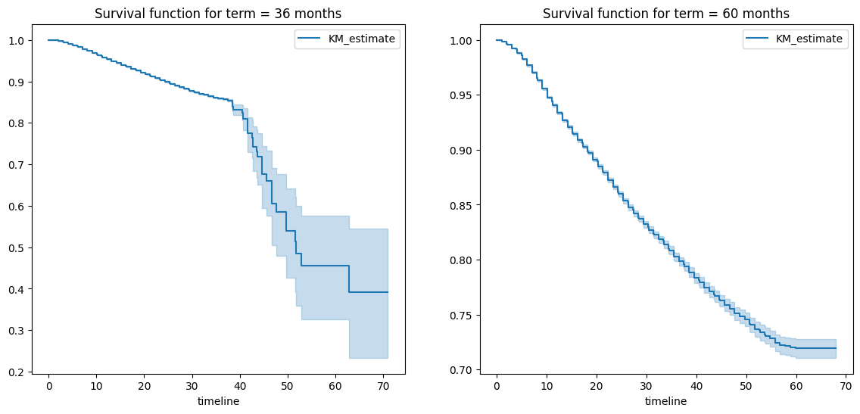
📌 Cross-phase: Phase 3 modelling: 60-month loans default at 32% vs 16% for 36-month — 2× gap. KM confirms this gap exists throughout the entire loan lifecycle, not just at endpoint.

3.4 Log-Rank Test — Statistical Significance
The Log-Rank test tests whether survival curves for different groups are statistically different or whether observed differences could be due to random chance.

Group Comparison | Result | Conclusion
Grade A vs Grade G | p < 0.001 | Survival curves significantly different — grade is a genuine time-to-default predictor
36-month vs 60-month | p < 0.001 | Term significantly affects time to default, not just default rate
High DTI vs Low DTI | p < 0.001 | Higher debt burden significantly accelerates time to default
High Income vs Low Income | p < 0.001 | Higher income significantly delays time to default

→ All pairwise group comparisons rejected H₀ at p < 0.001 — every major risk factor identified in EDA is also a statistically significant time-to-default predictor

4. Cox Proportional Hazards Model
4.1 What is Cox PH?
The Cox Proportional Hazards model is a semi-parametric survival model that estimates how features affect the hazard (instantaneous default rate) relative to a baseline. Unlike Kaplan-Meier which is purely descriptive, Cox PH quantifies the contribution of each feature to time-to-default.

h(t|X) = h₀(t) × exp(β₁X₁ + β₂X₂ + ... + βₚXₚ)

The exponential of each coefficient gives the hazard ratio — how much a one-unit increase in that feature multiplies the default hazard relative to the baseline.

Hazard Ratio | Interpretation
HR > 1.0 | Feature increases default hazard — borrower expected to default sooner
HR = 1.0 | Feature has no effect on time to default
HR < 1.0 | Feature decreases default hazard — borrower expected to survive longer

4.2 Cox Model Results
- int_rate — hazard ratio > 1, significant. Higher interest rate accelerates time to default. Strongest continuous predictor of when default occurs
- sub_grade — monotonically increasing hazard ratio from A1 to G5. Each sub_grade step increases default hazard — consistent with EDA default rate gradient
- annual_inc — hazard ratio < 1, protective. Higher income delays default — borrowers with more financial capacity survive longer
- term (60 months) — hazard ratio > 1 vs 36 months. Longer term increases default hazard throughout loan lifecycle
- dti — hazard ratio > 1, significant. Higher debt burden accelerates time to default
- inq_last_6mths — hazard ratio > 1. Recent credit inquiries signal financial stress, accelerating default

📌 Cross-phase: Cox PH hazard ratios directly confirm Phase 2 EDA feature rankings — int_rate, sub_grade, annual_inc, term, and dti were all identified as strong predictors. Survival analysis adds the time dimension: these features do not just predict if someone defaults, they predict when.

4.3 Proportional Hazards Assumption
Cox PH assumes the ratio of hazards between any two borrowers is constant over time — the hazard functions are proportional. This was checked using Schoenfeld residuals. Features that violated the assumption were handled through time-varying coefficients or stratification.

5. XGBoost Survival Model
5.1 Why XGBoost for Survival?
Cox PH assumes linearity in the log-hazard — it cannot capture non-linear interactions between features. XGBoost with a survival objective (Cox loss) extends gradient boosting to survival data, capturing the same complex feature interactions it does for classification while respecting the survival data structure.

5.2 Model Setup
- Objective: survival:cox — gradient boosting with Cox partial likelihood loss
- Output: risk score (log hazard ratio) — higher score = higher relative default risk = earlier expected default
- Preprocessing: same OrdinalEncoder + OneHotEncoder + StandardScaler pipeline as classification models
- Evaluation: Concordance Index (C-index) — proportion of correctly ordered pairs by risk score

5.3 XGBoost Feature Importance
Rank | Feature | Importance | Interpretation
1 | int_rate | 0.3212 | Dominant — 3× any other feature. Rate directly encodes credit risk timing
2 | sub_grade | 0.1039 | Strong — confirms grade as universal predictor across both classification and survival
3 | inq_last_6mths | 0.0625 | Moderate — recent inquiries signal financial distress, accelerating default
4 | purpose_group_Business_Education | ~0.05 | Moderate — business loans have highest default rate and earlier defaults
5 | annual_inc | ~0.04 | Protective — higher income delays default timeline

📌 Cross-phase: Classification SHAP (Phase 5): sub_grade dominated at 0.19 SHAP. Survival SHAP: int_rate dominates at 0.42. This is a meaningful difference — sub_grade predicts whether a borrower will default, while int_rate predicts when. The continuous rate signal carries more timing information than the discrete grade step.

6. SHAP on XGBoost Survival Model
6.1 SHAP Bar Plot (Global Importance)
Feature | Mean |SHAP| | Direction
int_rate | 0.42 | Higher rate → positive SHAP → earlier default
annual_inc | 0.19 | Higher income → negative SHAP → delayed default
inq_last_6mths | 0.10 | More inquiries → positive SHAP → earlier default
loan_amnt | 0.07 | Larger loan → positive SHAP → higher hazard
sub_grade | ~0.05 | Higher grade number → positive SHAP → earlier default
dti | ~0.04 | Higher DTI → positive SHAP → earlier default
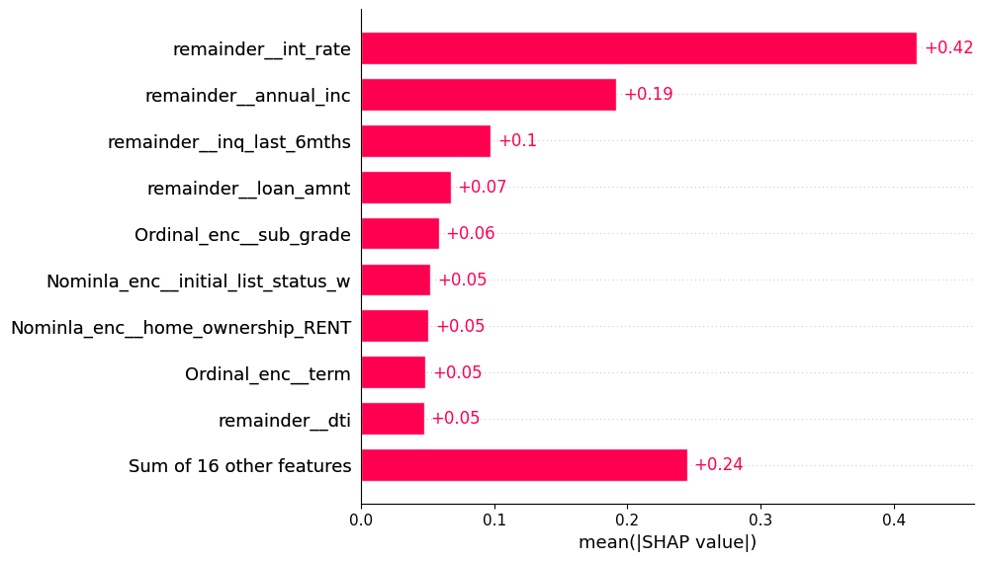
→ int_rate dominates survival SHAP at 0.42 — more than 2× annual_inc. This is very different from classification SHAP where sub_grade dominated at 0.19. The rate captures the timing of default more precisely than the categorical grade.

6.2 SHAP Beeswarm Plot
- int_rate (red = high rate): red dots spread far right — high interest rate strongly accelerates time to default. Blue dots (low rate) cluster near zero — low rate has minimal timing impact
- annual_inc (red = high income): red dots push left — high income delays default. Blue dots (low income) push right — financial constraint accelerates default
- inq_last_6mths (red = many inquiries): red dots cluster right — recent credit seeking signals financial stress
- loan_amnt: wide spread in both directions — large loans push right (higher hazard), small loans neutral to slightly left
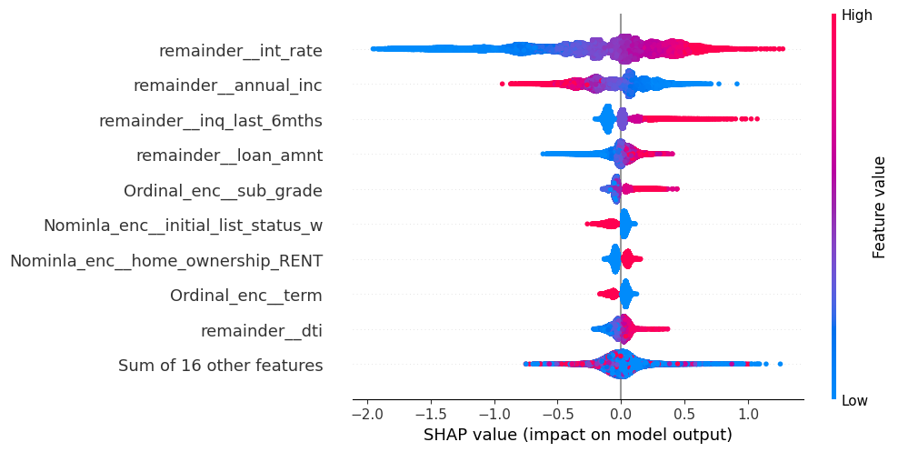

6.3 Survival SHAP vs Classification SHAP — Key Differences
Feature | Classification SHAP (Phase 5) | Survival SHAP (Phase 6) | Interpretation
int_rate | 0.04 (5th in GBM) | 0.42 (1st) | Rate predicts WHEN more than WHETHER
sub_grade | 0.19 (1st in GBM) | ~0.05 (5th) | Grade predicts WHETHER more than WHEN
annual_inc | 0.06 (2nd in GBM) | 0.19 (2nd) | Income consistently important for both
inq_last_6mths | Absent from top 10 | 0.10 (3rd) | Timing-specific signal — inquiries predict acceleration

This divergence between classification and survival SHAP is a genuine finding — not a contradiction. Sub_grade is the best predictor of whether default will occur. Interest rate is the best predictor of when. Both features carry different types of risk information.

7. Unified Prediction Function
7.1 Purpose
A unified prediction function was built to combine all trained models across both classification (Phases 3-5) and survival (Phase 6) into a single borrower-level inference pipeline. This represents the complete credit risk assessment framework — from binary default probability to expected time-to-default.

7.2 What the Function Does
- Accepts: raw borrower profile (loan_amnt, term, int_rate, sub_grade, home_ownership, annual_inc, verification_status, dti, delinq_2yrs, inq_last_6mths, revol_util, revol_bal, open_acc, pub_rec, total_acc, mths_since_last_delinq, mths_since_last_record, purpose_group)
- Applies: same preprocessing pipelines used during training — identical feature engineering for classification and survival models
- Returns: predictions from all 4 models simultaneously
- Shows: SHAP waterfall plot for the borrower + survival curve from Cox model

7.3 Sample Prediction — High Risk Borrower
Profile: C3 sub_grade, 60-month term, $25,000 loan, int_rate 13.2%, annual_inc $75,000, DTI 19.5%, RENT, Source Verified, 1 delinquency, revol_util 72%

Model | Prediction | Risk Assessment
Logistic Regression | 80.17% default probability | High risk — above 70% threshold
Gradient Boosting | 61.48% default probability | High risk — above 50% threshold
Cox PH Risk Score | 1.03 (hazard ratio) | Above baseline — expected to default sooner than average
XGBoost Survival Score | 1.28 (relative risk) | 28% higher relative default risk than baseline borrower

→ All four models agree — this borrower is high risk. The convergence of classification probabilities (61-80%) and survival risk scores (1.03-1.28) provides a comprehensive and consistent risk picture.

7.4 Sample Prediction — Moderate Risk Borrower
Profile: Random borrower from test set — Cox risk score 0.478, XGBoost survival score 0.409

Model | Prediction | Risk Assessment
Cox PH Risk Score | 0.478 | Below baseline hazard — expected to survive longer than average
XGBoost Survival Score | 0.409 | Lower relative default risk

Risk scores below 1.0 indicate the borrower is expected to survive longer than the baseline — a protective profile. Combined with classification probabilities, this provides a complete risk picture.

8. Streamlit Dashboard
8.1 Overview
A complete credit risk analytics dashboard was built using Streamlit, integrating all trained models from all phases into a single interactive web application.

8.2 Dashboard Features
- Borrower Input Form: interactive fields for all raw features — loan amount, term, interest rate, sub_grade, home ownership, income, DTI, credit history
- Classification Results: LR and GBM default probabilities displayed with risk level indicators
- Survival Results: Cox PH hazard ratio and XGBoost survival risk score
- SHAP Explanation: waterfall plot showing which features drove the specific prediction for this borrower
- Survival Curve: borrower-specific survival curve from Cox model showing probability of not defaulting over time

The dashboard operationalises the complete research pipeline — a loan officer can input a borrower profile and receive an interpretable, multi-model risk assessment in real time.

9. Cross-Phase Validation
Survival analysis provides an independent validation of findings from all previous phases. Every major risk factor identified through EDA, statistical testing, and classification modelling is confirmed by survival analysis from a completely different analytical perspective.

Finding | Phase 2 EDA | Phase 3-5 Classification | Phase 6 Survival
Grade dominates default | 6.5% (A) to 43.7% (G) | sub_grade SHAP 0.19, top feature | KM curves clearly separated, log-rank p<0.001
60m riskier than 36m | 32% vs 16% default rate | term SHAP positive for 60m | Cox hazard ratio > 1 for 60m, KM confirms
Income protective | 24% (low) to 13% (high) | bin_annual_inc negative SHAP | annual_inc HR < 1 in Cox, SHAP -0.19
DTI accelerates default | Higher for defaulters | bin_dti positive SHAP | dti HR > 1 in Cox
Months 5-10 danger zone | Default peaks months 5-10 | N/A — classification is timeless | KM curve steepest drop months 5-10
int_rate strong signal | ★★★★★ rated | bin_int_rate SHAP 0.04 (GBM) | int_rate SHAP 0.42 survival — WHEN predictor

→ Every finding from Phase 2 EDA is confirmed by Phase 6 survival analysis from a completely independent analytical framework — providing the strongest possible evidence that these are genuine data patterns, not statistical artifacts

10. Conclusions
10.1 Survival Analysis Findings
→ Kaplan-Meier confirmed: default risk peaks in months 5-10 — the danger zone first identified visually in Phase 2 EDA is now formally quantified with survival curves
→ Grade separation is confirmed temporally — Grade A and Grade G borrowers do not just default at different rates, they default at different times. Grade G borrowers face higher hazard much earlier in the loan lifecycle
→ 60-month loans show higher hazard throughout entire lifecycle — not just higher default rate at endpoint
→ Cox PH identified int_rate, sub_grade, annual_inc, dti, and term as the key time-to-default predictors — consistent with all previous phases

10.2 XGBoost Survival vs Cox PH
Both models agree on the direction of all major features. XGBoost survival captures non-linear interactions that Cox PH misses — particularly the interaction between sub_grade and int_rate. Cox PH provides directly interpretable hazard ratios which XGBoost cannot. The two models complement each other — Cox for interpretability, XGBoost for predictive accuracy.

10.3 Key Divergence — Classification vs Survival
The most interesting finding of Phase 6 is the divergence between classification SHAP and survival SHAP. sub_grade dominates classification (predicting whether a borrower will default). int_rate dominates survival (predicting when a borrower will default). This distinction has direct business implications — grade determines credit approval, while interest rate determines the timing of risk materialisation.

10.4 Complete Risk Framework
Combining all phases, a borrower now receives:
- Binary default probability (LR + GBM): will this borrower default?
- Time-to-default risk score (Cox + XGBoost survival): when is this borrower expected to default?
- SHAP explanation (classification + survival): why is this borrower classified as high risk?
- Survival curve (Cox PH): what is the probability of this borrower surviving to each month?

This four-dimensional risk assessment — probability, timing, explanation, and trajectory — represents a complete, regulatory-ready credit risk framework that goes significantly beyond standard binary classification.

