PHASE 2
Exploratory Data Analysis
Lending Club Loan Dataset | 2007 – 2014

Credit Risk Prediction Project
Explainable ML in Corporate Banking

1. Overview
This report documents the exploratory data analysis performed on the cleaned Lending Club loan dataset (230,288 resolved loans). Each feature was analysed through distribution plots, default rate comparisons, and correlation analysis to identify its predictive strength before modelling.

Property | Value
Dataset | Lending Club Loan Data — 2007 to 2014
Records | 230,288 resolved loans (Fully Paid + Charged Off)
Target variable | loan_status — Defaulter (1) vs Not Defaulter (0)
Class split | 81% Not Defaulter | 19% Defaulter
Features analysed | Loan details, borrower profile, credit history, time features

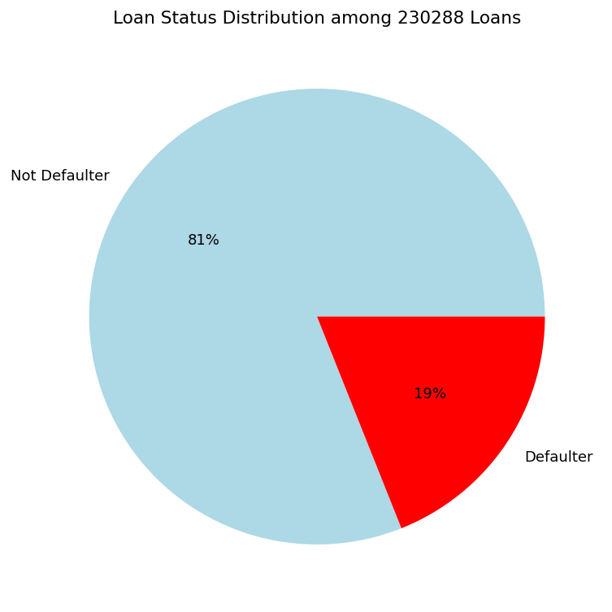
Figure 1: Target variable split — 19% Defaulter vs 81% Not Defaulter
2. Loan Amount
Loan amount ranges from $500 to $35,000, with a mean of $13,418 and median of $12,000. The distribution is right-skewed with notable peaks at round numbers ($5,000, $10,000, $15,000, $20,000, $35,000), indicating loans are sanctioned in predefined amounts rather than arbitrary values.

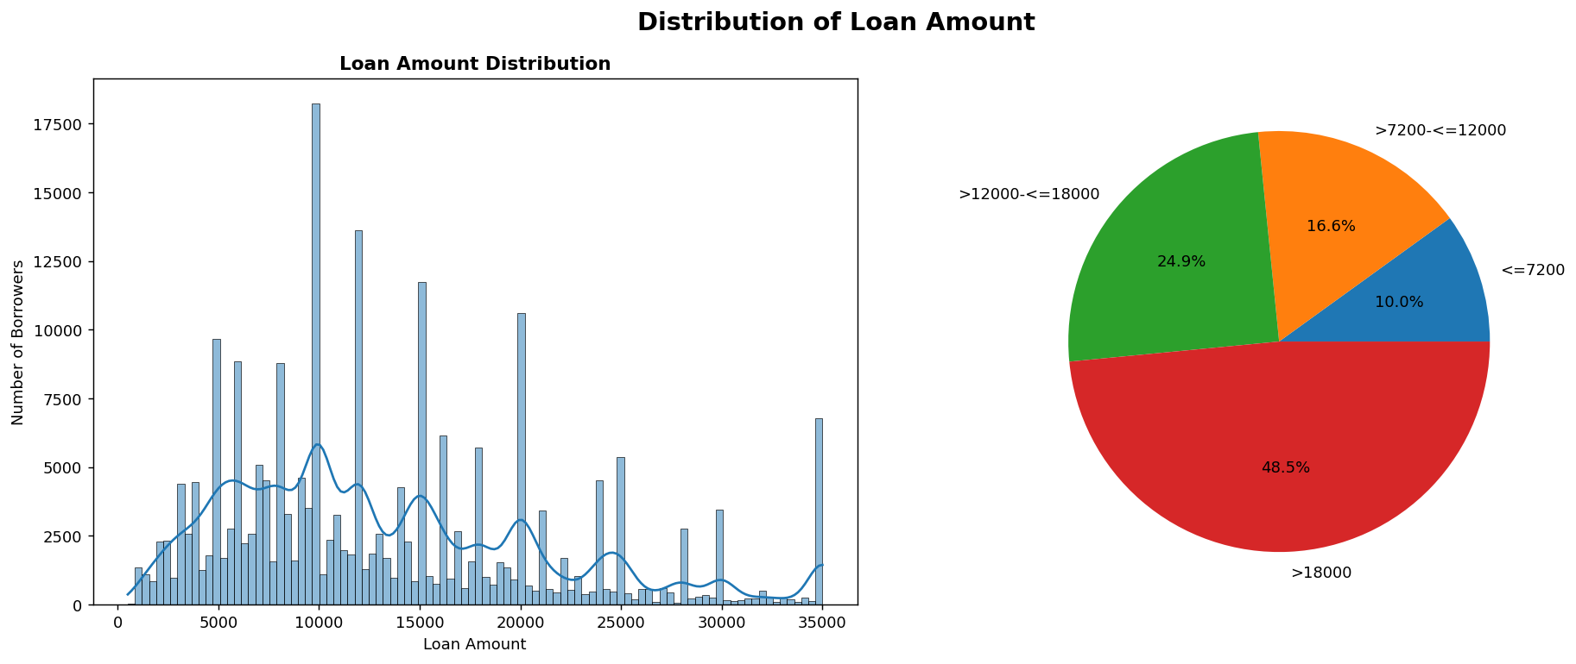
Figure 2: Loan amount distribution (histogram + quartile breakdown)

Bracket | Default Rate | Signal Strength
< $10,000 | 16.7% | Lowest risk
$10,000 – $20,000 | 19.6% | Moderate
$20,000 – $30,000 | 23.0% | Higher risk
$30,000+ | 24.4% | Highest risk

Defaulters have a slightly higher average funded amount ($14,426) compared to non-defaulters ($13,124), but distributions overlap substantially — loan amount is a weak standalone predictor.
3. Loan Term
78.6% of loans are on a 36-month term and 21.4% on a 60-month term. Despite the imbalance, term is one of the strongest predictors identified — 60-month loans default at nearly twice the rate of 36-month loans.

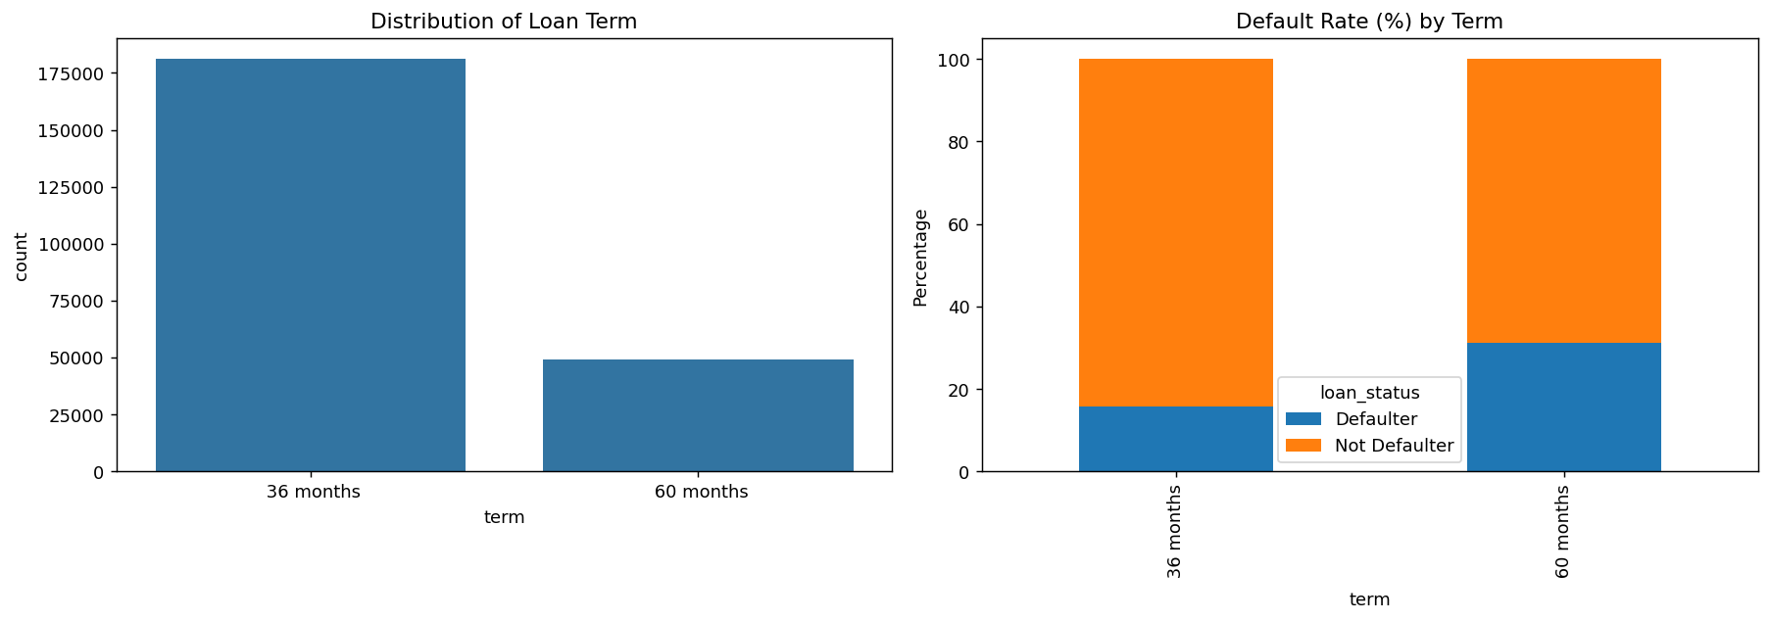
Figure 3: Term distribution and default rate by term

Term | Default Rate | Relative Risk
36 months | ~16% | Baseline
60 months | ~32% | 2× higher risk
4. Interest Rate
Interest rate ranges from 5.42% to 26.06% (mean: 13.78%). The distribution shows distinct peaks corresponding to sub-grade rate tiers rather than a smooth continuum. This is the clearest continuous separator between defaulters and non-defaulters identified in the entire EDA.

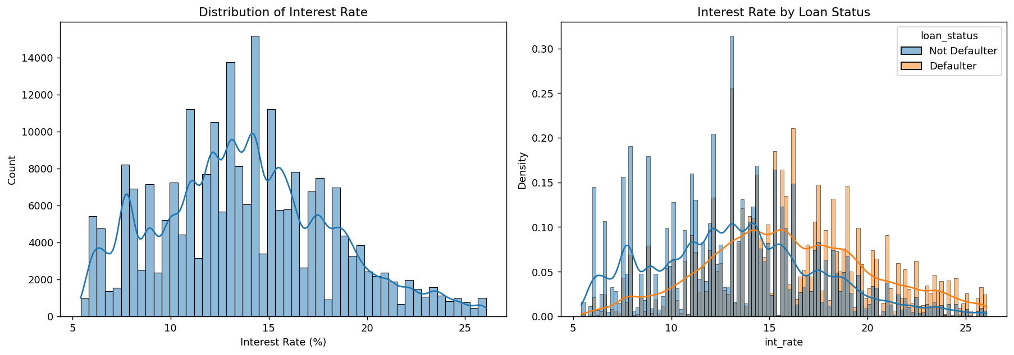
Figure 4: Interest rate distribution (overall and by loan status)

Non-defaulters concentrate at 8–13% while defaulters shift notably higher to 14–20%+, with defaulters dominating beyond 20%. Interest rate encodes the same underlying risk as grade but in continuous form — both features effectively capture the platform's own credit assessment.
5. Grade & Sub-Grade
Grade is the single strongest predictor in the dataset. Default rate rises perfectly from 6.5% (Grade A) to 43.7% (Grade G) — a 7× increase — with not a single exception across all 7 grades or all 35 sub-grades.

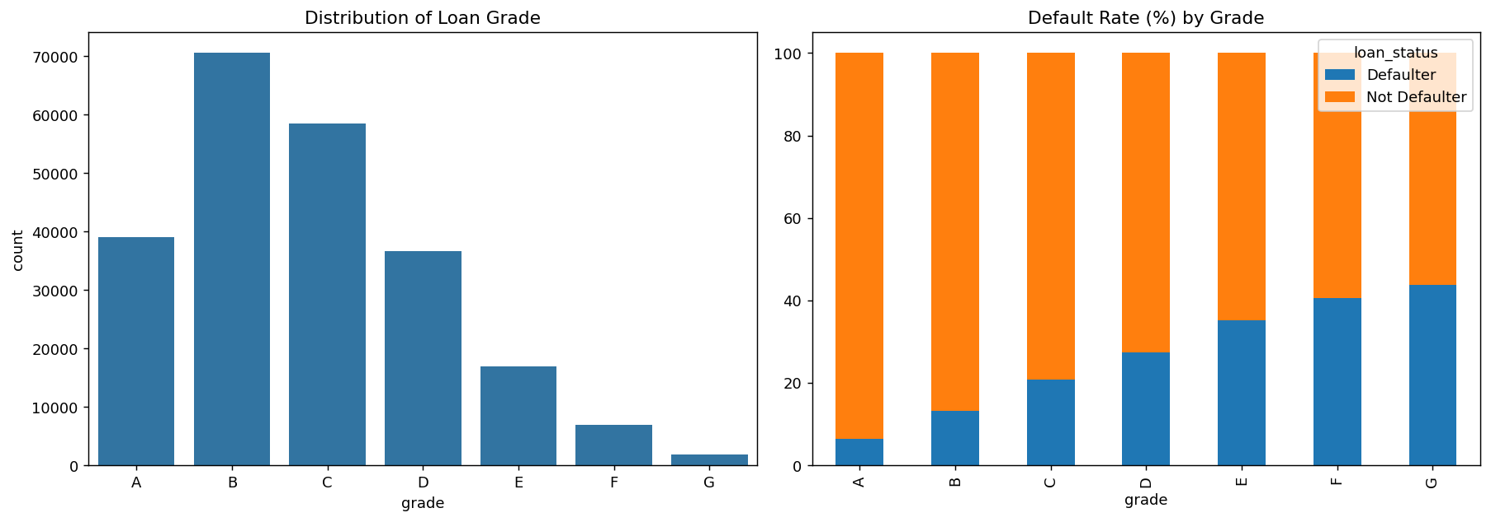
Figure 5: Grade distribution and default rate by grade

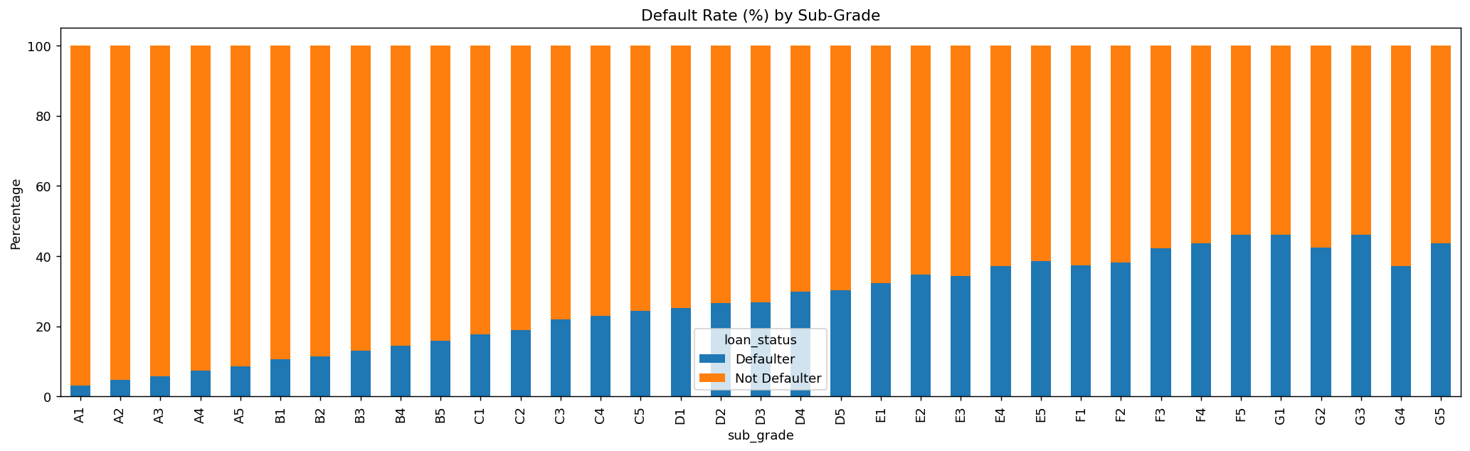
Figure 6: Default rate by sub-grade — near-perfectly monotonic from A1 to G5

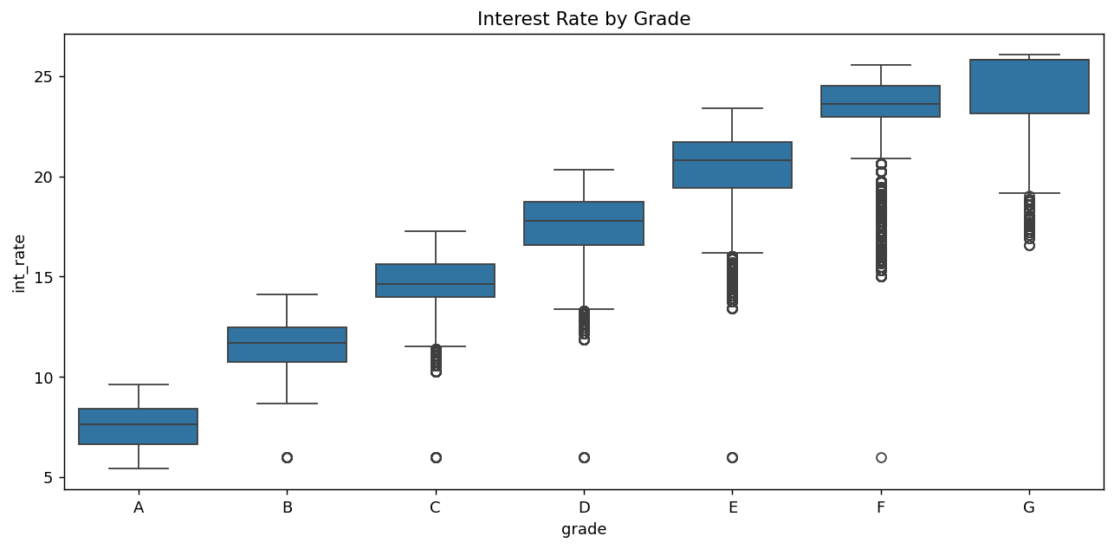
Figure 7: Interest rate by grade — near non-overlapping rate bands from A to F

Grade | Default Rate | Grade | Default Rate
A | 6.50% | E | 35.12%
B | 13.22% | F | 40.62%
C | 20.90% | G | 43.73%
D | 27.45% | — | —

Interest rate increases in near-lockstep with grade — the two features encode the same risk signal from different angles. Sub-grade refines this into 35 finer categories with equally clean monotonic behaviour.
6. Employment Length
Employment length shows no meaningful relationship with default risk. Every category from "< 1 year" to "10+ years" produces a default rate hovering between 18–20%, with no monotonic trend and no separation between groups. This is one of the weakest features in the dataset.

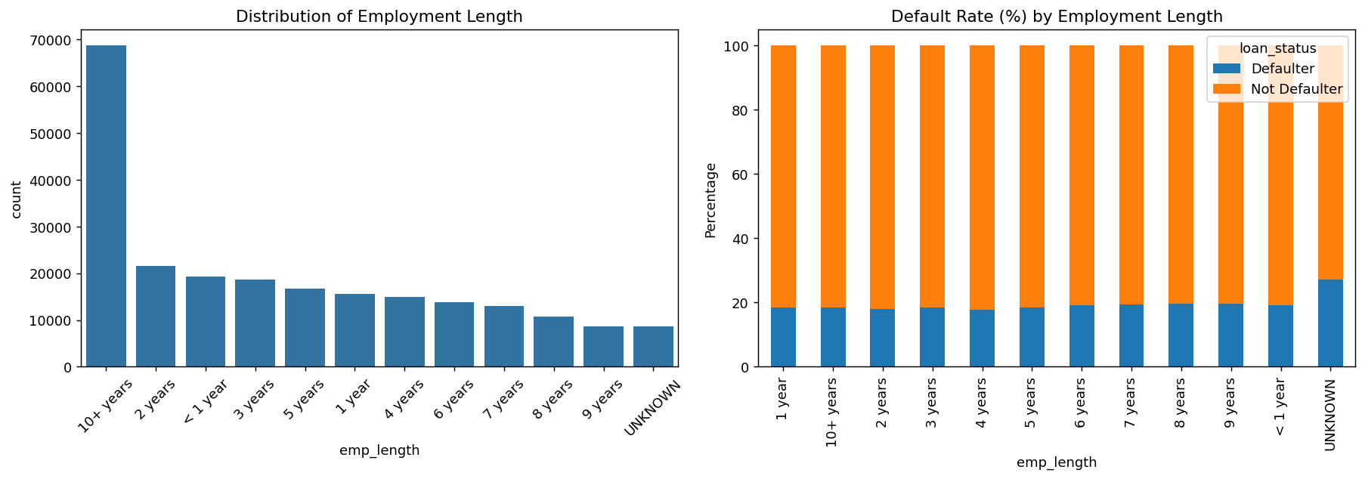
Figure 8: Employment length distribution and default rate — flat across all categories

The only exception is the UNKNOWN category (27.1% default rate), representing borrowers whose employment is unverifiable. This single category was retained as a binary flag (emp_status_unverifiable) for modelling while the rest of emp_length was effectively discarded.
7. Home Ownership
The rare categories OTHER, NONE, and ANY were merged into UNSPECIFIED (~0.1% of data) to reduce noise. Mortgage holders default least frequently while renters default most — a 3–4 percentage point range across categories.

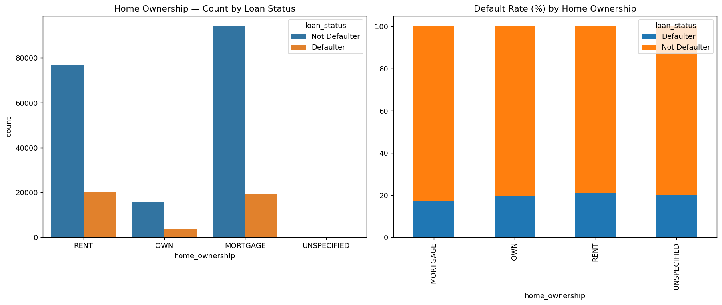
Figure 9: Home ownership count and default rate by category

Category | Default Rate
MORTGAGE | 17.09%
OWN | 19.75%
RENT | 20.99%
UNSPECIFIED | 20.18%

While the signal exists, the 3.9 percentage point gap between mortgage and rent is modest compared to grade (37.2pp gap). Home ownership is a moderate predictor — useful as a supporting feature but not dominant.
8. Annual Income
Annual income is highly right-skewed (mean $73,283 vs median $63,000), with the distribution normalising substantially after log-transformation. A clear negative gradient exists — higher income consistently predicts lower default risk.

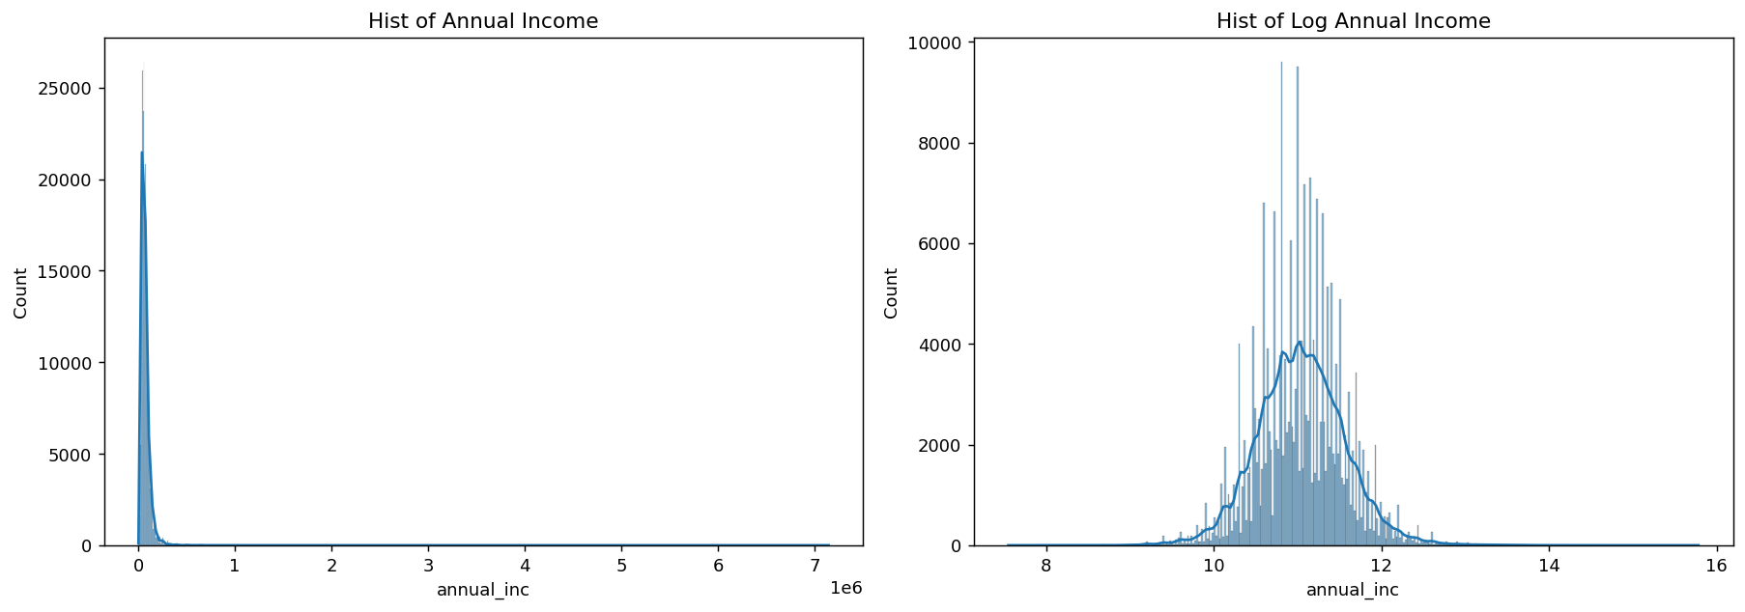
Figure 10: Annual income distribution (raw and log-transformed)

Income Bracket | Default Rate
< $40,000 | 24.05%
$40,000 – $80,000 | 19.61%
$80,000 – $120,000 | 14.91%
> $120,000 | 13.16%
9. Loan Purpose
The original 13 purpose categories were grouped into 5 business-oriented groups to reduce noise and improve model stability. Business & Education carries the highest default risk while Vehicle & Major Purchases carries the lowest.

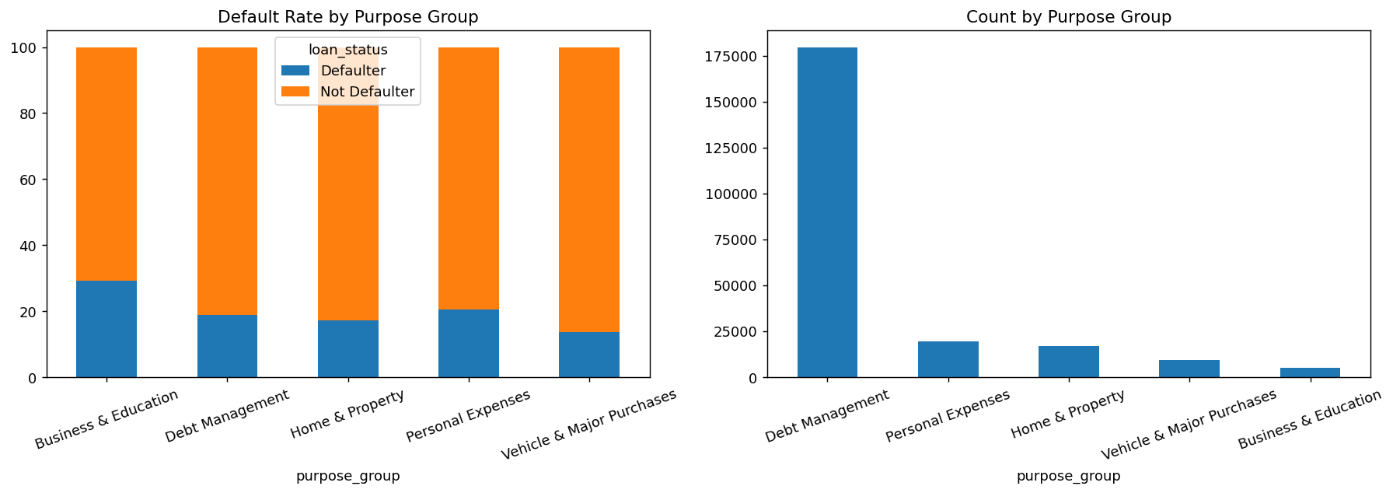
Figure 11: Default rate and count by purpose group

Purpose Group | Default Rate
Business & Education | 28.66%
Personal Expenses | 20.48%
Debt Management | 18.95%
Home & Property | 17.25%
Vehicle & Major Purchases | 13.56%
10. Debt-to-Income Ratio (DTI)
DTI shows a consistent and statistically significant difference between defaulters and non-defaulters across all loan purpose subgroups. Defaulters carry higher DTI in every single subgroup (Z-test p-value = 0.0 for all groups).

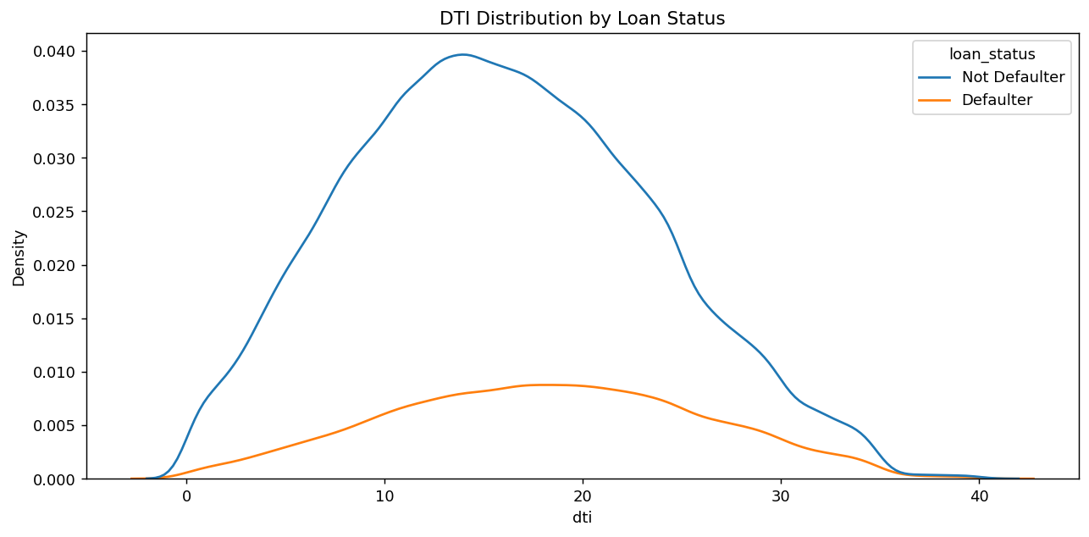
Figure 12: DTI distribution by loan status — defaulters shifted right

Group | Mean DTI — Defaulter | Mean DTI — Not Defaulter
Overall | 18.19 | 15.92
Debt Management | 18.95 | 16.66
Business & Education | 13.78 | 11.41
Vehicle & Major Purchases | 14.23 | 11.87

DTI has low correlation with other features (max r = 0.31 with open_acc), confirming it provides largely independent predictive signal — an important characteristic for feature selection.
11. Delinquencies in Last 2 Years
84.2% of borrowers have zero delinquencies. The raw count variable is extremely right-skewed with unreliable sparsity beyond 3 delinquencies. When collapsed to a binary flag, the signal is weak but present.

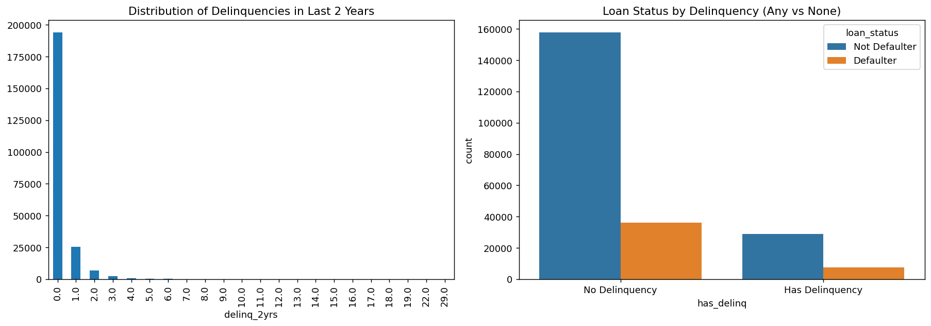
Figure 13: Delinquency distribution and loan status by binary flag

Group | Default Rate
No delinquency (0) | 18.67%
Has any delinquency (1+) | 20.50%

A difference of less than 2 percentage points confirms delinq_2yrs is one of the weakest predictors in the dataset. It is retained only as a binary flag (has_delinq) — the raw count adds noise rather than signal.
12. Revolving Balance
Revolving balance shows essentially no relationship with default status. Mean balances are nearly identical between defaulters ($15,170) and non-defaulters ($15,244), and even after log-transformation the distributions remain indistinguishable.

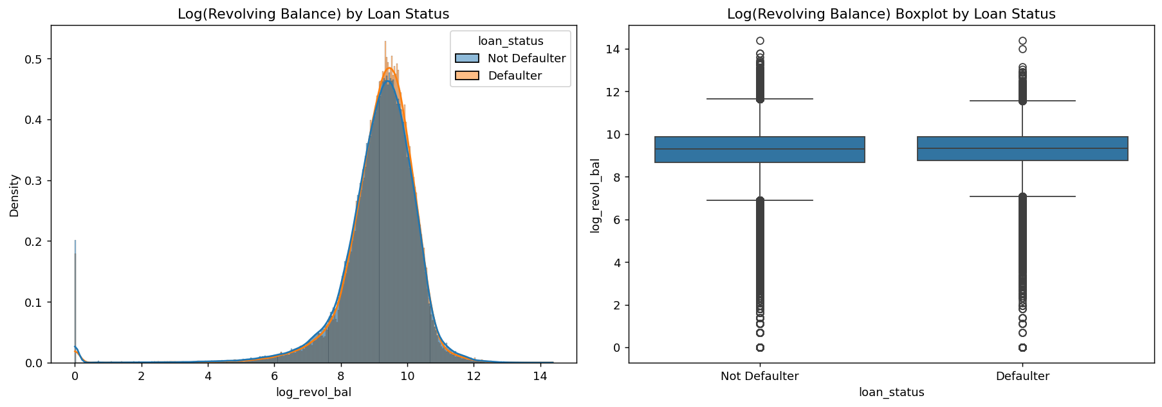
Figure 14: Log(revolving balance) — identical distributions for both groups

Correlation between revol_bal and revol_util is only 0.22 — they capture entirely different dimensions of credit usage. Revolving balance without context on credit limit is meaningless; revolving utilization (the ratio) is what carries genuine credit stress signal. revol_bal was dropped from modelling entirely.
13. Revolving Utilization
Revolving utilization is a pre-loan characteristic captured from the borrower's credit bureau at application time — it measures how much of the available credit limit was already being used before a single rupee was disbursed. This makes it a genuine pre-loan risk indicator with no data leakage concerns.

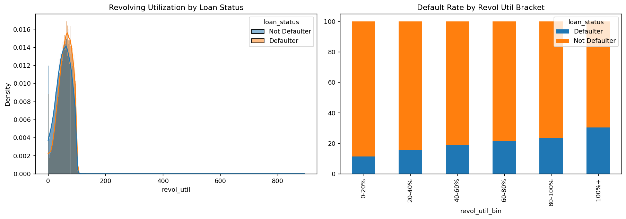
Figure 15: Revolving utilization by loan status and default rate by bracket

Utilization Bracket | Default Rate
0–20% | 11.26%
20–40% | 15.47%
40–60% | 18.73%
60–80% | 21.20%
80–100% | 23.58%
100%+ | 30.30%

A perfectly monotonic increase from 11.26% to 30.30% — nearly a 3× increase in default risk across the utilization range. One extreme outlier at 892.3% was identified as a likely data quality error and flagged for treatment.
14. Open Credit Accounts
Number of open accounts has minimal predictive power on its own. Mean values are nearly identical (11.02 for defaulters vs 10.79 for non-defaulters). A mild binned trend exists but the range is small.

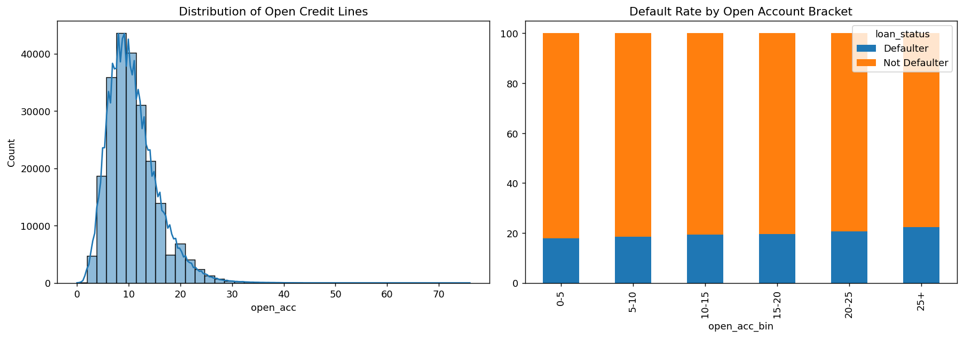
Figure 16: Open account distribution and default rate by bracket

Default rate rises from 17.88% (0-5 accounts) to 22.40% (25+ accounts) — a 4.5 percentage point range. This is a real but weak signal compared to grade (37pp) or revol_util (19pp).
15. Total Accounts
Total accounts (all credit accounts ever opened) shows a mild negative relationship with default — more credit history is marginally associated with lower default risk. Most borrowers have 15–30 total accounts.

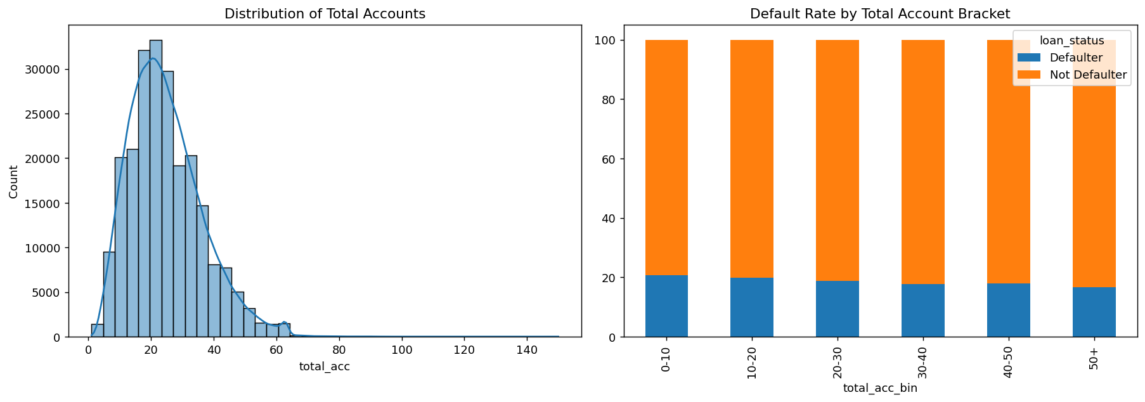
Figure 17: Total account distribution and default rate by bracket

Bracket | Default Rate
0–10 | 20.78%
10–20 | 19.86%
20–30 | 18.73%
30–40 | 18.30%
40–50 | 17.56%
50+ | 16.65%
16. Public Records
87.5% of borrowers have zero public derogatory records. When collapsed to a binary flag the difference in default rate is less than 1 percentage point — confirming public records are among the weakest predictors in this dataset.

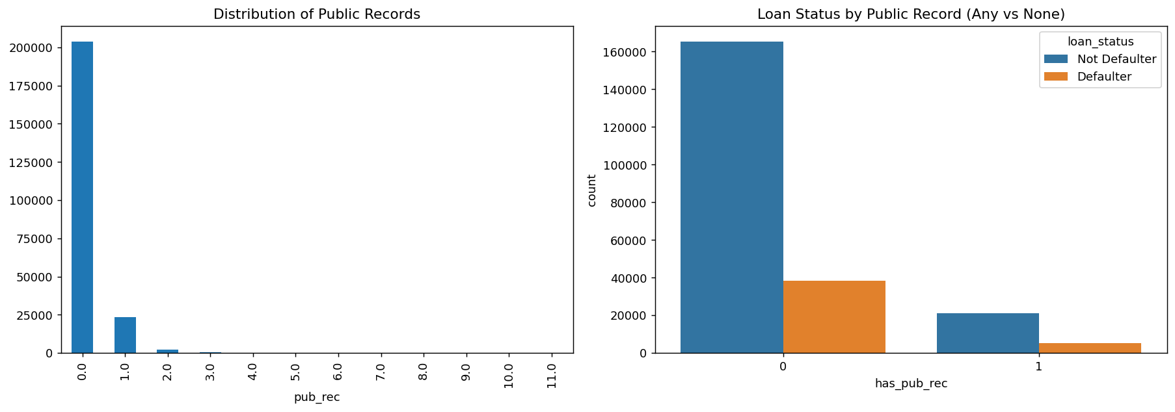
Figure 18: Public record distribution and loan status by binary flag

Group | Default Rate
No public record (0) | 18.86%
Has public record (1+) | 19.74%
17. Loan Issuance Trend & Default by Tenure
17.1 Issuance Trend
Loan issuances show a strong upward trend from 2007 to 2014, with acceleration from 2012 onward during a platform expansion period. Critically, the proportion of defaulters did not increase alongside total volume — defaults rose proportionally, confirming consistent underwriting quality throughout the period.

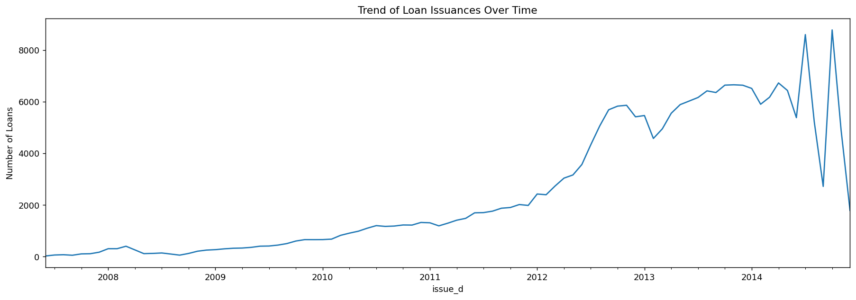
Figure 19: Total loan issuances over time (2007–2014)

17.2 Default Risk by Loan Tenure
This is one of the most important time-based findings of the entire EDA. Default risk is not uniform across the loan lifecycle — it peaks sharply in the early months and then declines steadily as borrowers continue making payments.

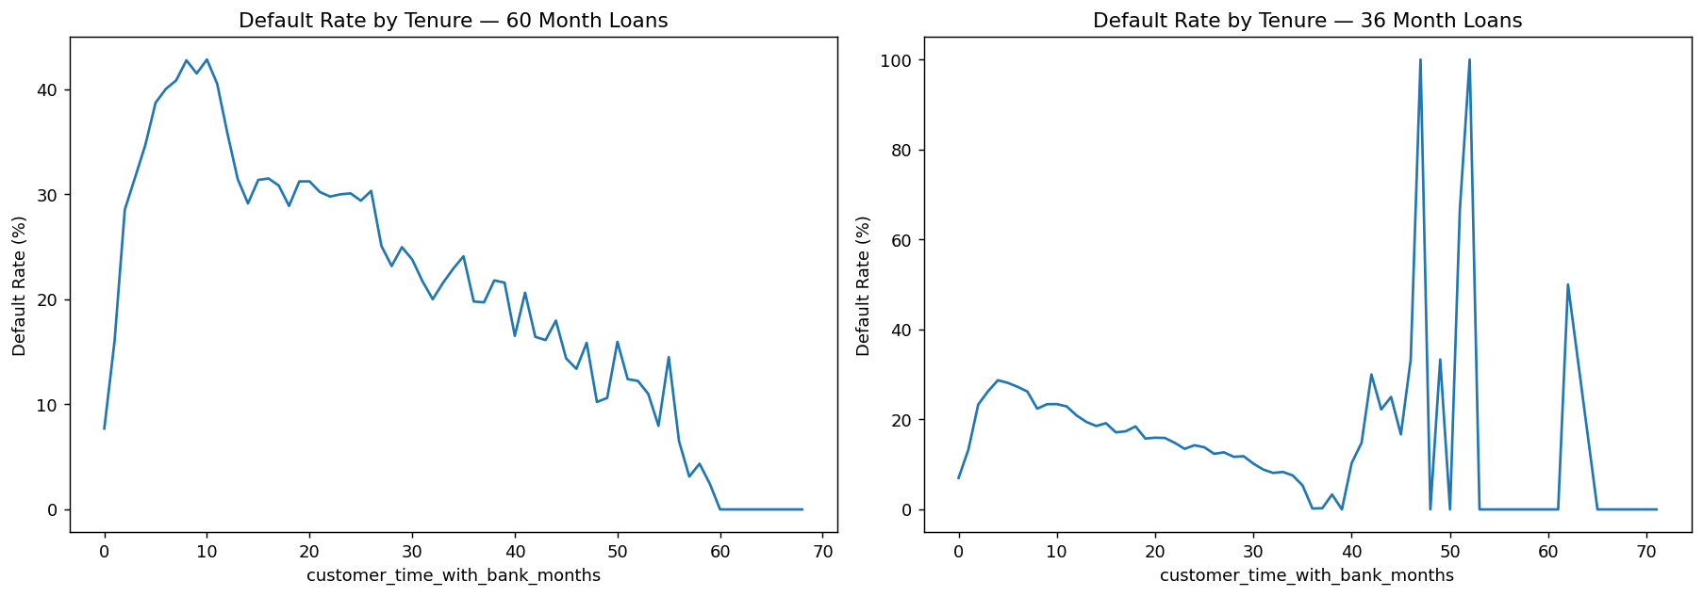
Figure 20: Default rate by months with bank — 60-month (left) and 36-month (right) loans

For 36-month loans, default risk peaks in months 5–7. For 60-month loans, the peak occurs at months 8–10, reaching approximately 40%+ before gradually falling toward zero near loan maturity. A borrower who successfully navigates the first 10–12 months is significantly more likely to fully repay.
This front-loaded default risk pattern directly motivates the survival analysis phase — understanding not just whether a borrower defaults but when within the loan lifecycle default is most likely to occur.
18. Feature Predictive Strength Summary
Feature | Default Rate Range | Strength | Action
grade / sub_grade | 6.5% – 43.7% | ★★★★★ Strongest | Keep — both encode risk score
int_rate | 8–13% vs 14–20%+ | ★★★★★ Very Strong | Keep — continuous version of grade
term | ~16% vs ~32% | ★★★★ Strong | Keep — doubles default risk
revol_util | 11.3% – 30.3% | ★★★ Moderate-Strong | Keep — genuine pre-loan stress signal
annual_inc | 24.1% → 13.2% | ★★★ Moderate | Keep — log-transform recommended
dti | Higher for defaulters | ★★★ Moderate | Keep — independent signal, low collinearity
purpose_group | 13.6% – 28.7% | ★★ Moderate-Weak | Keep — grouped from 13 to 5 categories
home_ownership | 17.1% – 21.0% | ★★ Weak-Moderate | Keep — supporting feature
open_acc | 17.9% – 22.4% | ★★ Weak | Keep as bin — mild monotonic signal
total_acc | 20.8% → 16.7% | ★ Weak | Keep as bin — mild negative trend
delinq_2yrs | 18.7% vs 20.5% | ★ Weak | Keep as binary flag only
pub_rec | 18.9% vs 19.7% | ✗ Negligible | Drop or binary flag — <1pp difference
revol_bal | ~Equal both groups | ✗ None | Drop — zero discriminative power
emp_length | 18–20% flat | ✗ None | Drop — UNKNOWN flag only

19. Key Conclusions
- Grade and interest rate are the dominant signals — grade rises from 6.5% to 43.7% (7× gap), interest rate separates the two groups more cleanly than any other variable
- Revolving balance has zero discriminative power — but revolving utilization (the ratio) shows a clean 3× increase in default rate from low to high utilization
- Employment length is essentially useless — flat 18–20% default rate across all tenure categories; only the UNKNOWN status carries signal
- Default risk is front-loaded in the loan lifecycle — peaks in months 5–10 then declines; surviving the first year is the strongest signal of full repayment
- Loan issuance grew rapidly but quality remained consistent — default rate did not increase proportionally with volume across the 2007–2014 period
- DTI provides independent information — low correlation with all other features (max r=0.31) means it adds unique predictive signal

