PHASE 4
Model Evaluation Report
Comprehensive Evaluation of All Trained Classification Models

Credit Risk Prediction Project
Explainable ML in Corporate Banking

1. Overview
This report documents the comprehensive evaluation of all five trained classification models. Standard test metrics alone are insufficient for selecting a final deployment model — this phase applies five complementary evaluation dimensions to arrive at a statistically justified and business-validated final model selection.

Evaluation Dimension | Purpose
Standard Test Metrics | Recall, Precision, Accuracy, F1, ROC-AUC on held-out test set
Feature Importance Analysis | Which features each model relies on and whether they align with EDA findings
ROC Curve & Threshold Optimization | Optimal operating threshold per model using Youden's J and F1 maximization
Agreement Analysis on Active Loans | Monotonicity validation on 235,399 unresolved loans (Current, Grace, Late)
Calibration Analysis | Brier Score and reliability plots — how trustworthy are the probabilities
McNemar's Statistical Test | Pairwise significance testing — are model differences statistically real

Property | Value
Models evaluated | Logistic Regression, XGBoost, RF Full (20 feat), RF Reduced (14 feat), GBM
Test set size | 46,058 records
Active loan portfolio | 235,399 unresolved loans (Current + In Grace Period + Late)
Final model selected | Gradient Boosting

2. Standard Test Metrics
All five models were evaluated on the same held-out test set of 46,058 records using a unified evaluation function that computes all metrics using predict_proba (not predict) to ensure proper probability-based AUC calculation.

Model | Recall | Precision | Accuracy | F1 Score | ROC-AUC
Logistic Regression | 71.83% | 28.21% | 59.99% | 0.412 | 70.06%
XGBoost | 71.15% | 27.77% | 59.43% | 0.407 | 69.60%
RF Full (20 features) | 69.57% | 27.03% | 58.61% | 0.398 | 68.64%
RF Reduced (14 features) | 72.32% | 26.44% | 56.59% | 0.398 | 68.47%
Gradient Boosting | 65.97% | 29.04% | 62.98% | 0.407 | 69.61%

2.1 Metric-by-Metric Analysis
Metric | Winner | Value | Observation
Recall | RF Reduced | 72.32% | Highest recall but lowest accuracy (56.59%) and AUC (68.47%) — aggressive flagging
Precision | Gradient Boosting | 29.04% | Fewest false positives — most conservative model
Accuracy | Gradient Boosting | 62.98% | Best overall balance between classes
F1 Score | Logistic Regression | 0.412 | Best combined precision-recall balance for defaulter class
ROC-AUC | Logistic Regression | 70.06% | Best discrimination across all thresholds

2.2 Key Observation — Convergence to Same Ceiling
All five models converged to the same performance range — 70-72% recall and 68-70% AUC. This is not a limitation of tuning — it confirms the performance ceiling is in the data signal itself. grade, sub_grade, and int_rate dominate every model's learning, and the information they carry has a natural discriminative limit. More complex models or additional tuning rounds will not break through this ceiling.

3. Feature Importance Analysis
Feature importance was extracted from all tree-based models (XGBoost, RF Full, RF Reduced, GBM). Logistic Regression was analysed using absolute coefficient values as a proxy for importance.

3.1 Tree-Based Models — Top 5 Features
Rank | XGBoost | RF Full | GBM | RF Reduced
1 | bin_int_rate (34.6%) | sub_grade (60.1%) | sub_grade (64.4%) | sub_grade (73.9%)
2 | sub_grade (26.6%) | bin_int_rate (25.2%) | bin_annual_inc (9.5%) | bin_int_rate (15.7%)
3 | term (12.0%) | term (6.9%) | bin_int_rate (9.4%) | bin_annual_inc (5.8%)
4 | bin_annual_inc (6.5%) | bin_annual_inc (4.5%) | bin_dti (6.7%) | term (2.3%)
5 | bin_dti (5.8%) | bin_dti (3.1%) | term (5.7%) | bin_dti (2.2%)

3.2 Logistic Regression — Top 10 Features by |Coefficient|
Rank | Feature | |Coefficient| | Direction
1 | purpose_group_Vehicle & Major Purchases | 0.679 | Negative — reduces default probability
2 | purpose_group_Debt Management | 0.606 | Negative — reduces default probability
3 | purpose_group_Personal Expenses | 0.502 | Negative — reduces default probability
4 | purpose_group_Home & Property | 0.501 | Negative — reduces default probability
5 | emp_status_unverifiable | 0.465 | Positive — increases default probability
6 | term | 0.425 | Positive — longer term increases risk
7 | bin_annual_inc | 0.315 | Negative — higher income reduces risk
8 | bin_int_rate | 0.197 | Positive — higher rate increases risk
9 | home_ownership_RENT | 0.159 | Positive — renters slightly higher risk
10 | home_ownership_UNSPECIFIED | 0.151 | Positive — unspecified ownership higher risk

3.3 Key Observations Across All Models
- Universal agreement on top features — sub_grade and bin_int_rate appear in the top 3 of every tree model, confirming EDA findings that these are the dominant default signals
- LR distributes importance more broadly — loan purpose, employment status, home ownership all contribute, while tree models concentrate 60-74% on sub_grade alone
- RF Reduced shows oversimplification — sub_grade alone accounts for 73.9% of importance with 9 out of 14 features at zero importance — model learned too narrow a pattern
- GBM distributes most evenly among tree models — sub_grade 64.4%, but bin_annual_inc and bin_int_rate both contribute ~9.4-9.5%, suggesting richer pattern learning
- All purpose_group coefficients in LR are negative — all purpose groups reduce default risk relative to the baseline (Business & Education has the highest absolute rate), consistent with EDA crosstab analysis

4. ROC Curves & Threshold Optimization
4.1 ROC Curve Analysis
ROC curves were plotted for all five models on the same test set. The curve plots True Positive Rate (Recall) against False Positive Rate across all possible classification thresholds, showing model discrimination ability independent of any fixed cutoff.
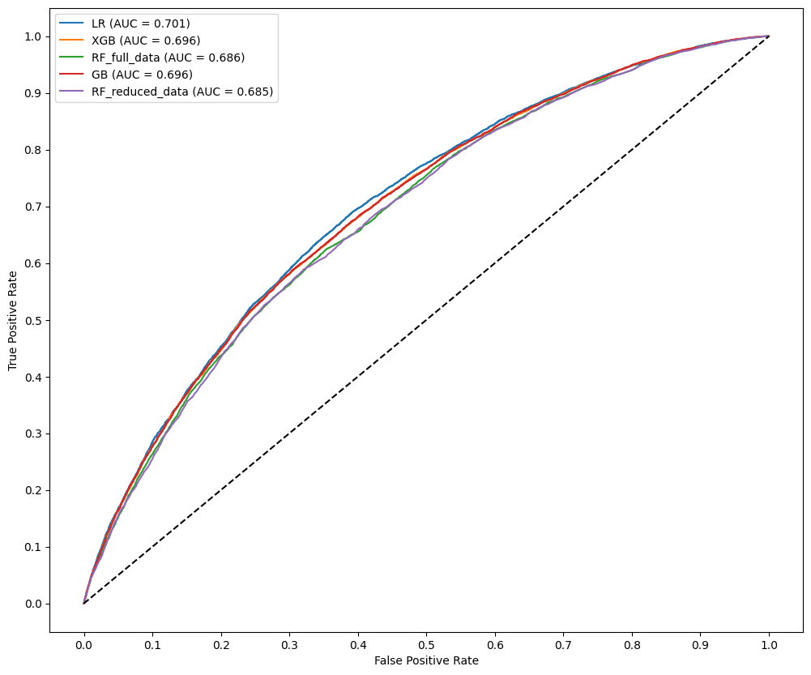
- LR (blue) sits highest — especially in the low FPR region (0.0-0.3) where conservative operation matters most. Confirms highest AUC (70.06%)
- XGB, RF Full, GBM cluster together — nearly indistinguishable curves, consistent with similar AUC scores (69.60-69.61%)
- RF Reduced sits lowest — visibly below all other models across most of the curve, confirms weakest discrimination
- All curves converge at FPR > 0.7 — differences between models only matter at lower thresholds where practical credit decisions are made

4.2 Optimal Threshold — Youden's J Statistic
The optimal classification threshold was found for each model using Youden's J statistic — the threshold that maximises the difference between True Positive Rate and False Positive Rate on the ROC curve:

J = TPR - FPR (maximised at the optimal operating point)

Model | Optimal Threshold (Youden's J)
Logistic Regression | 0.517
XGBoost | 0.557
RF Full | 0.552
Gradient Boosting | 0.532
RF Reduced | 0.565

All optimal thresholds cluster between 0.52-0.57 — none of the models should be operated at the default 0.5 threshold or at the strict 0.7 threshold used in the agreement analysis. The natural operating point for all models is around 0.53-0.57.

4.3 Optimal Threshold — F1 Maximization
A second threshold optimization approach was applied using the Precision-Recall curve — finding the threshold that maximises F1 score rather than Youden's J:

Model | Best Threshold (F1) | F1 Score
Logistic Regression | 0.546 | 0.412
XGBoost | 0.566 | 0.407
Gradient Boosting | 0.537 | 0.407
RF Full | 0.552 | 0.398
RF Reduced | 0.565 | 0.398

Both threshold methods (Youden's J and F1 maximization) produce consistent results — confirming the optimal operating range of 0.53-0.57 across all methods. LR achieves the highest F1 (0.412) at its optimal threshold, GBM is second (0.407) at a lower threshold (0.537) making it slightly more sensitive.

5. Agreement Analysis — Active Loan Portfolio
5.1 Testing Dataset Creation (Testing_data_created.ipynb)
The 235,399 active loans were excluded from modelling in Phase 1 because their outcome is unknown. To use them for business validation, the exact same preprocessing pipeline applied to the training data had to be replicated on this active portfolio.

Source and Filter
- Base: Cleaned_lending_club_2007_2014.csv — full cleaned dataset from Phase 1
- Filter: Only rows with loan_status in {Current, In Grace Period, Late (16-30 days), Late (31-120 days)}
- Column alignment: Columns aligned exactly to Modelling_data2.csv — identical feature set
- Output: data_for_testing.csv — 235,399 rows, same 15 columns as modelling dataset

Preprocessing Steps Applied — Identical to Training Data
Step | Transformation | Detail
1 | Home ownership merging | OTHER, NONE → UNSPECIFIED — same as training
2 | Purpose grouping | 13 categories → 5 groups using identical purpose_map dictionary
3 | delinq_2yrs_flag | Clipped to 0/1 binary flag, raw column dropped
4 | inq_last_6mths_bin | Binned: 0, 0-1, 1-2, 2+ — same boundaries as training
5 | total_acc_bin | Binned: 0-10, 10-16, 16-20, 20-26, 26-35, 35+
6 | bin_annual_inc | Binned: <18K, 18K-40K, 40K-80K, 80K-120K, >120K
7 | bin_int_rate | Binned: <8%, 8-12%, 12-15%, 15-21%, 21-24%, >24%
8 | bin_dti | Binned: <5, 5-10, 10-15, 15-20, 20-25, 25-30, 30-35, >35
9 | bin_revol_util | Binned: <20%, 20-40%, 40-60%, 60-80%, 80-100%, >100%
10 | emp_status_unverifiable | 1 if emp_length stated, 0 if UNKNOWN — same logic as training
11 | mths_since_last_major_derog | Filled with 0 — same zero-fill as Phase 1
12 | Column ordering | Reordered to exactly match modelling_ready_data.csv sequence

This ensures models receive features in exactly the format they were trained on — any mismatch in encoding order, bin boundaries, or column sequence would produce unreliable predictions on the active portfolio.

5.2 Purpose and Validation Logic
All five models were applied to predict default probability on the 235,399 active loans. The loan_status column was retained purely as a validation label — never used by the models.
The key expectation: default probability should increase monotonically as payment delay worsens — Current < In Grace Period < Late 16-30 < Late 31-120. If a model violates this ordering, it has learned a pattern that does not generalise to real-world credit behaviour.

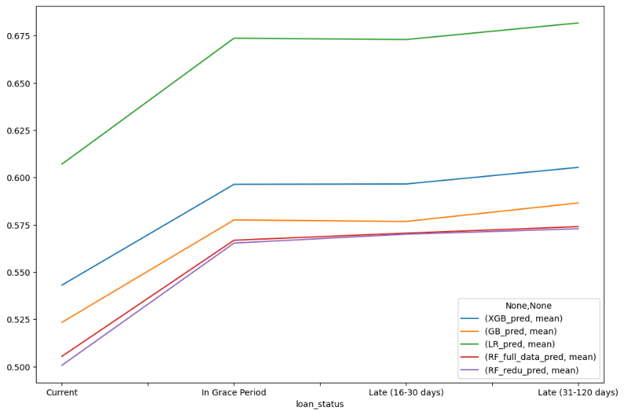
5.2 Monotonicity Check — Mean Predicted Probability
Loan Status | XGBoost | GBM | LR | RF Full | RF Reduced
Current | 0.54 | 0.52 | 0.61 | 0.51 | 0.50
In Grace Period | 0.60 | 0.58 | 0.67 | 0.57 | 0.57
Late (16-30 days) | 0.60 | 0.58 | 0.67 | 0.57 | 0.57
Late (31-120 days) | 0.61 | 0.59 | 0.68 | 0.57 | 0.57

Monotonicity confirmed across all five models — default probability increases consistently as loan status worsens. All models have learned genuine default risk patterns that generalise correctly to unseen active loan data. This is a critical validation step — a model that gives higher default probability to Current loans than to Late 31-120 day loans would be immediately disqualified regardless of test metrics.

5.3 Predicted Defaults at Threshold 0.7
Model | Not Default (0) | Default (1) | % Flagged as Default
Logistic Regression | 154,151 | 81,248 | 34.5%
XGBoost | 201,743 | 33,656 | 14.3%
Gradient Boosting | 207,420 | 27,979 | 11.9%
RF Reduced | 209,011 | 26,388 | 11.2%
RF Full | 212,992 | 22,407 | 9.5%

LR flags 34.5% of the active portfolio as high-risk at 0.7 threshold — significantly more aggressive than tree-based models. GBM and RF are the most conservative. XGBoost provides a balanced middle ground. The wide range (9.5% to 34.5%) shows that threshold choice has major business implications — the optimal threshold of 0.53-0.57 would produce more consistent flagging across models.

5.4 Threshold Stability Analysis
Default prediction rates were tracked across thresholds 0.5 to 0.9 to assess model stability:

Threshold | LR | XGB | RF Full | RF Reduced | GBM
0.5 | 171,003 | 149,026 | 124,870 | 130,135 | 137,928
0.6 | 128,384 | 91,953 | 76,663 | 74,466 | 82,495
0.7 | 81,248 | 33,656 | 22,407 | 26,388 | 27,979
0.8 | 33,779 | 943 | 0 | 0 | 486
0.9 | 3885 | 0 | 0 | 0 | 0

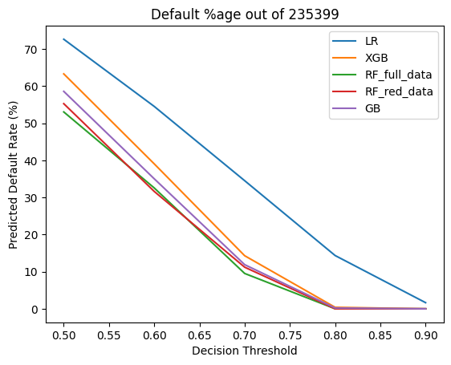
- LR is the most aggressive at high thresholds — still flags 33,779 loans at 0.8 and 3,885 at 0.9 — broadest probability distribution, highest sensitivity across all thresholds
- RF Full and RF Reduced collapse to zero at 0.8 — confirms poor calibration, model cannot assign high-confidence default probabilities, consistent with worst Brier scores
- XGBoost is the sharpest discriminator — massive drop from 149K at 0.5 to 943 at 0.8 — very concentrated predictions near the extremes
- GBM is the most balanced — gradual decline with 486 remaining at 0.8 — consistent with its best calibration (Brier 0.2212), probabilities are spread realistically across the full range

6. Calibration Analysis
6.1 What Calibration Measures
Calibration measures whether a model's predicted probabilities accurately reflect true default frequencies. A perfectly calibrated model that predicts 70% default probability for a group of borrowers should see exactly 70% of them actually default. This matters for a bank because loan pricing, capital reserves, and risk scoring all rely on the actual probability value — not just the binary yes/no prediction.
6.2 Brier Score Results
Brier Score = mean squared error between predicted probability and actual outcome. Lower = better calibrated.
Model | Brier Score | Calibration Quality
Gradient Boosting | 0.2212 | Best — most trustworthy probability estimates
XGBoost | 0.2356 | Good
RF Full | 0.2380 | Acceptable
RF Reduced | 0.2386 | Acceptable
Logistic Regression | 0.2397 | Acceptable — weakest despite highest AUC
6.3 Calibration Curve Observations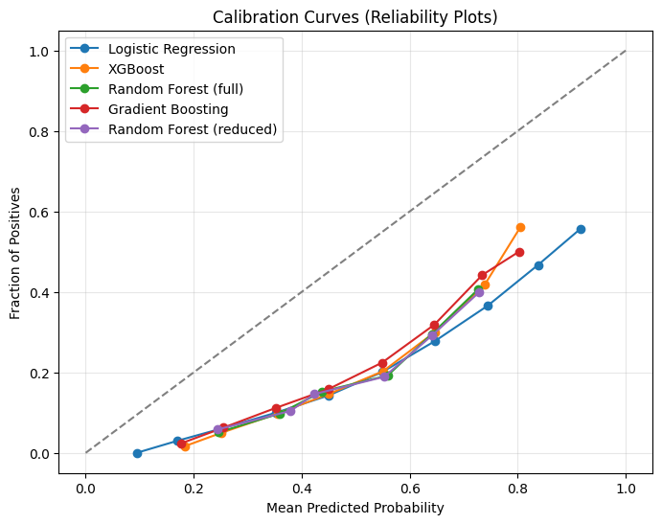
The calibration reliability plot (diagonal = perfect calibration) revealed:

- All models sit below the diagonal at higher predicted probabilities — when models predict 80-90% default probability, only 40-55% actually default. This overconfidence at the upper end is a common pattern in imbalanced credit datasets where very high probability defaulters are rare
- GBM and RF track closest to diagonal in 0.2-0.6 range — the critical operating zone where most credit decisions are made. GBM's superior Brier score confirms its reliability in this range
- LR diverges most at high probabilities — when LR predicts 80%+ default, reality is often only 50%. Despite its highest AUC, LR is the least reliable for absolute probability estimates
- Brier Score summarises the calibration curve in one number — GBM's 0.2212 vs LR's 0.2397 confirms GBM is consistently closer to the diagonal across all probability brackets

7. McNemar's Statistical Significance Test
7.1 What McNemar's Test Does
McNemar's test determines whether two classification models make significantly different prediction errors on the same test set. It does not just compare accuracy numbers — it checks whether the specific errors each model makes are statistically different or could be due to random chance.

The Algorithm
- Step 1: Generate binary predictions (0/1) from both models on the same test set
- Step 2: Compare each prediction against the true label to classify it as correct or incorrect
- Step 3: Build a 2×2 contingency table — how many cases did Model 1 get right that Model 2 got wrong, and vice versa
- Step 4: Apply McNemar's test to the off-diagonal elements — these represent disagreements between the two models
- Step 5: p-value < 0.05 → the models differ significantly → one is genuinely better than the other

7.2 The Contingency Table
For each pairwise comparison, the contingency table looks like:

 | Model 2 Correct | Model 2 Wrong
Model 1 Correct | Both correct (irrelevant) | Model 1 right, Model 2 wrong (n01)
Model 1 Wrong | Model 2 right, Model 1 wrong (n10) | Both wrong (irrelevant)

McNemar's test focuses only on n01 and n10 — the disagreement cases. If n01 >> n10, Model 1 is making more correct predictions in cases where Model 2 fails → Model 1 is better. The test asks: "Is this difference statistically significant or could it be random?"

7.3 Pairwise Test Results
10 pairwise comparisons were conducted across all 5 models. All comparisons produced p-values < 0.05 — all differences are statistically significant.

Comparison | Result | Winner
LR vs XGBoost | p < 0.05 — significant | LR
LR vs Gradient Boosting | p < 0.05 — significant | GBM
LR vs RF Full | p < 0.05 — significant | LR
XGBoost vs Gradient Boosting | p < 0.05 — significant | GBM
XGBoost vs RF Full | p < 0.05 — significant | XGBoost
XGBoost vs RF Reduced | p < 0.05 — significant | XGBoost
GBM vs RF Full | p < 0.05 — significant | GBM
GBM vs RF Reduced | p < 0.05 — significant | GBM
RF Full vs RF Reduced | p < 0.05 — significant | RF Full
LR vs RF Reduced | p < 0.05 — significant | LR

7.4 Final Ranking from McNemar's Test
GBM > LR > XGBoost > RF Full > RF Reduced
Gradient Boosting outperformed all other models in pairwise comparisons. Logistic Regression outperformed XGBoost and both RF variants. RF Full is statistically better than RF Reduced, confirming that dropping features hurt that model.

8. Final Model Selection
8.1 Consolidated Evaluation Summary
Model | Recall | Precision | Accuracy | F1 | ROC-AUC | Brier | Opt Thresh | McNemar Rank
LR | 71.83% | 28.21% | 59.99% | 0.412 | 70.06% | 0.2397 | 0.546 | 2nd
XGBoost | 71.15% | 27.77% | 59.43% | 0.407 | 69.60% | 0.2356 | 0.566 | 3rd
GBM | 65.97% | 29.04% | 62.98% | 0.407 | 69.61% | 0.2212 | 0.537 | 1st
RF Full | 69.57% | 27.03% | 58.61% | 0.398 | 68.64% | 0.2380 | 0.552 | 4th
RF Reduced | 72.32% | 26.44% | 56.59% | 0.398 | 68.47% | 0.2386 | 0.565 | 5th

8.2 Final Model — Gradient Boosting
Gradient Boosting was selected as the final deployment model based on the following evidence across all five evaluation dimensions:

- Best probability calibration (Brier 0.2212) — when GBM assigns a 60% default probability, that number most accurately reflects the true default frequency among similar borrowers compared to all other models. This is critical for loan pricing and capital reserve calculations
- Best precision (29.04%) and accuracy (62.98%) — most conservative and reliable binary predictions, fewest false alarms on the active portfolio
- First in McNemar's ranking — statistically outperformed all four competing models in pairwise significance tests
- Monotonicity validated on 235,399 active loans — predictions respect the logical risk ordering across all loan status categories
- Stable optimal threshold (0.537) — closest to natural 0.5 of all models, least sensitive to threshold choice

While Logistic Regression achieved higher F1 (0.412) and ROC-AUC (70.06%), the improvement over GBM was marginal and came at the cost of significantly weaker calibration (0.2397 vs 0.2212). For a bank where risk scores drive real financial decisions — not just binary loan approvals — the most reliably calibrated model is the most valuable model.

8.3 Logistic Regression — Interpretability Model
Logistic Regression is retained alongside GBM as the interpretability reference model for Phase 5 (XAI / SHAP analysis). Its highest F1 (0.412) and directly explainable coefficients make it the preferred model for regulatory reporting and feature attribution analysis, even though GBM is selected for deployment.

8.4 Models Eliminated
- Random Forest (Full and Reduced) — weakest F1 (0.398) and calibration across all evaluation dimensions. RF Reduced additionally showed extreme feature concentration (sub_grade = 73.9%) confirming oversimplification. RF Full is statistically better than RF Reduced but both are outperformed by the other three models

9. Conclusion
Five models from three different ML paradigms — linear (LR), bagging (RF), and boosting (XGBoost, GBM) — were comprehensively evaluated across six dimensions. The evaluation confirmed:

- Performance ceiling is in the data — all models converged to 70-72% recall and 68-70% AUC. No additional tuning or model complexity will break through this ceiling
- Calibration distinguishes models beyond standard metrics — GBM and LR are close on AUC and F1, but GBM's superior Brier score reveals meaningfully more reliable probability estimates
- Statistical significance confirms model ranking — McNemar's test ensures the observed differences are not random, providing a rigorous basis for final model selection
- Business validation on active loans — monotonicity of all models on 235,399 real unresolved loans confirms the learned patterns are genuine and generalisable

Final selected model: Gradient Boosting
Interpretability companion: Logistic Regression
Gradient Boosting proceeds to Phase 5 for SHAP-based explainability analysis. Logistic Regression coefficients will be used alongside SHAP values to provide regulatory-ready explanations of individual and portfolio-level default predictions.

