EXPLAINABLE CREDIT RISK MODEL
USING MACHINE LEARNING IN CORPORATE BANKING
Consolidated Project Report — Phases 1 through 6
Lending Club Loan Dataset (2007–2014)
Data Cleaning · Exploratory Data Analysis · Statistical Feature Selection
Model Training & Evaluation · SHAP Explainability · Survival Analysis
Prepared by Dev

Executive Summary
This report consolidates a six-phase research project that builds a complete, explainable credit risk framework on 230,288 resolved Lending Club loans issued between 2007 and 2014. The project addresses three linked questions: who is likely to default (binary classification), when within the loan lifecycle default is likely to occur (survival analysis), and why a model reaches a given decision (SHAP-based explainability applied to both the classification and survival models).
Five classifiers spanning three ML paradigms — Logistic Regression (linear), Random Forest (bagging), and XGBoost and Gradient Boosting (boosting) — were trained on a statistically justified 15-feature set and converged to the same performance ceiling of 70–72% recall and 68–70% ROC-AUC, confirming that the discriminative limit lies in the data signal itself rather than in model choice. Gradient Boosting was selected as the primary deployment model on the strength of its probability calibration (Brier score 0.2212) and a first-place finish across pairwise McNemar significance tests, while Logistic Regression was retained as an interpretability companion for regulatory reporting.
Kaplan-Meier curves and a Cox Proportional Hazards model extended the analysis into the time dimension, confirming that default risk is front-loaded — peaking in months 5–10 of the loan lifecycle — and that grade, term, interest rate, income and DTI are all statistically significant predictors of time-to-default (log-rank p < 0.001 in every comparison). A striking and practically important divergence emerged between the two SHAP analyses: sub_grade is the dominant driver of whether a borrower defaults (classification SHAP 0.19, rank 1), while int_rate is the dominant driver of when a borrower defaults (survival SHAP 0.42, rank 1). This distinction — grade governs approval, rate governs timing — is a direct, actionable input to loan pricing strategy.
All classification and survival findings were independently validated by re-scoring 235,399 still-active loans (Current, In Grace Period, Late) and confirming that predicted risk increases monotonically as repayment delinquency worsens across every model, with no exceptions. A unified prediction function and Streamlit dashboard integrate all six phases into a single interactive tool that returns a default probability, a time-to-default risk score, and a SHAP-based explanation for any borrower profile.

Key Numbers at a Glance
Metric | Value
Dataset | 230,288 resolved loans, Lending Club 2007–2014
Class split | 81% Not Defaulter / 19% Defaulter
Final feature set | 15 columns after statistical testing + binning
Best ROC-AUC | 70.06% (Logistic Regression)
Best calibration (Brier) | 0.2212 (Gradient Boosting)
Deployment model | Gradient Boosting (GBM)
Interpretability model | Logistic Regression (LR)
Grade A vs Grade G default rate | 6.5% vs 43.7% (7× gap)
36-month vs 60-month default rate | 16% vs 32% (2× gap)
Default danger zone | Months 5–10 of loan lifecycle
Active loans validated (Phase 4) | 235,399 loans, monotonicity confirmed
Top classification signal (SHAP) | sub_grade — 0.19 (predicts WHETHER)
Top survival signal (SHAP) | int_rate — 0.42 (predicts WHEN)
Project Pipeline Overview
The project was executed across six sequential phases, each building on the outputs and findings of the previous one.
Phase | Name | Core Output
Phase 1 | Data Cleaning | Resolve target variable, drop irrelevant/leaky columns, treat 20 columns with missing values individually
Phase 2 | Exploratory Data Analysis | Distribution and default-rate analysis of every retained feature; identify the danger-zone pattern
Phase 3 | Feature Engineering & Modelling | Chi-Square / Anderson-Darling / Mann-Whitney testing, binning, pipeline design, training 5 classifiers
Phase 4 | Model Evaluation | 6-dimension evaluation: metrics, feature importance, ROC thresholds, active-loan agreement, calibration, McNemar's test
Phase 5 | Explainability (SHAP) | TreeExplainer on GBM, LinearExplainer on LR; global and individual-level attribution
Phase 6 | Survival Analysis | Kaplan-Meier, Cox PH, XGBoost Survival + SHAP; unified prediction function and Streamlit dashboard

Phase 1 — Data Cleaning
This phase documents every data-cleaning decision made on the raw Lending Club dataset so that the process is fully reproducible and auditable — a requirement for a credit risk model intended for regulatory review.

1.1 Dataset at a Glance
Property | Value
Source | Lending Club public loan data
Period covered | 2007 – 2014
Raw shape | 466,285 rows × 75 columns
Shape after cleaning | 466,099 rows × 55 columns
Target variable | loan_status
Before any cleaning began, the accounting identity total_pymnt = total_rec_prncp + total_rec_int + total_rec_late_fee + recoveries was verified across all records, confirming the internal consistency of the payment-related columns.

1.2 Target Variable Resolution
The raw dataset contains 9 loan-status categories. Only resolved loans — those whose final outcome is definitively known — were retained for binary classification, removing unresolved/active loans and policy-exception categories to prevent label noise and data leakage.
Status | Count | Action
Fully Paid | 184,739 | Keep → 0 (Not Defaulter)
Charged Off | 42,475 | Keep → 1 (Defaulter)
Default | 832 | Keep → 1 (Defaulter)
Current | 224,226 | Removed — outcome unknown
Late (31–120 days) | 6,900 | Removed — unresolved
Late (16–30 days) | 1,218 | Removed — unresolved
In Grace Period | 3,146 | Removed — unresolved
Policy-exception statuses | 2,749 | Removed — excluded for clean split

1.3 Columns Dropped
18 columns were structurally irrelevant (empty joint-loan / instalment-loan fields, administrative identifiers, free text) and dropped immediately. A further set — id/member_id, pymnt_plan and policy_code (constant values), zip_code/addr_state (geography out of scope), and title/emp_title (high-cardinality free text) — were dropped during analysis.

1.4 Missing Value Treatment
Every column with missing values was individually diagnosed with a custom missing_values() function rather than blanket-imputed. Where a missing value carried real meaning — e.g. mths_since_last_record missing implies no public record ever existed — a semantic zero-fill was used instead of a statistical estimate.
Column | Missing % | Strategy
emp_title | 5.9% | Fill → UNKNOWN
emp_length | 4.5% | Fill UNKNOWN where emp_title=UNKNOWN; drop 186 rows
desc | 73.0% | Column dropped — NLP out of scope
mths_since_last_delinq | 53.7% | Fill → 0 (no delinquency ever occurred)
mths_since_last_record | 86.6% | Fill → 0 (no public record ever reported)
mths_since_last_major_derog | 78.8% | Fill → 0 (no major derogatory event)
revol_util | 0.07% | Computed from balance/limit; zero-fill where balance=0; 6 rows dropped
next_pymnt_d | 48.7% | Retained as NaN — structural missingness for resolved loans
last_pymnt_d / last_credit_pull_d | <0.1% | Derived where possible; residual rows dropped
annual_inc, open_acc, pub_rec, total_acc, etc. | <0.01% | Median or semantic zero-fill — negligible impact

1.5 Output
Property | Value
Output file | Cleaned_lending_club_2007_2014.csv
Rows | 230,288 resolved loans (Fully Paid + Charged Off + Default)
Columns | 55 features + target variable
Target split | 81% Not Defaulter (0) / 19% Defaulter (1)
Missing values remaining | None in modelling features

Phase 2 — Exploratory Data Analysis
Every retained feature was analysed through distribution plots, default-rate comparisons, and correlation analysis on the 230,288 resolved loans to establish its predictive strength ahead of modelling.
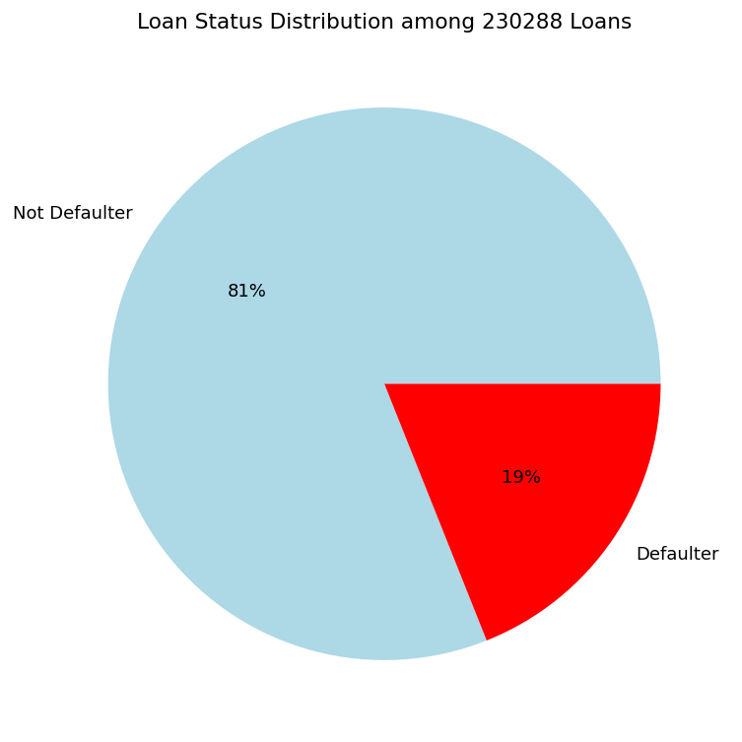
Figure 2.1 — Target split: 19% Defaulter vs 81% Not Defaulter

2.1 Loan Amount & Term
Loan amount ranges $500–$35,000 (mean $13,418) and is a weak standalone predictor — defaulters average only ~$1,300 more than non-defaulters, with heavily overlapping distributions.
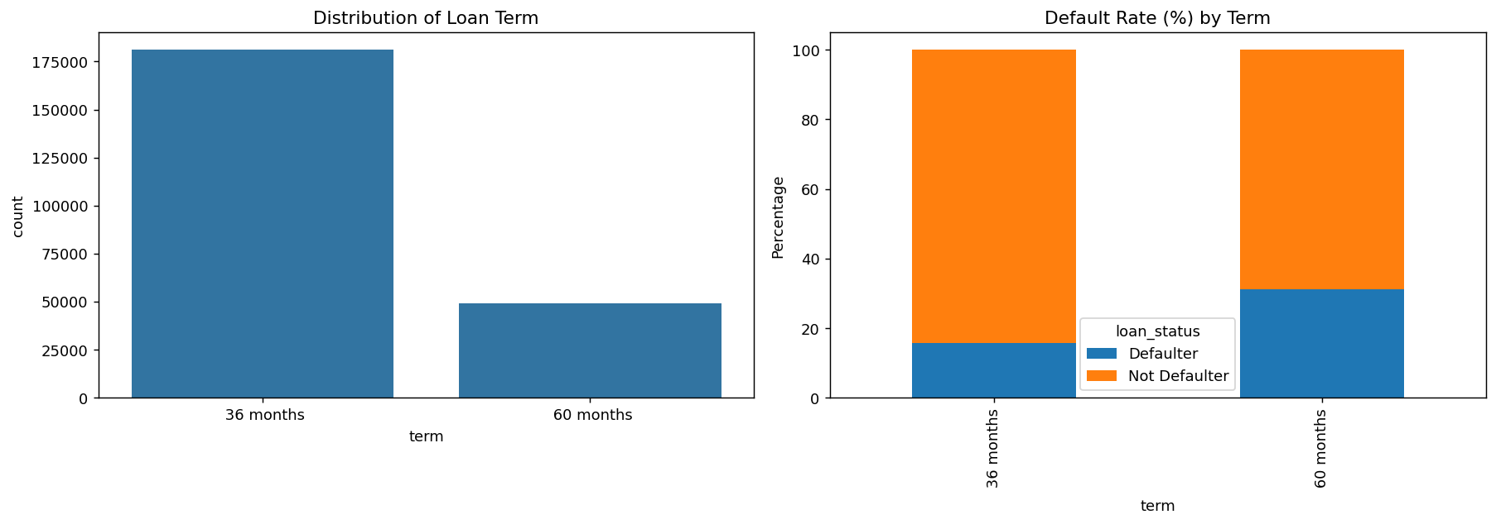
Figure 2.2 — Term distribution and default rate by term
Term, however, is one of the strongest categorical predictors: 60-month loans default at ~32% versus ~16% for 36-month loans — a 2× gap — despite only 21.4% of loans being 60-month.

2.2 Interest Rate, Grade & Sub-Grade
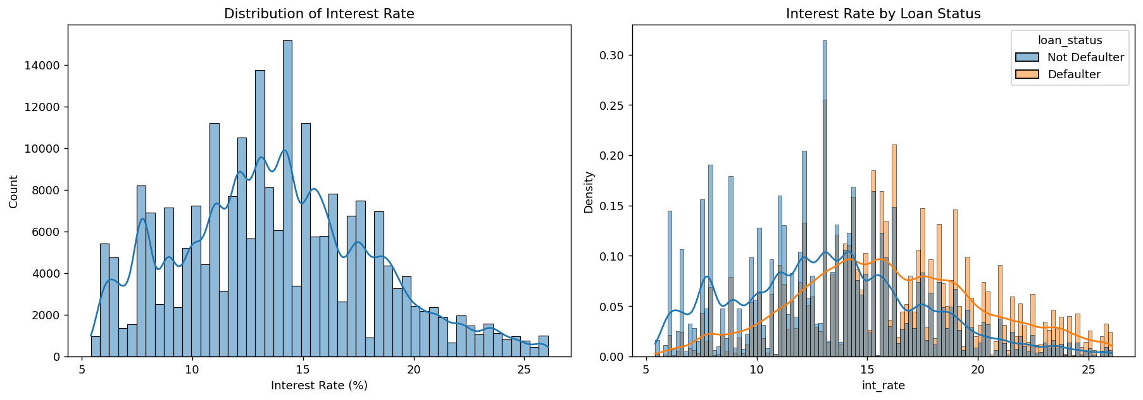
Figure 2.3 — Interest rate distribution, overall and by loan status
Interest rate (5.42%–26.06%) is the clearest continuous separator in the dataset: non-defaulters concentrate at 8–13% while defaulters shift to 14–20%+.
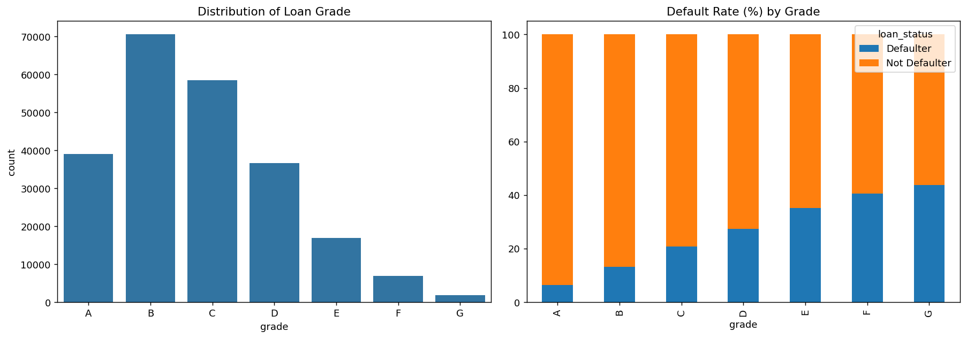
Figure 2.4 — Default rate by grade — rises from 6.5% (A) to 43.7% (G)
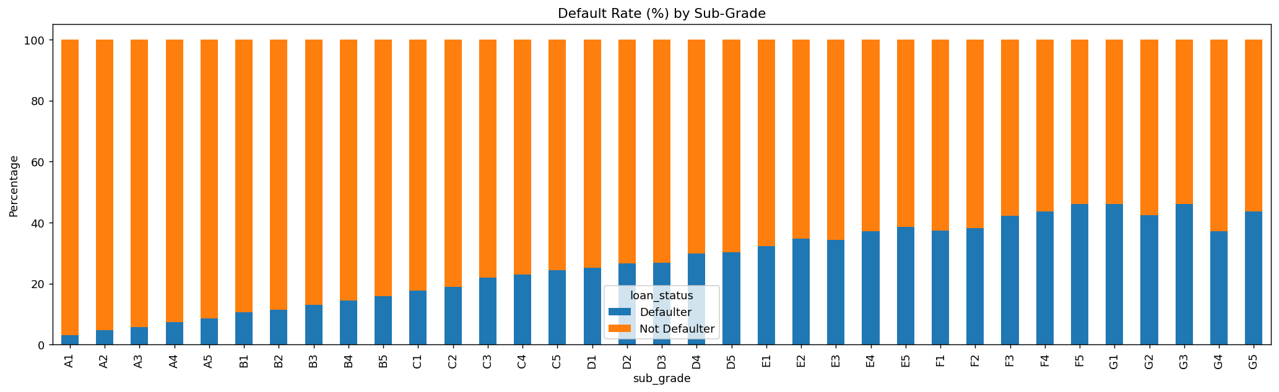
Figure 2.5 — Default rate by sub-grade — near-perfectly monotonic A1→G5
Grade is the single strongest predictor in the dataset — default rate rises from 6.5% (A) to 43.7% (G), a 7× increase with no exceptions across all 7 grades or 35 sub-grades. Interest rate rises in near-lockstep with grade — the two encode the same underlying risk assessment from different angles.

2.3 Income, DTI & Revolving Utilisation
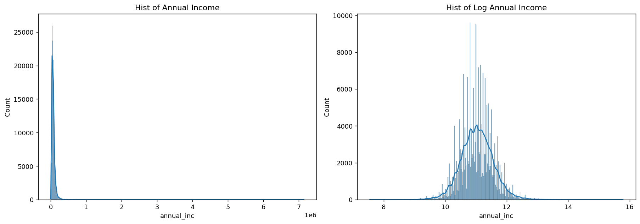
Figure 2.6 — Annual income distribution, raw and log-transformed
Annual income shows a clear negative gradient with default risk: 24.05% default below $40K versus 13.16% above $120K. DTI is consistently higher among defaulters in every purpose subgroup (Z-test p = 0.0) and carries largely independent signal (max correlation r = 0.31 with other features).
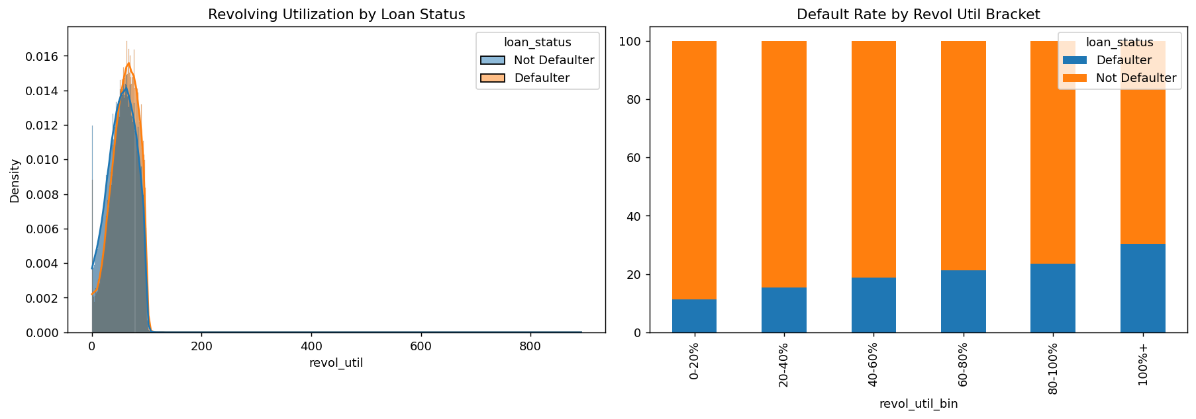
Figure 2.7 — Revolving utilisation by loan status and default rate by bracket
Revolving utilisation shows a near-perfectly monotonic increase in default rate from 11.26% (0–20% utilisation) to 30.30% (100%+) — nearly a 3× range. This is a genuine pre-loan risk signal, unlike raw revolving balance, which shows essentially zero discriminative power between the two groups and was dropped from modelling.

2.4 Default Risk Over the Loan Lifecycle
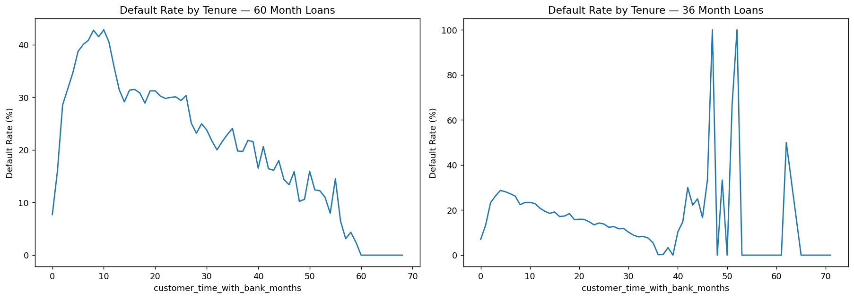
Figure 2.8 — Default rate by months on book: 60-month (left) vs 36-month (right) loans
This is one of the most consequential findings in the entire EDA: default risk is not uniform across the loan lifecycle. It peaks sharply in months 5–7 for 36-month loans and months 8–10 for 60-month loans (reaching 40%+) before declining steadily toward maturity. This front-loaded pattern directly motivated the Phase 6 survival analysis.

2.5 Feature Predictive Strength Summary
Feature | Default Rate Range | Strength
grade / sub_grade | 6.5% – 43.7% | ★★★★★ Strongest
int_rate | 8–13% vs 14–20%+ | ★★★★★ Very Strong
term | ~16% vs ~32% | ★★★★ Strong
revol_util | 11.3% – 30.3% | ★★★ Moderate-Strong
annual_inc | 24.1% → 13.2% | ★★★ Moderate
dti | Higher for defaulters | ★★★ Moderate
purpose_group | 13.6% – 28.7% | ★★ Moderate-Weak
home_ownership | 17.1% – 21.0% | ★★ Weak-Moderate
open_acc / total_acc / delinq_2yrs | small ranges | ★ Weak
pub_rec / revol_bal / emp_length | <1pp / flat | ✗ Negligible-to-none
Key conclusion: grade and interest rate are the dominant, near-identical risk signals; default risk is front-loaded in months 5–10; employment length and public records carry almost no independent signal.

Phase 3 — Feature Engineering & Model Training
This phase covers statistical feature selection, binning of continuous variables, pipeline design, and training of five classification models on the final 15-feature dataset.

3.1 Statistical Feature Selection
Every candidate feature was formally tested for association with loan_status before inclusion — no feature entered the model on intuition alone.

Categorical features — Chi-Square test of independence
H0: the feature is independent of loan_status. Decision rule: p < 0.05 → reject H0 → keep. All categorical features were retained except application_type (p = 1.0, completely independent, dropped).

Numerical features — Anderson-Darling normality test, then Mann-Whitney U
All 7 numerical columns (loan_amnt, int_rate, installment, annual_inc, dti, revol_bal, revol_util) rejected normality by a very large margin, so the non-parametric Mann-Whitney U test — rather than a T-test — was used to test association with the target. All 7 showed statistically significant association; installment was nonetheless dropped for multicollinearity (r = 0.956 with loan_amnt) and revol_bal for zero discriminative power confirmed in the EDA.

3.2 Continuous Variable Binning
Four continuous variables — annual_inc, int_rate, dti, revol_util — were binned prior to modelling for two reasons: (1) regulatory interpretability, since banks reason in risk tiers rather than raw decimals, and (2) empirical performance, since binned features consistently produced better recall and AUC than their raw continuous counterparts across every model tested. For each variable, 3–4 binning schemes were compared and the final scheme selected for monotonicity of default rate, adequate sample size per bracket, and meaningful separation between adjacent brackets.

3.3 Final Modelling Dataset
Output: modelling_ready_data.csv — 230,288 rows × 15 columns.
Type | Features | Encoding
Ordinal (8) | term, sub_grade, inq_last_6mths_bin, total_acc_bin, bin_annual_inc, bin_int_rate, bin_dti, bin_revol_util | OrdinalEncoder — respects natural risk order
Nominal (3) | home_ownership, verification_status, purpose_group | OneHotEncoder (drop = first)
Binary (2) | delinq_2yrs_flag, emp_status_unverifiable | Already 0/1
Numerical (1) | loan_amnt | StandardScaler

3.4 Pipeline & Training Strategy
A unified sklearn/imblearn pipeline — OrdinalEncoder → OneHotEncoder → StandardScaler → SelectKBest (mutual_info_classif) → Model — was applied consistently to prevent data leakage across folds, with StratifiedKFold (n_splits = 3) preserving the 81/19 class ratio in every fold.
Recall was chosen as the primary optimisation metric: a missed defaulter (false negative) costs the bank the entire loan principal, while a falsely flagged good borrower (false positive) costs only a declined applicant — a clear cost asymmetry. Class imbalance was handled through native class-weighting (class_weight, scale_pos_weight, sample_weight) for each model rather than SMOTE, since weighting adjusts the learning signal on real data whereas SMOTE introduces synthetic data — a meaningful trust and explainability concern for a regulated credit model.

3.5 Final Model Comparison
Model | Recall | Precision | Accuracy | F1 | ROC-AUC | Brier
Logistic Regression | 71.83% | 28.21% | 59.99% | 0.412 | 70.06% | 0.2397
XGBoost | 71.15% | 27.77% | 59.43% | 0.407 | 69.60% | 0.2356
RF Full (20 feat) | 69.57% | 27.03% | 58.61% | 0.398 | 68.64% | 0.2380
RF Reduced (14 feat) | 72.32% | 26.44% | 56.59% | 0.398 | 68.47% | 0.2386
Gradient Boosting | 65.97% | 29.04% | 62.98% | 0.407 | 69.61% | 0.2212
- scale_pos_weight was the single most impactful XGBoost hyperparameter — recall jumped from 8% to 67% in one tuning round.
- Gradient Boosting has no native class_weight; sample_weight inflated CV precision (60–65%) relative to the true test precision (27–28%).
- RF Reduced (14 features) over-concentrated on sub_grade (73.9% importance, 9 of 14 features at zero) — a sign of oversimplification.
- All five models converged to the same 70–72% recall / 68–70% AUC ceiling — the ceiling is in the data, not the algorithms.

Phase 4 — Model Evaluation
Standard test metrics alone are insufficient for selecting a deployment model. This phase applies six complementary evaluation dimensions — standard metrics, feature importance, ROC/threshold optimisation, agreement analysis on active loans, calibration, and McNemar's pairwise significance testing — across all five models on a held-out test set of 46,058 records.

4.1 Standard Test Metrics
Metric | Winner | Value | Observation
Recall | RF Reduced | 72.32% | Highest recall but lowest accuracy/AUC — aggressive flagging
Precision | Gradient Boosting | 29.04% | Fewest false positives — most conservative model
Accuracy | Gradient Boosting | 62.98% | Best overall class balance
F1 Score | Logistic Regression | 0.412 | Best precision-recall balance
ROC-AUC | Logistic Regression | 70.06% | Best discrimination across thresholds
All five models converged to the same 70–72% recall / 68–70% AUC range — confirming the performance ceiling lies in the strength of the underlying data signal (grade, sub_grade, and int_rate dominate every model's learning), not in tuning or model complexity.

4.2 Feature Importance Across Models
Rank | XGBoost | RF Full | GBM | RF Reduced
1 | bin_int_rate (34.6%) | sub_grade (60.1%) | sub_grade (64.4%) | sub_grade (73.9%)
2 | sub_grade (26.6%) | bin_int_rate (25.2%) | bin_annual_inc (9.5%) | bin_int_rate (15.7%)
3 | term (12.0%) | term (6.9%) | bin_int_rate (9.4%) | bin_annual_inc (5.8%)
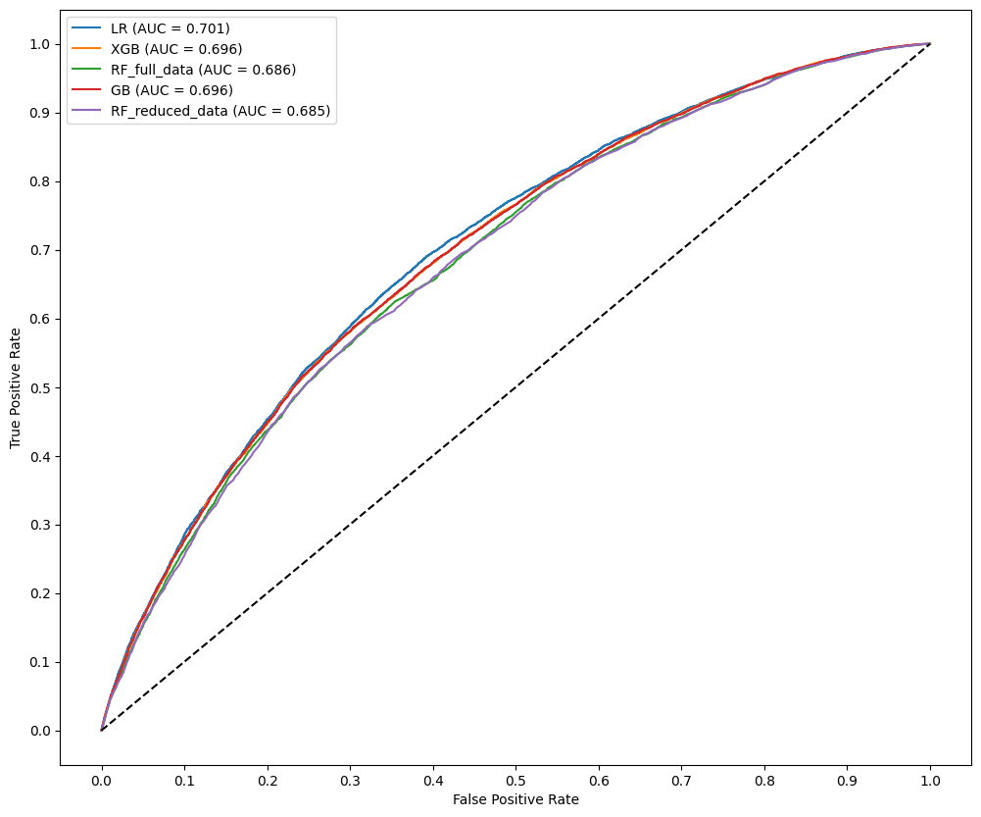
Figure 4.1 — Feature importance comparison across models

4.3 Agreement Analysis on 235,399 Active Loans
The same preprocessing was applied to Current, In Grace Period, and Late loans, where the true outcome is not yet known. The expectation is that predicted default probability should rise monotonically as payment delay worsens.
Loan Status | XGB | GBM | LR | RF Full | RF Reduced
Current | 0.54 | 0.52 | 0.61 | 0.51 | 0.50
In Grace Period | 0.60 | 0.58 | 0.67 | 0.57 | 0.57
Late (16–30 days) | 0.60 | 0.58 | 0.67 | 0.57 | 0.57
Late (31–120 days) | 0.61 | 0.59 | 0.68 | 0.57 | 0.57
Monotonicity confirmed across all five models with no exceptions — strong evidence that the learned risk patterns generalise to real, currently-active loans rather than being artifacts of the training data.

4.4 ROC Threshold Optimisation & Calibration
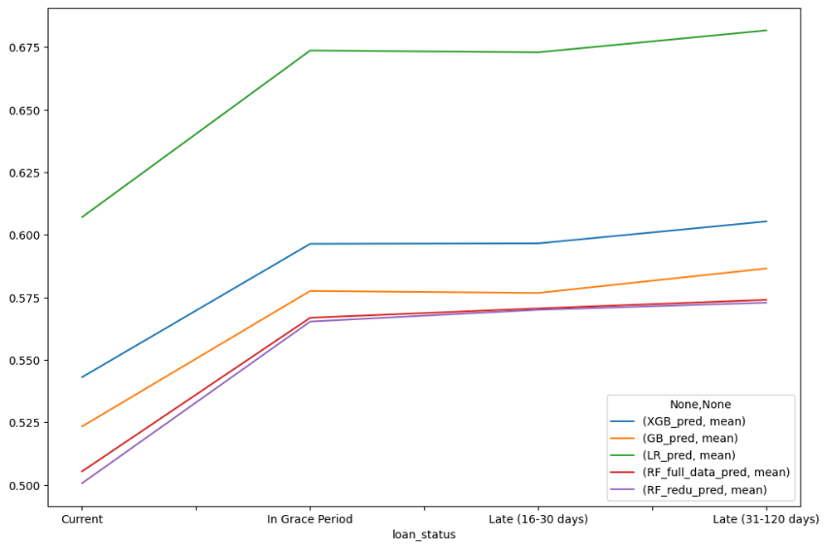
Figure 4.2 — ROC curves and optimal threshold selection
Model | Youden's J | F1 Maximisation
Logistic Regression | 0.517 | 0.546
XGBoost | 0.557 | 0.566
Gradient Boosting | 0.532 | 0.537
RF Full | 0.552 | 0.552
RF Reduced | 0.565 | 0.565
All optimal thresholds cluster between 0.53 and 0.57 — the default 0.5 cut-off is suboptimal for every model. On calibration, Gradient Boosting posts the best (lowest) Brier score of 0.2212, meaning its predicted probabilities most accurately reflect true default frequency — critical for loan pricing and capital reserve calculations.

4.5 McNemar's Pairwise Significance Test
10 pairwise comparisons were run across the 5 models; every comparison returned p < 0.05, meaning all performance differences are statistically real rather than due to chance.
Ranking | Result
Final McNemar ranking | GBM > LR > XGBoost > RF Full > RF Reduced

4.6 Final Model Selection
Model | Recall | Precision | Accuracy | F1 | AUC | Brier | McNemar Rank
LR | 71.83% | 28.21% | 59.99% | 0.412 | 70.06% | 0.2397 | 2nd
XGBoost | 71.15% | 27.77% | 59.43% | 0.407 | 69.60% | 0.2356 | 3rd
GBM | 65.97% | 29.04% | 62.98% | 0.407 | 69.61% | 0.2212 | 1st
RF Full | 69.57% | 27.03% | 58.61% | 0.398 | 68.64% | 0.2380 | 4th
RF Reduced | 72.32% | 26.44% | 56.59% | 0.398 | 68.47% | 0.2386 | 5th
Gradient Boosting is selected as the final deployment model: best calibration (Brier 0.2212), best precision and accuracy, and first place in McNemar's pairwise ranking, with predictions that remain monotonic across 235,399 active loans. Logistic Regression is retained as the interpretability companion for Phase 5 and for regulatory reporting, given its highest F1 (0.412) and directly explainable coefficients.

Phase 5 — Explainability (SHAP)
SHAP (SHapley Additive exPlanations) was applied to both final models — Gradient Boosting via shap.TreeExplainer and Logistic Regression via shap.LinearExplainer — to provide mathematically rigorous, additive feature attribution at both the portfolio (global) and individual-borrower (local) level.

5.1 Gradient Boosting — Global Feature Importance
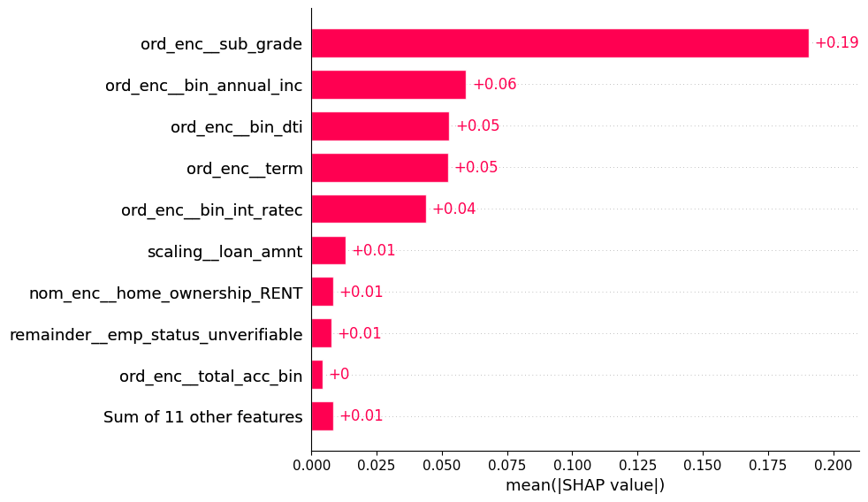
Figure 5.1 — GBM SHAP global importance (mean |SHAP|)
Feature | Mean |SHAP| | Observation
sub_grade | 0.19 | Dominant — 3× more than any other feature
bin_annual_inc | 0.06 | Second tier — independent signal
bin_dti | 0.05 | Second tier
term | 0.05 | Second tier
bin_int_rate | 0.04 | Lower than expected — GBM routes signal through sub_grade
total_acc_bin | 0.00 | Completely ignored — confirms EDA finding
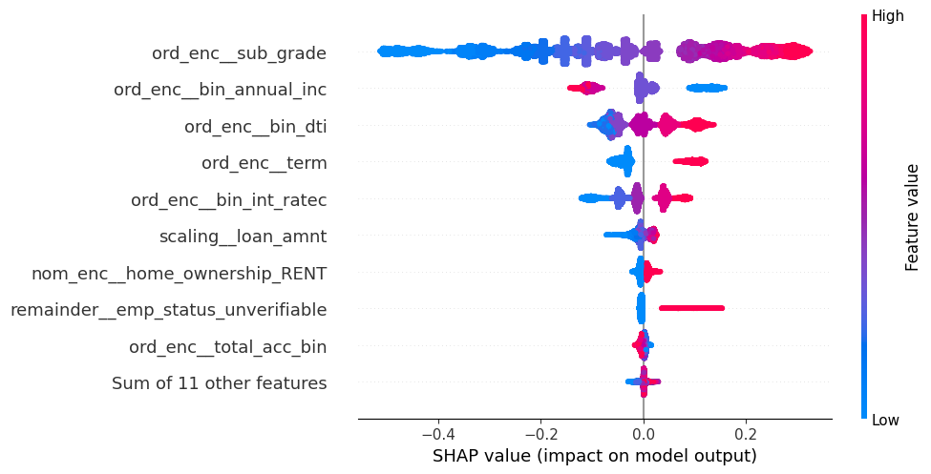
Figure 5.2 — GBM SHAP beeswarm: direction and distribution of impact per feature
sub_grade shows the widest spread of any feature — Grade A pushes strongly toward Not Defaulter, Grade G pushes strongly toward Defaulter, a perfectly monotonic confirmation of the Phase 2 EDA finding. total_acc_bin sits at zero across every borrower — the model has completely learned to ignore it.

5.2 Logistic Regression — Global Feature Importance
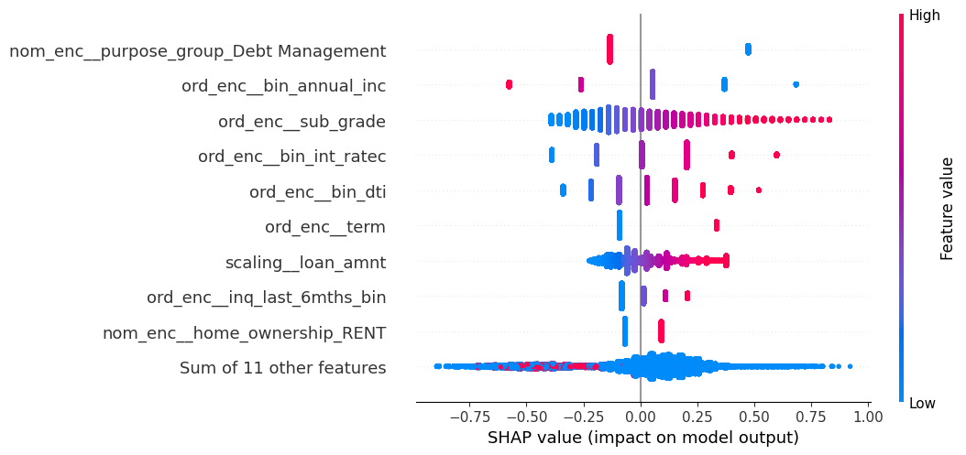
Figure 5.3 — LR SHAP beeswarm — importance spread more evenly than GBM
Feature | Mean |SHAP|
purpose_group_Debt Management | 0.21
bin_annual_inc | 0.21
sub_grade | 0.19
bin_int_rate | 0.18
bin_dti | 0.16
Unlike GBM, LR distributes importance evenly across its top features rather than concentrating on a single dominant one — a direct consequence of its linear structure, which cannot learn the same interaction effects a tree ensemble can.

5.3 GBM vs LR — Side-by-Side Comparison
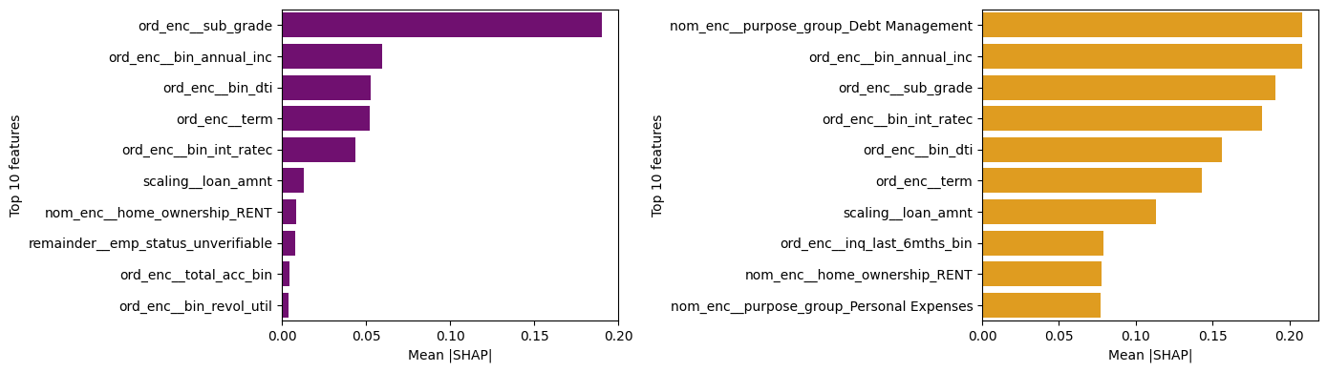
Figure 5.4 — GBM vs LR SHAP importance, side by side
Feature | GBM SHAP | LR SHAP | Agreement
sub_grade | 0.19 (1st) | 0.19 (3rd) | Both top 3
bin_annual_inc | 0.06 (2nd) | 0.21 (2nd) | Both top 3
bin_int_rate | 0.04 (5th) | 0.18 (4th) | Both top 5
bin_dti | 0.05 (3rd) | 0.16 (5th) | Both top 6
term | 0.05 (4th) | 0.14 (6th) | Both top 6
purpose_group_Debt Mgmt | Absent from top 10 | 0.21 (1st) | Architecture difference

5.4 Individual Prediction Example (Same Borrower, Both Models)
 | GBM | LR
Non-Defaulter probability | 44% | 36%
Defaulter probability | 56% | 67%
LR is more aggressive in both directions than GBM, consistent with its wider SHAP value ranges observed in the dependence plots (e.g. sub_grade spans −0.4 to +0.8 in LR, a perfectly linear relationship with no plateau, versus −0.45 to +0.25 with a plateau at Grade G in GBM).

5.5 Conclusion
- sub_grade is the universal dominant signal — confirmed by both models and consistent with the EDA's 6.5%→43.7% default-rate gradient.
- The two-model approach is deliberate: GBM gives sharper, better-calibrated probabilities; LR gives transparent, evenly-distributed, regulator-auditable coefficients.
- Every major EDA finding — income, DTI, term, interest rate direction — is confirmed by SHAP with no reversals or contradictions.
- Waterfall plots give plain-language, per-loan explanations suitable for regulatory disclosure, e.g. "flagged because E1 grade (+0.22) and low income (+0.11) outweighed the 36-month term (−0.05)."

Phase 6 — Survival Analysis & Unified Risk Framework
Classification answers whether a borrower will default. This phase addresses the complementary question — when. Kaplan-Meier, Cox Proportional Hazards, and an XGBoost survival model estimate time-to-default, correctly handling Fully Paid loans as right-censored observations rather than discarding or mislabelling them.

6.1 Core Concepts
Concept | Definition | In this project
Duration | Time from start to event or censoring | Months from loan issue to last payment
Event | Whether the event of interest occurred | 1 = Defaulted, 0 = Fully Paid (censored)
Survival function S(t) | Probability of surviving beyond time t | Probability of not defaulting by month t
Hazard function h(t) | Instantaneous default rate at time t | Default rate at each month, given survival to that point

6.2 Kaplan-Meier Estimator
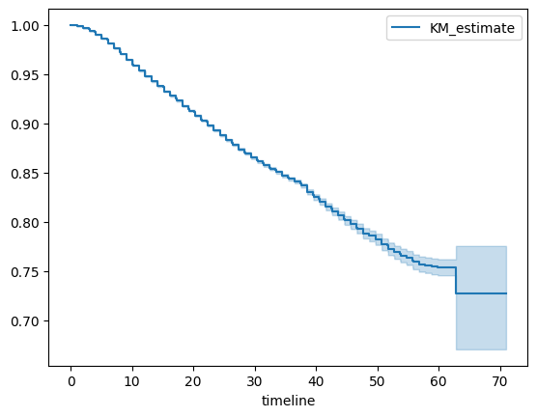
Figure 6.1 — Overall Kaplan-Meier survival curve
Survival probability starts at 1.0 and drops steeply in months 5–10 — formally confirming the danger zone first observed visually in Phase 2 — then flattens after month 20. Final survival probability settles around 0.80, i.e. roughly 20% of borrowers default over the loan lifecycle.
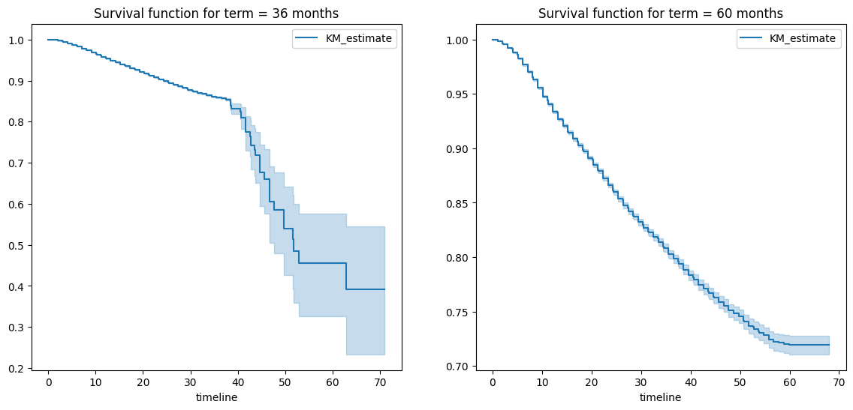
Figure 6.2 — Kaplan-Meier survival curves by loan term
By grade, curves show perfect separation with no crossing across all 7 grades — Grade A has the highest, slowest-declining survival curve, Grade G the lowest and steepest. By term, 60-month loans show lower survival throughout the entire lifecycle, a dual disadvantage of higher default rate and earlier-occurring defaults.
Log-Rank Comparison | Result | Conclusion
Grade A vs Grade G | p < 0.001 | Grade is a genuine time-to-default predictor
36-month vs 60-month | p < 0.001 | Term affects timing, not just overall rate
High vs Low DTI | p < 0.001 | Higher debt burden accelerates default
High vs Low Income | p < 0.001 | Higher income delays default

6.3 Cox Proportional Hazards Model
h(t|X) = h0(t) × exp(β1X1 + β2X2 + ... + βpXp) — the exponential of each coefficient is a hazard ratio (HR): HR > 1 accelerates default, HR < 1 is protective.
Feature | Hazard Ratio | Interpretation
int_rate | HR > 1 | Higher rate accelerates default — strongest continuous predictor of timing
sub_grade (G vs A) | HR > 1, monotonic | Each grade step increases hazard
annual_inc | HR < 1 (protective) | Higher income delays default
term (60m vs 36m) | HR > 1 | Longer term increases hazard throughout the lifecycle
dti | HR > 1 | Higher debt burden accelerates default
inq_last_6mths | HR > 1 | Recent credit inquiries signal financial stress

6.4 XGBoost Survival Model & SHAP
Cox PH assumes linearity in the log-hazard; an XGBoost model with the survival:cox objective extends gradient boosting to time-to-event data, capturing non-linear feature interactions while producing a relative risk score.
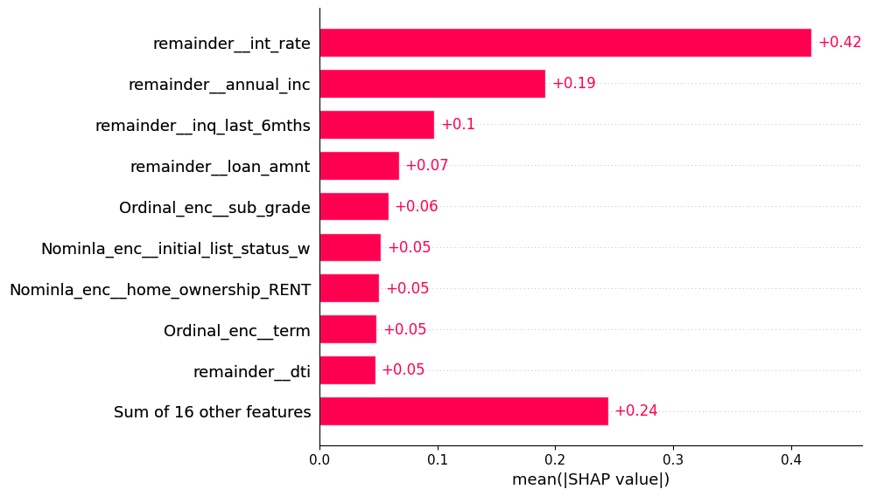
Figure 6.3 — SHAP global importance for the XGBoost survival model
Rank | Feature | Importance / SHAP | Interpretation
1 | int_rate | 0.3212 importance / 0.42 SHAP | Dominant — 3× the next feature; rate directly encodes timing
2 | sub_grade | 0.1039 importance / ~0.05 SHAP | Confirms grade as universal, but weaker for timing than for outcome
3 | inq_last_6mths | 0.0625 importance / 0.10 SHAP | Recent inquiries accelerate expected default
4 | annual_inc | ~0.04 importance / 0.19 SHAP | Protective — higher income delays default
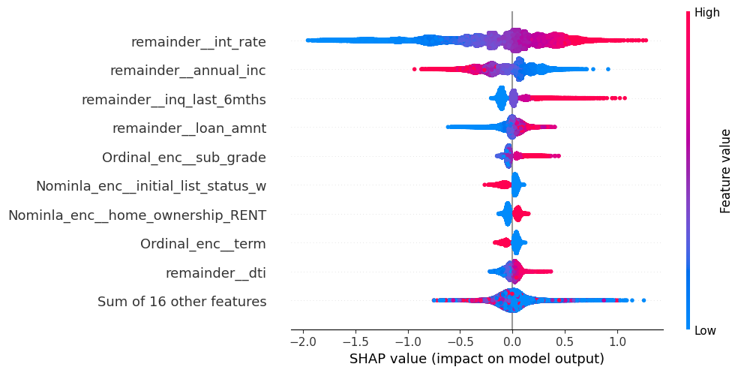
Figure 6.4 — SHAP beeswarm for the XGBoost survival model

6.5 Classification vs Survival SHAP — The Key Divergence
Feature | Classification SHAP (Phase 5) | Survival SHAP (Phase 6) | What it means
sub_grade | 0.19 (1st) | ~0.05 (5th) | Best predictor of WHETHER a default occurs
int_rate | 0.04 (5th) | 0.42 (1st) | Best predictor of WHEN a default occurs
annual_inc | 0.06 (2nd) | 0.19 (2nd) | Important for both outcome and timing
inq_last_6mths | Absent from top 10 | 0.10 (3rd) | Timing-specific signal only
Key finding: sub_grade determines credit approval risk; int_rate determines the timing of risk materialisation. This has a direct implication for loan pricing strategy — grade should drive the approve/decline decision, while rate should inform monitoring and early-warning timelines.

6.6 Unified Prediction — Sample High-Risk Borrower
Profile: C3 grade, 60-month term, $25,000 loan, income $75,000, DTI 19.5%, RENT, 1 delinquency, revol_util 72%.
Model | Prediction | Assessment
Logistic Regression | 80.17% | High risk
Gradient Boosting | 61.48% | High risk
Cox PH | 1.03 risk score | Above baseline hazard
XGBoost Survival | 1.28 risk score | 28% higher relative risk than baseline
All four models agree this borrower is high risk — the convergence of classification probability and survival risk score provides a consistent, cross-validated picture.

6.7 Streamlit Dashboard
All six phases were integrated into a single interactive Streamlit application: a borrower input form feeding LR and GBM default probabilities, Cox and XGBoost survival risk scores, a SHAP waterfall explanation for the specific borrower, and a borrower-specific survival curve from the Cox model — giving a loan officer an interpretable, multi-model risk assessment in real time.

Cross-Phase Validation
A defining strength of this project is that the same handful of risk drivers were independently re-discovered by every phase, using entirely different statistical machinery — descriptive EDA, supervised classification with SHAP, and time-to-event survival analysis.
Finding | Phase 2 (EDA) | Phase 3–5 (Classification) | Phase 6 (Survival)
sub_grade dominates | 6.5% → 43.7% | SHAP 0.19 (1st) | KM curves perfectly separated; log-rank p<0.001
int_rate predicts timing | ★★★★★ signal | SHAP 0.04 (5th) | Survival SHAP 0.42 (1st)
Income is protective | 24% → 13% | SHAP negative | Cox HR < 1
60-month term is riskier | 32% vs 16% | SHAP confirms | KM + Cox HR > 1
Months 5–10 danger zone | Visual observation | N/A — classification is timeless | KM curve confirms formally
revol_bal is useless | Identical distributions | Dropped from model | Not included in Cox model
emp_length is useless | 18–20% flat | Reduced to binary flag | Low Cox coefficient

Limitations
- Performance ceiling of 70–72% recall and 68–70% AUC across all 5 models from 3 different ML paradigms — the ceiling is in the available data signal, not the algorithms.
- Class imbalance (81/19): class weighting handles it, but recall cannot be pushed materially above ~75% without accuracy collapsing.
- GBM cross-validation precision inflation: sample_weight inflates CV precision (60–65%) relative to true test precision (27–28%) — a scoring artifact that required test-set validation to catch.
- Temporal scope is 2007–2014 only; post-2014 borrower and platform behaviour is not represented in the model.
- The Cox PH proportional-hazards assumption may be violated for some features — checked via Schoenfeld residuals; violating features are handled with stratification or time-varying coefficients.
- Survival analysis requires resolved loans for training; survival curves projected onto the 235,399 currently-active loans are extrapolations, not direct observations.

Final Conclusions

Classification
- All five models converge to the same performance ceiling — confirming the ceiling is in the data, not the algorithms.
- Gradient Boosting is selected as the primary deployment model: best calibration (Brier 0.2212), ranked 1st in McNemar's test, and monotonicity-validated on 235,399 active loans.
- Logistic Regression is retained as the interpretability model: highest F1 (0.412), highest AUC (70.06%), and directly regulator-auditable coefficients.
- SMOTE was rejected in favour of native class weighting, both empirically (no performance gain observed in testing) and on principle (learning from real data is preferable to synthetic data for a regulated credit model).

Survival Analysis
- Kaplan-Meier formally confirms the danger zone identified visually in EDA: default risk peaks in months 5–10 of the loan lifecycle.
- Grade G borrowers default both sooner and more frequently than Grade A borrowers — the risk difference is temporal as well as probabilistic.
- int_rate predicts WHEN a default occurs; sub_grade predicts WHETHER a default occurs — a genuine, business-actionable divergence, not a contradiction between models.
- Every survival-analysis finding is independently consistent with the classification-phase findings, providing strong cross-validation from two structurally different analytical frameworks.

Complete Risk Framework
Combining all six phases, a single borrower now receives a four-dimensional, regulator-ready risk assessment:
- Binary default probability (LR + GBM) — will this borrower default?
- Time-to-default risk score (Cox + XGBoost Survival) — when is this borrower expected to default?
- SHAP explanation (classification + survival) — why is this borrower classified as high risk?
- Survival curve (Cox PH) — what is the probability of this borrower surviving to each future month?

Interview — One-Line Summary
"We built a complete credit risk framework on 230K Lending Club loans — Gradient Boosting for deployment (best calibration, Brier 0.2212), Logistic Regression for regulatory transparency, survival analysis to predict when default occurs using Kaplan-Meier and Cox PH, and SHAP on both classification and survival models — validated on 235K active loans with monotonicity confirmed."

