PHASE 5
Explainability Report
SHAP Analysis — Gradient Boosting & Logistic Regression

Credit Risk Prediction Project
Explainable ML in Corporate Banking

1. Overview
This phase applies SHAP (SHapley Additive exPlanations) to both final models — Gradient Boosting (primary deployment model) and Logistic Regression (interpretability model). SHAP provides mathematically rigorous feature attribution for both global portfolio-level explanations and individual borrower-level predictions.

Property | Value
GBM Explainer | shap.TreeExplainer — exact Shapley values for tree-based models
LR Explainer | shap.LinearExplainer with Independent masker on training data
Test set | 46,058 records from Evaluation_Ready_data.csv
Masker for LR | X_train (184,230 samples) — background distribution for LinearExplainer
Plots generated | Bar, Beeswarm, Waterfall (defaulter + non-defaulter), Dependence (sub_grade, bin_int_rate, term), Side-by-side comparison

1.1 Why SHAP?
- Model-agnostic — works on both tree models (GBM) and linear models (LR) with consistent methodology
- Additive — individual SHAP values sum to the final prediction, making explanations mathematically complete
- Both global and local — explains the overall model behaviour AND individual borrower predictions
- Regulatory ready — SHAP waterfall plots provide the "why" behind each loan decision in an auditable format

2. Gradient Boosting — SHAP Analysis
2.1 Global Feature Importance — Bar Plot
Feature | Mean |SHAP| | Observation
sub_grade | 0.19 | Dominant — 3× more than any other feature
bin_annual_inc | 0.06 | Second tier — income is a meaningful independent signal
bin_dti | 0.05 | Second tier — debt burden adds independent information
term | 0.05 | Second tier — loan duration equally important as income
bin_int_rate | 0.04 | Lower than expected — sub_grade absorbs most rate signal
loan_amnt | 0.01 | Minor contributor
home_ownership_RENT | 0.01 | Minor contributor
emp_status_unverifiable | 0.01 | Minor but consistent signal
total_acc_bin | 0.00 | Zero contribution — model ignores completely
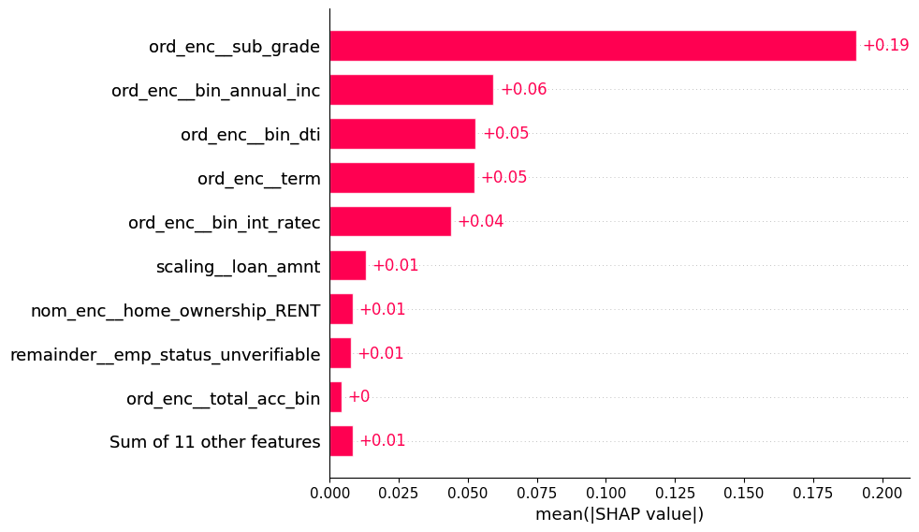
sub_grade dominates GBM at 0.19 — more than 3× the next feature. The model learned that Lending Club's own risk assessment (encoded in sub_grade) is the single most reliable signal. bin_int_rate scores lower (0.04) because sub_grade and int_rate are correlated — GBM routes the shared information through sub_grade.

2.2 Beeswarm Plot — Direction & Distribution
- sub_grade — blue dots (Grade A) push strongly left (reduces default risk), red dots (Grade G) push right. Widest spread of any feature — perfectly monotonic confirmation of EDA finding
- bin_annual_inc — blue (low income) pushes right (higher risk), red (high income) pushes left — clear negative relationship with default
- bin_dti — red (high DTI) pushes right, blue (low DTI) pushes left — higher debt burden increases default probability
- term — red (60-month) pushes right, blue (36-month) pushes left — clean binary signal
- emp_status_unverifiable — red dots cluster on right — unknown employment consistently increases risk, no blue dots on right confirming one-directional signal
- total_acc_bin — all dots at zero — model completely ignores this feature
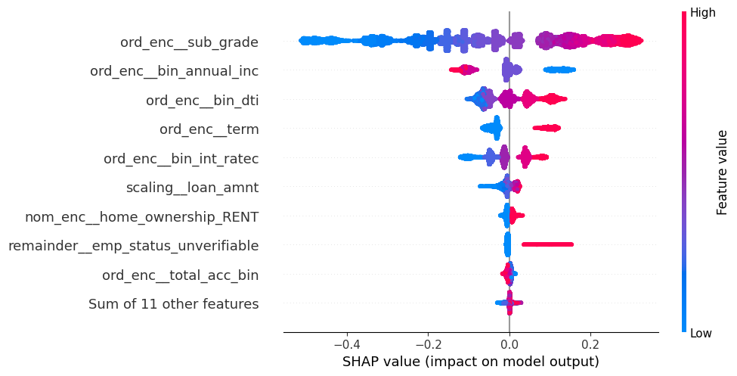

2.3 Waterfall Plots — Individual Predictions
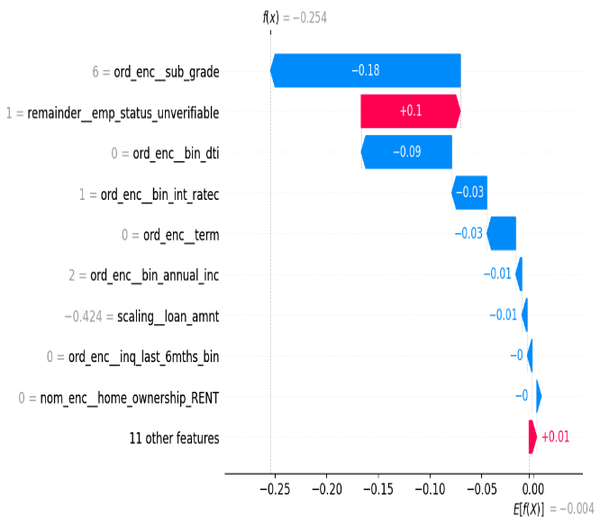
Non-Defaulter (Observation 0) — f(x) = -0.254, Probability = 44%
Feature | Value | SHAP | Direction
sub_grade | 6 (B1) | −0.18 | Protects — Grade B reduces default probability
bin_dti | 0 (<5) | −0.09 | Protects — very low DTI strongly reduces risk
bin_int_rate | 1 (8-12%) | −0.03 | Protects — low interest rate reduces risk
term | 0 (36 months) | −0.03 | Protects — shorter term reduces risk
emp_status_unverifiable | 1 | + 0.10 | Risk — unknown employment pushes toward default

Despite having unverifiable employment (+0.10), the combination of Grade B sub_grade, very low DTI, and 36-month term keeps this borrower safely in the Not Defaulter zone at 44% default probability.

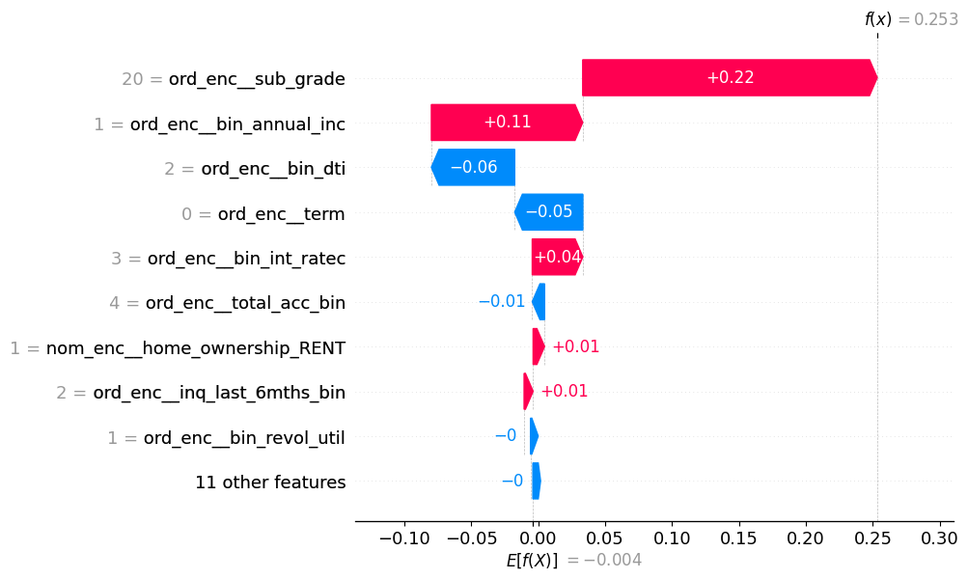
Defaulter (Observation 1) — f(x) = +0.253, Probability = 56%
Feature | Value | SHAP | Direction
sub_grade | 20 (E1) | + 0.22 | Risk — Grade E strongly pushes toward default
bin_annual_inc | 1 (18K-40K) | + 0.11 | Risk — low income increases default probability
bin_int_rate | 3 (15-21%) | + 0.04 | Risk — high rate bracket adds further risk
bin_dti | 2 (10-15) | −0.06 | Protects — moderate DTI partially offsets risk
term | 0 (36 months) | −0.05 | Protects — 36-month term reduces risk

Grade E sub_grade (+0.22) and low income (+0.11) together drive this borrower to 56% default probability. The 36-month term and moderate DTI provide partial protection but cannot overcome the grade and income signals.

2.4 Dependence Plots — Top 3 Features
sub_gradeA1-A5 (0-4): SHAP around -0.45 — Grade A borrowers strongly reduce default probability
- B-C tier (5-14): smooth monotonic increase from -0.25 to 0.0 — transition zone
- D1 onwards (15+): SHAP crosses zero — sub_grade now actively pushes toward default
- G tier (30-34): SHAP plateaus around +0.25 — model treats G-tier as equally high risk
- Perfectly monotonic — not a single reversal across all 35 sub-grades
bin_int_rate
- <8% (0): SHAP around -0.10 — safest borrowers, bank priced them correctly
- 12-15% (2): SHAP crosses zero — neutral zone
- >21% (4-5): SHAP jumps to +0.07 to +0.09 — high rate = high risk
- Discrete clusters — binned feature creates clean tier separation

term
- 36 months (0): SHAP -0.025 to -0.065 — consistently reduces default risk
- 60 months (1): SHAP +0.075 to +0.125 — consistently increases default risk
- Large gap (~0.15) — model learned a strong binary boundary between the two terms
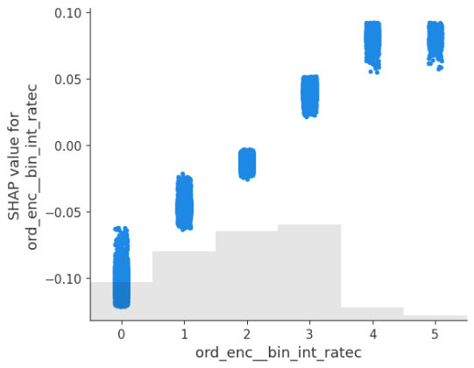
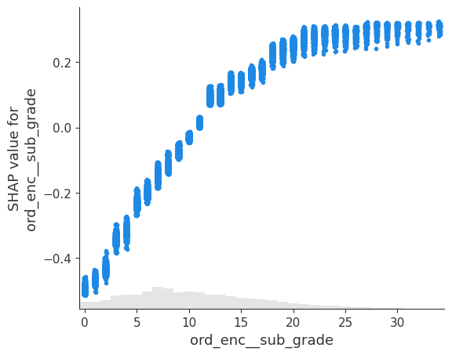
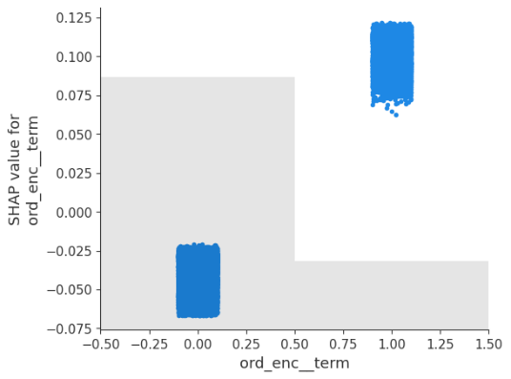

3. Logistic Regression — SHAP Analysis
3.1 Global Feature Importance — Bar Plot
Feature | Mean |SHAP| | Observation
purpose_group_Debt Management | 0.21 | Joint top — LR uses loan purpose heavily unlike GBM
bin_annual_inc | 0.21 | Joint top — income equally important as purpose
sub_grade | 0.19 | Strong but not dominant — LR distributes more evenly
bin_int_rate | 0.18 | Near-equal with sub_grade — LR weights rate independently
bin_dti | 0.16 | Higher than GBM — LR captures DTI independently
term | 0.14 | Meaningful contribution
loan_amnt | 0.11 | Higher than GBM — LR assigns more weight to loan size
inq_last_6mths_bin | 0.08 | LR captures inquiry signal, GBM largely ignores it
home_ownership_RENT | 0.08 | Consistent with EDA findings
Sum of 11 others | 0.43 | LR uses all features collectively — no single dominant
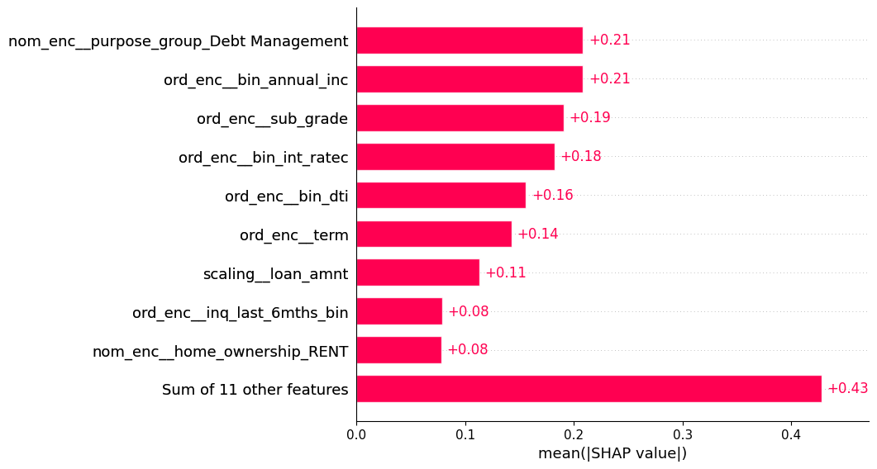
LR distributes importance far more evenly than GBM. No single feature dominates — the top 9 features all contribute meaningfully. This is a fundamental property of linear models — they cannot concentrate learning on one feature the way tree models can.

3.2 Beeswarm Plot — Direction & Distribution
- purpose_group_Debt Management — red (= Debt Management) pushes left — reduces default risk consistent with EDA (18.95% default rate vs 28.66% for Business & Education)
- bin_annual_inc — blue (low income) pushes right, red pushes left — clear income-default gradient
- sub_grade — red dots spread right — higher grade number = higher risk confirmed
- loan_amnt — widest horizontal spread — LR is uncertain about loan size, pushes both directions unlike GBM
- Sum of other features — massive blue cluster on left — collectively many features act as protective signals
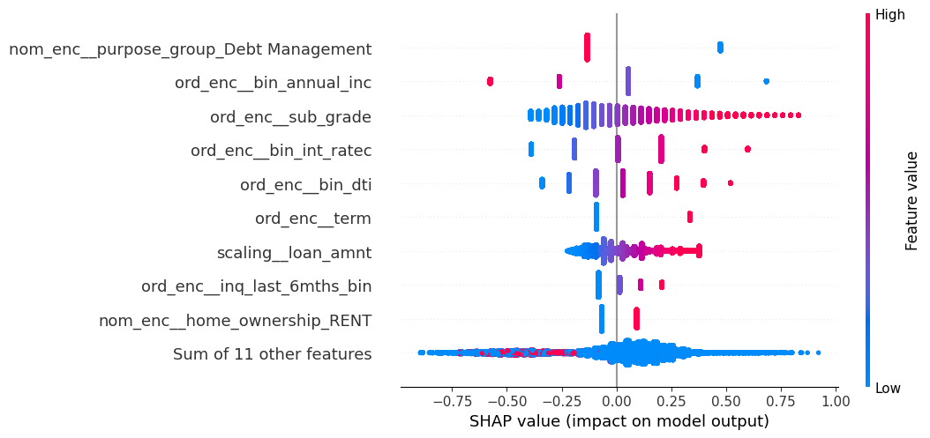
3.3 Waterfall Plots — Individual Predictions
Non-Defaulter (Observation 0) — f(x) = -0.571, Probability = 36%
Feature | Value | SHAP | Direction
emp_status_unverifiable | 1 | +0.45 | Risk — unknown employment biggest single push toward default
bin_dti | 0 (<5) | −0.34 | Protects — very low DTI is the strongest protective factor
bin_int_rate | 1 (8-12%) | −0.19 | Protects — low rate confirms safe borrower profile
sub_grade | 6 (B1) | −0.18 | Protects — Grade B reduces default probability
purpose_group_Debt Management | 1 | −0.13 | Protects — debt consolidation purpose reduces risk

LR predicts 36% default probability (vs GBM's 44%) for the same borrower. LR gives emp_status_unverifiable a much higher SHAP (+0.45) than GBM did, but the protective factors — especially very low DTI (−0.34) — outweigh it strongly.
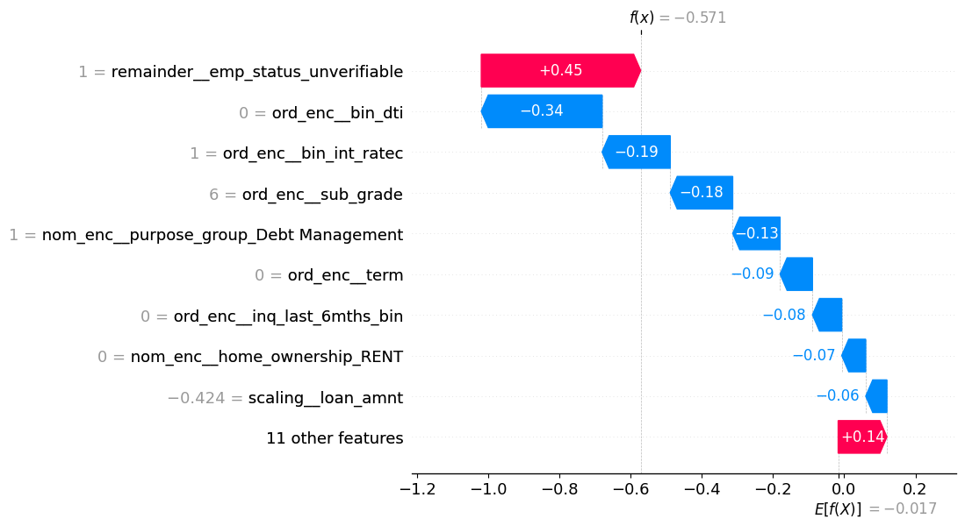

Defaulter (Observation 1) — f(x) = +0.715, Probability = 67%
Feature | Value | SHAP | Direction
bin_annual_inc | 1 (18K-40K) | +0.37 | Risk — low income is LR's biggest default signal for this borrower
sub_grade | 20 (E1) | +0.33 | Risk — Grade E confirms high risk
bin_int_rate | 3 (15-21%) | +0.20 | Risk — high rate adds further risk
purpose_group_Debt Management | 1 | −0.13 | Protects — only meaningful protective factor
inq_last_6mths_bin | 2 | +0.11 | Risk — recent inquiries add marginal risk

LR predicts 67% default probability (vs GBM's 56%) for the same borrower — LR is more aggressive. Low income (+0.37) leads over sub_grade (+0.33) — LR weights income more heavily than GBM does for this borrower.
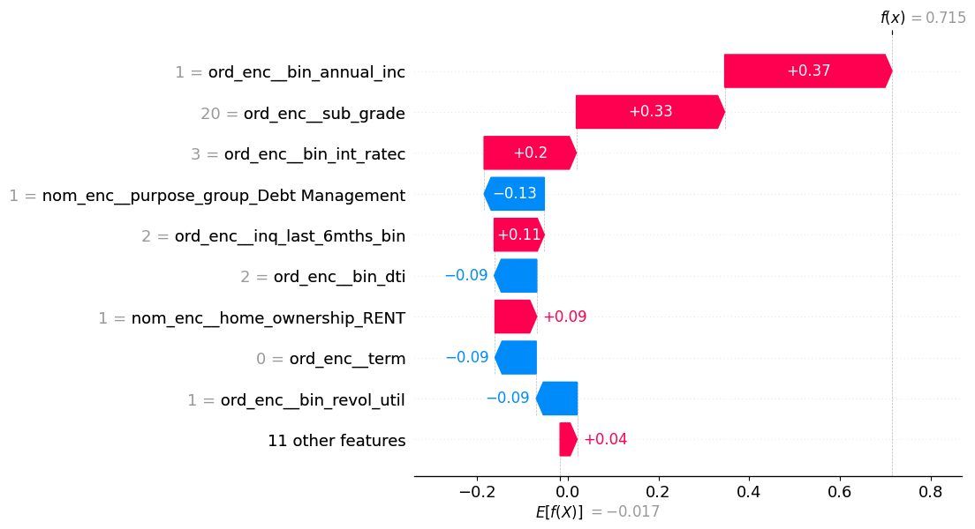

3.4 Dependence Plots — Top 3 Features
sub_grade
- Perfectly linear — straight line from -0.4 (A1) to +0.8 (G5), unlike GBM which plateaued at G tier
- No plateau — LR treats every sub_grade step as equally meaningful, cannot learn diminishing returns
- Much wider range — -0.4 to +0.8 vs GBM's -0.5 to +0.3 — LR relies more heavily on extreme grades
bin_int_rate
- Discrete jumps — 6 clean steps from -0.4 (<8%) to +0.6 (>24%)
- Much larger SHAP range than GBM — -0.4 to +0.6 vs -0.12 to +0.09 — LR assigns far more weight to interest rate
- Perfectly monotonic — each bracket meaningfully higher than previous
term
- 36 months (0): SHAP = -0.10 — reduces default risk
- 60 months (1): SHAP = +0.33 — strongly increases default risk
- Larger gap than GBM — LR weights term more aggressively

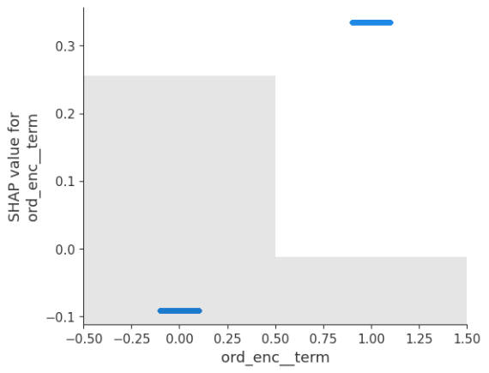
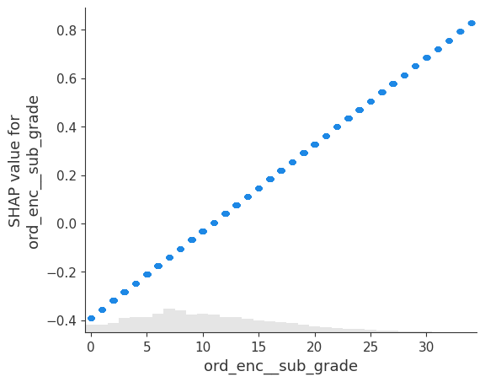
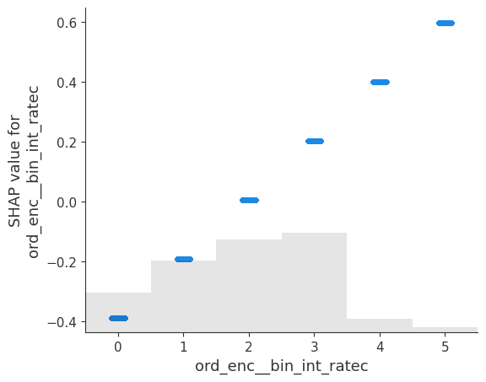

4. Side-by-Side Comparison — GBM vs LR
Feature | GBM SHAP | LR SHAP | Agreement
sub_grade | 0.19 (1st) | 0.19 (3rd) | ✅ Both top 3
bin_annual_inc | 0.06 (2nd) | 0.21 (2nd) | ✅ Both top 3
bin_dti | 0.05 (3rd) | 0.16 (5th) | ✅ Both top 6
term | 0.05 (4th) | 0.14 (6th) | ✅ Both top 6
bin_int_rate | 0.04 (5th) | 0.18 (4th) | ✅ Both top 5
purpose_group_Debt Mgmt | Absent from top 10 | 0.21 (1st) | ❌ Key difference
loan_amnt | 0.01 | 0.11 | ❌ LR weights much higher
inq_last_6mths_bin | Absent | 0.08 | ❌ Only LR captures
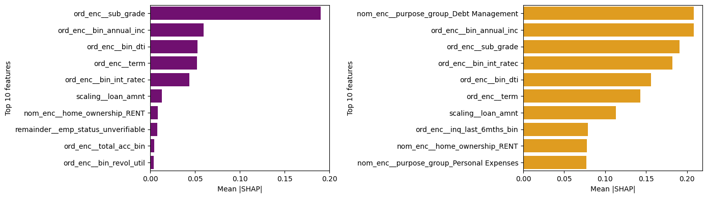

4.1 Key Findings from Comparison
- Core agreement — sub_grade, bin_annual_inc, bin_int_rate, bin_dti, term appear in top 6 of both models — confirms these are genuine default signals, not model artifacts
- GBM concentrates, LR distributes — GBM relies heavily on sub_grade (0.19 vs next at 0.06). LR spreads importance evenly — top features all within 0.08-0.21 range
- Purpose group difference — purpose_group_Debt Management ranks 1st in LR (0.21) but absent from GBM top 10. LR directly uses purpose as a linear signal; GBM absorbs it through interactions with sub_grade and income
- Interest rate disagreement — LR assigns SHAP 0.18 to bin_int_rate vs GBM's 0.04. LR cannot separate the collinear signal between sub_grade and int_rate — it uses both independently. GBM routes the shared information through sub_grade
- Individual prediction differences — for the same defaulter: GBM predicts 56%, LR predicts 67%. For the same non-defaulter: GBM predicts 44%, LR predicts 36%. LR is more extreme in both directions — consistent with its wider SHAP ranges

5. Conclusion
SHAP analysis across both models confirms the findings from Phase 2 EDA and Phase 4 evaluation, providing a statistically rigorous and visually interpretable layer of explanation:

- sub_grade is the universal dominant signal — confirmed by both models, perfectly monotonic in dependence plots, consistent with EDA finding of 6.5% to 43.7% default rate gradient
- The two-model approach is justified — GBM provides sharper, more calibrated probability estimates. LR provides a more transparent, evenly distributed explanation that regulators can audit directly through coefficients and SHAP values
- All major EDA findings confirmed by SHAP — income, DTI, term, and interest rate all show correct directional signals. No surprising reversals or contradictions
- Waterfall plots provide individual-level regulatory explanations — each loan decision can be explained in plain terms: "This borrower was flagged because their E1 grade (+0.22) and low income (+0.11) outweighed their 36-month term (-0.05)"
- GBM and LR agree on the top 5 features — this agreement strengthens confidence that the identified risk signals are genuine data patterns, not model-specific artifacts

