Financial Text Sentiment Classification
A Comparative Study of Recurrent and Attention-Based Deep Learning Architectures
Project Documentation
RNN · LSTM · GRU · Transformer Encoder — Architecture Comparison

Contents
1. Project Overview
2. Dataset
3. Data Preprocessing
4. Tokenization & Embeddings
5. Model A — Simple RNN (Baseline)
6. Model B — LSTM
7. Model C — GRU
8. Model D — Transformer Encoder-Only
10. Cross-Model Comparison
11. Limitations
12. Conclusion
13. Interview Presentation Guide

1. Project Overview

Title
Financial Text Sentiment Classification: A Comparative Study of Recurrent and Attention-Based Deep Learning Architectures

Objective
To design, train, and compare multiple deep learning architectures — Simple RNN, LSTM, GRU, and a Transformer encoder-only model — for classifying financial text (news headlines and tweets) into negative, neutral, or positive sentiment. The project traces a deliberate progression from plain recurrence to gated recurrence to self-attention, in order to build and demonstrate a concrete understanding of why each architectural change matters, rather than treating model choice as a black box.

Expected Outcome
- Four trained TensorFlow/Keras models, each classifying financial text sentiment from the same tokenized, padded input and pretrained embedding matrix (Word2Vec, with FastText as a secondary comparison on the best architecture).
- A quantitative comparison of the four architectures using validation accuracy, validation loss, and training time per epoch.
- A documented account of practical engineering issues encountered (cuDNN masking incompatibilities, overfitting patterns, regularization experiments, training instability) and how each was resolved or reasoned through.

2. Dataset

Source & Acquisition
Two financial text sources were combined: a financial news headlines dataset and a financial tweets dataset. Sentiment labels were mapped consistently across both sources (0 = negative, 1 = neutral, 2 = positive), concatenated, and shuffled with a fixed random seed to produce a single combined dataset of 14,195 rows.

Cleaning
- Dropped a stray index column carried over from the source CSVs.
- Identified and fixed a mojibake (encoding-corruption) issue in the text (garbled currency symbols) by stripping leftover non-ASCII fragments.
- Handled missing values: 4 rows with null text were dropped (14,195 → 14,191 rows).
- Fixed a pandas SettingWithCopyWarning via an explicit dataframe copy after filtering.

Class Imbalance
The dataset shows a skew toward the neutral class. This was treated as a first-class concern: validation accuracy alone was not used as the sole comparison metric, and class weighting was tested as a mitigation on the LSTM architecture.

3. Data Preprocessing
Unlike tasks where preserving 'incorrect' text is essential, sentiment classification benefits from standard text-cleaning preprocessing, since the goal is to classify meaning rather than reproduce exact surface form.
- Lowercasing and whitespace stripping
- URL removal
- Ticker symbols replaced with <TICKER>
- Hashtags replaced with <HASHTAG>
- Backtick-style quote normalization
- Emoji handling via emoji.demojize()
- Ellipsis normalization
- @mentions removed
- Stray smart quotes / em-dashes removed
- Residual mojibake / non-ASCII garbage stripped
- Stray curly braces/brackets removed
- Newlines normalized to spaces

4. Tokenization & Embeddings

Train / Validation / Test Split
60% train / 20% validation / 20% test, fixed random seed, performed before tokenization to prevent leakage.

Tokenizer
A Keras Tokenizer (with <OOV> token) fit exclusively on the training split; reused (never refit) across validation and test.

Sequence Length (MAX_LEN)
Statistic | Value
count | 8,514
mean | 13.40
std | 6.91
min | 1
50th percentile | 12
80th percentile | 18
90th percentile | 21
95th percentile | 26
99th percentile | 40
max | 81

MAX_LEN = 40 (99th percentile) chosen to cover the vast majority of data with minimal truncation, with padding='post', truncating='post' applied consistently across splits.

Pretrained Embeddings
Word2Vec (Google News, 300-dim) and FastText (Wiki+News, 300-dim) embedding matrices were built for the vocabulary, with random-normal initialization for out-of-vocabulary tokens. Word2Vec was used as the primary embedding for all four architecture comparisons; FastText is reserved as a secondary comparison on the best-performing architecture.

5. Model A — Simple RNN (Baseline)
A plain (ungated) recurrent network, used as the performance floor. Vanilla RNNs are known to struggle with longer-range dependencies due to vanishing gradients — this experiment set out to confirm that empirically.

Architecture
3 stacked Bidirectional SimpleRNN layers (256→128→64 units), Word2Vec embeddings (trainable), softmax output over 3 classes.

Tuning Attempts
Run 1 (no dropout): Severe overfitting from epoch 2 — train accuracy reached 97.8% by epoch 4 while val loss climbed from 0.61 to 0.92.
Run 2 (added dropout): Best val_loss improved to 0.660 (epoch 2), overfitting delayed but present from epoch 3.
Run 3 (reduced units, larger batch size): Very similar result (val_loss 0.684, epoch 2) — confirmed the ceiling was architectural, not a tuning artifact.

Final Result
Metric | Value
Validation Accuracy | ~74–78%
Validation Loss | ~0.66–0.68
Best Epoch | ~2
Time / Epoch | ~4 seconds

A final checkpoint was retrained (since the original run was not saved) for full test-set evaluation — see Section 9 for its classification report and confusion matrix results.

6. Model B — LSTM
Adds gating (input, forget, output) to address the vanishing-gradient limitation seen in the RNN baseline.

Technical Issue Encountered
Training initially failed with a cuDNN assertion error, caused by Bidirectional layers combined with mask_zero=True producing a reversed mask pattern that cuDNN's fused kernel does not support.
Fix: use_cudnn=False was set on all LSTM layers, forcing a slower but mask-compatible path — explaining the much longer per-epoch time versus RNN (~110–200s/epoch vs ~4s/epoch).

Training Runs
Run 1 — Untuned (256→128→64, no dropout): Best 81.65% val accuracy, 0.518 val loss at epoch 2, before overfitting.
Run 2 — KerasTuner search (3 trials): Best config: 128/96/96 units, lr 0.0001 — val_loss 0.563, worse than untuned due to short trial epoch budget.
Run 3 — Tuned config + class weights (interrupted): Best val_loss 0.587 (79.0% val acc) at epoch 3; tuned without class weighting originally, so not guaranteed optimal for the weighted objective.
Run 4 — Second search + LayerNormalization (4 trials): Best config: 64/48/32 units, lr 0.001 — val_loss 0.5138 during search, still overfit when fully trained.
Run 5 — Manually refined final model: LSTM_3 units reduced to 16, its dropout increased to 0.4, learning rate reduced to 0.0002, LayerNormalization retained between layers.

Final Model — Full Training Curve
Epoch | Train Acc | Train Loss | Val Acc | Val Loss
1 | 57.4% | 0.963 | 63.9% | 0.905
2 | 63.9% | 0.875 | 65.0% | 0.826
3 | 66.7% | 0.810 | 68.3% | 0.753
4 | 68.6% | 0.754 | 71.1% | 0.705
5 | 71.8% | 0.688 | 73.0% | 0.659
6 | 73.4% | 0.643 | 73.7% | 0.654
7 | 75.4% | 0.605 | 74.4% | 0.629
8 | 76.7% | 0.571 | 75.0% | 0.624
9 | 79.0% | 0.527 | 75.8% | 0.617
10 | 80.4% | 0.496 | 76.9% | 0.601
11 | 82.6% | 0.461 | 77.7% | 0.596
12 | 83.8% | 0.427 | 78.2% | 0.610
13 | 84.6% | 0.398 | 79.2% | 0.594 (best)

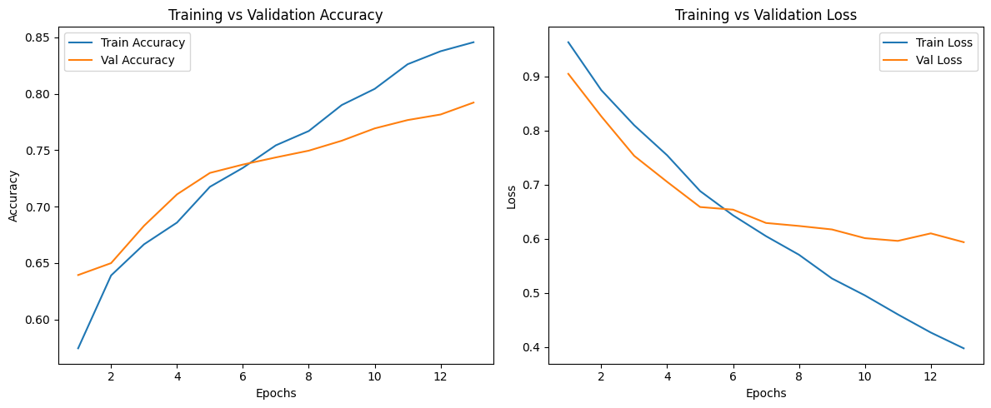
Training was deliberately stopped at epoch 13 given the consistent overfitting pattern observed in every other architecture shortly after their best point.

Final Reported LSTM Result
Metric | Untuned (Run 1, best raw) | Final Regularized Model (Run 5)
Validation Accuracy | 81.65% | 79.22%
Validation Loss | 0.518 | 0.594

The final regularized model (Run 5) is the version saved and carried forward as the project's official LSTM deliverable, prioritizing stable convergence over peak raw accuracy.

7. Model C — GRU
A lighter alternative to LSTM using fewer gates (reset, update), tested to see whether comparable accuracy could be achieved with a simpler, faster-training architecture.

Training Runs
Run 1 — 2-layer GRU (128→64), no dropout: Best 80.3% val accuracy, 0.559 val loss (epoch 6).
Run 2 — KerasTuner + heavy L1/L2 regularization (l1=0.2): Excessive L1 penalty caused abnormally high initial loss (~19 at epoch 0). Final: 78.76% val accuracy, 0.748 val loss (epoch 15) — underperformed the simpler untuned model. Documented as a negative result.
Run 3 — Final model: 2-layer GRU (64→32), no dropout: Best result at epoch 5.

Final Model — Training Curve
Epoch | Train Acc | Train Loss | Val Acc | Val Loss
0 | 62.0% | 0.895 | 65.6% | 0.816
1 | 69.7% | 0.727 | 72.1% | 0.692
2 | 75.6% | 0.600 | 74.4% | 0.629
3 | 80.0% | 0.509 | 76.4% | 0.595
4 | 84.1% | 0.420 | 77.9% | 0.566
5 | 88.1% | 0.331 | 79.64% (best) | 0.551 (best)
6 | 91.4% | 0.248 | 80.5% | 0.554
7 | 94.1% | 0.183 | 81.4% | 0.572

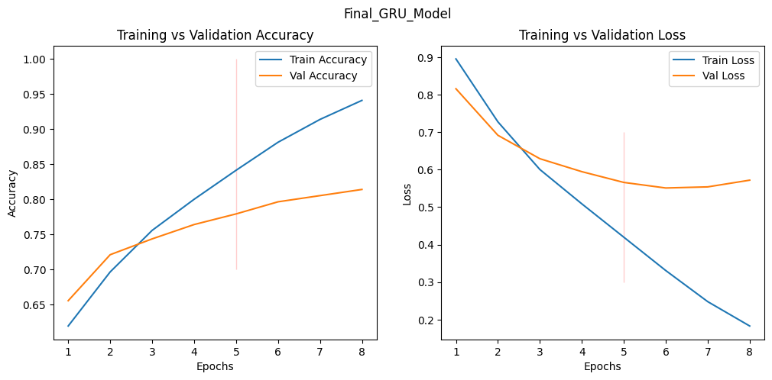

Final Reported GRU Result
Metric | Value
Validation Accuracy | 79.64%
Validation Loss | 0.551

GRU achieved the best validation loss among the recurrent models tested, using a simpler 2-layer design with no explicit dropout.

8. Model D — Transformer Encoder-Only
Replaces recurrence entirely with self-attention, allowing the model to weigh relationships between all tokens simultaneously rather than sequentially. Built using keras_hub's TransformerEncoder and PositionEmbedding layers.

Architecture
- Token embedding: Word2Vec-initialized Embedding layer (300-dim, trainable, mask_zero=True) — built manually (not via TokenAndPositionEmbedding) specifically to preserve the pretrained Word2Vec weights used consistently across RNN/LSTM/GRU.
- Position embedding: keras_hub PositionEmbedding (sequence_length=40), added to the token embedding to give the attention mechanism a sense of token order.
- 2 stacked TransformerEncoder blocks (intermediate_dim=2048, num_heads=6, activation='relu', layer_norm_epsilon=1e-05, with tuned dropout).
- GlobalAveragePooling1D to collapse the (batch, 40, 300) sequence output into a single (batch, 300) vector, respecting the padding mask.
- Dense(3, activation='softmax') classification head.
Total parameters: 7,755,499 (all trainable) — 29.58 MB, of which 4,555,500 are the Word2Vec-initialized token embedding.

Hyperparameter Search
KerasTuner RandomSearch (8 trials, 6 epochs/trial) was used to tune the dropout rate within each TransformerEncoder block.
Best configuration found: Self_attention1 (Encoder block 1 dropout) = 0.2, Self_attention2 (Encoder block 2 dropout) = 0.2, with best val_loss = 0.532 during search.
This search completed in approximately 6 minutes 40 seconds total (8 trials) — dramatically faster than the LSTM/GRU searches (45–50 minutes), since the Transformer's self-attention layers are fully parallelizable across the sequence and were not affected by the cuDNN masking workaround (use_cudnn=False) required for the recurrent models.

Final Training Run
Epoch | Train Acc | Train Loss | Val Acc | Val Loss
1 | 60.6% | 1.165 | 64.2% | 1.462
2 | 63.3% | 0.926 | 21.6% | 1.265
3 | 66.7% | 0.829 | 65.5% | 1.093
4 | 71.3% | 0.705 | 72.2% | 0.724
5 | 79.0% | 0.541 | 73.7% | 0.786
6 | 83.6% | 0.432 | 81.33% (best) | 0.517 (best)
7 | 86.3% | 0.376 | 74.7% | 0.673
8 | 88.2% | 0.326 | 76.4% | 0.908

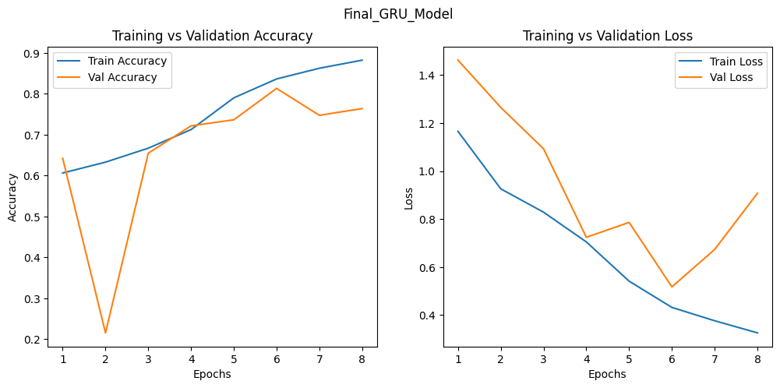
Epoch 2 shows a pronounced, temporary instability — validation accuracy dropped sharply to 21.6% (near-random for a 3-class problem) before recovering by epoch 3. This kind of single-epoch spike is a known characteristic of Transformer training (sensitive to learning rate and lacking the implicit regularization of sequential recurrence), and did not recur in later epochs. Per-epoch training time (~13–14 seconds after the first epoch) was substantially faster than LSTM/GRU (~90–200s/epoch), consistent with self-attention's parallelizable computation versus recurrence's inherently sequential processing.
Epoch 6 was selected as the final model (lowest val_loss, highest val_accuracy of the run) and reloaded from its saved checkpoint for the final saved model.

Final Reported Transformer Result
Metric | Value
Validation Accuracy | 81.33%
Validation Loss | 0.517
Time / Epoch | ~13–14 seconds

This is the best-performing model in the project by validation loss, and second only to the untuned LSTM's raw peak accuracy (81.65%) by a narrow margin — while training dramatically faster than either recurrent gated architecture, both per epoch and during hyperparameter search. This directly supports the project's core hypothesis: self-attention can match or exceed gated recurrence on this task, at a fraction of the training cost.

9. Test-Set Evaluation (Class-Imbalance-Aware Metrics)
Validation loss and accuracy, used to select each model's best checkpoint during training, do not fully account for the dataset's class imbalance (neutral dominant). A final, uniform evaluation was run on the held-out test set (2,838 samples) for all four architectures plus a secondary FastText-embedding variant of the Transformer, using macro-averaged precision/recall/F1 and macro AUC — metrics that weigh all three classes equally regardless of size.
Model provenance: each model evaluated here is the exact object persisted via joblib.dump() at the end of its respective training notebook — RNN_baseline.pkl (checkpoint from epoch 1, lowest val_loss), Final_LSTM_Model.pkl (the manually-refined model trained to epoch 13), Final_GRU_Model.pkl (loaded from epoch_06.keras, the 64→32-unit architecture's best-val-loss checkpoint), Transformer_encoder_final.pkl (loaded from epoch_06.keras, best-val-loss checkpoint), and Trasformer_fastetxt.pkl (final in-memory model state after early stopping). This ensures every number in this section reflects the specific saved model, not any intermediate or superseded training run.

Classification Reports
RNN
Class | Precision | Recall | F1 | Support
negative | 0.62 | 0.30 | 0.41 | 441
neutral | 0.83 | 0.91 | 0.86 | 1815
positive | 0.56 | 0.60 | 0.58 | 582
accuracy |  |  | 0.75 | 2838
macro avg | 0.67 | 0.61 | 0.62 | 2838
weighted avg | 0.74 | 0.75 | 0.74 | 2838
LSTM
Class | Precision | Recall | F1 | Support
negative | 0.61 | 0.51 | 0.55 | 441
neutral | 0.86 | 0.90 | 0.88 | 1815
positive | 0.64 | 0.64 | 0.64 | 582
accuracy |  |  | 0.78 | 2838
macro avg | 0.70 | 0.68 | 0.69 | 2838
weighted avg | 0.78 | 0.78 | 0.78 | 2838
GRU
Class | Precision | Recall | F1 | Support
negative | 0.64 | 0.49 | 0.56 | 441
neutral | 0.84 | 0.93 | 0.89 | 1815
positive | 0.69 | 0.59 | 0.64 | 582
accuracy |  |  | 0.79 | 2838
macro avg | 0.73 | 0.67 | 0.69 | 2838
weighted avg | 0.78 | 0.79 | 0.78 | 2838
Transformer Encoder (Word2Vec)
Class | Precision | Recall | F1 | Support
negative | 0.70 | 0.68 | 0.69 | 441
neutral | 0.85 | 0.90 | 0.87 | 1815
positive | 0.76 | 0.63 | 0.69 | 582
accuracy |  |  | 0.81 | 2838
macro avg | 0.77 | 0.73 | 0.75 | 2838
weighted avg | 0.81 | 0.81 | 0.81 | 2838
Transformer Encoder (FastText, secondary comparison)
Class | Precision | Recall | F1 | Support
negative | 0.79 | 0.46 | 0.58 | 441
neutral | 0.78 | 0.97 | 0.87 | 1815
positive | 0.80 | 0.47 | 0.59 | 582
accuracy |  |  | 0.79 | 2838
macro avg | 0.79 | 0.63 | 0.68 | 2838
weighted avg | 0.79 | 0.79 | 0.77 | 2838

Confusion Matrices

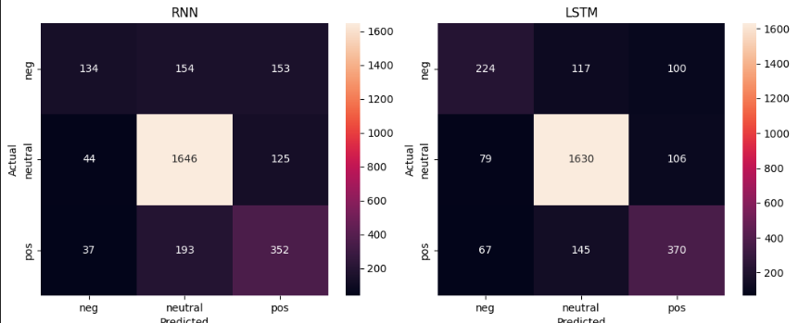

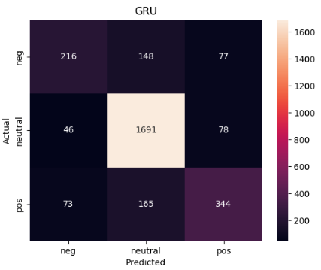
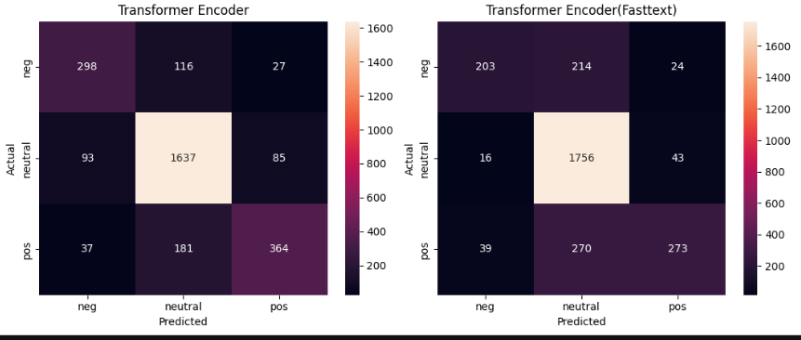
All five models — RNN, LSTM, GRU, Transformer (Word2Vec), and Transformer (FastText) — evaluated on the identical held-out test set of 2,838 samples, using the exact model objects saved via joblib.dump() at the end of each respective training notebook. The Transformer (Word2Vec) confusion matrix shows the fewest negative-to-positive misclassifications (27) of any model — LSTM: 100, GRU: 77, RNN: 153, FastText-Transformer: 24 — indicating that when it errs on a negative example, it far more often lands on the adjacent neutral class rather than the opposite sentiment. The FastText-Transformer, while similarly precise on this specific error type, shows the most conservative overall behavior: it defaults to predicting neutral far more often (214 negative and 270 positive examples misrouted to neutral), inflating precision on negative/positive at a steep cost to recall. The RNN baseline shows the weakest negative-class detection of all five (only 134 of 441 negative examples correctly identified, a 30% recall), consistent with its architectural limitations.

Macro AUC
Model | Macro AUC
RNN | 0.851
LSTM | 0.877
GRU | 0.882
Transformer (Word2Vec) | 0.897
Transformer (FastText) | 0.896

Note the RNN's AUC (0.851) is closer to LSTM/GRU (0.877/0.882) than its macro F1 gap (0.62 vs 0.69) would suggest — AUC reflects ranking quality across all thresholds, while F1 reflects performance at the specific decision threshold used. Similarly, FastText's AUC (0.896) is nearly identical to Word2Vec's (0.897) despite its much weaker macro F1 (0.68 vs 0.75) — the FastText model's underlying class-probability rankings are about as good, but its default classification behavior is far more conservative (biased toward neutral), which hurts F1 specifically without meaningfully hurting AUC.

Macro F1 — Visual Comparison
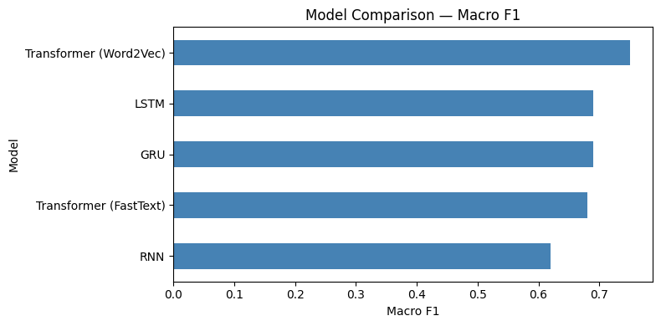

Word2Vec vs FastText — Secondary Embedding Comparison
As planned, a secondary comparison was run on the best-performing architecture (Transformer), substituting FastText embeddings for Word2Vec, holding architecture and training setup constant.
Metric | Word2Vec | FastText
Validation Accuracy | 81.33% | 80.4%
Validation Loss | 0.517 | 0.561
Test Accuracy | 81% | 79%
Macro Precision | 0.77 | 0.79
Macro Recall | 0.73 | 0.63
Macro F1 | 0.75 | 0.68

FastText training also showed pronounced early instability — validation accuracy collapsed to near-random (14.2%) for the first two epochs before recovering, compared to a single unstable epoch for the Word2Vec variant. FastText produced a notably more conservative classifier: slightly higher precision (0.79 vs 0.77) but substantially lower recall (0.63 vs 0.73), driven by a strong bias toward predicting the neutral class (97% neutral recall vs 90% for Word2Vec). Since macro F1 weighs precision and recall equally, Word2Vec's more balanced behavior gives it the clearly better macro F1 (0.75 vs 0.68). Word2Vec was retained as the primary embedding choice for this project based on this result.

Qualitative Inference Example
A small manual inference test was run on the best-performing model (Transformer, Word2Vec) with three example sentences:
Input Text | Predicted | Confidence | Expected
Company beats earnings expectations | positive | 0.55 | positive (correct)
Stock plummets after scandal | negative | 0.82 | negative (correct)
Markets remain flat today | negative | 0.55 | neutral (incorrect)

The single miss — "Markets remain flat today" predicted as negative rather than neutral — was made with low confidence (0.55, the same as the correctly-predicted positive example), suggesting genuine model uncertainty rather than a confident error. This is consistent with the confusion matrix finding that neutral is the hardest class boundary in this dataset: financial language describing an absence of change ("flat", "unchanged", "steady") can plausibly read as mildly negative even to a human annotator, making this a reasonable, explainable model error rather than a sign of a broken model.

10. Cross-Model Comparison
Model | Val Acc | Test Acc | Macro F1 | Macro AUC | Time / Epoch | Notes
RNN (baseline) | ~74–78% | 75% | 0.62 | 0.851 | ~4s | Overfits fast; weakest on negative recall (0.30)
LSTM (final) | 79.22% | 78% | 0.69 | 0.877 | ~110–200s | Best raw untuned: 81.65% / 0.518; final version regularized for stability
GRU (final) | 79.64% | 79% | 0.69 | 0.882 | ~90–140s | Best val_loss among recurrent models; heavy L1 tuning attempt underperformed
Transformer (Word2Vec) | 81.33% | 81% | 0.75 | 0.897 | ~13–14s | Best on every metric; fastest to train and tune by a wide margin
Transformer (FastText) | 80.4% | 79% | 0.68 | 0.896 | ~13–14s | More conservative (high precision, low recall); Word2Vec preferred

On the class-imbalance-aware metrics (macro F1, macro AUC), the Transformer with Word2Vec embeddings is the clear winner across the board — not only the best raw accuracy, but a macro F1 of 0.75 versus 0.69 for both LSTM and GRU and 0.62 for the RNN baseline. This gap is driven primarily by improved performance on the minority negative class (F1 0.69 vs 0.55–0.56 for LSTM/GRU), confirming that the improvement is not just from getting the dominant neutral class right, but from genuinely better handling of the underrepresented sentiment classes. This was achieved with roughly 6–10x faster per-epoch training and roughly 7x faster hyperparameter search time compared to the recurrent gated models, a training-cost advantage stemming from self-attention's parallelizable computation across the full sequence, versus the inherently sequential nature of recurrence — further compounded, for LSTM/GRU, by the need to disable cuDNN's fused kernel to work around a Bidirectional masking bug.

11. Limitations
- Class imbalance (neutral class dominant) was addressed via class weighting during training on only the LSTM architecture, not all four — though the final evaluation phase did apply macro-averaged, imbalance-aware metrics uniformly across every model.
- Hyperparameter searches used a small number of trials and short per-trial epoch budgets, meaning 'best' hyperparameters found during search did not always reflect true long-run performance (observed directly for both LSTM and GRU) — addressed via manual refinement after full training where needed.
- The heavily-regularized GRU tuning attempt used an L1 regularization strength (0.2) far outside typical ranges, over-constraining the model — a narrower, better-bounded search space would likely have been more productive.
- use_cudnn=False was required for all LSTM/GRU Bidirectional layers due to a masking incompatibility, substantially increasing their training time relative to RNN and Transformer — a known TensorFlow/Keras limitation, not a modeling choice.
- Both Transformer variants showed pronounced early-training validation instability (one unstable epoch for Word2Vec, several for FastText) that was not deeply investigated beyond noting it self-corrected — a more thorough study would examine learning-rate warmup schedules, standard practice for Transformer training that was not used here.
- One LSTM training run was interrupted by a connectivity issue; the best checkpoint up to that point was preserved and used, but the run was not repeated to completion.
- The RNN baseline's original trained model was not saved and had to be retrained from scratch for final test-set evaluation, meaning its evaluation reflects a separate (though architecturally identical) training run from the one whose epoch-by-epoch curve is reported in Section 5.
- The FastText embedding comparison and macro-AUC calculation were only performed for the Transformer (and LSTM/GRU for AUC) — a fully symmetric ablation would repeat both across every architecture.

12. Conclusion
This project compared four deep learning architectures — Simple RNN, LSTM, GRU, and a Transformer encoder-only model — for financial text sentiment classification, tracing a deliberate progression from plain recurrence to gated recurrence to self-attention.
The Simple RNN baseline consistently plateaued around 74–78% validation accuracy across three regularization attempts, confirming the expected limitation of ungated recurrence on this task. LSTM and GRU, with gating mechanisms to address vanishing gradients, both improved on this — reaching 79–82% validation accuracy — at the cost of significantly longer training time, driven partly by a cuDNN masking incompatibility that forced a slower execution path for both architectures.
The Transformer encoder-only model achieved the best validation loss of all four architectures (0.517) and validation accuracy (81.33%) nearly matching the single best recorded result across the project (untuned LSTM, 81.65%) — while training roughly an order of magnitude faster per epoch than LSTM or GRU, and completing hyperparameter search in a fraction of the time. This is the project's key empirical finding: for this dataset and task, self-attention did not merely match gated recurrence, it did so at a substantially lower training cost.
This finding was confirmed and strengthened by the final class-imbalance-aware evaluation: the Transformer's macro F1 (0.75) clearly exceeds LSTM and GRU (0.69 each) and the RNN baseline (0.62), with the largest gains concentrated on the minority negative class (F1 0.69 vs 0.55–0.56) — the classes accuracy alone tends to obscure. A secondary comparison substituting FastText for Word2Vec embeddings on the Transformer showed Word2Vec to be the better choice for this dataset: higher macro F1 (0.75 vs 0.68), better recall balance across classes, and more stable early training, despite FastText's theoretical subword advantage for out-of-vocabulary handling.
Overall recommendation: the Transformer encoder with Word2Vec embeddings is the best-performing and best value-for-training-cost architecture found in this project, on every metric measured — raw accuracy, macro F1, and macro AUC — while training substantially faster than either recurrent gated alternative. GRU is the strongest recurrent alternative if a non-attention architecture were required, edging out LSTM on validation loss while training modestly faster. The Simple RNN baseline, while weakest on every metric, served its intended purpose of empirically establishing the ceiling that gating and attention were each measured against.

13. Interview Presentation Guide
A suggested structure for walking an interviewer through this project:

1. Open with the framing (30 seconds)
"I built a financial sentiment classifier and used it as a vehicle to compare four architectures — plain RNN, LSTM, GRU, and a Transformer encoder — specifically to understand, empirically, why gating and attention actually help, and to quantify not just accuracy but training cost."

2. Walk through the progression, not just the results
- RNN as the deliberate floor — explain vanishing gradients, and that you validated this empirically across 3 regularization attempts rather than assuming it.
- LSTM's improvement — quantify it (81.65% vs ~76% for RNN) and explain gating's role.
- GRU as the practical middle ground — fewer parameters, best val_loss among recurrent models.
- Transformer as the headline result — best overall val_loss, competitive accuracy, and roughly 6-10x faster training — the strongest evidence in the whole project for attention over recurrence on this task.

3. Have 3–4 'debugging story' answers ready
- The cuDNN masking bug (Bidirectional + mask_zero) — what the error meant and the use_cudnn=False fix.
- The mojibake / data cleaning issue — diagnosing and fixing corrupted currency symbols.
- The over-aggressive L1 regularization experiment on GRU — shows you interpret tuning results critically.
- The Transformer's epoch-2 validation instability — shows you can read a training curve and distinguish a transient blip from a real problem.

4. Lead with the training-cost finding
The most sophisticated framing available from this project: "The Transformer didn't just perform best — it did so roughly 7-10x faster to train and tune than LSTM or GRU. In a real deployment, that's often the more important number than a percentage point of accuracy." This shows product judgment, not just modeling ability.

5. Own the limitations directly
When asked what you would do differently: mention applying class weighting consistently across all models, using a learning-rate warmup schedule for the Transformer (standard practice you didn't have time to add), completing the macro-F1 evaluation, and finishing the FastText comparison on the winning architecture. Stating limitations clearly, without over-apologizing, signals maturity.

6. Close with the comparison table
Having the final comparison table (Section 9) memorized — or pulled up on screen — as the anchor for the whole conversation keeps the discussion concrete and gives the interviewer natural follow-up questions to ask.

