DEV AASTHA · SHIPROCKET PERFORMANCE REVIEW
Where the wallet money went
17 August – 15 September 2026 · 30 days · Prepared 15 September 2026
Sources: Shiprocket exports for shipping charges (671 shipments), orders (861), weight discrepancy (130 cases, 29 Jun – 7 Aug), COD remittance (13 batches) and wallet recharges (16 transactions).

1. Executive summary
In the last 30 days ₹1,98,000 was added to the Shiprocket wallet and ₹1,50,458 was consumed by 671 shipments. Those shipments carried ₹11,65,094 of sales, so shipping cost 12.9% of sales overall. The average is misleading: a COD order costs ₹302 to deliver (18.2% of its value) while a prepaid order costs ₹195 (9.5%).
Three leaks explain most of the bill. Returns (RTO) burned ₹23,501 of freight and blocked ₹1,09,126 of sales; almost all of it was COD. Air shipping added about ₹12,500 over Surface for no service gain on COD. And every product in Shopify is set to 0 kg, so the courier re-weighs each parcel: the last discrepancy report shows 130 cases and ₹13,185 extra, none of which was disputed.
COD remittance is healthy: 13 batches, ₹2,82,707 paid, zero deductions, on a steady D+8 cycle. ₹1,54,831 of delivered COD is queued for the next batches and ₹1,75,535 is still in transit.
Metric | Value | Note
Wallet recharged | ₹1,98,000 | 15 recharges; one ₹15,000 attempt failed on 2 Sep
Wallet spent (freight + COD charges + RTO) | ₹1,50,458 | 671 shipments · 76% of recharge
Unexplained balance | ₹47,542 | Needs passbook to confirm balance vs older dues
Orders received | 861 | 626 shipped · 114 cancelled · 67 new · 54 self-fulfilled
Sales on shipped orders | ₹11,65,094 | AOV ₹1,861 · shipping = 12.9% of sales
Sales delivered | ₹6,92,368 | 374 orders
Sales lost to RTO | ₹1,09,126 | 64 orders · freight lost ₹23,501
Cost per delivered order: COD vs Prepaid | ₹302 vs ₹195 | 18.2% vs 9.5% of order value
Weight discrepancy (29 Jun – 7 Aug) | ₹13,185 | 130 cases, all auto-accepted
COD remitted in period | ₹2,82,707 | 13 batches, 0 deductions

2. Recharge → Spend → Orders → Sales
Week-by-week view of what went into the wallet, what Shiprocket charged, and the orders and sales behind it. The last row covers only 14 and 15 September.
Week starting | Recharge | Wallet spend | Shipments | Orders | Sales (shipped) | Spend % of sales
17 Aug | ₹25,000 | ₹20,697 | 97 | 139 | ₹1,60,363 | 12.9%
24 Aug | ₹40,000 | ₹24,480 | 99 | 158 | ₹2,08,208 | 11.8%
31 Aug | ₹58,000 | ₹39,976 | 195 | 234 | ₹3,53,023 | 11.3%
07 Sep | ₹45,000 | ₹43,086 | 171 | 241 | ₹3,62,043 | 11.9%
14 Sep | ₹30,000 | ₹22,219 | 109 | 89 | ₹81,456 | 27.3%
30-day total | ₹1,98,000 | ₹1,50,458 | 671 | 861 | ₹11,65,093 | 12.9%

Payment type | Orders shipped | Sales | Share of sales
COD | 364 | ₹6,08,238 | 52.2%
Prepaid | 262 | ₹5,56,856 | 47.8%

3. Where 100% of the wallet spend went
By purpose: forward freight on delivered orders and the COD collection charge are productive spend (82.5%). The three RTO slices, ₹27,014 or 17.5%, are money lost on parcels that came back.
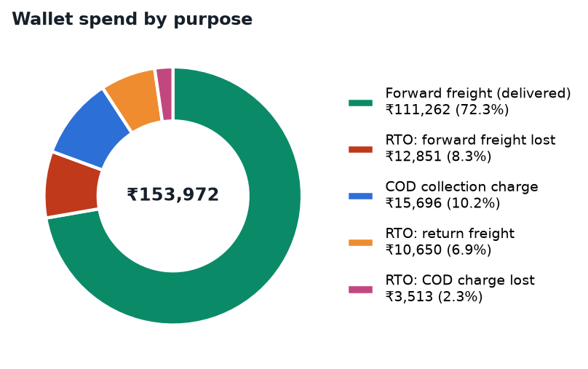
Purpose | Amount | Share
Forward freight on delivered orders | ₹1,11,262 | 72.3%
COD collection charge (about ₹50 per COD order) | ₹15,696 | 10.2%
RTO: forward freight lost | ₹12,851 | 8.3%
RTO: return freight | ₹10,650 | 6.9%
RTO: COD charge lost | ₹3,513 | 2.3%
Total wallet spend | ₹1,53,972 | 100%
By order type: COD Air is 18% of shipments but 25% of the wallet. COD overall takes 62.7% of spend for 56.8% of shipments.
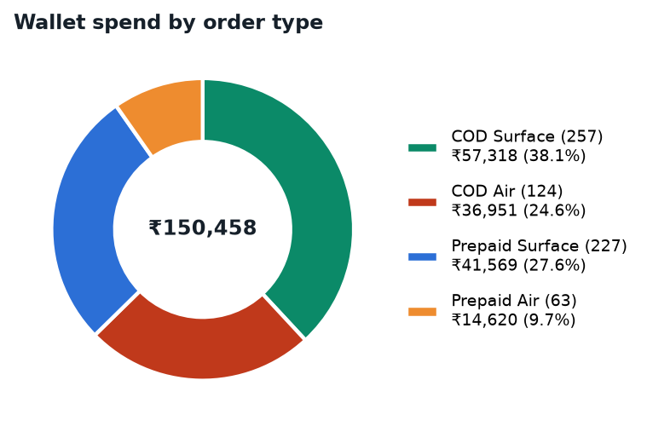

4. AOV vs ASC (Average Order Value vs Average Shipping Cost)
"ASC per shipment" is what Shiprocket charged per parcel. "ASC per delivered order" spreads the RTO losses over the orders that actually reached a customer, which is the true cost of getting one sale delivered.
Segment | Orders | Sales | Shipping paid | AOV | ASC / shipment | ASC % of AOV | ASC / delivered | % of AOV (deliv.) | RTO
All | 671 | ₹11,49,698 | ₹1,50,458 | ₹1,828 | ₹224 | 12.3% | ₹251 | 13.6% | 71
COD | 381 | ₹6,14,209 | ₹94,269 | ₹1,669 | ₹247 | 14.8% | ₹302 | 18.2% | 69
Prepaid | 290 | ₹5,35,489 | ₹56,189 | ₹2,052 | ₹194 | 9.4% | ₹195 | 9.5% | 2
COD Surface | 257 | ₹4,14,610 | ₹57,318 | ₹1,672 | ₹223 | 13.3% | ₹272 | 16.3% | 46
COD Air | 124 | ₹1,99,600 | ₹36,951 | ₹1,663 | ₹298 | 17.9% | ₹366 | 22.3% | 23
Prepaid Surface | 227 | ₹4,14,801 | ₹41,569 | ₹2,074 | ₹183 | 8.8% | ₹185 | 8.9% | 2
Prepaid Air | 63 | ₹1,20,688 | ₹14,620 | ₹1,978 | ₹232 | 11.7% | ₹232 | 11.7% | 0
Shipping consumes 18.2% of sales on COD orders versus 9.5% on prepaid. Same products, same customers, double the logistics cost. On COD Air it reaches 22.3%.

Shipping ratio by order value
Shipping cost is nearly flat (₹200 to ₹320 per order) regardless of order value, so the ratio is decided by AOV. Orders under ₹1,300 are 31% of volume and the worst-performing bucket.
Order value | Orders | Sales | Shipping paid | AOV | ASC | ASC % of AOV | RTO
Under ₹1,300 | 198 | ₹2,33,937 | ₹42,398 | ₹1,181 | ₹214 | 18.1% | 16
₹1,300–1,600 | 214 | ₹3,12,768 | ₹42,265 | ₹1,462 | ₹197 | 13.5% | 31
₹1,600–2,100 | 71 | ₹1,39,699 | ₹15,972 | ₹1,968 | ₹225 | 11.4% | 8
₹2,100–3,000 | 107 | ₹2,78,875 | ₹28,045 | ₹2,606 | ₹262 | 10.1% | 13
₹3,000+ | 39 | ₹1,84,420 | ₹12,501 | ₹4,729 | ₹321 | 6.8% | 0

5. Weight discrepancy
The courier weighs and measures every parcel and bills the higher of actual and volumetric weight. The latest discrepancy report covers 29 Jun 2026 to 7 Aug 2026. Nothing has been raised for the current 30 days yet because 628 of 671 shipments are still unbilled; those charges will follow.
Metric | Value
Discrepancy cases | 130
Amount originally billed | ₹25,566
Amount after re-weigh | ₹38,751
Extra charged | ₹13,185 (average ₹101 per case)
Average entered weight | 0.61 kg
Average charged weight | 1.67 kg (2.7× the entered weight)
Cases disputed | 0 of 130 – all auto-accepted after the 7-day window

By courier
Courier | Cases | Entered kg | Charged kg | Extra charged
Blue Dart Surface | 73 | 0.58 | 1.61 | ₹7,460
Delhivery Surface | 22 | 0.51 | 1.27 | ₹1,409
Delhivery Air | 7 | 0.63 | 1.79 | ₹1,060
Blue Dart Air | 4 | 0.35 | 1.5 | ₹856
DTDC Air 500gm | 3 | 0.27 | 2.33 | ₹749
DTDC Surface | 6 | 0.69 | 1.67 | ₹653
Delhivery Reverse Surface | 3 | 0.33 | 1.33 | ₹303
DTDC Surface 2kg | 3 | 2.02 | 4 | ₹200

By product (top 8)
Product | Cases | Entered kg | Charged kg | Extra charged
Dev Aastha Silver-Plated Kamdhenu Cow Idol with Calf - 6 Inc | 2 | 0.1 | 3.25 | ₹942
Silver-Plated Lakshmi Ganesha Idol Set | Auspicious Ganesh L | 13 | 0.5 | 1.04 | ₹881
Standing Balaji Silver-Plated Idol (4.7") | 10 | 0.6 | 1.2 | ₹809
Handcrafted Ganesha Silver Shankh - Dual-Tone Divine Decor | 8 | 0.62 | 1.88 | ₹803
Kamdhenu Cow with Calf Silver Plated Idol | Auspicious Home | 9 | 0.48 | 1.28 | ₹730
Handcrafted Silver-Plated Elephant Pair for Vastu & Gifting | 10 | 0.1 | 2 | ₹681
Silver Plated Shubh Labh Door Decor for Home Entrance - 5 In | 4 | 0.5 | 1.75 | ₹673
Dev Aastha Silver-Plated Kamdhenu Cow Idol with Calf - 2.5 I | 4 | 0.28 | 1.75 | ₹596
Root cause. Every active product in Shopify has weight 0 kg, so Shiprocket books each parcel at a guessed weight (usually 0.5 kg in a 17×14×10 cm box). The courier measures 1 to 3.5 kg and larger boxes, and wins every time. Silver-plated idols with wooden bases are heavy; the entered weights do not reflect the packed parcel.

6. COD remittance: total vs paid vs scheduled vs pending
Status of the cash from COD orders delivered in the period. Remittance runs on a D+8 cycle: every order in the data was paid 8 to 10 days after delivery, in batches every 2 to 3 days.
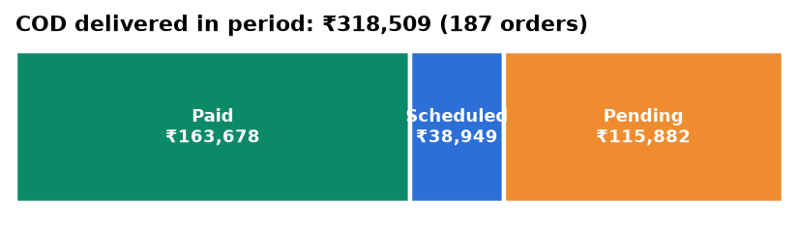
Status | Orders | Amount | When
Total COD delivered (17 Aug – 15 Sep) | 187 | ₹3,18,509
Paid – remitted to bank | 94 | ₹1,63,678 | Received
Scheduled – delivered by 7 Sep, due in next batch | 24 | ₹38,949 | Around 16 Sep
Pending – delivered after 8 Sep | 69 | ₹1,15,882 | 18 – 25 Sep
COD still in transit, NDR or pickup | 110 | ₹1,75,535 | 8 days after delivery
COD returned (RTO), sale not realised | 63 | ₹1,07,773 | Not receivable
Remittance batches paid in period (includes older orders) | 13 batches | ₹2,82,707 | 0 deductions

Remittance batches
Date | CRF ID | Amount | UTR | Status
2026-09-14 | 13458022 | ₹68,406 | CMS5878985786 | Remitted
2026-09-11 | 13452842 | ₹14,467 | CMS5876183772 | Remitted
2026-09-09 | 13439501 | ₹23,393 | CMS5872865301 | Remitted
2026-09-07 | 13427893 | ₹27,855 | CMS5868879102 | Remitted
2026-09-04 | 13421375 | ₹11,718 | CMS5863412783 | Remitted
2026-09-02 | 13406562 | ₹15,491 | CMS5859796551 | Remitted
2026-08-31 | 13392797 | ₹23,982 | CMS5854746969 | Remitted
2026-08-28 | 13385334 | ₹21,662 | CMS5849848664 | Remitted
2026-08-26 | 13375200 | ₹15,763 | CMS5846250485 | Remitted
2026-08-24 | 13360440 | ₹28,185 | CMS5840149743 | Remitted
2026-08-21 | 13353791 | ₹7,196 | CMS5836869899 | Remitted
2026-08-19 | 13343831 | ₹7,946 | CMS5833969439 | Remitted
2026-08-17 | 13330440 | ₹16,643 | CMS5829345677 | Remitted

7. Pickup status
At export time 90 orders were awaiting pickup. 88 of them belong to the 14 September batch (AWB generated in the afternoon, pickup scheduled for the next day), which is the normal one-day lag. Three orders are genuinely stuck:
- Order 3573 · Delhivery Air · since 7 Sep · Out for pickup, 8 days
- Order 3548 · Bluedart Surface · since 14 Sep · Customer could not hand over, ₹6,799
- Order 3836 · Bluedart Surface · since 14 Sep · Pickup rescheduled, ₹7,774

8. Gaps identified
Twelve process and data gaps found in the exports. Each row gives the evidence and what it costs.
# | Gap | Evidence | Impact
1 | Product weights not set in Shopify | All active products carry 0 kg. Parcels are booked at a guessed weight and the courier scale decides the bill. | 130 discrepancies, ₹13,185 extra in 6 weeks; 1.67 kg charged vs 0.61 kg entered on average.
2 | Weight discrepancies never disputed | 130 of 130 cases auto-accepted. Courier photos are attached to each case but nobody reviewed them within 7 days. | ₹13,185 lost with no recovery attempt; will repeat when the current period is billed.
3 | Billing lag hides this month's real cost | 628 of 671 shipments (94%) still "Unbilled"; discrepancy charges for Aug–Sep have not hit the wallet. | True cost of the last 30 days will exceed ₹1,50,458.
4 | No courier selection rule | 187 shipments (28%) on Air, 124 of them COD. Air costs ₹67 more than Surface at the same zone and weight. | ₹12,499 extra in 30 days; COD Air RTO rate 19%.
5 | No risk check before shipping COD | GoKwik tags orders High/Medium/Low risk, but every COD order ships without a confirmation call or partial payment. | 69 COD returns (18%): ₹22,874 freight lost, ₹1,07,773 sales not realised.
6 | No minimum order value or shipping fee on COD | 198 orders (31%) under ₹1,300, mostly COD, all free shipping. | Shipping = 18.1% of order value; most RTOs in this bucket.
7 | Zone E shipped at standard terms | 27 orders to North-East, J&K and remote pincodes on the same free-shipping COD terms as metros. | Shipping = 21.2% of AOV in Zone E.
8 | Pickup one day after AWB generation | AWBs generated in the afternoon, pickup next day; 88 orders from 14 Sep still waiting on 15 Sep. | Orders 3573 (since 7 Sep), 3548 (₹6,799) and 3836 (₹7,774) stuck beyond the normal lag.
9 | Wallet not reconciled | ₹1,98,000 recharged vs ₹1,50,458 charged; no passbook provided; one ₹15,000 recharge failed on 2 Sep. | ₹47,542 unaccounted for (balance or older dues).
10 | Orders handled outside Shiprocket have no tracking | 80 orders "Self fulfilled" or via "OTHER" with no AWB; 67 still "New order"; 114 cancellations (13%) with no reason captured. | No delivery visibility or cost data for 80 orders; cancellation causes cannot be fixed.
11 | COD cash locked for 8–10 days | Remittance on D+8. ₹1,54,831 delivered COD waiting plus ₹1,75,535 in transit. | About ₹3.3 lakh tied up at any time; Early COD not evaluated.
12 | Same courier on two rate cards | "Blue Dart Surface" (59 shipments, ₹217 avg) and "Bluedart_Surface" (278 shipments, ₹206 avg) both in use. | The costlier courier ID still gets about 1 in 6 Blue Dart shipments.

9. Action plan
Four actions, in order of effort. Savings are monthly estimates from this 30-day data.
# | Action | Why | Estimated saving
1 | Stop using Air for COD; set Surface as default in courier priority | 124 COD shipments went by Air at ₹67 more than Surface, with a higher return rate. Delivered cost per COD order falls from ₹366 to ₹272. | About ₹8,000 / month
2 | Prepaid-only or ₹99 shipping fee for orders under ₹1,300 | 198 orders (31%) with an 18% shipping ratio and the highest return count. | About ₹6,000 / month plus fewer RTOs
3 | Confirmation call or partial COD on GoKwik "High Risk" orders | 69 COD returns cost ₹22,874 in freight and ₹1.08 lakh in unrealised sales. | RTO 18% → 10% is about ₹10,000 / month
4 | Set real packed weight and box size on every Shopify product; dispute new discrepancies within 7 days | All products are at 0 kg today, so the courier scale always wins. | About ₹10,000 / month
5 | Monthly wallet reconciliation from the passbook; review courier ID mapping; add a cancellation-reason field | Closes gaps 9, 10 and 12. | Visibility
Definitions. Shipping cost = Shiprocket "Applied Total Amount" (forward freight + COD charge + RTO freight). Sales = Shiprocket order total of shipped orders; cancelled, new and self-fulfilled orders are excluded. AOV vs ASC covers 671 shipments, of which 629 matched an order value.

