

22CSCI03P

Principles of Web Programming

# Final Submission

## Group # (4)

### **Members:**

|  |  |  |
| --- | --- | --- |
| ID | Student Name | BUE Email |
| 231051 | Ahmed Maged Elgalaly | [Ahmed231051@bue.edu.eg](mailto:Ahmed231051@bue.edu.eg) |
| 235669 | Farida Shrief Azouz | [Farida235669@bue.edu.eg](mailto:Farida235669@bue.edu.eg) |
| 235576 | Abdelrahman Mahmoud Almakhzangy | [Abdelrahman235576@bue.edu.eg](mailto:Abdelrahman235576@bue.edu.eg) |
| 229698 | Youssef Hesham Abdelfatah | [Youssef229698@bue.edu.eg](mailto:Youssef229698@bue.edu.eg) |
| 235185 | Nouran Mostafa Elkady | [Nouran235185@bue.edu.eg](mailto:Nouran235185@bue.edu.eg) |
| 231881 | Mohamed Mamdouh Shams | [Mohamed231881@bue.edu.eg](mailto:Mohamed231881@bue.edu.eg) |

About Us

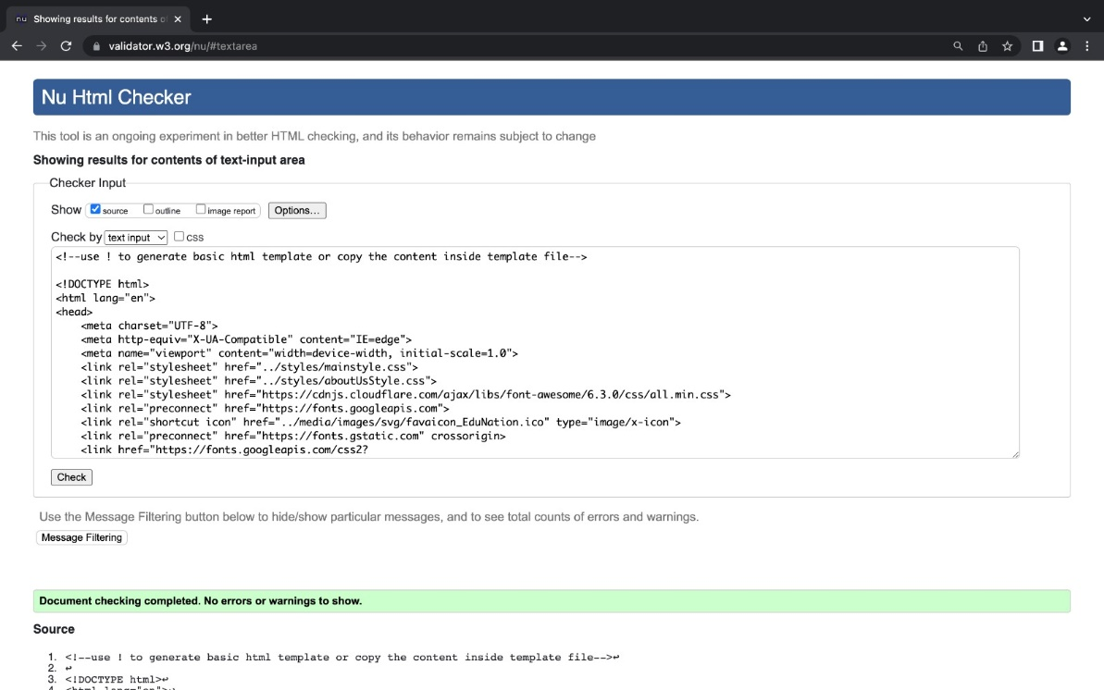

Categories

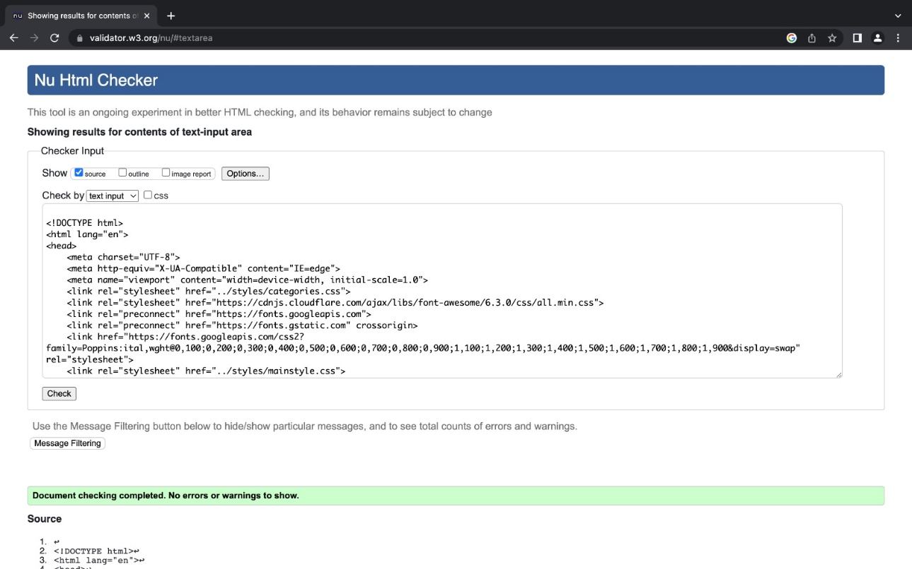

languages html

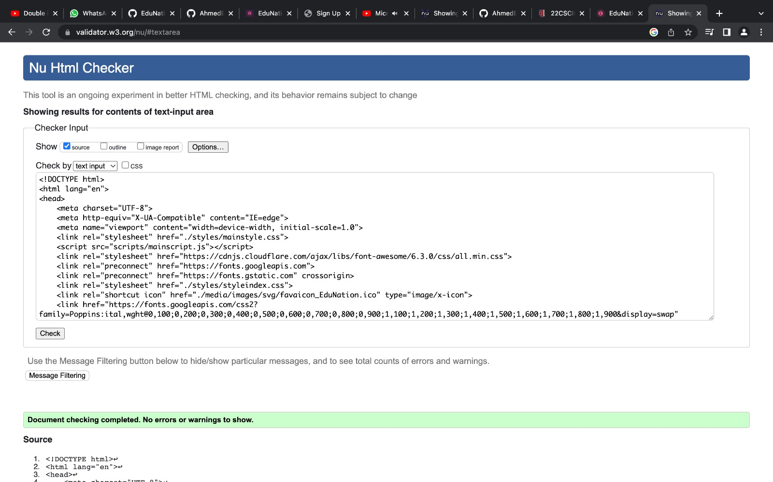

login used

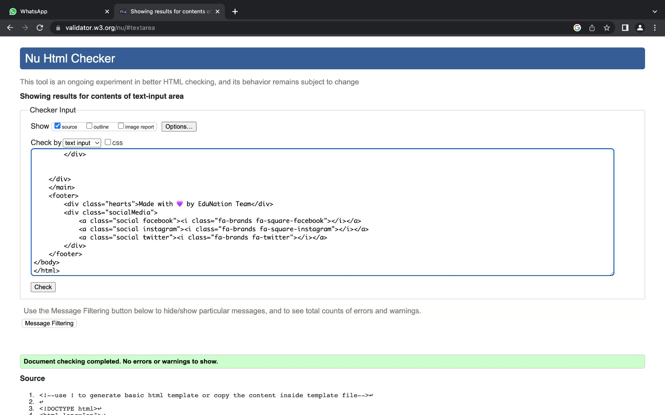

maths html

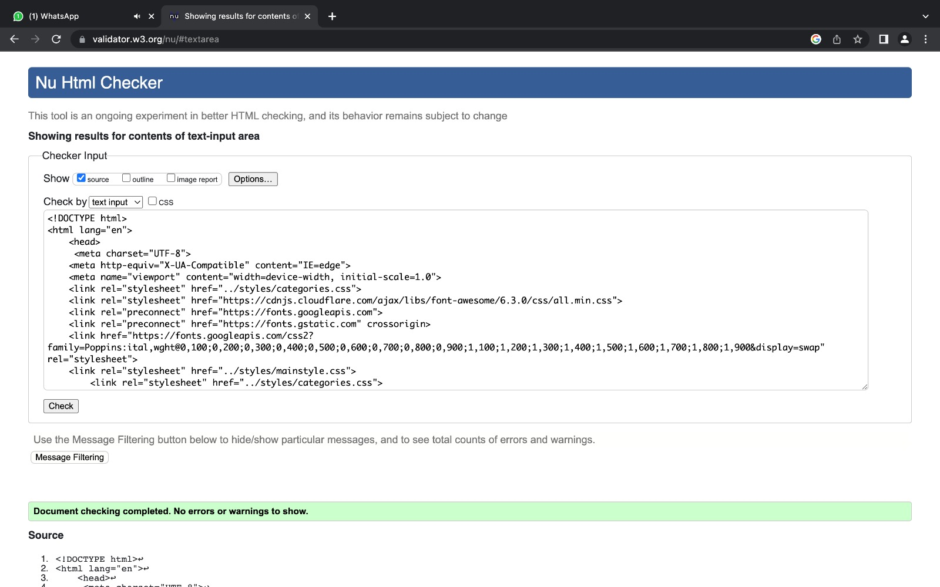

programming.html



Qa.html

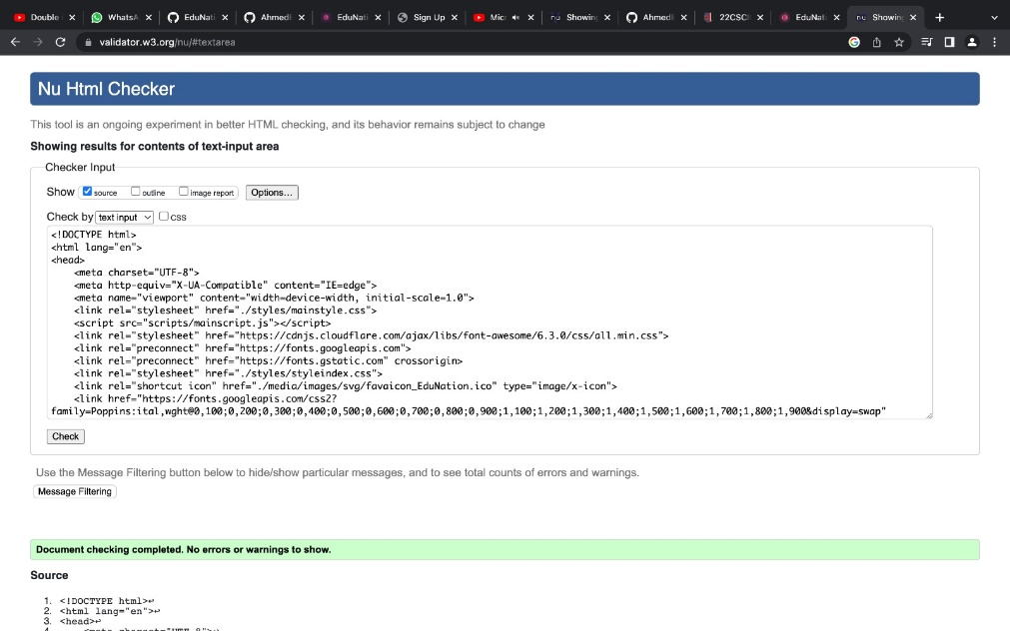

signup.html

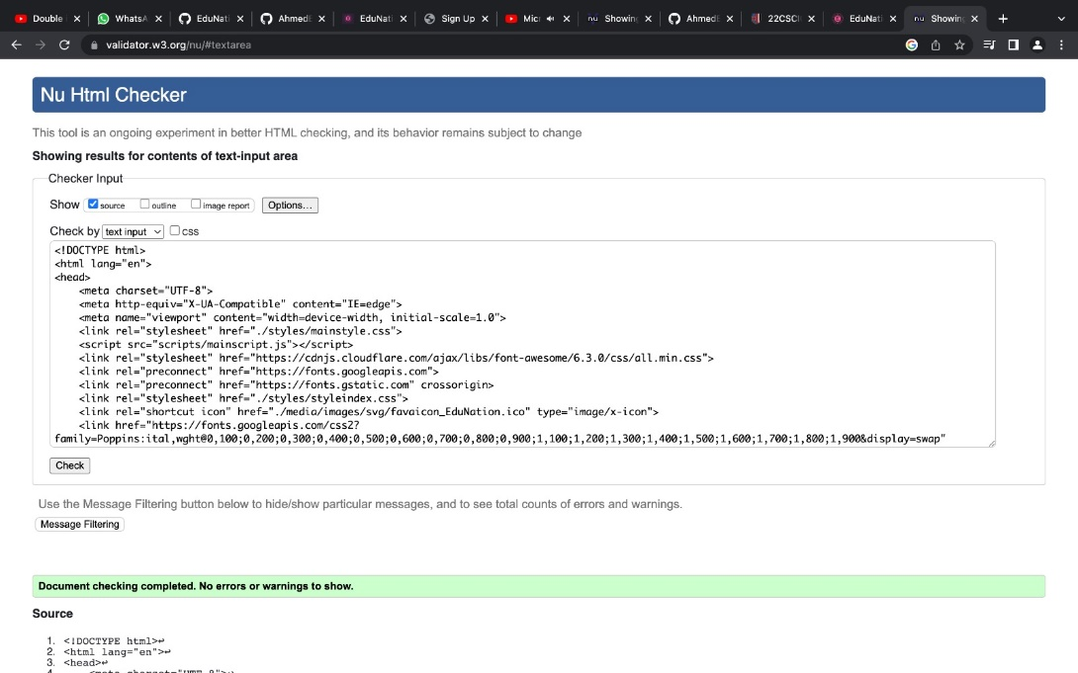

skills.html

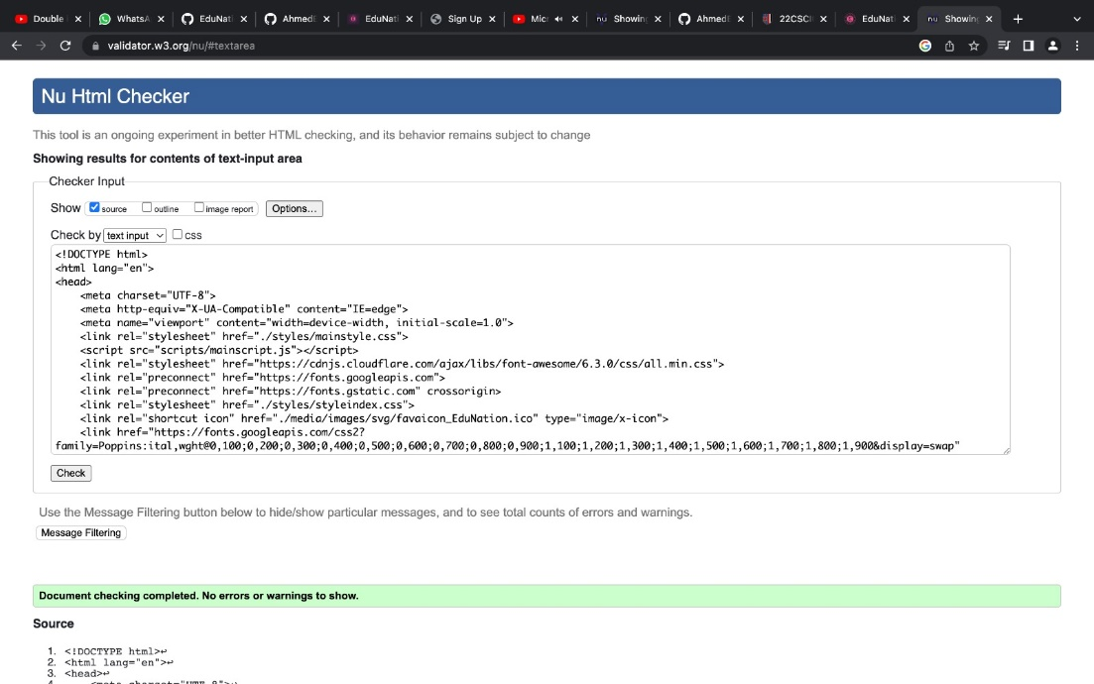

techused.html

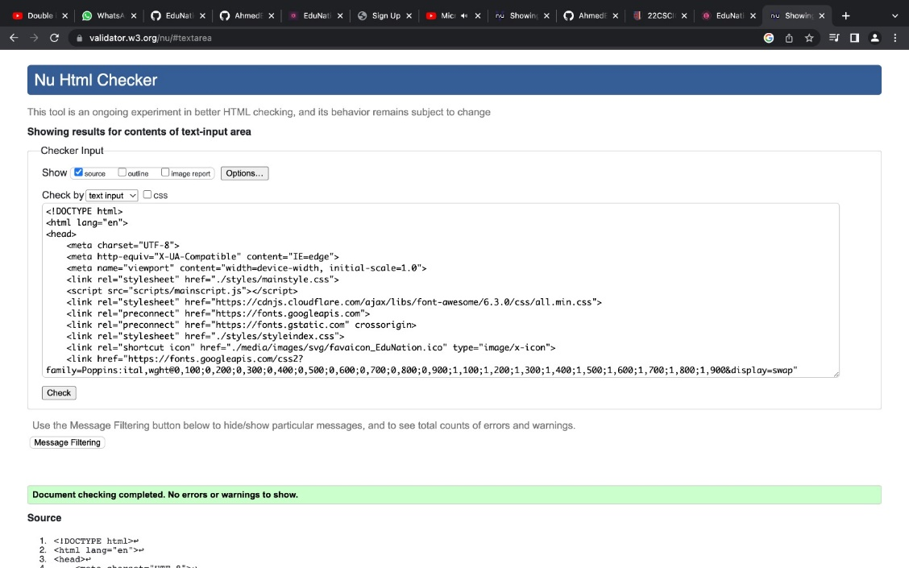

video.html

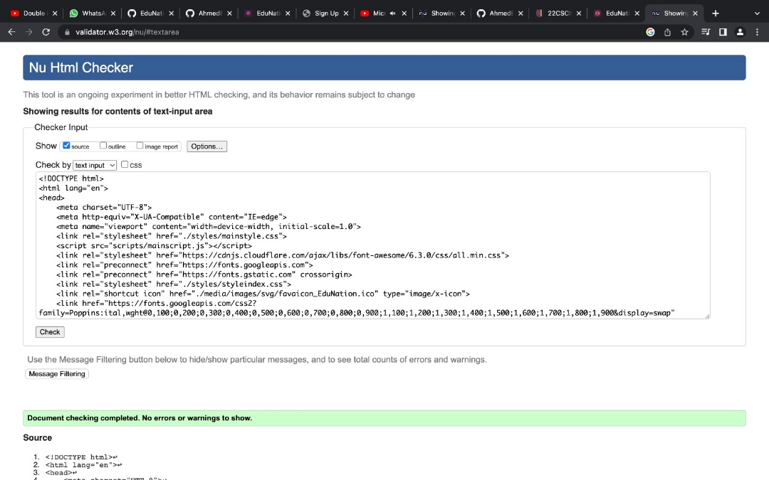

index.html

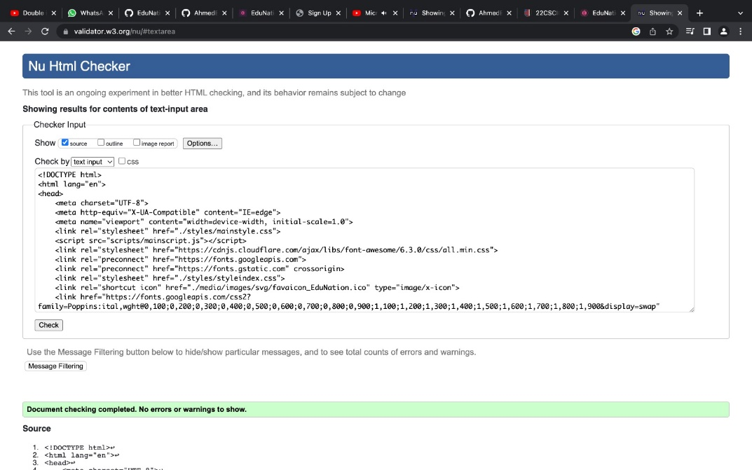

Main style css

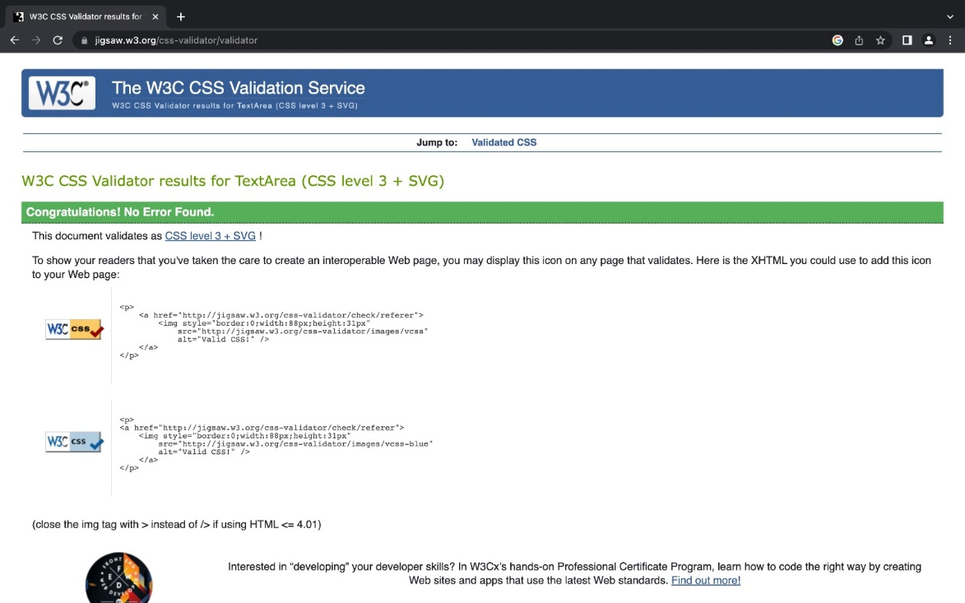

Wire Frame

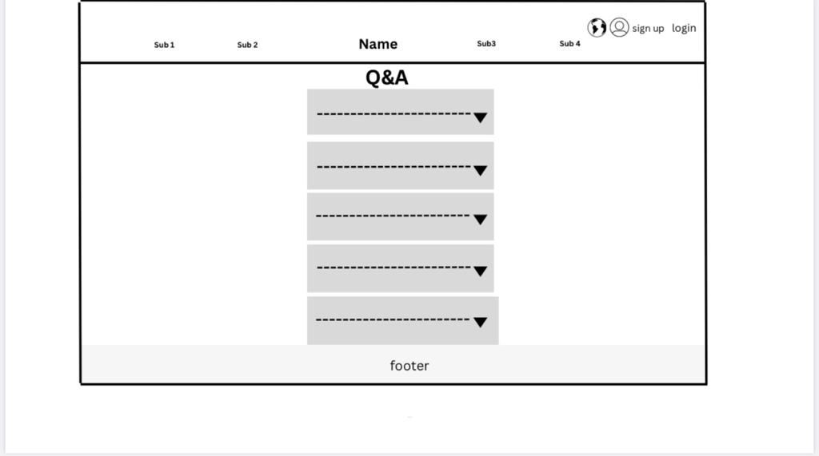

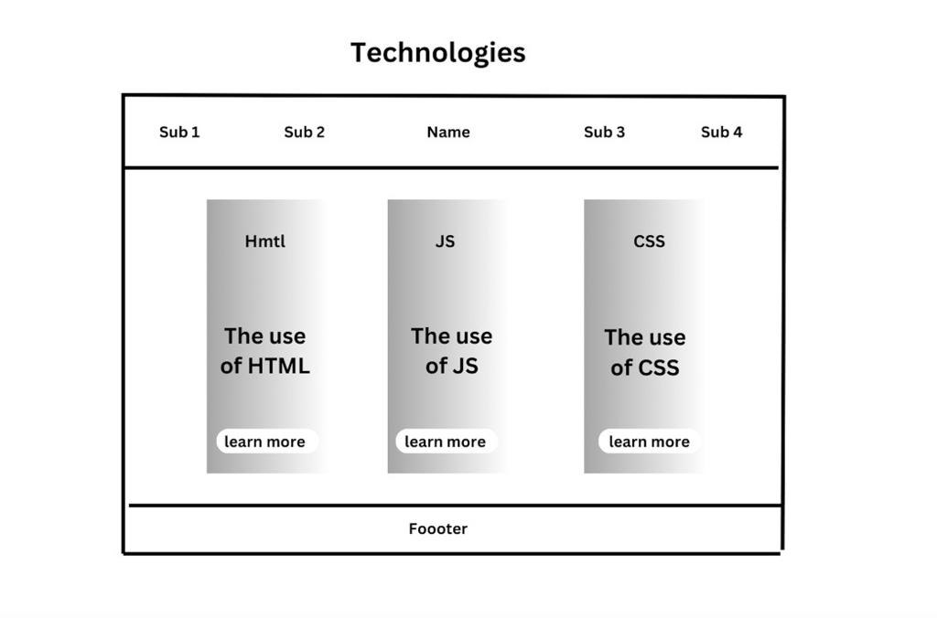

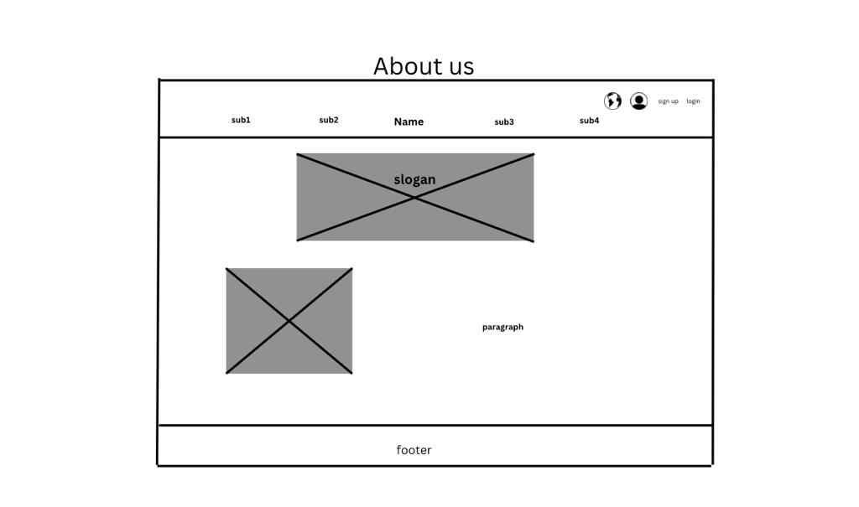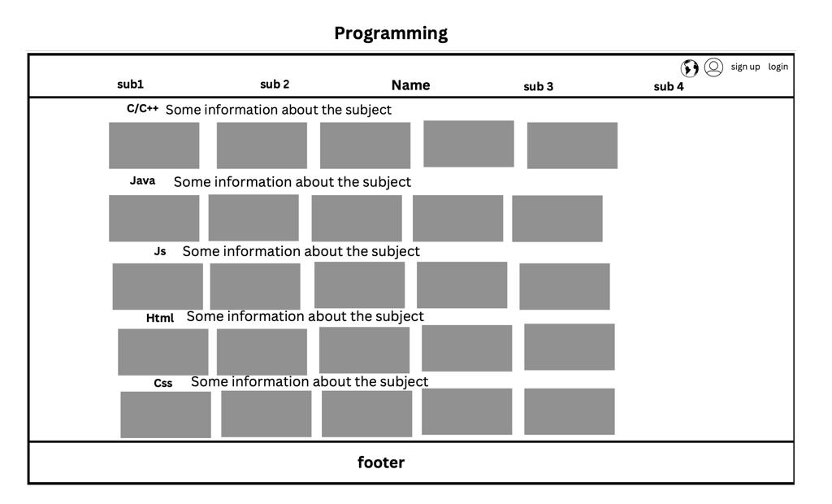

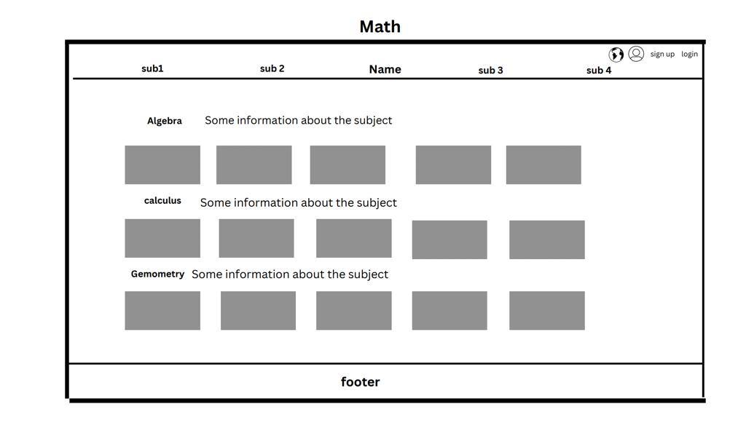

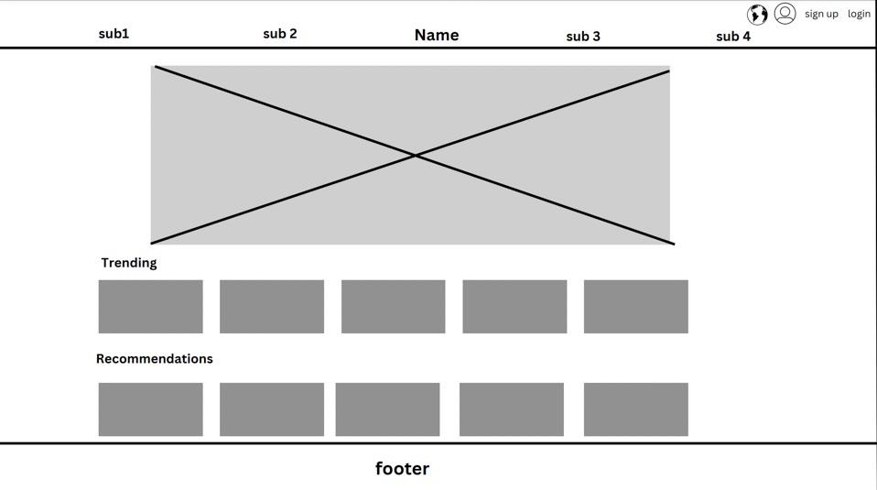

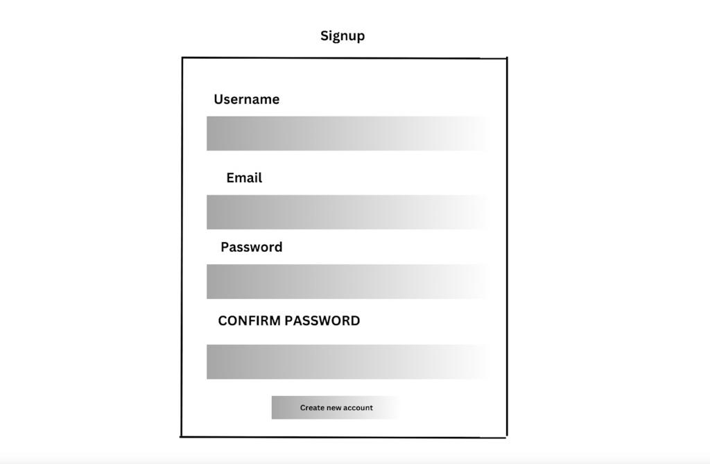 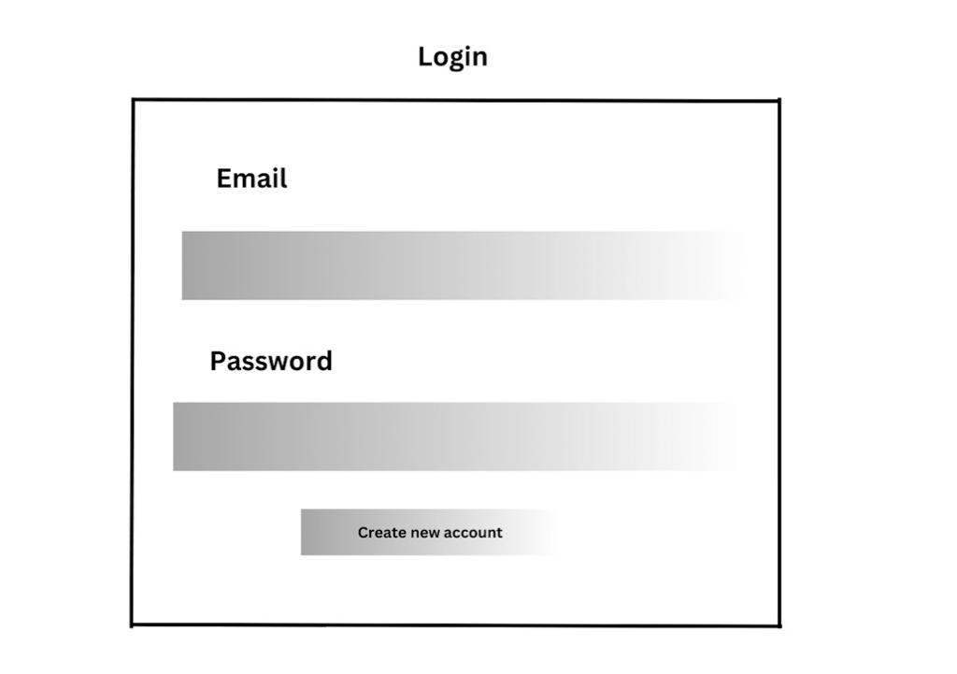

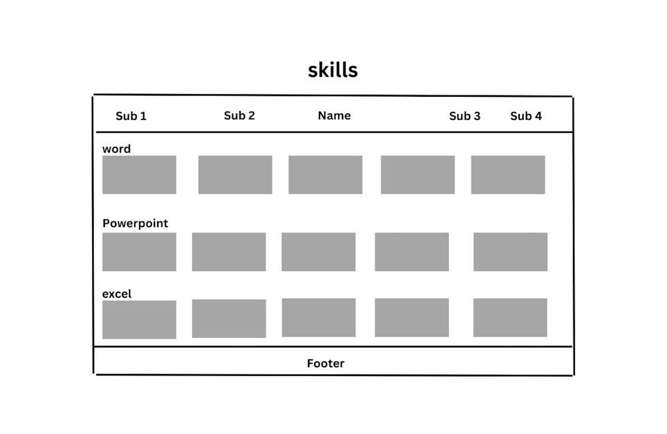

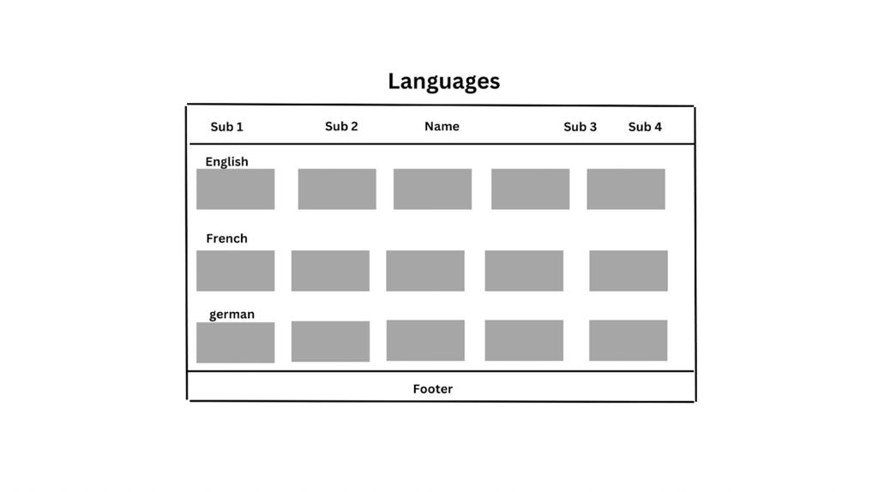

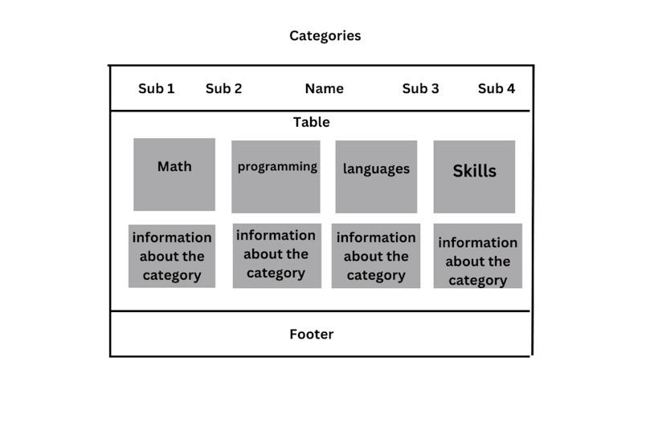

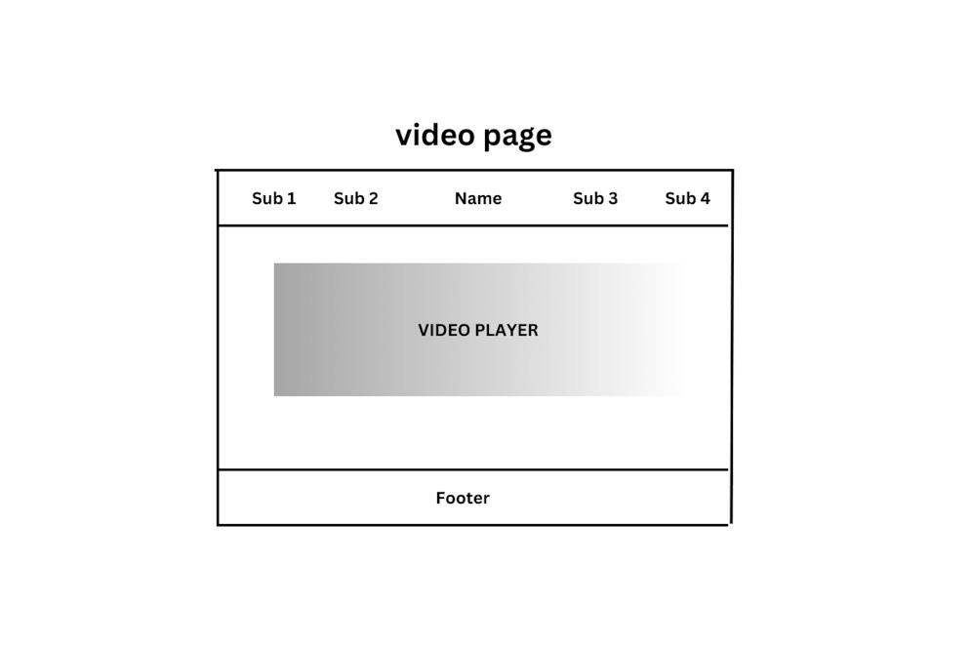

Sitemap

