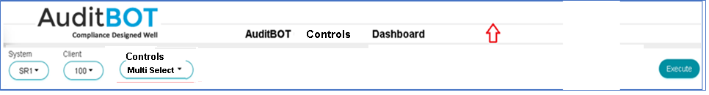
Change summary
- Header section should include AuditBOT Logo (Get the Logo from auditbots.com website) and Heading will be AuditBOT GRC Report
- Add 2 more Dropdown filters such as Mitigation and Drilldown
- Reduce the height of Header / Dropdown filter section (Red Arrow shows to reduce the height so Dashboard won’t scroll down)
- Download button should download report output in comma delimited CSV format so it can be viewed using Microsoft Excel

Dropdown Filter | Function Module | Input Parameter ZTYPE
Controls | /BOT/JAVA_0001 | ZTYPE = 21

AuditBOT Controls Dashboard
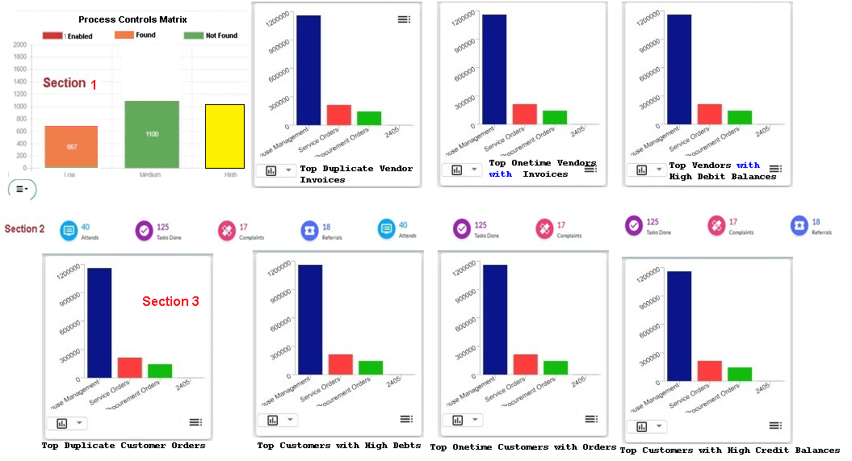

AuditBOT Controls Dashboard
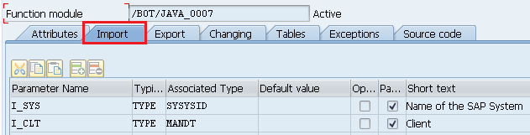 | System and Client are mandatory parameters
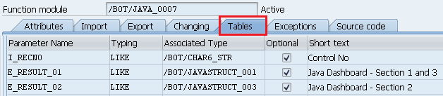 | Controls Dashboard filter is optional Array filter
E_RESULT_01 (Section 1 & 3 Data set)  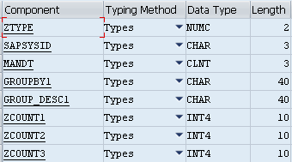 | E_RESULT_02 (Section 2 Data set)  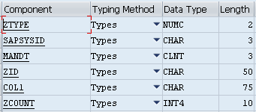

Chart 1 in Section 1 for ZTYPE = 01 from E_RESULT_01  Chart 2 in Section 1 for ZTYPE = 02 from E_RESULT_01  Chart 3 in Section 1 for ZTYPE = 03 from E_RESULT_01  Chart 4 in Section 1 for ZTYPE = 04 from E_RESULT_01  Chart 1 in Section 3 for ZTYPE = 05 from E_RESULT_01  Chart 2 in Section 3 for ZTYPE = 06 from E_RESULT_01  Chart 3 in Section 3 for ZTYPE = 07 from E_RESULT_01  Chart 4 in Section 3 for ZTYPE = 08 from E_RESULT_01 | Section 2 from E_RESULT_02  Note: - If possible, Show COL1 value in Init cap  Example: - DUPLICATE INVOICES => Duplicate Invoices

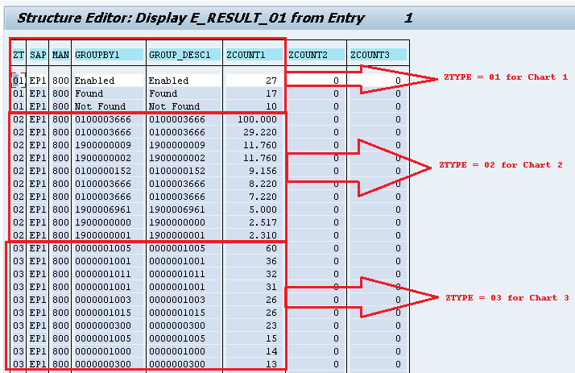 | 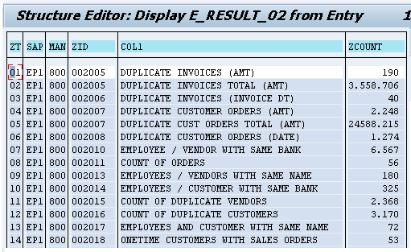

AuditBOT Controls Summary Report

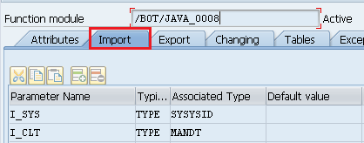
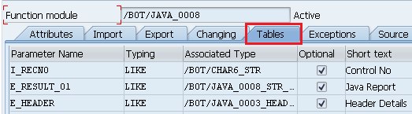
E_RESULT_01 => Report Data  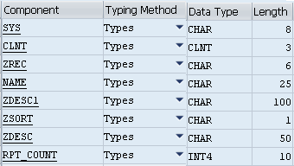 | E_HEADER => Report Column Heading (Used in other Reports)
AuditBOT Controls Details Report
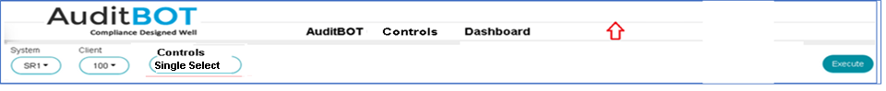

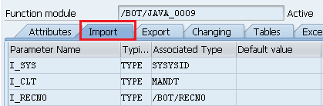 | ALL 3 parameters are mandatory and single values
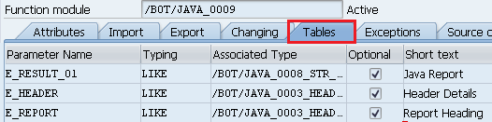
E_RESULT_01 => Report Data which has 30 columns maximum  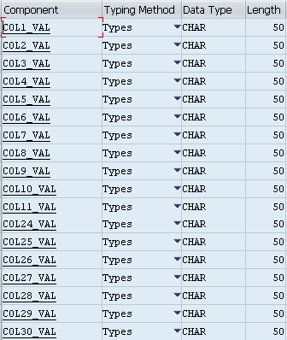 | E_HEADER => Report Column Heading (Used in other Reports)  E_REPORT => Report Heading  Note: - Each Report output is dynamic no of columns based on a specific control is chosen from Controls dropdown filter.  If E_HEADER returns 10 column headings then show first 10 columns of E_RESULT_01.  If E_HEADER returns 25 column headings then show first 15 columns of E_RESULT_01.

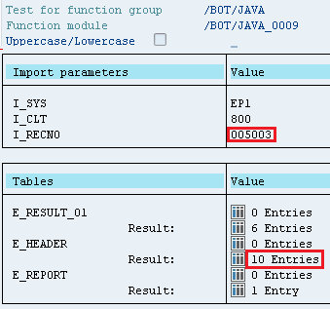  Control 005003 returns 10 column headings which means Report layout has only 10 columns to show. Please show first 10 fields of array E_RESULT_01. Treat every column is like a string in E_RESULT_01 | 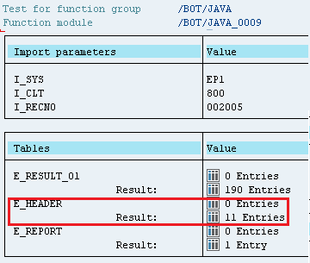  Control 002005 returns 11 column headings which means Report layout has only 11 columns to show. Please show first 11 fields of array E_RESULT_01. Treat every column is like a string in E_RESULT_01

Control 005003 shows 10 columns

Control 002005 shows 11 columns

