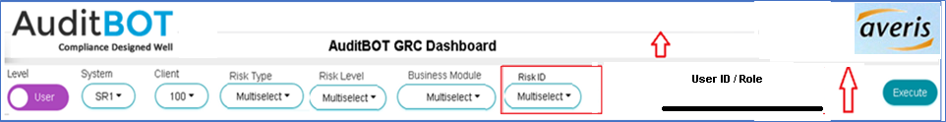
Change summary
- Header section should include AuditBOT Logo and Customer Logo (Averis). So, keep 2 Logo files (Std file names like LOGO1.jpg & LOGO2.jpg) in Unix server to read for AuditBOT and Customer Logo which will give customized experience to AuditBOT customers. (Get the Logo from auditbots.com website) and Heading will be AuditBOT GRC Dashboard
- Add 1 more Dropdown filter such as Risk ID s as shown in Red box
- Add User enterable field such as User ID / Role (Red Arrow shows to reduce the height so Dashboard won’t scroll down)

Dropdown Filter | Function Module (Call below FM) | Input Parameter ZTYPE
Risk ID | /BOT/JAVA_0001 | ZTYPE = 6 | 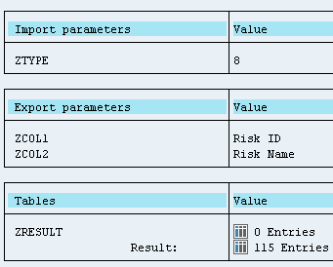

Use Function Module # /BOT/JAVA_0002 (Dashboard Data)

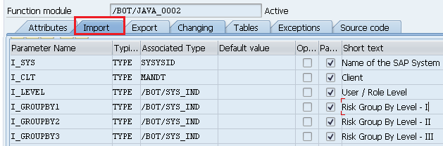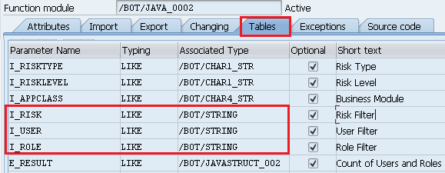

Level = User | I_USER = Enterable User ID Field
Level = Role | I_ROLE = Enterable Role ID Field

Export Tab -> I_RISK = Multiple Optional selection from Risk ID Dropdown Filter (same as Risk Type, Risk Level, Business Module)
Use Array E_RESULT_01 for entire Dashboard chart data

Array # E_RESULT_01 structure for Dashboard Data | 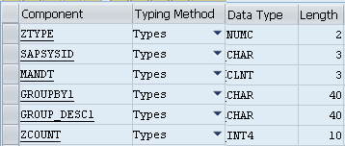

ZTYPE = 01 | Chart 1 Data (1st Row)
ZTYPE = 02 | Chart 2 Data (1st Row)
ZTYPE = 03 | Chart 3 Data (1st Row)
ZTYPE = 04 | Chart 4 Data (2st Row)
ZTYPE = 05 | Chart 5 Data (2st Row)
ZTYPE = 06 | Chart 6 Data (2st Row)
ZTYPE = 07 | Chart 7 Data (3st Row)
ZTYPE = 08 | Chart 8 Data (3st Row)
ZTYPE = 09 | Chart 9 Data (3st Row)

