Dashboard Filter

Dashboard Summary
- Start Date & End Date are Enterable Fields with default date. Start Date = Current System Date – 365, End Date = Current System Date
- Logon Days, %(or) Count are Enterable Fields with default values. Logon Days = 90, %(or)Count = 10
- User ID is Enterable field without any default value.

Dropdown Filter | Function Module | Input Parameter ZTYPE
USMM / USR02 | /BOT/JAVA_0001 | ZTYPE = 11
User Type | /BOT/JAVA_0001 | ZTYPE = 12
User Group | /BOT/JAVA_0001 | ZTYPE = 13
Account | /BOT/JAVA_0001 | ZTYPE = 14
License Type | /BOT/JAVA_0001 | ZTYPE = 15
User Status | /BOT/JAVA_0001 | ZTYPE = 16
Active Users | /BOT/JAVA_0001 | ZTYPE = 17
TCodes | /BOT/JAVA_0001 | ZTYPE = 18
Criteria | /BOT/JAVA_0001 | ZTYPE = 19
Side bar Menu Entries | /BOT/JAVA_0001 | ZTYPE = 20 | Show Side bar menu  Return Value = 1 to show GRC,  Return Value = 2 to show License,  Return Value = 3 to show Controls,  Return Value = 4 to show Auditor,  Return Value = 5 to show Manager  Note :- It could return one (or) more values so One (or) more menu entries should be displayed on side bar.

License Dashboard
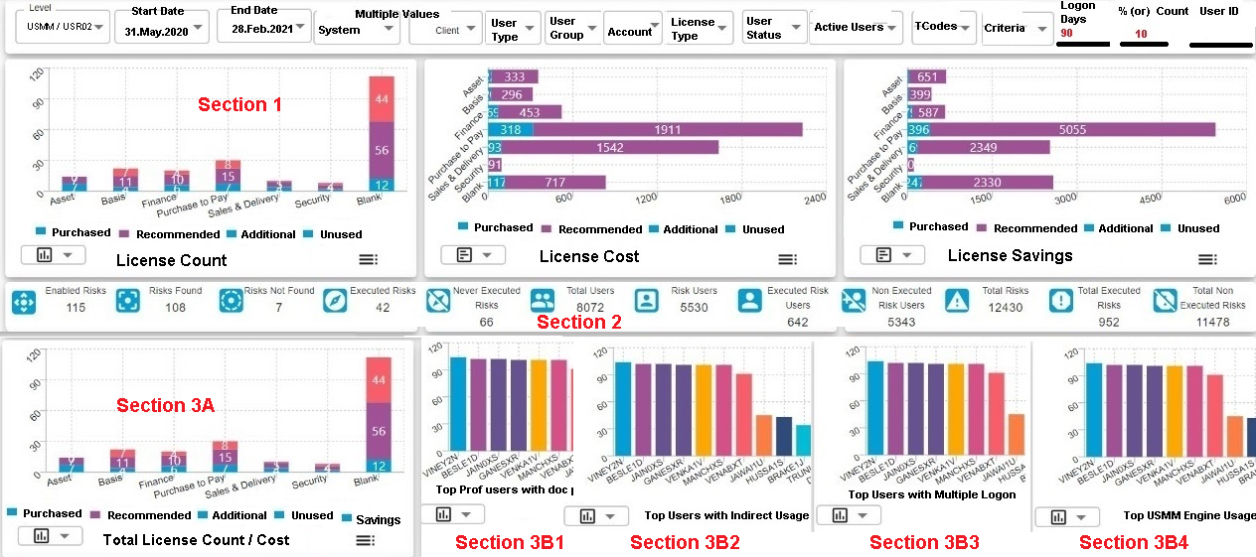

Use Function Module # /BOT/JAVA_0005 (Dashboard Data)

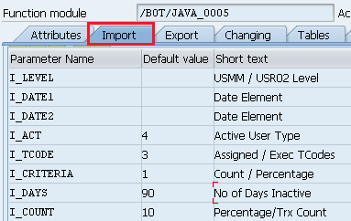 | 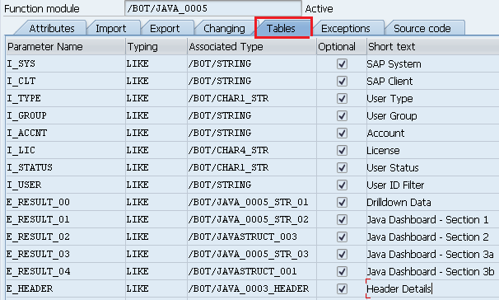

Dashboard Data from SAP Function Module Tables tab
Section 1 | E_RESULT_01 | 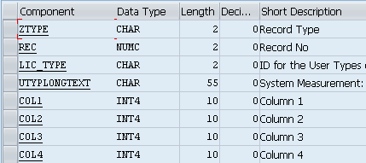
Section 2 | E_RESULT_02 | 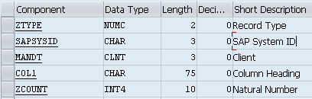
Section 3A | E_RESULT_03
Section 3B | E_RESULT_04 | 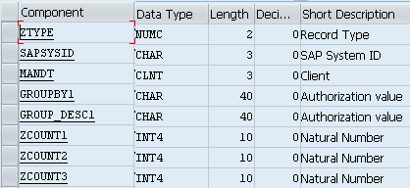
Drilldown from Chart ICON (Section 1, Section 3A Charts)  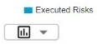  Note: - when User clicks on above ICON of any charts in above sections should use this table | E_RESULT_00  &  E_HEADER (has column headings) | 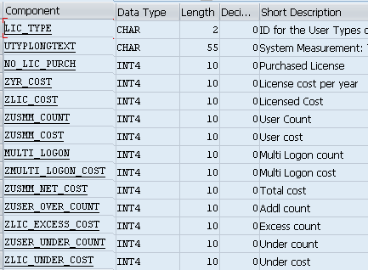
Drilldown from Chart Bar | Call License Report to pass Dashboard filters Plus specific License type from the bar where user clicked
Dashboard Data from SAP Function Module Tables Output Data

Section 1 | E_RESULT_01
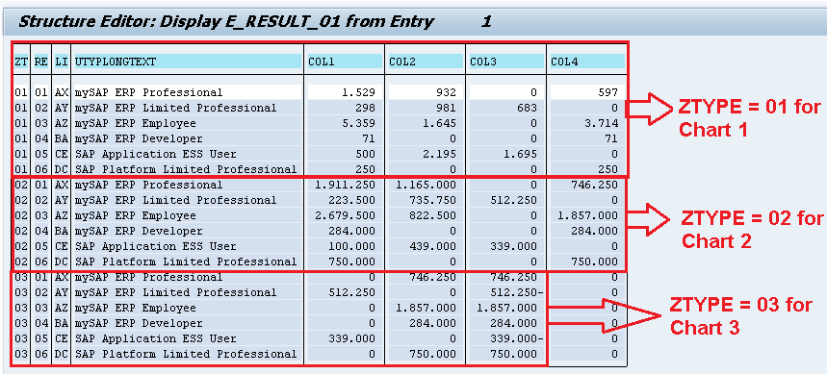

Section 2 | E_RESULT_02
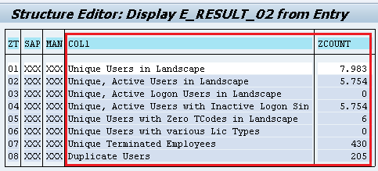

Section 3A | E_RESULT_03
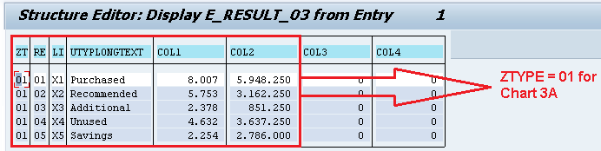

Section 3B | E_RESULT_04
