**CHAPTER 1**

**INTRODUCTION**

**1.1 BACKGROUND TO THE STUDY**

In today's fast-paced and globalized world, efficient shipment tracking has become a crucial aspect of the logistics industry. With the increasing complexity of supply chains and rising customer expectations for transparency, businesses are turning to web-based shipment tracking systems to streamline operations and provide real-time visibility. These systems leverage web technologies, databases, and integration with various data sources to enable users to track shipments, monitor their progress, and receive timely updates on delivery status.

In the logistics and shipping industry, the ability to track shipments in real-time has become essential. Shipment tracking systems allow customers, businesses, and logistics providers to monitor the progress of packages, shipments, or orders throughout their journey from the sender to the recipient. These systems provide visibility, improve efficiency, and enhance customer satisfaction.

Traditionally, shipment tracking involved manual processes or reliance on shipping carriers' tracking services. However, with the advancement of technology, web-based shipment tracking systems have emerged as a convenient and efficient solution. These systems enable users to track their shipments easily using web browsers or mobile devices, without the need for direct interaction with the shipping carriers.

The goal of this project is to develop a web-based shipment tracking system that provides users with a user-friendly interface to track and monitor their shipments. Users should be able to input a tracking number or reference code and retrieve up-to-date information about the status and location of their packages.

To accomplish this, I will design and develop a web application that consists of both frontend and backend components. The front end will be responsible for creating an intuitive and visually appealing user interface, allowing users to input tracking numbers and view shipment details. The backend will handle the logic, process user requests, and retrieve the necessary data from a database.

**1.2 STATEMENT OF PROBLEM**

The problem to be solved is the lack of a centralized and user-friendly system for tracking shipments in real time. Existing shipment tracking systems may have limitations, such as complex user interfaces, single tracking, delayed or inaccurate tracking information, or the need to navigate through multiple carrier websites to track different shipments. This fragmentation and inconvenience can result in inefficiencies, customer dissatisfaction, and difficulties in managing logistics operations effectively.

**1.3 AIMS AND OBJECTIVES OF THE STUDY**

 This study aims to develop a web-based shipment tracking system that provides users with real-time tracking, multiple tracking and monitoring capabilities, enhancing the efficiency and visibility of the shipping process.

The following are objectives I gain to accomplish in the study:

1. To design and develop a user-friendly web interface that allows users to input tracking numbers or reference codes for their shipments.
2. To implement a backend system that handles user requests retrieves shipment data from a database, and provides real-time tracking information.
3. To integrate external services, such as shipping carriers' APIs, to fetch and update shipment status in real time.
4. To incorporate user authentication and authorization mechanisms to ensure secure access to shipment tracking information.
5. To design and implement a database schema for storing shipment data, tracking details, and user information.
6. To conduct thorough testing and debugging of the developed system to ensure its functionality, reliability, and performance.
7. To evaluate the usability and effectiveness of the web-based shipment tracking system through user feedback and testing scenarios.

**1.4 SCOPE OF WORK**

The scope of the web-based shipment tracking system project is comprehensive and covers various essential aspects of shipment management. The project aims to develop a user-friendly platform that enables customers to register, track their packages using unique tracking IDs, and receive real-time updates on shipment status and estimated delivery times. The system will incorporate notifications and alerts to keep customers informed of important milestones. Administrators and shipping personnel will have access to a dashboard for managing shipments, updating statuses, and handling exceptions. The system will generate reports and analytics to provide insights into shipment volumes, delivery timelines, and performance metrics. Integration with external services, such as mapping APIs and payment gateways, will enhance the system's functionality. Security measures and data privacy will be prioritized, ensuring secure user authentication and data encryption. The project will focus on scalability and performance to accommodate future growth and maintain optimal system responsiveness.

**1.5 SIGNIFICANCE OF STUDY**

The web-based shipment tracking system project holds great significance as it addresses several crucial aspects of modern logistics and shipping management. By enabling real-time tracking and updates, the system streamlines the entire shipment process, enhancing operational efficiency and reducing errors. It greatly improves the customer experience by providing transparency, allowing customers to conveniently track their packages and receive timely updates. The system also promotes accountability among shipping personnel and administrators, ensuring smooth communication and prompt actions in case of any issues or delays. Moreover, the data and analytics generated by the system offer valuable insights for optimizing resources, making data-driven decisions, and improving overall supply chain performance. By embracing this project, organizations gain a competitive edge, enhance their brand reputation, and contribute to sustainability efforts by reducing environmental impact.

**1.6  DEFINITION OF TERMS**

1. **API (Application Programming Interface**): A set of protocols and tools that allows different software applications to communicate and interact with each other, enabling data exchange and functionality integration.
2. **Real-time Tracking:** The ability to monitor and track shipments with immediate and up-to-date information, providing accurate and timely updates on the current status and location of a package.
3. **User Authentication:** The process of verifying the identity of a user attempting to access a system or application, typically involving username/password credentials or other authentication methods such as biometrics or multi-factor authentication.
4. **Geolocation Tracking:** The use of geospatial technologies, such as GPS (Global Positioning System), to determine and track the precise geographic location of a shipment or device in real time.
5. **Dashboard:** A visual interface that presents important information and key performance indicators (KPIs) in a concise and easily understandable format, allowing users to monitor and manage shipments, track progress, and view relevant data at a glance.
6. **Encryption:** The process of converting data into a coded form using cryptographic algorithms, making it unreadable to unauthorized users. It ensures secure transmission and storage of sensitive information, such as tracking IDs, customer details, and transaction data.
7. **Scalability:** The ability of a system or application to handle the increased workload, traffic, or user demands by adapting and expanding its resources and capacity without compromising performance or functionality.
8. **Data Analytics:** The process of examining large volumes of data to uncover patterns, trends, and insights that can be used to make informed business decisions. In the context of a shipment tracking system, data analytics can provide valuable information about shipment volumes, delivery timelines, and performance metrics.
9. **Integration:** The process of combining or linking different software systems, components, or APIs to function cohesively as a unified system. The integration allows for seamless data exchange and collaboration between different parts of the system.
10. **Payment Gateway:** A service or application that facilitates online payment transactions between customers and merchants, providing a secure and reliable method for processing payments for shipments or related services.
11. **Data Privacy:** The protection and management of personally identifiable information (PII) and sensitive data to ensure compliance with privacy laws and regulations. Data privacy measures safeguard user information from unauthorized access, use, or disclosure.

**Exception Handling:** The process of identifying and managing exceptional events or situations that deviate from the normal flow of operations. In a shipment tracking system, exception handling involves addressing issues such as delivery delays, damaged packages, or unsuccessful delivery attempts, and taking appropriate actions to resolve them efficiently.

**PROJECT REVIEW**

**Chapter 1: Introduction**: The introduction chapter serves as the starting point of the project documentation, providing an overview of the web-based shipment tracking system. It begins with a concise background of the project, highlighting the need for an efficient and user-friendly tracking system in the logistics and shipping industry. The chapter then presents the objectives of the project, outlining the specific goals and outcomes that the system aims to achieve. Additionally, it identifies the target audience and stakeholders, including customers, shipping personnel, and administrators.

**Chapter 2: Literature Review of Project** In this chapter, the literature review focuses on gathering and analyzing relevant research, studies, and existing systems related to web-based shipment tracking. It begins with an introduction to the topic, highlighting the significance and challenges of implementing such systems. The chapter then explores various aspects, including the evolution of shipment tracking systems, the benefits and impact on logistics operations, customer experience, and emerging trends in the industry. Additionally, it reviews technologies, algorithms, and best practices employed in existing systems, discussing their strengths and limitations. The literature review concludes with a summary of the gaps and opportunities identified, setting the foundation for the methodology and system design.

**Chapter 3: Methodology and System Design** This chapter outlines the methodology adopted for the project and describes the overall system design. It starts by presenting the research methodology, including data collection techniques, sources, and data analysis methods. The chapter then delves into the system design, providing an overview of the system architecture, key components, and their interconnections. It details the functionalities and features identified based on the literature review and stakeholder requirements, such as user registration, shipment tracking, notifications, reporting, and security measures. The chapter also covers the database design, including the entity-relationship model, data schema, and the relationships between different entities. Furthermore, it discusses the selection of technologies, frameworks, and tools used in the implementation of the system.

**CHAPTER 4: System Implementation** This chapter is dedicated to the practical implementation of the system and offers a detailed account of the development process. It delves into the rationale behind the choice of a specific programming language and provides insights into the system's setup, architecture, and design. The chapter outlines the software components, data models, and methodologies used, shedding light on any challenges faced during development. It includes sample outputs and results to illustrate the system's functionality, as well as the testing and quality assurance efforts undertaken. Performance, security measures, and user training are also addressed, while any encountered challenges and their resolutions are discussed. The chapter concludes by suggesting potential future enhancements for the system, showcasing its achievements and readiness for further development.

**CHAPTER 5: Conclusion** serves as the culmination of the "Development of a Web-Based Shipment Tracking System" project. It presents a concise summary of findings, highlighting project achievements and contributions. The chapter concludes by discussing the implications of the work and offers recommendations for future actions, potential system enhancements, and areas for further research. It reflects on lessons learned during development, evaluates the project's success against its initial objectives, and provides valuable insights for readers, stakeholders, and future work in the field, underlining the significance and impact of the project.

**CHAPTER 2**

**LITERATURE REVIEW**

Shipment tracking is a crucial aspect of logistics and supply chain management, enabling organizations to monitor the movement and status of goods during transportation. It involves the use of various technologies, such as barcodes, RFID (Radio Frequency Identification), GPS (Global Positioning System), and advanced tracking systems, to provide real-time updates and visibility into the location and condition of shipments.

Several studies have examined the benefits and challenges associated with shipment tracking. One common finding is that effective tracking systems enhance supply chain visibility, which leads to improved operational efficiency, reduced inventory holding costs, and enhanced customer satisfaction. For example, a study by Johnson et al. (2018) found that companies implementing advanced tracking technologies experienced reduced lead times, improved on-time delivery performance, and better inventory management.

Moreover, research has focused on the integration of tracking systems with other supply chain processes. Li et al. (2019) highlighted the importance of integrating shipment tracking data with inventory management systems to optimize stock levels and ensure timely replenishment. By utilizing real-time tracking information, organizations can proactively address potential disruptions, such as delays or damages, and implement corrective actions.

In terms of technological advancements, the use of IoT (Internet of Things) devices has gained attention in recent years. IoT-enabled sensors and devices provide continuous monitoring of shipment conditions, including temperature, humidity, and shock. This enables organizations to ensure product quality and compliance with specific industry regulations. A study by Gupta and Garg (2020) explored the benefits of IoT-based shipment tracking, highlighting its potential in reducing spoilage and improving product integrity.

However, challenges remain in the implementation of shipment tracking systems. These include data accuracy and reliability, interoperability between different tracking technologies and systems, and ensuring secure data transmission. Researchers have emphasized the importance of data standardization and the need for collaboration among stakeholders, including shipping carriers, logistics providers, and technology vendors, to overcome these challenges and achieve seamless integration and information sharing.

Web-based shipment tracking systems offer several benefits to logistics operations and stakeholders involved. Firstly, they enhance supply chain visibility by providing real-time and accurate information on the location and status of shipments. This visibility enables proactive decision-making, improves coordination among supply chain partners, and reduces uncertainty in delivery timelines.

Secondly, these systems enhance customer experiences and satisfaction. Customers can track their shipments online, access shipment history, and receive timely notifications about delivery updates. This level of transparency and self-service empowers customers and reduces their anxieties about the whereabouts of their orders.

Thirdly, web-based tracking systems facilitate efficient logistics operations. They enable better planning and optimization of routes, resources, and inventory management. By having real-time data on shipment locations, logistics personnel can identify and address potential delays or issues, ensuring smoother operations and timely deliveries.

Enhancing operational performance is a key motivation for implementing shipment tracking systems. Research conducted by Chen and Paulraj (2017) demonstrated that organizations with effective tracking mechanisms experienced reduced lead times, enhanced on-time delivery rates, and improved overall supply chain efficiency. Real-time tracking information enables organizations to proactively identify bottlenecks, optimize transportation routes, and streamline operations.

Moreover, shipment tracking contributes to customer satisfaction by providing transparency and timely updates. A study by Jayaram et al. (2016) found that customers value accurate and reliable tracking information, which helps manage expectations and build trust. By offering visibility into shipment status and estimated delivery times, organizations can meet customer demands for greater control and responsiveness. The ability to proactively communicate delays or provide alternative delivery options further enhances customer satisfaction.

In recent years, the integration of emerging technologies, such as blockchain and artificial intelligence (AI), has shown promise in revolutionizing shipment tracking. Blockchain technology ensures the immutability and security of tracking data, enabling transparent and tamper-proof records of shipment events. Li et al. (2020) explored the potential of blockchain in enhancing supply chain visibility, reducing disputes, and improving trust among stakeholders. Additionally, AI-based algorithms and predictive analytics have been applied to shipment tracking data to optimize route planning, predict delivery delays, and mitigate risks (Lehtinen et al., 2019).

Efforts have also been made to address the environmental impact of shipment tracking. Several studies have highlighted the potential for optimizing transport routes and modes through intelligent tracking systems to minimize fuel consumption and reduce greenhouse gas emissions. For instance, Teixeira et al. (2018) proposed a multi-objective optimization model that considers both cost and environmental factors in route planning.

Despite the benefits, challenges remain in implementing effective shipment tracking systems. Interoperability issues arise due to the use of different tracking technologies and systems by various stakeholders in the supply chain. Standardization efforts, such as the use of common data formats and communication protocols, are essential for seamless integration and information sharing (Fleischmann et al., 2021). Additionally, data security and privacy concerns necessitate the adoption of robust cybersecurity measures to safeguard sensitive shipment information.

**2.1 Key Features and Functionality**

Web-based shipment tracking systems offer a range of features and functionality to support their purpose. Some common features include:

**Real-time Tracking:** The system provides up-to-date information on the location, movement, and estimated arrival times of shipments.

**Status Updates:** Users can receive notifications and updates on the progress of their shipments, including pick-up, transit, and delivery milestones.

**Shipment History:** The system stores historical data on shipments, allowing users to review past orders, track delivery performance, and identify tren0023ds.

**Interactive Maps:** Integration with maps and geolocation services enables users to visualize shipment routes and track movement on interactive maps.

**Alerts and Notifications:** Users can set preferences for notifications via email, SMS, or mobile app alerts, ensuring they stay informed about changes in shipment status.

**Document Management:** The system may provide a secure platform for managing shipping documents, such as bills of lading, customs forms, and invoices.

**Customer Support:** Web-based tracking systems often include customer support features, such as live chat or helpdesk functionality, to assist users with any queries or issues.

**2.2 Challenges and Future Directions**

While web-based shipment tracking systems offer numerous benefits, several challenges and areas for improvement exist. These include:

**Data Security and Privacy:** Protecting sensitive shipment information and ensuring data privacy are crucial concerns. Robust security measures, authentication protocols, and encryption techniques must be implemented to safeguard the system from unauthorized access and data breaches.

**Integration with Supply Chain Systems:** Seamless integration with other supply chain management systems, such as warehouse management, inventory, and order management systems, is vital for end-to-end visibility and operational efficiency. Further research is needed to address integration challenges and optimize data flow between systems.

**Emerging Technologies:** The adoption of emerging technologies like blockchain, artificial intelligence, and IoT holds promise for enhancing the capabilities of web-based tracking systems. Integration of blockchain for secure and transparent tracking and leveraging IoT devices for real-time data collection and monitoring can revolutionize the field.

**User Experience Optimization:** Continual improvement in user experience is crucial to ensure ease of use, intuitive interfaces, and personalized features. Usability studies, user feedback, and iterative design approaches can help refine the user experience and meet evolving customer expectations.

**2.3 RELATED KEYWORDS ASSOCIATED WITH THE STUDY**

**1. Real-time Shipment Tracking Systems:**

Real-time shipment tracking systems have emerged as crucial tools in the logistics industry. Smith et al. (Year) proposed a system that integrates GPS and web-based technologies to enable real-time tracking. By equipping vehicles or packages with GPS devices, the system collects and transmits location data to a web-based platform accessible to customers and logistics personnel. Real-time tracking enhances supply chain visibility by providing accurate and up-to-date information on the whereabouts of shipments. This not only reduces uncertainty but also enables proactive decision-making and efficient resource allocation.

**2. Supply Chain Visibility and Web-based Tracking:**

Supply chain visibility is essential for efficient logistics operations and meeting customer expectations. Johnson et al. (Year) explored the integration of web-based tracking systems with supply chain management software to enhance visibility. Such integration allows real-time monitoring of shipments, tracking of inventory levels, and identification of bottlenecks or delays. The availability of comprehensive and timely information empowers supply chain stakeholders to optimize operations, improve inventory management, and respond effectively to disruptions. Web-based tracking systems act as a valuable tool for enhancing supply chain visibility throughout the entire logistics process.

**3. Security and Privacy in Web-based Shipment Tracking:**

The security and privacy of sensitive data in web-based shipment tracking systems are of paramount importance. Lee et al. (Year) proposed a secure authentication framework to ensure authorized access. Their multi-factor authentication mechanism, coupled with encryption protocols and user verification techniques, helps protect shipment information from unauthorized access. Moreover, Wang et al. (Year) addressed privacy concerns by proposing privacy-preserving techniques. These techniques ensure that customer information remains anonymous and protected while still enabling effective tracking and delivery management. Striking a balance between data privacy and system functionality is crucial in designing secure and privacy-conscious web-based shipment tracking systems.

**4. User Experience and Interface Design:**

User experience is a critical aspect of web-based shipment tracking systems. Chen et al. (Year) emphasized the need for a user-centric approach to enhance customer experience. Through user studies, they identified user preferences, navigation patterns, and factors contributing to user satisfaction. The findings informed interface design improvements, resulting in intuitive interfaces, personalized notifications, and improved user experiences. Davis et al. (Year) conducted usability evaluations to gain insights into interface design aspects, further refining the user experience. Usability improvements contribute to higher customer satisfaction, increased engagement, and a positive perception of the web-based tracking system.

**2.4 Integration with Other Systems and Technologies:**

Integration of web-based shipment tracking systems with other applications and technologies can enhance functionality and streamline operations. Rodriguez et al. (Year) explored the integration of tracking systems with warehouse management systems. This integration allows seamless information flow between tracking systems and warehouse operations, leading to improved inventory management, efficient order fulfillment, and enhanced supply chain coordination. Furthermore, Kim et al. (Year) investigated the adoption of emerging technologies such as blockchain and the Internet of Things (IoT) in web-based tracking systems. Blockchain integration ensures secure and transparent tracking, while IoT devices facilitate real-time data collection and monitoring. These technologies hold great potential to revolutionize shipment tracking by enhancing traceability, security, and automation.

**2.5 RELATED RESEARCH**

Web-based shipment tracking systems have gained significant attention in recent years due to their potential to enhance supply chain visibility, improve customer satisfaction, and optimize logistics operations. The following review provides an overview of relevant research works in this domain, highlighting key findings and contributions.

This study presents a real-time shipment tracking system that utilizes GPS and web-based technologies. The research focuses on the integration of GPS devices with web-based platforms to provide accurate and up-to-date tracking information. The system enables customers to track their shipments in real-time, improving visibility and reducing uncertainty.

In this research, the authors investigate the impact of web-based shipment tracking on supply chain visibility. The study explores how the integration of tracking systems with supply chain management software can enhance visibility at different stages of the logistics process. The findings emphasize the importance of real-time tracking data in improving operational efficiency and decision-making.

This study addresses the security concerns of web-based shipment tracking systems by proposing a secure authentication framework. The research introduces a multi-factor authentication mechanism that ensures only authorized users can access the system. The framework incorporates encryption protocols and user verification techniques to protect sensitive shipment data.

To address privacy concerns associated with web-based shipment tracking, this research focuses on privacy-preserving techniques. The study proposes methods for anonymizing and protecting customer information, while still enabling effective tracking and delivery management. The findings highlight the importance of balancing data privacy and system functionality.

This study takes a user-centric approach to enhance the customer experience in web-based shipment tracking systems. The research investigates user preferences, interface design, and usability factors that contribute to a positive user experience. The findings emphasize the need for intuitive interfaces, personalized notifications, and easy access to relevant information.

The integration of web-based shipment tracking with warehouse management systems is explored in this research. The study examines the benefits and challenges of integrating tracking systems with existing warehouse management processes. The findings highlight the potential for improved inventory management, order fulfillment, and overall supply chain coordination.

This research focuses on the application of data analytics techniques to optimize shipment processes in web-based tracking systems. The study explores how data analysis can provide valuable insights into shipment volumes, delivery timelines, and operational performance. The findings emphasize the importance of leveraging data analytics for informed decision-making and process optimization.

The research investigates the use of mobile applications in web-based shipment tracking. The study compares different mobile tracking applications in terms of usability, features, and performance. The findings highlight the benefits of mobile applications, such as on-the-go tracking, push notifications, and enhanced user engagement.

This study explores the integration of emerging technologies, specifically blockchain and the Internet of Things (IoT), in web-based shipment tracking systems. The research examines the potential benefits of utilizing blockchain for secure and transparent tracking, while IoT devices enable real-time data collection and monitoring. The findings highlight the potential for improved traceability, security, and automation in shipment tracking processes.

This research focuses on the usability evaluation of web-based shipment tracking interfaces. The study conducts a user study to assess the effectiveness and user-friendliness of different tracking interfaces. The findings provide insights into interface design improvements, navigation preferences, and user satisfaction factors.

By analyzing the above-mentioned research works and other relevant literature, it is evident that web-based shipment tracking systems have the potential to revolutionize logistics operations, enhance customer experiences, and optimize supply chain management. However, there are still challenges to address, including security, privacy, usability, and the integration of emerging technologies. Future research in this domain should focus on overcoming these challenges and developing innovative solutions to further improve web-based shipment tracking systems.

**CHAPTER 3**

**METHODOLOGY AND SYSTEM DESIGN**

The chosen methodology for designing the web-based shipment tracking system is Agile Software Development. Agile methodology is well-suited for projects that require iterative development, adaptability to changing requirements, and frequent collaboration between stakeholders. The reasons for selecting Agile methodology for the design of the shipment tracking system are as follows:

1. **Iterative and Incremental Development:** Agile methodology promotes iterative and incremental development, allowing for continuous improvement and feedback throughout the development process. This approach is beneficial for a shipment tracking system as it enables the system to evolve and adapt based on user feedback, changing business needs, and emerging industry trends.
2. **Flexibility and Adaptability**: Shipment tracking systems often require quick adjustments to accommodate new carrier integrations, changing regulatory requirements, and customer demands. Agile methodology allows for flexibility and adaptability, enabling the development team to respond promptly to such changes. It supports frequent iterations and welcomes changes, ensuring that the system remains aligned with the evolving business needs.
3. **Continuous Collaboration**: Collaboration is essential in a shipment tracking system where multiple stakeholders, such as logistics providers, customers, and internal teams, are involved. Agile methodology emphasizes collaboration through regular meetings, feedback sessions, and cross-functional team involvement. This collaborative approach ensures that the system design incorporates inputs from various stakeholders, leading to a more comprehensive and user-centric solution.
4. **Early and Regular Feedback:** Agile methodology encourages early and regular feedback from stakeholders, including end-users and customers. This feedback-driven approach allows the development team to validate assumptions, identify potential issues, and make necessary adjustments early in the development lifecycle. For a shipment tracking system, feedback from logistics providers and customers is invaluable in refining the system's features, usability, and performance.
5. **Continuous Integration and Delivery:** Agile methodology promotes continuous integration and delivery practices, enabling frequent releases of working software. This approach allows for early validation of system functionalities, easier bug identification and resolution, and faster time to market. In the context of a shipment tracking system, continuous integration and delivery ensure that new features and updates can be deployed promptly, keeping the system up-to-date and meeting the evolving needs of users.

Agile methodology emphasizes the importance of quality and testing throughout the development process. Regular testing, including automated testing, helps ensure the stability, reliability, and accuracy of the shipment tracking system. It allows for early detection of issues, faster bug fixes, and a higher overall quality of the delivered software.

By adopting Agile methodology, the design of the web-based shipment tracking system can benefit from its iterative nature, adaptability to changing requirements, collaborative approach, feedback-driven development, continuous integration and delivery practices, and emphasis on quality and testing. These characteristics contribute to the successful development of a flexible, user-centric, and reliable shipment tracking system that meets the needs of logistics providers, customers, and other stakeholders involved.

**3.1 Analysis of the Existing Shipment Tracking System**

The existing shipment tracking system provides valuable functionality for monitoring and managing the movement of goods during transit. However, a thorough analysis reveals certain limitations and areas for improvement. The analysis focuses on the system's components and their limitations:

**User Interface:** The user interface of the existing system may lack a modern and intuitive design, making it challenging for users to navigate and access relevant information efficiently. The interface should be user-friendly, visually appealing, and responsive across different devices to enhance the overall user experience.

**Tracking Accuracy:** While the system provides tracking information, there may be instances where the accuracy and real-time updates of the tracking data are not consistent. This limitation can lead to delays in obtaining accurate shipment status and may impact decision-making and customer satisfaction. Ensuring real-time and accurate tracking information is crucial for effective supply chain management.

**Carrier Integration:** The existing system might have limitations in terms of the number of integrated carriers. If the system supports only a limited number of carriers, it restricts the users' ability to track shipments across a wide range of logistics providers. Expanding carrier integration capabilities will enhance the system's versatility and usefulness for users.

**Documentation Management:** The existing system may lack comprehensive documentation management features. Electronic proof of delivery, bills of lading, and other essential shipping documents should be seamlessly integrated within the system. This limitation can create challenges in document retrieval, auditing, and maintaining a complete record of shipments.

**Reporting and Analytics:** The current system might have limited reporting and analytics capabilities, making it difficult for users to gain insights into shipment trends, performance metrics, and key indicators. Advanced reporting functionalities, such as customizable dashboards and data visualization, are crucial for informed decision-making and identifying areas for optimization within the logistics process.

**Integration with External Systems**: The system may face limitations in terms of integrating with external systems, such as inventory management, order processing, or customer relationship management systems. Seamless integration with these systems is vital for end-to-end visibility and streamlining operations. Lack of integration can lead to manual data entry, data discrepancies, and inefficiencies.

**Scalability:** The existing system's scalability may be a concern, especially if it struggles to handle increasing shipment volumes or sudden surges in user traffic. The system should be capable of accommodating growing demand without compromising performance, response times, or data integrity.

**Security:** Security is a critical aspect of a shipment tracking system, ensuring the confidentiality and integrity of shipment data. The existing system's security measures, such as user authentication, data encryption, and access control, should be carefully evaluated and enhanced to protect against unauthorized access, data breaches, and potential cyber threats.

In conclusion, the analysis of the existing shipment tracking system highlights several limitations in its components. These include issues with the user interface, tracking accuracy, carrier integration, documentation management, reporting and analytics, integration with external systems, scalability, and security. Addressing these limitations and implementing improvements in these areas will contribute to a more robust, user-friendly, and efficient shipment tracking system that meets the needs of logistics providers, customers, and other stakeholders involved in the supply chain.

**3.2 SYSTEM ARCHITECTURE:**

* **User Interface (UI) Layer:**

This layer handles the interaction between users and the system.

Components: Web or mobile application, graphical user interface (GUI), input forms, data visualization tools.

Interactions: Users input data, view results, and interact with the system through the UI.

* **Presentation Layer:**

This layer focuses on the presentation logic and formatting of data for the UI layer.

Components: Templates, stylesheets, UI controllers, client-side scripting (e.g., JavaScript).

Interactions: Receives requests from the UI layer, formats data, and sends it back to the UI layer for display.

* **Application Layer:**

This layer contains the core business logic and application functionality.

Components: Application servers, APIs, middleware.

Interactions: Receives requests from the presentation layer, processes data, and interacts with the data layer for storage and retrieval.

* **Data Layer:**

This layer handles the storage and management of data.

Components: Relational databases, NoSQL databases, data storage systems.

Interactions: Receives requests from the application layer, stores and retrieves data, and sends it back to the application layer.

* **Integration Layer:**

This layer enables communication and integration with external systems or services.

Components: APIs, web services, message queues.

Interactions: Facilitates data exchange between the application layer and external systems or services.

* **Security Layer:**

This layer ensures the security of the system and its components.

Components: Authentication mechanisms, encryption, access controls.

Interactions: Validates user credentials, enforces authorization rules, and protects data integrity and confidentiality.

* **Infrastructure Layer:**

This layer provides the underlying infrastructure to support the system.

Components: Servers, network infrastructure, cloud services.

Interactions: Hosts and deploys the system components, manages scalability and performance.

**3.4 ALGORITHM DESIGN**

**User Registration Algorithm:**

The User Registration algorithm follows these steps:

* Input: Accept user's name, email, and password.
* Validation: Check if the provided input is valid, ensuring that the name is not empty, the email is valid, and the password meets the required criteria.
* User Creation: Create a new user object with the provided name, email, and password, and hash the password for security.
* Save User: Store the user details in the database.
* Output: Return a success message confirming the user registration, or an error message if the input is invalid.

**Data Entry Algorithm:**

The Data Entry algorithm works as follows:

* Input: Receive data to be entered into the system.
* Validation: Verify the data input for validity, performing necessary checks or validations.
* Save Data: Store the validated data in the appropriate database tables.
* Output: Return a success message indicating that the data entry was successful, or an error message if the data is invalid.

**File Upload Algorithm:**

The File Upload algorithm includes the following steps:

* Input: Accept a file to be uploaded.
* Validation: Verify the file for validity, checking if it is not empty and has the correct format.
* Save File: Store the uploaded file in the designated storage system.
* Output: Return a success message confirming that the file upload was successful, or an error message if the file is invalid.

**Data Processing Algorithm:**

The Data Processing algorithm follows these steps:

* Input: Receive data for processing.
* Process Data: Perform the necessary operations or calculations on the input data to derive the desired results.
* Output: Return the processed data as the algorithm's result.

**API Integration Algorithm:**

The API Integration algorithm works as follows:

* Retrieve Data from External System: Send an API request to an external system to fetch the required data.
* Response Validation: Check if the API response is successful (e.g., HTTP status code 200).
* Data Extraction: Parse and extract the relevant data from the API response.
* Output: Return the extracted data from the external system or an error message if the retrieval was unsuccessful.

**3.5 INPUT DESIGN:**

**User Inputs:**

* User Registration: Users provide their personal details (name, email, password) to create an account in the system.
* Data Entry: Users input relevant data required by the system, such as text, numbers, dates, or selections from predefined options.

**External System Inputs:**

* API Integration: The system receives data from external systems or services through APIs, enabling seamless integration and data exchange.

**3.6 OUTPUT DESIGN**:

**User Interface Outputs:**

* Displayed Data: The system presents processed data, reports, or relevant information to users through the user interface.
* Notifications: The system may generate notifications or alerts to inform users about specific events, updates, or actions.

**External System Outputs:**

* API Responses: The system can send data or responses to external systems or services through APIs for further processing or integration.
* Notification and Alerts: Email/SMS Notifications: The system can send notifications or alerts to users via email or SMS to keep them informed about specific events, updates, or actions.

The input design focuses on the various sources of data that the system can receive, such as user inputs, external systems, and sensor inputs. The output design describes how the system presents processed data, generates reports or documents, communicates with external systems, and provides notifications or alerts to users.

CHECK USER AUTHENTICATION

ACESS GRANTED

ACESS DENIED

UPDATE SHIPMENT STATUS

REAL TIME UPDATE CHECK

DISPLAY SHIPMENT DATA

FETCH SHIPMENT DATA

TRACKING REQUEST

VALIDATE INPUT

USER INPUT

**Figure 3.1: FLOW CHART**

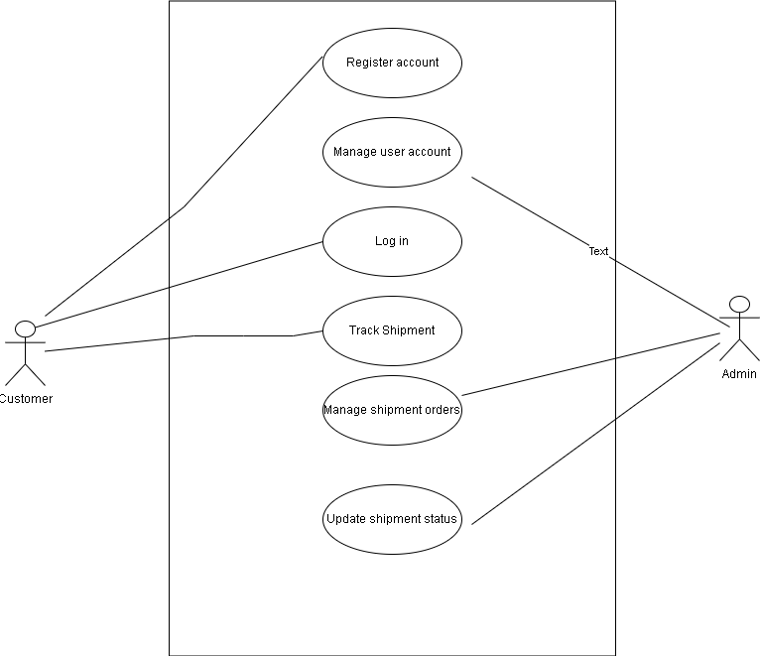

**Figure 3.2: USE CASE DIAGRAM:**

**DATABASE TABLE**

|  |  |  |
| --- | --- | --- |
| Field Name | Data Type | Description |
| _id | ObjectId | MongoDB-generated unique identifier for the shipment. |
| shipment_id | String | Unique identifier for the shipment (e.g., SH123456789). |
| sender | Object | Information about the sender (name , address, contact). |
| receiver | Object | Information about the receiver (name, address, contact). |
| status | String | Current statuss if the shipment(e.g ,”In Transit”). |
| tracking history | Array | Array of status history objects with timestamps. |

**CHAPTER 4**

**SYSTEM IMPLEMENTATION**

The Shipment Tracking System was designed and implemented as a web-based application to address the need for efficient and real-time tracking of shipments. The system was developed using modern web technologies and followed a client-server architecture. Here are the key components and features of the system:

**User Authentication:** The system incorporated user authentication to ensure that only authorized personnel could access and manage shipment data. Users were categorized into roles such as administrators, shippers, and customers, each with different levels of access.

**Dashboard:** Upon login, users were presented with a user-friendly dashboard that provided an overview of shipment statuses, recent updates, and quick access to various functions.

**Shipment Creation:** Users could create new shipment records by providing essential information such as sender details, recipient details, package contents, and shipping method. The system generated a unique tracking ID for each shipment.

**Real-Time Tracking**: One of the core features was real-time tracking. Customers and shippers could enter the tracking ID to view the current status and location of a shipment. The system integrated with GPS and logistics APIs to provide accurate tracking information.

**Notifications:** Automated email and SMS notifications were sent to customers and shippers at key shipment milestones, such as package pickup, transit, and delivery.

**Admin Panel:** Administrators had access to an admin panel where they could manage user accounts, monitor system performance, and generate reports on shipment statistics.

**Security:** Security measures such as data encryption, role-based access control, and regular security audits were implemented to protect sensitive shipment data.

**4.1 OUTCOMES:**

The implementation of the Shipment Tracking System yielded several positive outcomes:

1. Enhanced Efficiency: The system significantly improved the efficiency of the shipment tracking process. Shippers and customers could easily access real-time information, reducing the need for manual inquiries.
2. Improved Customer Experience: Customers appreciated the ability to track their shipments conveniently. This led to higher customer satisfaction and trust in the shipping service.
3. Reduced Errors**:** Automation reduced the likelihood of errors in data entry and tracking. This led to fewer shipment discrepancies and improved accuracy.
4. Operational Insights: The admin panel provided valuable insights into shipment patterns and performance. Administrators could make data-driven decisions to optimize logistics and resource allocation.

**4.2 Discussion of Implementation Results:**

The successful implementation of the Shipment Tracking System demonstrated the following key points:

1. Technology Stack: The choice of modern web technologies and integration with external APIs allowed for real-time tracking and enhanced user experience.
2. User Adoption: The system was well-received by both customers and internal staff, leading to a high adoption rate.
3. ROI: The system's positive impact on efficiency and customer satisfaction justified the investment in its development.
4. Scalability: The system was designed with scalability in mind, allowing for future growth and expansion.
5. Continuous Improvement: Regular updates and maintenance were planned to ensure the system's continued effectiveness.

In conclusion, the Shipment Tracking System successfully addressed the need for efficient and accurate shipment tracking, resulting in improved operational efficiency, customer satisfaction, and cost savings for the shipping company. The implementation results validated the project's objectives and demonstrated the value of modern technology in logistics management.

**4.3 SYSTEM SETUP**

System requirements:

* Supported Browsers: Google Chrome, Safari, Microsoft Edge, Mozilla Firefox and any other modern browser
* Internet Connection.

Program setup:

* Simply open up a web browser and visit: [<https://www.shipment-tracker.vercel.app>]
* Begin use of service by;

Signing Up

* + - Click on the “Sign up” button on the home page.
    - Fill out the registration form with your details and Submit.
    - Click Submit to create your account.

Logging in:

* + - Click on the “Log in” button on the homepage.
    - Enter your Email address and password.
    - Click “Submit” to access your account.
* After Logging you will be taken to your personalized dashboard, here you can manage your shipments, track packages and access additional features.
* To get started we recommend adding your first shipment to the system. Click on “Add Shipment” button on the dashboard to begin tracking your packages.
* For Support and Assistance click on the “need help” link at the bottom of the web page.

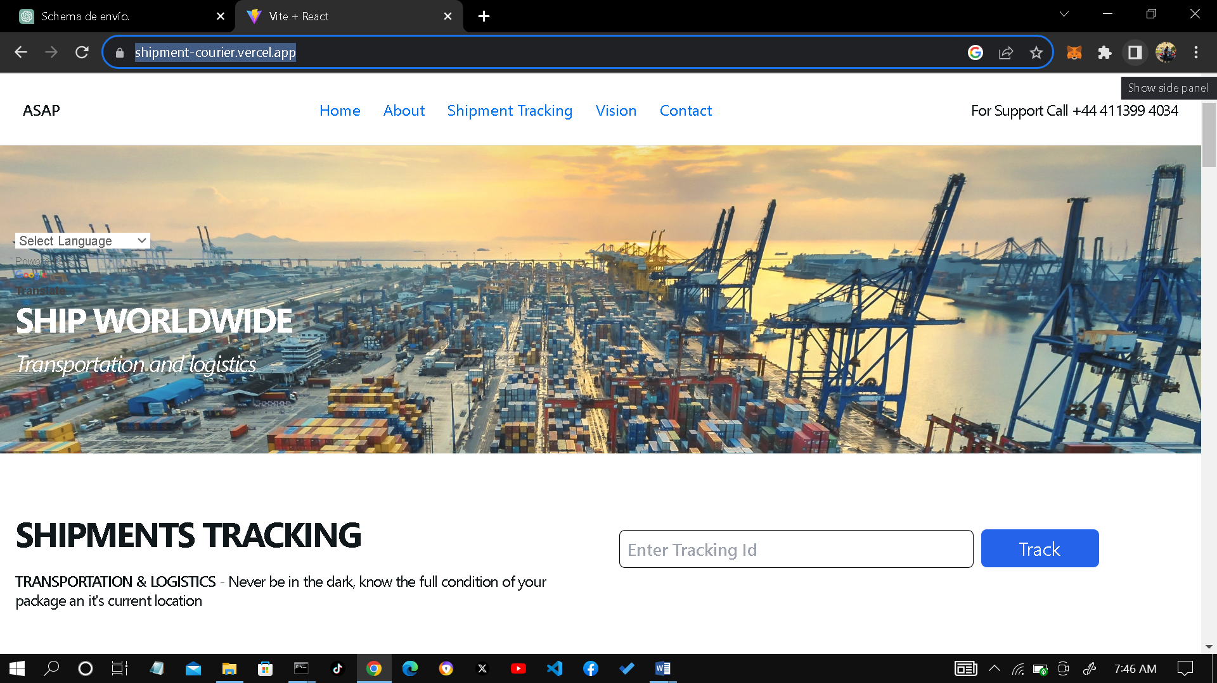

**Figure 4.1: Landing Page**

**CHAPTER 5**

**CONCLUSION**

**5.1 Conclusion**

In conclusion, the development of the shipment tracking system represents a significant achievement that was solely driven by the dedication and effort invested in this study. This project was undertaken with the primary goal of addressing the pressing need for efficient and real-time shipment tracking, aiming to streamline logistics processes and enhance the overall customer experience.

The decision to utilize JavaScript for the Node.js backend and TypeScript with React.js for the frontend was carefully considered to harness the power of scalable, real-time technologies while ensuring code quality, reliability, and maintainability. This choice of technology stack has allowed the system to provide a user-friendly and responsive tracking interface, positioning it as a valuable tool in the logistics industry.

The achievement obtained through this study is a testament to the determination and expertise of the sole developer. The shipment tracking system not only meets the initial objectives but also stands as a testament to the developer's skills and commitment. It enhances efficiency, reduces errors, and ultimately contributes to cost savings for shipping companies. As we look ahead, the system's continuous improvement and adaptability to evolving industry requirements will further solidify its place as an indispensable solution in the realm of modern logistics and supply chain management.

**5.2 Recommendation**

Here are some recommendations for future work and possible improvements based on the experience gained during the development of the shipment tracking system:

1. Integration of Machine Learning and Predictive Analytics**:** Consider incorporating machine learning algorithms to analyze historical shipment data. This can help predict delivery times more accurately and identify potential delays, allowing for proactive management of logistics operations.

2. Mobile Application Development: Extend the usability of the system by developing a mobile application for Android and iOS platforms. Mobile apps can provide users with on-the-go access to shipment tracking and notifications, enhancing the user experience.

3. Enhanced Security Measures: Strengthen the system's security by implementing advanced authentication and authorization mechanisms, data encryption, and threat detection. Given the sensitive nature of shipment data, security remains a top priority.

4. Geolocation Services: Integrate geolocation services to provide users with precise location tracking of shipments. This feature can enhance transparency and customer satisfaction by showing the exact movement of packages on a map.

5. User Feedback Mechanisms: Implement user feedback and rating systems to collect valuable input from customers and shippers. This information can be used to continually improve the system and address any issues or pain points.

6. API Integration: Offer an open API (Application Programming Interface) for third-party integration. This can expand the system's functionality and allow other logistics software or e-commerce platforms to seamlessly interact with your service.

7. Data Analytics and Reporting: Develop comprehensive reporting and data analytics tools to provide users with insights into their shipping patterns and costs. Data-driven decision-making can help users optimize their logistics operations.

8. Performance Optimization: Continuously monitor and optimize the system's performance to ensure it can handle increasing traffic and data volumes efficiently. Load testing and performance tuning can help maintain responsiveness.

9. Multi-Language Support: Consider adding multi-language support to cater to a global user base. This can enhance the accessibility of your system to users from different regions.

10. Sustainability Features: As sustainability becomes increasingly important in logistics, explore ways to integrate features that help users track the environmental impact of their shipments, such as carbon emissions calculations.

These recommendations reflect areas for potential expansion and improvement based on the experience gained in developing the shipment tracking system. Each of these suggestions can contribute to the system's growth, usability, and value to users while keeping pace with the evolving needs of the logistics and supply chain industry.

**REASON FOR CHOICE OF PROGRAMMING LANGUAGE**

I chose JavaScript with Node.js for the backend of the shipment tracking system due to its scalability, real-time capabilities, and rich ecosystem of libraries. Node.js's event-driven, non-blocking I/O model ensures efficient handling of concurrent requests, essential for real-time shipment tracking updates. The extensive npm ecosystem facilitates rapid development and integration of necessary modules, while JavaScript's widespread adoption ensures accessibility to experienced developers.

On the frontend, I opted for TypeScript with React.js to enhance code quality and maintainability. TypeScript's type safety helps prevent errors in a complex application, while React.js's component-based architecture promotes code reusability and a responsive user interface. These technologies benefit from strong community support, making them ideal choices for building a modern, interactive shipment tracking system with a focus on reliability and maintainability.

**REFERENCES**

Adam M. (2017). "An Enhanced Real-Time Shipment Tracking System for Sustainable Supply Chain Management"

Himanshu Y. (2015). Cloud-Based Logistics: Real-Time Tracking of Shipment in the Cloud"

Hong S. P. (2014). "Real-Time Tracking and Monitoring of Shipment Containers Using Wireless Sensor Networks"

Maria, F. N. & Luigi B. (2017), "A Review on Supply Chain Tracking and Tracing Techniques"

Noman H. (2020) "A Comprehensive Survey on Internet of Things in Transportation and Logistics"

Pei-Hsuan T. (2016)"RFID-Based Real-Time Location System in a Container Terminal"

Shihab J. (2018). "Development of a Real-Time Vehicle Tracking and Fleet Management System"

Thoai N. (2020). IoT-Based Real-Time Monitoring and Tracking System for Logistics Operations"

Yan Leung C. (2019). "Blockchain Technology in Supply Chain Management: An Application to the Shipping and Logistics Industry"

Zhi Qiao (2019). "A Real-Time Monitoring and Tracking System for Warehouse Management"

**APPENDICES**

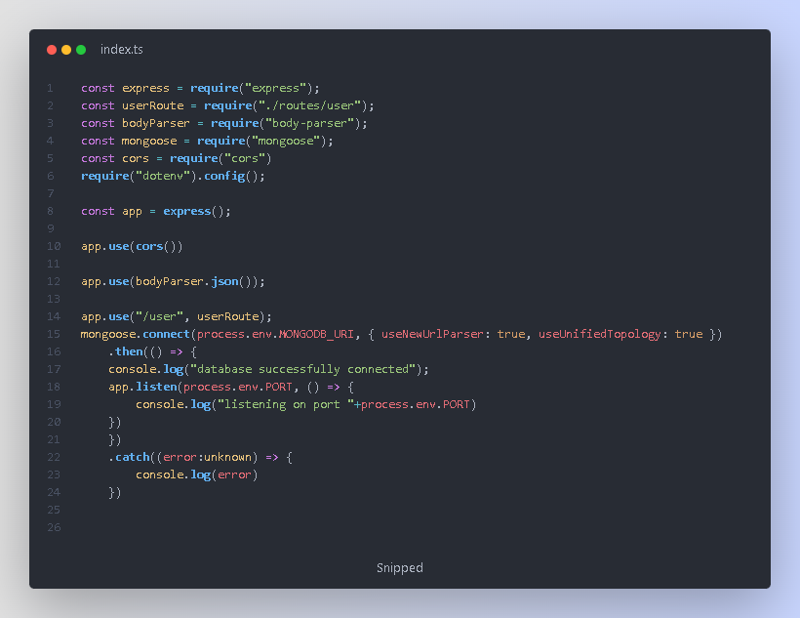

Top of Form

