1. Creating and Renaming Files/Directories

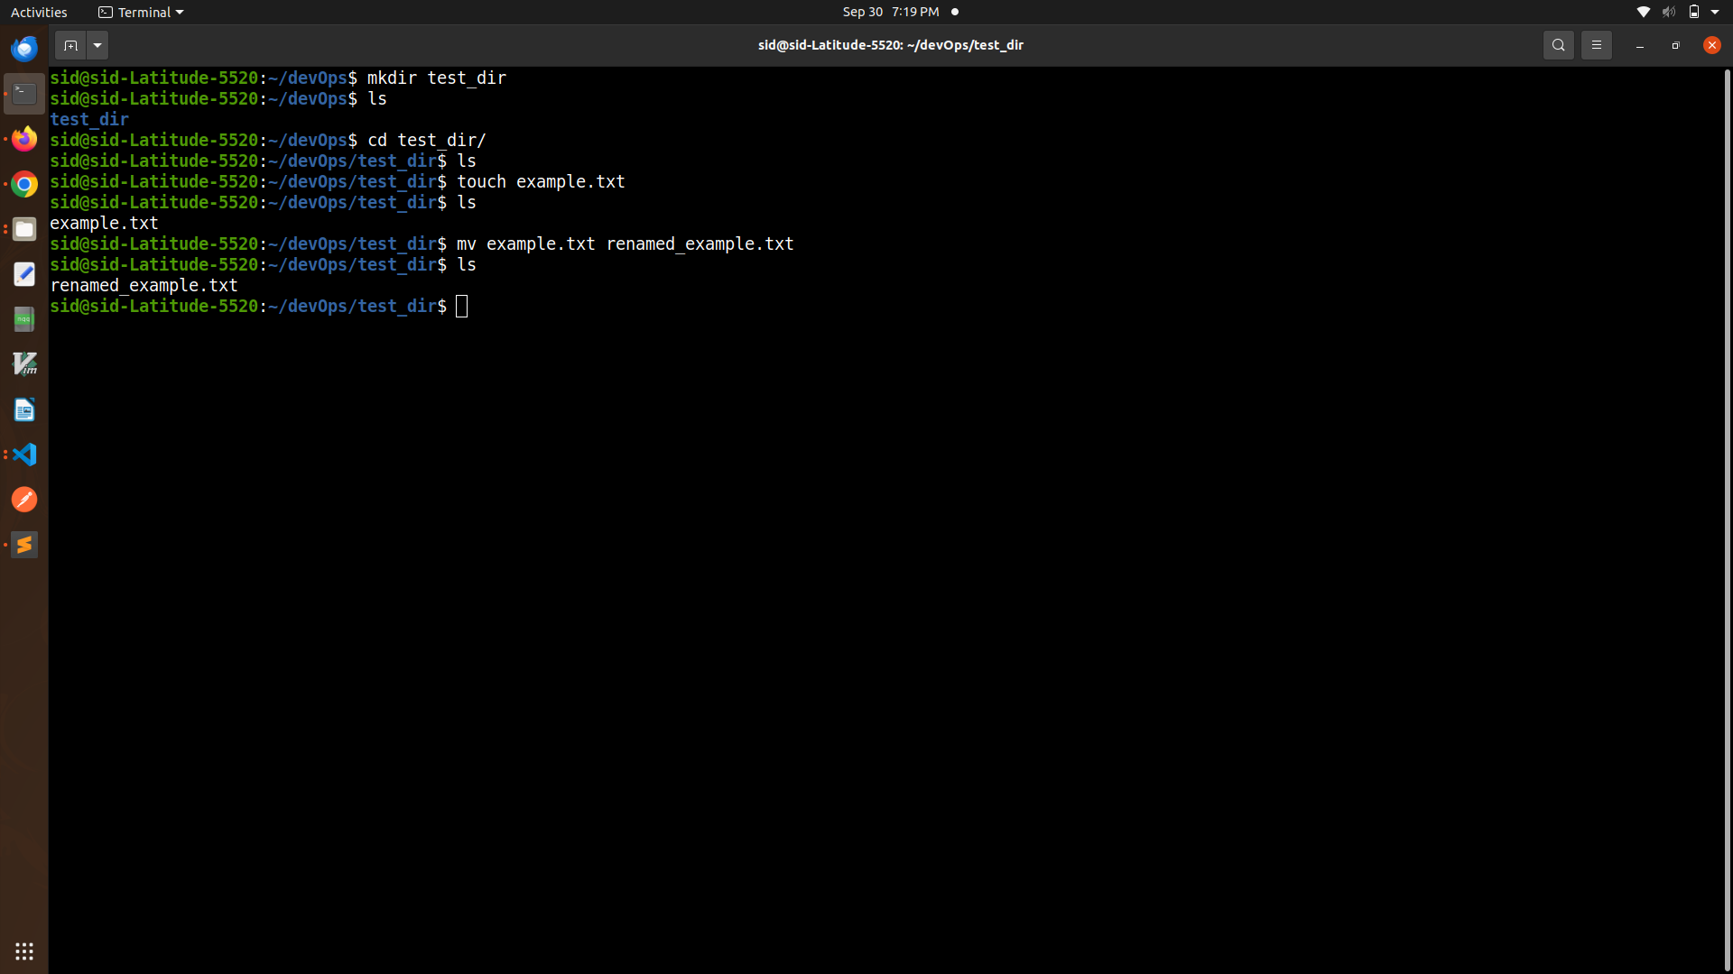

2. Viewing File Contents

Used cat to display the contents of /etc/passwd.

Displayed only the first 5 lines of /etc/passwd using head.

Displayed only the last 5 lines of /etc/passwd using tail.

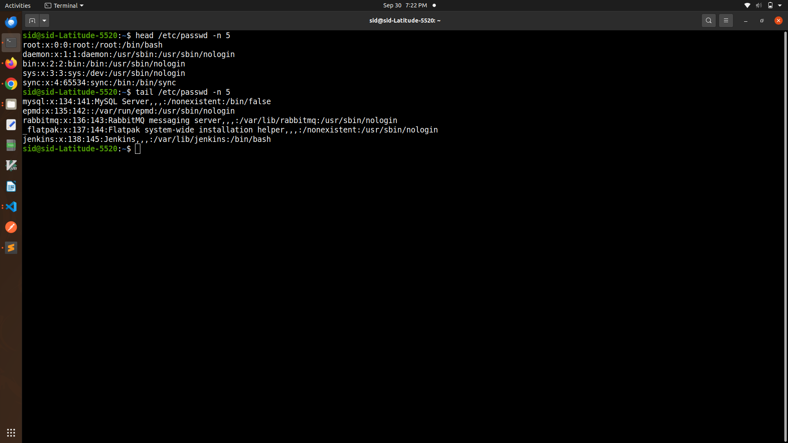

3.Searching for Patterns

Used grep to find all lines containing the word "root" in /etc/passwd.

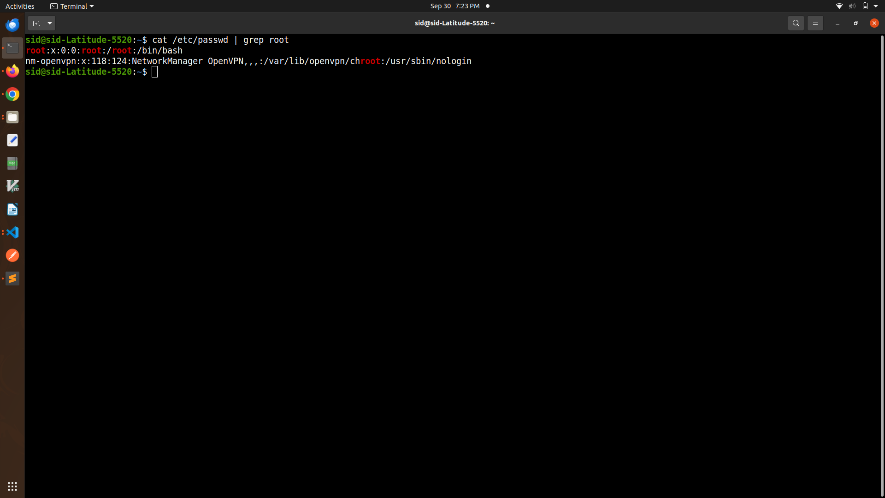

4. Zipping and Unzipping

Compressed the test_dir directory into a file named test_dir.zip using zip.

Unziped test_dir.zip into a new directory named unzipped_dir.

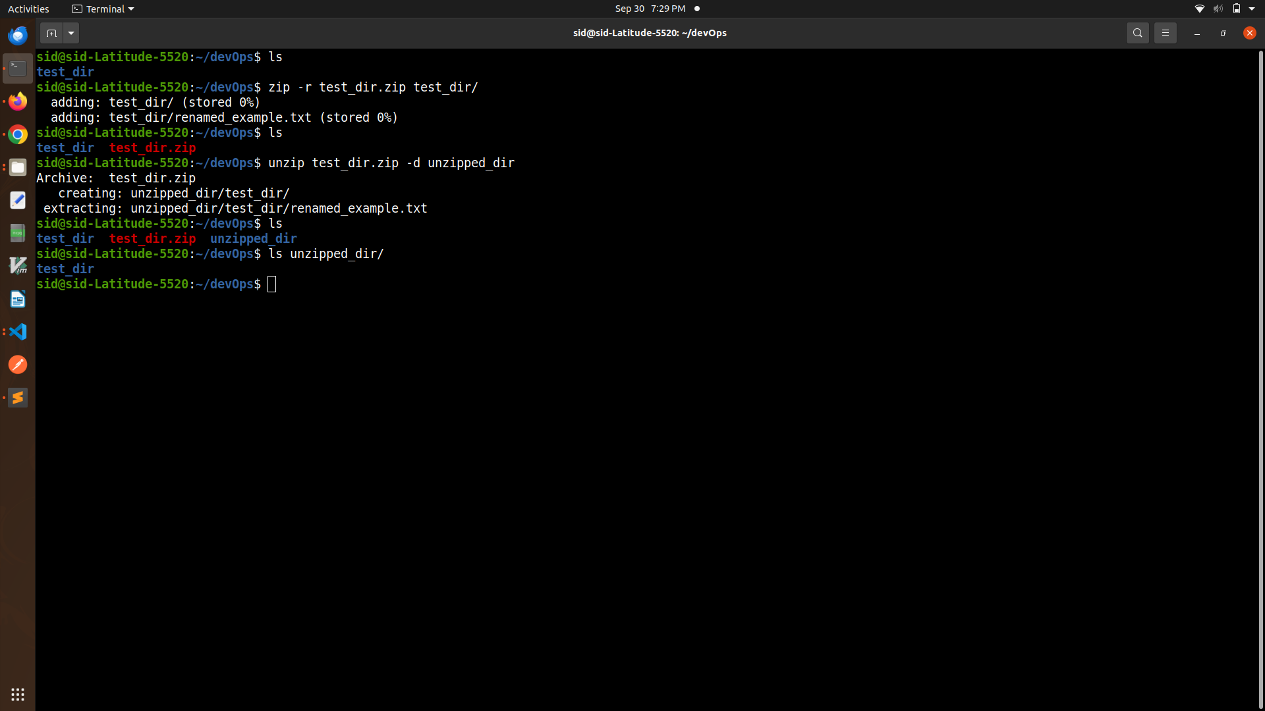

5. Downloading Files

Used wget to download a file from a URL <https://www.iana.org/help/example-domains>

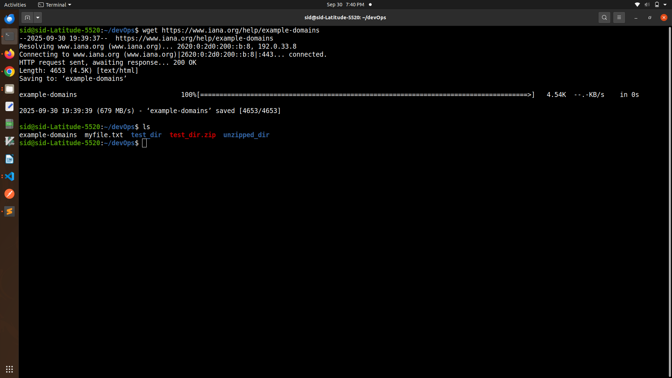

6. Changing Permissions

Created a file named secure.txt and change its permissions to read-only for everyone using chmod.

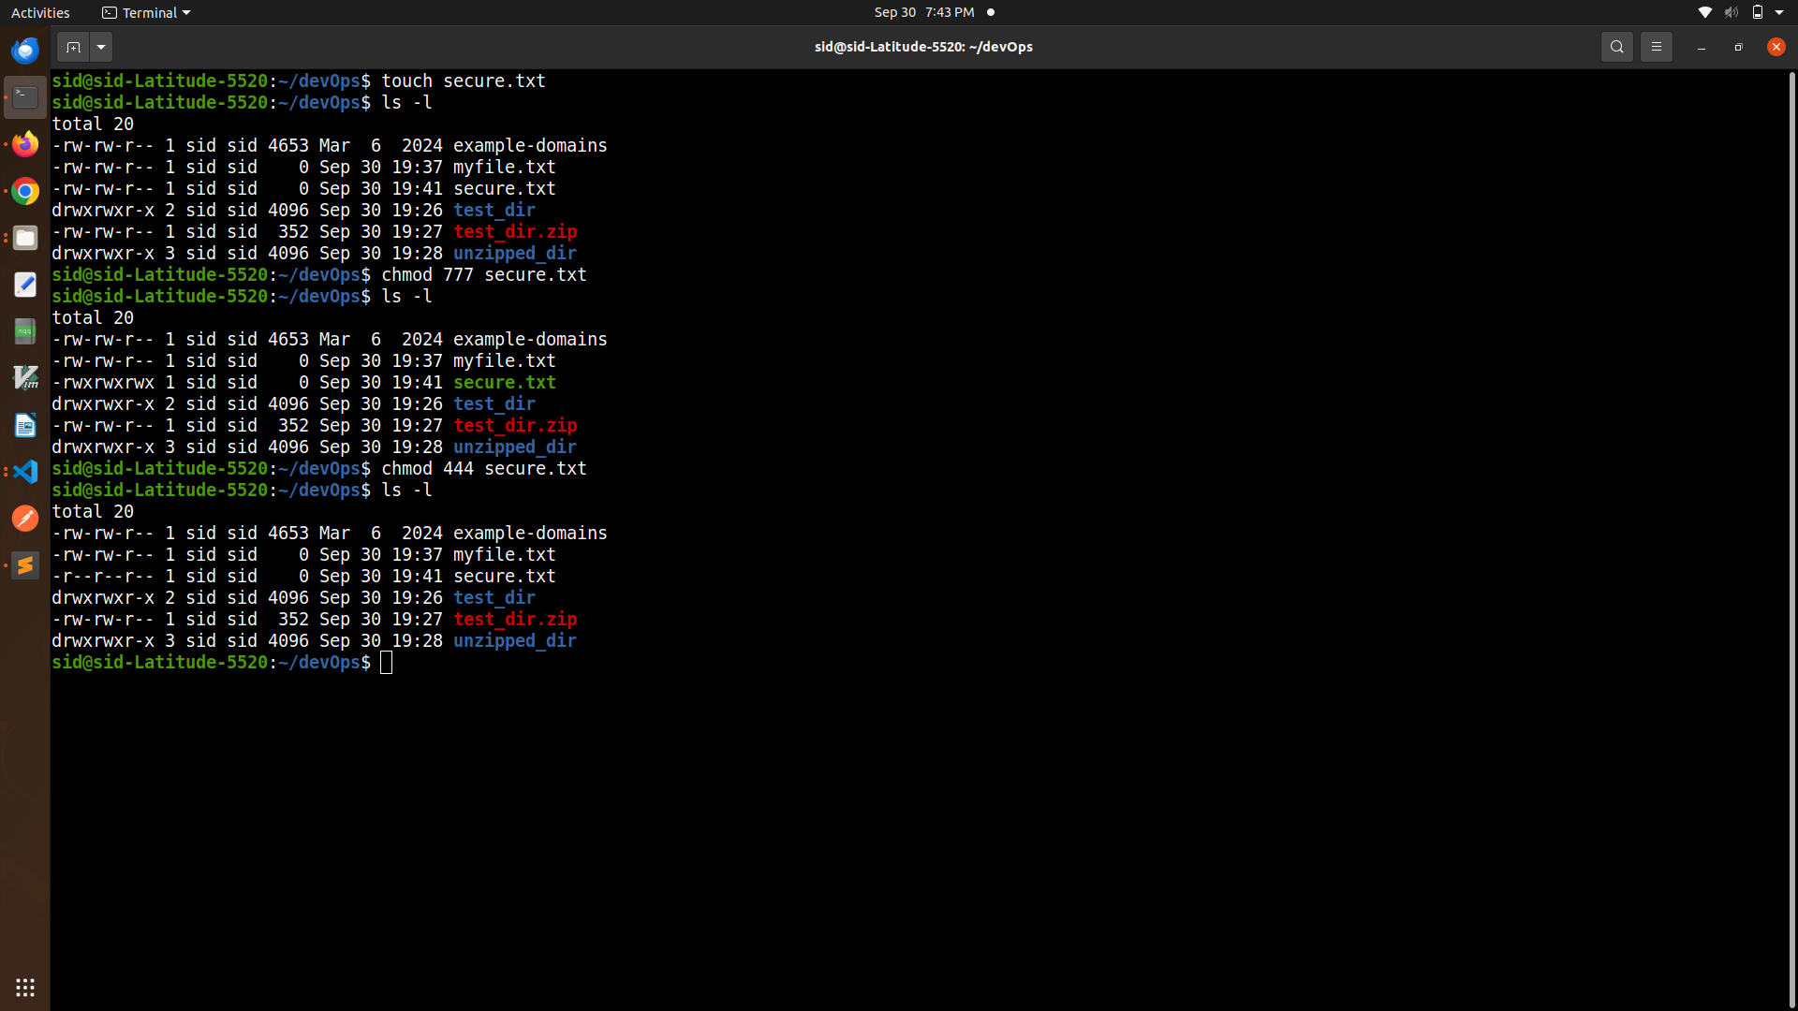

7. Working with Environment Variables

Used export to set a new environment variable called MY_VAR with the value "Hello, Linux!".

